Progress report 3 of 10
LLM-Guided Neural Network Compilation for Real-time UAV Edge Inference
Atul Kumar Gupta · 25MCSS06
A tiny network proves the rewrite
Report 2 said an engine rewrites the graph.
This note shows one rewrite, on a network small enough to inspect by hand.
The fixture is one image of size 1×1×8×8. Flatten turns that map into 64 values. The Gemm that follows must use width 64. Width 16 is kept as a test that must fail.
The pass graph_fuse joins Conv and Relu. On ONNX Runtime for the CPU, the Relu node disappears and a FusedConv node remains. That change is in the graph itself.
Both facts are locked by tests. A Gemm width of 16 must not be treated as a successful compile. graph_fuse on this fixture must leave one FusedConv and no Relu.

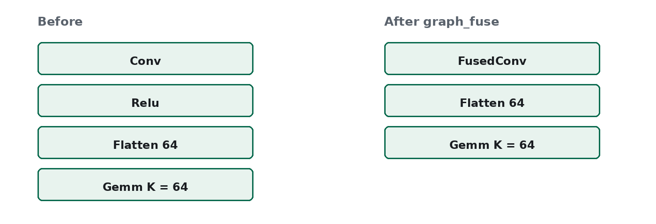
Figure 1. Conv and Relu become one FusedConv. The Flatten width stays 64.
The rewrite is visible on this fixture. The next note runs the same commands on the networks a companion computer uses.

