Progress report 4 of 10
LLM-Guided Neural Network Compilation for Real-time UAV Edge Inference
Atul Kumar Gupta · 25MCSS06
One loop, seven companion models
Report 3 used a toy graph.
This note runs the same compile commands on seven camera networks. The compiler does not contain a special case for any one of them.
Each model is one record: a task, a file, and an export script.
- yolov8n and yolo11n detect people and vehicles.
- yolov8n-pose detects body keypoints.
- yolov8n-seg produces masks.
- ssdlite_mobilenetv3 is a lighter detector.
- mobilenetv3_small is a small classifier.
- midas_small estimates depth from one camera.
Ultralytics YOLO graphs use SiLU, which is Conv, then Sigmoid, then Mul. The CPU fusion pass only joins Conv and Relu, so those YOLO graphs do not get smaller. MobileNet and MiDaS do get smaller where Conv is followed by batch-norm or Relu. That difference is a result.
There is no fused CPU kernel for SiLU in this project, and none will be invented to make the node count fall. The list of models lives in experiments/zoo.yaml. Adding a model means a new record and an export script, not a new branch in the compiler.

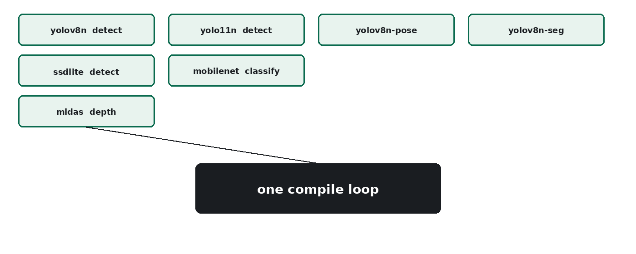
Figure 1. Seven models enter one compile loop.
One loop covers the zoo. The next note is the gate that can refuse a plan before any rewrite.

