Progress report 5 of 10
LLM-Guided Neural Network Compilation for Real-time UAV Edge Inference
Atul Kumar Gupta · 25MCSS06
A plan can be refused
Report 4 put seven models through one loop.
This note is only the gate in front of the engine.
A plan is JSON. It holds at most eight steps. Each step name must come from a closed list. The plan may also set how hard ONNX Runtime optimizes the graph, how many threads to use, and whether execution is sequential or parallel.
An unknown name rejects the whole plan. The engine never sees it. A known name that does not match this graph, such as batch-norm fusion when the graph has no batch norm, is dropped. The rest of the plan continues.
The checker allows three tries. If the reply is still illegal, an offline heuristic plan is used. That result is labelled as a fallback.
On this CPU, a thread count above the number of cores is cut down to that number. Parallel execution is left as the plan asked for it. The checker does not rename the plan. It only removes or clamps what cannot run.

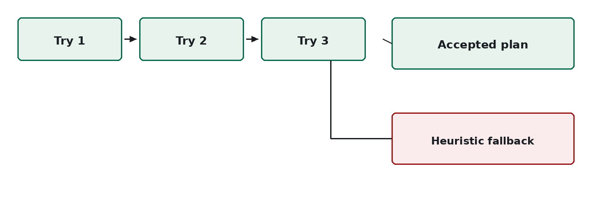
Figure 1. Three tries. Then an accepted plan, or the heuristic fallback.
Illegal plans stop or shrink before the rewrite. The next note is how a winner is chosen after measurement.

