Progress report 8 of 10
LLM-Guided Neural Network Compilation for Real-time UAV Edge Inference
Atul Kumar Gupta · 25MCSS06
A hosted model, one revision
Reports 5 and 6 already had a planner.
This note says that planner can be a model on a remote host, without a second client.
There is one HTTP client. Groq is one named host. OpenAI, Anthropic, Gemini, DeepSeek, and other hosts that speak the same chat API are further rows. A new host is a URL and a model id. The API key stays outside git.
After a plan has been measured, there is at most one extra call. If compile or the numeric check failed, that call is named llm_revised. If the plan passed but was strictly slower than the best legal plan, the call is named llm_improved. A rate limit is stored as the text LLM HTTP 429. The extra plan is allowed to lose.
A slow reasoning model needs a longer timeout and sometimes no temperature field. Those are settings in the environment, not a new program. The same three tries from the gate still apply on that extra call. Only one extra compile is run.

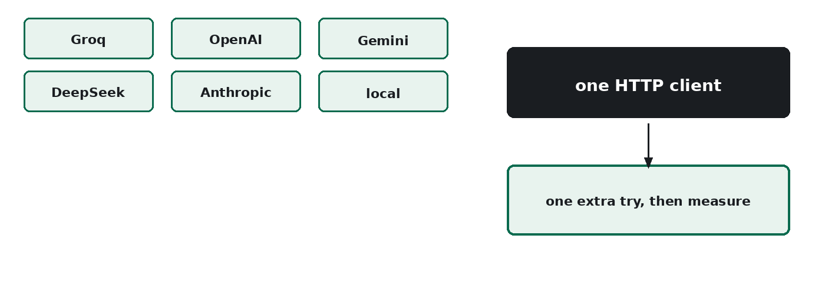
Figure 1. Many hosts, one client, then one extra measured try.
A remote model can propose a plan, and the record can show that it was wrong. The next note is the page used to run and show this loop.

