Progress report 9 of 10
LLM-Guided Neural Network Compilation for Real-time UAV Edge Inference
Atul Kumar Gupta · 25MCSS06
A page that runs the loop
Reports 3 to 8 were command-line steps.
This note is a page on this machine that calls those same functions.
The page shows the host, the graph notes, the plan and its attempts, the ranking, a table across the seven models, and a fresh timing of the chosen file. The operator picks a host and a model id. If the key is missing, the page says key not set. It does not ask for the key.
The seven ONNX files are stored in experiments/models.
The page listens only on this machine, at 127.0.0.1. One job runs at a time. If the console process is down, the buttons become usable again and the bar says the console is not reachable. Analyze, plan, optimize, export, and a remeasure of the chosen file all call the same Python functions as the command line.

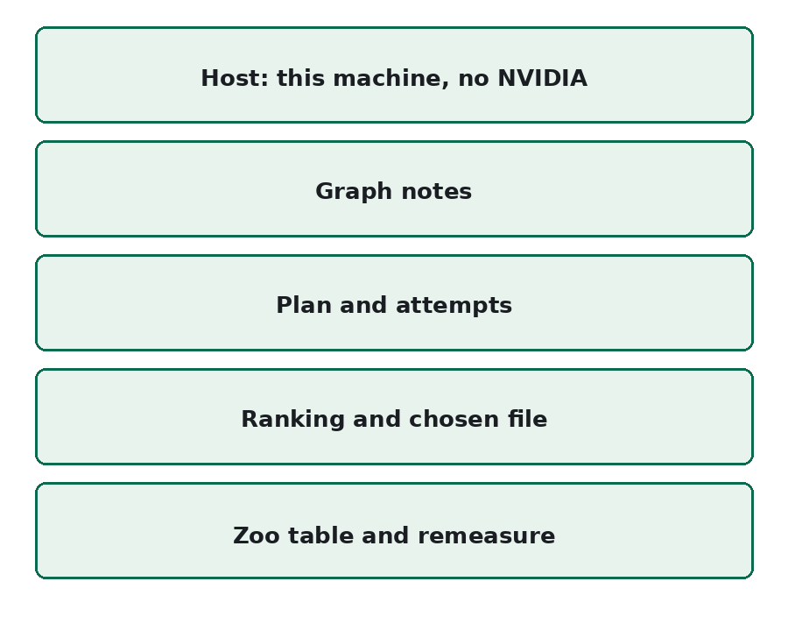
Figure 1. The page is those five bands, in that order.
The loop can be run and shown from one page. The last note states what the thesis can claim.

