Progress report 10 of 10
LLM-Guided Neural Network Compilation for Real-time UAV Edge Inference
Atul Kumar Gupta · 25MCSS06
What can be claimed
Reports 1 to 9 are the path from the problem to a measured file on a simulated camera.
This note adds no new tool. It states the claim.
The work can say that a language model names an allowlisted plan, that a checker can refuse it, that an engine rewrites ONNX, that a profiler measures, that the kept plan is the fastest one that passed, that one extra try is allowed after measurement, and that ROS only loads the file.
It cannot yet say TensorRT speed, board power, or accuracy on labelled images. Those need a board with an NVIDIA GPU. This machine is QEMU on ARM and has none. Latency from this machine must not be compared with a Jetson.
Every stored run sets fps_claimed to false. When a throughput number appears, it is 1000 divided by the mean latency in milliseconds. It is not a camera frame rate, and it is not a claim about a Jetson.

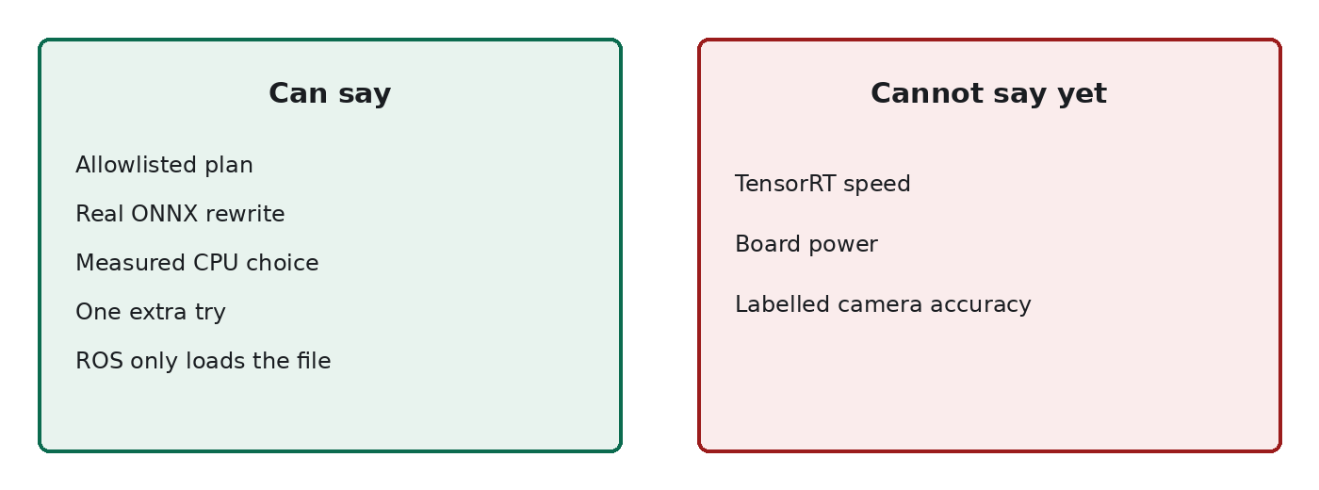
Figure 1. The left column is the thesis. The right column waits for a board.
The next measurement, on a real board, is TensorRT and power. These ten reports are not that result.

