Thesis progress report
LLM-Guided Neural Network Compilation for Real-time UAV Edge Inference
Atul Kumar Gupta · 25MCSS06
The winner is the fastest plan that passed
A plan can be legal and still be a bad compile. This report is about which legal plan is kept.
Several legal plans are compiled on the same machine: fixed presets, the heuristic, and the model's plan. Each run records whether compile succeeded, whether the outputs still match the untouched graph, and the latency percentile p50.
The chosen plan is the one with the lowest p50 among the plans that passed the numeric check. A plan that is faster but fails the check stays in the table. It is not chosen. If the model's plan has no rank, that is the reason, not a missing run.
p50 is the median latency of repeated runs on this machine. It moves when the QEMU load moves, so two runs from different sessions are not one experiment. The numeric check compares the rewritten network with the original 32-bit graph.
Each row stores where the plan came from, its name, the node count before and after the rewrite, whether the graph changed, and whether the numeric check passed. The model's row is never deleted when it matches a preset. It is marked as the same plan, so the record still shows what the model said.
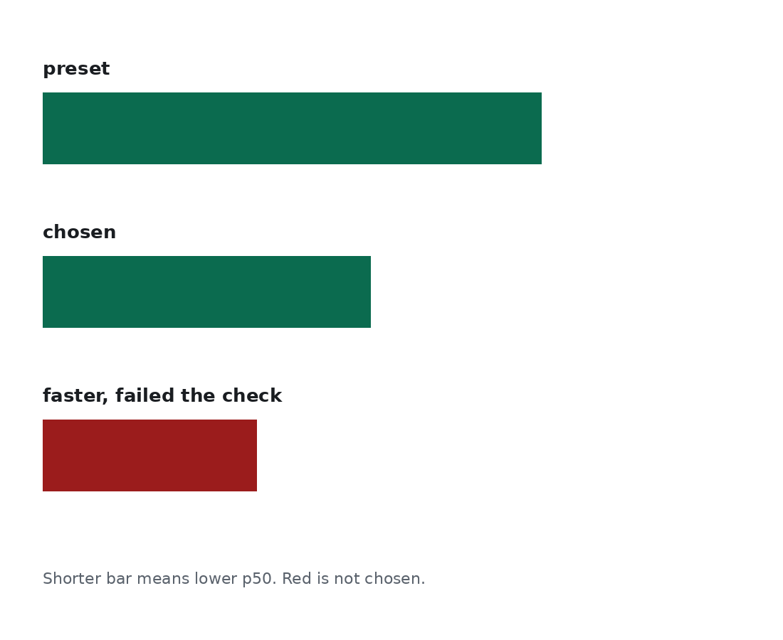
Figure 1. The short green bar can win. The red bar is faster and still rejected.
A faster plan that fails the numeric check is not the result. The file that is kept still has to be loaded somewhere.

