Exercise 4:

1. docker build -t theav/week2 .

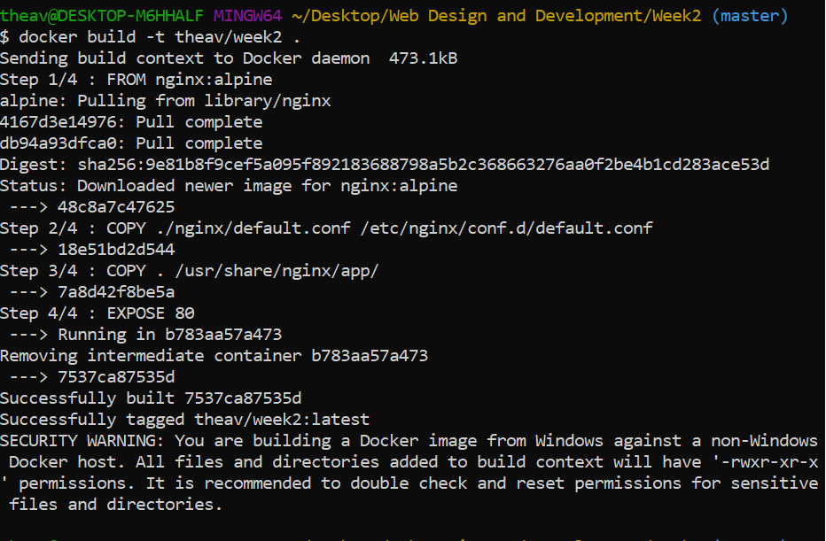

1. docker images

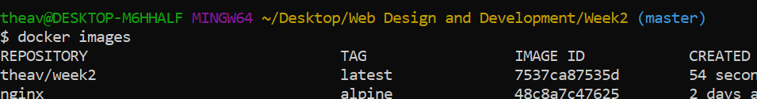

1. docker run -p 8080:80 --name week2 theav/week2

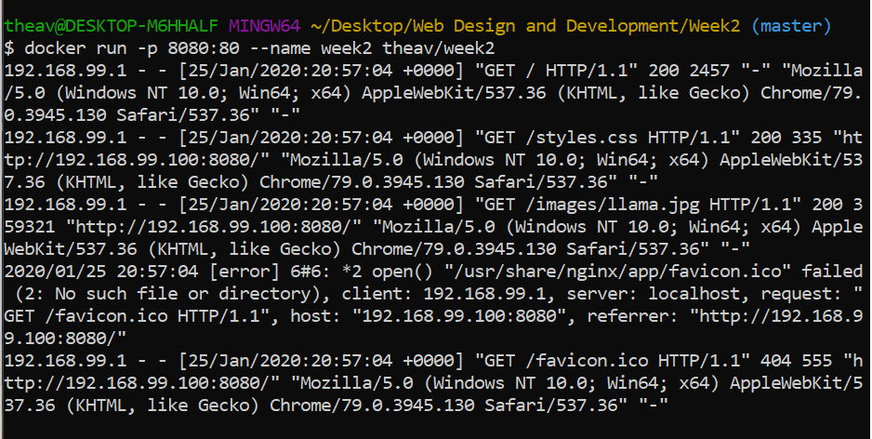

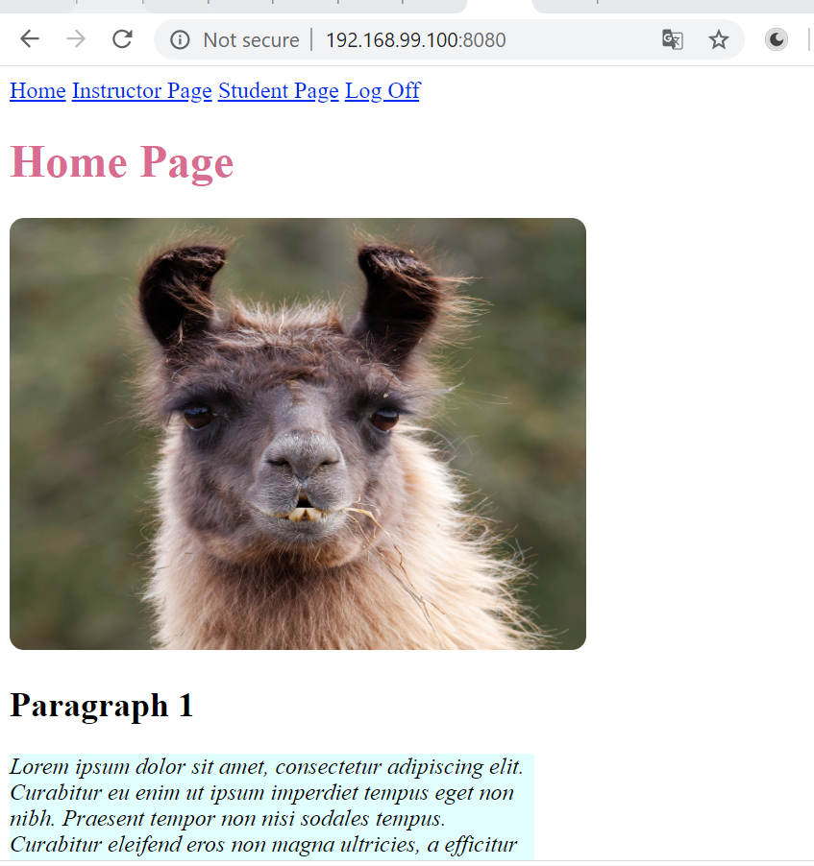

1. docker login

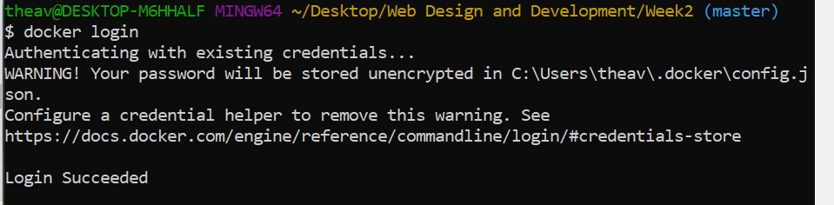

1. docker push theav/week2

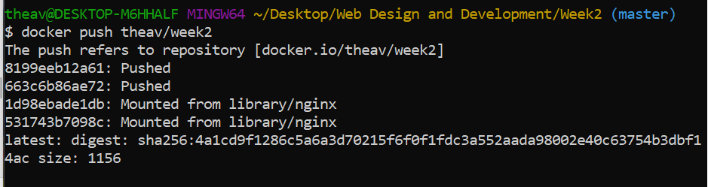

1. docker rm -f week2

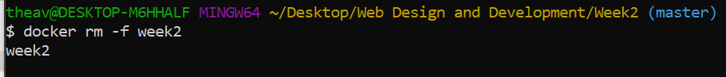

Docker hub: <https://hub.docker.com/repository/docker/theav/week2>