**Kafka Cluster**: Kafka is a distributed system, it acts as agent it consist of set of Broker / software, for production cluster must have 3 Broker.

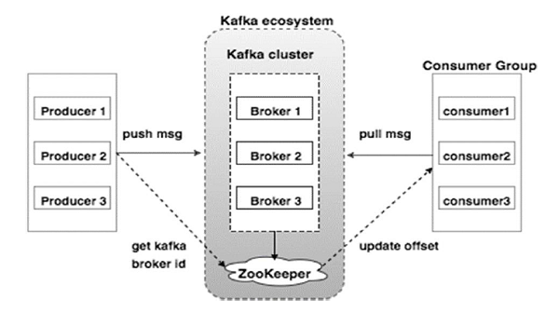

**Producer**: Produce messages any in format. (JSON, XML, Text etc.) And send to Kafka cluster.

**Consumer**: Consume messages from Kafka broker.

**Kafka Broker**: it’s a Kafka server or s/w, the producer and Consumer don’t interact directly, they use Kafka broker / agent to exchange messages.

**Zookeeper**: Manages the state of the all Kafka broker in the Kafka cluster. It also maintains the configuration of all topics of producer and consumer.

**Fault Tolerance**: If any broker gets down then automatically another broker handles the traffic as data is duplicated across the Kafka brokers in the cluster.

**Reference**: <https://kafka.apache.org/documentation/>

**Kafka Topic**: Is like Table in database or folder in file system, and is identified by name we can have any number of Topics in Kafka broker. Consumer subscribes the topic.

**Kafka Partition**: Topic has multiple partitions.

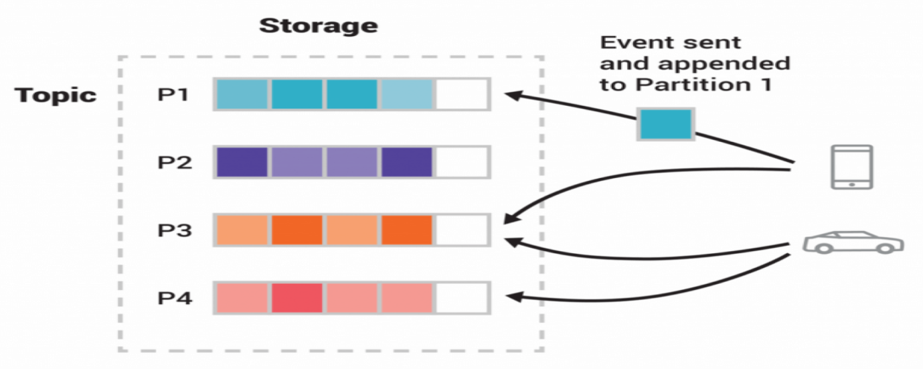

**Offset**: Is a sequence of Ids given to the messages at arrive position. Once the offset is assigned it will never changes.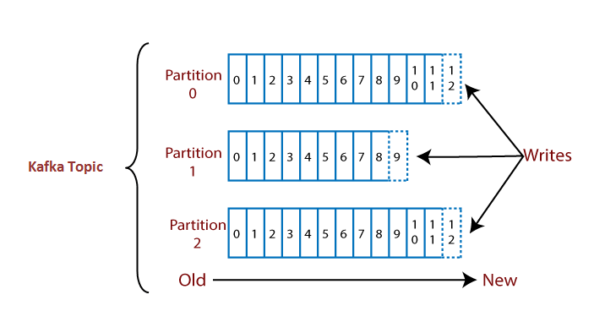

**Consumer Group**: A consumer group contains a one or more consumer’s working together to process the messages. 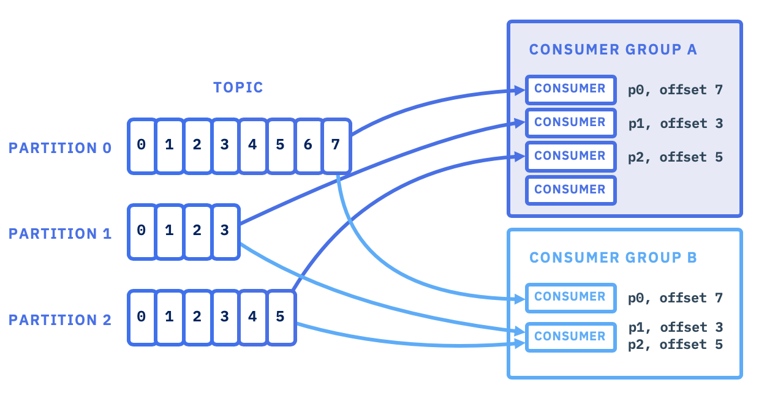

* **Can multiple consumers consume messages from same partition?**

|  |
| --- |
| Within same group: **NO**   * Two consumers (*Consumer 1, 2*) within the same group (*Group 1*) **CAN NOT** consume the same message from partition (*Partition 0*).   Across different groups: **YES**   * Two consumers in two groups (*Consumer 1* from *Group 1*, *Consumer 1* from *Group2*) CAN consume the same message from partition (*Partition 0*). |

**How to install Kafka:**

Reference: [**https://kafka.apache.org/quickstart**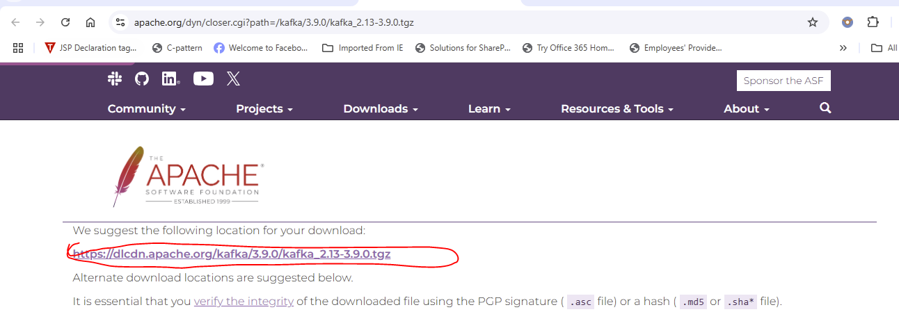](https://kafka.apache.org/quickstart)Extract Here

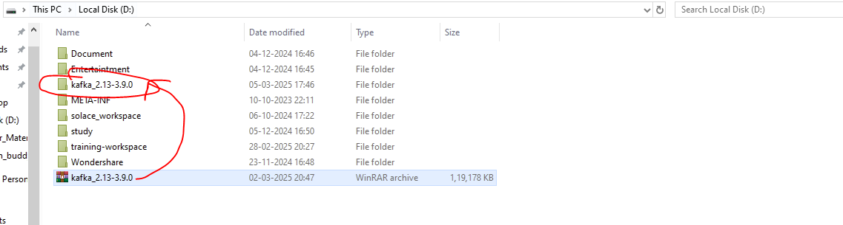

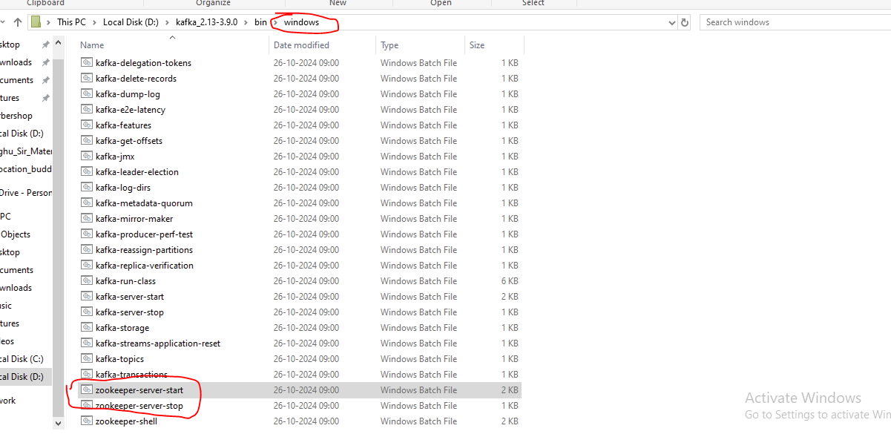

**Start Zookeeper:**

.\bin\windows\zookeeper-server-start.bat .\config\zookeeper.properties



**Start Kafka broker:**

.\bin\windows\kafka-server-start.bat .\config\server.properties



**Create Spring Application**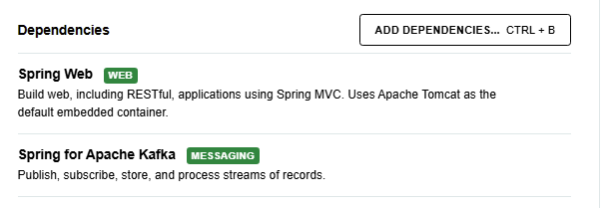

Reference: <https://docs.spring.io/spring-kafka/reference/quick-tour.html>