PART D – Debugging

## Screen Shot of Performance tab in DevTools

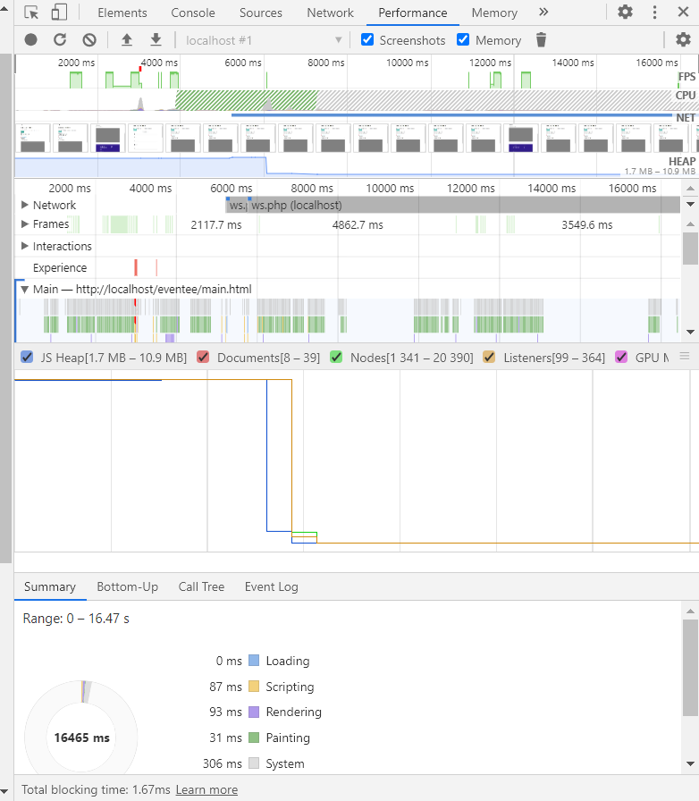

## Screen shot showing AJAX (network tab)

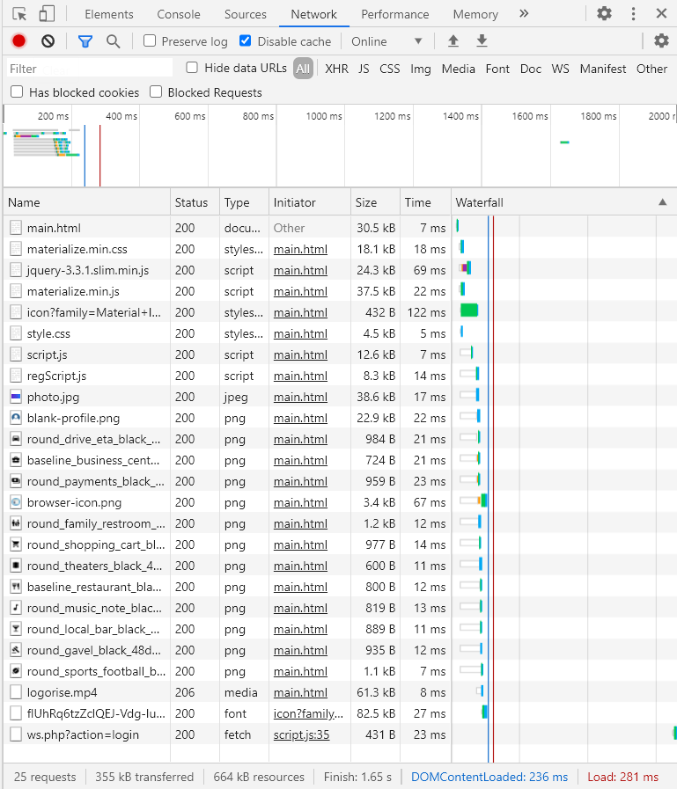

## localStorage (application tab) inside devtools to prove app works

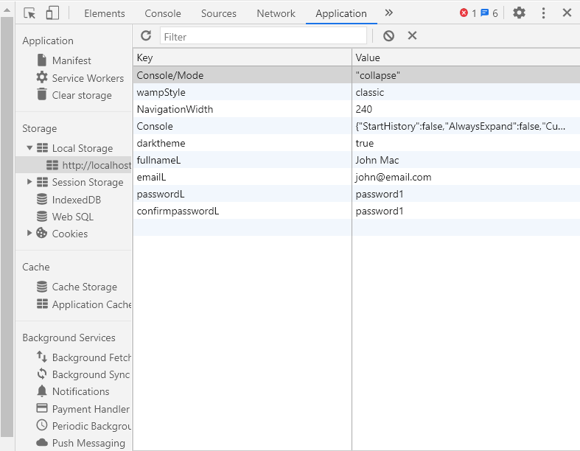

## PWA audit completed under lighthouse tab

### [**index.html**](https://d.docs.live.net/93945a1760e15820/Desktop/TAFE%20-%20ICT50615%20%5e0%20ICT50515/Semester%202/UX%20Development/Assessment%202/Lighthouse%20Report%20-%20index.pdf)

### [**main.html**](https://d.docs.live.net/93945a1760e15820/Desktop/TAFE%20-%20ICT50615%20%5e0%20ICT50515/Semester%202/UX%20Development/Assessment%202/Lighthouse%20Report%20-%20main.pdf)