

Title: Design a full-fledged network for an organization with multiple subnets.

Semester: Spring 2024
Course Title: Computer Networks
Course Code: CSE 405
Section no: 03

Submitted by
Ayon Adhikary
ID: 2022-3-60-137

Submitted to
Dr. Anisur Rahman
Associate Professor
Dept. of CSE

Submission date:
9/14/2025

Table of Content

- Introduction………………………………………………………………03
- Tools Used………………………………………………………………..03
- Purpose of the Network…………………………………………………..04
- Network Summary & Logical Diagram………………………………….05
- Servers Used in the Network…………………………………………….06
- Wireless Access & Security……………………………………………...08
- Limitations of the Network………………………………………………08
- Testing & Verification……………………………………………………09
- Router Configuration Codes……………………………………………..11
- Routing Table using Dynamic Routing (OSPF)…………………………15
- Conclusion……………………………………………………………….16

Introduction

In today’s academic environment, universities rely heavily on efficient and secure computer networks to ensure smooth operation of both academic and administrative activities. Apex University, like many modern institutions, requires a large and complex network infrastructure to connect classrooms, laboratories, offices, libraries, and other facilities across multiple campuses. The network must support both wired and wireless access while maintaining reliable connectivity between different sites.
The aim of this project is to design a complete model of the university’s network with multiple subnets, ensuring proper interconnection between campuses. The design will incorporate essential services such as DNS and DHCP, along with appropriate routing mechanisms to maintain seamless communication across the network. Special attention is given to scalability, so that the network can accommodate future growth and expansion. This project not only demonstrates technical implementation but also reflects best practices in professional network design.

Tools Used
To set up the network, the following devices and tools were used:
- Networking Devices: Routers, switches, wireless access points, and servers (DNS, DHCP, Web).
- End Devices: Desktop PCs, laptops, and mobile devices for testing.
- Cables: Straight-through cables for PC to switch and switch to router connections and serial DCE cables for router-to-router connections.
- Software: Cisco Packet Tracer for designing and simulating the network.

Purpose of the network
- Interconnect Multiple Campuses:
The network connects Campus 1 (172.10.0.0) and Campus 3 (172.30.0.0) to allow communication between different sites of the organization.
- Provide IP Addressing for Devices:
Using subnets like 172.10.0.0 and 172.20.0.0, each campus can assign unique IPs to hosts (computers, printers, servers), enabling proper addressing and routing.
- Enable Routing Between Networks:
Routers with serial interfaces (Se0/3/0, Se0/3/1) connect the campuses, allowing data to travel across different subnets via proper routing.
- Serve as a Gateway for Internet or External Access:
The router interfaces (like Fa0/0 for LAN and Se0/3/0/1 for WAN) allow traffic to flow between local campus networks and potentially the internet or other external networks.
- Support Scalable and Organized Network Structure:
Using separate subnets for each campus ensures easier management, security, and future expansion without IP conflicts.
- Test/Practice Real-World Networking:
This setup is similar to a lab or simulation scenario (like in Packet Tracer) for learning routing, IP addressing, and inter-campus communication.

Network Summary & Logical Diagram
- The network connects eight campuses of Apex University under one system.
- Each campus has its own subnet with routers, switches, and end devices.
- A central router 8 links all campus routers together, allowing communication between campuses.
- Campus 7 acts as the service hub with DNS, DHCP, and Web servers placed in one LAN for easier management.
- Other campuses mainly include PCs, laptops, and wireless access points for users.
- Straight-through cables are used for end device connections, serial cables for router-to-router links, and wireless access for mobile and laptop devices.

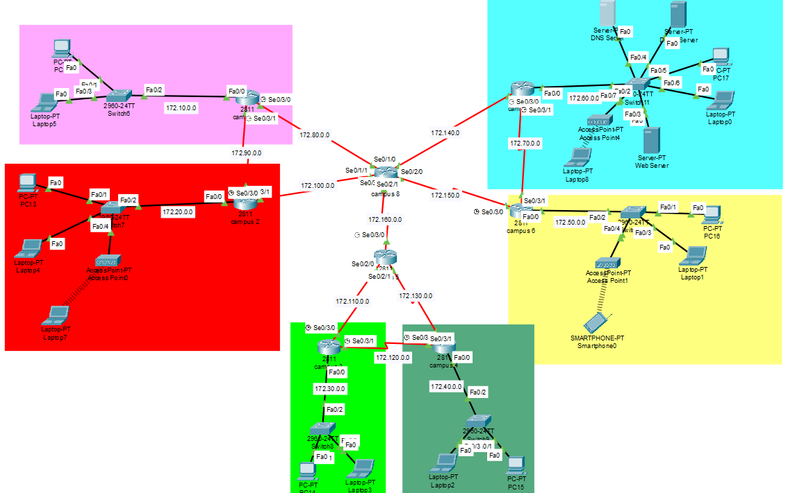
• Web Server is incorporated to access the university website: http://www.apex.edu.bd
• Every device can request IP from the DHCP server.

There were 3 servers that were used. Those were DHCP, DNS and Web Server. All these servers were kept in a Server Room, separate from all the other Campus networks.

DHCP Server
- Assigns IP addresses automatically to devices.
- Prevents duplicate IP conflicts.
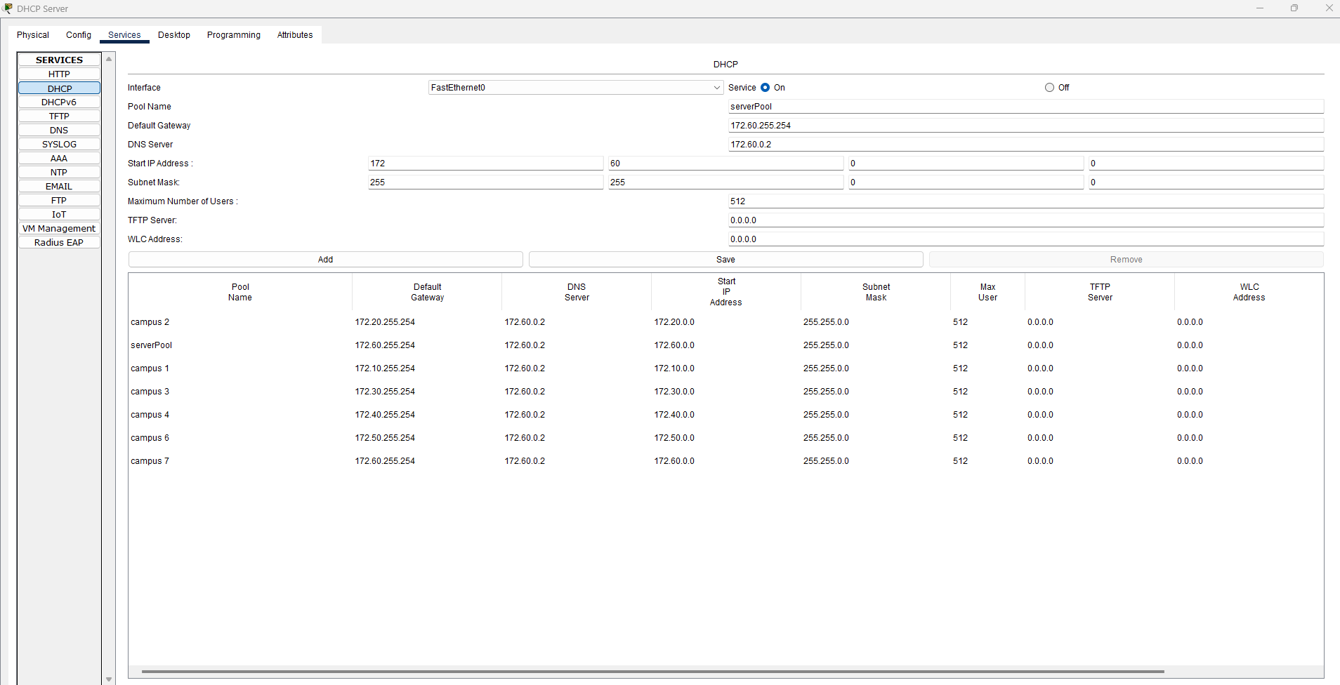

DNS Server
Converts website names into IP addresses so we can access them easily.
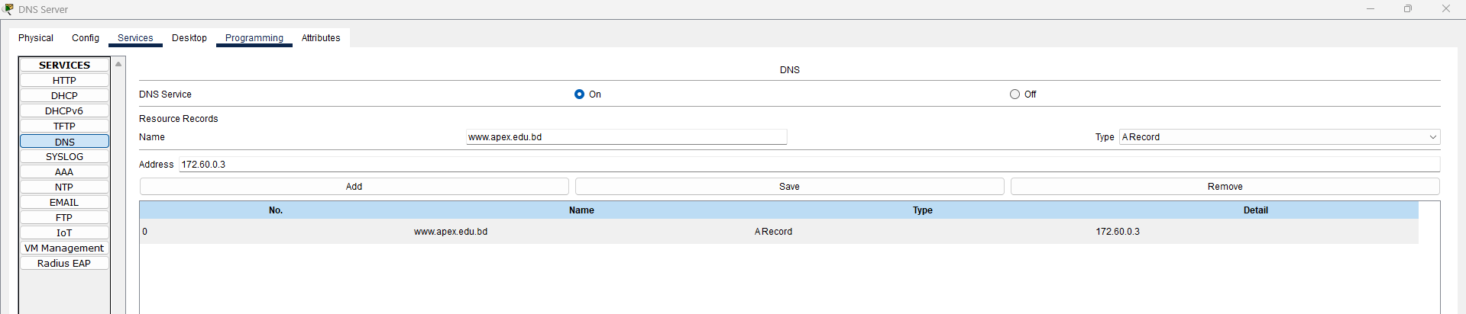

WEB Server
Hosts websites and delivers web pages to users over the internet . Responds to browser requests using HTTP/HTTPS. Stores website files like HTML, CSS, images, and scripts and also can handle multiple users at the same time.

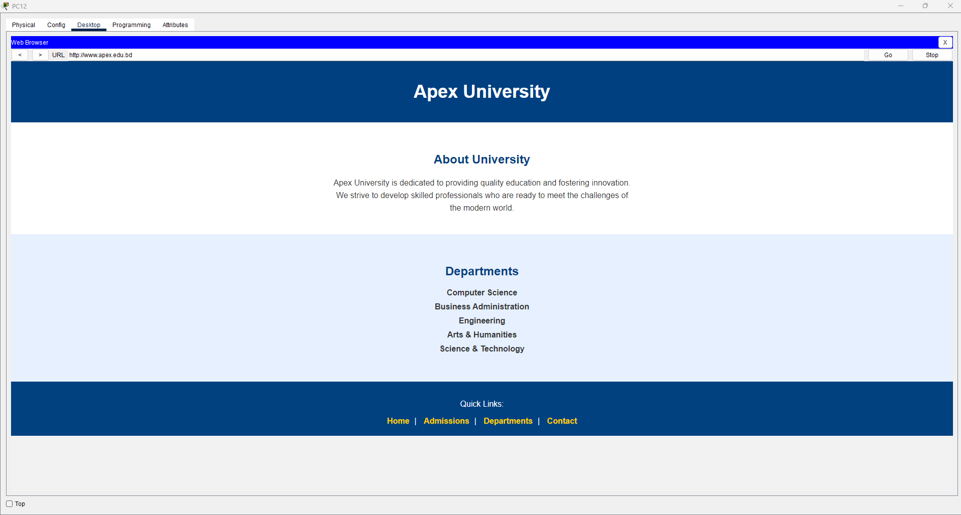
The wireless connections were possible through wireless Access Points present in each network. The Access Points were secured through WEP protection and the connecting devices would require password to connect to the wireless network.

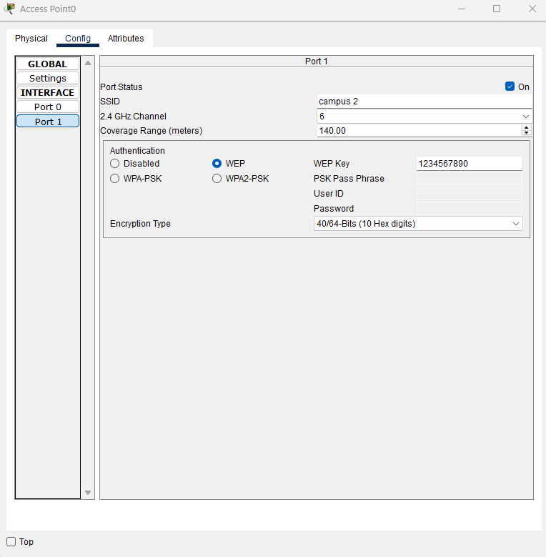

Limitations: For consistency of this complex network we used many devices which is very costly. Moreover, the unique server room need extra cost and maintenance.

DHCP request from different Campus network:

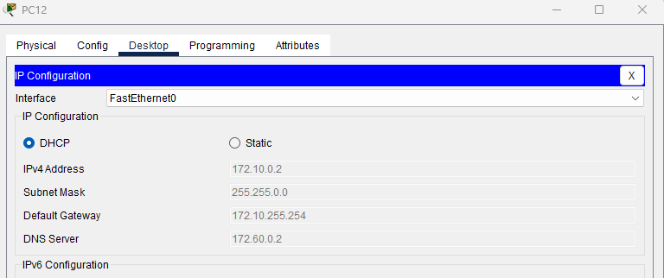

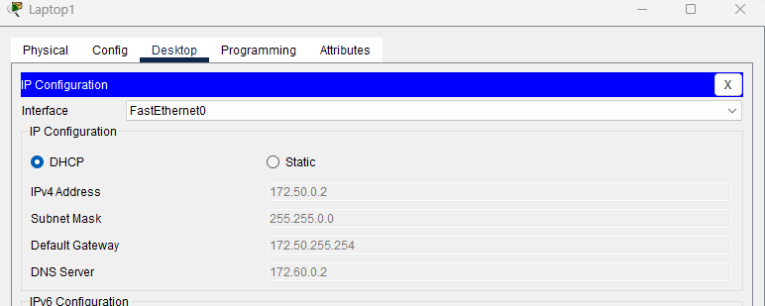

Ping from a one to another network wired and wireless (Different Network):

PC to PC:
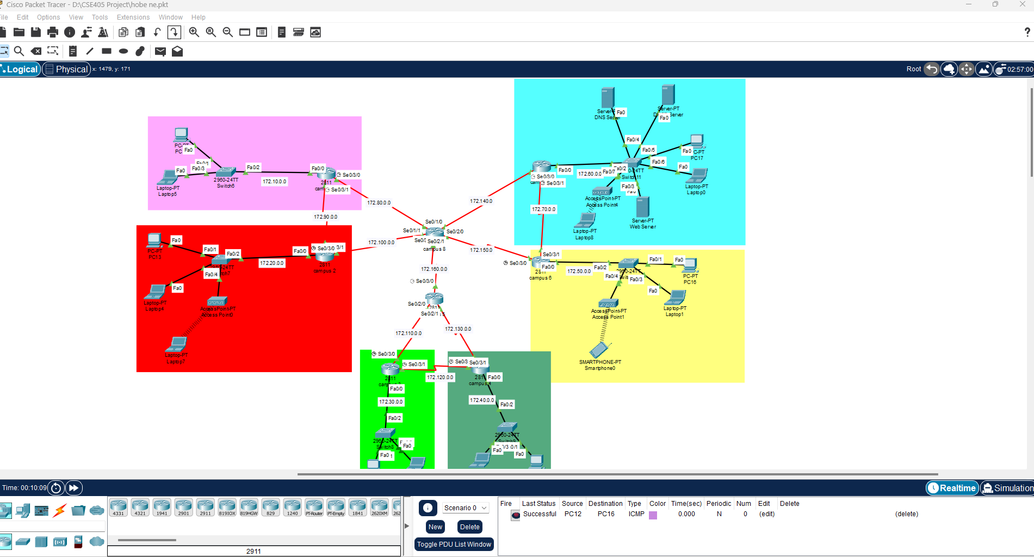

Wireless Laptop to smartphone:
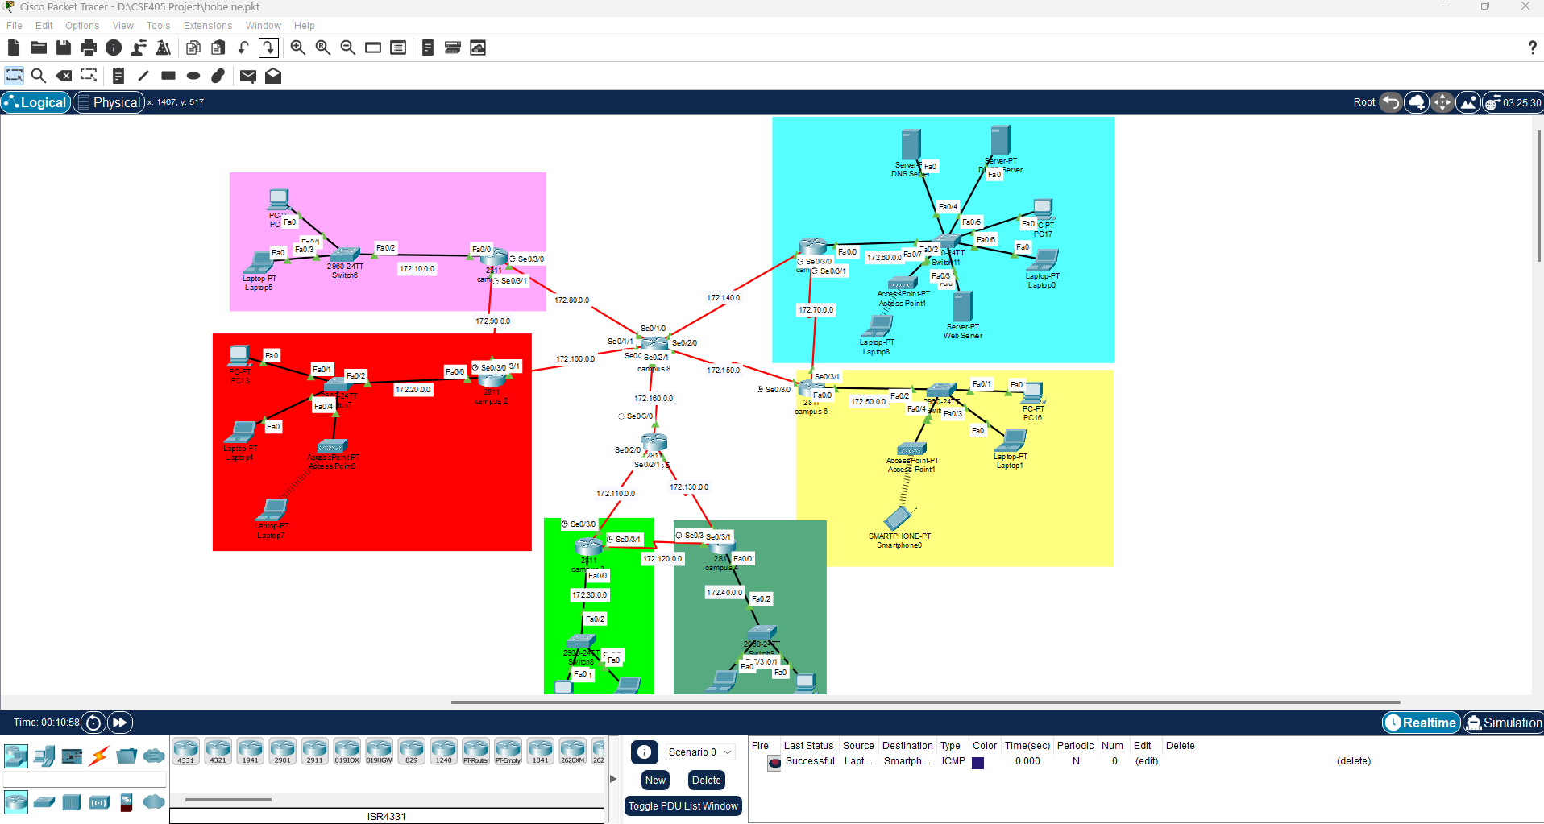
Codes to configure the router:

###campus 1### | interface fa0/0  ip address 172.10.255.254 255.255.0.0  no shut  do wr  exit  interface se0/3/0  ip address 172.80.0.1 255.255.0.0  clock rate 64000  no shut  do wr  exit  interface se0/3/1  ip address 172.90.0.1 255.255.0.0  clock rate 64000  no shut

###campus 2### | interface fa0/0  ip address 172.20.255.254 255.255.0.0  no shut  do wr  exit  interface se0/3/0  ip address 172.100.0.1 255.255.0.0  clock rate 64000  no shut  do wr  exit  interface se0/3/1  ip address 172.90.0.2 255.255.0.0  no shut  do wr  exit

###campus 3### | interface fa0/0  ip address 172.30.255.254 255.255.0.0  no shut  do wr  exit  interface se0/3/0  ip address 172.110.0.1 255.255.0.0  clock rate 64000  no shut  do wr  exit  interface se0/3/1  ip address 172.120.0.1 255.255.0.0  clock rate 64000  no shut  do wr  exit

###campus 4### | interface fa0/0  ip address 172.40.255.254 255.255.0.0  no shut  do wr  exit  interface se0/3/0  ip address 172.130.0.1 255.255.0.0  clock rate 64000  no shut  do wr  exit  interface se0/3/1  ip address 172.120.0.2 255.255.0.0  no shut  do wr  exit

###campus 5### | interface se0/2/0  ip address 172.110.0.2 255.255.0.0  no shut  do wr  exit  interface se0/2/1  ip address 172.130.0.2 255.255.0.0  no shut  do wr  exit  interface se0/3/0  ip address 172.160.0.1 255.255.0.0  clock rate 64000  no shut  do wr  exit

###campus 6### | interface fa0/0  ip address 172.50.255.254 255.255.0.0  no shut  do wr  exit  interface se0/3/0  ip address 172.150.0.1 255.255.0.0  clock rate 64000  no shut  do wr  exit  interface se0/3/1  ip address 172.70.0.2 255.255.0.0  no shut  do wr  exit

###campus 7### | interface fa0/0  ip address 172.60.255.254 255.255.0.0  no shut  do wr  exit  interface se0/3/0  ip address 172.140.0.1 255.255.0.0  clock rate 64000  no shut  do wr  exit  interface se0/3/1  ip address 172.70.0.1 255.255.0.0  clock rate 64000  no shut  do wr  exit

###campus 8### | interface se0/1/0  ip address 172.80.0.2 255.255.0.0  no shut  do wr  exit  interface se0/1/1  ip address 172.100.0.2 255.255.0.0  no shut  do wr  exit  interface se0/2/0  ip address 172.140.0.2 255.255.0.0  no shut  do wr  exit  interface se0/2/1  ip address 172.150.0.2 255.255.0.0  no shut  do wr  exit  interface se0/3/0  ip address 172.160.0.2 255.255.0.0  no shut  do wr  exit

Routing Table using Dynamic Routing Algorithm
###campus 1### | router ospf 1  network 172.10.0.0 0.0.255.255 area 1  network 172.80.0.0 0.0.255.255 area 1  network 172.90.0.0 0.0.255.255 area 1  exit
###campus 2### | router ospf 2  network 172.20.0.0 0.0.255.255 area 1  network 172.90.0.0 0.0.255.255 area 1  network 172.100.0.0 0.0.255.255 area 1  exit
###campus 3### | router ospf 3  network 172.30.0.0 0.0.255.255 area 1  network 172.110.0.0 0.0.255.255 area 1  network 172.120.0.0 0.0.255.255 area 1  exit
###campus 4### | router ospf 4  network 172.40.0.0 0.0.255.255 area 1  network 172.120.0.0 0.0.255.255 area 1  network 172.130.0.0 0.0.255.255 area 1  exit
###campus 5### | router ospf 5  network 172.110.0.0 0.0.255.255 area 1  network 172.130.0.0 0.0.255.255 area 1  network 172.160.0.0 0.0.255.255 area 1  exit
###campus 6### | router ospf 6  network 172.50.0.0 0.0.255.255 area 1  network 172.150.0.0 0.0.255.255 area 1  network 172.70.0.0 0.0.255.255 area 1  exit
###campus 7### | router ospf 7  network 172.60.0.0 0.0.255.255 area 1  network 172.140.0.0 0.0.255.255 area 1  network 172.70.0.0 0.0.255.255 area 1  exit
###campus 8### | router ospf 8  network 172.80.0.0 0.0.255.255 area 1  network 172.100.0.0 0.0.255.255 area 1  network 172.140.0.0 0.0.255.255 area 1  network 172.150.0.0 0.0.255.255 area 1  network 172.160.0.0 0.0.255.255 area 1  exit

Conclusion:
The designed network successfully interconnects multiple campuses, providing structured IP addressing, efficient routing, and seamless communication between subnets. It demonstrates a scalable and organized network layout that can support current and future organizational needs, while also serving as a practical model for learning and testing real-world networking concepts.

