

Assignment 2: Implementation of 4 ML and Comparison.

Course Title: Statistics for Data Science
Course Code: CSE303
Section No: 06

Submitted To:
Dipayan Bhadra
Faculty
Department of Computer Science and Engineering

Submitted By:
Name: Ayon Adhikary
ID: 2022-3-60-137

Objectives
In this assignment, the primary goal is to build and evaluate machine learning models that can effectively classify breast tumors as either malignant (cancerous) or benign (non-cancerous), based on diagnostic features extracted from medical images.
Specifically, this work focuses on the following objectives:
- Explore and apply multiple machine learning methods — including Linear Regression, Decision Tree, K-Nearest Neighbors (KNN), and Random Forest — to solve the classification problem.
- Assess and compare the performance of each model using both accuracy and Root Mean Square Error (RMSE), in order to understand their predictive strengths and weaknesses.
- Determine the most effective algorithm for this task by balancing predictive accuracy with generalization to unseen data — a key factor in building reliable medical tools.
- Analyze the internal logic of the best-performing model, with a focus on identifying which features (tumor characteristics) contribute most to the prediction — helping to interpret and explain the decision-making process.
- Emphasize the importance of preprocessing (e.g., data cleaning, normalization) and thoughtful feature selection, which are crucial steps in preparing high-quality inputs for machine learning.
Ultimately, the assignment aims to show how machine learning can turn complex diagnostic data into useful insights — supporting early detection efforts, minimizing misdiagnosis, and helping healthcare professionals make better-informed decisions in the fight against breast cancer.

Dataset Overview
The dataset used for this analysis is the Breast Cancer Wisconsin (Diagnostic) Dataset, a well-established benchmark in both medical research and machine learning. Each entry in the dataset represents a tumor sample collected from a patient, providing a range of diagnostic features that help distinguish between malignant and benign tumors.

Dataset Characteristics
In this analysis, I worked with a dataset containing 569 samples and 32 features. Most of these features are numerical and describe various characteristics of breast tumors, such as radius, texture, perimeter, area, and smoothness. I noticed that the 'ID' column was simply a unique identifier and didn't provide any useful information for prediction, so I dropped it during the preprocessing stage. For the target variable, I used the 'Diagnosis' column, which labels each tumor as either malignant (M) or benign (B) — making it suitable for a binary classification task.

Target Variable – Diagnosis
Indicates the classification of the tumor:
  - M → Malignant (coded as 1)
  - B → Benign (coded as 0)
This is the variable we aim to predict using machine learning algorithms.

Data Quality
- One column (Worst Smoothness) contained non-numeric values (#) and was cleaned using type conversion.
- The ID column was dropped since it holds no predictive value.
- Rows with missing or invalid data were removed to ensure model stability and performance.

Data Preprocessing
Dropped ID column
df.drop(columns=["ID"], inplace=True)
Encoded Diagnosis as binary (M = 1, B = 0)
df["Diagnosis"] = LabelEncoder().fit_transform(df["Diagnosis"])
Convert the problematic column to numeric and handle errors
df["Worst Smoothness"] = pd.to_numeric(df["Worst Smoothness"], errors='coerce')
Drop rows with missing values
df.dropna(inplace=True)
Split into features and target
X = df.drop(columns=["Diagnosis"])
y = df["Diagnosis"]
Split data into:
X_train, X_test, y_train, y_test = train_test_split(X, y, test_size=0.3, random_state=42)
Here test size 0.3 means 70% training set and 30% testing set.

Machine Learning Models Applied

#store the result - results = {}

#For Linear Regression
lr = LinearRegression()
lr.fit(X_train, y_train)
lr_preds = lr.predict(X_test)
lr_binary = [1 if pred >= 0.5 else 0 for pred in lr_preds]
results['Linear Regression'] = {
'Accuracy': accuracy_score(y_test, lr_binary),
'RMSE': root_mean_squared_error(y_test, lr_preds)
}

#For Decision Tree
dt = DecisionTreeClassifier(random_state=42)
dt.fit(X_train, y_train)
dt_preds = dt.predict(X_test)
results['Decision Tree'] = {
'Accuracy': accuracy_score(y_test, dt_preds),
'RMSE': root_mean_squared_error(y_test, dt_preds)
}

#For K-Nearest Neighbors
knn = KNeighborsClassifier()
knn.fit(X_train, y_train)
knn_preds = knn.predict(X_test)
results['KNN'] = {
'Accuracy': accuracy_score(y_test, knn_preds),
'RMSE': root_mean_squared_error(y_test, knn_preds)
}

# For Random Forest
rf = RandomForestClassifier(random_state=42)
rf.fit(X_train, y_train)
rf_preds = rf.predict(X_test)
results['Random Forest'] = {
'Accuracy': accuracy_score(y_test, rf_preds),
'RMSE': root_mean_squared_error(y_test, rf_preds)
}

From evaluation result I found
Linear Regression:
'Accuracy': 0.9457831325301205,
'RMSE': 0.25464175340399775
Decision Tree:
‘Accuracy': 0.9036144578313253,
'RMSE': 0.3104602102825332
'KNN': 'Accuracy': 0.9337349397590361,
'RMSE': 0.2574200074605
'Random Forest': 'Accuracy': 0.963855421686747, 'RMSE': 0.19011727515734336
Model Performance Table:
Model | Accuracy | RMSE
Linear Regression | 0.94 | 0.25
Decision Tree | 0.90 | 0.31
KNN | 0.93 | 0.25
Random Forest | 0.96 | 0.19

Based on the performance of all the models, I found that Random Forest was the most effective algorithm. It achieved the highest accuracy of 96% and the lowest RMSE of 0.19, making it the most reliable for this classification task. Additionally, it handles feature importance exceptionally well, helping to interpret which tumor characteristics have the most impact on the prediction.

Feature importances from Random Forest
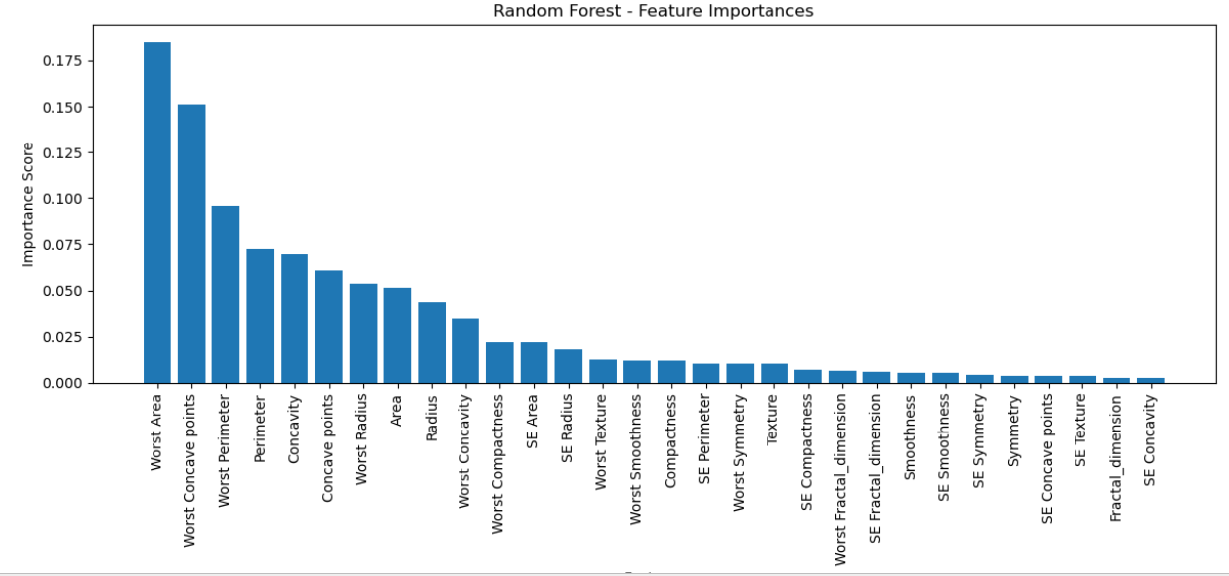

Top 5 Most Important Features that I found from the bar chart:

- Worst Area
  - Importance Score: ~0.18
  - Explanation: This represents the area of the largest (worst-case) tumor region. Larger tumor areas are strongly associated with malignancy, making this feature a key indicator for classification.
- Worst Concave Points
  - Importance Score: ~0.15
  - Explanation: "Concave points" measure the number of concave sections of the contour. A higher value often suggests irregular tumor shapes, which are typical in malignant tumors.
- Worst Perimeter
  - Importance Score: ~0.095
  - Explanation: Refers to the perimeter of the worst (largest) tumor region. Larger perimeters often indicate more aggressive or irregular growth patterns.
- Perimeter
  - Importance Score: ~0.07
  - Explanation: This is the mean perimeter across all tumor measurements. It's a general indicator of tumor size and shape and supports overall model prediction when combined with worst-case metrics.
- Concavity
  - Importance Score: ~0.065
  - Explanation: Concavity measures the severity of concave portions in the tumor's contour. Malignant tumors tend to have more deeply concave shapes compared to benign ones.

Conclusion
In this project, I applied and compared four machine learning algorithms like Linear Regression, Decision Tree, K-Nearest Neighbors (KNN), and Random Forest to classify breast tumors as malignant or benign, using the Breast Cancer Wisconsin (Diagnostic) dataset. After preprocessing the data and splitting it into training and testing sets, I evaluated each model based on accuracy and Root Mean Square Error (RMSE).
Among all the models I tested, the Random Forest algorithm performed the best, achieving an accuracy of 96% and the lowest RMSE of 0.19. This made it the most reliable and effective choice for the classification task.
I also analyzed the feature importance from the Random Forest model, which showed that Worst Concave Points, Worst Area, and Worst Perimeter were the most influential features in predicting whether a tumor was cancerous. These findings are consistent with known medical patterns and support the model’s interpretability.

