ART 3870 CSS ANIMATIONS

NAME: JACK THAMMAVONG
NET ID: DV5459
COURSE: 2017 / WI / SECTION 01

Project Title: CSS ANIMATIONS

Project Description: Choose and Artist Manifesto from this list and interpret it using css html ad css.
https://en.wikipedia.org/wiki/Art_manifesto
You must be able to explain the way the animation works (so do not copy and paste someone else's code!)
html and css only
can use sprites, transition or animation properties
must use absolute positioning and not be bigger than 1200 px wide
must NOT use zurb foundation
must validate on w3 validator!

Project URL on github.com:
Project URL on github.io: https://thebadkid.github.io/art3870-wi17/
Project URL on ada.csueastbay.edu:

Project Design considerations: Using sprites and dots to show speed.

Project Screenshots: 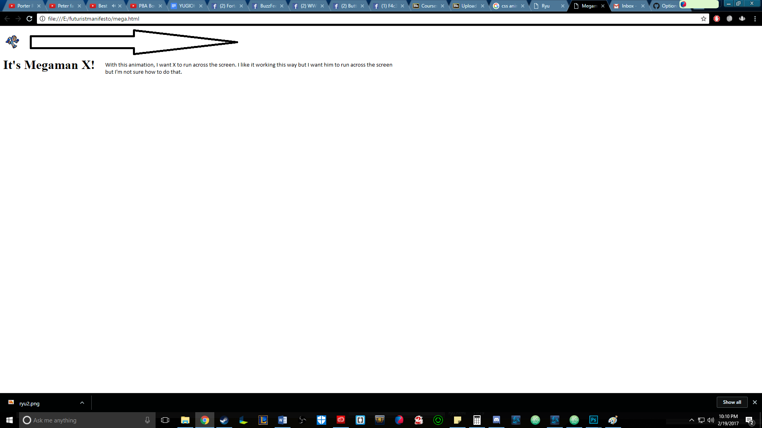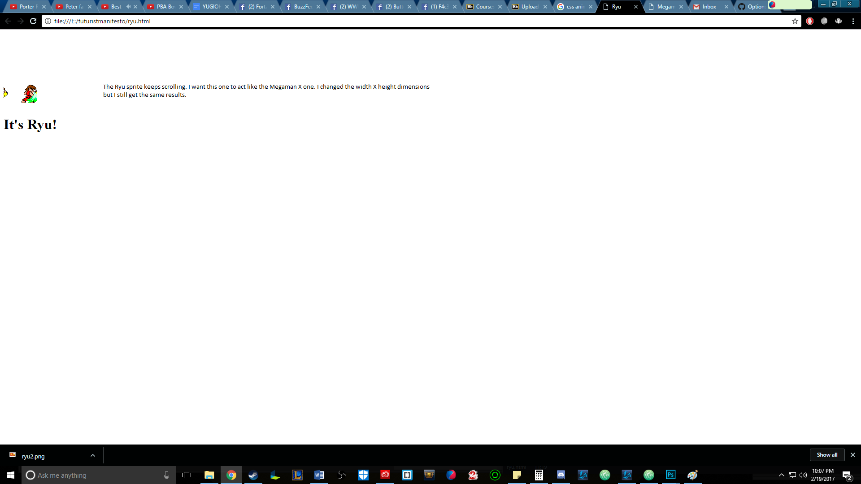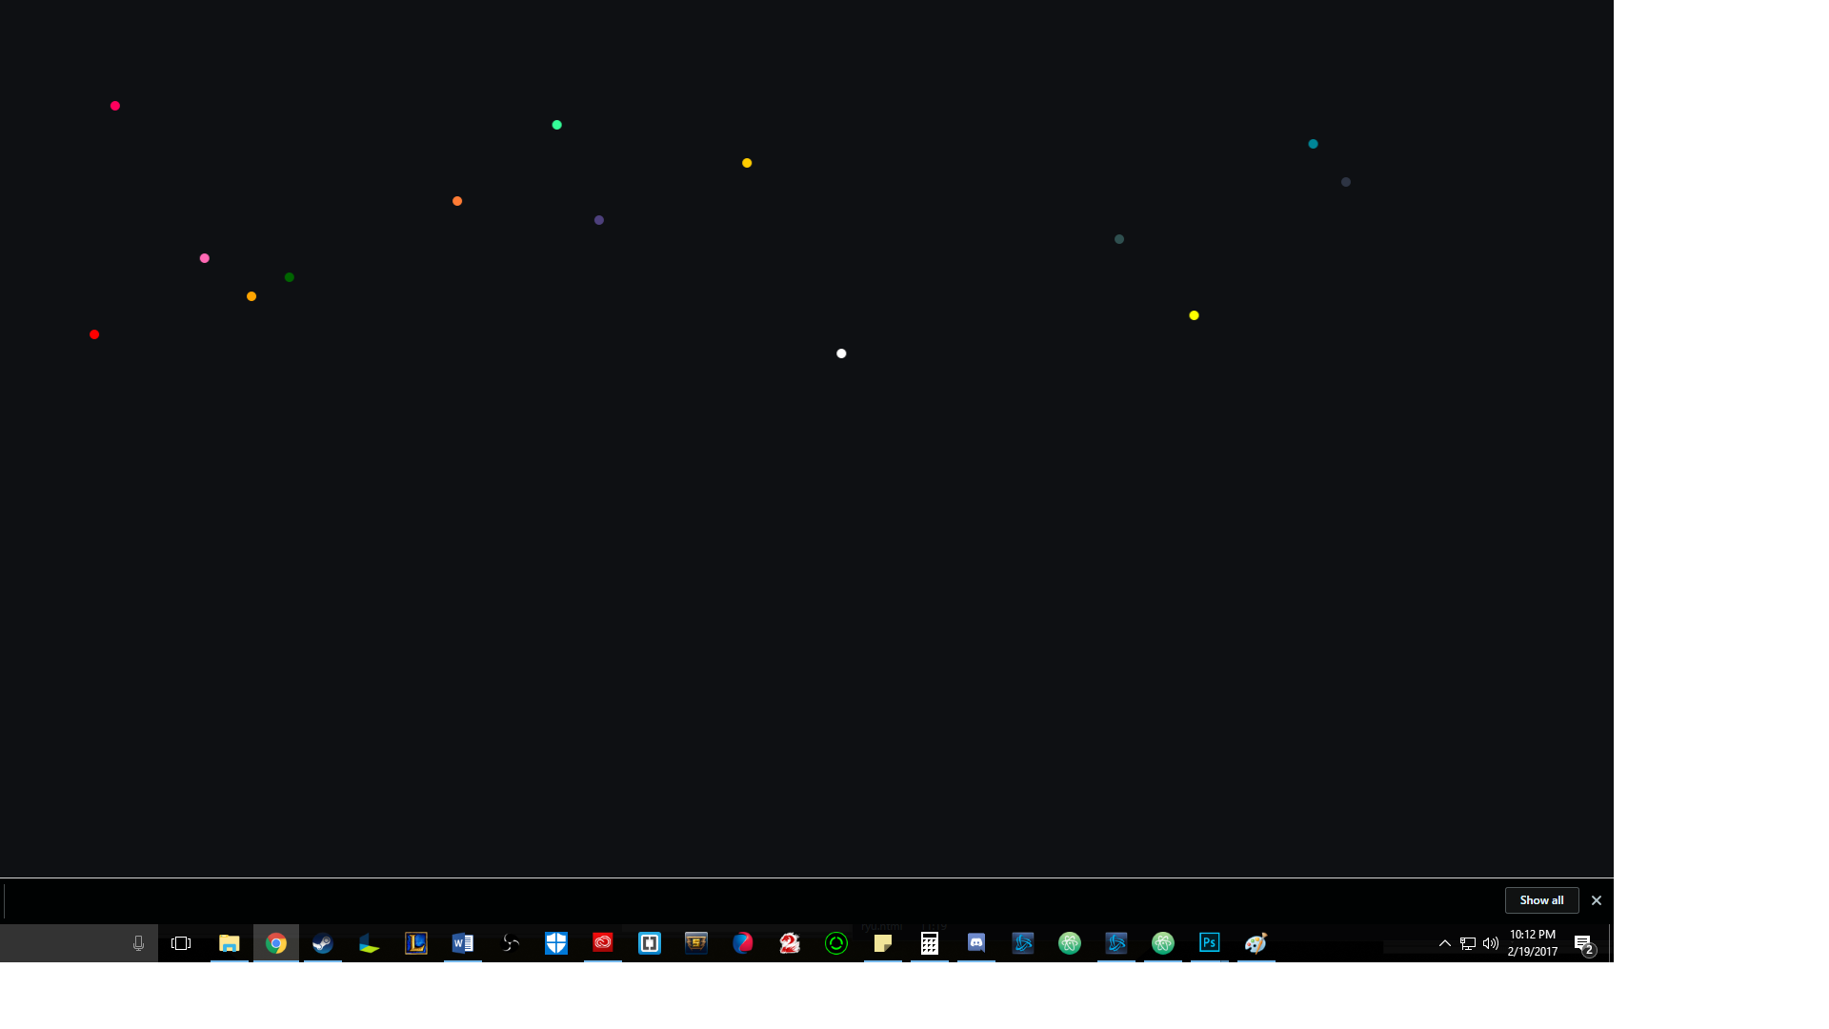

Project Reflection: Wow this was tough with limited time. Still having the toughest time with sprites and trying to make them scrolling across the screen. Though making the sprites and the dots animations were really fun! Slowly I’ll understand them a little more if I have the time. I would really love to keep making these.

Also, still having problems with uploading to github so my stuff won’t be showing on github until I troubleshoot/figure this out in class.

