Art Asset Document

# Assets

1. <Player> 
2. face.bmp

This is the player’s avatar. This character will be seen the longest on the screen and will be directly controlled by the player. The face image is for use in the HUD for showing the player’s lives.

1. <Love interest> 

The player’s love interest and the goal of the game.

1. <1-Up Ballon> 

Used to illustrate to the player that he/she has gotten a new life.

1. <EnvironmentBlocks> block1.bmp
2. block2.bmp
3. block3.bmp
4. water.bmp

These bitmaps are going to be used to build the game’s environment and levels along with the backgrounds below.

1. <Doors> door1.bmp
2. door2.bmp

These doors lie at the end each level to provide access to the next.

1. <Pickup items> heart.bmp
2. purple_gem.bmp
3. red_gem.bmp
4. blue_gem.bmp

Pickups – Heart = Extra Life; Blue Gem = 1 Point; Red Gem = 5 Points; Purple Gem = 10 Points

1. <OutputText> 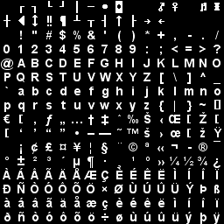
2. <Enemies> 
3. 
4. 
5. 

These are the enemies that the player will face. Introduced as he/she progresses.

1. 
2.  patientFace2.bmp
3. 
4. patientFace1.bmp

They are the two patients that the player interacts with inside the game. Their faces are provided to illustrate dialogue.

1. <BackGrounds> 
2. 
3. 

The backgrounds for the levels.