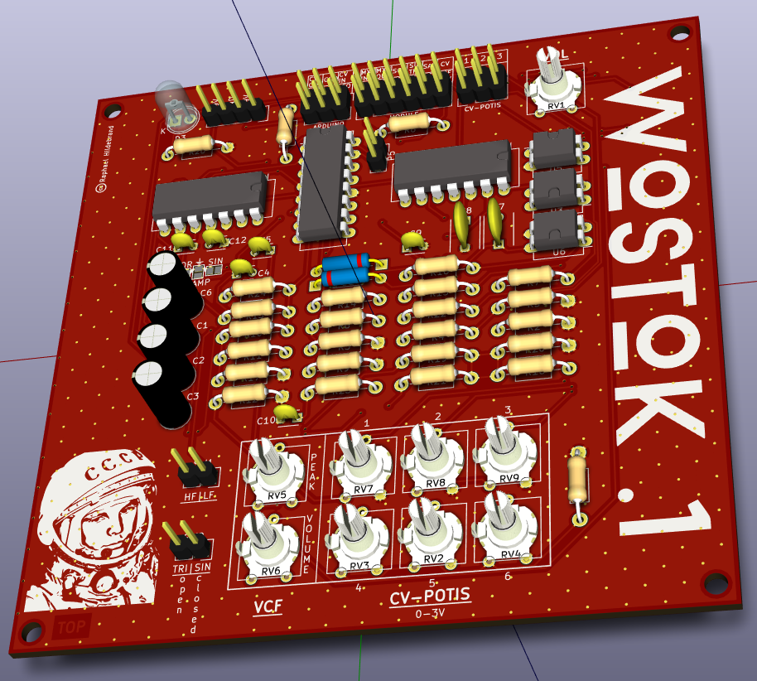

Documentation – Wostok.1

Table of Contents
Documentation – Wostok.1 2
Table of Contents 2
About the Wostok.1 2
Getting started with the Wostok.1 2
Get everything needed 2
Solder the board 2
Bill of materials 2
The modules in detail 3
The VCO 3
The VCF 3
The VCA 3
The ADSR 3
The LFO 3
The Delay 3
The Sequencer 3
Supported controlling devices 3
Schematics 3

About the Wostok.1
The Wostok.1 is an open source analog semi-modular synthesizer for everyone. It is fully patchable, so there are no restrictions for the connections between single modules.
This synthesizer is monophonic but has a full-analog voltage controlled oscillator (VCO) with four voices. It's simple design makes it small and easy to build. Also it holds down the costs and makes synthesis affordable for everyone.

Getting started with the Wostok.1

Get everything needed

Solder the board

Bill of materials

The modules in detail

The VCO

The VCF

The VCA

The ADSR

The LFO

The Delay

The Sequencer

Supported controlling devices

Schematics

