**Steps to Virtualize a VIO CD-ROM**

1. Start on the profile for the VIO server that has the CD/DVD ROM on its bus.

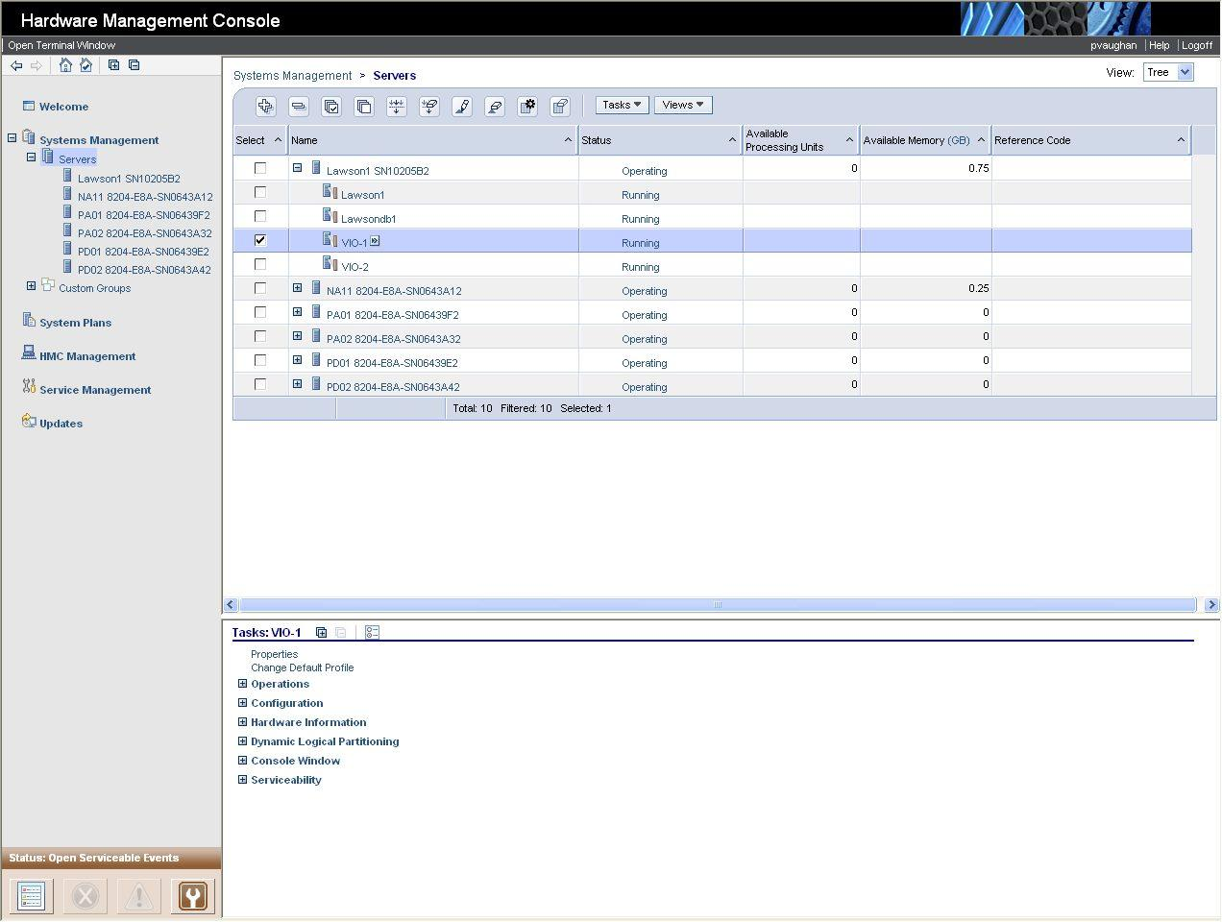

2. Create a new SCSI virtual adapter.

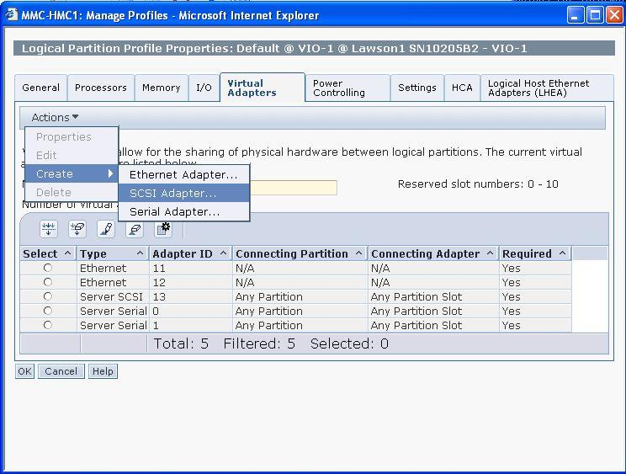

3. On the "Add" screen, make it required for partition activation, make sure it's set for Any Partition, Note the virtual SCSI adapter ID, and hit OK

4. Deactivate and Reactivate the VIO server so that it reads the new profile.

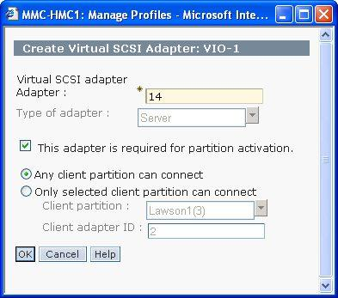

5. Log into the VIO server as padmin

6. Issue the command "lsdev -type optical" to verify that the VIO server has an available CD rom

7. Issue the command "lsdev -type adapter" to identify the vhost number of the newly added vscsi adapter.

8. Issue the command "mkvdev -vdev cd0 -vadapter vhost#" where vhost# is the newly added vscsi adapter.

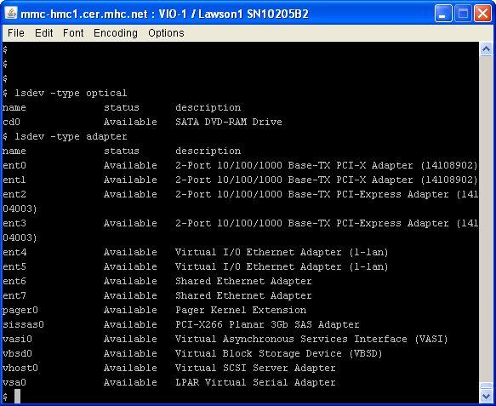

9. The command "lsmap -vadapter vhost#" should display the vhost and backing device information.

10. At this point, we're done on the VIO server. Log out.

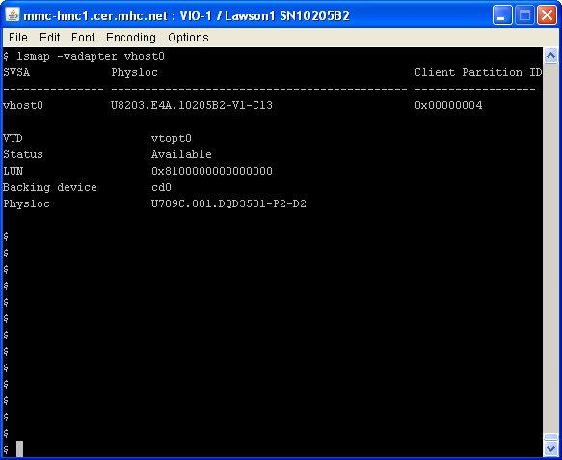

11. Open up a profile for one of the LPARs, go to Virtual Adapters, and Create a new SCSI adapter.

12. Make sure the Server partition is the VIO server and make sure the Server adapter ID matches what you've noted from step 3 (when you added the CD to the VIO server).

13. Perform steps 11 & 12 on any LPAR that you want to see the CD.

14. Deactivate and Reactivate the LPAR and it should see the CD.

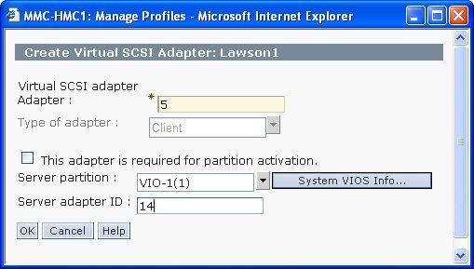

To remove the CD from an LPAR to discover on another, perform these steps:

1. Log into the LPAR

2. Issue the command "lsdev -l cd0 -F parent". This should identity the virtual scsi bus.

3. Issue the command "rmdev -dl vscsi# -R" to remove the bus and the CD.

4. Run "cfgmgr" on another LPAR to discover it (Assuming the virtual SCSI adapter for the CD has already been added and the LPAR reactivated)