In Host Name field:  Enter the Bastion Server

1. Select Connection/SSH

* In the Remove command field, enter the ssh command line:
* e.g.
* ssh -o TCPKeepAlive=yes -o ServerAliveInterval=60 [EID@prf4az1re.aws-rc.cb4good.com](mailto:EID@prf4az1re.aws-rc.cb4good.com)

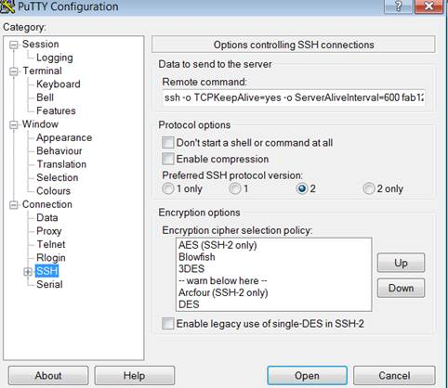

Set keepalives value to avoid timeout: from 0 to 60:

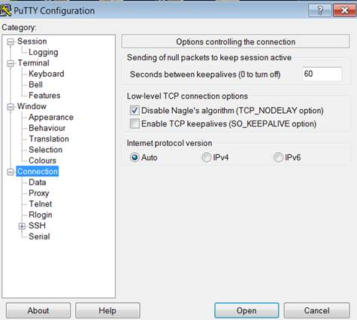

save session