In Host Name field: Enter the Bastion Server

- Select Connection/SSH
- In the Remove command field, enter the ssh command line:
- e.g.
- ssh -o TCPKeepAlive=yes -o ServerAliveInterval=60 EID@prf4az1re.aws-rc.cb4good.com
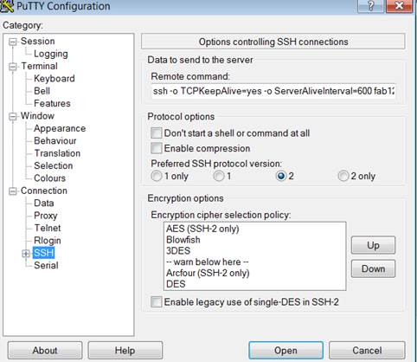

Set keepalives value to avoid timeout: from 0 to 60:
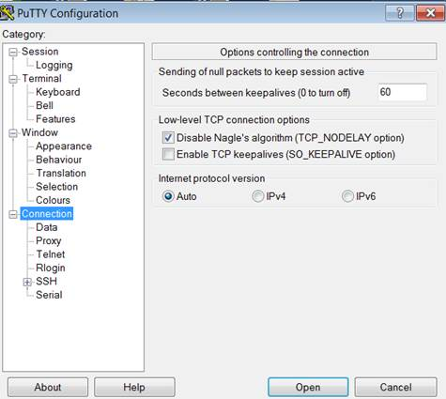

save session

