TECHNOLOGY LEARNING SERIES
Developer Enablement | Module 1 of 1
Git Fundamentals
Day 1 — The Three-Stage Model of Version Control

A first-principles briefing on why Git exists, what problem it solves, and how a single change travels from an editor to permanent project history. Written to be understood before any command is memorised.
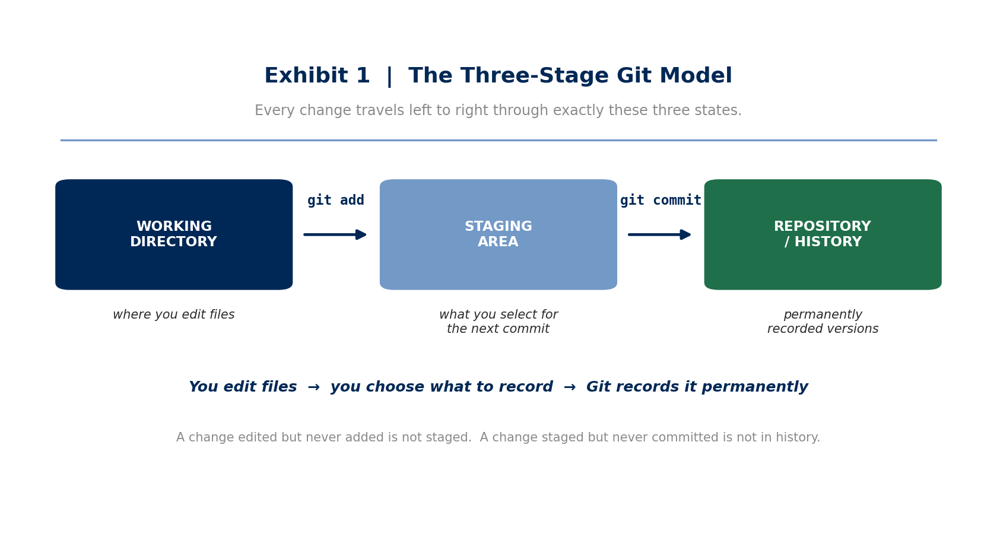

Prepared for | Developers beginning structured Git training
Prerequisites | None. No prior version-control experience assumed.
Format | Nineteen sections, four exhibits, one practical exercise, one command reference.
Learning approach | First principles — understand why and how before memorising commands.
Follows | Branching, remotes, pull requests, merge conflicts, CI/CD

This is an independently prepared training document. It is not affiliated with, endorsed by, or produced by any financial institution; the layout follows a general institutional research house style.

1 | Why Does Git Exist?

Software projects change constantly. A file that works today may be modified tomorrow and break after a further change the day after. The fundamental question every development team must answer is therefore a simple one: how do we keep a reliable, inspectable record of how a project changed over time?
Absent a version-control system, developers improvise. The improvisation almost always takes the same form — a proliferation of manually named copies, each representing a state someone was afraid to lose:
app.py
app_v2.py
app_final.py
app_final_latest.py
app_final_latest_REAL.py
The naming convention every developer has encountered, and none can decode a month later.
This approach fails on every dimension that matters. It does not record what changed between one copy and the next, who made the change, when, or why. It offers no reliable way to return to a known-good state, and it degrades further as soon as a second person is involved. Git exists to replace this improvisation with a disciplined, queryable history of the project.
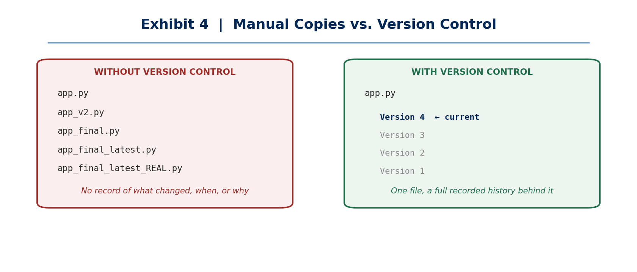
Exhibit 4 — Manual copies preserve states without context; version control preserves the history that explains them.
2 | What Is Version Control?

Definition
Version control — A system for tracking changes to files over time, maintaining a recorded history of versions rather than requiring manually managed copies.

Instead of keeping five differently named files, a version-control system keeps one file and a chain of recorded versions behind it. Each version in that chain is a deliberate, labelled point that the project passed through, and any of them can be inspected.
Version 1
↓
Version 2
↓
Version 3
↓
Version 4 ← the current state of the file

Key point
The value of version control is not storage — it is history. Copies preserve states. Version control preserves the sequence, the authorship, and the reasoning that connects those states to one another.

3 | What Is Git?

Definition
Git — A distributed version-control system whose primary function is to track changes to a project and maintain the history of those changes.
Distributed — Each developer holds a complete copy of the repository and its full history locally, rather than depending on a central server for every operation.

Git runs on your own computer and maintains the repository history locally. This has an important practical consequence for anyone beginning: the core Git workflow — initialising a repository, staging changes, committing them, and reading the history — requires no external service and no internet connection whatsoever.
4 | Git vs GitHub

Git and GitHub are related but are not the same thing, and conflating them is the most common early misconception.
 | Git | GitHub
What it is | Version-control software | An online hosting platform
Where it runs | On your local machine | On remote servers, accessed over the internet
What it does | Tracks project history | Hosts repositories and supports collaboration
Required? | Yes — it is the engine | No — optional, for sharing and collaboration

The distinction in one line
- Git is the version-control engine.
- GitHub is an online hosting and collaboration platform built around that engine.
- You can use Git without GitHub. Everything in this Day 1 module is pure Git and runs entirely offline.

5 | What Is a Repository?

Definition
Repository (repo) — A Git-managed project. It comprises your project files together with Git's internal record of the repository and its history.
.git directory — The hidden folder Git creates inside a repository to store its internal data — the object database, references, and configuration.

github-learning/
│
├── .git/ ← Git's internal repository data
└── hello.py ← your project file

Handling the .git directory
- The .git directory is where the entire history of your project physically lives.
- Git manages its contents. Do not edit it manually while learning — there is no reason to, and a corrupted .git directory means a lost history.
- Deleting .git does not delete your files; it deletes the repository, converting the project back into an ordinary folder with no history.

6 | Working Directory

Definition
Working directory — The directory in which you are currently working on your project files — what you see and edit in your editor.

github-learning/
├── hello.py
├── calculator.py
└── README.md

When you edit a file, that change first exists only in the working directory. It is not automatically part of a commit, and it is not yet in the project's history. This is the first of three distinct states a change occupies, and understanding the boundary between them is the entire objective of Day 1.
7 | Staging Area

Definition
Staging area (index) — The intermediate area in which you select precisely which changes will be included in your next commit.

Suppose three files have changed: login.py, database.py, and payment.py. These may represent three unrelated pieces of work. The staging area allows you to record only the login change now, leaving the other two in the working directory to be committed separately later.
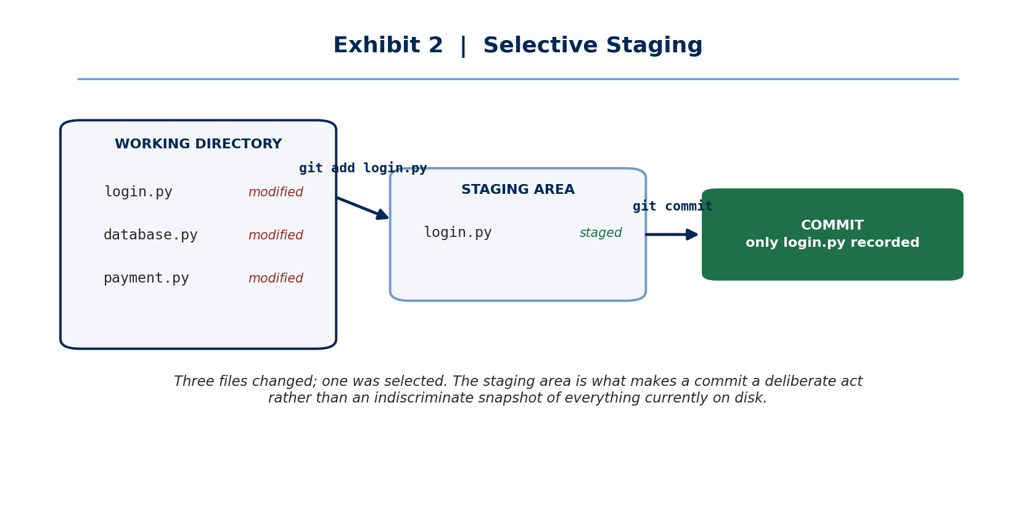
Exhibit 2 — Three files changed; one was deliberately selected for the commit.
Key point
Staging gives you control over what belongs in the next recorded version. Without it, a commit would be an indiscriminate snapshot of everything currently on disk, rather than a deliberate statement about one unit of work.

8 | Commit

Definition
Commit — A recorded point in the project's Git history, capturing the changes that were staged at the moment it was created.
Commit message — The short description accompanying a commit, explaining what that commit represents.

git commit -m "Add login functionality"

A commit is permanent in the sense that matters: it becomes part of the project's history and can be returned to. The commit message is not decoration — it is the only explanation a future reader, including yourself, will have for why the change was made.
Quality | Message | Why
Good | "Add login validation" | States what changed and is searchable later
Poor | "changes" | True of every commit ever made; conveys nothing
Poor | "asdf" | Actively misleading noise in the history

9 | The Most Important Model in Git

Everything covered so far resolves into a single three-stage model. If one diagram from this module is retained, it should be this one.
Exhibit 1 — The three-stage model. Every change passes through these states in this order.
YOU EDIT FILES
↓
┌─────────────────┐
│ Working │
│ Directory │
└────────┬────────┘
│
git add
│
↓
┌─────────────────┐
│ Staging Area │
└────────┬────────┘
│
git commit
│
↓
┌─────────────────┐
│ Git Repository │
│ / History │
└─────────────────┘
The same model as it is conventionally drawn in Git documentation.
What each transition means
- A change that is edited but never git added is **not staged** — it will not be in the commit.
- A change that is staged but never git committed is **not in history** — it exists only in the index.
- Once committed, the change is part of the permanent, inspectable record of the project.

10 | Why Do We Need the Staging Area?

A newcomer reasonably asks why Git requires two steps where one might do. The answer is that a project frequently contains several unrelated changes at the same time, and not every change should belong to the same commit. The staging area is the mechanism that lets you decide.
Working Directory
login.py changed
database.py changed
payment.py changed

↓ git add login.py

Staging Area
login.py staged

↓ git commit

Commit — contains the login change only

Why this matters in practice
A history in which each commit represents exactly one coherent change is one you can read, search, and selectively undo. A history in which every commit bundles three unrelated changes is one you cannot. The staging area is what makes the first outcome possible.

11 | Git History

Each commit becomes part of the project's history. That history is what lets you understand how the project evolved and inspect any previous recorded state.
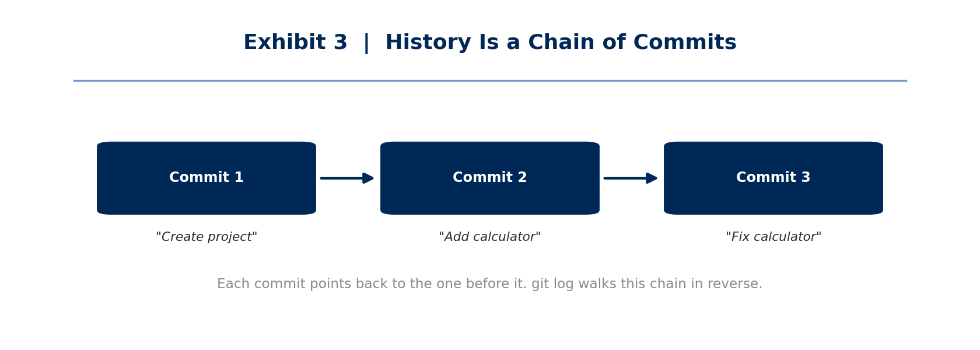
Exhibit 3 — Commits form a chain, each linked to the one before it.
Commit 1 — "Create project"
↓
Commit 2 — "Add calculator"
↓
Commit 3 — "Fix calculator"

Use git log to inspect this history.
12 | git status

git status answers a single question: what is the current state of my Git project? It is the most frequently used command in Git, and running it before and after every other command is the fastest way to build an accurate mental model.
git status

What git status reports
- Modified files — changed in the working directory, not yet staged.
- Staged files — selected for inclusion in the next commit.
- Untracked files — present in the directory but not yet known to Git at all.
- The current branch.

13 | git log

git log answers the complementary question: what happened previously? It displays the commit history — the chain shown in Exhibit 3 — walking backwards from the most recent commit.
git log

14 | Day 1 Practical Exercise

The objective is to create a small repository and make a first commit, running git status at each stage to observe how a single change moves through the three states.
mkdir github-learning
cd github-learning

git init

echo 'print("Hello Git")' > hello.py

git status # hello.py appears as UNTRACKED

git add hello.py

git status # hello.py is now STAGED

git commit -m "Add hello Git program"

git status # working tree clean - nothing left to commit

git log # your first commit appears in the history
Run every line. The three git status calls are the point of the exercise, not an afterthought.
What to observe
- After git init — the .git directory now exists and the folder is a repository.
- After creating the file — Git sees it but is not tracking it. It is *untracked*.
- After git add — the file has moved to the staging area. Nothing is in history yet.
- After git commit — the change is recorded. git status reports a clean working tree.
- After git log — the commit, its message, its author, and its timestamp are all visible.

15 | Day 1 Mental Model

I create / change files
↓
Working Directory
↓ git add
Staging Area
↓ git commit
Git Repository
↓
Git History

16 | What You Must Understand

Day 1 comprehension checklist
- Git exists because software projects change continuously and that change must be recorded.
- Version control keeps a history of those changes rather than a pile of manually named copies.
- **Working Directory** — where I currently work.
- **Staging Area** — what I have selected for inclusion in my next commit.
- **Commit** — a recorded version in Git history.
- Git and GitHub are different things; Day 1 uses Git alone.

17 | Day 1 Golden Rule

The rule
Do not memorise git add and git commit. Understand the journey of a change.
Commands are trivially re-lookupable; the model is not. A developer who knows the model can reason about any Git command they have never seen. A developer who has memorised commands without the model will be stuck the first time something unexpected happens.

CHANGE
↓
WORKING DIRECTORY
↓
STAGE
↓
COMMIT
↓
HISTORY

18 | Commands Learned Today

Command | Purpose
git init | Create / initialize a Git repository
git status | Show the current repository state
git add | Stage changes for the next commit
git commit | Record staged changes in Git history
git log | View commit history

A note on proportion
- Five commands. That is the entire operational surface of Day 1.
- Everything else covered in this module was conceptual — and the concepts are what make the five commands make sense.

19 | What Comes Next

Do not jump to advanced topics yet. The next lessons will deepen the Day 1 foundation before moving on. Attempting branching or merge-conflict resolution without a solid grasp of the three-stage model reliably produces confusion, because those topics are defined in terms of it.
Stage | Topics
Immediately next | Deepening Day 1 — tracked vs untracked files, unstaging, amending, .gitignore
Then | Branches — creating, switching, and reasoning about parallel lines of work
Then | Remotes and GitHub — push, pull, clone, repository hosting
Then | Collaboration — pull requests, code review, merge conflicts
Later | Automation — GitHub Actions, CI/CD pipelines, Docker
Later still | Applied work — AI and data projects built on this foundation

Closing note
Day 1 has no branches, no remotes, and no collaboration in it by design. One developer, one directory, one linear history. Every later concept in Git is an extension of the model established here — which is why it is worth being certain of it before moving on.

