FPGA Audio Synthesizer

By
Ethan Granucci
and Ben Stockett

Advisor
Dr. Afsaneh Minaie

ECE 4950 - Electrical and Computer Engineering Capstone II
Engineering Department
Utah Valley University

Spring 2023

Table of Contents
Table of Contents 1
Abstract 2
Introduction 3
Description of Design 6
System Overview 6
MIDI 8
Power Supply 14
DAC 15
VGA Display 17
Mixer 19
Operational Amplifier 20
Lowpass Filter 21
Front Panel 22
Market Comparison 24
Simulation Results 27
Voltage Regulator 27
MIDI Interface 28
VGA Interface 30
VCO Control 33
Channel Mixer Control 37
Synthesizer Simulator for Comparison 39
Testing 40
MIDI Interface 40
VGA Interface 42
DAC Interface 45
VCO Control 47
Mixer 49
Marketing and Engineering Specifications 50
Conclusions and Recommendations 52
Future Work 59
References 60
Appendices 63
Original Project proposal 63
Slide Show 65
Part Specification 83

Abstract
Audio synthesizers, first invented in 1955, are devices that electronically produce sound through methods like amplitude and frequency modulation, additive synthesis, and filtering. They have been widely used in movie and music production since their conception. The purpose of this project is to design and construct an FPGA-based audio synthesizer which can digitally control the synthesis of analog signals. The synthesizer, named the Artix Wolverine, is a unique device that offers a different approach to the world of audio synthesis. The Wolverine deviates away from common practices in order to learn more about audio synthesizers and to improve upon existing ideas. Instead of performing signal processing wholly in either the digital or analog domain, this synthesizer attempts to combine the best of both worlds by utilizing analog components that can be controlled digitally. The synthesizer utilizes the Digilent Basys 3 FPGA, VCOs (Voltage Controlled Oscillators) for pitch generation, LFOs (Low Frequency Oscillators) for effects generation such as tremolo, mixers for combining signals, filters, and I/O for user control and playback. The VCOs are capable of producing periodic waves within the audible range (20Hz-20kHz) without distortion, while the LFO operates within 1-10Hz. The majority of the audio processing including mixing and filtering are implemented on analog circuitry such as oscillators and peripheral I/O interface with the FPGA. In combination with the addition of a display, something that most synthesizers lack, the Artix Wolverine has come to be a valuable learning tool.

Introduction
Audio synthesizers are electronic devices that generate audio synthetically. Audio synthesizers are capable of generating tones from a variety of basic waveforms, including sinusoids, triangle, sawtooth, and square waves. Audio synthesizers are also capable of a variety of effects, usually including waveform shaping, filtering, and modulation. Audio synthesizers are popular among musicians because of their usefulness for creating music, and hobbyist groups who enjoy designing and constructing them. There can be a lot of overlap between different synthesizer devices, as most audio synthesizers are built around similar design patterns. Audio synthesizers generally have one or more VCOs (Voltage Controlled Oscillators), which are components responsible for generating basic waveforms like sinusoids and square waves. Typically VCO outputs are summed together with other signals, like microphone input or even other VCO outputs. The resulting signal can then be mixed with a LFO (Low Frequency Oscillator) to provide a variety of effects such as tremolo. The result is usually filtered, amplified, and fed to a speaker [2], [15], [22]. Traditional analog synthesizers utilize analog components for each module, while modern projects implement most of these modules within digital devices like microcontrollers or FPGAs. The majority of the latter type of projects utilize DDS (Direct Digital Synthesis) to generate their signals. This means that waveforms come directly from the digital realm and are later converted into analog signals after digital signal processing. Some examples of hobbyist audio synthesizers implementing DDS, include the TinySynth, which uses the AES-A7EV-7A50T-G board which includes the XILINX ARTIX-7 [22], and a synthesizer by MavisT2, which uses the Basys 3 FPGA [3]. Depending on the device, the signal will then be passed to a DAC (Digital to Analog Converter) or passed through a low pass filter to convert the digital signal to an analog signal. When it comes to filtering, most audio filters are implemented digitally as well [1], [25]. In short, digital audio synthesizers sample analog signals to convert them into digital signals, perform digital signal processing on those signals, and then convert those digital signals back into analog signals for output. Direct digital synthesis, like the name suggests, is direct, and is sufficient for the vast majority of applications.
Unlike most modern audio synthesizers, the Artix Wolverine does not use DDS for audio synthesis. Instead, this project uses both digital and analog components. Specifically, it uses analog components to generate and mix waveforms, however, these analog components are controlled by digital components. The Artix Wolverine uses analog function generator ICs to perform the functions of a VCO. The specific IC used in the design is the XR2206, which can generate sinusoids, triangle waves, and square waves. This IC can generate signals with a frequency that depends on a voltage signal coming from the FPGA. This means that the FPGA can change the generated frequency dynamically. For this project, most components of the design will be digitally controllable analog elements. By taking this approach, the design plans will merge the purity and fundamentality of analog signals with the flexibility of digital design.
Another new aspect of this project is visual feedback. Many audio synthesizers have little or no built in way to visualize waveforms. Some of the higher end audio synthesizers have LCD displays, but these are generally dedicated to displaying menus and other functions. It is possible to connect a computer to some synthesizers to feed them instructions and see what is going on inside them but in general this is not a feature for amateur or hobbyist devices [3], [15], [22], [23]. The synthesizer will be connected to a monitor display that will provide visual feedback corresponding to the internal synthesizer state and display the output waveform and the input waveforms that constitute it. This feature will allow the user to better understand what is happening internally. The user interface for this project will also feature a 2.5 mm MIDI port so that the device can interface with musical instruments [8], [9]. MIDI (Musical Instrument Digital Interface) is a standard for communication between different musical devices [7]. Supporting the MIDI protocol means the Artix Wolverine isn’t dependent on any specific instrument. The design includes a simple piano keyboard, but if a different instrument was needed, the setup process would only require plugging in a different instrument and changing accepted note range. In this project, the MIDI keyboard will send MIDI messages to the FPGA. This synthesizer will only respond to two messages: key down and key up messages. These messages will tell the FPGA what button is being pressed on the keyboard and how hard it is pressed. The synthesizer will also feature knobs and switches for filtering and volume control. The design will utilize the audio line-in of the FPGA to incorporate any audio signal (including voice) into the audio output. Another important part of this project will be modular design. Generalizing the design into different modules allows for a more flexible design where different parts can easily be swapped in and out. This feature will also allow users of the device to easily extend the synthesizer to add additional functionality and features.
The intent of this project is to create a functional audio synthesizer that explores new ideas in the realm of audio synthesizers. As such, this project does not attempt to compete directly with big name brands such as KORG [4] as its main goals serve exploratory and educational purposes. If this project is successful, it will function as a unique educational device that can be used to interactively demonstrate how audio synthesis works audibly and visually. The audio synthesizer is also meant to implement audio synthesis in a way that hasn’t been explored previously. This project is estimated to cost around $630 which is similar to the price range of a medium range professional audio synthesizer [4], [15].

Description of Design

System Overview

The system diagram in Figure 1 shows the basic operation of the Artix Wolverine FPGA-based synthesizer. The MIDI module decodes a key press from the keyboard via MIDI protocol and sends a signal to the waveform synthesizer to control the pitch (or frequency) of the VCO via the control signals bus. The control board controls elements of the Waveform Synthesizer such as volume, LFO frequency, and filter cutoff frequency. These signals are sent to the FPGA via the PMOD port, and routed to the waveform synthesizer over the Control Signals bus. The resulting signal created in the Waveform Synthesizer is sent over the Audio Signal bus to the ADC PMOD port of the Basys 3. The Basys 3 then processes the signal and sends the signal to a VGA monitor that acts as a very simple oscilloscope. The signal can also be sent back to a DAC further waveform shaping like down-sampling or digital FIR filters if desired.
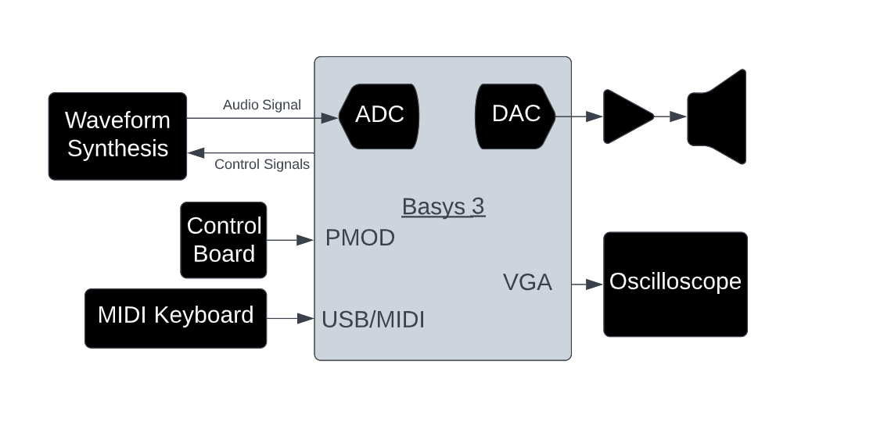
Figure 1: Artix Wolverine System Diagram
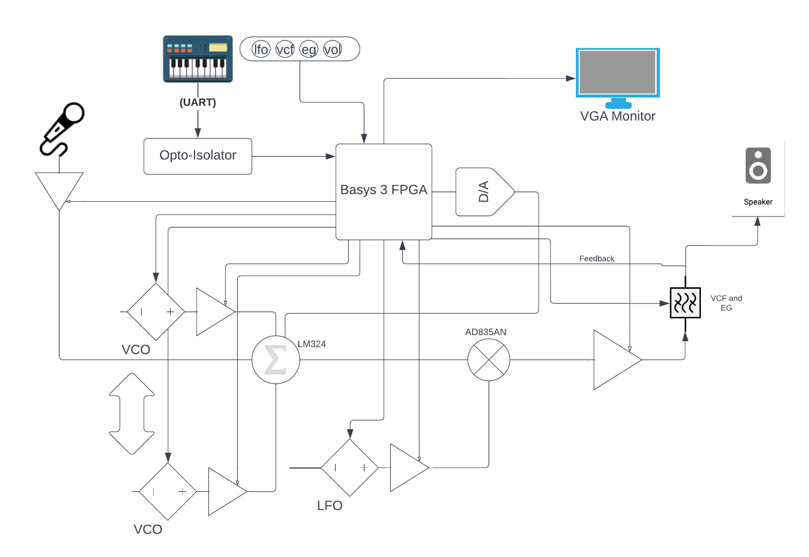
Figure 2: Artix Wolverine Block Diagram

For this project, audio synthesis begins with the VCOs. The VCOs generate primitive waveforms such as sine waves, triangle waves, and square waves. These primitives can be amplified and summed together in variable proportions to generate a wide variety of output waves [24]. Afterwards the signal can be mixed or modulated with the LFO to produce different effects. Next the signal is sent to the FPGA for visualization and to a configurable filter. After being filtered, the signal is sent to the speaker. By using its D/AC and digital outputs, the FPGA can control every step of these processes dynamically. For example, the FPGA can control what frequencies each VCO generates, what proportions of each signal are summed together, and how the resulting signal is mixed and filtered. There is a lot of external analog circuitry that the VCO signals are routed through, but the Basys 3 FPGA is the brains of the design. The FPGA takes the keyboard input, and input from the various knobs and dials and based on that input and internal FPGA state; the FPGA controls all of this.

MIDI

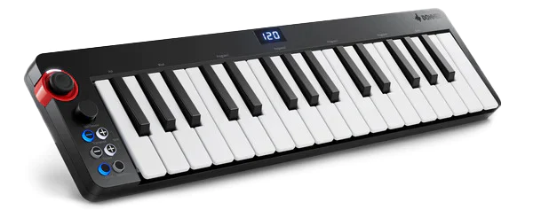
Figure 3: Donner N-32 MIDI Keyboard [21]

Audio Synthesizers need input sources to tell them what sounds to generate. The Artix Wolverine will use the Donner N-32 MIDI Keyboard as its input source. This keyboard does not have the capability to produce sound on its own and is meant to communicate with some other device to do so. The protocol the keyboard uses is one of the most common communication protocols used to communicate with musical instruments, called MIDI (Musical Instrument Digital Interface) [21].

Figure 4: MIDI Logo [7]

This project implements the MIDI protocol, like most professional synthesizers, and some hobbyist synthesizers, because of its availability and simplicity. The MIDI protocol can be encapsulated within existing transport protocols, including USB, Bluetooth, UDP/IP, and UART [7], [9]. Most MIDI instruments use MIDI over USB due to its ubiquity nowadays, but USB is very difficult to support from scratch without specialized microcontrollers or hardware. Ruling USB out, MIDI over UART was chosen to support because it is another common setup for instruments with wired connections and it is much easier to interface with UART when using FPGAs. To connect the instrument to the synthesizer, a 2.5 mm port was added to the design. Traditionally MIDI used a 5 pin connector for MIDI over UART but modern devices using MIDI over UART have a 2.5 mm jack connection [8]. This is probably because only three of the five pins were ever utilized, so going with a 2.5 mm jack offers a smaller form factor.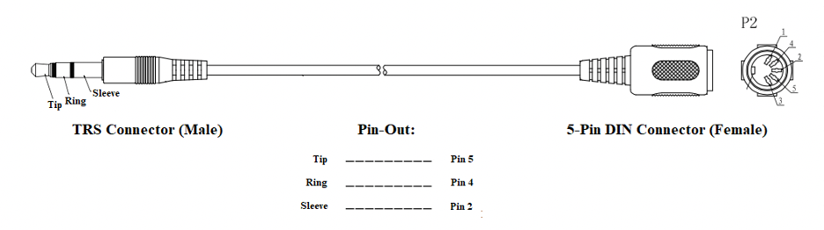
Figure 5: 2.5 mm MIDI Connection [8]

On the synthesizer side, the 2.5 mm jack signal is fed through an opto-isolator which separates the keyboard’s circuit from the FPGA circuit [8]. This electrical isolation is important so that electrical malfunctions from the instrument or the synthesizer do not damage each other.
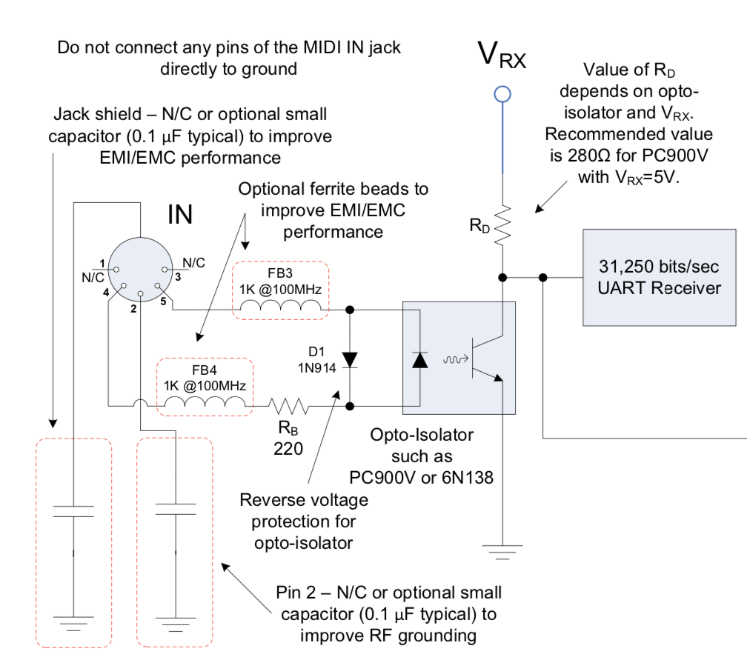
Figure 6: MIDI Isolation Circuit [8]

After passing through the opto-isolator, the signal from the instrument is fed to the FPGA through one of its digital input pins. A module implemented in the FPGA can then read in MIDI data.
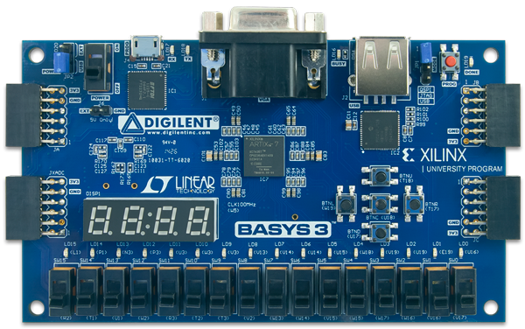
Figure 7: The Digilent Basys 3 [10]

The Digilent Basys 3 is a common FPGA trainer board containing the XILINX ARTIX-7 FPGA. The board has a plethora of peripheral interfaces, expansion capabilities, and extensive online resources and documentation. The Basys 3 has 16 switches, 5 buttons, 16 LEDs, a four digit seven segment display, interfaces for VGA, USB, and UART, as well four PMOD connectors [10]. These PMOD connectors can be used either to connect daughter boards, or for digital I/O. Each 12 pin PMOD connection consists of eight I/O pins and two sets of VCC and ground. The PMOD port on the bottom left can be used for digital I/O and A/DC input while the others can only be used for digital I/O [10]. These capabilities combined with the fact that the Basys 3, and other boards containing the XILINX ARTIX-7 are used in similar synthesizer projects [3], [22], make it a good fit for the Artix Wolverine.

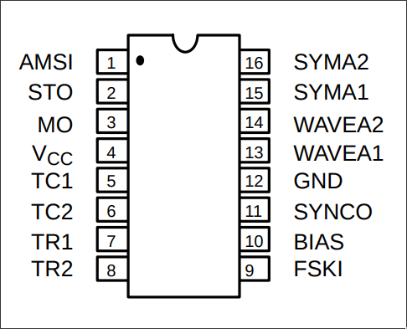
Figure 8: The XR2206 IC [14]

The basis of the generated waveforms will be basic sinusoidal, square, or sawtooth waves so it is important to generate those fundamentals accurately. To simplify things, this project leaves the task up to an IC. The IC used in this project is the XR2206. The XR2206 is an analog IC used to generate modulated sine waves, triangle waves, and square waves. The XR2206’s function generation and amplitude and frequency modulation abilities make it popular for hobbyist synthesizer and radio projects. The XR2206 is a good fit for this project because it performs the functions of a signal generator, and because its modulation abilities will prove useful for creating audio effects [14]. Other hobbyist projects, such as the POLY555, which utilizes the common 555 timer as a VCO [23], have had success with using simpler integrated chips, so the XR2206 seems like the way to go.
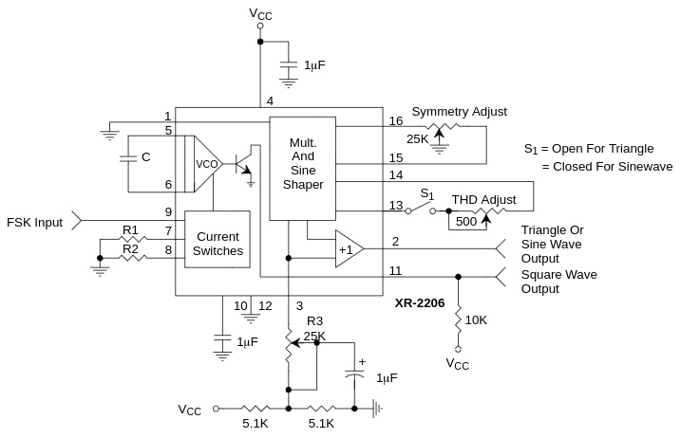
Figure 9: XR2206 Typical Setup [14]

The XR2206 has five main input pins the Artix Wolverine cares about. Pins seven and eight are dedicated to frequency generation. The generated frequency depends on the timing capacitor used between pins five and six, and is proportional to the current drawn from either pins seven or eight [14]. By setting up a voltage divider circuit connected to one of these pins and varying the voltage applied to one branch of the divider, it is possible to use a voltage control signal from the FPGA to control how much current is drawn from these pins [14].

Power Supply
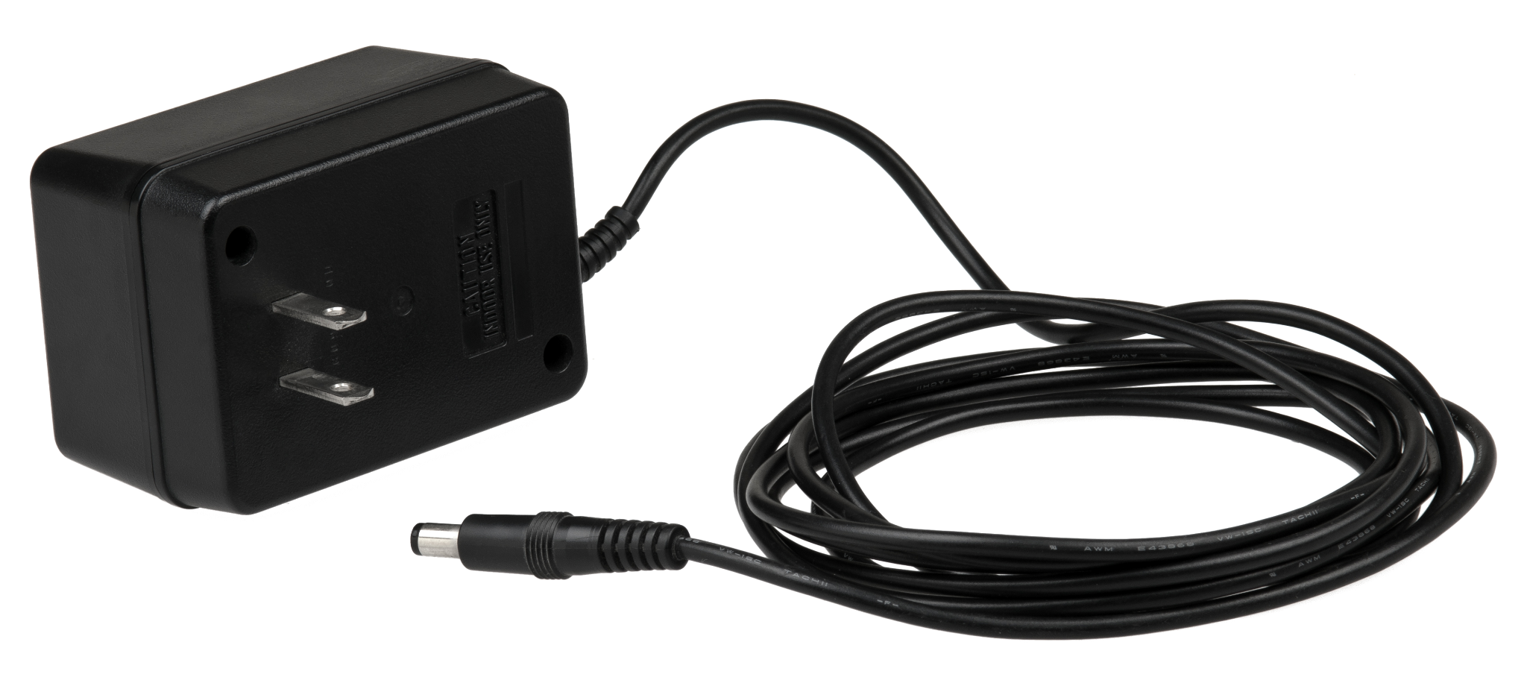
Figure 10: Example AC/DC Adapter [5]

One important part of the Artix Wolverine is the power supply. This project requires a five volt power supply for the FPGA and a power supply with a voltage greater than 10 volts. In order to simplify the design, a single 12 volt AC to DC adapter is used as the power supply. This will suffice for the components which require a high voltage, however the voltage will need to be lowered for the FPGA. To lower the voltage, this project uses a 7805 IC voltage regulator because they are relatively common and easy to use. Similar synthesizer designs also use this IC to achieve a five volt power supply [23], so it should be possible to use the 7805 for the Artix Wolverine as well.
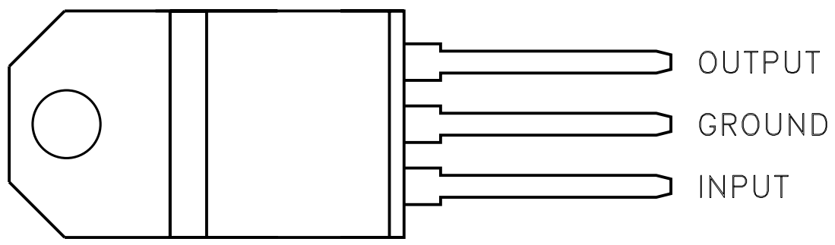
Figure 11: 7805 Pin Diagram [6]

DAC
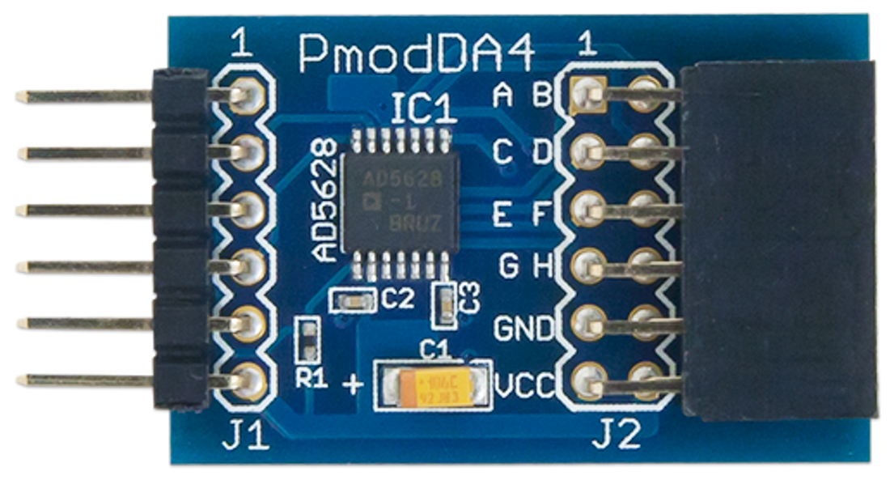
Figure 12: 12 Bit DAC [16]

While the Digilent Basys 3 does come with a built-in ADC, it does not come with a built-in DAC. Thankfully, it is possible to connect a DAC to the FPGA with the help of a daughter board [10]. The DAC used for the Artix Wolverine has a resolution of 12 bits and is capable of eight simultaneous outputs with a maximum output voltage of 2.5 V [16]. The DAC can be configured using SPI (Serial Peripheral Interface), or by using a XILINX IP within Vivado. “By driving the Chip Select (CS) line to a logic level low voltage, users may send a series of 32 bits of information with the data clocked into the appropriate register on the falling edge of the Serial Clock (SCLK). Once the 32nd bit of information has been clocked in, the command that was sent in the data stream is executed.” [https://digilent.com/reference/pmod/pmodda4/reference-manual?redirect=1]
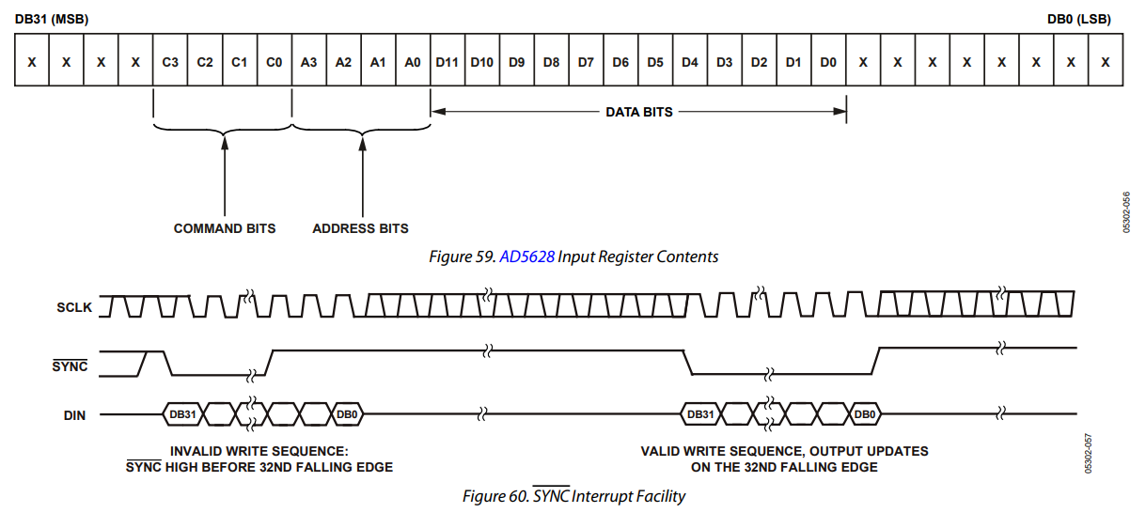
Figure 13 - Instruction and Timing Diagram for DAC

VGA Display

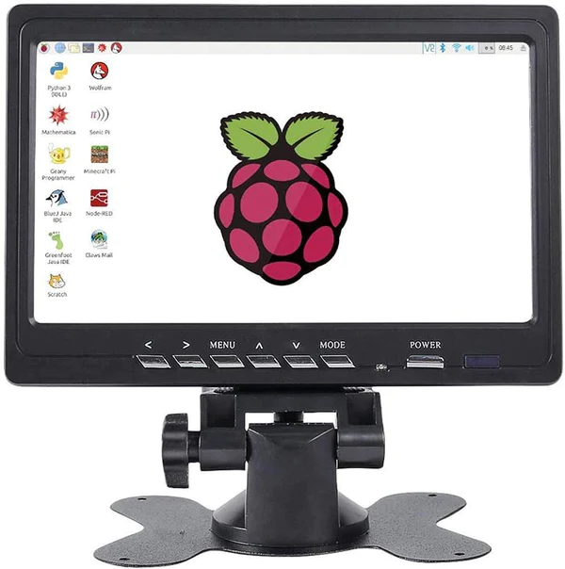
Figure 14: 7 Inch VGA Display [17]

This specific VGA monitor was chosen because of its size, as portability is an appreciated feature of many audio synthesizers. This VGA display will be used as an oscilloscope as well as a menu to see what control signals the user has enabled.
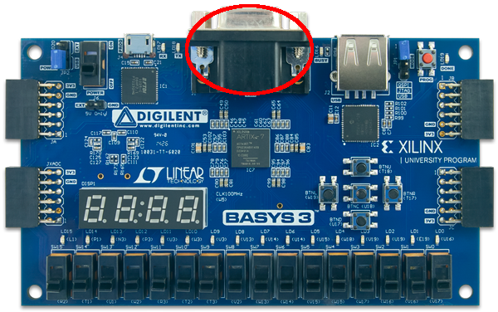
Figure 15: Basys 3 VGA Connector [10]

In order to display visual feedback on a monitor, some kind of protocol is required to communicate with the monitor. The Artix Wolverine supports the VGA protocol (Video Graphics Array) mainly because a VGA connector is built-in to the Digilent Basys 3 and similar FPGA boards [10], and there is lots of existing documentation for VGA.

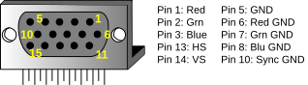
Figure 16: VGA Pins [11]

The Basys 3 has its own 12 bit resistor ladder DAC connected to its VGA port, so no external circuitry is needed to interface with VGA [11]. All the FPGA needs to do to display things on a monitor is to drive five digital pins.

Mixer
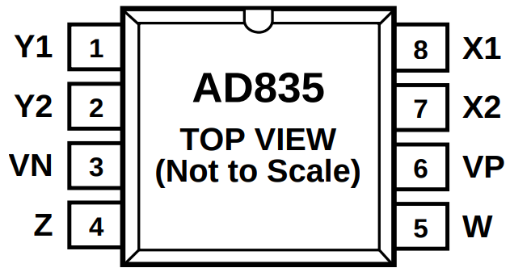
Figure 17: AD835N Pin Diagram [18]

Summing and mixing is another function the Artix Wolverine leaves up to dedicated ICs. The AD835N IC was chosen for this purpose. The IC performs the operation W = XY + Z, with X being the difference between the pins X1 and X2 and Y being the difference between the pins Y1 and Y2 [18]. Pins VP and VN are the pins for the positive and negative power supplies [18]. The primary function of this circuit is to multiply (or mix) the VCO with the LFO to create a tremolo effect.

Operational Amplifier
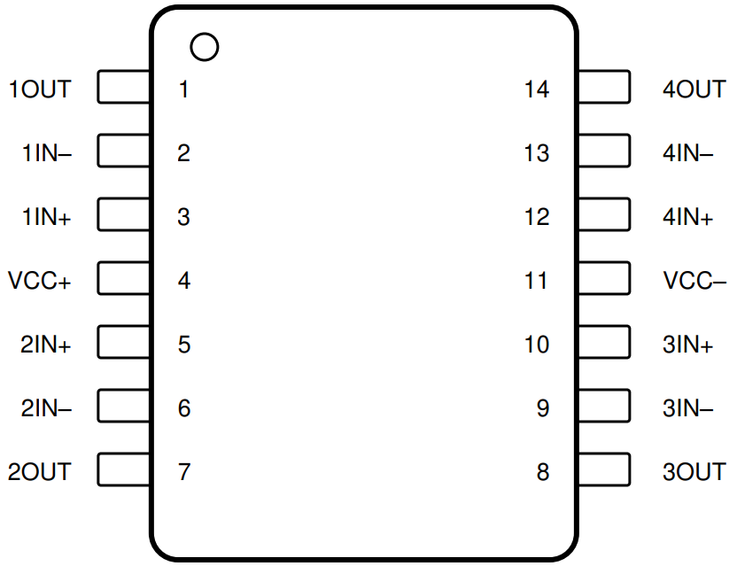
Figure 18: LM324N Pin Diagram [19]

Operational Amplifiers are a requirement for every synthesizer. The Artix Wolverine uses the LM324N IC, which contains four operational amplifiers [19]. The pinouts for this IC are simple. Aside from the positive and negative power supply ports, the IC has one positive input, one negative input, and one output port for each of the four operational amplifiers [19]. The primary function of the op-amps in this circuit are for summing and amplification.

Lowpass Filter
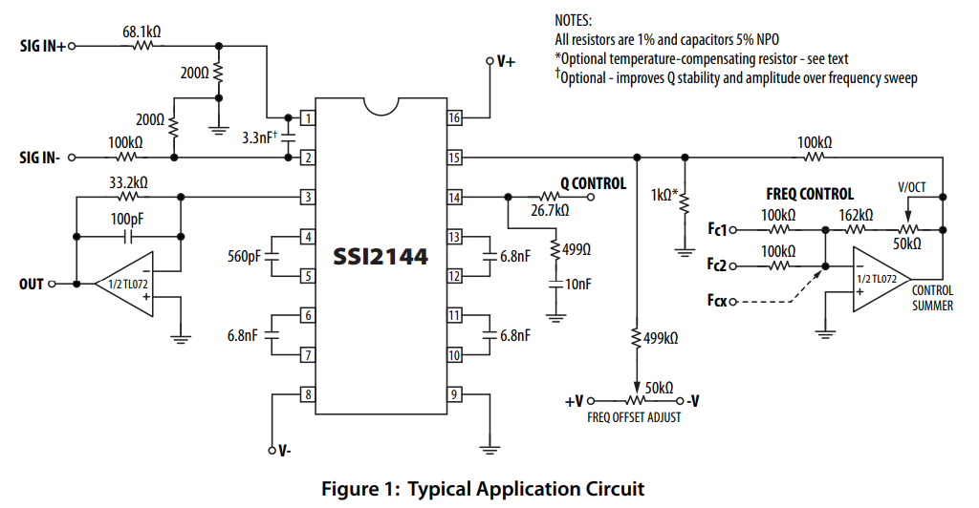
Figure 19: SSI2144 Pin Diagram [20]

Another component found in many audio synthesizers is a filter. It is important for output signals to be filtered before sending them to a speaker in order to ensure that there are no unwanted frequencies in the output [1]. Filters can also be used to produce interesting effects such as bass-boosted signals. The Artix Wolverine uses the SSI2144 IC to filter audio. This IC is a variable filter that has controllable parameters. The IC filters signals according to the four capacitor values between the C?A and C?B pins and input signals to the “FREQ CTRL” and “Q CTRL” pins [20].

Front Panel

The Artix Wolverine front panel allows for user control of LFO frequency, VCO frequency offset, filter cutoff-frequency adjustment, mixer toggle, and VCO mode toggle. Five of the eight potentiometers and single-pole, single throw (SPST) switches have been left unconfigured for future design implementations and improvements.

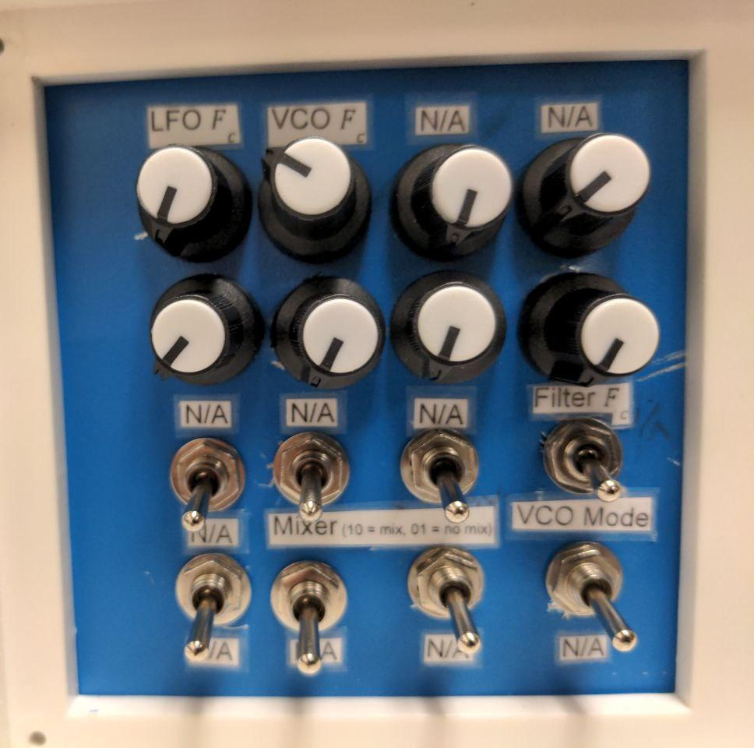
Figure 20 - Artix Wolverine Front Control Panel

Figure 20 displays the mixer toggle and VCO toggle circuitry. A design flaw in the mixer toggle circuit is that if both switches are closed, there is a feedback loop between the mixer output and input, causing increased current draw and unwanted effects. Closing both switches should be avoided.

The VCO toggle circuit simply opens and closes the connection between pins 13 and 14 on the XR2206, toggling between a sine wave and triangle wave for all VCO’s.
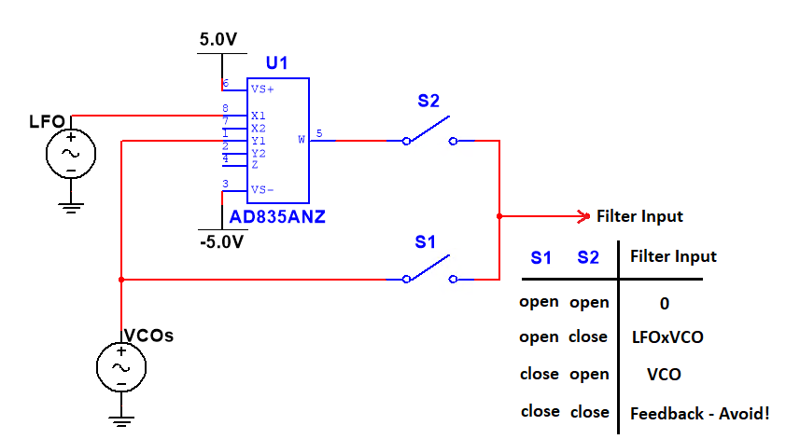
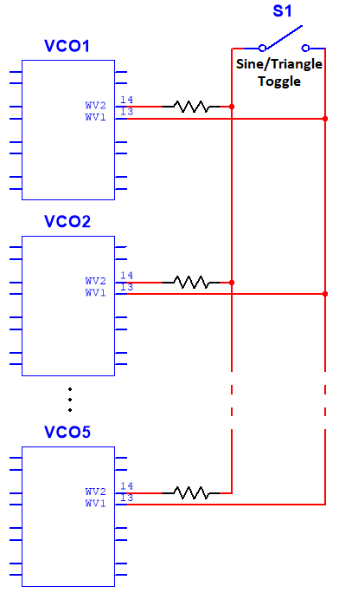
Figure 21 - Mixer Toggle Circuit (Left)
VCO Mode Toggle (Right)

Market Comparison
The abilities of similarly priced commercial synthesizers of analog, digital and hybrid types have been compared to the Artix Wolverine, which is also a hybrid type synthesizer. Figure 20 shows the comparison of the Korg Minilogue XD (Hybrid) [4], Beringer Poly D (Analog), and ASM Hydrasynth Explorer (Digital) vs the Wolverine (Hybrid). The Korg Minilogue XD (Figure 20.2), like the other two synthesizers in this comparison, is a single package, 37 key device equipped with VCO, LFO, mixers, and envelope generator. It comes with a small oscilloscope to visualize the current waveform, a 16-step sequencer to record and playback sounds, and hundreds of programmable presets that allow you to easily access premade sounds. This device is digital and analog, controlled by a 9V DC supply.

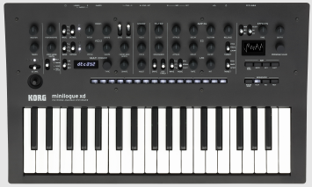
Figure 22 - Korg Minilogue XD [4]

The Beringer Poly D Figure 23 is a fully analog synthesizer with 84 controls, 32- step sequencer, and an onboard modular arpeggiator. An arpeggiator allows you to press single or multiple keys, and the device will play a sequence of sounds based on the current harmonic scale. The Poly D has “matched JFETs, … 0.1% thin film resistors, and polyphenylene sulfide capacitors” [15], giving it its very flexible sound shaping capabilities.
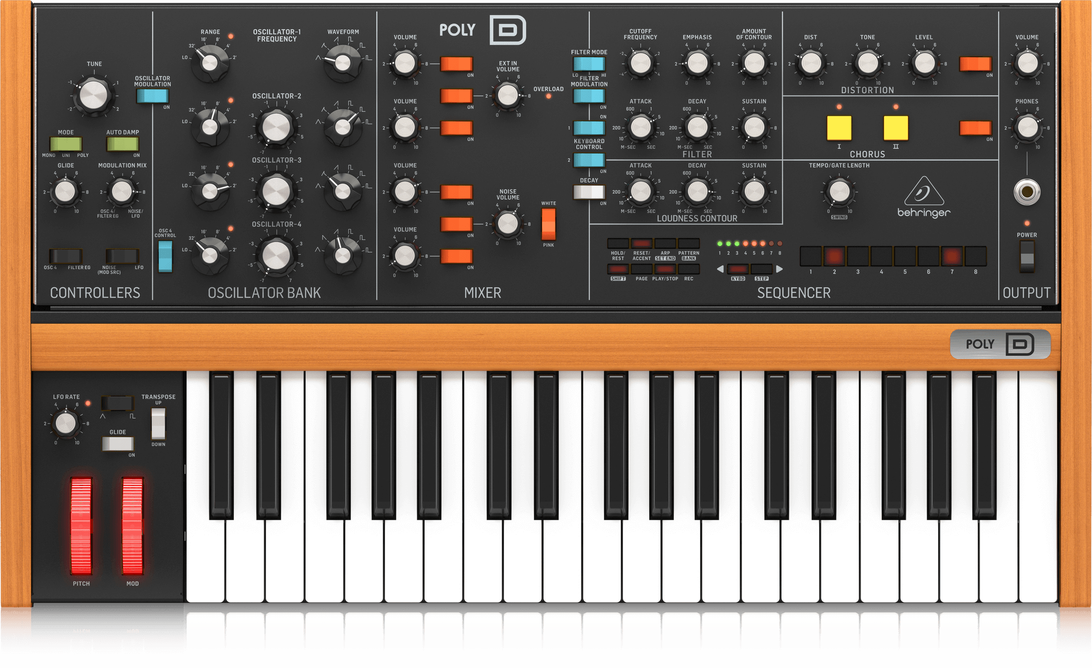
Figure 23 - Beringer Poly D [15]

Lastly, the ASM Hydrasynth Explorer is a fully digital synthesizer with 8-voice polyphony, meaning 8 keys can be played simultaneously as opposed to 4-voice of the Poly D and the Minilogue. The pitch-bender and mod wheel come equipped with depth sensitive LED’s as a visual indicator. The benefit of a fully digital synthesizer is that it has more oscillators, filters, envelope generators and effects than its analog and hybrid counterparts.

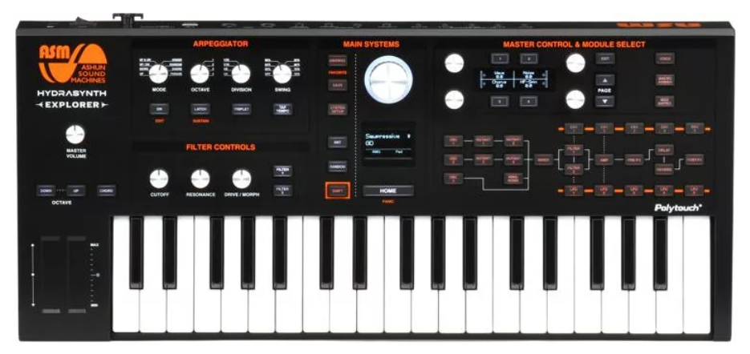
Figure 24 - ASM Hydrasynth Explorer

Korg Minilogue
Wolverine
16-step sequencer

9V Power Supply

500 presets

Single package

Digital VCO

Joystick

2-pole filter
Hybrid Type

37 keys

1x ¼” Audio Out

Velocity Sensitive

No sequencer

12V Power Supply

No presets

Multi-part package

Analog VCO

No joystick

4-pole LP filter

Beringer Poly D
Wolverine
32-step sequencer

Single package

2x EG’s

Pitchbend/Modwheel

24 dB ladder filter

2x ¼” Audio Out

37 keys

Velocity Sensitive

No presets

12V PS

No sequencer

Multi-part package

No EG’s

No modwheel

4-pole LP filter

1x ¼” Audio Out

ASM Hydrasynth
Wolverine
Arpeggiator

Single package

5x EG’s

Pitchbend/Modwheel

LP,HP,BP,Notch Filter

2x ¼” Audio Out

640 presets
37 keys

Velocity Sensitive

No presets

12V PS

No sequencer

No Arpeggiator

Multi-part package

No EG’s

No modwheel

4-pole LP filter

1x ¼” Audio Out

No presets

Figure 25: Comparison of similarly priced synthesizers of analog, digital, and hybrid types

Simulation Results

Voltage Regulator

The 7805 voltage regulator ICs take in high voltages and convert them into a stable five volt supply. When simulating their capabilities in multisim they seemed to perform well and did a good job of eliminating DC ripple when simulating a non-ideal input supply. There is one downside to this type of voltage regulator, and that is they tend to heat up under large current draw. The 7805 functions as a variable resistor as part of a voltage divider. This means that as supplied current increases, the voltage regulator becomes less efficient. At the maximum power the FPGA will draw (one amp, five watts) the voltage regulator will consume about seven watts. At this maximum power usage, the 7805 will be about 42% efficient and will require a heat sink.

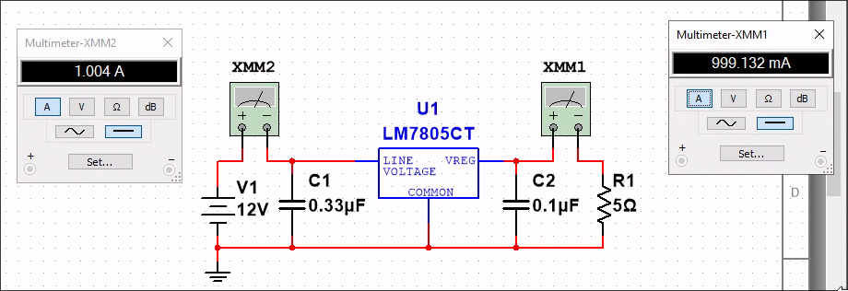
Figure 26: Voltage Regulator Simulation

Depending on the FPGA actual usage this may or may not be necessary. If the FPGA does not draw much current the heat sink may not be required. Regardless, the 7805 will function for this project’s intended purposes.

MIDI Interface

When MIDI messages become available, a MIDI receiver module implemented within the FPGA will read in the message over UART one byte at a time. This UART connection has a baud rate of 31250 bps with one stop bit and no parity [9].

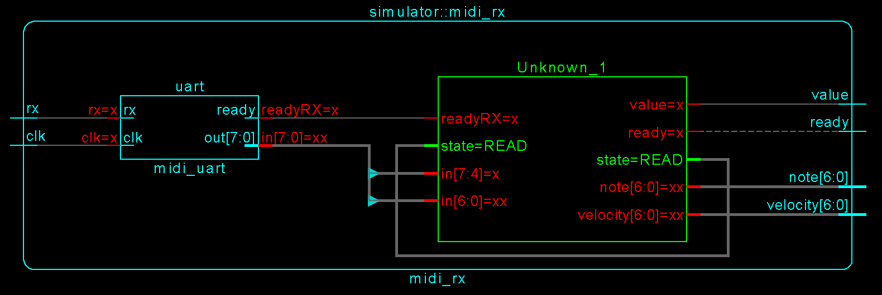
Figure 27: MIDI Receiver Module

The MIDI Receiver has two inputs, “rx” and “clk”. The input “rx” is the UART output from the MIDI instrument. The input “clk” is the FPGA clock. The MIDI receiver module has its own internal UART receiver module. The UART module receives one byte at a time from the instrument and raises its “ready” output when a byte becomes available. The byte is then fed to a state machine that interprets the byte as either a status message or a data message. After a full MIDI message sequence has been interpreted, the state machine will set its “ready” output to high to signal that its outputs are ready to read.
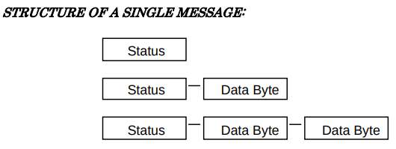
Figure 28: MIDI Message Format [7]

The MIDI protocol consists of one status byte and zero to two data bytes directly following the status byte [7]. Depending on the internal state machine the MIDI module will interpret the byte as a status byte, note number data byte, or a velocity data byte. After every three bytes received, the MIDI module will output whether a key was pressed or released, what key was pressed/released, and how hard the key was pressed/released. This information can then be fed to the rest of the synthesizer FPGA logic. The state machine will set “value” to high if a key was pressed and low if a key was released. The “note” output is the note number associated with the message and the “velocity” output is a number corresponding to how hard the note was pressed or released.

VGA Interface
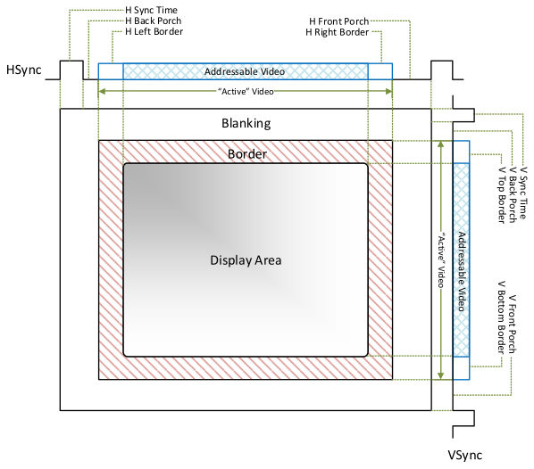
Figure 29: VGA Timing Diagram [11]

The VGA signal source is responsible for sending every pixel on the screen to the monitor one at a time starting with the pixel in the top left corner in row-major order [11]. To do this, VGA monitors have five input signals; one analog signal for each of the red, green, and blue pixel components, one signal signaling the end of a row (hsync), and another signaling the end of a frame (vsync) [11]. For each pixel of the row, the source will set the signals for red, green, and blue to voltages corresponding to their respective intensity in the pixel. These signals are held there for some time and then they are changed for the next pixel. After the last pixel of the row is transmitted the row end signal becomes low for a while and is then raised again before the start of the next row. When all rows have been transmitted the frame end signal is lowered for some time and is then raised again before the start of the next frame [11]. The exact delays and timing specifications differ depending on the video mode used. A video mode is a standardized combination of video resolution and refresh rate. The traditional 640x480 @ 60 Hz video mode was chosen for this project because it is one of the oldest and most supported existing video modes [11]. The values for each pixel can either be calculated on the fly or stored in a memory buffer. One of the functions of this synthesizer is to display waveforms so in this case, a memory buffer will be more useful. However, it will also be useful to display text in addition to waveforms. One method of displaying text is to embed a bitmap of the entire text that’s intended to be displayed. This is a straightforward way to do it but it requires a lot of memory; a valuable resource for an FPGA. Instead a font look up table can store a bitmap for each character. Then, instead of storing a bitmap of the entire text, numbers could be stored corresponding to the characters to be displayed on the screen. One suitable font table is Code Page 437, a character set used by the IBM PC.

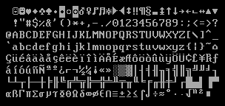
Figure 30: Code Page 437 [12]

This character set is useful because each character is eight pixels wide and 16 pixels tall. These measurements divide evenly into the chosen video resolution. This gives us a screen space of 80x30 characters to work with. Using the box drawing characters of Code Page 437 it is much simpler to build a good looking menu.

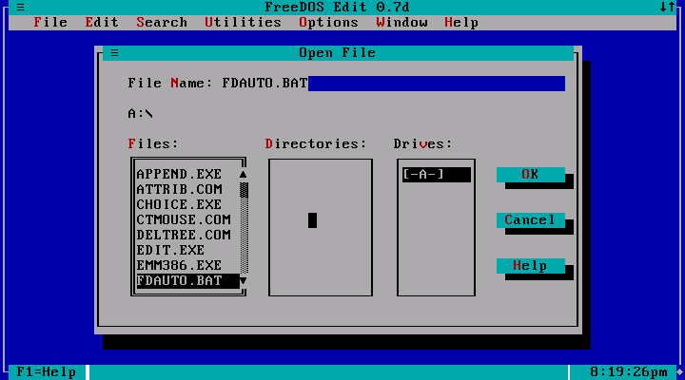
Figure 31: Example of a Menu Built With Box Drawing Characters [13]

VCO Control

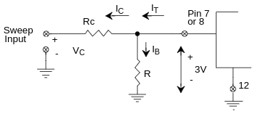
Figure 32: XR2206 Voltage Controlled Frequency Setup [14]

In order to control which pin is used for frequency generation, pin nine can be used as a select pin [14]. This can be used to alternate between two frequencies quickly. Pins 13 and 14 can be used to select the type of output waveform [14]. This can be used to change between a sinusoidal output and a triangle wave for example. Ideally it would be possible to connect the DAC output of the FPGA directly to the circuit in Figure 28, however the DAC used in this project has two limitations that necessitate the use of an operational amplifier. These limitations are that the DAC cannot sink current and that the DAC is limited to an output voltage of 2.5 V [16]. According to the datasheet for the XR2006 [14], the generated frequency, and the current drawn from pin seven or eight must be within the following range: . To ensure that the current falls within this range, the following calculations will be based on this range: . The range of desired frequencies is the same as the human hearing range, or . Based on the frequency formula above and the maximum current and desired frequency, the capacitor . This capacitor determines the slope of the current-frequency relationship. After circuit analysis of the circuit in Figure 27, the current drawn from pins seven or eight is found to be . Substituting the minimum and maximum values for the voltage and current into this equation yields two equations with the two unknowns being the two resistor values. In order for this equation to have a solution for which the resistor values are both positive, the applied voltage must be greater than three. An operational amplifier is already needed so it is easy to set it up so that the DAC voltage is doubled for a maximum of five. Solving this equation yields the resistor values .
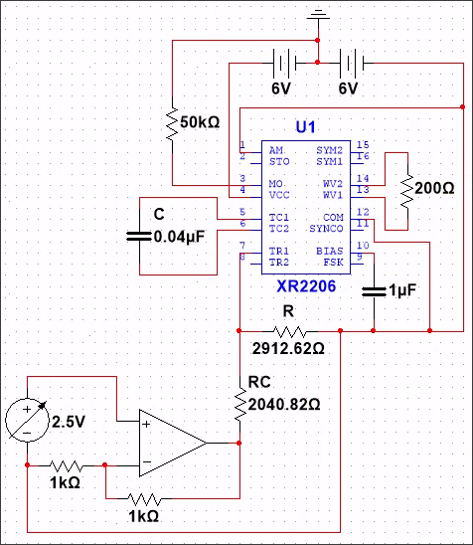

Figure 33: The XR2206 in Multisim

In simulations of the XR2206 the range of generated signals was from about 1 kHz to 17 kHz, which is less than the expected range. This could be due to the fact that the voltage between port seven and 12 is supposed to be three and is not exactly three. In fact, this voltage changes depending on the input voltage from the DAC as seen in Figure 29. Hopefully this is something that can be resolved with the physical IC.

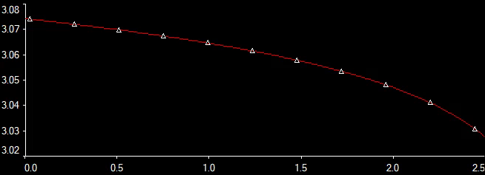
Figure 34: Pin Seven/Eight Voltage vs DAC Voltage
Figure 30 below shows what the anticipated VCO circuit will look like on a breadboard.
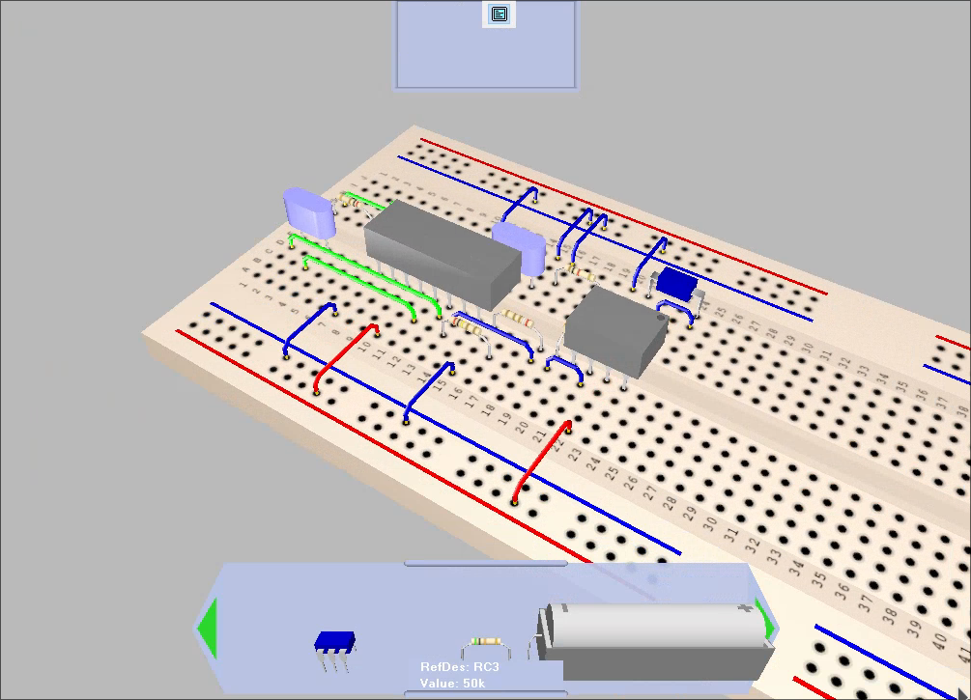
Figure 35: VCO Circuit on a Breadboard

Channel Mixer Control

A synthesizer may want to have multiple key presses at the same time to construct chords. This means multiple XR2206 VCOs will be needed, each with their own channel. In order to hear multiple frequencies, they need to be combined into a single signal using something called a mixer. To implement this, the project will use a LM324 op-amp in a summing configuration, with potentiometers to control the magnitude of each channel.

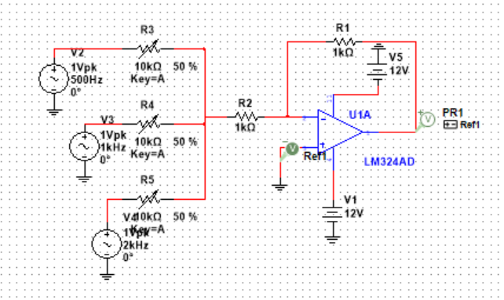
Figure 36: 3-channel VCO mixer schematic
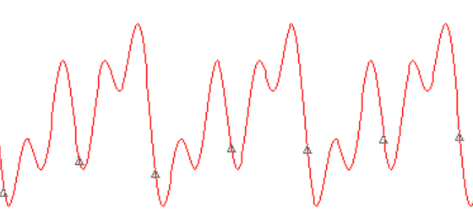
Figure 37: Superposition of 3 sine waves of different frequencies

To create more interesting effects such as a tremolo, a low frequency oscillator (LFO) is used which typically operates from 1-10Hz [2]. The LFO signal will also be produced by the XR2206 monolithic function generator. To produce the tremolo effect, the output signal from the summing amplifier will be multiplied by the LFO using the AD835N multiplier IC. By multiplying two sine waves of frequencies ⍵₁ and ⍵₂, an output signal is produced that is the superposition of two sine waves that are the sum and difference of ⍵₁ and ⍵₂.

Equation 1: Signal Multiplication

By grounding X2, Y2, and Z of the AD835 shown in Figure 3, the result is W = X1 * Y1.

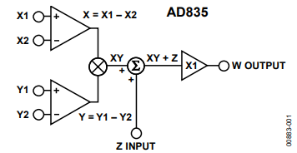
Figure 38: AD835 Functional Block Diagram

Synthesizer Simulator for Comparison
It is important to be able to compare the overall quality and functionality of the synthesizer design to what is already available. With the many Digital Audio Workstations (DAW’s) and Virtual Studio Technologies (VST’s), it isn’t necessary to buy a physical synthesizer. With this setup, any tone can be created by using the Vital .vst plugin, play notes on a virtual MIDI keyboard, record them into Reaper, and export the audio signal as a .wav file. Vital is a free, highly configurable digital audio synthesizer equipped with oscillators and LFO’s of any waveform, envelope generators, and filters of all kinds. Vital can then interface with an external MIDI keyboard, or via Reapers built in virtual MIDI keyboard. Reaper and DAW’s alike allow you to mix and alter multiple tracks into a final piece. Reaper will be used to export audio signals produced by Vital for analysis and comparison against the design. Figure 34 shows what the VST3i plugin looks like in Reaper

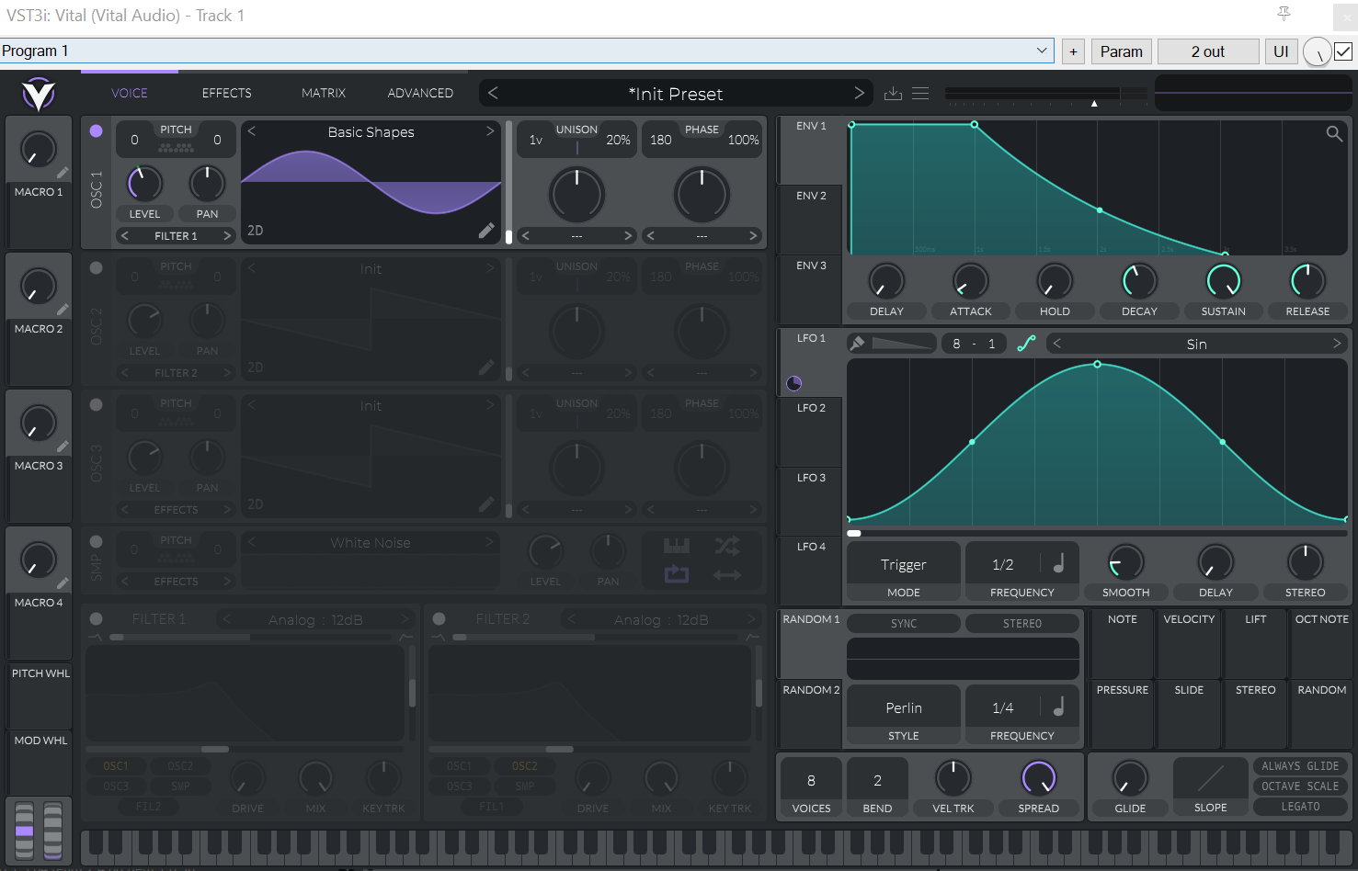

Figure 39: VST3i plugin for Reaper

Testing
Testing is an important part of any project, but for a large digital design such as the Artix Wolverine, testing is even more so because of all the different components that need to work together.

MIDI Interface
The MIDI receiver module is a major part of the Artix Wolverine so it’s essential to have a robust testbench for this SystemVerilog module. Writing a testbench that simulates a MIDI device would be time consuming and difficult to get right, so the output of a virtual MIDI keyboard was used to test the receiver instead. The popular program, VMPK (Virtual MIDI Piano Keyboard) [27] seemed like a good match for the actual MIDI instrument used in this project so it was used for the testbench. VMPK is capable of sending MIDI messages over a network, so a script was written that receives these messages and pipes them to the SystemVerilog simulator that’s running the testbench. The testbench was manually tested for accuracy by playing notes on VMPK while watching the testbench outputs.

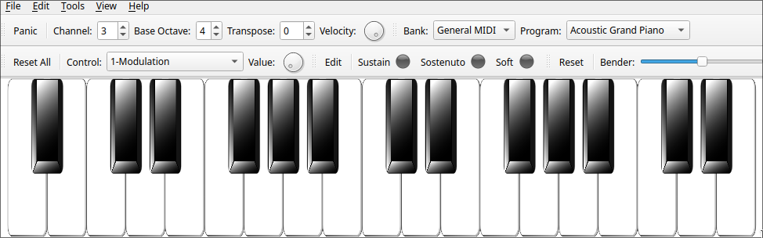
Figure 40: VMPK (Virtual MIDI Piano Keyboard)

Shown in the figure below are the inputs and outputs of the MIDI receiver module after the leftmost three keys were pressed on VMPK.
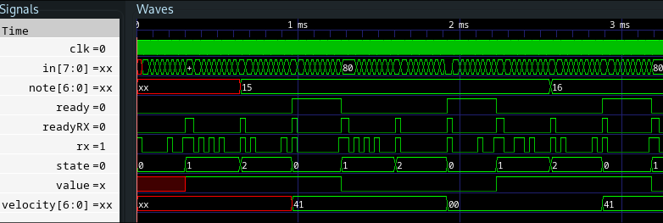
Figure 41: MIDI Receiver Output

The image below shows an early test of the MIDI receiver working on real FPGA hardware. The key shown on the screen corresponds to the key pressed on the MIDI keyboard.

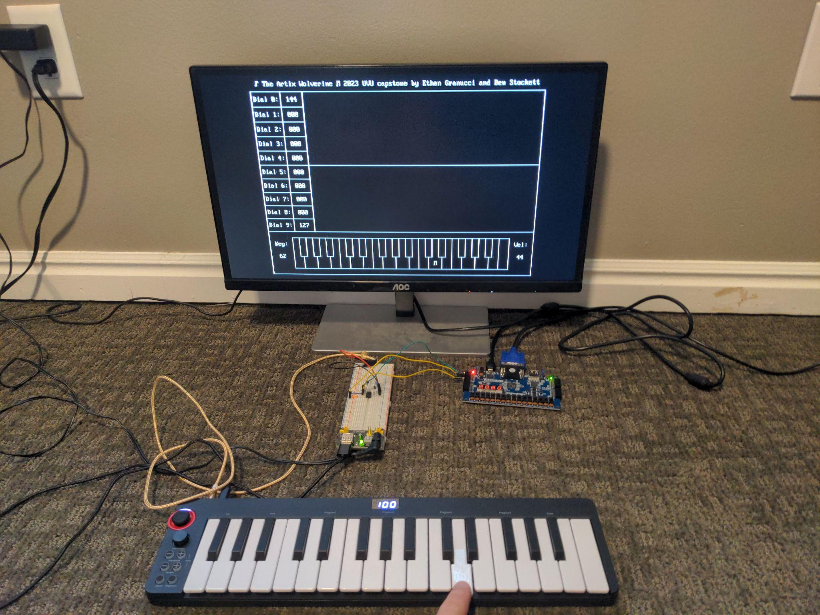
Figure 42: The MIDI Receiver Working on Real Hardware

VGA Interface
The VGA interface was difficult to get working because there are no simple methods of visualizing the visual outputs without testing on real VGA hardware. Before displaying any type of complex graphics, the basic video interface needed to be fully completed and tested. To start with, the VGA interface was tested by displaying a test pattern shown below.

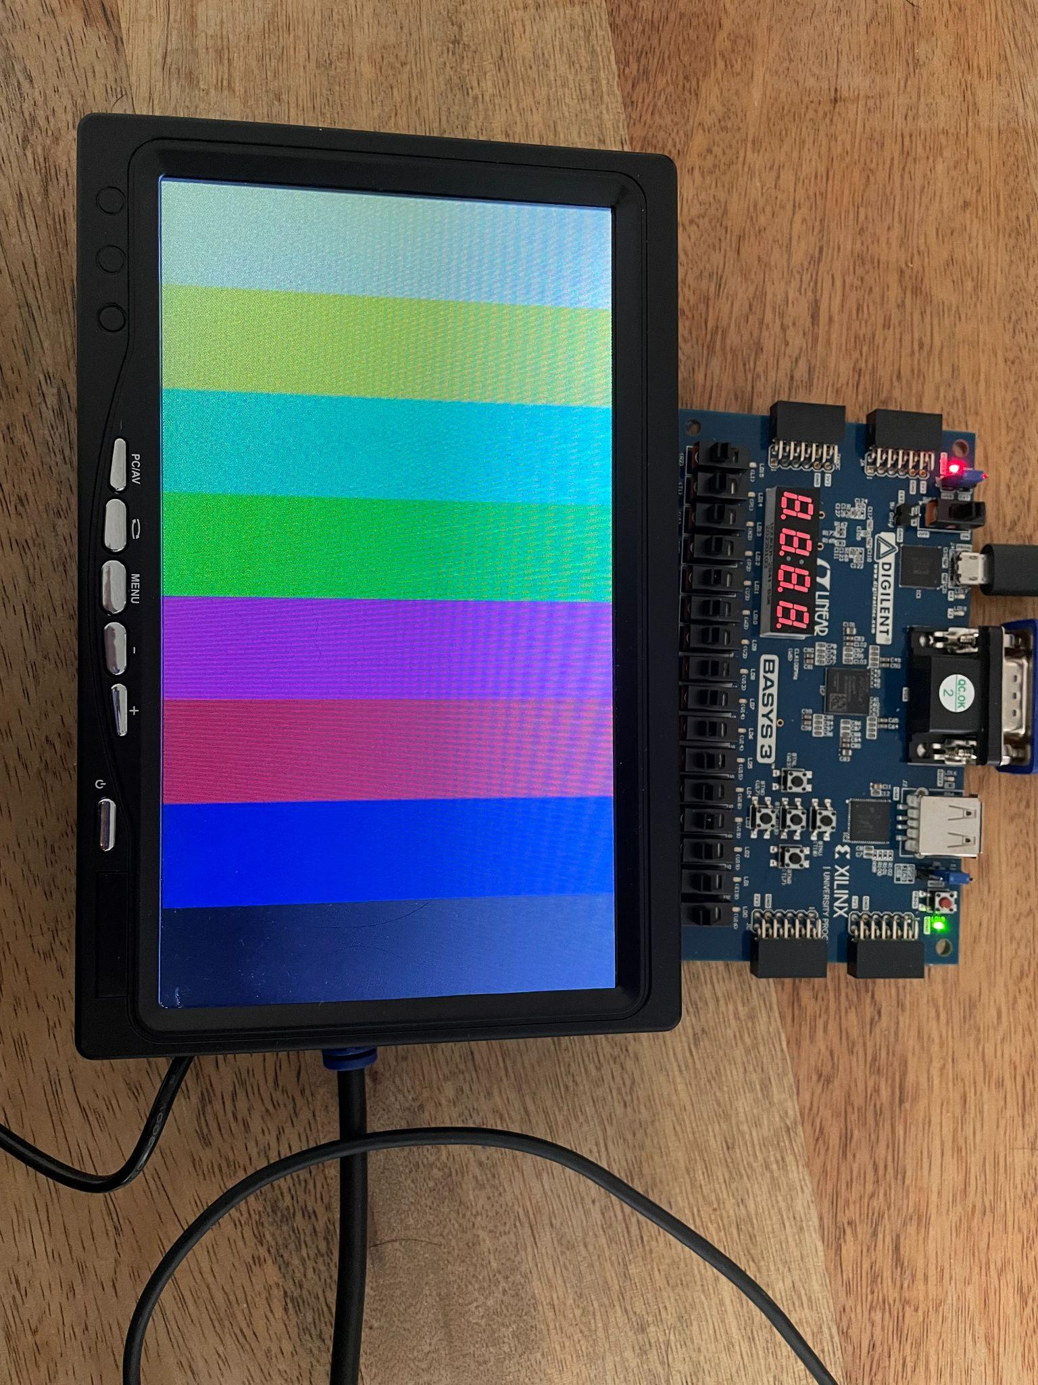
Figure 43: VGA Test Pattern
Once the VGA interface was perfected, more complicated graphics could be developed as shown in the image below.

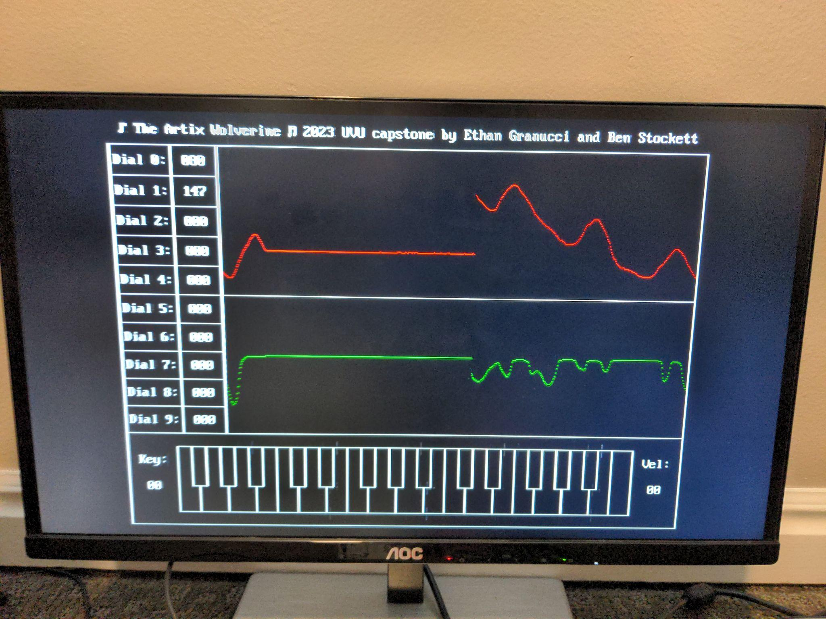
Figure 44: An Early Test of Text and Waveform Video Graphics

After the design of the video graphics had been completed, the VGA monitor could be inserted into the Artix Wolverine body housing as shown on the following page.
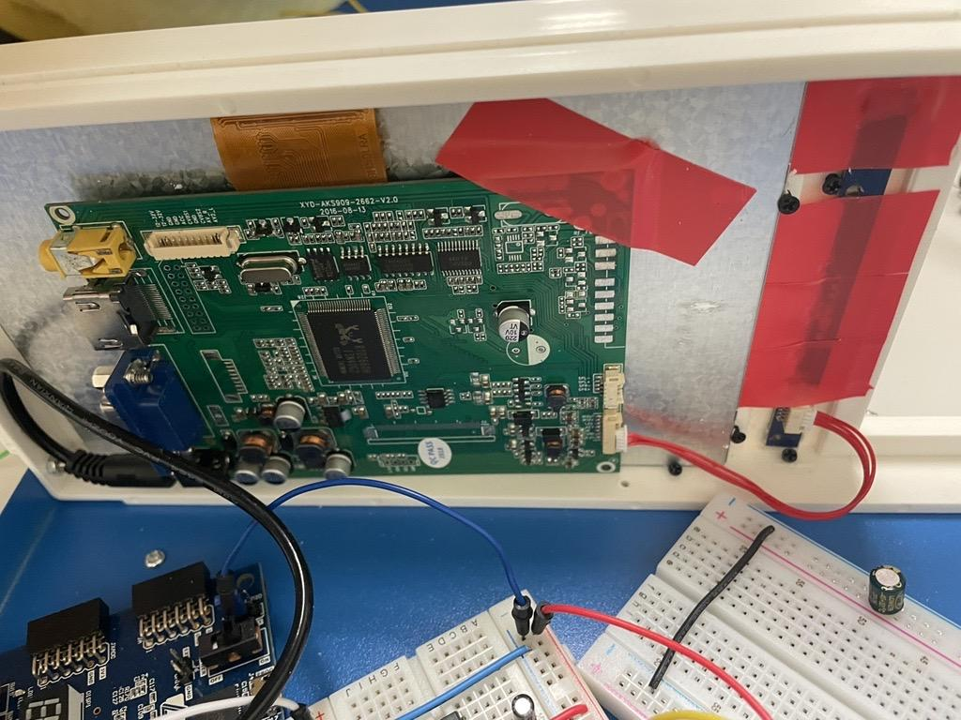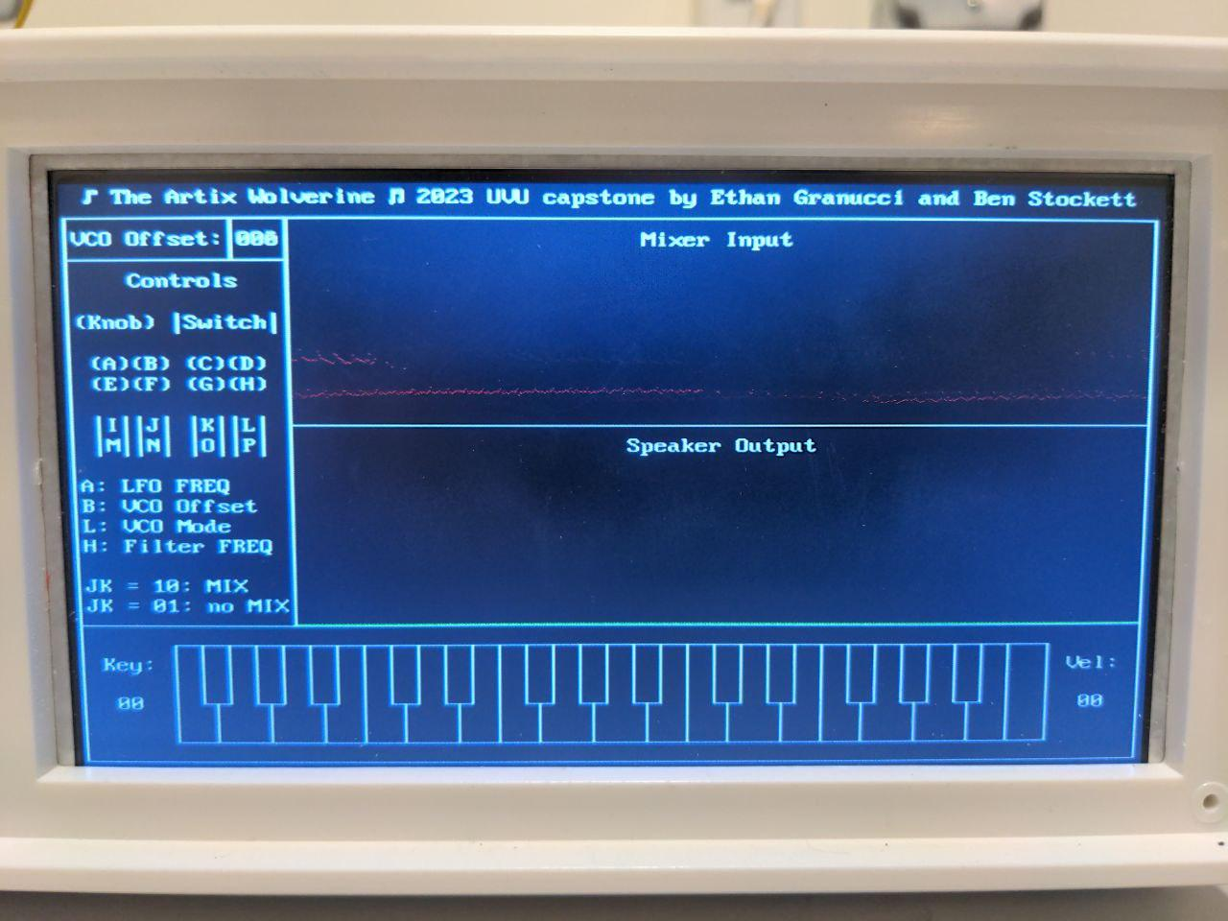
Figure 45: The Artix Wolverine’s VGA Display

DAC Interface
Another very important part of the Artix Wolverine is the DAC. In order to control the VCOs’ outputs, the FPGA needs to be able to generate analog voltages corresponding to frequencies. The FPGA communicates with the DAC using SPI. Knowing that, it’s possible to inspect the output signals both with a SystemVerilog testbench and an oscilloscope as shown below.

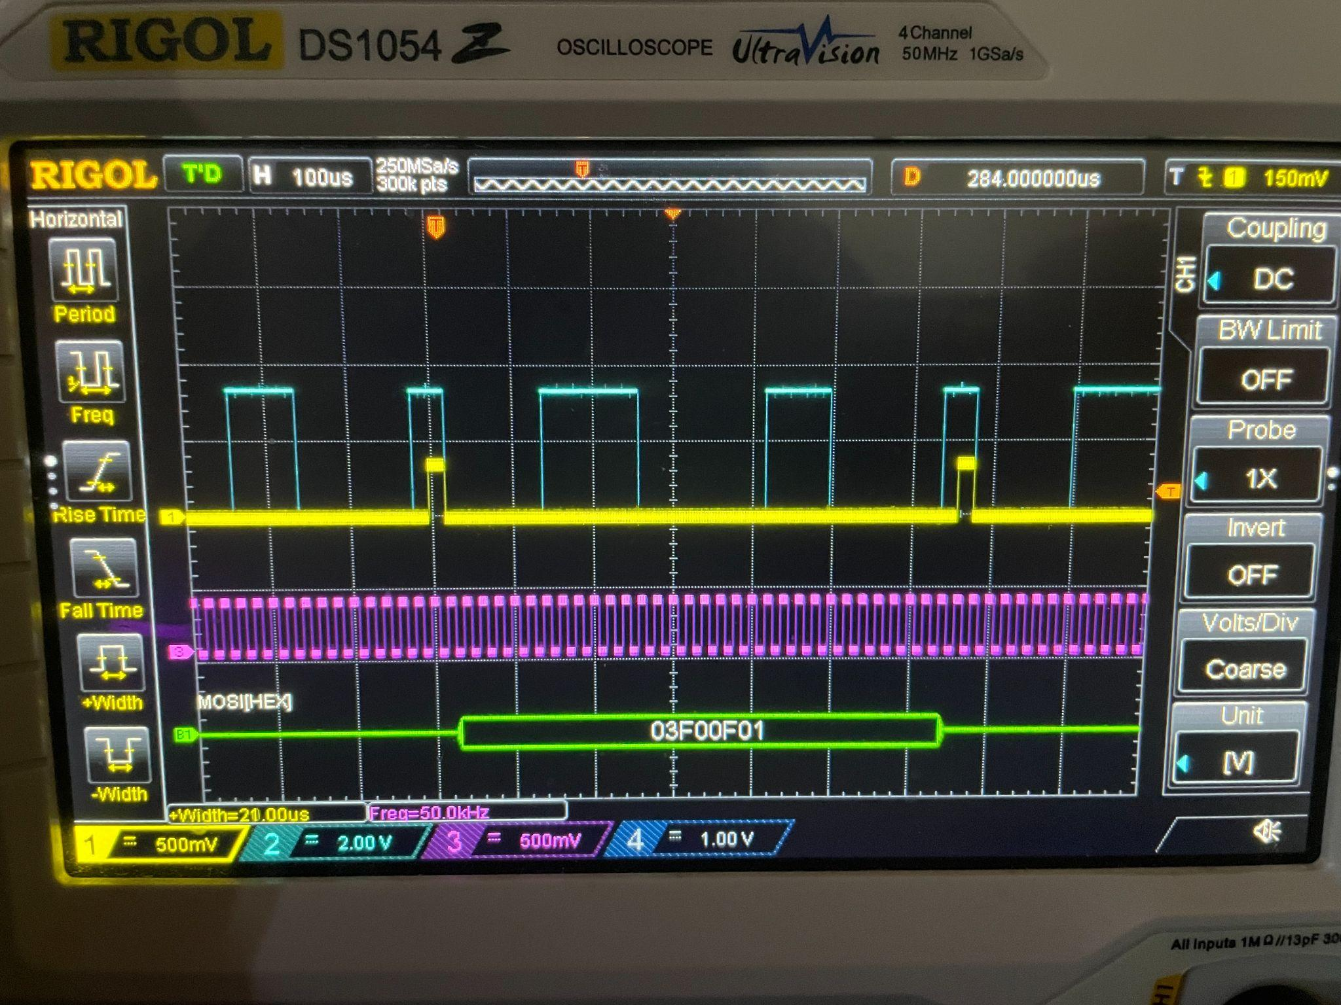
Figure 46: DAC Output Signals Shown on an Oscilloscope
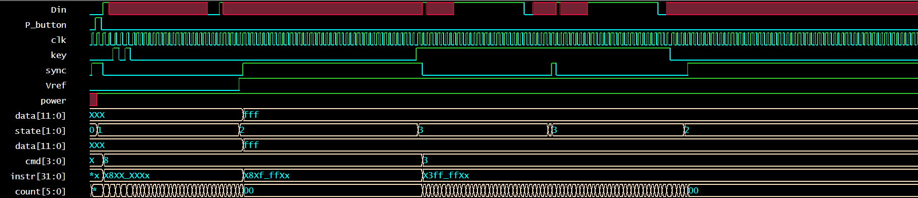
Figure 47: DAC Output Signals Shown on a SystemVerilog Testbench

After ensuring the DAC module’s output signals looked correct, it was time to test the DAC with a multimeter to see if it could generate the proper analog voltages for this project. In the image shown below, the DAC is set to output its maximum voltage of 2.5 V.

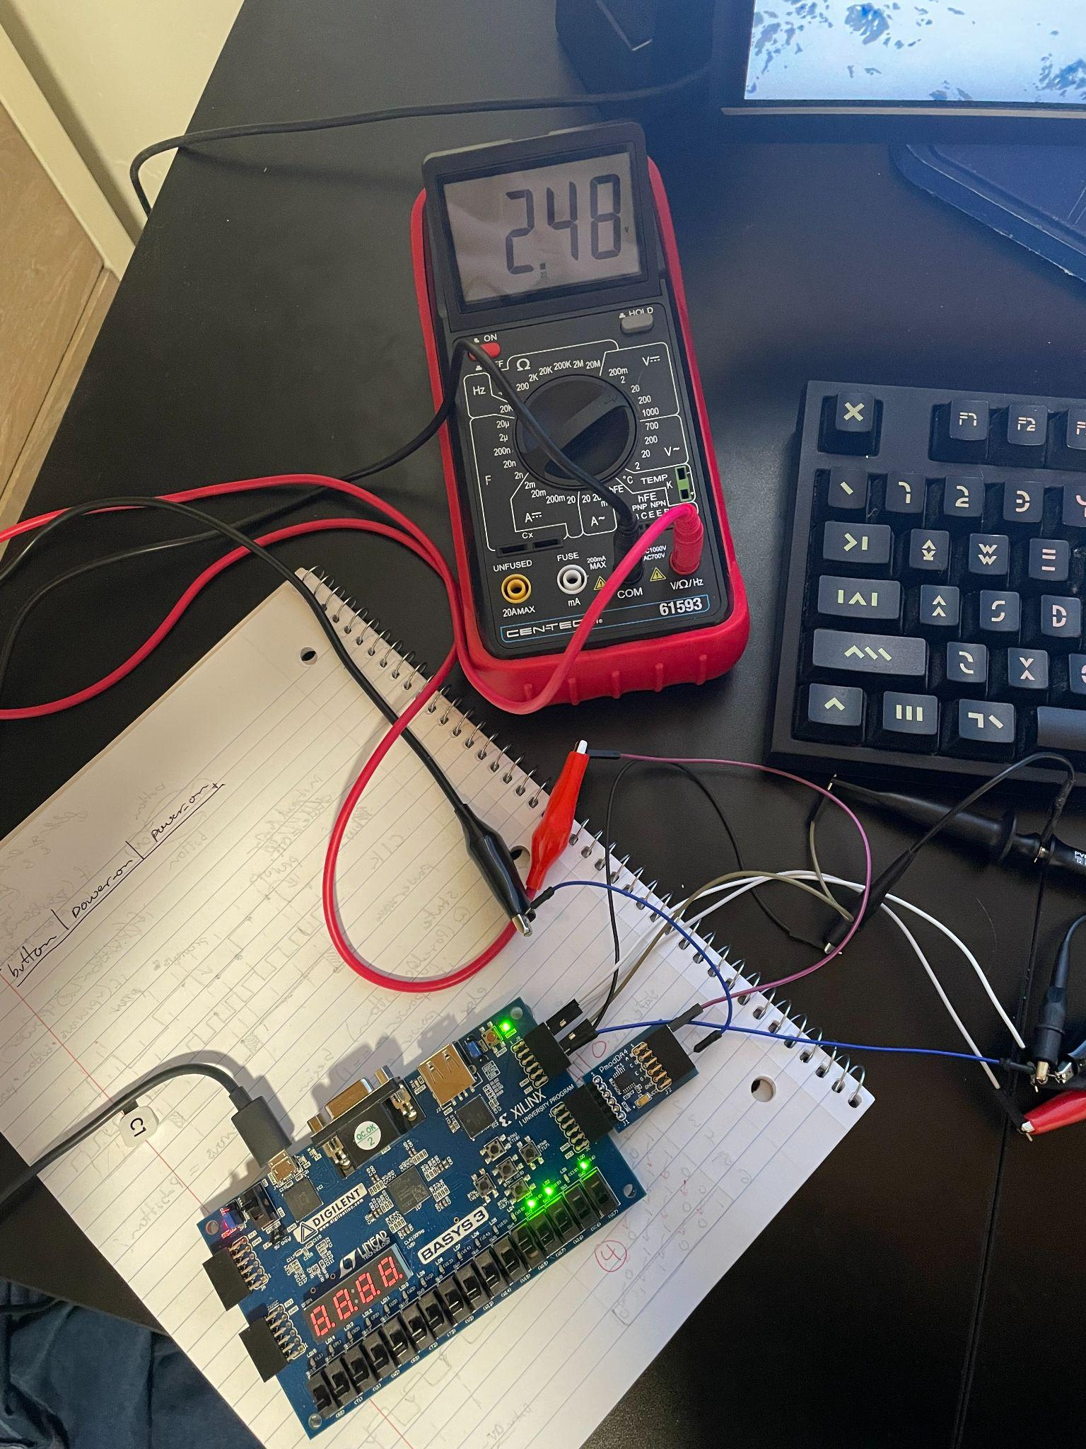
Figure 48: DAC Working on Real FPGA Hardware

VCO Control
The VCO ICs were fairly easy to test, given existing simulation modules in programs such as Multisim. In the figure below, the DAC output is represented as a variable DC voltage source. The VCO output is analyzed in both the time and frequency domains.

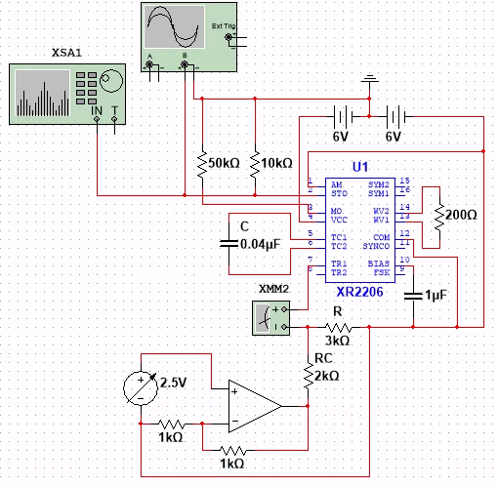
Figure 49: VCO Testing Simulation
As the voltage from the virtual DAC increased, the VCO output frequency decreased as shown in the figures below representing the time and frequency domains.

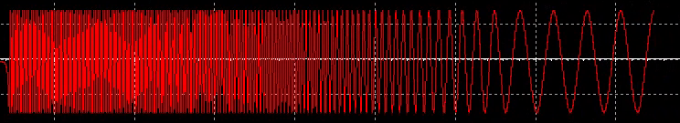
Figure 50: VCO Simulation Output in the Time Domain

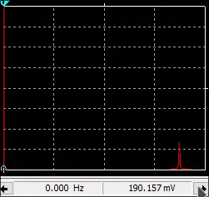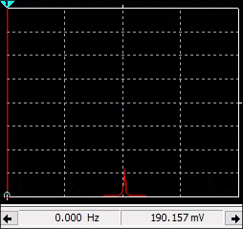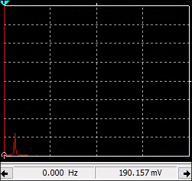
Figure 51: VCO Simulation Output in the Frequency Domain

After the simulation results were verified, it was time to build the actual VCO control circuits. The image below shows an early implementation of the circuit.

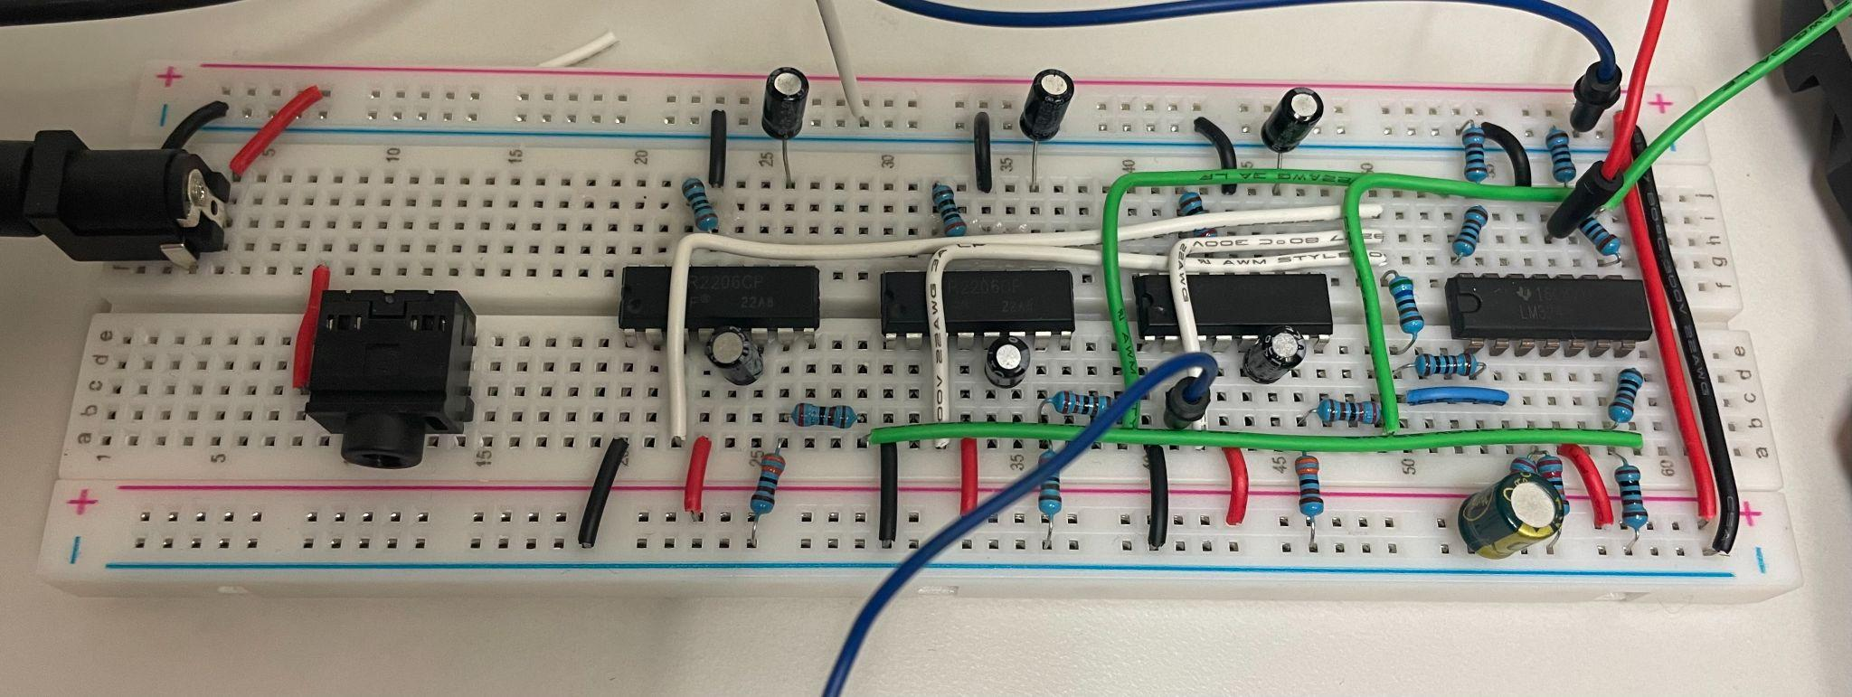
Figure 52: An Early Implementation of the VCO Control Board.

Mixer
In order to combine the different VCO voices, as well as create an oscillating sound effect, a mixer was needed. The VCO voices are added together via an inverting op-amp with unity gain. The sum of the VCO outputs is then multiplied by the LFO via the AD835N IC. This design can be easily tested using simulation software such as Multisim. The figure below shows the design of the mixer.

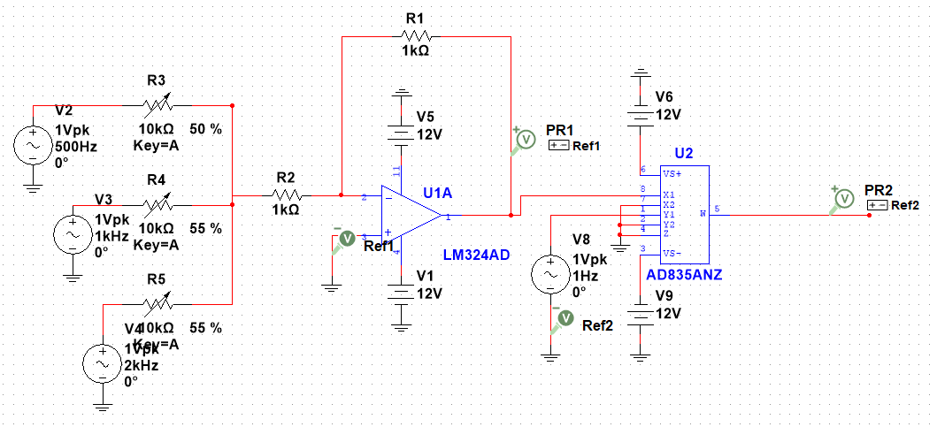
Figure 53: Mixer Design in Multisim

Marketing and Engineering Specifications
Below is a table of some relevant marketing requirements for the Artix Wolverine.

Table 1: Marketing Requirements

Marketing Requirements | Engineering Requirements | Justification
High sound quality | VCO must generate waves from 20-20k Hz without distortion. | Poorly shaped waves sound unpleasant to human ears.
Ease of use | Function of each component must be clearly labeled, and visual display should accurately represent the synthesized wave. | A confusing user-interface detracts from experience and can have a negative impact on marketability.
Ease of use | Setup should be easy for users. | A difficult setup process can dissuade users from using the product.
Programmability | Housing should have micro-USB port access as well as free PMOD ports for additional external components. | The user should have the freedom to design and implement their own modules if they choose.
Cost | At minimum, should perform the basic synth functions for ~$500 or less. | This is the cost for a low-mid range synthesizer by Korg, one of the leading synth manufacturers.
Size/portability | Should be self-contained and easy to transport. | Musicians and students need to travel frequently.
Safety | The power supply must be rated to provide power within the specifications of each individual component. There must be no exposed wires or dangerous parts. | Having exposed components could expose the user to electric shock. It is important to follow electrical specifications to avoid potential damage to the device and people.
Attractive Design | The device housing must enclose the device while not compromising on aesthetics. | People will be less willing to use the device if it looks bad.

Below is a comparison of each marketing requirement. The boxes of the table contain the relative importance of the column with respect to the row. Each column’s rankings are summed to obtain the corresponding score. Higher scores indicate a greater importance.

Table 2: Pairwise Comparison Matrix

 | Ease of Use | Programmability | Cost | Size and  Portability | Safety | Attractive Design
High Sound Quality | ↑ | ↓ | ↑ | = | ↑ | ↑
Ease of Use | - | ↓ | ↓ | ↓ | ↑ | =
Programmability |  | - | ↑ | = | ↑ | ↑
Cost |  |  | - | ↓ | ↑ | ↑
Size and Portability |  |  |  | - | ↑ | ↑
Safety |  |  |  |  | - | ↓
Score | 1 | -2 | 1 | -2 | 5 | 3

From the pairwise comparison matrix, in regards to the Artix Wolverine, safety was found to be most important, followed by attractiveness, cost and ease of use, and finally portability and programmability.

Conclusions and Recommendations
Developing the Artix Wolverine has been a complex learning experience involving both electrical and computer expertise. In any large digital system there are many different components and protocols that work together. For this project we have needed to learn about several of these standards including VGA, SPI, UART, and MIDI. Shown in the figures below is the final design of the Artix Wolverine.
Shown below is the final design of the Artix Wolverine as it has been wired.
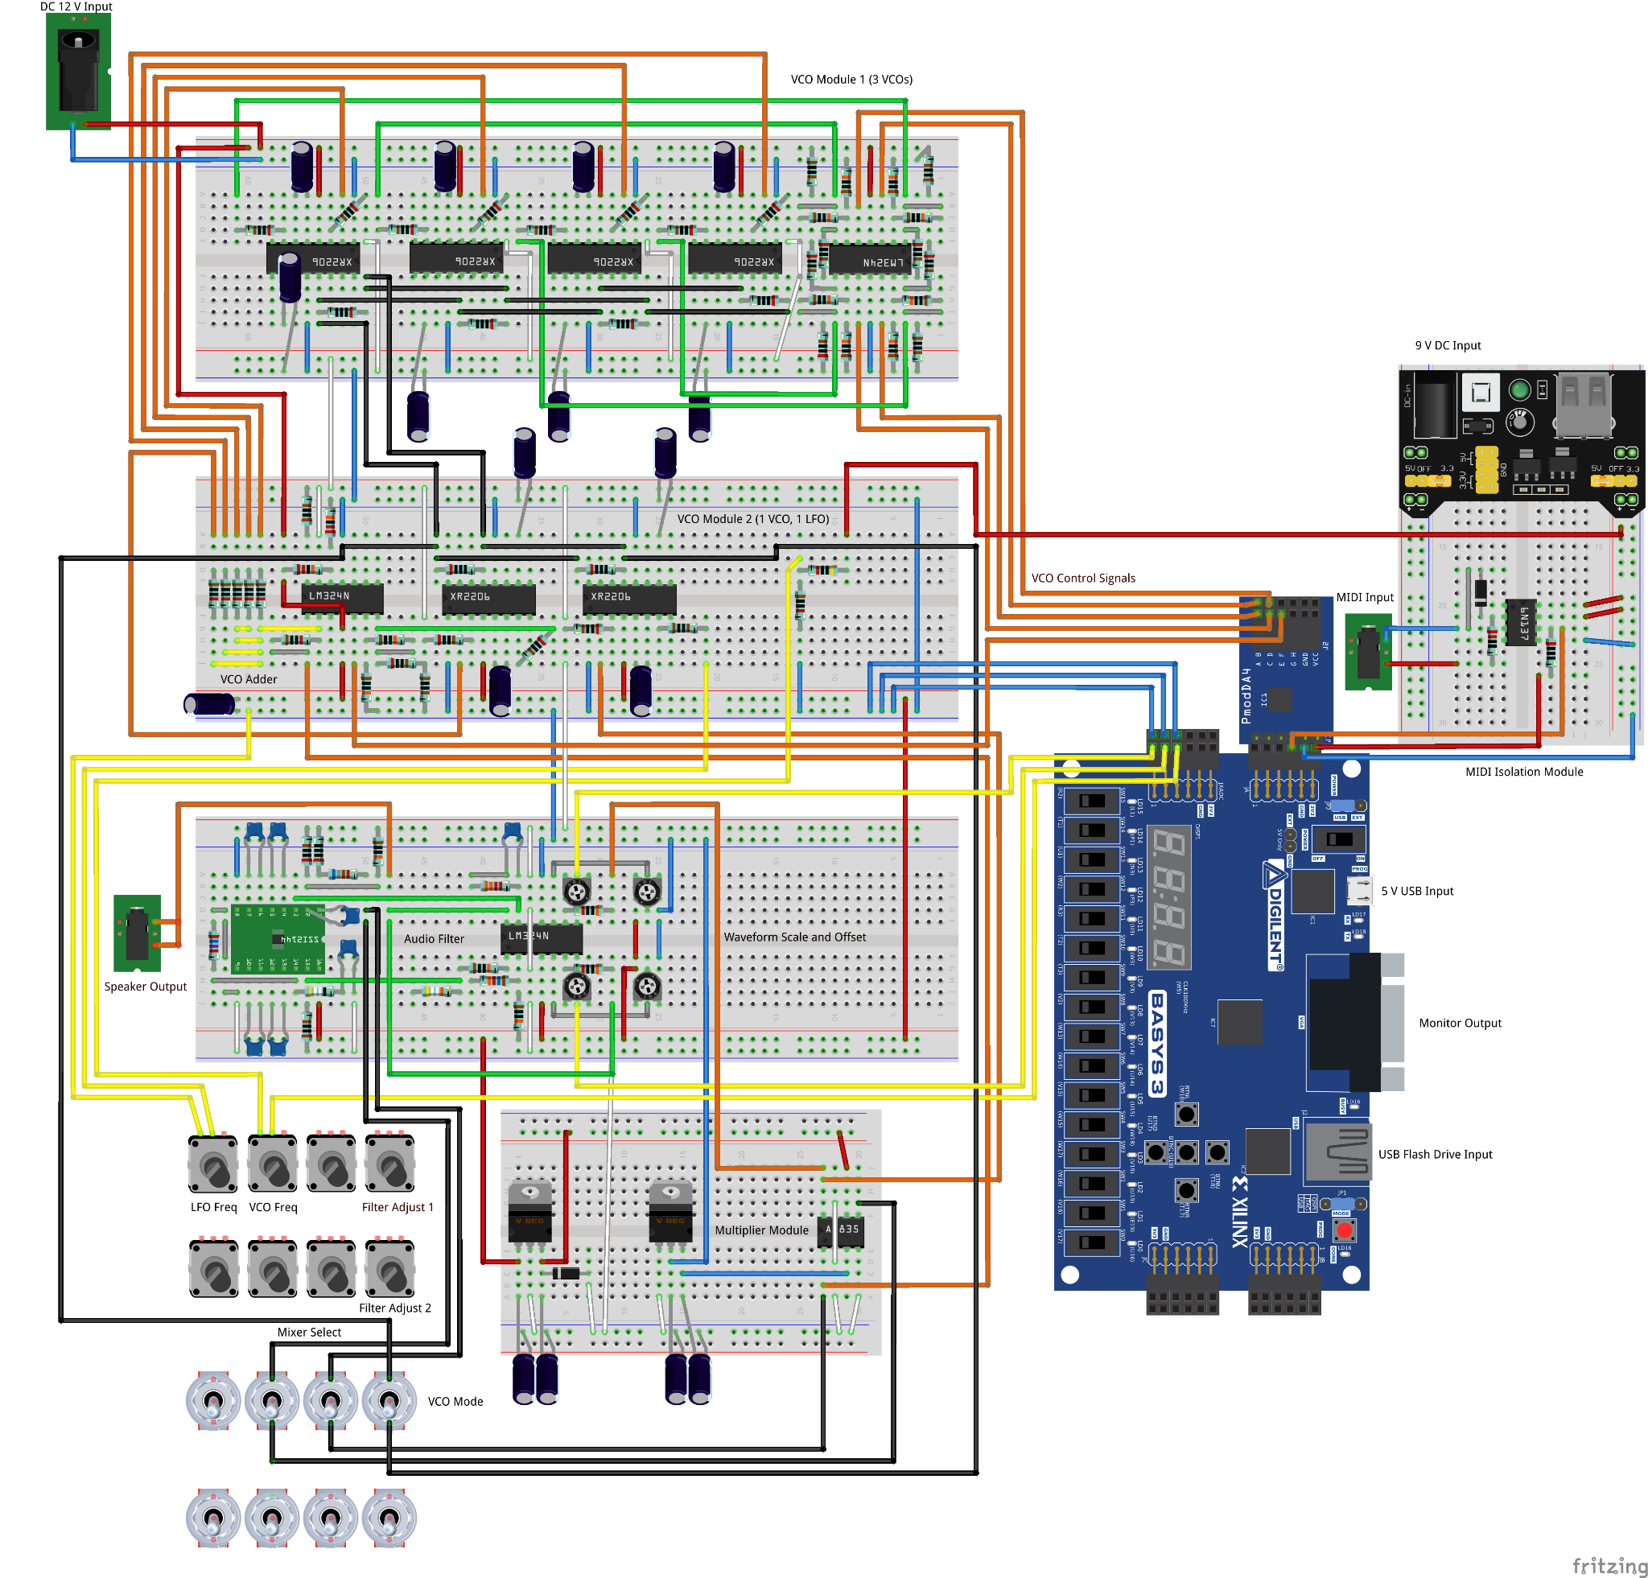
Figure 54: Artix Wolverine Wiring Diagram
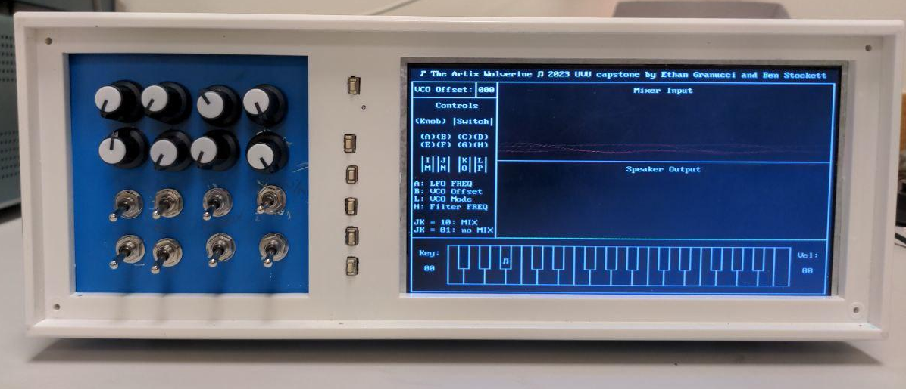
Figure 55: The Artix Wolverine Front View

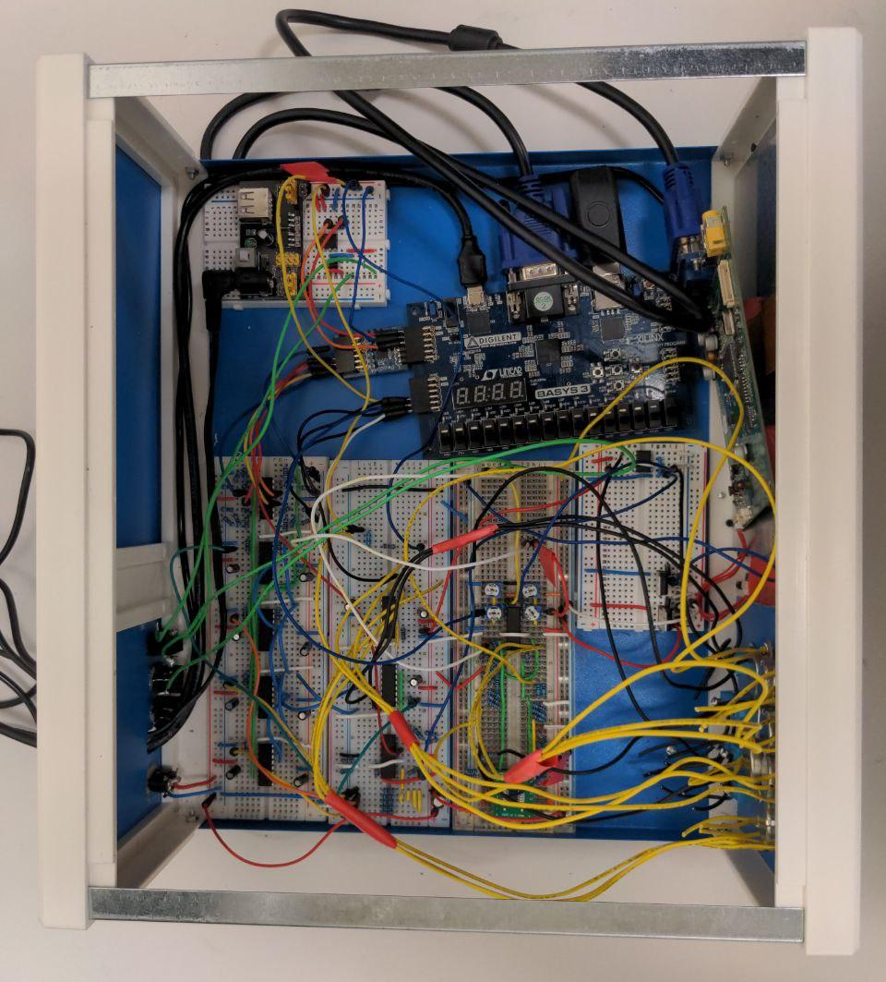

Figure 56: Artix Wolverine Inside View
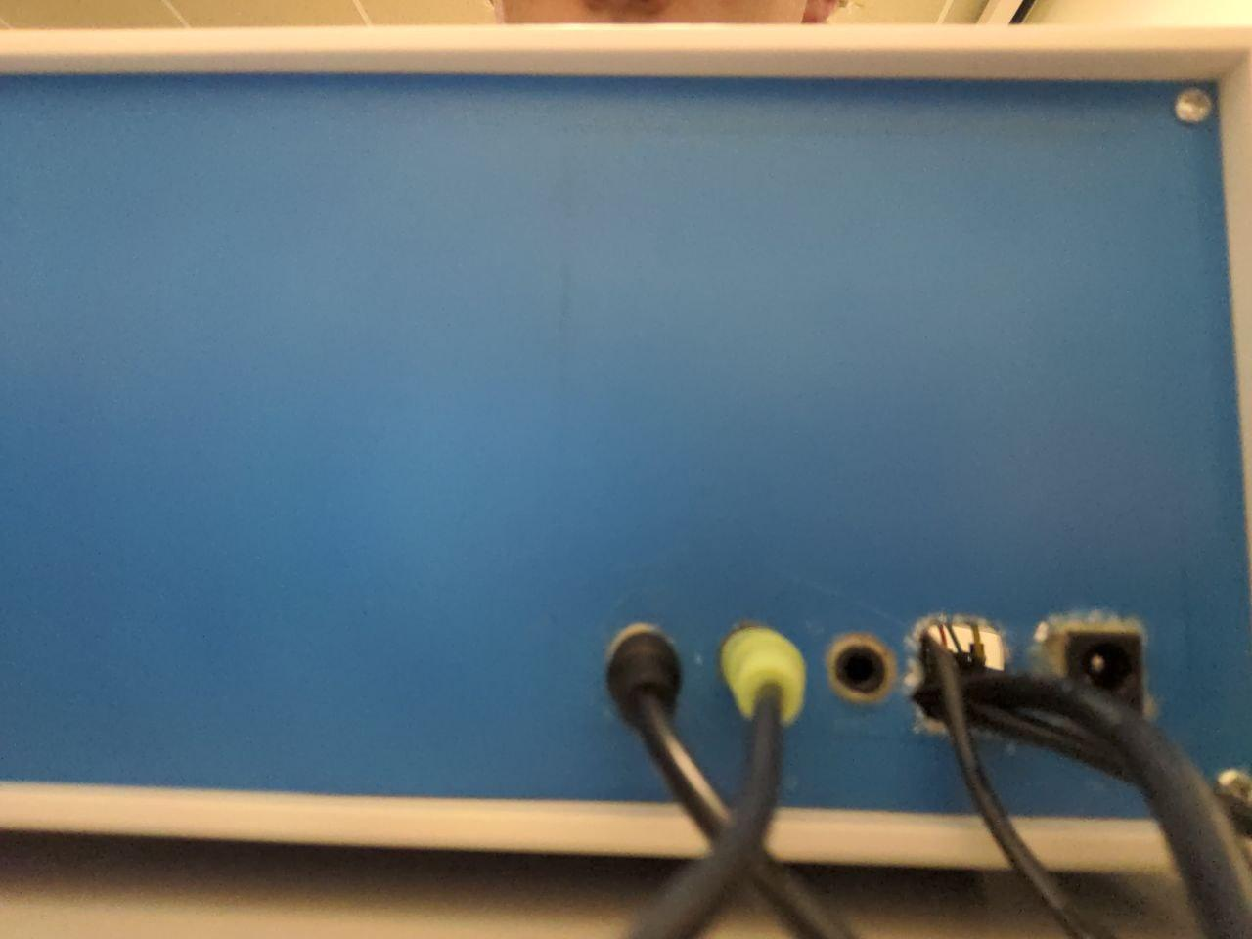
Figure 57: Artix Wolverine Back View

There are a few parts of the design of the Artix Wolverine that were either modified or left out of the final design due to time constraints or other factors. One of these features was the microphone intended to be used for karaoke. When testing the microphone as an integrated part of the design, audible noise was introduced via the power supply that could not be reconciled. A large amount of time was focused on resolving this issue, however it was decided that the microphone was not a crucial feature compared to the rest of the work that remained. Due to these issues, the microphone feature was removed from the final design. Another aspect of the project that was changed was the project housing. The original plan featured a 3D printed enclosure, however it was simpler and cheaper to use a common premade project box. The project box was perfect for the Artix Wolverine as the openings fit the video display perfectly and allowed the control panel to be drilled into the front.
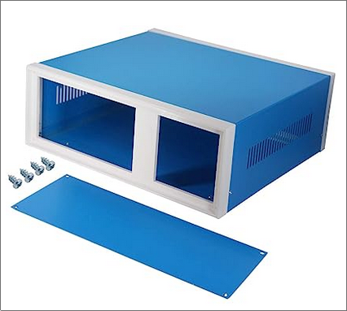
Figure 58: Project Box Housing
One feature not present in the original design is the addition of a 500 mA fuse. The Artix Wolverine needs to be a safe product for end users, and there may be aspects of the design that could fail or malfunction should the end user make modifications. The fuse acts as a failsafe to protect the end user and to prevent damage to the product. The Artix Wolverine’s maximum power draw is about 120 mA. The fuse’s value was chosen to accommodate fluctuations in current and future hardware additions while setting a cap on the device’s current and power consumption.

Future Work
Many of the knobs and switches were left unused for future configuration such as Q-control for the low pass filter. Those controls could be utilized to give the Artix Wolverine additional configurability. More features could be added as well, such as a FFT (Fast Fourier Transform) plot of the audio signal on the video display and additional sound effects. An original intent was to use the auxiliary microphone to modulate the user's voice, but this was not implemented.

References
[1] | J. Jiang, "Audio processing with channel filtering using DSP techniques," 2018 IEEE 8th Annual Computing and Communication Workshop and Conference (CCWC), 2018, pp. 545-550, doi: 10.1109/CCWC.2018.8301696.
[2] | RO. A.. Moog, "Voltage Controlled Electronic Music Modules," J. Audio Eng. Soc., vol. 13, no. 3, pp. 200-206, (1965 July.). doi:
[3] | MavisT2. “Basys3 FPGA Digital Audio Synthesizer : 5 Steps.” Instructables. https://www.instructables.com/Basys3-FPGA-Digital-Audio-Synthesizer (accessed Oct. 4, 2022).
[4] | KORG (USA). https://korg.com/us (accessed Oct. 4, 2022).
[5] | E. Amos, “SONY DSC.” File:Wall-Wart-AC-Adapter.jpg - Wikimedia Commons. Aug. 12, 2011, [Online]. Available: https://commons.wikimedia.org/wiki/File:Wall-Wart-AC-Adapter.jpg.
[6] | “POSITIVE VOLTAGE REGULATORS.” STMicroelectronics, 2004. [Online]. Available: http://cdn.sparkfun.com/datasheets/Components/General/TO-220.pdf.
[7] | “MIDI 1.0 Detailed Specification.” The MIDI Manufacturers Association, Los Angeles, CA, Feb. 1996. [Online]. Available: https://www.midi.org/specifications/midi1-specifications/m1-v4-2-1-midi-1-0-detailed-specification-96-1-4.
[8] | “Specification for Use of "TRS" Connectors with MIDI Devices.” The MIDI Association. https://www.midi.org/midi/specifications/midi-transports-specifications/specification-for-use-of-trs-connectors-with-midi-devices-2 (accessed Oct. 18, 2022).
[9] | “5 Pin DIN Electrical Specs.” The MIDI Association. https://www.midi.org/midi/specifications/midi-transports-specifications/5-pin-din-electrical-specs (accessed Oct. 18, 2022).
[10] | “Basys 3 - Digilent Reference.” Digilent. https://digilent.com/reference/programmable-logic/basys-3/start (accessed Oct. 18, 2022).
[11] | “VGA Display Controller.” Digilent. https://digilent.com/reference/learn/programmable-logic/tutorials/vga-display-congroller/start (accessed Oct. 18, 2022).
[12] | M. Giuca, File:Codepage-437.png - Wikimedia Commons. Feb. 18, 2009, [Online]. Available: https://commons.wikimedia.org/wiki/File:Codepage-437.png.
[13] | NTOSKRNL VXE, Intgr, File:Fdedit.png - Wikimedia Commons. July 3, 2006, [Online]. Available: https://commons.wikimedia.org/wiki/File:Fdedit.png.
[14]  [15] | EXAR. “Monolithic Function Generator”. https://www.sparkfun.com/datasheets/Kits/XR2206_104_020808.pdf (accessed Oct. 18, 2022).  Beringer “Poly D” https://www.behringer.com/product.html?modelCode=P0D9J (accessed Oct. 27, 2022)
[16] | “Top view product image of the Pmod DA4: Eight 12-bit D/A Outputs.” Pmod DA4: Eight 12-bit D/A Outputs - Digilent. [Online]. Available: https://digilent.com/shop/pmod-da4-eight-12-bit-d-a-outputs (accessed Nov. 16, 2022).
[17] | “7" HDMI 1024x600 LCD Screen Display for Raspberry Pi, Support AV/VGA/HDMI with Built in Speaker.” 7" HDMI 1024x600 LCD Screen Display for Raspberry Pi, Support AV/VGA/H. [Online]. Available: https://cdn.shopify.com/s/files/1/0474/7729/3217/products/SF-TFTLCDV2.0-01_600x.jpg (accessed Nov. 16, 2022).
[18] | Analog Devices. “250 MHz, Voltage Output, 4-Quadrant Multiplier”. AD835 datasheet. 2014. https://www.analog.com/media/en/technical-documentation/data-sheets/AD835.pdf (accessed Nov. 16, 2022).
[19] | Texas Instruments. “LMx24, LMx24x, LMx24xx, LM2902, LM2902x, LM2902xx, LM2902xxx Quadruple Operational Amplifiers”. LM324N datasheet. https://www.ti.com/lit/ds/symlink/lm224.pdf?HQS=dis-dk-null-digikeymode-dsf-pf-null-wwe Sept. 1975 [revised Oct. 2022] (accessed Nov. 16, 2022).
[20] | Sound Semiconductor. “FATKEYS™ FOUR-POLE VOLTAGE CONTROLLED FILTER”. SSI2144 datasheet. https://soundsemiconductor.com/downloads/ssi2144datasheet.pdf 2017 [revised Jan. 2018] (accessed Nov. 16, 2022).
[21] | “Donner N-32 32-Key MIDI Keyboard Controller Sequencer with Digital Tub – Donner music- CA.” [Online]. Available: https://donnerca.com/products/donner-n-32-midi-keyboard (accessed Nov. 15, 2022).
[22] | M. D. Cosmo. The Tiny Synth. “The Tiny Synth – A very tiny polyphonic FPGA-based DIY synthesizer.” https://thetinysynth.wordpress.com (accessed Oct. 4, 2022).
[23] | “POLY555 Synth,” 2020. https://blog.tommy.sh/posts/poly555-synth (accessed Oct. 4, 2022).
[24] | Soni, Marmik & Makharia, Piyush. (2017). IMPLEMENTATION OF INNOVATIVE LOW COST MUSIC SYNTHESIZER USING FPGA. ICTACT Journal on Microelectronics. 3. 394-397. 10.21917/ijme.2017.0070.
[25] | Chou, Chi-Jui, Satish Mohanakrishnan, and Joseph B. Evans. "FPGA implementation of digital filters." Proc. Icspat. Vol. 93. 1993.
[26] | P. Rzeszut, E. Jamro, and K. Wiatr, “Oscilloscope based on small-size FPGA with VGA display,” Measurement Automation Monitoring, vol. 64, no. 1, pp. 2–4, 2018.
[27] | “VMPK. Virtual MIDI Piano Keyboard,” 2020. vmpk.sourceforge.io. https://vmpk.sourceforge.io.

Appendices

Original Project proposal

FPGA Audio Synthesizer

Team Members

Name | Email Address | Phone Number
Dr. Afsaneh Minai | minaieaf@uvu.edu
Ethan Granucci | 10955260@uvu.edu | 661-993-2122
Ben Stockett | 10940841@uvu.edu | 603-558-9415

Problem Definition

The first audio synthesizer was built in 1955, and since then, synthesizers have seen many thousands of digital and analog designs. Most modern commercial synthesizers implement digital waveform generation and synthesis to create a desired sound. In this project, we will be digitally synthesizing sounds from analog-produced waves. We hope to produce sounds that maintain the raw quality of an analog wave with the processing power and flexibility of a digital synthesizer. We would also like for the design to be used as an educational tool. The device will be connected to a screen so that it can demonstrate what is happening under the hood and how the device functions.

Literature Review

Digital audio filters are most commonly implemented on DSP (Digital Signal Processor) chips, which are microprocessors that are dedicated to the manipulation of digital signals. These chips sample analog signals to convert them into digital signals, perform digital signal processing on those signals, and then convert those digital signals back into analog signals for output. These processors are typically located on the same board as other components and are used in devices that require signal processing capabilities such as mobile phones.

Project Theory/Approach

We plan to use a combination of analog and digital circuits to develop a device which can perform the functions of an audio synthesizer. The basic elements of an audio synthesizer are a VCO (Voltage Controlled Oscillator) for pitch generation, LFO (Low Frequency Oscillator) for effects generation such as tremolo, mixers for combining signals, filters, and I/O for user control and playback. The VCO must be capable of producing a periodic wave within the audible range (20Hz-20kHz) without distortion, while the LFO must operate within 1-10Hz. A majority of the audio processing including mixing and filtering will be implemented on an FPGA, while the analog circuitry such as oscillators and peripheral IO will interface with the FPGA. High quality audio requires ADC/DAC with at least 16 bits of resolution at 44.1kHz sampling rate, so an FPGA must be chosen to handle this constraint.
The user interface will feature multiple buttons (or “keys”) for tonal generation, knobs and switches for filtering and volume control, and a digital display. The display will provide visual feedback and display the output waveform and the input waveforms that constitute it. We also intend to utilize the audio line-in of the FPGA to modulate any audio signal (including voice).
Another important part of our approach will be modular design. Generalizing our design into different modules allows for a more flexible design where we can easily swap in and out different parts.

Circuits/Software

The proposed design will utilize many external analog circuits and components such as the VCO and LFO, however the majority of our work will be focused on the FPGA. Based on the inputs and internal state of the design, the FPGA core will decide what inputs to give the external circuits, and how to combine and connect their outputs. We will attempt to preserve the signals from the analog components as much as possible by having the FPGA control modifications to them in some cases rather than modify them directly. By doing this we hope to avoid ADC and DAC conversions which can affect the quality of the signals. In order for the FPGA to control such modifications, our design will need to utilize analog circuit components that can combine analog signals in different ways based on external control. In some instances certain effects may not be possible to be implemented in this way. In those cases we will use traditional signal processing to achieve the desired effect.

Sources

J. Jiang, "Audio processing with channel filtering using DSP techniques," 2018 IEEE 8th Annual Computing and Communication Workshop and Conference (CCWC), 2018, pp. 545-550, doi: 10.1109/CCWC.2018.8301696.

Izhaki, R. (2018). Mixing audio: Concepts, practices and Tools. Routledge, Taylor and Francis.

BA. A.. Blesser, "Advanced Analog-to-Digital Conversion and Filtering: Data Conversion," Paper Rye-005, (1982 June.). doi:

RO. A.. Moog, "Voltage Controlled Electronic Music Modules," J. Audio Eng. Soc., vol. 13, no. 3, pp. 200-206, (1965 July.). doi:

Chou, Chi-Jui, Satish Mohanakrishnan, and Joseph B. Evans. "FPGA implementation of digital filters." Proc. Icspat. Vol. 93. 1993.

Slide Show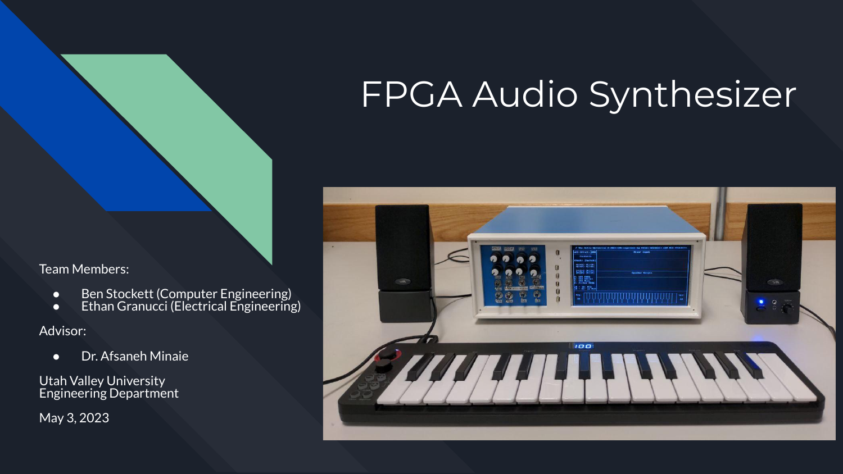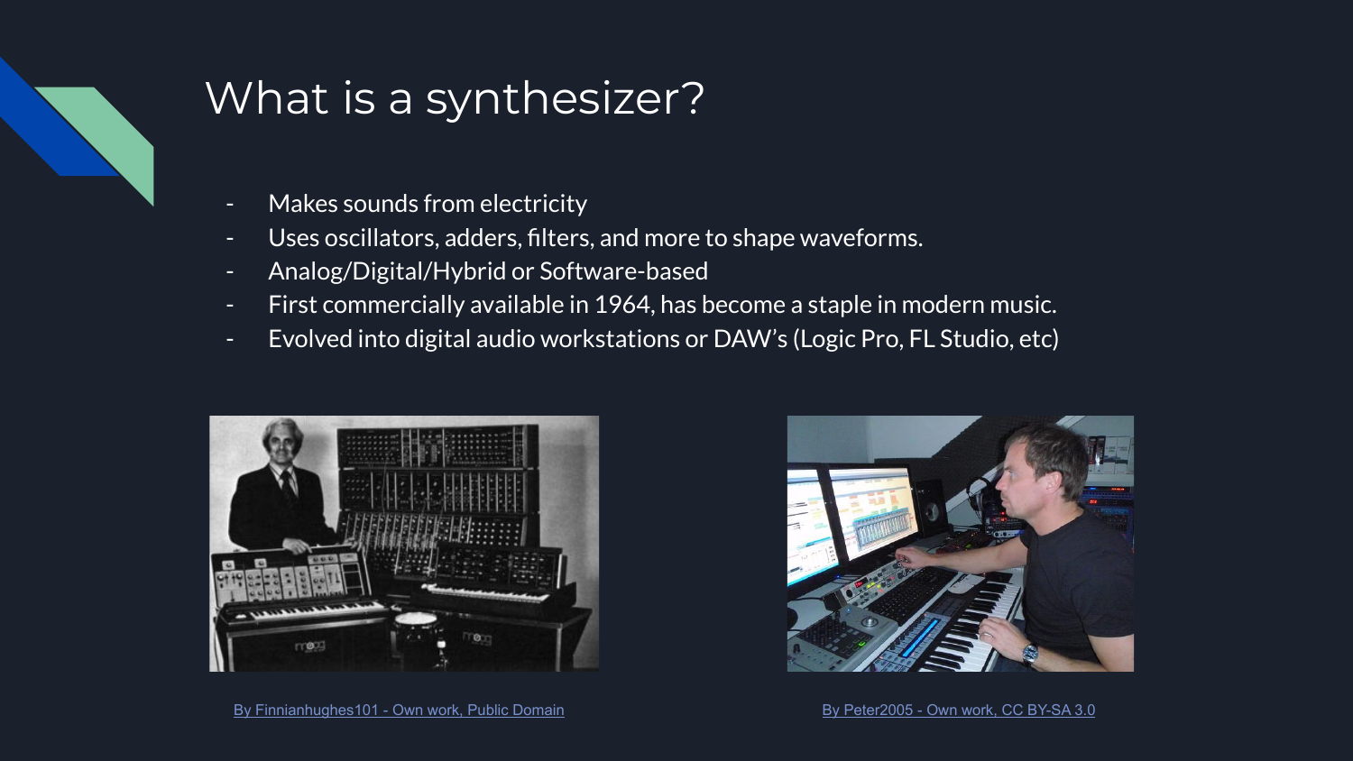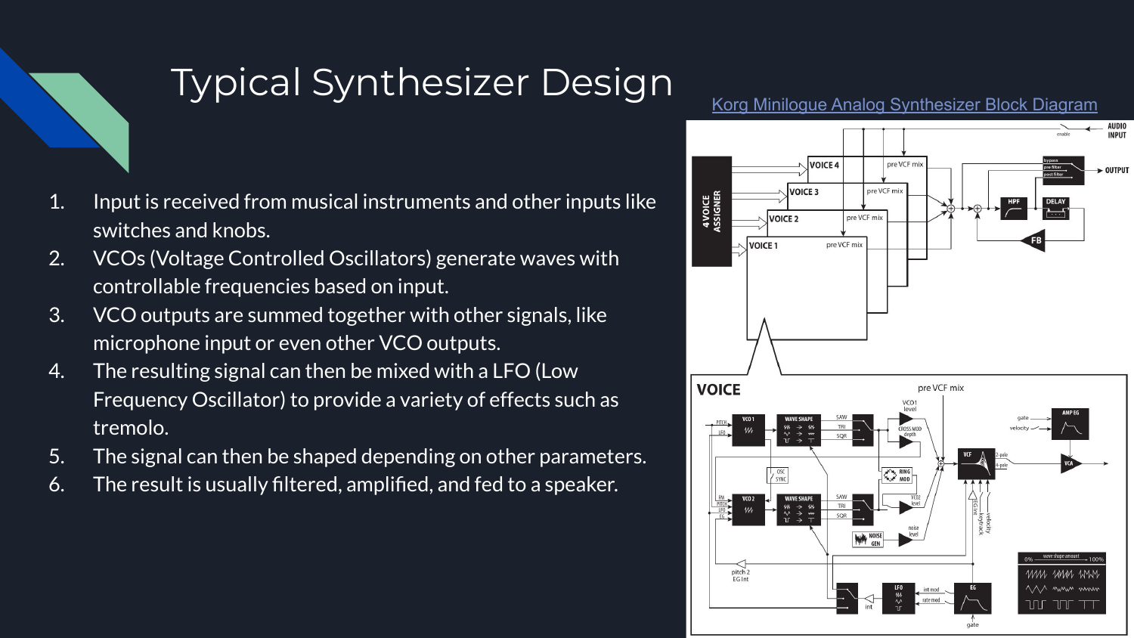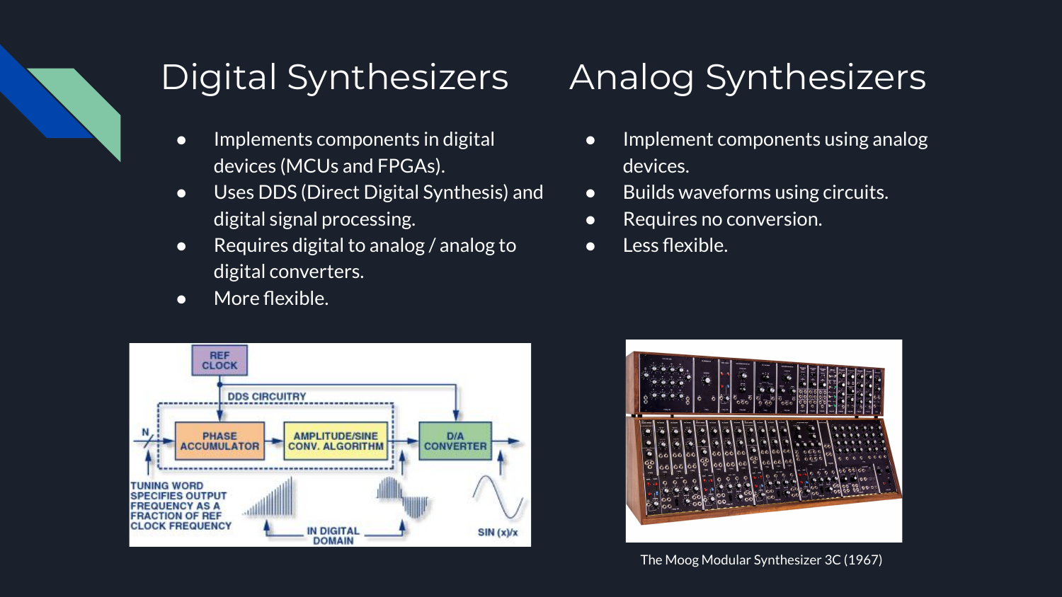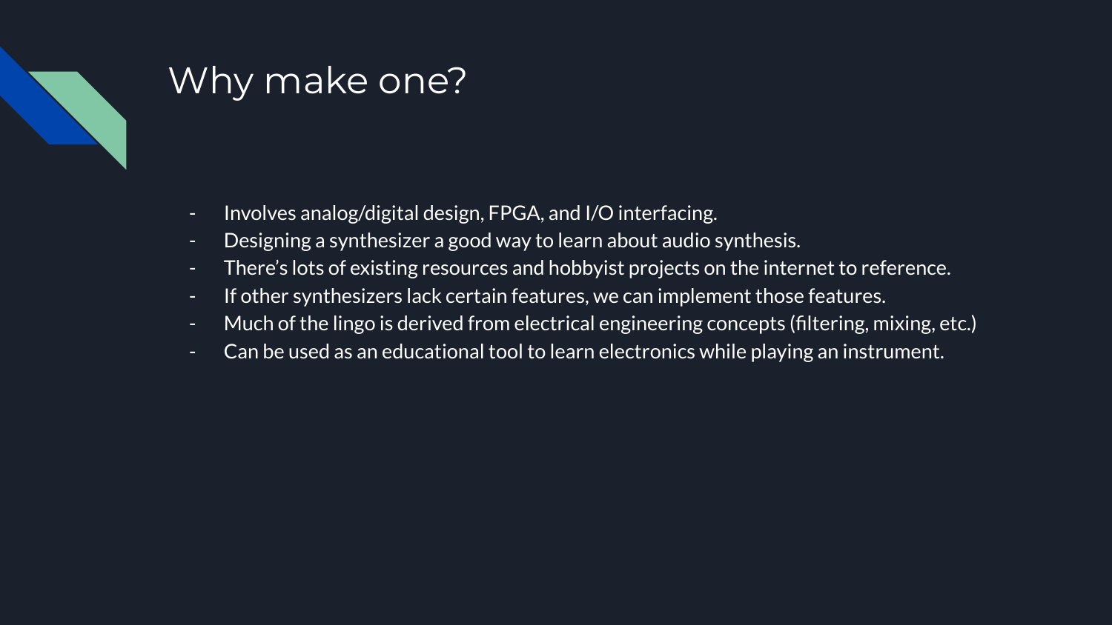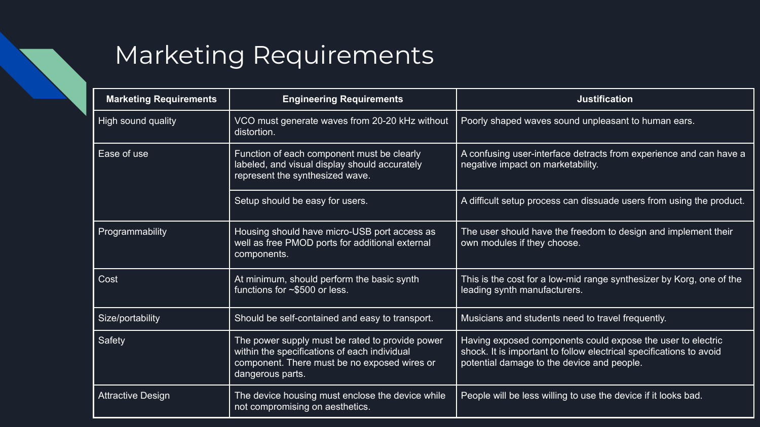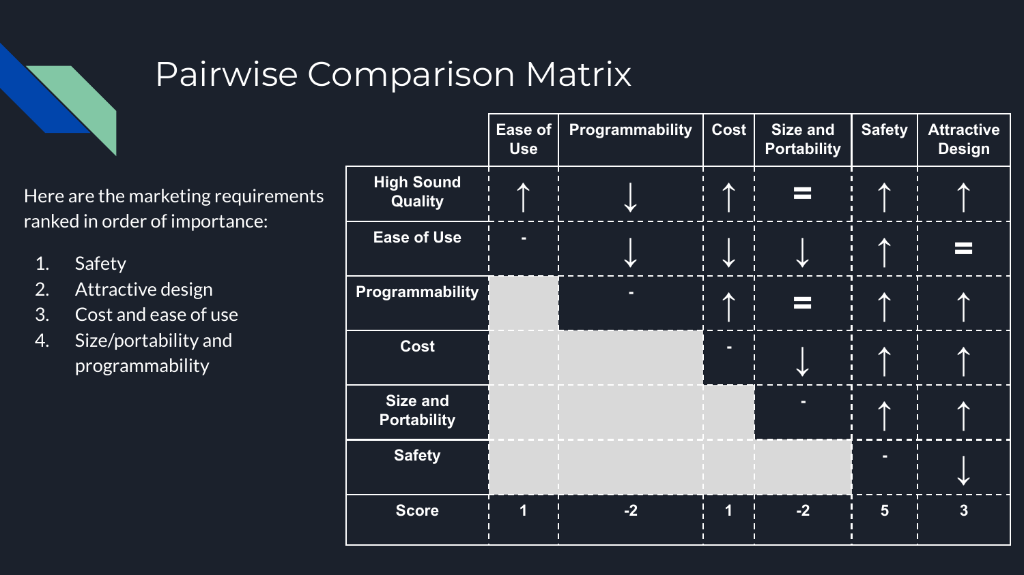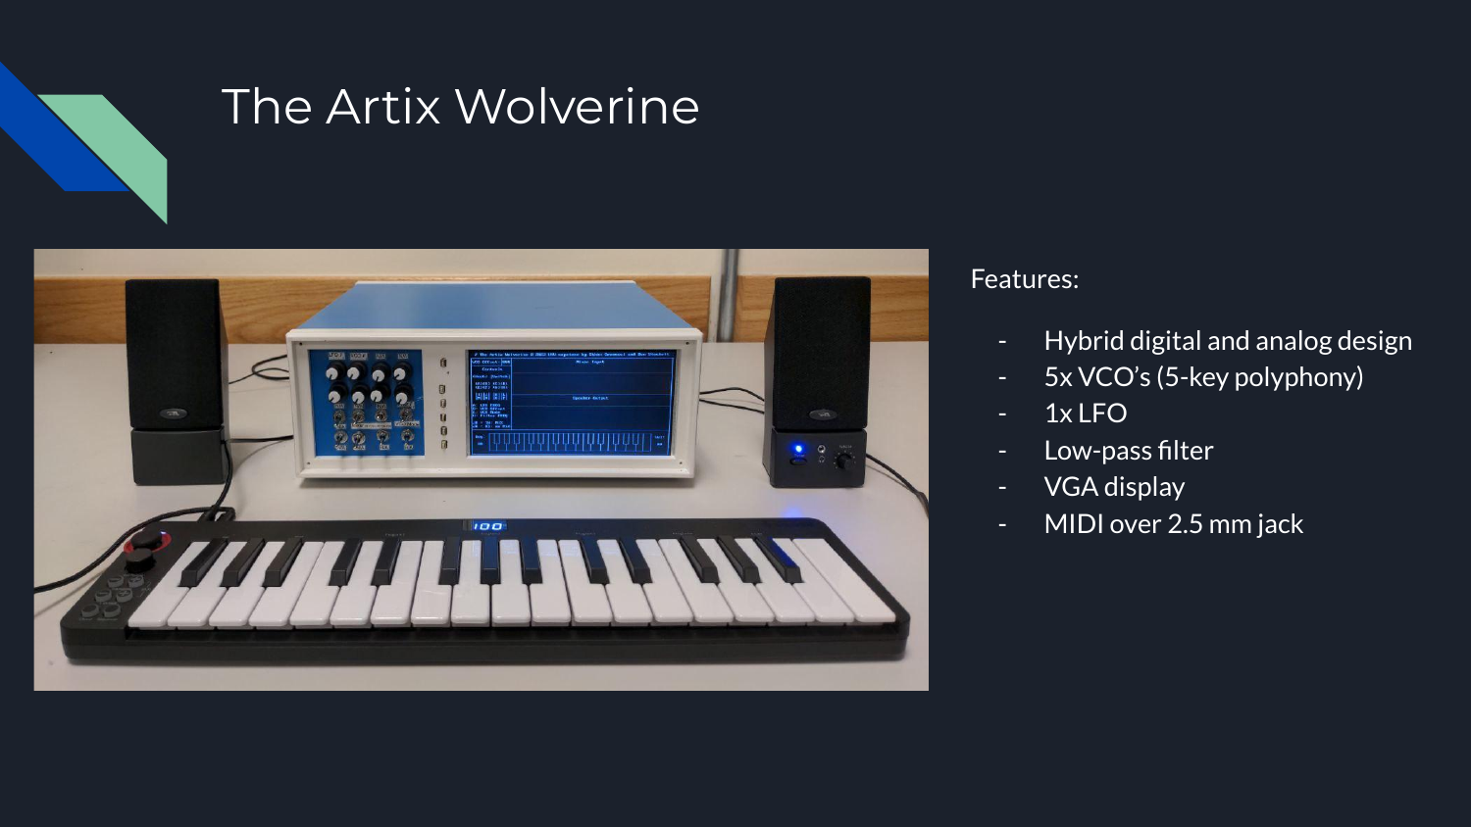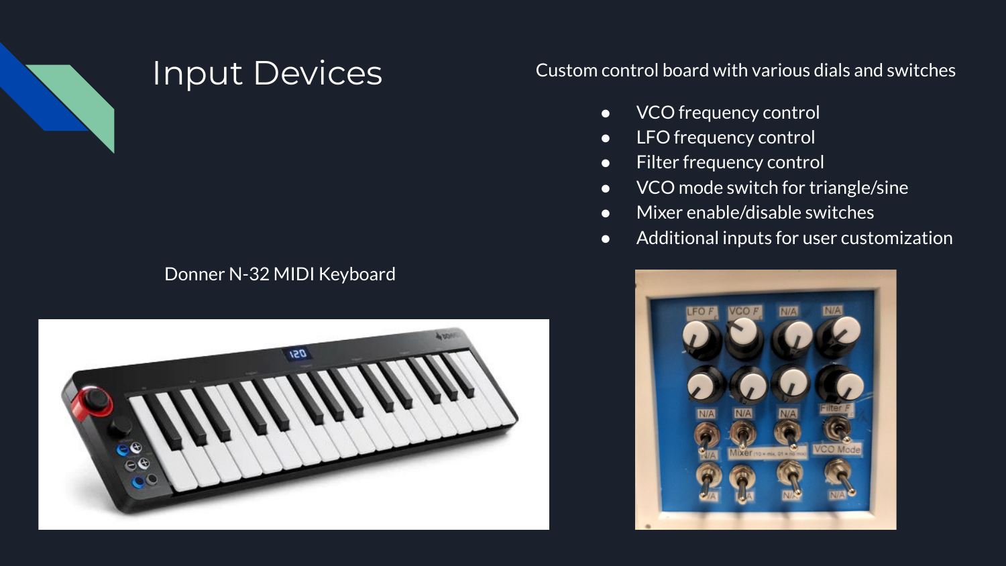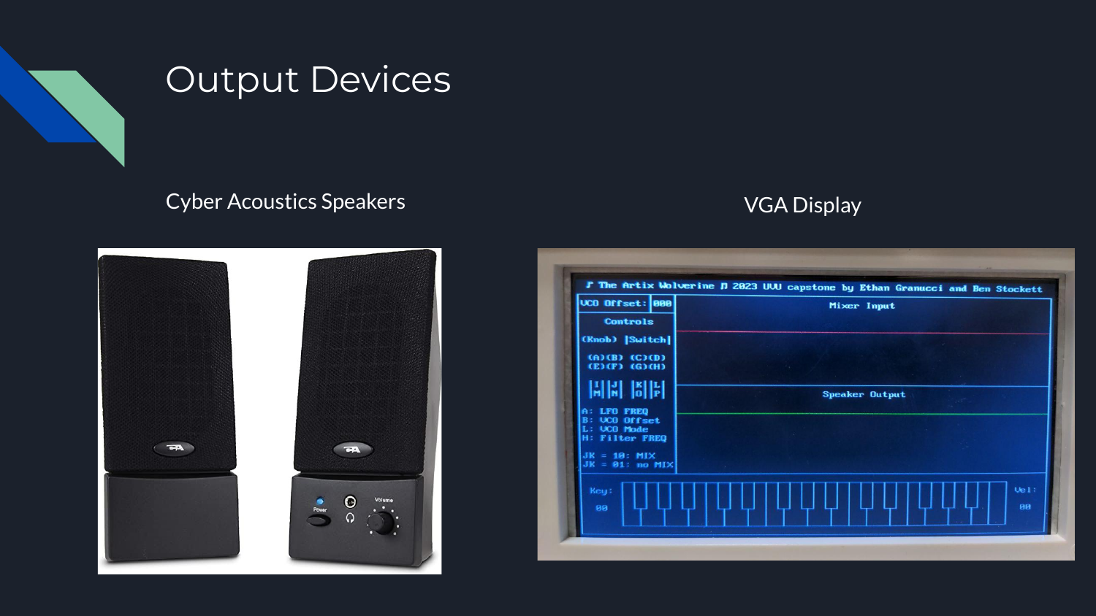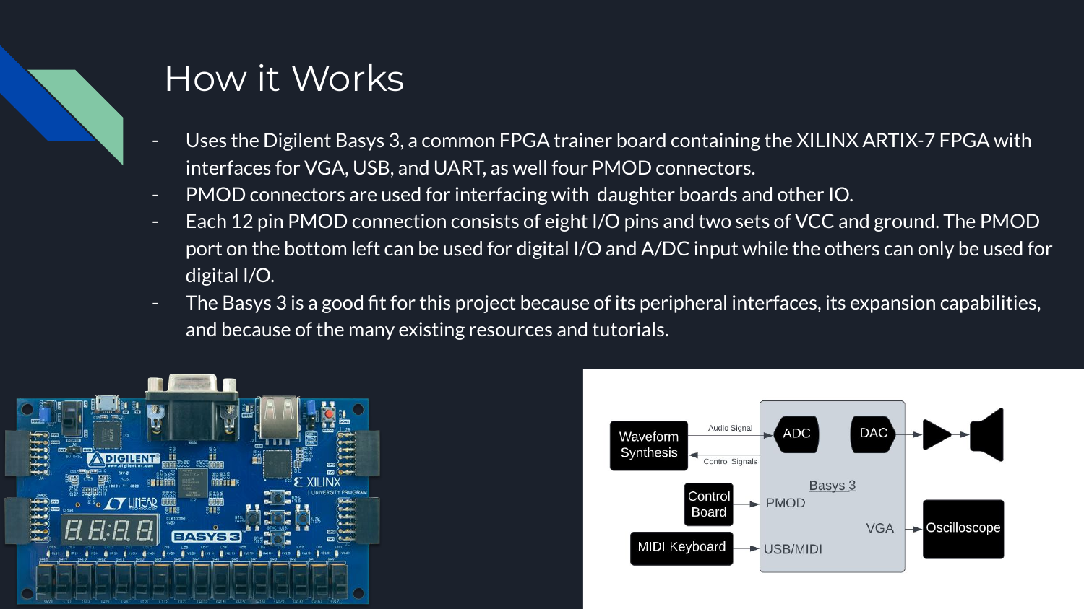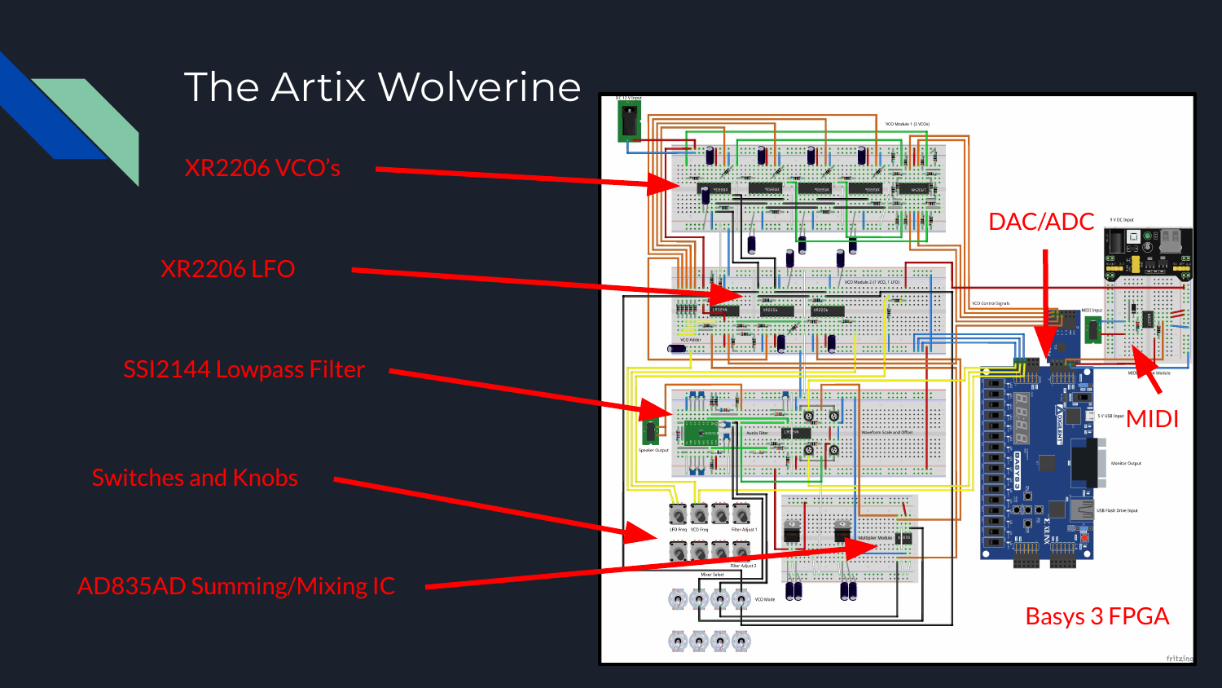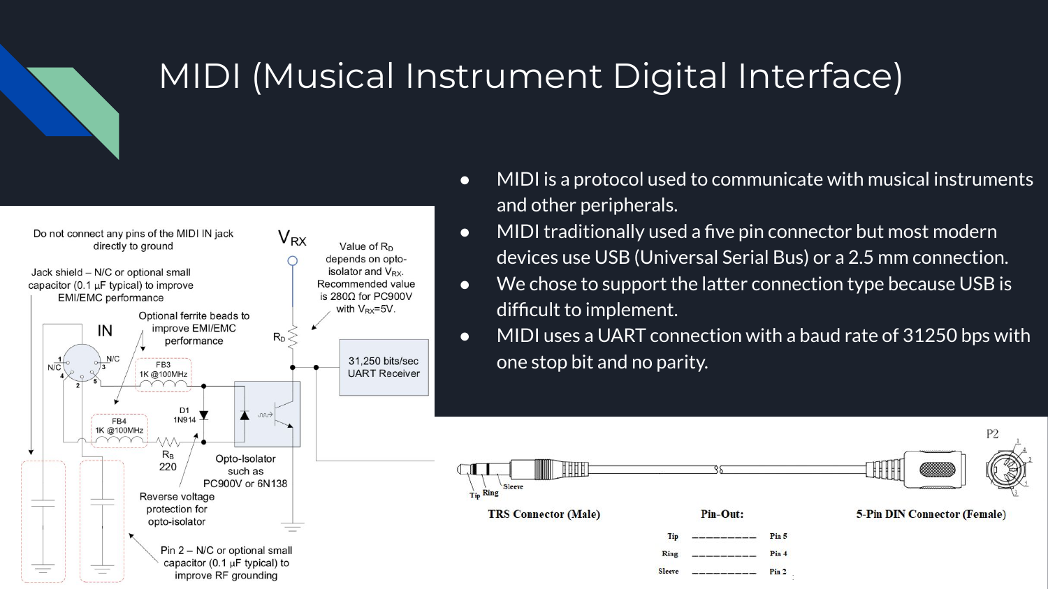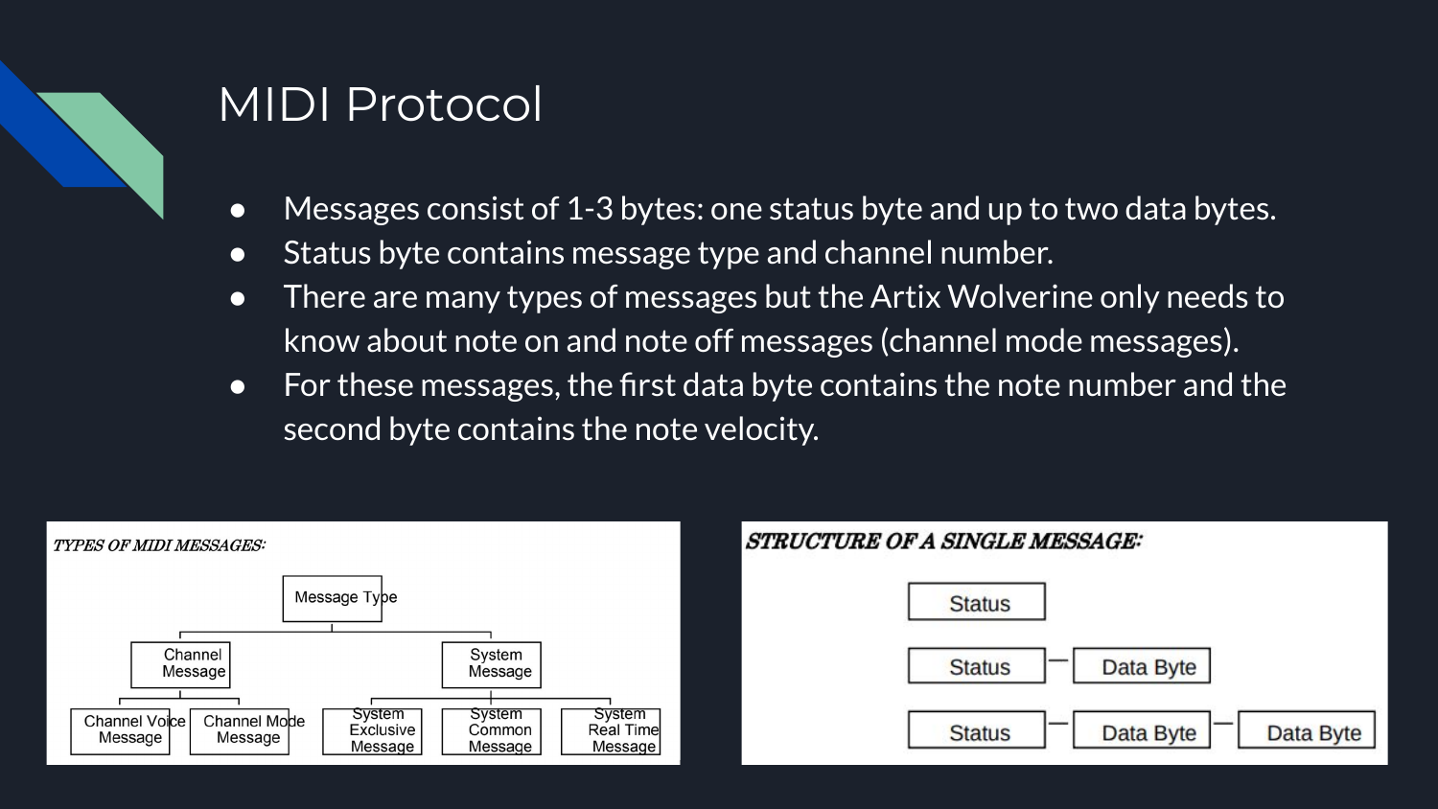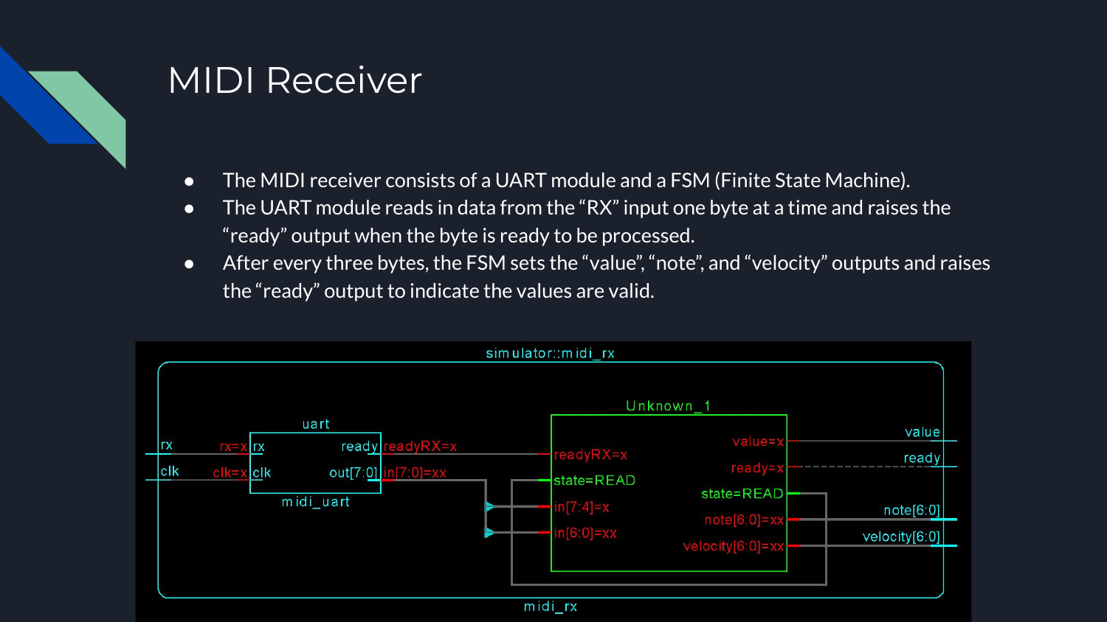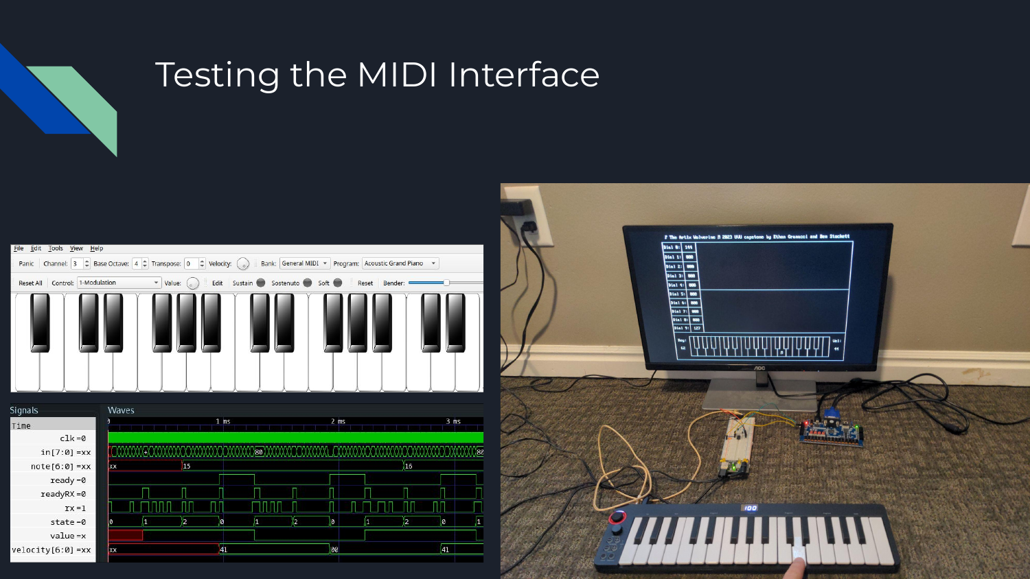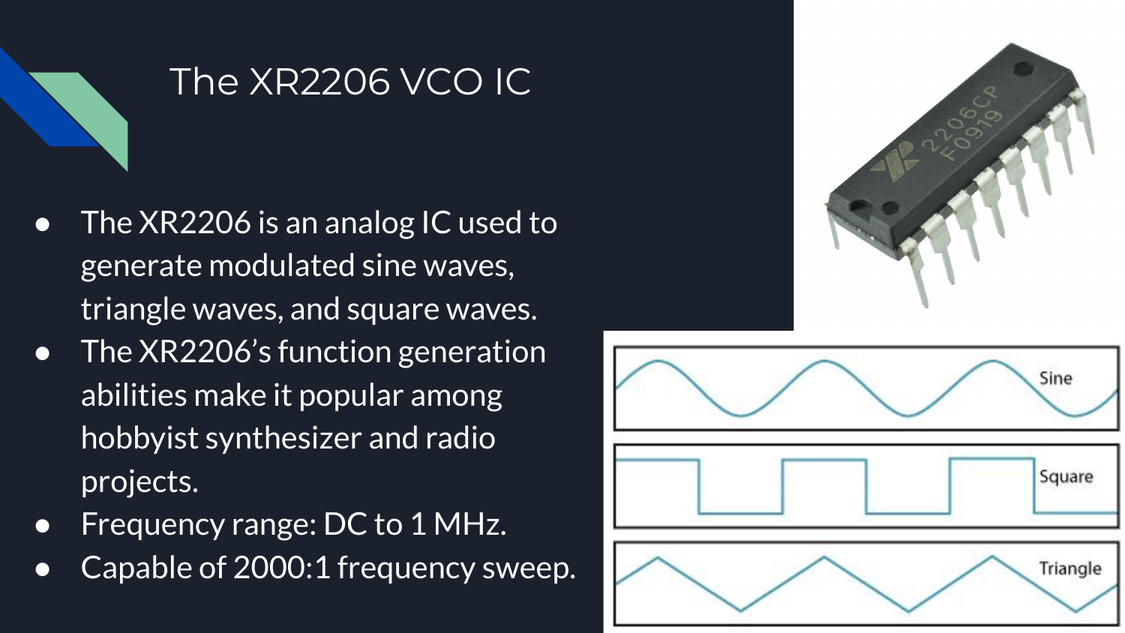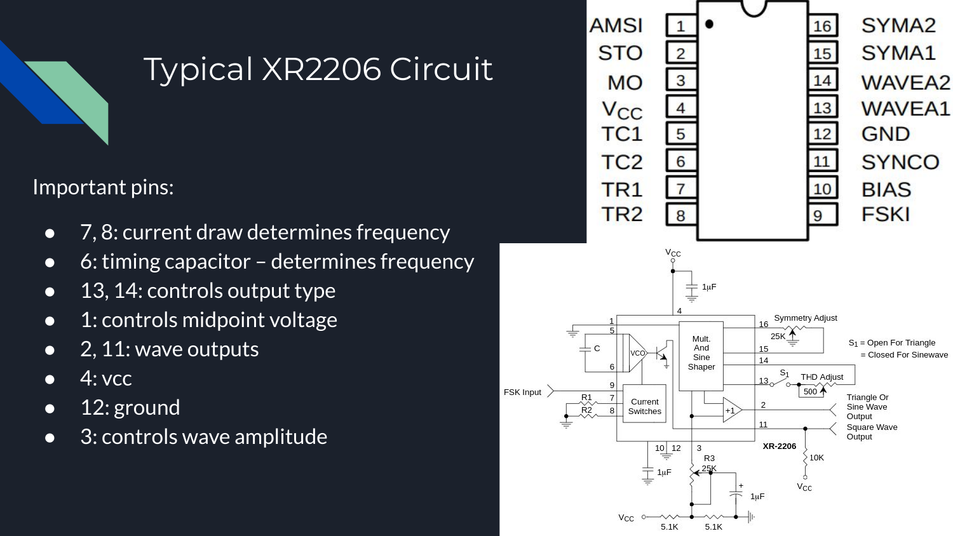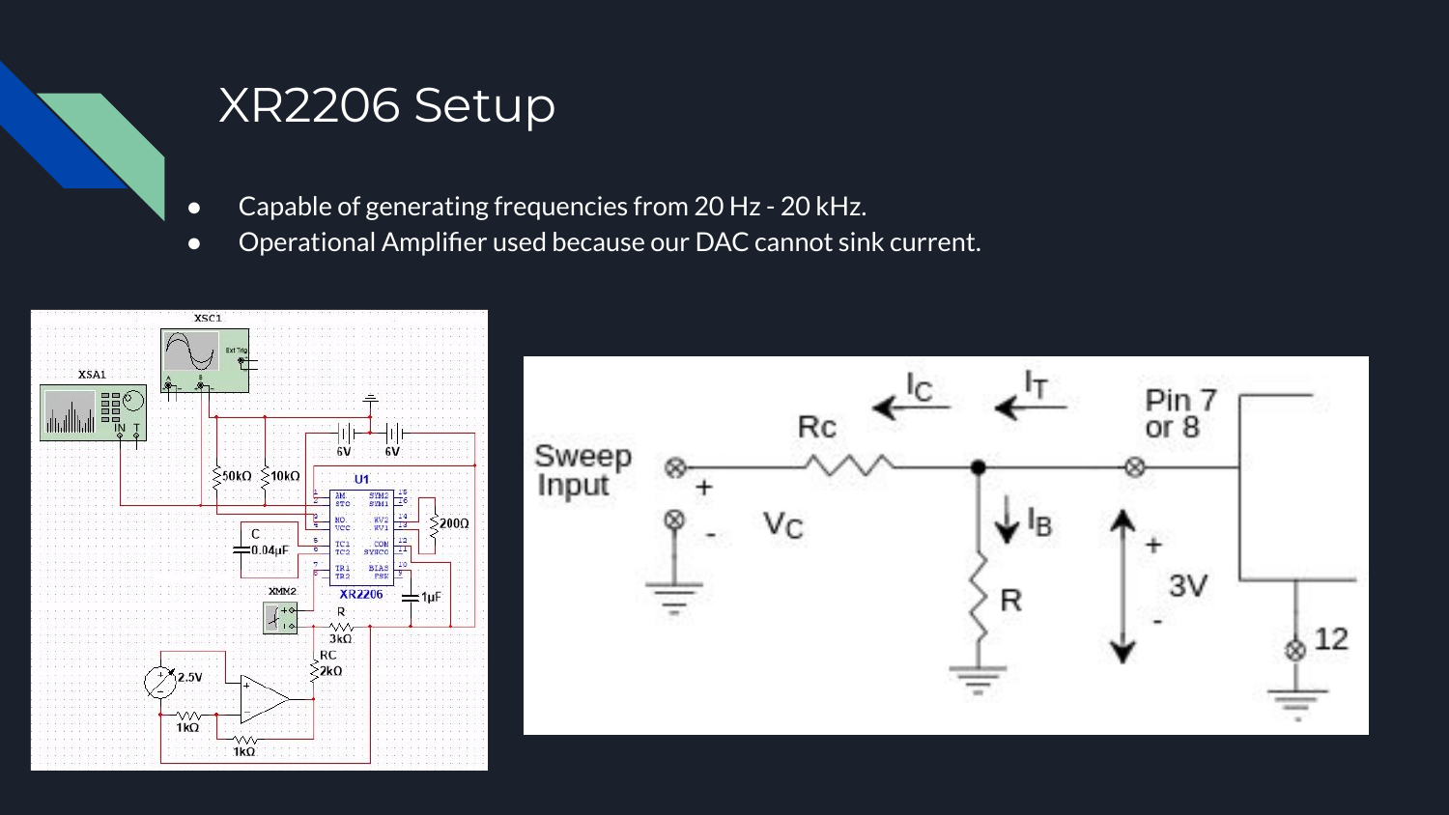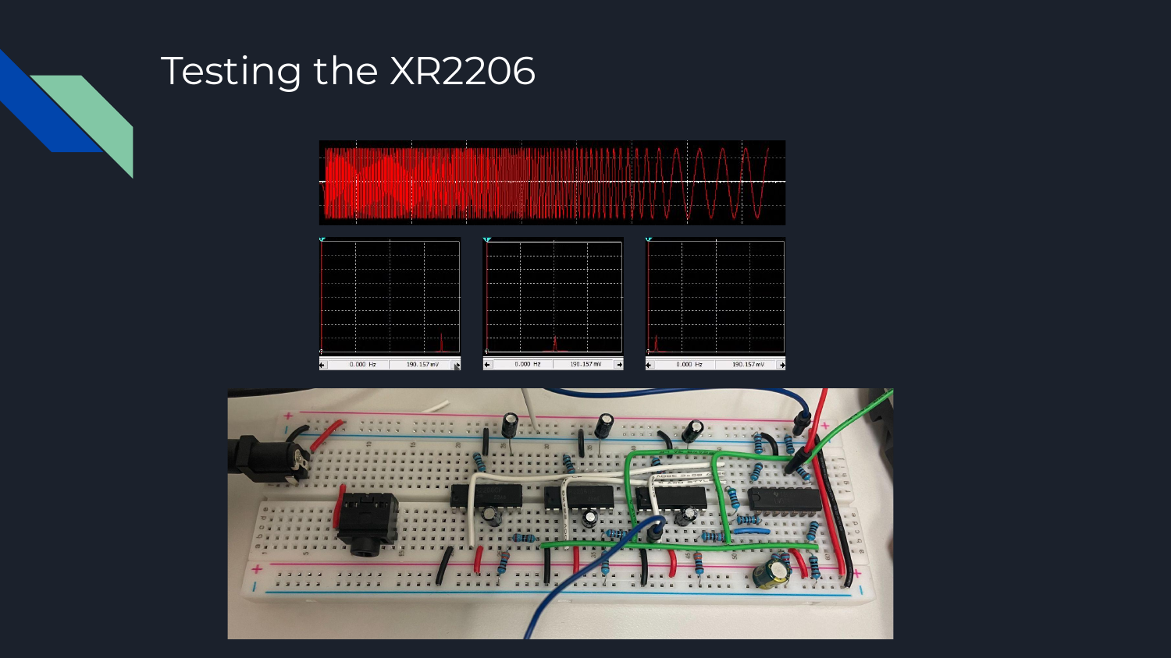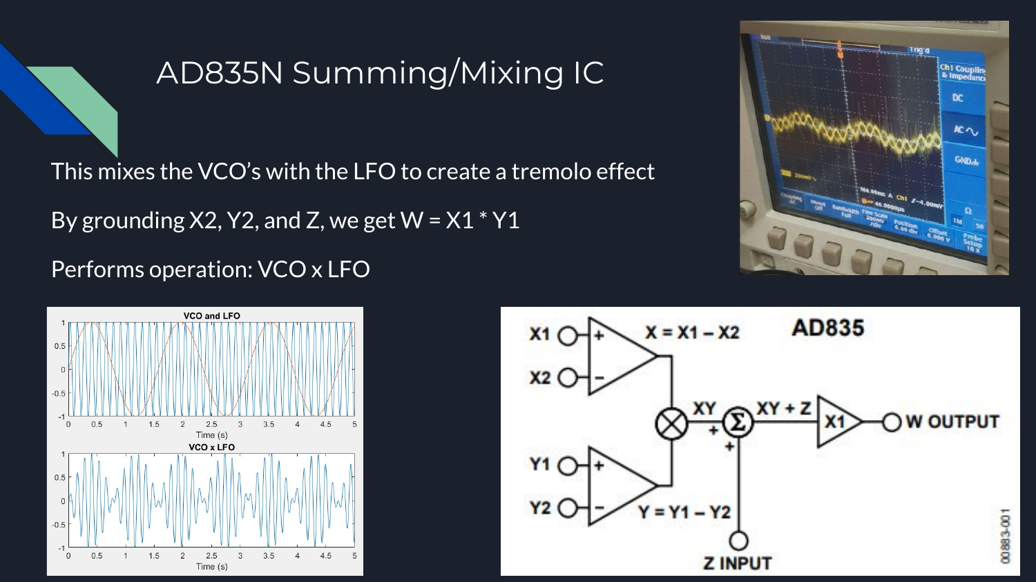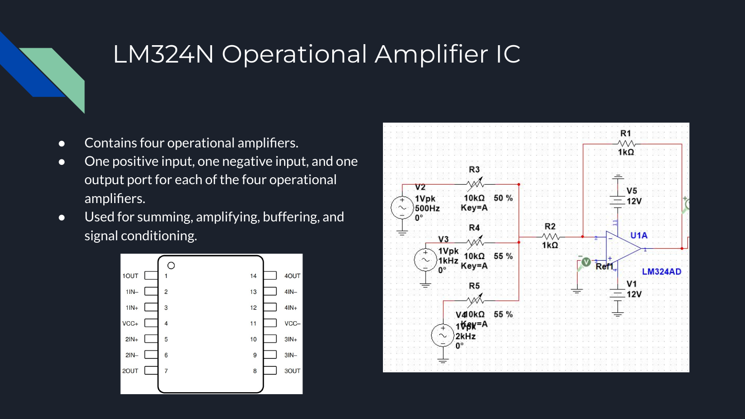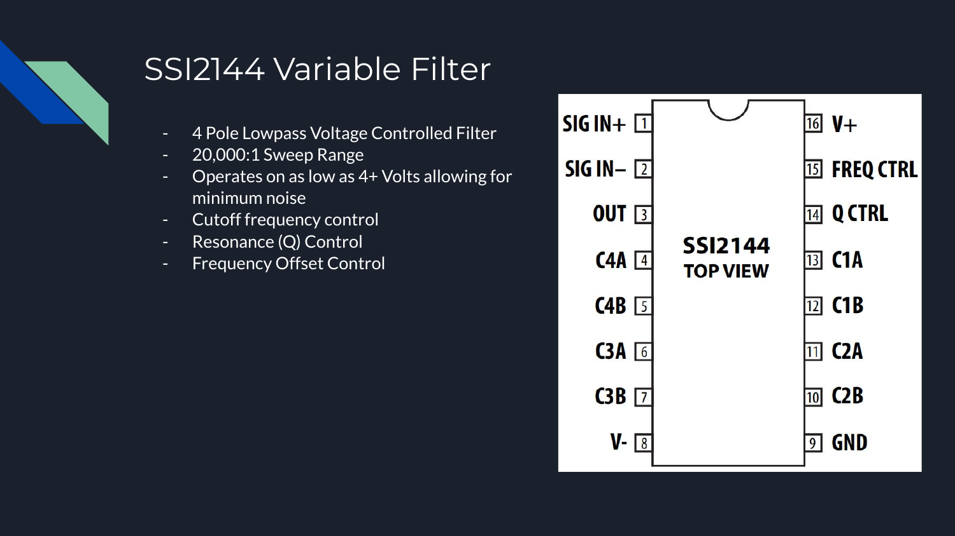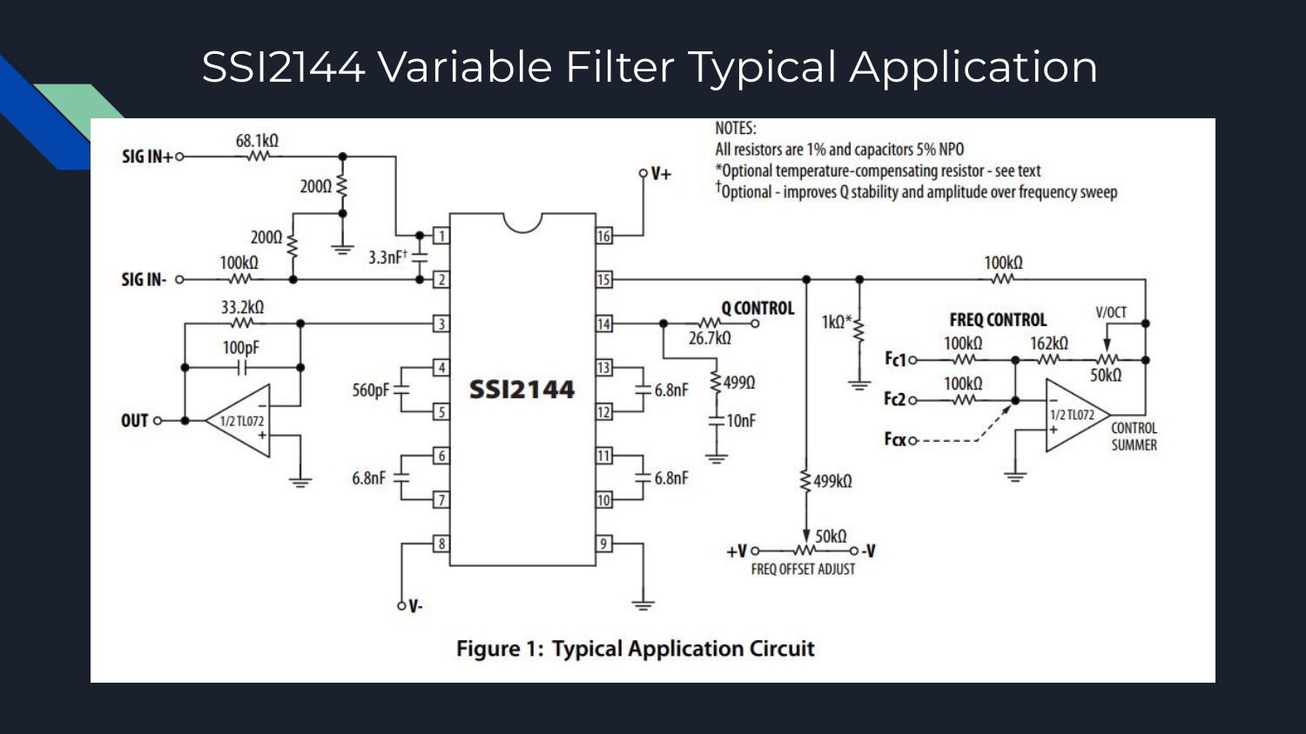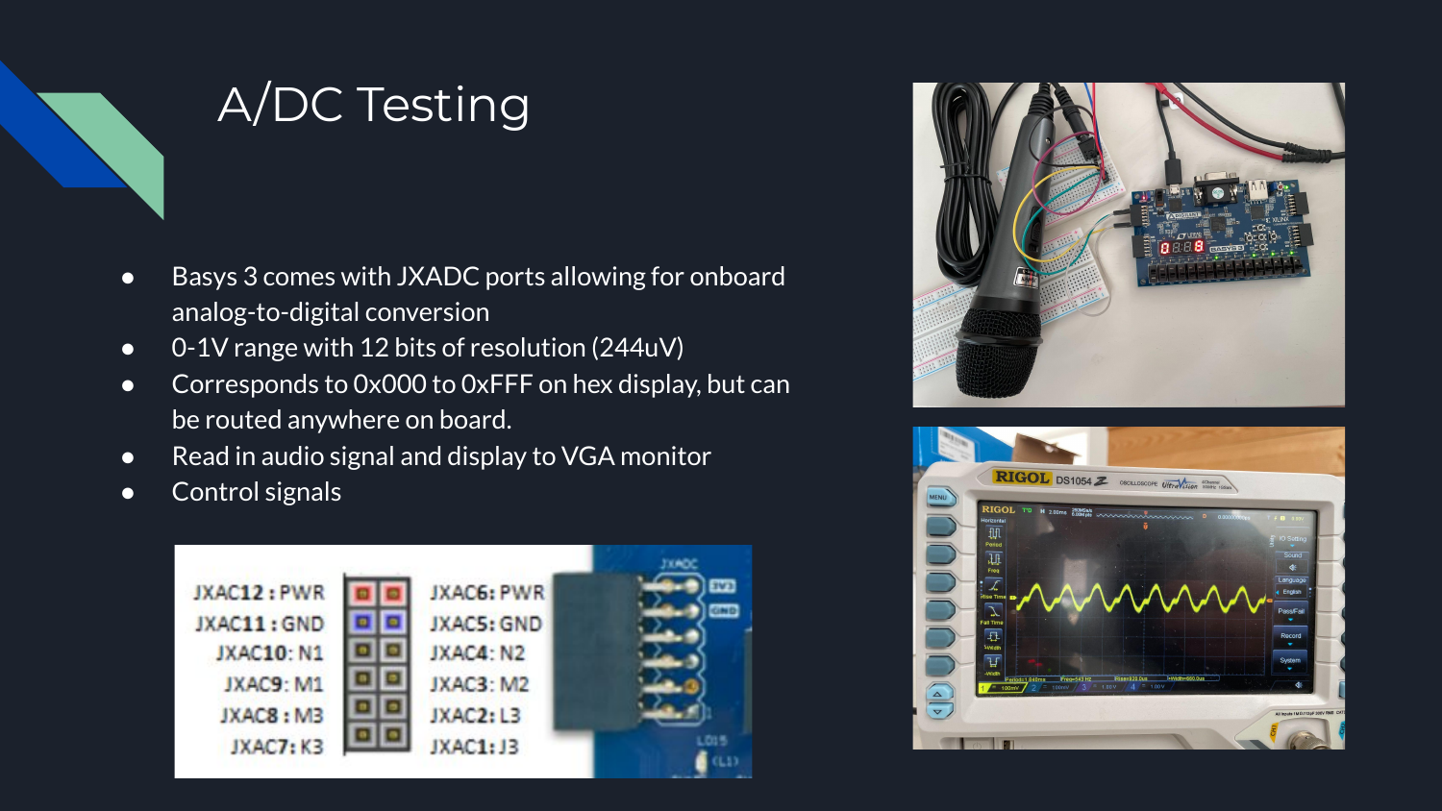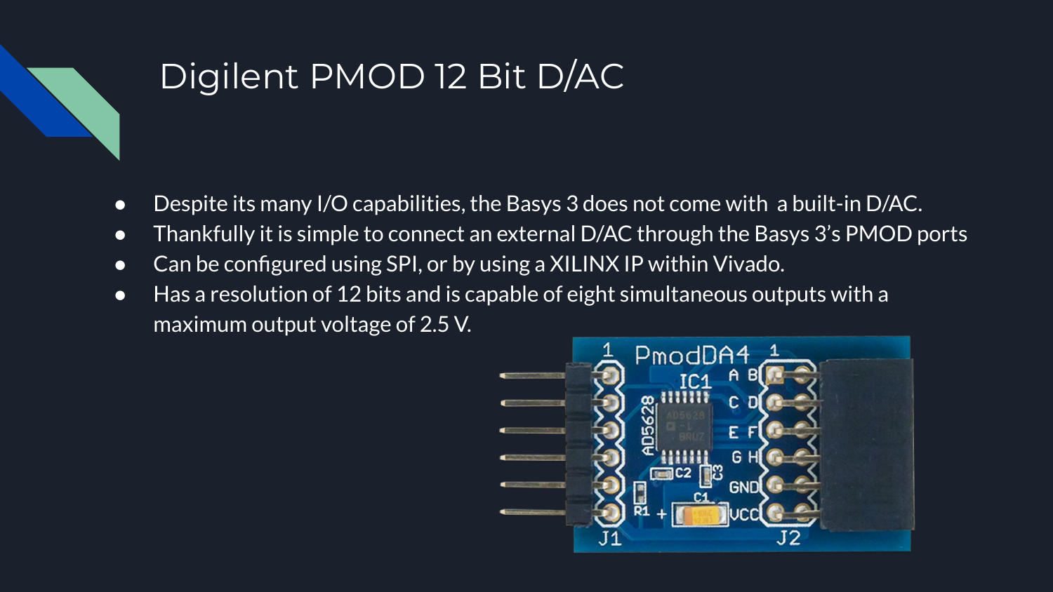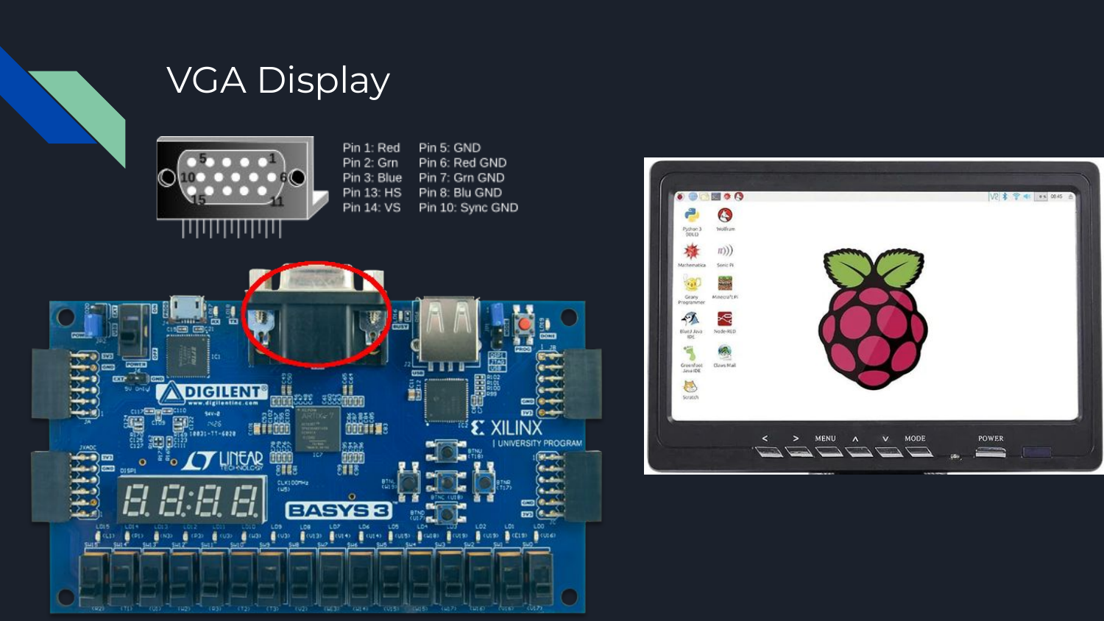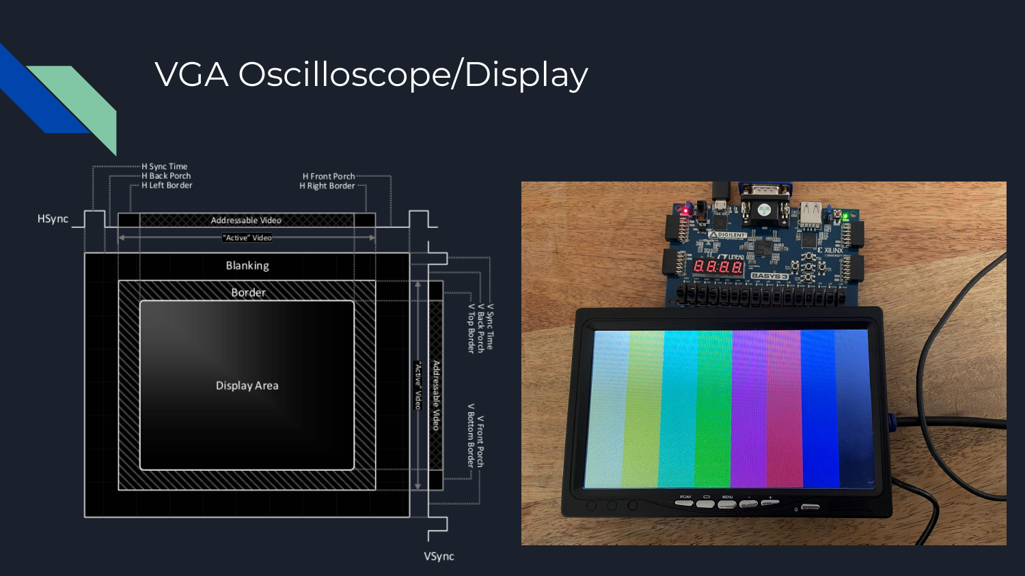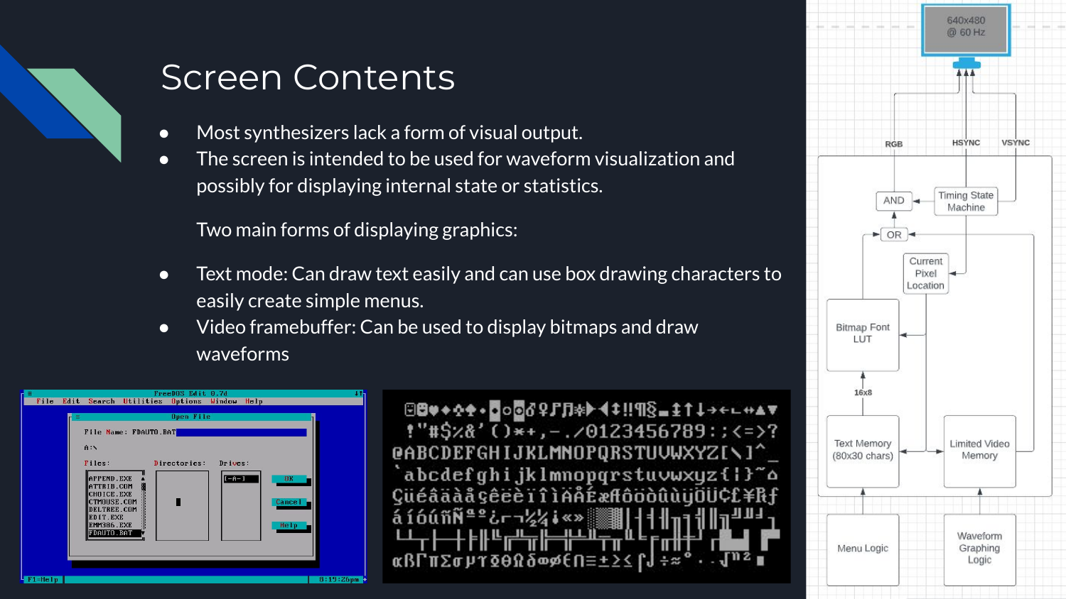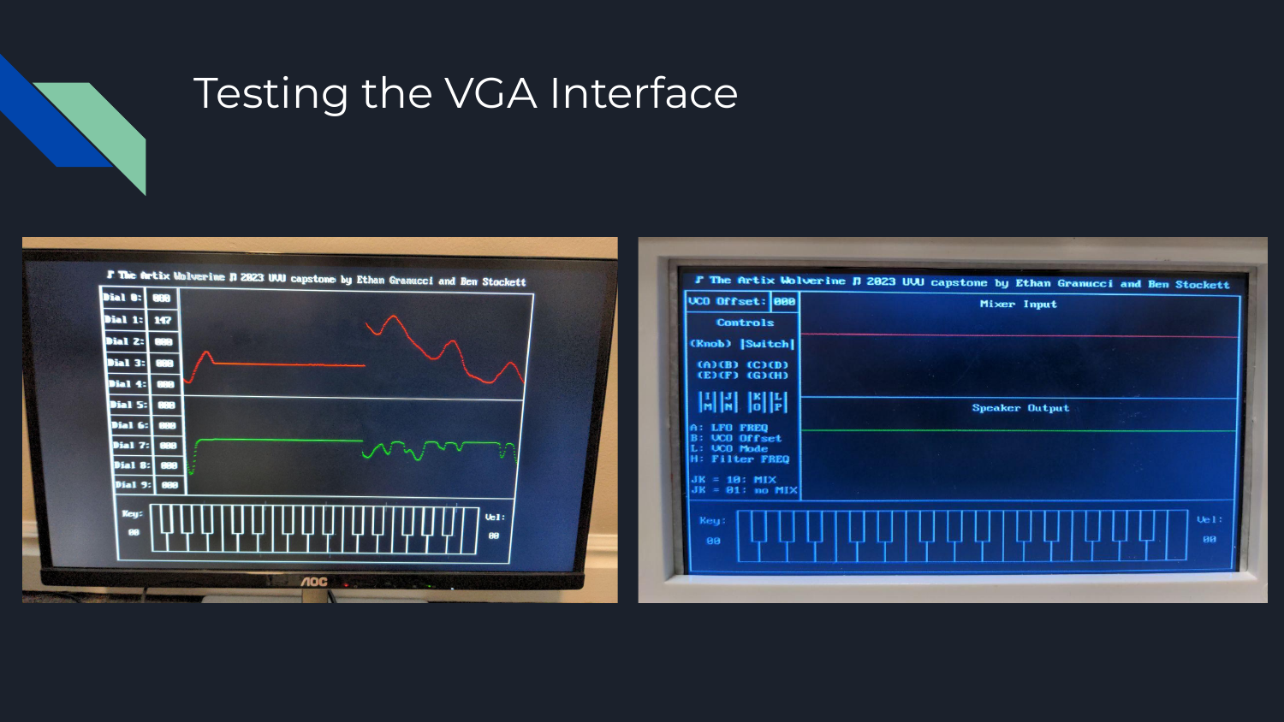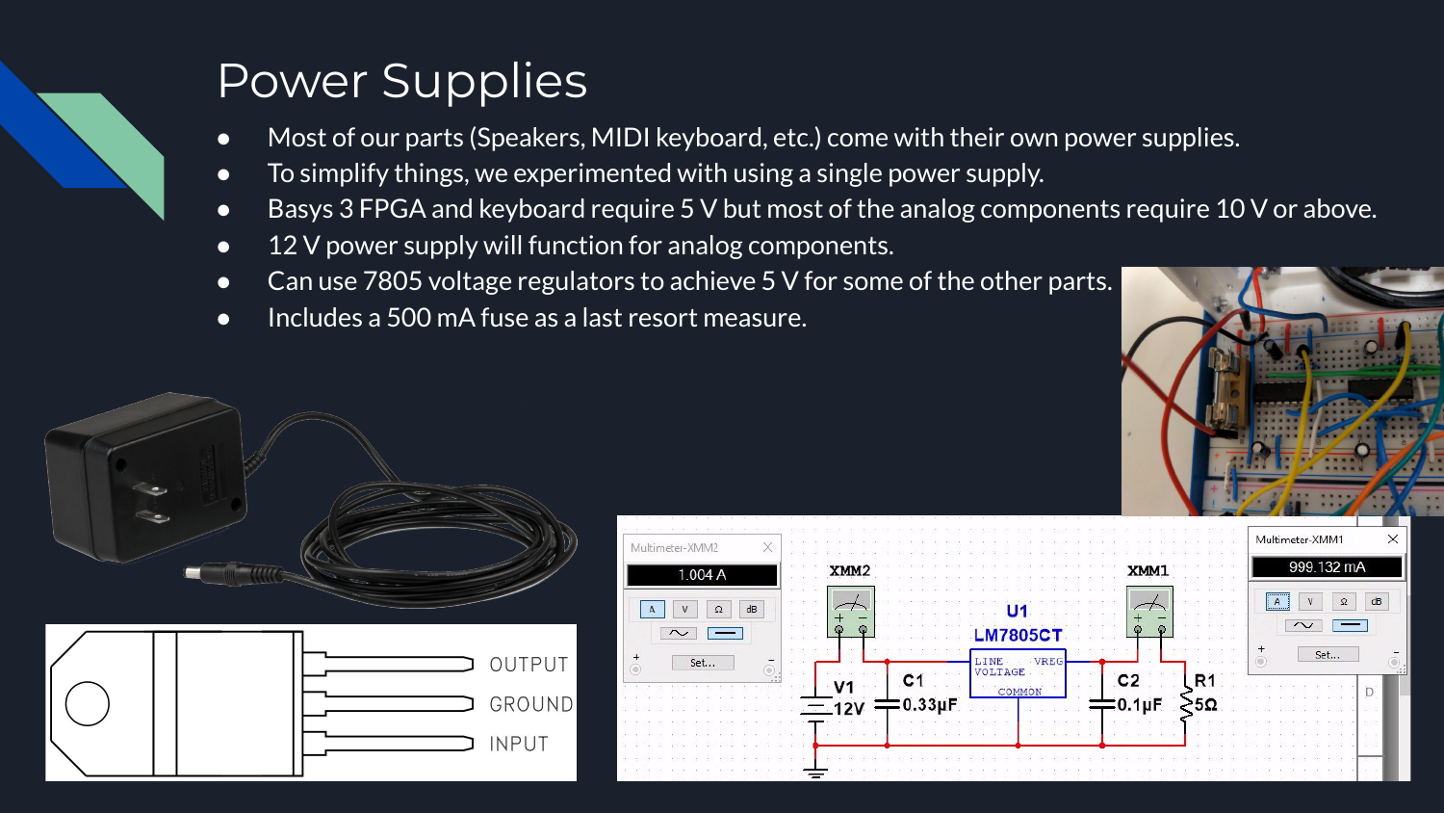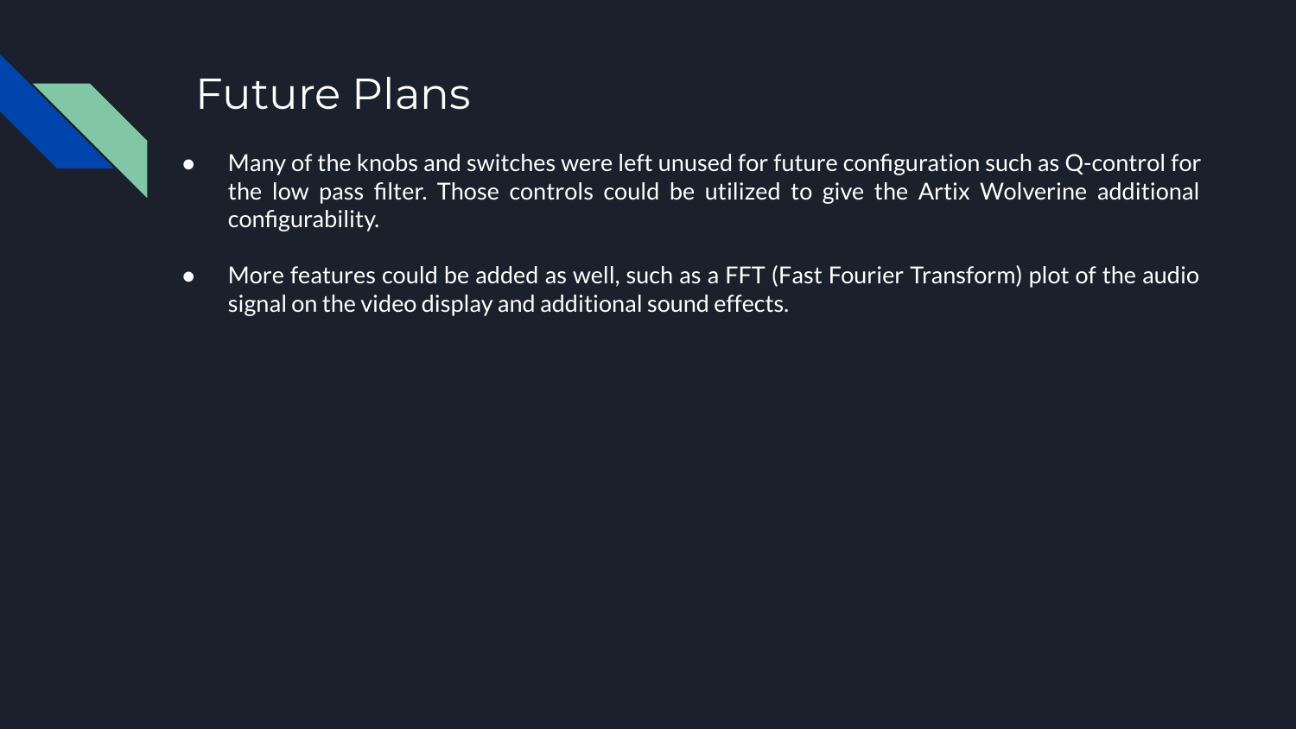

Part Specification
Part | Quantity | Unit Price | Total Price | Notes | URL
Digilent Basys 3 | 2 | $148.95 | $297.90 | One for each of us. | https://www.jameco.com/z/410-183-Digilent-Basys-3-Artix-7-FPGA-Trainer-Board-Recommended-for-Introductory-Users_2283911.html
3.5 mm to BB | 3 | $0.95 | $2.85 | Audio in, audio out, and MIDI in. | https://www.adafruit.com/product/1699
12 bit DAC | 1 | $24.99 | $24.99 | Basys 3 has no built in DAC | https://digilent.com/shop/pmod-da4-eight-12-bit-d-a-outputs
Microphone | 1 | $13.99 | $13.99 |  | https://www.amazon.com/Moukey-Dynamic-Cardioid-Microphone-Handheld/dp/B07SQQ81D6
Speaker | 1 | $8.29 | $8.29 |  | https://www.amazon.com/Cyber-Acoustics-CA2016-2-Piece-Computer/dp/B00006B9WE
Breadboards | 1 | $9.99 | $9.99 |  | https://www.amazon.com/DEYUE-breadboard-Set-Prototype-Board/dp/B07LFD4LT6
130 Wire Jumpers | 1 | $8.99 | $8.99 |  | https://www.amazon.com/RGBZONE-Solderless-Flexible-Breadboard-Raspberry/dp/B07FDY64Q5
Res/Cap kit | 1 | $14.99 | $14.99 |  | https://www.amazon.com/Electronic-Components-Electrolytic-Capacitor-Transistor/dp/B08BF58FWX
Pot/knob kit | 1 | $7.99 | $7.99 |  | https://www.amazon.com/Taiss-Potentiometer-Washers-Different-Aluminum/dp/B0B3126K2M
VGA monitor | 1 | $55.99 | $55.99 |  | https://www.amazon.com/SunFounder-Inch-Screen-Monitor-HDMI/dp/B012ZRYDYY
VGA Cable | 1 | $5.49 | $5.49 |  | https://www.amazon.com/Computer-Laptop-Monitor-Screen-Projector/dp/B088R551DD
VCO/LFO XR2206 | 2 | $4.60 | $9.20 | This listing includes two ICs so four total. | https://www.amazon.com/XR-2206-XR2206CP-XR2206-Monolithic-Generator/dp/B00VIDRZK6
MIDI Keyboard | 1 | $41.99 | $41.99 |  | https://www.amazon.com/Keyboard-Controller-Donner-Velocity-Sensitive-Light-up/dp/B09T6QLR97
LM324N | 4 | $0.49 | $1.96 |  | https://www.digikey.com/en/products/detail/texas-instruments/LM324N/277627
3.5 mm cable | 2 | $1.95 | $3.90 | One for audio out and one for MIDI in. | https://www.sparkfun.com/products/18983
6N137 Opto-Isolato | 1 | $1.05 | $1.05 | To isolate circuit from the MIDI keyboard. | https://www.sparkfun.com/products/15105
Switches Pack | 1 | $7.99 | $7.99 |  | https://www.amazon.com/MTS-101-Position-Miniature-Toggle-Switch/dp/B0799LBFNY
AD835N Mult. IC | 1 | $16.04 | $16.04 |  | https://www.digikey.com/en/products/detail/analog-devices-inc/AD835AN/11532103
SSI2144 VCF | 2 | $6.65 | $13.30 |  | https://www.amplifiedparts.com/products/integrated-circuit-ssi2144-ladder-vcf-sound-semiconductor
IC Sockets | 2 | $0.29 | $0.58 |  | https://www.amplifiedparts.com/products/ic-socket-dual-line-package-254mm-pitch-762mm-spacing
Project Housing | 1 | $50.00 | $50.00 | $3/$0.75 per cubic in depending on quality; $0.25 an hour at UVU. Had to call for pricing. | https://www.uvu.edu/cet/fabrication/printlab/index.html
Voltage Regulator | 4 | $1.05 | $4.20 | To convert 12 V power supply to 5 V. | https://www.sparkfun.com/products/107
2.1 mm DC Adapter Port | 1 | $0.95 | $0.95 |  | https://www.adafruit.com/product/373
12 V AC/DC Adapter | 1 | $8.99 | $8.99 |  | https://www.amazon.com/TMEZON-Power-Adapter-Supply-2-1mm/dp/B00Q2E5IXW
Extension Cord | 1 | $14.99 | $14.99 | To plug in non-circuit parts. | https://www.amazon.com/GE-Outlet-Protector-Extension-14092/dp/B00DOMYL24
Total: | $626.60

