Project 1 distributed computing systems
Made by Cakston Calvin & Lars Vonk

Introduction
In this project we have chosen the assignment to create a “Message exchange system with encryption”. We have chosen this assignment since it aligns well with current interests.
We will try to create a basic application where multiple clients will be able to exchange messages in an encrypted way between client and server and where using web sockets the updated messages will be shown live to all the users.

Design
For this project we have made two initial designs. One for how the network of systems will work. We will be using docker compose for the orchestration of the systems which will exist of 3 parts that are hosted by the orchestration tool and one which is hosted by the client itself. These are the client, the proxy, the server and the database. The server will be replicated and the proxy will be configured to sent requests to the correct server in the cluster.
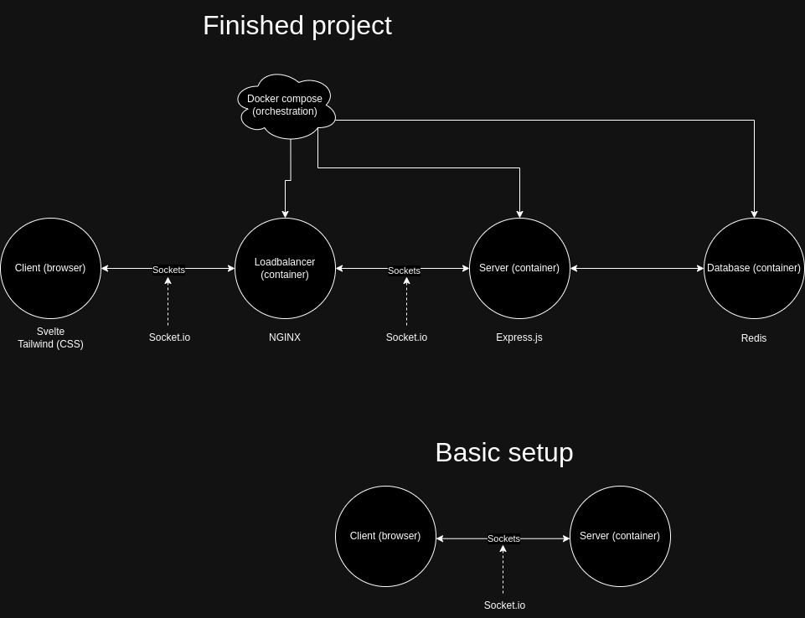

Secondly we have made a simple design how our encryption will work. We have decided to use the most common way of end to end encryption where both parties will create their own public and private key and exchange public keys. These can then be used to encrypt messages to be sent to the other user and decrypted. We will make this work in a group chat where all data will be encrypted in transit and to be decrypted at arrival.
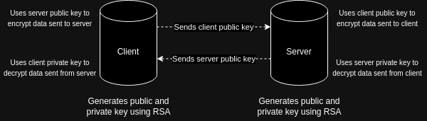
For this project we will be using Svelte for the client, NGINX for the proxy, Express.js for the server and redis for the database. These have been chosen for their simplicity of use but also their flexiblity for our use case. Redis has specifically been chosen to also try it out since SQLite would have also been a good choice and has been considered.

