9 July 2026, 14:00 UTC
Chief Investment Office GWM | Investment Research
Dominican Republic: The rebound has legs, the oil bill has teeth
Emerging market bonds
Authors: Alberto Rojas, Investment Strategist, UBS Financial Services Inc. (UBS FS); Alejo Czerwonko, Chief Investment Officer Emerging Markets Americas, UBS Financial Services Inc. (UBS FS)
- Activity accelerated through the first half: the monthly indicator rose 4.7% year on year in May and 4.2% on average in January-May, near the top of the 4.0-4.5% range we projected for the year — and, on our reading, pointing to a firm second quarter.
- Fiscal delivery has, if anything, improved: the primary balance was already in surplus and ahead of the full-year plan by early June, and — for the first time since 2024 — the authorities passed a revenue package (Law 30-26, about 0.7% of GDP).
- The swing factor is energy. The oil-price spike lifted headline inflation above target and prompted Fitch to move its outlook back to stable from positive; with crude already back near USD 70 and core inflation contained, we treat it as a fading, supply-side story over our 12-month horizon.

Activity: the rebound has legs
As we anticipated in March, 2025 looks to have been the anomaly rather than the start of a trend. The monthly economic activity indicator (IMAE) rose 4.7% year on year in May and averaged 4.2% over January-May, up sharply from 2.7% in the same period of 2025 and broadly in line with the roughly 4.1% pace we estimate for the first quarter. In other words, the economy did not just bounce off a low base early in the year — it carried the momentum into the second quarter, which on the monthly track appears to be running at or slightly above the first.
The composition is encouraging because it is broad. In May, construction led with 7.1% growth — underpinned by a striking 26.1% year-on-year expansion in construction credit through April — while services rose 5.3%, with financial services (+8.2%), professional services (+8.3%) and hotels, bars and restaurants (+6.2%) all contributing. Tourism remains the headline act: the country logged more than 2.6 million non-resident air arrivals in the first quarter, including an unprecedented 900,000-plus in March alone, a tailwind that partly reflects travelers rerouted from Melissa-hit islands late last year. The one soft spot is free-zone manufacturing, down about 4.1% in May on weaker external demand — worth monitoring, but roughly a tenth of value added and not enough to derail the aggregate.
Set against expectations, the Dominican Republic is tracking at the upper half of the consensus range: multilateral and sell-side forecasts cluster around 3.7-4.8% for 2026, and at 4.2% year-to-date with positive momentum we are comfortable holding our 4.0-4.5% call, with risks now tilted modestly to the upside should energy prices continue to normalize.
Figure 1 - Activity carried 1Q momentum into 2Q (IMAE, % y/y)  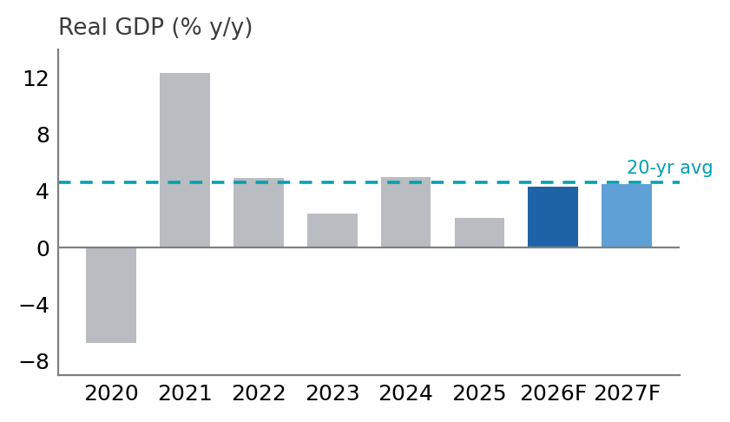  Central Bank of the Dominican Republic, UBS, as of July 2026 (illustrative — refresh from Haver) | Figure 2 - Primary balance running ahead of plan  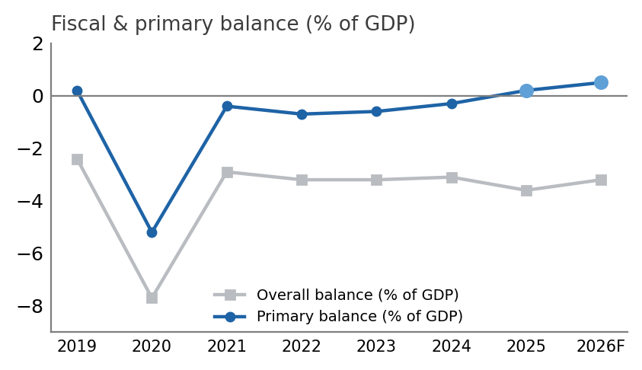  Ministry of Finance, BCRD, UBS, as of July 2026 (illustrative — refresh from Haver)

Fiscal: reform in hand, execution ahead
There may be the occasional volatility in activity, but fiscal metrics remain sturdy as ever — and this year they are running ahead of plan. Through the first week of June the central government had recorded an overall deficit of about RD$64bn, only some 23% of the amount budgeted for the full year, while the primary balance was already in surplus to the tune of roughly RD$63bn — equivalent to about 0.7% of GDP and, remarkably, already 144% of the surplus penciled in for all of 2026. The government closed 2025 with a deficit near 3.6% of GDP and a small primary surplus of about 0.2%; for 2026 the targets are an overall deficit of 3.2% and a primary surplus of 0.5%, both of which we now see as comfortably within reach, with the primary line likely to beat.
The more consequential development is structural. In mid-June the authorities enacted Law 30-26, a modernization package expected to raise around RD$50bn — close to 0.7% of GDP — through a higher tax take, alongside a tax amnesty, the repeal of the microenterprise advance regime, a cut in the real-estate capital-gains rate from 25% to 10%, and roughly RD$18bn a year earmarked for the chronically weak electricity sector. This matters for two reasons. First, it is the first revenue measure to clear Congress since the 2024 attempt was withdrawn — the 'pending assignment' we have flagged for two years is finally being addressed. Second, it was passed under an urgency procedure and framed explicitly as a pre-emptive response to the external shock, a governance signal that plays well with the rating agencies.
Not everything is rose-colored, though. Independent analysts are right that Law 30-26 does not fix the structurally low tax take — revenues still sit in the mid-teens as a share of GDP — so we would characterize it as a meaningful down-payment rather than the comprehensive reform the credit ultimately needs. But a down-payment delivered in a difficult year is more than most regional peers have managed.
Prices: an oil bump the central bank is looking through
Inflation has drifted above the target band, but for the right reasons. Headline CPI rose 5.35% year on year in May, above the 3-5% target, driven almost entirely by fuel pass-through from higher international oil prices; core inflation, at 4.86%, remained inside the band — the classic signature of a supply shock rather than demand overheating. The Banco Central has read it exactly that way, holding the policy rate at 5.25% through its June meeting (with the standing repo facility at 5.75% and the overnight deposit rate at 4.50%) and projecting that headline inflation will moderate through the second half and return to target by the fourth quarter as base effects and the recent pullback in crude feed through.
We are not concerned about a hawkish turn crimping the recovery. Real rates are moderate, the central bank has signaled patience, and — tellingly — private credit is accelerating (up roughly 8.6% year on year), which is consistent with the activity rebound rather than a squeeze. If the disinflation path plays out as the BCRD expects, the more likely policy risk over our horizon is a modest easing bias into year-end that would support 2027, not a growth-dampening tightening.
External accounts — the energy footnote, quantified
On the current account this is still largely a 'nothing to see here' story: we expect a deficit around 2.5% of GDP in 2026, comfortably financed by net foreign direct investment of 3.5-4.0% of GDP. The two external pillars are intact and growing. Remittances reached US$5.17bn in January-May, up 5.4% year on year, and are on track for roughly US$12.2bn for the full year, while tourism receipts are set to exceed US$11.9bn — together dwarfing the merchandise gap. The 1% US levy on outbound remittances enacted in mid-2025 is a modest drag, on the order of US$0.2bn a year, and has not dented the trend.
The wrinkle, again, is oil. The Dominican Republic imports essentially all of its fuel, and the hydrocarbon bill was the single largest import line at US$1.87bn in January-April alone, up 13.1% year on year; over a full year the energy bill typically runs US$4.5-7.5bn, or 3.5-7% of GDP. The central bank's own sensitivity is a useful yardstick: every US$1 per barrel on the reference price adds roughly US$63mn to the import bill, so a US$10 average overshoot would cost around US$634mn and widen the current-account deficit by about 0.48% of GDP. The relevant point for our horizon is that the shock is already reversing — WTI spiked toward US$90 during the Strait of Hormuz episode before falling back to about US$70 following the reopening agreement — so the peak drag on the external accounts is behind us rather than ahead.
Figure 3 - Public debt steady within its multi-year band  [ insert chart from Charts file ]  Ministry of Finance, BCRD, IMF, UBS, as of July 2026 | Figure 4 - Spread widening was energy-led; retraces as crude falls  [ insert chart from Charts file ]  JP Morgan, Bloomberg, UBS, as of July 2026

Debt holding its ground
A country running primary surpluses on robust nominal growth offers a stable foundation for its debt, and the Dominican Republic is no exception. Non-financial public sector debt stood at about 49.3% of GDP as of March 2026, within the 47-49% band of recent years, and we expect it to hold there in 2026 — with the passage of Law 30-26 and a firmer peso offering scope for a slight decline over the medium term. Market access remains excellent: in February the sovereign printed US$2.75bn across eight- and twelve-year tranches and, for the first time, a US$750mn green bond at 6.70%, extending the curve without straining the metrics.
Ratings: the upgrade path pauses, not closes
The ratings picture is the one place the oil shock left a mark. S&P holds the sovereign at BB (stable) and Moody's at Ba2 (stable), but in May 2026 Fitch moved its BB- outlook back to stable from positive. Importantly, Fitch framed this as removing a near-term upgrade bias, not signaling distress: it flagged the Dominican Republic as the most exposed of its BB peers to the oil shock, with the heaviest import reliance, the least policy flexibility and the thinnest buffers. We read the strong fiscal execution and the passage of Law 30-26 as partial offsets, and would expect the positive bias to be restored once energy prices and inflation normalize — the swing factor for the eventual move to investment grade remains, as ever, the revenue side of the ledger.
Politics — continuity, and a reform delivered
President Luis Abinader's approval has held in the mid-50s, and the administration used that political capital to push Law 30-26 through Congress under an urgency procedure — a notable contrast with the 2024 episode, when a broader reform was withdrawn amid public backlash. With roughly two years left in the term and no imminent electoral catalyst, we see governability and policy continuity as underpinning the credit; the reform's execution and the direction of the electricity-sector overhaul are the developments worth watching from here.
Investment implications
Dominican US-dollar sovereigns returned roughly 13% in 2025, outperforming the average BB issuer, and the fundamental narrative into 2026 is intact to marginally better: growth is running at the upper half of expectations, the primary balance is ahead of plan, a revenue reform is finally on the books, and market access is excellent. The first-quarter spread widening to about 221bps — some 52bps wider on the quarter — was driven by the global energy shock rather than a change in fundamentals; with crude retracing toward US$70 and the Fitch action now in the price, we would expect the energy risk premium embedded in the spread to fade over our horizon, and note that DomRep has historically traded around 30bps inside the BB median. Key risks remain external and familiar: a renewed spike in oil, adverse weather, the incremental drag from the US remittance levy, and the path of global rates. For bond-specific recommendations, see our Weekly Emerging Markets Bond List.
NEEDS ALBERTO — house-view calls before distribution
• Asset-class preference (12-mo): confirm Attractive / Neutral / Unattractive for DomRep USD sovereigns.
• Spread view: do you want to frame ~221bps as an entry level on the 'energy premium fades' thesis, and against which curve points?
• Growth: keep 4.0-4.5% (risks up) or nudge the range given the 4.2% YTD run-rate?
• Confirm you're comfortable characterizing Law 30-26 as a 'down-payment, not the full reform' — tone check.

What changed since the March note
• Growth confirmed and broad: IMAE +4.7% y/y May, +4.2% avg Jan-May (vs 2.7% a year earlier); 2Q holding up.
• NEW: Law 30-26 fiscal reform passed mid-June (~0.7% of GDP) — reverses the 'revenue reform pending' narrative.
• NEW: Fitch moved BB- outlook to STABLE from positive (May) on oil-import vulnerability — corrects the 'emerging star' line.
• Fiscal execution ahead: primary surplus ~144% of full-year plan by early June (~0.7% of GDP).
• Energy shock peaking and reversing: WTI ~US$90 → ~US$70 post-Hormuz; headline CPI 5.35%, core 4.86% (in target); rate held 5.25%.
• External math: hydrocarbon imports US$1.87bn Jan-Apr (+13.1%); BCRD sensitivity ~US$63mn/bbl, ~0.48% of GDP per US$10 overshoot.
• Remittances US$5.17bn Jan-May (+5.4%), FY ~US$12.2bn; tourism receipts FY >US$11.9bn.

Risk information (abridged — full CIO appendix attaches on final)
This publication is for your information only and is not intended as an offer, or a solicitation of an offer, to buy or sell any investment or other specific product. It does not constitute a personal recommendation or take into account the particular investment objectives, financial situation or needs of any specific recipient. All information and opinions as well as any forecasts, estimates and prices are current as of the date of this report and subject to change without notice. Past performance is not a guarantee of future results. Prepared by UBS Financial Services Inc. (UBS FS). The full standard CIO 'Global asset class preferences' definitions, Risk Information and country disclaimers from the approved template attach to the final version.

