COMPENSATION ALIGNMENT REQUEST — SUPPORTING EVIDENCE
What UBS pays for this seat
Alberto Rojas · Senior Emerging Markets Strategist, Executive Director · CIO Americas · September 2026

1. The three facts
UBS DOL FILING · FEBRUARY 2026 · CASE I-200-26047-642808
$175,000
Base salary UBS attested for a Director, Emerging Markets Strategist, New York — one rank below Executive Director, in my own specialty. My ED base is $180,000. The difference is $5,000 (2.9%).

UBS DOL FILING · DECEMBER 2020 · CASE I-200-20356-972064
$250,000
Base salary UBS attested for an Executive Director, Investment Strategist, New York — five years and roughly 20% of cumulative inflation ago. This is the figure I am requesting.

UBS'S OWN PUBLIC JOB POSTINGS · CIO · NEW YORK · 2025
$170K – $250K
Posted ranges for Executive Director Fixed Income Strategist ($170K–$245K) and US Senior Economist ($200K–$250K) in the CIO. $180K sits in the bottom quarter of the ED range.

2. UBS's own Department of Labor filings
Before sponsoring an H-1B employee, an employer must file a Labor Condition Application with the US Department of Labor stating the base wage it will pay. These filings are public record. Every row below is a filing by UBS Financial Services Inc for a New York worksite; the case number identifies the individual DOL record.

2a. Executive Director filings (all)
Title as filed by UBS | Base salary | Filed | Start | DOL case number
Executive Director, Investment Strategist | $250,000 | 12/21/2020 | 06/18/2021 | I-200-20356-972064
Executive Director, Investment Strategist | $250,000 | 12/22/2020 | 06/18/2021 | I-200-20357-975460
Executive Director, Sustainable & Impact Investing Strategist | $225,000 | 03/25/2025 | 09/15/2025 | I-200-25084-802134
Executive Director, Asset Allocation Strategist | $200,000 | 04/17/2025 | 10/01/2025 | I-200-25107-876910
Executive Director, Investment Strategist | $175,000 | 06/29/2020 | 07/08/2020 | I-200-20181-686000
Rows 1 and 2 are two filings for the same $250,000 role one day apart (an original and an amendment) and should be read as one data point.

2b. Emerging Markets filings
Title as filed by UBS | Base salary | Filed | Start | DOL case number
Director, Emerging Markets Strategist | $175,000 | 02/16/2026 | 08/13/2026 | I-200-26047-642808
Director, Emerging Markets Strategist, Americas CIO | $120,000 | 05/26/2023 | 08/21/2023 | I-200-23146-058193
Authorized Officer, Emerging Market Associate | $137,000 | 04/20/2023 | 08/21/2023 | I-200-23111-953712
Authorized Officer, Emerging Market Associate | $120,000 | 05/11/2023 | 08/21/2023 | I-200-23131-013289
The February 2026 Director-level EM Strategist at $175,000 is the most directly comparable record in the dataset.

2c. Other strategist filings (Director level)
Title as filed by UBS | Base salary | Filed | Start | DOL case number
Director, Alternative Investments Strategist | $205,000 | 12/13/2023 | 04/13/2024 | I-200-23347-563965
Director, Alternative Investments Strategist | $200,000 | 04/12/2021 | 04/13/2021 | I-200-21102-215279
Director, Quantitative Analyst | $175,000 | 05/02/2025 | 05/09/2025 | I-200-25122-932722
Director, Quantitative Analyst | $175,000 | 04/21/2025 | 09/30/2025 | I-200-25111-886372
Director, Sustainable & Impact Investing Strategist | $165,000 | 10/26/2022 | 04/16/2023 | I-200-22299-552304
Director, Portfolio Strategist | $150,000 | 02/16/2021 | 02/23/2021 | I-200-21047-079223
Director, Portfolio Strategist | $150,000 | 12/18/2020 | 06/17/2021 | I-200-20353-969658
Director, Sustainable Investing Strategist | $125,000 | 04/03/2020 | 04/16/2020 | I-200-20094-459368

2d. All UBS Financial Services filings above $200,000 (non-ED)
Title as filed by UBS | Base salary | Filed | DOL case number
Deputy Head, Wealth Management International | $400,000 | 03/30/2020 | I-200-20090-444621
First Vice President, Financial Advisor – Wealth Management | $400,000 | 04/19/2023 | I-203-23109-947727
Managing Director, Operating Head US Strategic Programs | $300,000 | 05/27/2025 | I-200-25147-018929
First Vice President, Financial Advisor | $250,000 | 05/01/2024 | I-200-24122-944314
Director, Evidence Lab Innovations, Data Scientist Lead | $225,000 | 04/18/2022 | I-200-22108-077838
Director, Product Owner, STAAT Data Science | $225,000 | 04/25/2025 | I-200-25115-905755
Head of Business Management, Wealth Management USA | $220,000 | 03/11/2020 | I-200-20071-397113
Director, Alternative Investments Strategist | $205,000 | 12/13/2023 | I-200-23347-563965

How to verify
US Department of Labor, Office of Foreign Labor Certification — H-1B Labor Condition Application (LCA) disclosure data. Employer: UBS Financial Services Inc. Worksite: New York, NY. Indexed at h1bdata.info (https://h1bdata.info/index.php?em=ubs+financial+services+inc&city=new+york&year=all+years). Each record: https://h1bdata.info/details.php?id=<case number>.
Method: filtered to employer "UBS Financial Services Inc" and worksite "New York, NY", all years (50 records, 2019–2026). Titles, wages, dates and case numbers are reproduced exactly as they appear in the DOL disclosure data. LCA filings exist only for sponsored employees, so this is a sample of the team, not the whole team; the wage stated is the wage the employer attested it would pay, which is normally the base salary.

3. Public job postings with NYC pay-transparency ranges
Collected and shared with management in 2025. Ranges are those printed on the postings themselves under New York City's pay-transparency law. Screenshots of each posting are in the appendix; the last column shows which screenshot(s) carry the range.
Firm | Role | Location | Posted base range | Note | Screenshot
UBS | Fixed Income Strategist – Executive Director (CIO, GWM) | New York | $170,000 – $245,000 | Job ref 301328BR | p6, p7
UBS | US Senior Economist (CIO) | New York | $200,000 – $250,000 |  | p7
UBS | Asset Allocation Strategist (CIO) | New York | $157,000 – $205,000 | Job ref 323654BR | p1, p2, p3
Deutsche Bank | LatAm Research Analyst – Director | New York (hybrid) | $225,000 – $275,000 |  | p4, p5
RBC | Vice President, Investment Grade Credit Desk Strategist | New York | $225,000 (expected) |  | p1
Barclays | Senior G10 FX/Macro Strategist | New York | $155,000 – $225,000 | Min/max stated | p4
Dalio Family Office | Investment Associate, Global Macro | New York (hybrid) | $200,000 – $300,000 | Inclusive of merit bonus | p3
Shaded rows are UBS's own CIO / Global Wealth Management postings.

Where $180,000 sits
Benchmark | Value | Versus $180,000 ED base
UBS ED Fixed Income Strategist, posted range midpoint | $207,500 | $180K is $27.5K below midpoint; 8% above the floor
UBS US Senior Economist, posted range floor | $200,000 | $180K is $20K below the floor
UBS Asset Allocation Strategist (non-ED), posted range top | $205,000 | $180K is $25K below the top of a more junior posting
UBS Director EM Strategist, DOL filing, Feb 2026 | $175,000 | $180K is $5K (2.9%) above a Director-level seat
UBS ED Investment Strategist, DOL filing, Dec 2020 | $250,000 | $180K is $70K below what UBS paid an ED strategist five years ago

Appendix — Screenshots of the postings (as shared in 2025)
Screenshot P1 — UBS Asset Allocation Strategist range ($157K–$205K) and RBC VP IG Credit Desk Strategist ($225K)
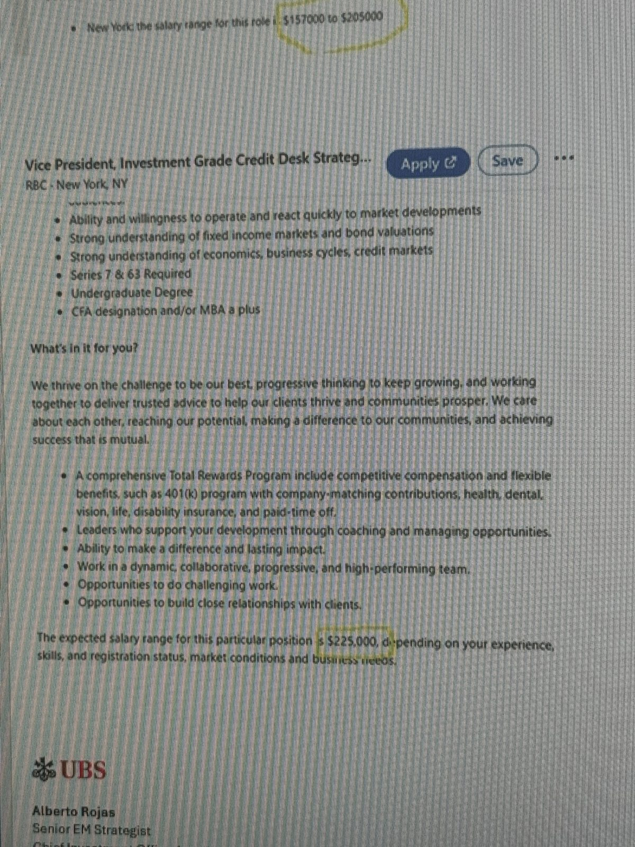
Screenshot P2 — UBS Asset Allocation Strategist, job ref 323654BR — full posting with salary range
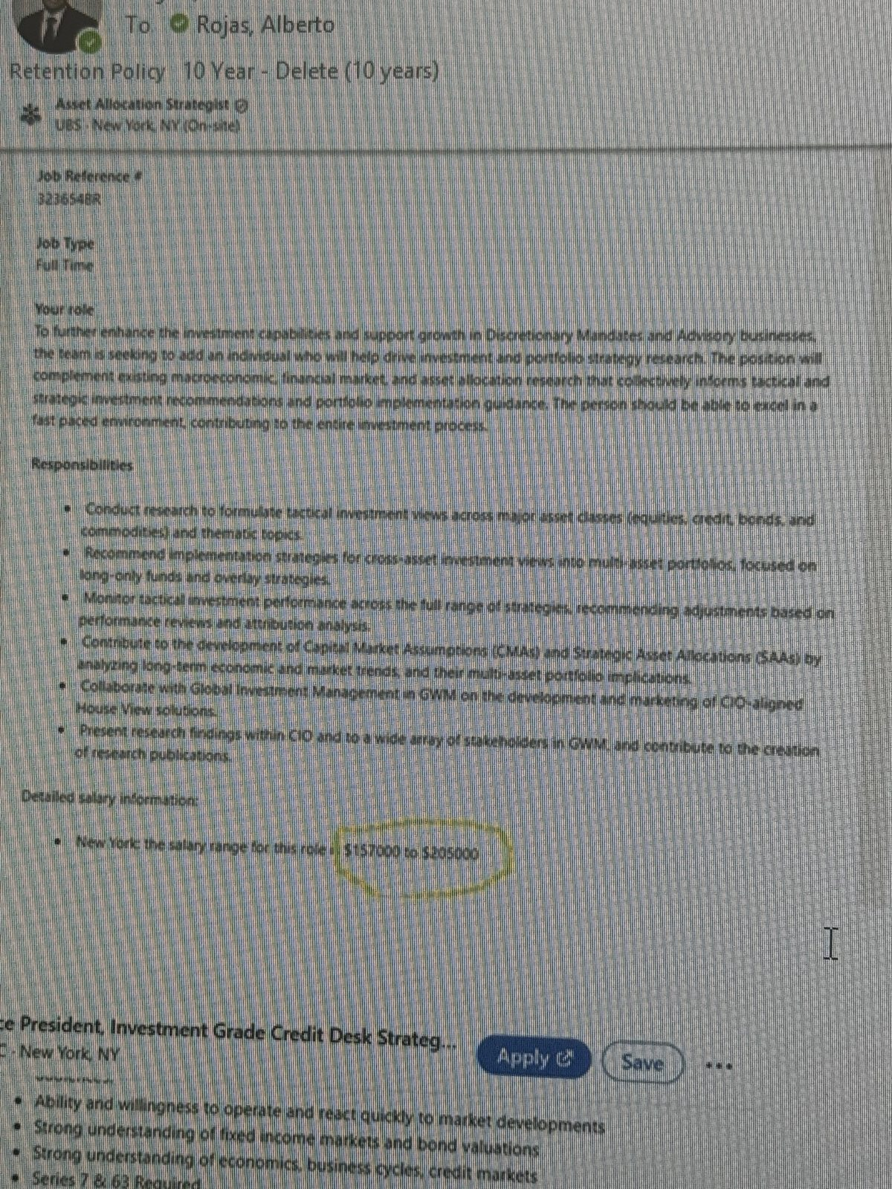
Screenshot P3 — Dalio Family Office Investment Associate, Global Macro ($200K–$300K)
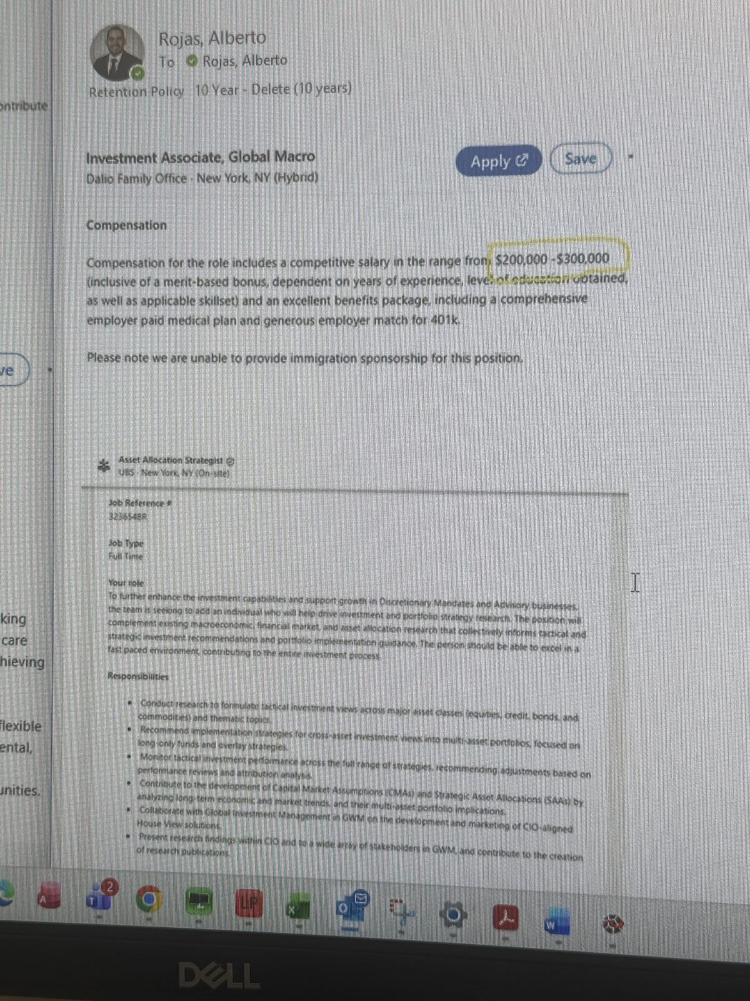
Screenshot P4 — Deutsche Bank LatAm Research Director ($225K–$275K) and Barclays Senior G10 FX/Macro Strategist ($155K–$225K)
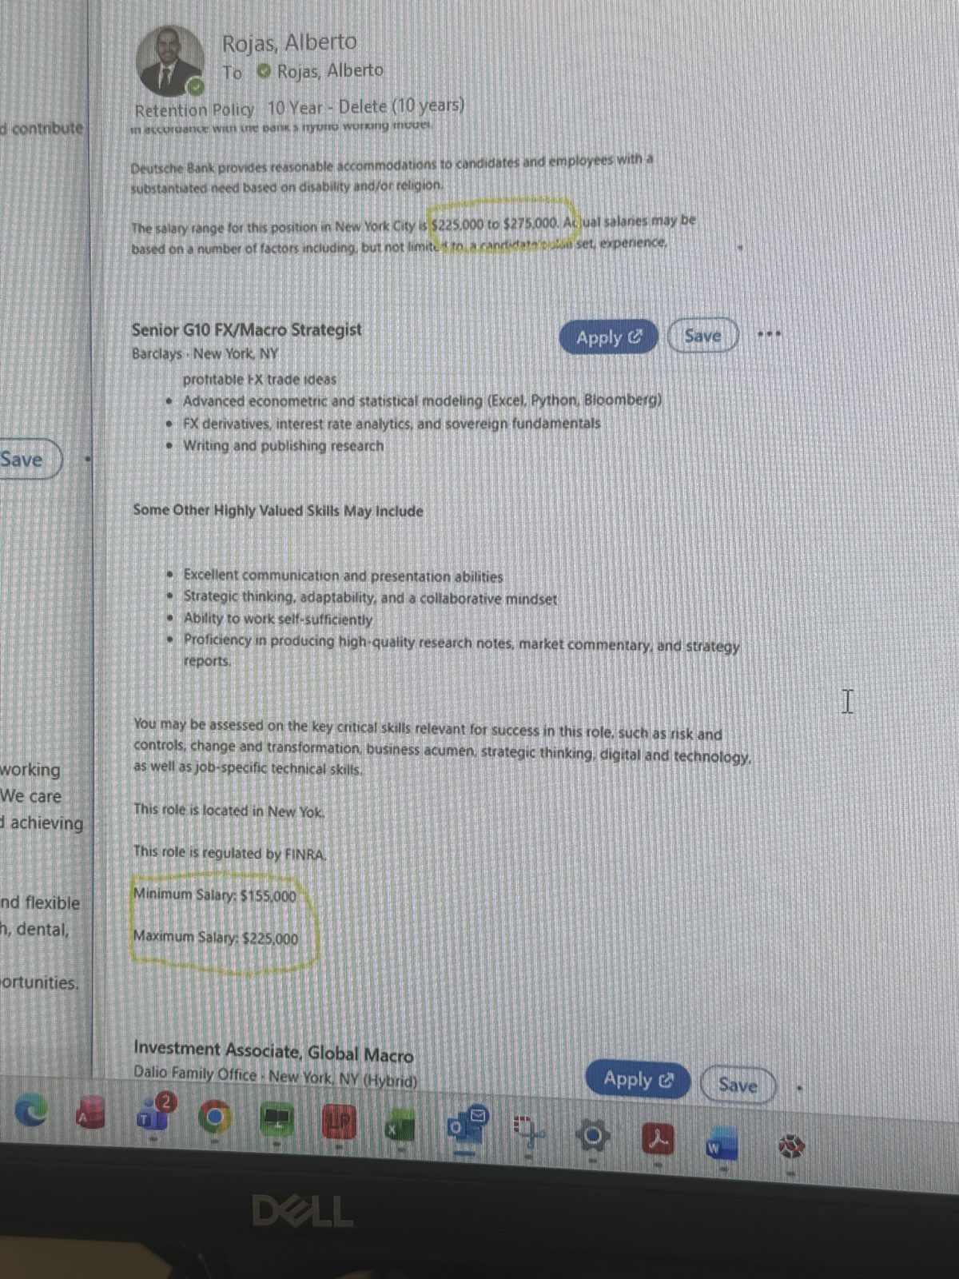
Screenshot P5 — Deutsche Bank LatAm Research Analyst – Director, full posting
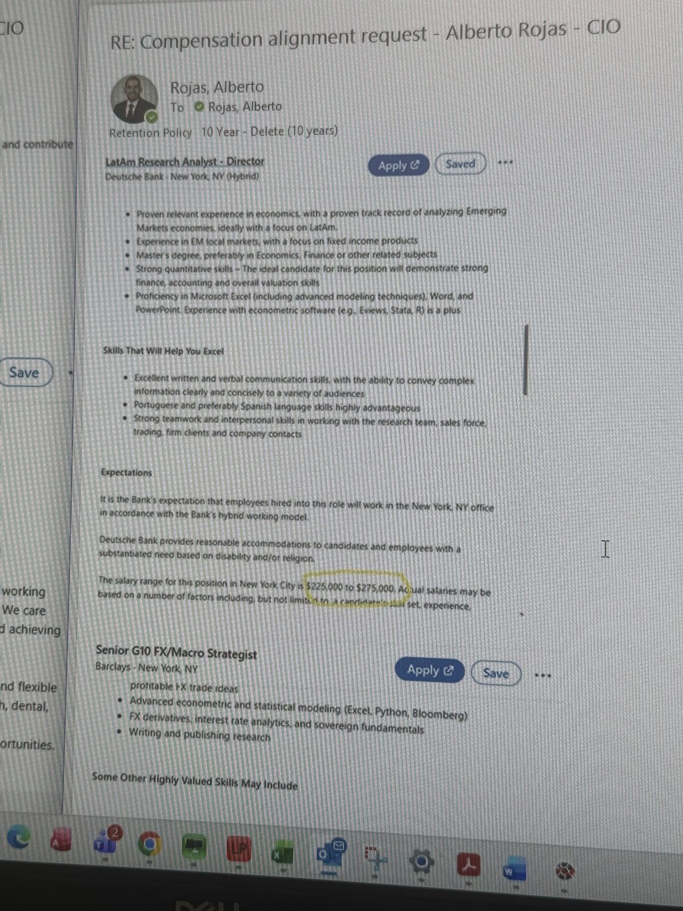
Screenshot P6 — UBS Fixed Income Strategist – Executive Director, CIO, job ref 301328BR ($170K–$245K)
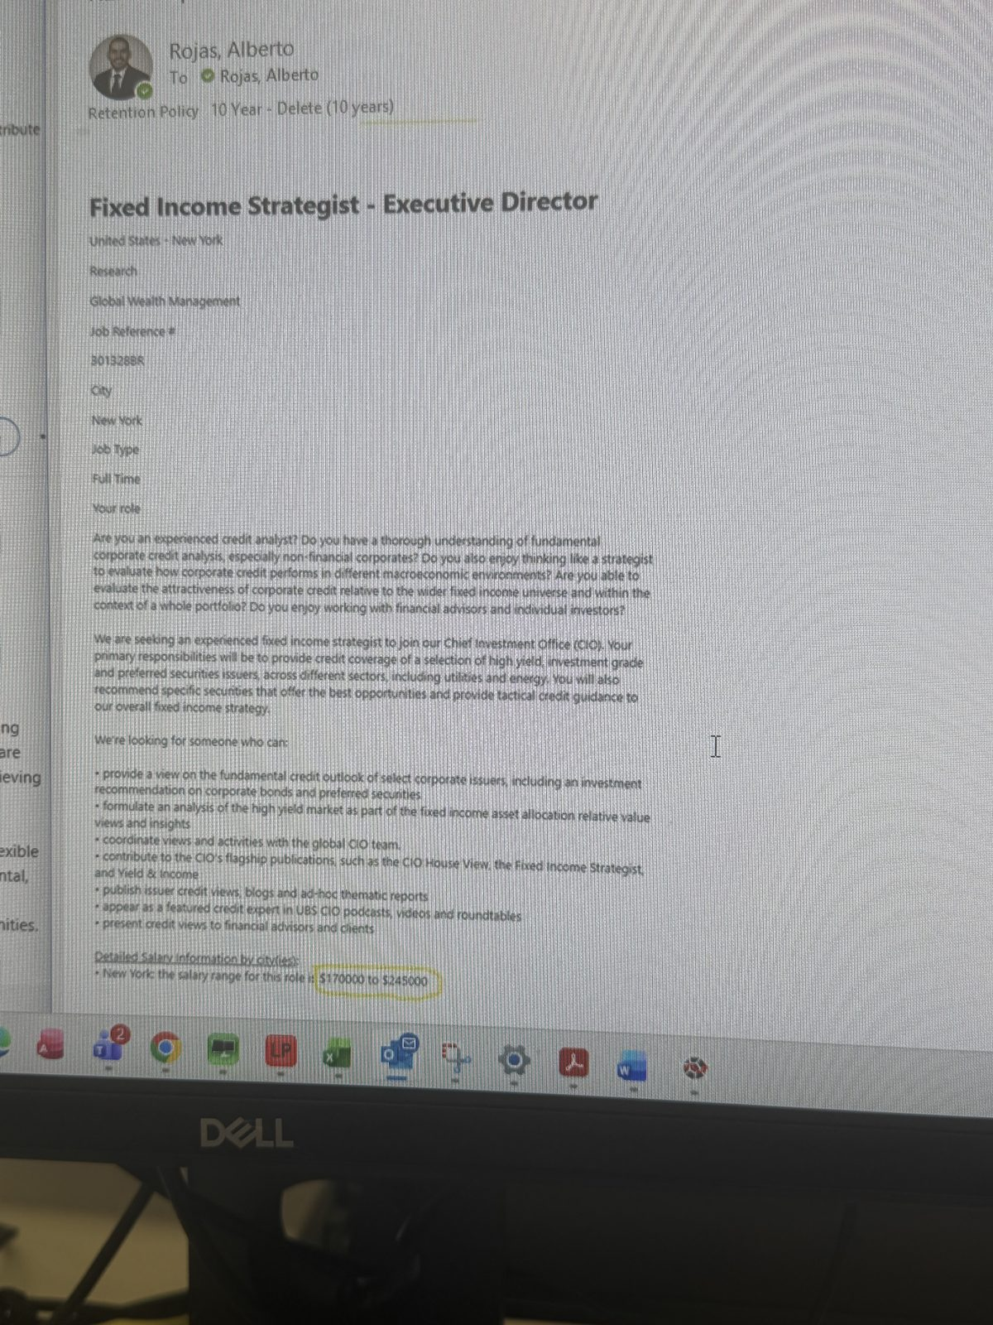
Screenshot P7 — UBS US Senior Economist, CIO ($200K–$250K), above the ED Fixed Income Strategist posting
