MACRO RESEARCH · LATIN AMERICA
El Niño: what we can’t forecast, and what we can
A framework for positioning around a recurring — but unpredictable — macro risk
As of July 2026
The one-line thesis
We are not meteorologists, and neither is anyone else who can tell you how hard this El Niño will hit. What we can do is map the two things that actually determine the economic outcome: which economies sit in the physical path of the phenomenon, and how much fiscal and inflation buffer each one holds to absorb a shock. That map is useful whether El Niño arrives strong, weak, or barely at all — and it points to the same conclusion either way: concentrate on resilience, respect what cannot be forecast, and diversify.

A known pattern, not a novel event
At heart, El Niño is a giant reshuffling of warm water across the Pacific. In a normal year, trade winds blow steadily from the Americas toward Asia, pushing warm surface water westward and letting cold, nutrient-rich water rise up along South America’s coast. El Niño turns that engine down: the winds weaken, the warm water slides back east toward South America, and the ocean releases a vast pulse of heat into the atmosphere.
The catch is that rain tends to follow the warm water — so when the warm pool shifts, the map of where it rains shifts with it. Places that are normally dry, such as the Peruvian coast, can be hit by torrential rain and flooding, while places that usually count on rain — Colombia, northern Brazil, parts of Central America — can tip into drought. The same warm water switches off the cold upwelling that feeds the anchovy fisheries off Peru. In other words, El Niño does not simply make everywhere hotter or wetter; it redraws where the water goes, striking crops, hydropower, fishing and infrastructure at the same time. That is how a weather pattern becomes a macro event.
And it is a recurring one. El Niño is not a surprise but a cycle the region has weathered many times, and it tends to rhyme. For investors, what matters is not the meteorology but the transmission — how these swings in rainfall feed through to food prices, power costs, growth, and ultimately central banks.
Figure 1. Impact of El Niño across the world
Typical wet and dry anomalies by region and season
▢ Insert existing “Impact of El Niño across the world” chart here
Source: NOAA

What history has taught us
Historically, El Niño has pushed up food prices, fuelling inflation and complicating central banks’ job — a supply-driven price shock can delay or slow rate cuts. Fiscal accounts feel it too, as governments spend more on infrastructure, emergency relief and reconstruction, in severe cases invoking escape clauses in their fiscal rules to run wider deficits. That is the baseline: the channels — food, hydrology, power, fiscal accounts and the currency — are well established, even before we know how intense this episode will be.
Figure 2. Colombia and Brazil still carry the highest policy rates
Policy rates, % · Brazil, Chile, Colombia, Mexico, Peru · Jul-16 to Jul-26
▢ Insert existing “Colombia and Brazil still carry the highest policy rates” chart here
Source: Central banks, UBS, as of July 2026

The honest limit: intensity cannot be forecast
Here is where most analysis overreaches, and where we will not. While the transmission mechanism from El Niño to the economy is conceptually clear, the outcomes are not linear. The impact depends on where and when the effects materialize, and on their severity — not simply on whether El Niño occurs, but on its intensity and duration.
Those are properties of nature, and nature does not publish a forecast we can trade on. The US National Oceanic and Atmospheric Administration (NOAA) currently puts a 63% probability on the current episode being very strong, with effects likely to persist through late 2026 and into early 2027. That is a probability, not a promise. We treat it as exactly that: a reason to prepare for a meaningful event, not a licence to predict its precise severity.
This is the pivot on which the rest of this note turns. Because we cannot trade the weather, we trade exposure and resilience instead. The next two questions — who stands in the path, and who can absorb the blow — are ones we can answer with evidence, and their answers hold up regardless of how the season unfolds.

A framework: exposure × resilience
We sort Latin American economies along two independent axes. The first is exposure: does El Niño physically disrupt this country’s food production, hydrology, power generation, or fisheries? The second is resilience: how much fiscal room and inflation-fighting credibility does the country hold to absorb a shock if one arrives? The two are separate questions — a country can be squarely in the path yet well-buffered, or barely exposed yet fragile.
The second axis is where the policy-rate and inflation-expectation charts earn their place. They are not macro decoration; they are the resilience axis made visible. Crucially, a country’s fiscal and inflation vulnerabilities are true whether or not El Niño comes. El Niño does not create these fragilities; it amplifies the ones that are already there. That is why the framework is useful in any weather: it identifies standing vulnerabilities that this phenomenon would stress-test.
On exposure, the region splits cleanly. Brazil, Peru, and Colombia face the clearest disruption — through food, hydrology, electricity, and fisheries. Mexico’s exposure is more mixed. Argentina and Chile sit at the benign end, where additional rainfall can actually help crops and reservoirs. On resilience, the standing picture — visible in Figures 2 and 3 — shows Colombia, Brazil, and Peru carrying the tightest combination of elevated rates, sticky inflation expectations, and constrained fiscal space. Where high exposure meets thin buffers, you get the names to watch.
Figure 3. Inflation risks in Peru, Colombia and Brazil are the most pressing
12-month-ahead median inflation expectations, % · Jun-16 to Jun-26
▢ Insert existing “Inflation risks in Peru, Colombia and Brazil are the most pressing” chart here
Source: Statistical authorities, UBS, as of July 2026

The map: where the risk actually sits
Rather than march through every economy, the picture collapses onto a single map (Figure 4). Two forces set the stakes: how physically exposed a country is to El Niño, and how much fiscal room it has to absorb a shock. Only where the two overlap does the phenomenon become a genuine macro problem. The danger zone — high exposure meeting thin buffers — belongs to Colombia, Brazil and Peru. Colombia pairs the region’s tightest fiscal position with a power grid over 80% dependent on hydro; Peru is the economy most physically battered by the cycle, through fisheries, manufacturing and infrastructure; Brazil combines real food-and-power exposure with high public debt and election-year noise.
The mirror image is only partly reassuring. Mexico is geographically removed from the worst effects, and Chile and the Dominican Republic see benign-to-neutral rainfall — for these, El Niño is close to a non-event. Venezuela is a different kind of exception. Because its economy is oil-driven rather than agricultural, the phenomenon carries little inflation risk — but that does not make it immune. El Niño’s droughts curtail hydropower, the backbone of the national grid, and the resulting shortfall lands on an energy infrastructure already known for chronic failures. Since reliable electricity is itself critical to sustaining oil output, a strong episode risks adding insult to injury: not an inflation shock, but an energy-and-growth shock in the economy that can least afford one. Argentina is the instructive special case at the other end: fiscally the most fragile economy in the region, yet El Niño tends to help rather than hurt it, as extra rainfall lifts soybean and corn yields. It is fragile, but off the path — a reminder that fiscal weakness and El Niño exposure are separate axes, and that a country’s standing vulnerabilities are true whether or not the phenomenon arrives.
Figure 4. Exposure vs. fiscal fragility — where El Niño actually bites
Bubble colour reflects overall El Niño-relevant macro risk (green = insulated, red = most at risk)
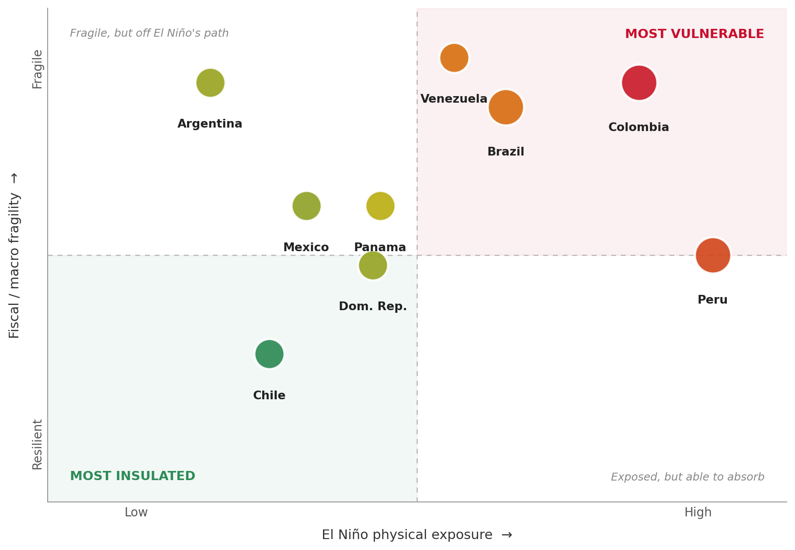
Source: UBS. Positioning is illustrative, based on hydrological exposure and fiscal-adjustment vulnerability.

Investment implications: position for asymmetry, not for a forecast
For investors, the cleanest read-through runs through the currency, not local rates. If El Niño feeds an inflation shock — directly through food, or indirectly through the supply-side destruction a severe episode can inflict — the market response is to price higher policy rates. And if the past few years have taught us anything about emerging-market central banks, it is that they would rather err on the side of hawkishness than test their credibility on the dovish side. Confronted with the growth-versus-inflation trade-off a supply shock forces on them, most will lean toward defending the inflation target. The near-term consequence is currency-supportive: higher rates raise financing costs and, further out, can revive questions about debt sustainability in the more fragile sovereigns — but in the short term they tend to keep the exposed currencies contained, and where the hawkish surprise is large enough, push them to appreciate. That is the asymmetry we would position around — an El Niño inflation scare is, in the first instance, more likely to support the exposed currencies than to sink them.
Within equities, companies in food staples, agribusiness, and logistics that can pass on higher prices should benefit from supply disruptions, while consumer-discretionary sectors in the most exposed countries may face headwinds from higher inflation and tighter policy. On the currency, the pressure is more directional than merely choppy: an inflation scare that forces hawkish policy tends to firm the exposed currencies rather than weaken them. Brazil is the main two-way risk, where the election cycle could cut against that support.
The through-line is the same one we started with: we cannot forecast the weather, but we can price the exposure. Diversification is the honest response to a risk you cannot time — lean toward the resilient, stay cautious on the exposed-and-fragile, and avoid concentrating capital on a single outcome that nature has not committed to delivering.

As a reference, the 2023/24 episode — which overlapped with severe flooding in Rio Grande do Sul — led to federal support measures totaling about 0.9% of GDP, including credit facilities. Historical experience indicates that governments typically respond with substantial spending on prevention, emergency relief, and reconstruction.

