UBS DRAFT | 19 October 2026
Chief Investment Office GWM | Investment Research | Year Ahead 2027
Dominican Republic 2027: Steady as she goes, with fiscal homework pending
Emerging market bonds
Authors: Alberto Rojas, Investment Strategist, UBS FS; Alejo Czerwonko, Chief Investment Officer Emerging Markets, UBS FS; Laura Assis Iragorri, CFA, Analyst, UBS Asesores Mexico, S.A. de C.V.
How to read this draft (delete before publishing). Yellow highlight = text that is new or changed versus the 14 September note (new data, new numbers, or re-aimed at 2027). Unhighlighted text is carried over from the published note as-is. Grey boxes marked CLAUDE NOTE are my recommendations, caveats or things for you to verify; none of it is meant for the client. Chart slots are placeholders with the refresh instruction written on them. Three alternative titles: (1) "Dominican Republic: A good year ahead, if the energy shock fades"; (2) "Dominican Republic in 2027: Strong growth, stable debt, slow fiscal consolidation"; (3) "Dominican Republic: Stable economy, sound governability, and a pre-election budget".
- Growth closed 2026 strong and should stay above the regional average in 2027. Real GDP is tracking 4.5% in 2026 (IMAE Jan-Aug), led by construction, financial services and tourism. For 2027 we pencil in 4% real growth, below the 4.75% assumed in the 2027 budget and the IMF's 4.4%, reflecting the drag from a prolonged energy shock on a net oil importer.
- Inflation has risen on higher energy prices, but core inflation is back on a downward path (4.61% in September) and the central bank has moved pre-emptively, lifting the policy rate 25bp to 5.50%. We expect headline CPI to close 2026 at 4.5-5.0% and run at 4.0-5.0% in 2027, with the policy rate on hold through the first half of next year. Risks remain biased to the upside.
- Fiscal consolidation remains the key challenge, with the low tax revenue base being a main factor behind it. The 2027 budget targets a 3.4% of GDP deficit, essentially unchanged from 2026, so the convergence toward a 3% deficit is deferred another year. Regardless, the performance of debt ratios and external accounts, along with high governability, provides the country with a solid macro and political backdrop heading into the 2028 election cycle.
CLAUDE NOTE Headline forecast changes I am recommending versus the September note: (a) 2026 real GDP from "near 5%" to "around 4.5%" - August IMAE was 3.8% y/y, the Jan-Aug average is 4.5%, and both the authorities (4.5%) and the IMF October WEO (4.6%) are below 5%. Keeping "near 5%" now looks stale. (b) Keep 2027 at 4%: it is deliberately below consensus and the note should say so. (c) Monetary stance language from "on hold" to "hiked once, on hold from here". (d) 2027 fiscal: replace the "overall deficit of 3% / primary surplus 0.7%" framing with the actual budget numbers (3.4% deficit; implied primary surplus ~0.2-0.3% by my arithmetic - please verify against the MGMP table).
The year ahead for the Dominican Republic looks a lot like the year that is ending: growth comfortably above the Latin American average, inflation hovering around the top of the target range, stable debt ratios and a fiscal consolidation that keeps getting pushed to the right. The improvement in 2026 has been multi-layered, with the sectors of construction, financial services and tourism fueling the dynamism. Meanwhile, the crisis in the Middle East has resulted in higher energy prices in the country, leading headline inflation to surpass the 5% mark. The shock has proven more persistent than most expected, which prompted the central bank to deliver a 25bp "preventive" hike at the end of September, its first move in a year. Core inflation, however, has been falling for two months and sits inside the target range.
The somewhat weak aspect of macro dynamics is the fiscal side. To be clear, we are not concerned about debt sustainability. It is a "weak" area in the sense that the expected convergence to a more moderate fiscal deficit has not materialized, and the 2027 budget submitted to Congress confirms it will not materialize next year either. The authorities have enacted temporary modifications to the tax code, but the increase in revenues has been rapidly allocated to selected lines of government spending.
Overall, though, we continue to believe the Dominican Republic has a stable economy, with sound governability. The ongoing challenge is how to keep generating economic gains and improving the country's welfare levels, all the while maintaining fiscal discipline. It is a balance that many policymakers battle with. The fact is that it is easier said than done - and 2027, the year before a presidential election, is rarely when it gets easier.
Growth: 2026 delivered; 2027 should hold up
There's been a sturdy recovery after a rather subdued 2025, in line with our expectations. The monthly activity indicator (IMAE) grew 4.5% y/y on average in January-August, up from 2.3% in the same period of 2025, and the authorities report the same 4.5% pace through September. August alone printed 3.8% y/y, with construction (+7.9%), free-zone manufacturing (+3.4%) and financial services (+9.4%) doing the heavy lifting, while mining contracted 14.6% in the month and agriculture 1.4%. We now estimate the economy will expand around 4.5% in 2026 (the IMF's October WEO has 4.6%), once again displaying one of the strongest performances in Latin America, where the IMF expects 2.3%.
CLAUDE NOTE The mining drop in August (-14.6% y/y) is worth a line if you have the detail from the BCRD release; it partly reverses the +11.3% you cited for 1H26 (YTD mining is now +3.6%). I could not find the cause in the sources available to me - likely a base effect or Pueblo Viejo maintenance - so I have left it as a bare fact.
Figure 1 - The acceleration in economic activity is underway
Monthly GDP proxy (original series); annual growth rates are shown in bars, while the line represents the 3-month moving average
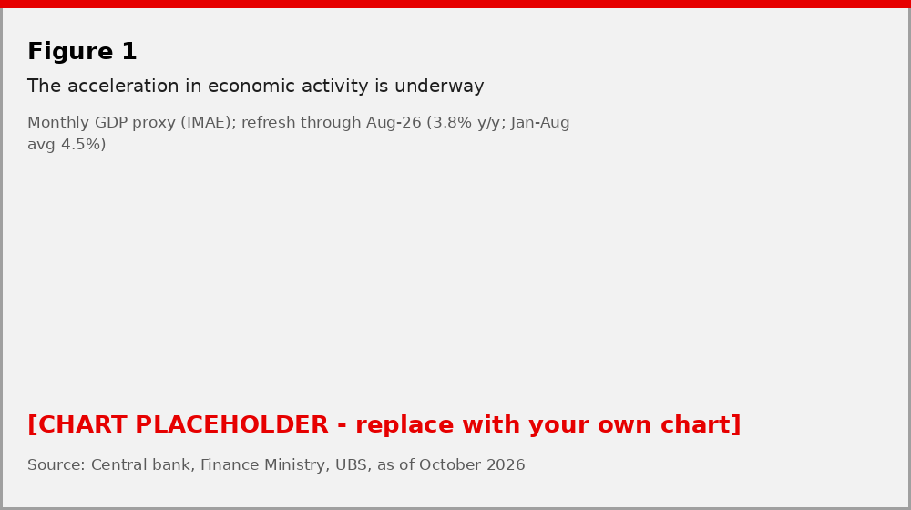
Source: Central bank, UBS, as of October 2026
From a supply-side perspective, the drivers have been the ones we flagged in September: elevated gold prices, which have supported mining activity for most of the year, and last year's monetary easing, whose delayed effects are feeding through to financial services and construction investment - construction credit was growing 16% y/y in August.
For 2027, we keep a 4% real GDP growth forecast. This sits below the 4.75% assumed in the 2027 budget, the IMF's 4.4% and the World Bank's 4.4%, and the gap is deliberate. The risk for activity is related to global factors more than domestic ones. If the conflict in the Middle East persists or escalates, the Dominican Republic as a net oil importer could face challenges, both via the loss in purchasing power for consumers and the headwinds it can create on the fiscal front. Brent was still trading around USD 100/bbl in early October, well above the USD 74.9 WTI assumption embedded in the 2027 budget; the budget also assumes an average exchange rate of RD$62.6 per dollar. If energy prices normalize toward the USD 65-75 range most forecasters expect for 2027, our growth number would have upside; if they do not, the drag runs through consumption, the fuel subsidy bill and the trade balance simultaneously.
Inflation and monetary policy: the central bank blinked, once
Consumer price dynamics have been impacted by the conflict in the Strait of Hormuz. Annual headline inflation stood at 5.12% y/y in September (5.13% in August, 5.67% at the June peak), still above the 4% +/- 1pp target range, with transport and food explaining most of the monthly print. The more constructive signal is core inflation, which has fallen for two consecutive months to 4.61%, back inside the target range.
The overall inflation backdrop remains somewhat contained, in part due to: (1) the government's price ceiling policy over selected fuels, which depends on fiscal space and international oil prices, and (2) the Dominican peso, which was up as much as 8% year to date in July. Note, however, that the peso has given back part of that gain since the end of September, moving from below RD$59.5 to around RD$61.3 per dollar by mid-October (year-to-date appreciation is now closer to 2.5%). The adjustment has been orderly and reserves exceed USD 15bn, but it removes some of the disinflationary tailwind we counted on in September.
Figure 2 - The fuel impact has kept headline CPI above the target range
Contributions to annual headline CPI, percentage points
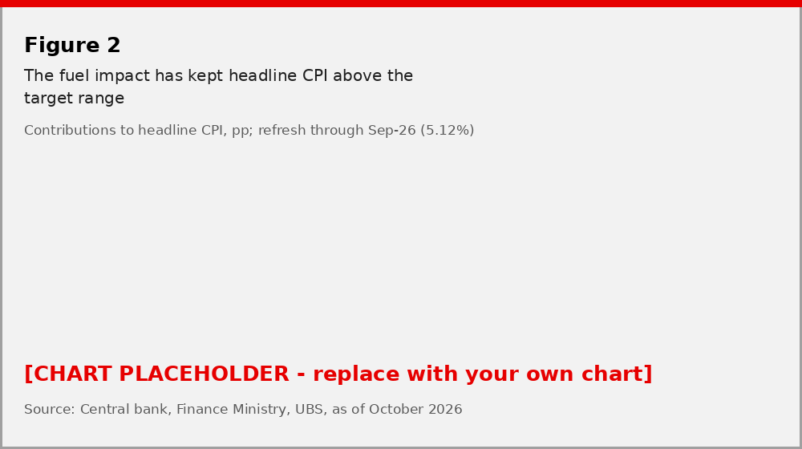
Source: Central bank, UBS, as of October 2026
On 30 September the central bank raised its policy rate by 25bp to 5.50%, the first change since October 2025, describing the move as preventive and aimed at avoiding second-round effects from supply shocks that "have been more persistent than anticipated". The decision came alongside its own view that inflation would keep converging to the target range by year-end and that expectations remain anchored. High base effects in 2025 should help annual headline CPI close the year between 4.5% and 5.0%, in our view (the IMF has 5.1% for 2026).
Figure 3 - The rise in inflation has been deemed transitory, but the BCRD hiked 25bp pre-emptively
Annual consumer price inflation and policy rate, inflation target range is section shaded in blue
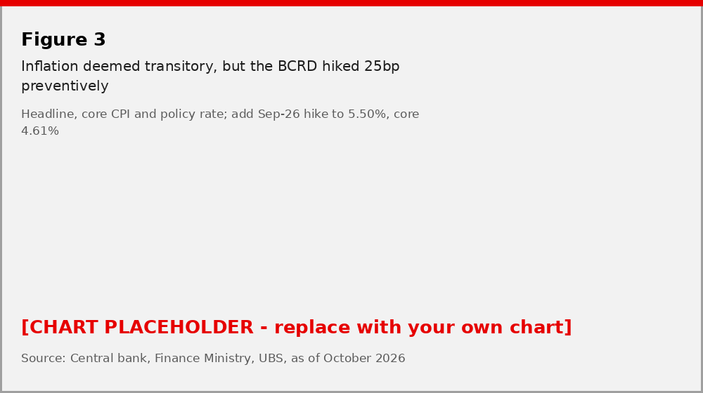
Source: Central bank, UBS, as of October 2026
For 2027 we keep a relatively wide inflation forecast range of 4.0% to 5.0%, which brackets the 4.5% average assumed in the budget. This reflects the elevated uncertainty on the energy outlook alongside our conviction of stable price dynamics in the country. On rates, our base case is that 5.50% is the terminal level: we expect the policy rate to stay on hold through at least the first half of 2027, with the central bank able to resume gradual easing in the second half if energy prices normalize and headline inflation settles inside the range. Unless the energy shock concerns subside, the balance of risks to inflation will remain biased to the upside, and so will the risk of a further hawkish move.
CLAUDE NOTE The IMF WEO has DR inflation at 5.3% for 2027, above your 4-5% range and above the budget's 4.5%. I have not changed your range (core is falling, base effects help, and the Fund's number looks mechanical), but you may want a sentence acknowledging the divergence so the client doesn't see it in a competitor's note first.
The fiscal front: 2026 on track; 2027 budget keeps the deficit at 3.4% of GDP
Through 25 September the central government ran a deficit of RD$191bn, or 2.2% of GDP, with a primary surplus of 0.5% of GDP and interest payments of RD$235bn. That is about two-thirds of the full-year deficit contemplated in the reformulated 2026 budget (around RD$285bn, 3.4% of GDP), so the 2026 outturn should land close to the 3.2-3.5% range we discussed in September and the 0.5% primary surplus target looks within reach. There are conflicting dynamics taking place under the hood, though. To the upside, the authorities enacted temporary legislation (the "anti-crisis" law) to boost fiscal revenues, mainly from higher corporate taxes, with part of the proceeds earmarked for targeted assistance. To the downside, the current price ceiling in gasoline prices is largely based on foregoing fuel tax revenue, which along with budget modifications to increase spending, cancel out much if not all of the new revenue.
Figure 4 - The 2026 fiscal targets appear feasible; the 2027 budget implies no further consolidation
Four-quarter rolling fiscal performance, % of GDP
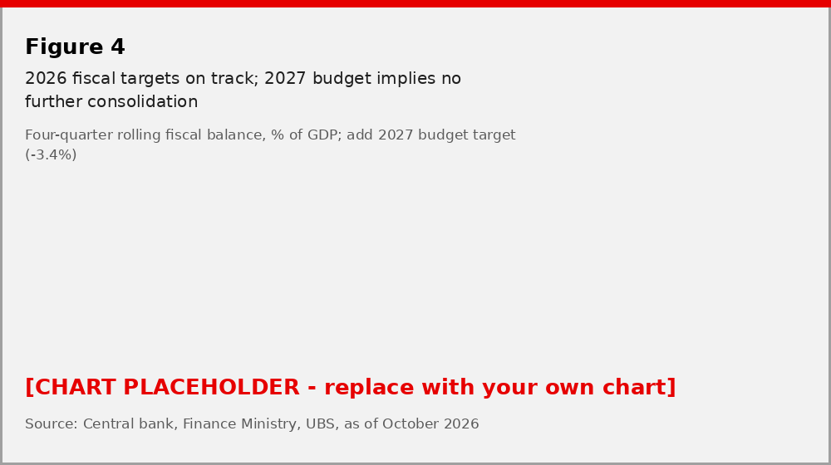
Source: Central bank, Finance Ministry, UBS, as of October 2026
The more consequential news for the year ahead is the 2027 budget bill, submitted to Congress in September. It projects central government revenue of RD$1.51trn (15.7% of GDP, down from 15.9% in 2026), spending of RD$1.84trn (19.2% of GDP, +10.5% y/y versus +9.2% for revenue) and an overall deficit of RD$327bn, or 3.4% of GDP. Interest payments are budgeted at RD$351bn, roughly 3.7% of GDP and 23% of revenue, which by our arithmetic leaves an implied primary surplus of only around 0.2-0.3% of GDP, well short of the 0.7% primary surplus that the medium-term framework had envisaged for 2027. Gross financing needs are put at 4.8% of GDP. Capital spending rises almost 20%, which is the right composition, but the bottom line is that the deficit path is flat rather than declining.
The fiscal rule key for the Dominican Republic is based on outflows, with primary expenses not allowed to increase 3 percentage points beyond annual headline inflation. Note that foregoing fuel taxes could lead to a weaker fiscal result, but since this hits revenues and not expenses, it allows the government to stay within the boundaries of the law. With headline inflation near 5%, the rule accommodates nominal primary spending growth of up to ~8%, so a 10.5% expansion in total spending (interest included) is consistent with the letter of the rule. It is not, however, consistent with the spirit of getting the deficit toward 3% of GDP.
In the short term we remain unconcerned about fiscal dynamics, but the test for 2027 is different from 2026. Last year the question was whether the authorities would tolerate slippage; next year the question is whether a budget that already bakes in a 3.4% deficit can be executed without further additions in the run-up to the 2028 election. Any willingness to expand on the approved numbers would start to erode the credibility of the 2035 debt objective, especially if global macro conditions were to deteriorate.
CLAUDE NOTE Two things to verify on the UBS terminal before this goes out: (1) the "reformulated 2026 budget = 3.4% of GDP" figure comes from local press citing DIGEPRES; the original 2026 law had RD$280.6bn / 3.2%, so check whether the 3.4% is a reformulation or a different GDP base. (2) My implied-primary-surplus calculation for 2027 (deficit 327bn minus interest 351bn = +24bn, ~0.25% of nominal GDP of RD$9.59trn) should be cross-checked against the primary balance line in the MGMP 2027-2030 table at digepres.gob.do - the budget may classify some items differently.
Benign government debt dynamics
The country's debt burden outlook looks stable, with government financing costs running on par with nominal GDP growth. As long as these dynamics are in place, and the government keeps the primary result largely balanced, then debt ratios should hold relatively steady. Non-financial public sector debt stood near USD 67.6bn, or about 46.6% of GDP, as of August, up roughly 10% in nominal terms from end-2025, with external creditors holding 71% of the stock. Yet, the goal that authorities have set out for 2035 is to lower the debt burden ratio to 40% of GDP. The challenge, considering the low revenue base of the country, is to find a way to get there - and a 2027 budget with a primary surplus near zero does not move the needle.
Figure 5 - Debt ratios are stable; the plan is to bring them down
% of GDP, dotted lines indicate BBB median gross debt range
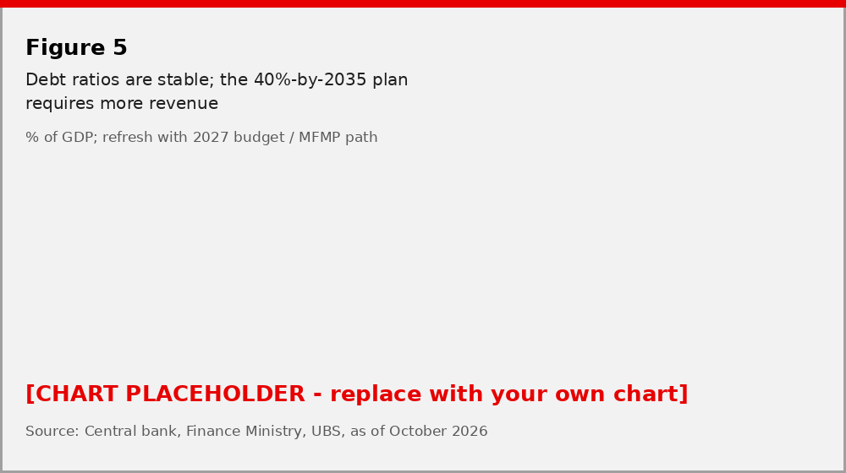
Source: IMF, Finance Ministry, UBS, as of October 2026
As a reference, the Dominican Republic has one of the lowest tax bases across Latin America. Tax revenue is about 16% of GDP, well below the LatAm average of 22% of GDP and the OECD average of 34%. This low revenue is part of the reason why nearly a quarter of the annual budget is devoted solely to interest payments on debt. For the Dominican Republic to increase on the ratings scale, it needs to give itself more fiscal room. The 2027 budget's 15.7% revenue ratio is a step in the wrong direction on that front, even if a small one.
Figure 6 - The Dominican Republic has a low tax base compared to other LatAm countries
Tax revenue, % of GDP
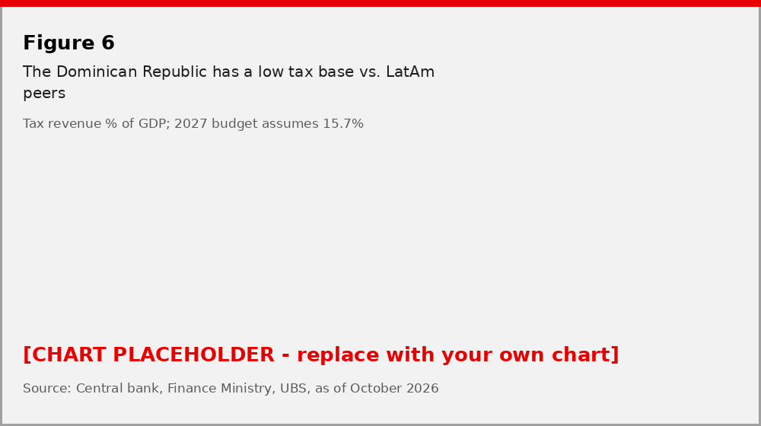
Source: OECD, Finance Ministry of the Dominican Republic, UBS, as of October 2026
Nonetheless, steadiness on debt metrics, along with prudence in fiscal management, provides a peaceful backdrop in terms of sovereign debt risk. The Dominican Republic's USD government debt carries a composite BB rating with stable outlooks by all three main agencies (Moody's Ba2, S&P BB, Fitch BB-; no rating actions since our September note). We expect no negative actions to the country over our forecast horizon, and we would not expect a positive one either until the revenue question is addressed.
Solid external metrics
On four-quarter rolling terms, the current account recorded a minor deficit of 0.6% of GDP as of 1Q26. The result was on the back of notable deficits in the trade merchandise and income account that are nearly mirrored by surpluses in the accounts of trade services and transfers. These latter two, as usual, benefit from sound tourism-related inflows and sturdy remittances, with tourist arrivals growing close to 10% and remittances still expanding according to the Finance Ministry.
Figure 7 - Tourism-related services and transfers (remittances) are a robust source of USD inflows
% of GDP
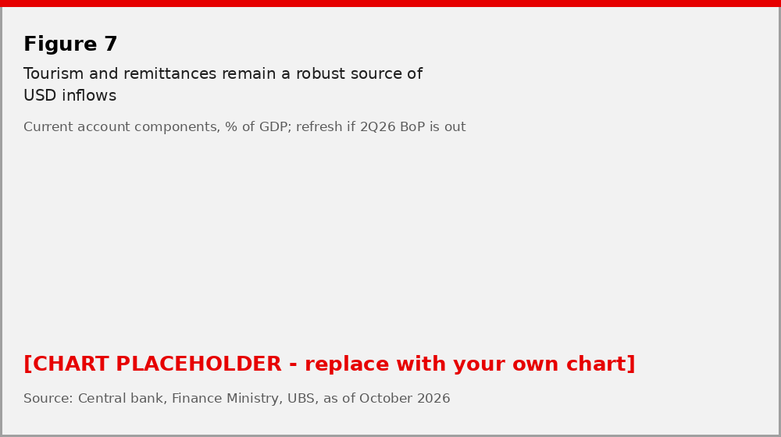
Source: Central bank, UBS, as of October 2026
At the same time, also in four-quarter rolling terms, net FDI reached 4% of GDP in 1Q26. This is nearly 8 times more than the external gap in the same period, and it's the strongest since 2018. The central bank highlighted that two-thirds of direct investment in 1H26 was new equity inflows, rather than reinvestment, while also noting that the sectors to receive the most capital were energy, tourism, and real estate.
We expect the current account deficit to close this year between 0.5% and 1.0% of GDP and to stay around 1% of GDP in 2027, with the oil bill the swing factor. Solid balance of payment dynamics should remain a supportive factor for the peso, though after the October move we would describe the currency as stable rather than strong: the budget's own assumption is a mild depreciation to an average of RD$62.6 in 2027, which we see as a reasonable anchor.
CLAUDE NOTE I did not find the 2Q26 balance of payments release; if the BCRD has published it, Figure 7 and the "as of 1Q26" references should move to 2Q26. Also worth one line on what drove the peso move after 30 Sep - local commentary points to global rates and seasonal import demand, but you will have a better read from the desk.
Political risks are quite limited
President Luis Abinader continues to have an approval rating above 50%. This is commendable for a leader that's been in office for over 6 years. Note that regional peers don't fare too well, and that incumbents across the globe are finding it particularly difficult to maintain political support. In terms of governability, the Abinader administration continues performing business as usual, largely due to its strong support in Congress. The next presidential elections are in 2028, so 2027 is the year in which the succession within the ruling PRM and the opposition's line-up will start to take shape. We do not expect this to disturb policy continuity, but it is the main reason we see the fiscal risk in 2027 as skewed toward more spending rather than less.
Investment implications
At the time of writing, Dominican Republic's US-dollar-denominated sovereign bonds have returned [UPDATE: __% year to date], below the EMBI global benchmark ([+__%]), and the Latin America average ([+__%]). The Dominican Republic's condition as a net oil importer led to an immediate weakening in performance as the Middle East crisis took off. Spreads have nonetheless held in well: at end-September the country traded at roughly 172bp over Treasuries versus 186bp for the Latin America EMBI average, still tighter than the BB median. Yet, as the global energy shock subsides, we think a more optimistic take from global investors should permeate, and we see the Dominican Republic as a core holding within our BB-rated LatAm exposure for 2027: a credit where the macro story is dull in the best sense, and where the main thing that could change our view - a visible loosening of fiscal discipline ahead of 2028 - is one we would see coming in the monthly execution data.
Figure 8 - The Dominican Republic's solid macro framework is part of why it trades slightly tighter than BB-rated peers
EMBI global spreads
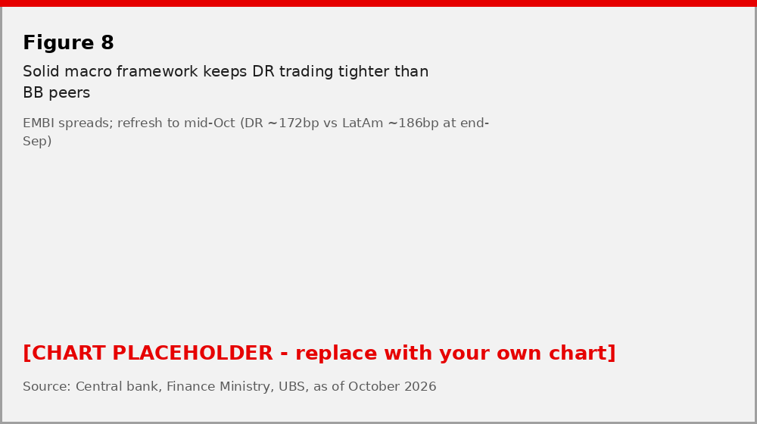
Source: JP Morgan, Bloomberg, UBS, as of October 2026
As usual, key risk factors for the sovereign include the potential for adverse weather events and selected governability challenges common to emerging markets. For 2027 specifically we would add: (1) an energy shock that does not fade, which hits growth, inflation and the fuel-subsidy bill at the same time; (2) pre-election spending additions on top of an already flat deficit path; and (3) a sharper peso adjustment if global financial conditions tighten, given the 71% external share of public debt.
See our Weekly Emerging Markets Bond List for bond specific investment recommendations.
CLAUDE NOTE The YTD return figures are the one hard data gap: I do not have Bloomberg access, so the three bracketed numbers need a BDH pull (EMBI Global DR sub-index, EMBI Global, EMBI Global LatAm). The 172bp / 186bp spread pair is from the BCRD's own JP Morgan-sourced riesgo-pais table dated 28 Sep; refresh to the latest close.
Forecast summary
 | 2025 | 2026E | 2027F | Memo: 2027 budget / IMF
Real GDP growth, % | 2.1 | ~4.5 (was "near 5") | 4.0 | 4.75 / 4.4
Headline CPI, eop, % | ~5.0 | 4.5-5.0 | 4.0-5.0 | 4.5 avg / 5.3
Policy rate, eop, % | 5.25 | 5.50 | 5.50 (easing 2H possible) | n/a
Central gov. overall balance, % GDP | -3.6 | -3.2 to -3.5 | -3.4 | -3.4 / n/a
Primary balance, % GDP | -0.1 | +0.5 | +0.2 to +0.3 (implied) | n/a
Current account, % GDP | -1.4 | -0.5 to -1.0 | ~ -1.0 | n/a
USD/DOP, avg | ~62 | ~60 | ~62.6 | 62.6 / n/a
Shaded cells are new or revised versus the September note. 2025 balances per Finance Ministry; 2026E/2027F are UBS unless noted.
CLAUDE NOTE This table did not exist in the September piece; a year-ahead note usually carries one. The 2025 column uses MEF figures (overall -3.56%, primary -0.1%) and the BCRD current account (-1.4%). The 2027 USD/DOP line simply adopts the budget assumption - replace with the house FX view if CIO has one for DOP.
This report has been prepared by UBS Financial Services Inc. (UBS FS), UBS Asesores Mexico, S.A. de C.V. Please see important disclaimers and disclosures at the end of the document. [Standard appendix / risk information to be appended in BlueMatrix.]

