UBS DRAFT | 19 October 2026
Chief Investment Office GWM | Investment Research | Year Ahead 2027
Panama 2027: The good times roll on, with three tests ahead
Emerging market bonds
Authors: Alberto Rojas, Investment Strategist, UBS Financial Services Inc. (UBS FS); Alejo Czerwonko, Chief Investment Officer Emerging Markets, UBS FS
How to read this draft (delete before publishing). Same convention as the DR file: yellow = new or changed versus the 1 September note; unhighlighted = your text carried over; grey CLAUDE NOTE boxes are for you only. Figures renumbered 1-7 (the published PDF has two "Figure 1"s). The three tests in the title are: Moody's outlook resolution, the mine decision, and the 3.0% deficit target. Alternative titles: (1) "Panama: From abyss to investment-grade defence in eighteen months"; (2) "Panama 2027: Growth is not the question, the rating is"; (3) "Panama: Let the good times roll - carefully".
- Panama's macro story has turned decisively more positive. Real GDP grew 6.4% y/y in 2Q26 and 5.5% in the first half, the strongest print among the major Latin American economies, and the July activity index accelerated further to 8.5%. We now see 2026 growth around 5.5% and pencil in 4.5% for 2027, as canal and trade tailwinds normalize.
- Fiscal consolidation has been resolute and faster than expected. The 2026 deficit is tracking the 3.5% of GDP legal cap, and the 2027 budget targets 3.0%. Debt metrics remain imperfect, but the improvement is large enough to defend Panama's composite investment grade rating - provided Moody's, which is resolving a negative outlook by year-end, agrees.
- Despite the macro improvement, President Mulino's popularity has declined sharply. However, the administration's governance remains solid and social distress issues appear limited. The October earthquake was handled within the fiscal rule, and the Cobre Panama file is moving toward a limited restart rather than a full reopening.
CLAUDE NOTE Recommended changes to the September view, in order of importance: (a) The mine. Your note said the mine "looks likely to reopen". Since then the inter-ministerial commission (30 Sep) recommended only a time-limited production phase to fund closure (closure cost est. USD 2.6-3.4bn), Mulino had not authorized even formal talks as of 9 Oct, and the government says no decision before year-end. I have reframed it as "limited restart to fund closure" and moved the full-reopening upside into risks. (b) The rating. S&P reaffirmed BBB- stable on 22 Sep, but Moody's (Baa3 negative) told the press on 8 Sep it is questioning whether Panama keeps IG and wants to resolve the outlook before end-2026. Since Fitch is already BB+, a Moody's cut would leave Panama IG at one agency only - the composite would drop to BB+. This is the single biggest 2027 risk and the note now says so. (c) Growth: 2026 from 5% to ~5.5%; new 2027 number of 4.5% (CEPAL 4.6%, World Bank 4.1%, IMF "4-5% medium term"). (d) Fiscal: Jan-Aug NFPS deficit is 3.56% of GDP on a year-to-date basis, already at the cap, though MEF notes canal contributions and dividends land in 4Q. Your 2Q rolling figures (3.3% overall, 0.3% primary) are now stale.
Panama remains one of the most successful economic stories in Latin America. Over the past few years, authorities were forced to walk a tightrope after post-pandemic profligacy deteriorated government accounts and threatened the country's investment grade rating. Simultaneously, the closure of a large copper mine fueled concerns of potential GDP losses and was coupled with social turmoil as the Mulino administration propelled unpopular legislative changes. All these moving pieces, along with geopolitical pressure involving the canal, heightened uncertainty about the economy's ability to maintain its historical dynamism.
In 2026 the data have put those concerns to rest. Real GDP expanded 5.5% in the first half, the canal is making multi-year high revenues amid solid bilateral relations with the US, and fiscal metrics display healthier dynamics. A few quarters ago a sort of abyss was at the nation's doorstep. Now the good times are rolling in, and the question for 2027 is whether Panama can convert a strong cyclical year into the three things that still need settling: a rating outlook, a mine decision and a deficit at 3% of GDP.
Real GDP growth - All good, real good
Official data confirmed what the activity proxy had suggested: real GDP grew 6.4% y/y in 2Q26 after 4.8% in 1Q, for 5.5% in the first half. This is the strongest result for major Latin American economies, and the most resilient Panama print for 1H since 2017 (excluding the post-pandemic rebound). Growth has been multi-variable, with solid consumption from households, a rekindling of the construction sector, robust tourism-related inflows, and the canal-related activities benefitting from a re-routing of global supply chains following the Strait of Hormuz turmoil. Transport and storage (+12.8% in 2Q) and wholesale and retail trade (+11.6%) led, with Colon Free Zone re-exports and port container moves both strong; construction (+1.3% in 2Q, +4.5% in 1H) and financial services (+2.1%) were the laggards. The July IMAE accelerated again to 8.5% y/y.
Figure 1 - Growth is running well above 5% this year
Real GDP growth, in %, full year data for 2026 and 2027 are forecasts
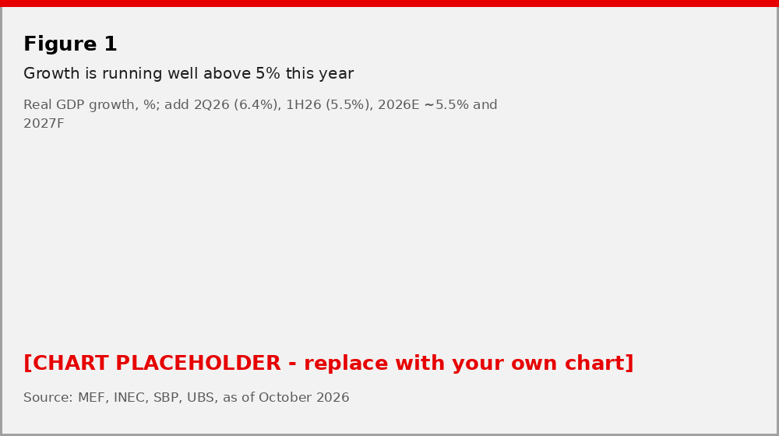
Source: INEC, UBS, as of October 2026
This performance follows close to 4.5% real GDP growth last year, so dynamism can't be justified via low-base effects. We now estimate 2026 growth of around 5.5%, up from 5%, in line with the IMF's updated "about 5%" after its October Article IV mission and well ahead of the official 4.4% (CEPAL) and the 4% the government had budgeted. For 2027 we pencil in 4.5%. The canal and trade-diversion tailwinds that lifted 2Q should fade as Middle East shipping normalizes, the fiscal rule caps public investment, and the ACP itself has flagged possible water restrictions if El Nino develops (the probability rose from 25% in April to 81% by July). Against that, the IMF sees medium-term growth of 4-5%, CEPAL has 4.6% and the World Bank 4.1% for 2027, and a limited restart at Cobre Panama would be pure upside to our number.
Moreover, when reviewing financial sector data, it is noticeable that loan books have not risen. Paradoxically, this implies that domestic demand is fueled by internal disposable income (more on this below) or foreign investment.
The fiscal improvement has exceeded our expectations
At the beginning of the Mulino administration, we expressed our worries given the initial delay in terms of belt tightening. Those concerns were reflected in wider USD sovereign bond spreads than similarly rated peers and a persistent sense among market participants that the loss of the investment grade rating was approaching. Nonetheless, we are pleased to highlight that the adjustment by the authorities has been one of the most resolute and profound over the past few years among the Americas.
Figure 2 - Impressive fiscal consolidation; 2026 cap is 3.5% of GDP, 2027 target 3.0%
Four-quarter rolling fiscal performance, % of GDP, markers are the targets announced by authorities
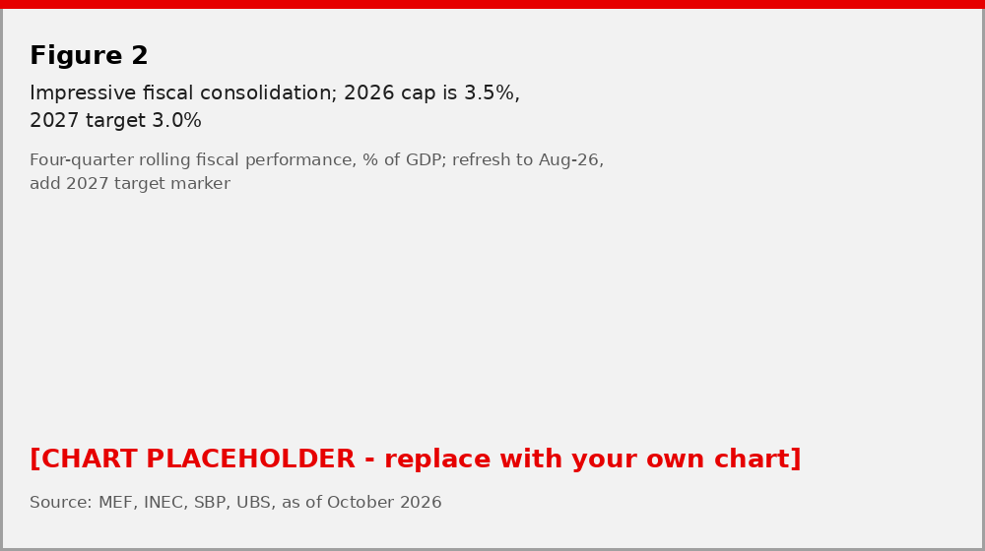
Source: Ministry of Finance, UBS, as of October 2026
Through August, the non-financial public sector deficit stood at USD 3.4bn, or 3.56% of GDP on a year-to-date basis, 14% lower than in the same period of 2025, with revenue growing faster than spending on stronger tax collection and social security contributions. Through July the primary deficit was 0.96% of GDP, down from 1.39% a year earlier. The year-to-date figure sits right at the 3.5% of GDP ceiling set by the fiscal responsibility law for 2026, but the Finance Ministry points out that canal contributions and state-enterprise dividends are concentrated in the final months of the year, which is why the 2025 outturn (3.7%, under a 4% cap) came in better than the mid-year run-rate suggested. The improvement has been on the back of expenditure cuts of ~2 percentage points (pps) of GDP since the 2024 peak, similarly distributed between current and capital expenditures, along with a slight increase in tax revenues in the order of 70 basis points of GDP. Finance Minister Felipe Chapman's stated intention to reach a primary surplus this year now looks a stretch on the year-to-date numbers; a primary balance close to zero is the more likely landing.
For 2027 the budget is USD 35.1bn, essentially flat (+0.6%) on 2026, with a deficit target of 2.97% of GDP and public investment of USD 12.6bn. The rule steps the cap down to 3.0% in 2027 and 1.5% by 2030. Fitch expects capital spending to fall a further 7.5% after a two-decade low in 2025, and part of the 2026 arithmetic rests on a one-off land sale to the Canal Authority worth about 0.2% of GDP; investment, in other words, is still the adjustment variable. The government has ruled out broad tax increases, so the 2027 path depends on evasion control, exemption reviews and the canal's contribution to the State, which the ACP budgets at USD 3.6bn for its FY2027, about USD 414m more than in FY2026.
The 9 October earthquake (magnitude 7.7, Azuero Peninsula) is a test the rule has already passed: the cabinet declared a national emergency with a USD 100m spending ceiling, released only against documented needs, and the Finance Ministry said within 48 hours that the 2026 target "remains intact" and it would not ask Congress for a waiver. Damage so far is concentrated in housing and rural bridges rather than productive capacity.
CLAUDE NOTE Two definitional flags per your standards: (1) the 3.56% is NFPS, year-to-date, as % of full-year GDP - not four-quarter rolling, so it is not directly comparable with your 2Q26 figure of 3.3%; if you want the rolling series, the MEF monthly balance report has the months. (2) The central government deficit through July was 3.54% of GDP (vs NFPS 2.78%) - the gap is CSS. Don't mix the two in Figure 2.
The debt picture has improved
The improvement in fiscal management is finally feeding through to debt metrics. Yes, debt levels remain elevated relative to pre-pandemic norms, but the trajectory is now considerably healthier. Total gross debt has hovered around 65-67% of GDP over the past four quarters, suggesting that stabilization is now within reach and that sustainability risks have subsided. The stock stood at USD 61.9bn in May (about 66% of 2025 GDP), and Moody's expects 66-67% at end-2026, which is where we expect it to stay through 2027. The weighted average cost of debt has fallen to 4.67% from 4.97% in December, a saving the minister expects to approach USD 1bn a year, and the IMF's October mission judged debt sustainable under the baseline as long as the legislated path holds. Interest still absorbs close to 20% of revenue, roughly twice the median of similarly rated sovereigns, which is the metric Fitch watches most closely.
Figure 3 - Debt metrics show that the rising trajectory has come to a halt
% of GDP
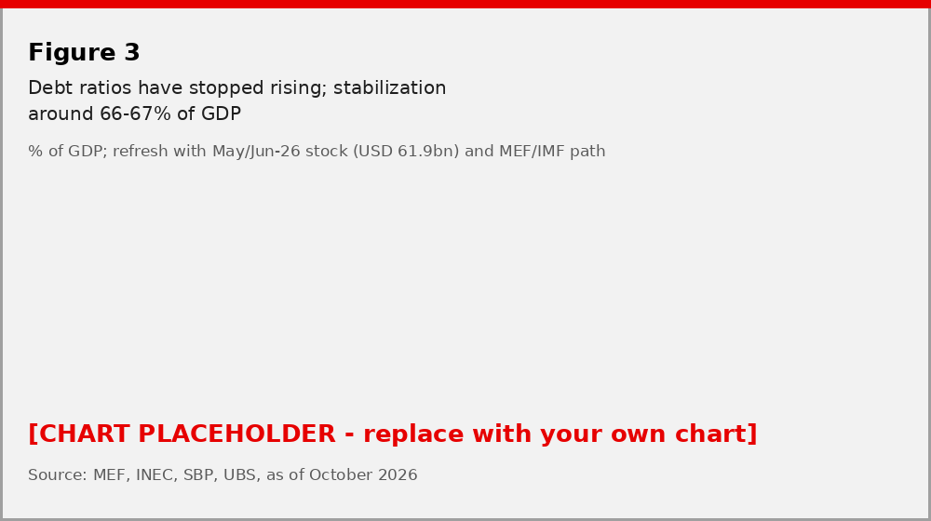
Source: Ministry of Finance, IMF, UBS, as of October 2026. NFPS: Non-financial public sector
Ratings: one reaffirmation, one open question
S&P reaffirmed Panama at BBB- with a stable outlook on 22 September, and Fitch has held BB+ stable since March 2024. The swing factor is Moody's. It rates Panama Baa3 with a negative outlook and, in early September, its regional sovereign lead said publicly that the agency is questioning whether the country should keep its investment grade and intends to resolve the outlook before the end of 2026 - while acknowledging the timing is complicated by the government's decision to defer the mine until after year-end. Because Fitch is already sub-IG, a Moody's downgrade would leave Panama investment grade at a single agency and take the composite rating to BB+, with the index and mandate consequences that implies. Our base case is that Moody's stabilizes the outlook on the fiscal track record, but we would put the odds no better than 60/40, and it is the first thing we will be watching in 2027.
CLAUDE NOTE This section is new. The 60/40 is my framing to make you commit to a number - change or delete it. The "19 percentage points of GDP" adverse-arbitration cost quoted in the press (Rio Times citing Moody's) is large enough that I left it out of the client text until you can confirm it against the Moody's credit opinion.
Dollarization is well supported, but liquidity is not translating into credit
In Panama's dollarized system, bank deposits provide a useful gauge of domestic liquidity. Unlike countries with central banks, net external dollar inflows are reflected in the financial system rather than in international reserves. Persistent inflows from services, foreign investment, and financial deposits are therefore important for supporting credit and economic activity.
Recent trends are reassuring. Since 2024, private sector deposits have increased by roughly USD 5-6 billion annually, equivalent to around 5% of GDP, indicating ample liquidity and continued foreign demand for Panama's financial system. Yet banks have directed much of this liquidity toward financial investments rather than domestic lending. The IMF's October assessment was that the system is well capitalized, profitable and passes its stress tests; what it is not doing, yet, is lending.
Figure 4 - Deposits in the financial system - Sound and rising
USD billions
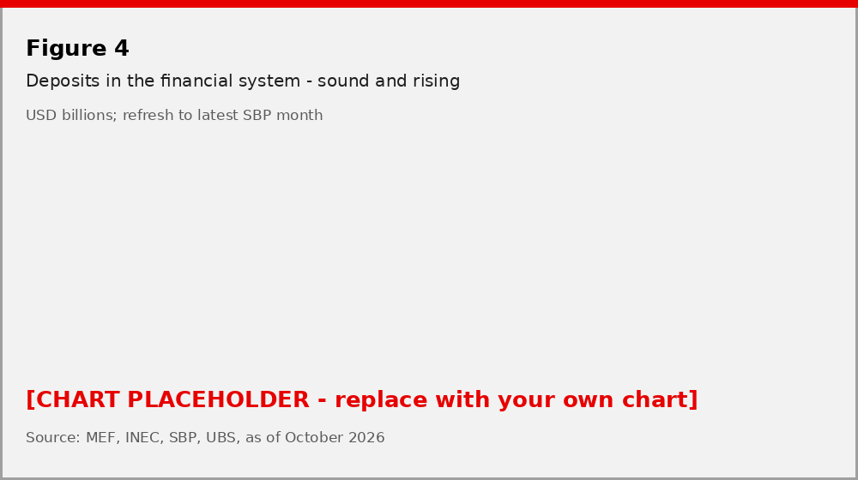
Source: SBP, UBS, as of October 2026
This helps explain an apparent paradox: economic activity is accelerating even as loan growth remains subdued. Liquidity is not the binding constraint. Instead, while domestic projects may offer insufficient risk-adjusted returns, elevated global yields make foreign assets attractive. Panama therefore has the financial capacity to support a stronger credit cycle, but not yet the incentives to generate one. A resolution of the rating overhang and a lower global rate path are the two things most likely to change that calculus in 2027.
Figure 5 - Subdued domestic credit expansion, growing financial investments abroad
Nominal terms, 3-month moving average
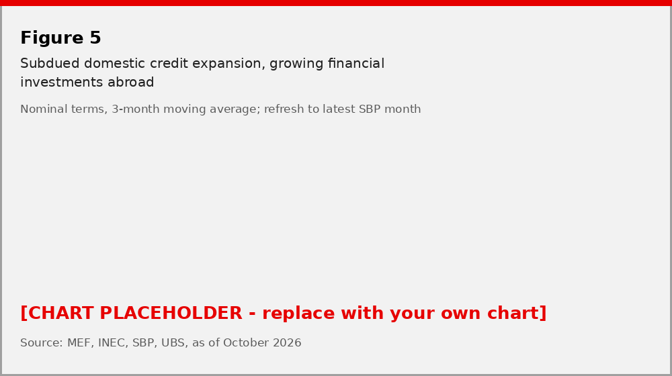
Source: SBP, UBS, as of October 2026
Cobre Panama: a limited restart to pay for closure, not a reopening
The mine file moved in September, though not in the direction a simple "reopening" implies. The state-commissioned environmental audit scored the operator's compliance at about 88% of 370 commitments, and on 30 September an inter-ministerial commission recommended negotiating with First Quantum a strictly time-limited production phase whose proceeds would fund remediation, monitoring and closure - a bill the government puts at USD 2.6-3.4bn if there is no agreement. The commission's criteria require respecting the 2023 Supreme Court ruling and imposing no cost on the budget, and envisage ending the pending arbitrations. As of 9 October the president had not authorized formal talks, and the government has said no decision will come before year-end. Our read: a controlled, finite restart in 2027 is now the central scenario, worth perhaps 0.4% of GDP a year in royalties plus several thousand jobs, but it is not the 2pp-of-GDP step-up that a full reopening would deliver. We no longer build any mine contribution into our growth or fiscal numbers; it is upside.
Mulino may be unpopular, but he is getting the job done
President Jose Raul Mulino has so far followed the path of the majority of Latin American presidents. Starting out with sturdy support, only to later face the backlash of the electorate. His approval rating now sits below 20%, an over 50 percentage point drop relative to 24 months ago. The main driver behind this fall appears to be the perception that the country's 5% growth is not benefiting most citizens, with the gains seen as accruing primarily to the highest income percentiles of the population.
Figure 6 - Approval rating of President Mulino well under water, but governability still solid
%
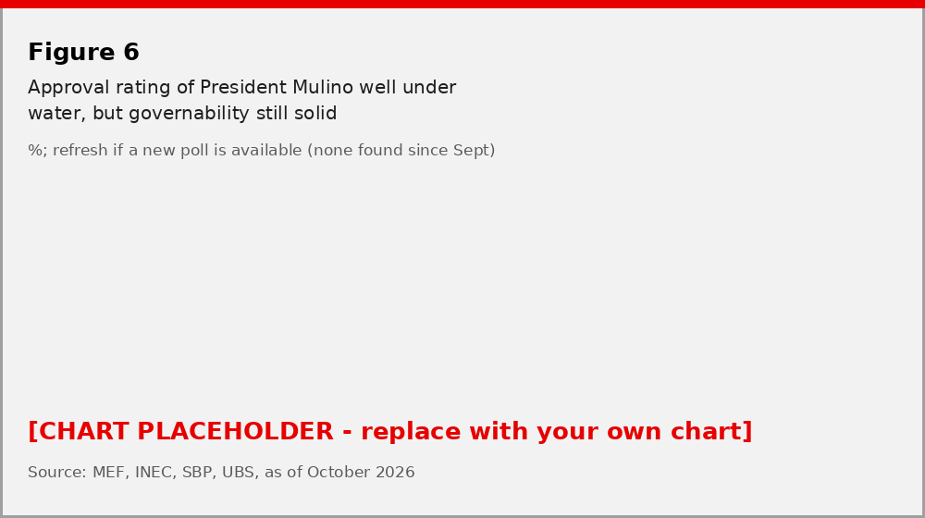
Source: La Estrella de Panama, Centroamerica360, UBS, as of October 2026
Even so, Mulino has so far been able to advance his agenda. He entered office with limited political capital, a fiscal problem to solve, and no reelection option. That gave him space to pursue difficult reforms. Social security reform has passed, fiscal performance has improved, and the mine is being steered toward a negotiated, limited solution. All the while relations with the US remain solid and Panama continues to benefit from the canal, whose FY2027 budget projects USD 5.6bn in revenue (+6.7%) with tolls unchanged. He may be unpopular, but he is getting the job done. Governance risks, for now, remain contained, and with the next general election not until 2029, 2027 is a year in which the administration can still spend political capital it does not have on reforms the fiscal rule requires.
CLAUDE NOTE I found no credible approval poll published since your note (the La Estrella "exclusiva" that search surfaces is from January 2025). "Below 20%" is carried over unchanged - refresh if you have a September/October reading.
Investment implications
At a composite sovereign rating of BBB-, Panama has delivered a total return of [UPDATE: __%] year to date, [in line with / ahead of] the EMBI Global ([+__%]) and ahead of comparable US corporate debt. The country's sovereign USD curve offers yields between 5% and 6%, supported by a solid macro story. We stay constructive for 2027. The macro and fiscal case is the strongest it has been since the pandemic, and spreads of roughly 150bp over Treasuries still embed a discount to BBB- peers that a Moody's outlook stabilization would close. The asymmetry is the point: a downgrade to BB+ composite is the identifiable downside, and we think a 12-month investor is being paid for it. For clients who cannot hold sub-IG paper, the Moody's decision - expected before year-end but possibly slipping into 1Q27 - is the date to manage around.
Figure 7 - Panama USD sovereign bonds offering ~150bps above US treasuries
EMBI global spreads, bp
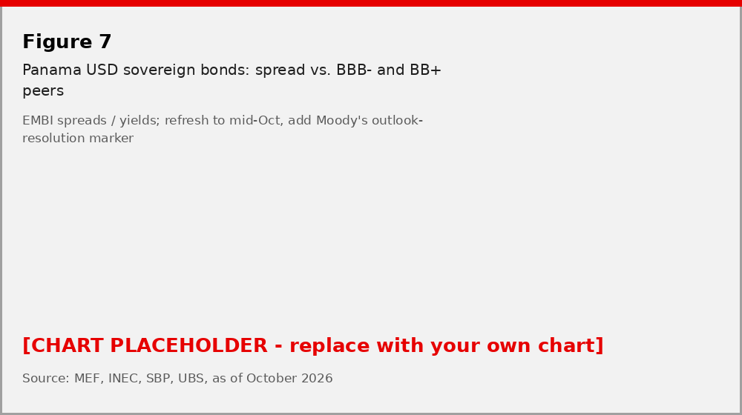
Source: JP Morgan, Bloomberg, UBS, as of October 2026
Key risks include adverse weather shocks that could weigh on activity and canal operations - the ACP is already budgeting for possible El Nino water restrictions in FY2027 - the Moody's outlook resolution, an adverse outcome in the mine arbitrations, and a 2027 deficit target that relies on continued restraint in public investment, as well as the governance risks typically associated with emerging markets.
CLAUDE NOTE Returns and the current spread need a Bloomberg pull; I kept your "150bp" from Figure 6 (now Figure 7) as a placeholder. If the house has an EM USD sovereign preference tag for Panama, the last paragraph should carry it.
Forecast summary
 | 2025 | 2026E | 2027F | Memo: official / IMF
Real GDP growth, % | 4.4 | ~5.5 (was 5.0) | 4.5 (new) | 4.4 CEPAL / ~5 IMF; 2027: 4.6 CEPAL, 4.1 WB
NFPS overall balance, % GDP | -3.7 | -3.5 (at cap) | -3.0 | -2.97 budget
NFPS primary balance, % GDP | ~ -1.0 | ~0.0 | +0.5 to +0.8 | n/a
Gross public debt, % GDP | ~66 | 66-67 | 66-67 | Moody's 66-67
Composite rating | BBB- | BBB- (Moody's neg.) | BBB- base; BB+ risk | S&P BBB- st / Moody's Baa3 neg / Fitch BB+ st
Shaded cells are new or revised versus the September note. 2025 figures per MEF and IMF.
CLAUDE NOTE The 2027 primary balance is my inference from a 3.0% overall deficit less interest of roughly 2.3-2.5% of GDP; replace with the MEF fiscal road-map number if you have it.
This report has been prepared by UBS Financial Services Inc. (UBS FS). Please see important disclaimers and disclosures at the end of the document. [Standard appendix to be appended in BlueMatrix.]

