Shadow-Free Gaussian Splatting
Sun estimation and orientation-guided inpainting: the full process, step by step
First test on one scene: a blue plastic Adirondack chair on grass (capture IMG_6556)
Tests run 12-13 October 2026
How to read this document
Each stage starts with a short "in plain words" box for readers who are not 3D-graphics specialists, then explains what was done, what came out, and what did not work. Every figure has a label printed on the image and a caption underneath. The sections follow the brief's stage order (1 to 5). In practice stage 3 was prototyped first, because the brief names it as the main risk, and stage 2 then used its chair surfaces.
A short glossary of technical terms is at the end.

Contents
1. Summary 3
2. Background: splats, shadows and the idea 4
2.1 What a Gaussian splat is 4
2.2 The problem 4
2.3 The approach in five stages 4
3. Stage 1: capture and 3D reconstruction 5
4. Stage 2: where is the sun? 6
4.1 Method 6
4.2 Improvements, one at a time 6
4.3 Limits 8
5. Stage 3: surfaces and grain 9
5.1 Method 9
5.2 Results 9
5.3 Limits 11
6. Stage 4: which parts are in shadow? 12
6.1 Geometry toward the sun 12
6.2 Brightness: two clear groups 13
6.3 The adjacent brightness-and-colour method 14
6.4 Teaching the shadow detector 16
7. Stage 5: repainting the shadows (first test) 18
7.1 Method 18
7.2 Results 18
7.3 What still needs work 20
8. Limitations and next steps 21
9. Glossary 22

1. Summary
The goal is to take an ordinary video of an object in sunlight and produce a 3D model (a Gaussian splat) with the shadows removed, so the object looks evenly lit and can be relit or placed elsewhere. Instead of simulating the physics of every material, the project treats shadow removal like careful photo retouching in 3D: find which parts are in shadow, then repaint them with the colour of matching sunlit parts of the same surface, following the direction of the surface texture.
All five stages of the brief were tested on one capture. Key results:
Stage | What it does | Result on the chair test
1. Capture and 3D model | Film the object, recover camera positions, build the splat | 650 frames, 2.9 million blobs (about 24,000 on the chair)
2. Sun direction | Find the sun from the shadows the object casts | 55.1 deg elevation vs the true 55.51 deg (from GPS and capture time)
3. Surfaces and grain | Group blobs into surfaces; find each surface's texture direction | Chair splits into seat, slats, arms, legs; grain matches photo texture to 9 deg median (random: 44 deg)
4. Which parts are in shadow | Geometry toward the sun, photo brightness and colour, retrained detector | 45% of the chair in shadow; three independent methods largely agree
5. Repaint the shadows | Borrow colour from sunlit parts of the same surface, along the grain | Shadowed parts lifted to about 87% of sunlit brightness; still blotchy

Everything here comes from a single scene that was not filmed with these tests in mind, so the numbers show that each idea works in principle, not that it generalises. The next capture is the real test.

2. Background: splats, shadows and the idea
In plain words
A Gaussian splat stores a 3D scene as millions of tiny, soft, coloured blobs. From any viewpoint the blobs blend into a photo-realistic image.
The blobs learn their colours from the photos, so whatever shadows were in the photos get painted onto the blobs permanently.
We want to remove those painted-on shadows by repainting the shadowed blobs, using sunlit blobs of the same surface as the colour source.

2.1 What a Gaussian splat is
3D Gaussian Splatting represents a scene as a large set of 3D Gaussians: small ellipsoid-shaped blobs, each with a position, a size along three axes (so it can be flat like a coin or stretched like a grain of rice), an orientation, a colour, and an opacity. To make an image, the blobs are projected into the camera and blended front to back. The blobs are fitted ("trained") so that the rendered images match the input photos.

2.2 The problem
Because the colours are fitted to photos taken under one sun, the shadows are part of the colours. If the object is moved or the lighting changes, the old shadows stay. Full physical decomposition (separating material colour from lighting) is hard and was tried earlier in the project with limited success, so the brief takes a different route.

2.3 The approach in five stages
- Capture and reconstruction: film the object, recover camera positions (Structure from Motion), build the splat.
- Sun estimation: find the sun's direction from the geometry of cast shadows and from shading, not from the splat's colour coefficients.
- Surface clustering with orientation: group blobs into continuous surfaces using geometry, and find each surface's dominant texture direction (its grain) from how the blobs are stretched.
- Visibility check: for each blob, test whether the object itself blocks the sun; blocked blobs are in shadow.
- Orientation-guided inpainting: repaint each shadowed blob from sunlit blobs of the same surface, spreading along the grain. The rule is same surface and lit, not simply the brightest thing nearby.

3. Stage 1: capture and 3D reconstruction
In plain words
We walked around the chair filming it. Software worked out where the camera was in every frame and then built the 3D blob model from the photos.
The capture IMG_6556 is a phone video (iPhone 15 Pro Max, 28 September 2026, 12:58 local time, Savannah, Georgia). 650 sharp frames were extracted. COLMAP (Structure from Motion) recovered all 650 camera poses, and a splat was trained with nerfstudio (splatfacto-big, 30,000 steps, full resolution), kept in COLMAP's coordinate frame so that later stages can reason about the cameras and the sun in the same space. The result has 2,889,332 blobs. The video's metadata records the exact time and GPS position, which gives the true sun position for checking stage 2.

4. Stage 2: where is the sun?
In plain words
Imagine the sun at some position. The chair blocks light, so we can work out the shadow it would cast on the grass. We compare that with the shadow actually seen in the photos, and search all sun positions for the best match.
Because the video records time and GPS, the true sun height was known (55.51 degrees above the horizon), so the method could be tested honestly.

4.1 Method
- Observed shadow: a published shadow detector (SDDNet) marks shadow in every photo. Each ground blob is checked in every frame that sees it, and called shadowed if most frames say so.
- Predicted shadow for a candidate sun: look along the sun's direction; any ground blob with a chair blob between it and the sun is shadowed.
- Search: all sun heights and directions on a coarse grid, then finer around the best, scoring how well predicted and observed shadow agree.

4.2 Improvements, one at a time
Version | Change | Sun height | Error
1 | Everything above the ground casts shadow | 57.0 deg | +1.5 deg
2 | Only the chair casts shadow (grass blades are not real casters; the chair's blobs come from stage 3) | 55.0 deg | -0.5 deg (unstable)
3 | Also use the chair's shadow on itself | 55.5 deg | about 0 (uncertainty 2.5 deg)
4 | Compare shadow outlines instead of shadow areas | 56.3 deg | +0.8 deg (stable)
5 | Also fit the height of the grass tops (about 2 cm) | 55.1 deg | -0.4 deg

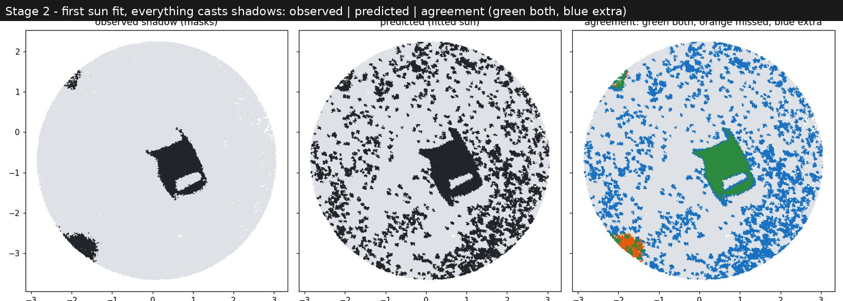
Figure 1. Version 1: observed shadow, predicted shadow and their agreement (green both, blue predicted only, orange observed only). Grass blades and stray blobs cast false shadows across the lawn (blue).
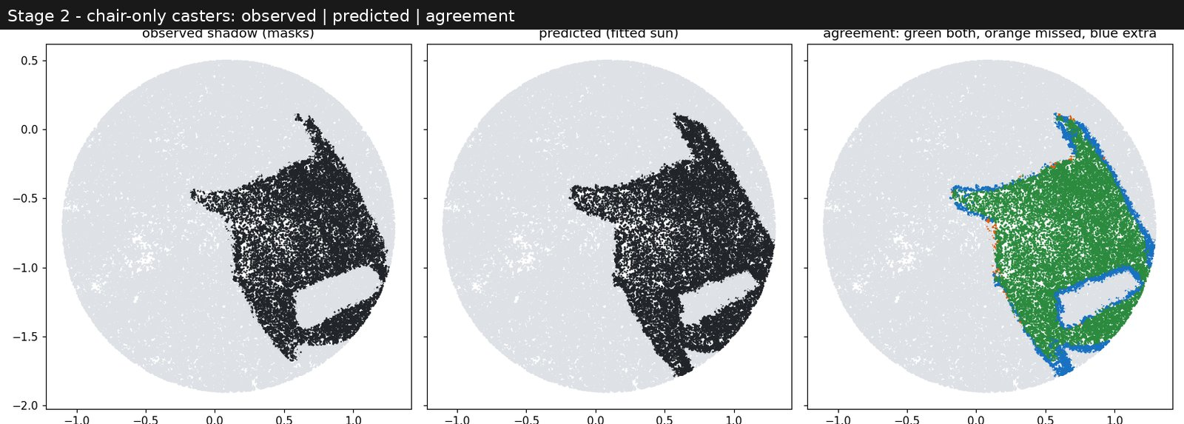
Figure 2. Version 2: only the chair casts shadow. The predicted shadow, including the lit gap under the seat, matches the observed one closely.
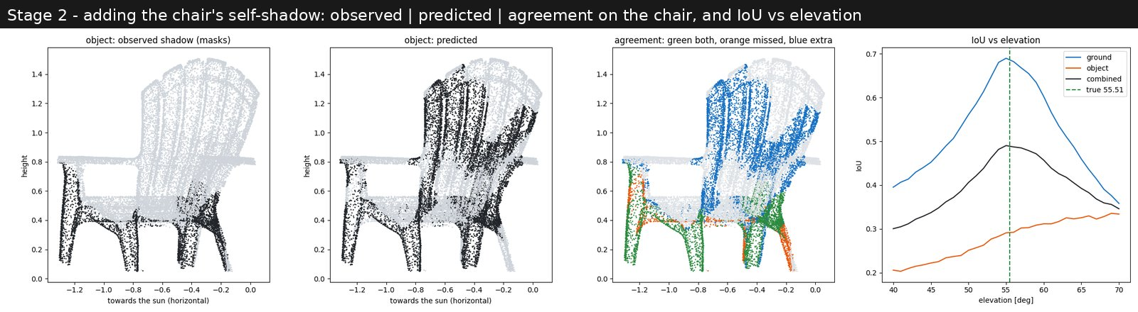
Figure 3. Version 3: adding the chair's shadow on itself. On its own this evidence did not find the sun, because the thin slats confuse the shadow votes.
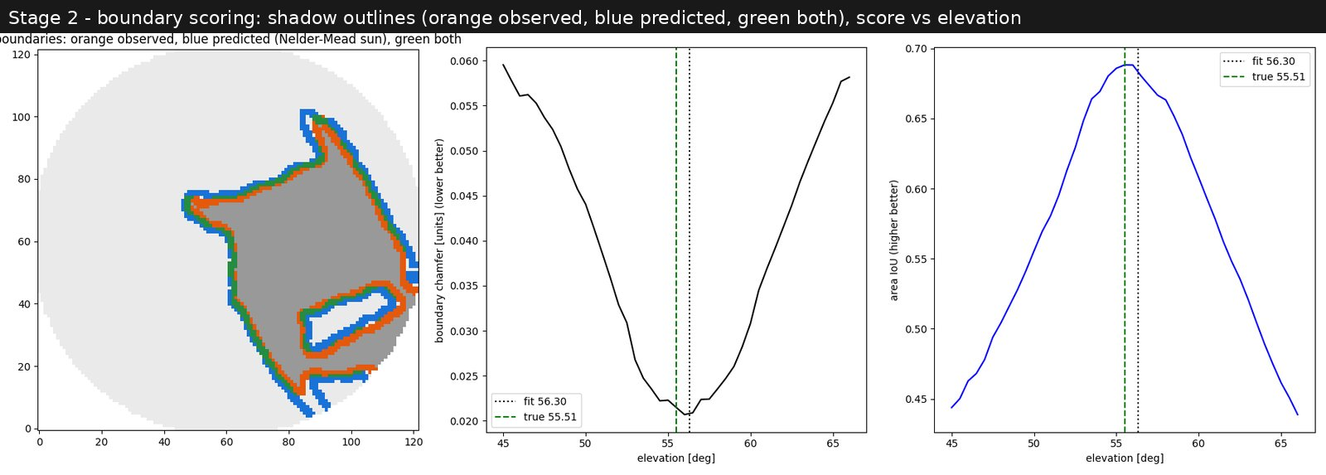
Figure 4. Version 4: comparing outlines. Observed (orange) and predicted (blue) shadow edges overlap almost everywhere (green), to about 1.5 cm.
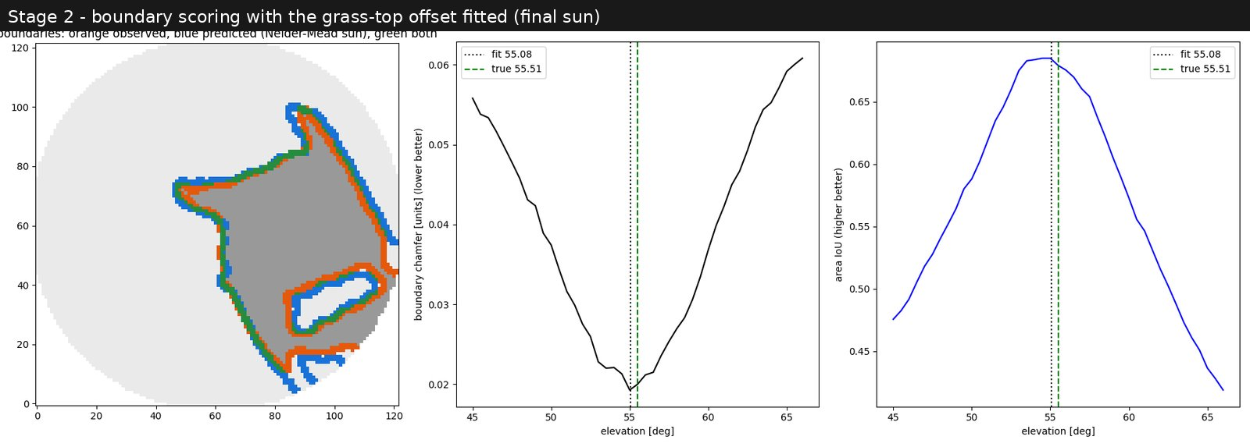
Figure 5. Version 5: final sun, 55.08 degrees against the true 55.51. The shadow edge sits on the grass tops, slightly above the average grass blob, and the method found this offset itself.

4.3 Limits
- On one scene the result should be read as 55 plus or minus about 1 degree; the grass offset is only weakly determined.
- The compass direction of the sun cannot be checked, because nothing in the scene is tied to north.
- The brief's second cue, shading (how brightness changes with surface angle), is not used yet.

5. Stage 3: surfaces and grain
In plain words
To repaint a shadow correctly we must know which blobs belong to the same surface, so colour is never borrowed from a different material.
Flat blobs behave like tiny tiles; the direction a tile faces tells us the surface direction. Neighbouring tiles that face the same way are joined into one surface.
Stretched blobs tend to line up with the surface texture, which gives each surface a grain direction.

5.1 Method
- Each flat blob's thinnest axis is taken as its surface direction (its normal).
- Blobs are linked to their nearest neighbours when they are close and face a similar way.
- Surfaces are grown region by region, admitting a blob only if it faces within 30 degrees of the region's running average direction. This stops a region from creeping around a corner one small step at a time (the first version did exactly that and merged almost the whole chair).
- A check showed that about half the blobs' own directions were unreliable (often 30-45 degrees off). Each blob's direction is therefore also estimated from the positions of its 16 nearest neighbours (fitting a small plane), and only blobs where both estimates agree within 30 degrees drive the grouping.
- Grain: the long axis of each stretched blob, projected onto its surface, is averaged into a dominant direction per surface (and a local direction per blob), with a coherence score from 0 (no grain) to 1 (all parallel).

5.2 Results
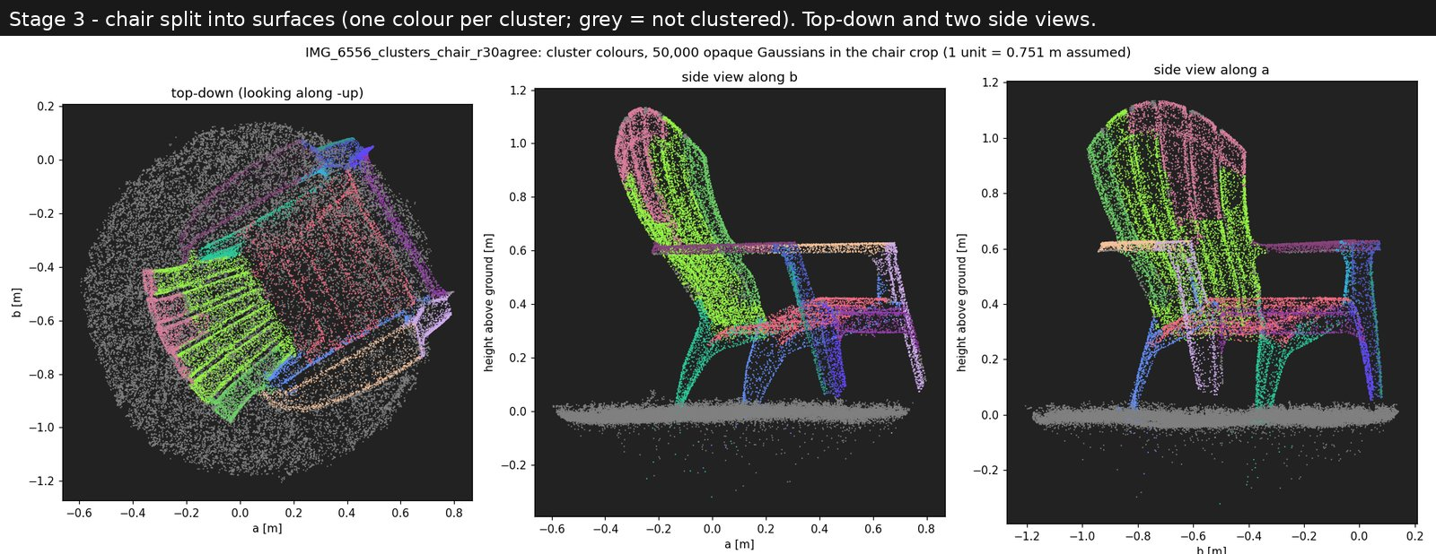
Figure 6. The chair split into surfaces, one colour per surface; grey points belong to no surface (mainly the grass). Seat slats, backrest slats, each arm and each leg come out as separate surfaces.
Checking the grain against reality. The grain was projected into six real photos and compared, pixel by pixel, with the direction of the texture visible in the photo. Two baselines were scored on the same pixels: the grain rotated by 90 degrees, and a random direction.
Pixels compared | Grain | Random direction | Grain rotated 90 deg
Edges and outlines | 5.5 deg | 43.5 deg | 81.8 deg
Flat surface texture only (the real test) | 9.1 deg | 43.6 deg | 79.7 deg

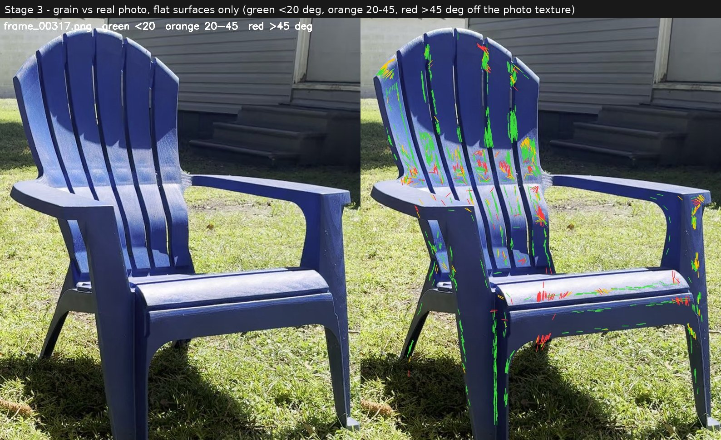
Figure 7. Grain compared with the photo on flat surfaces only: green within 20 degrees, orange 20-45, red over 45. Most red marks sit on the shadow edge, where the photo's texture follows the shadow rather than the plastic.
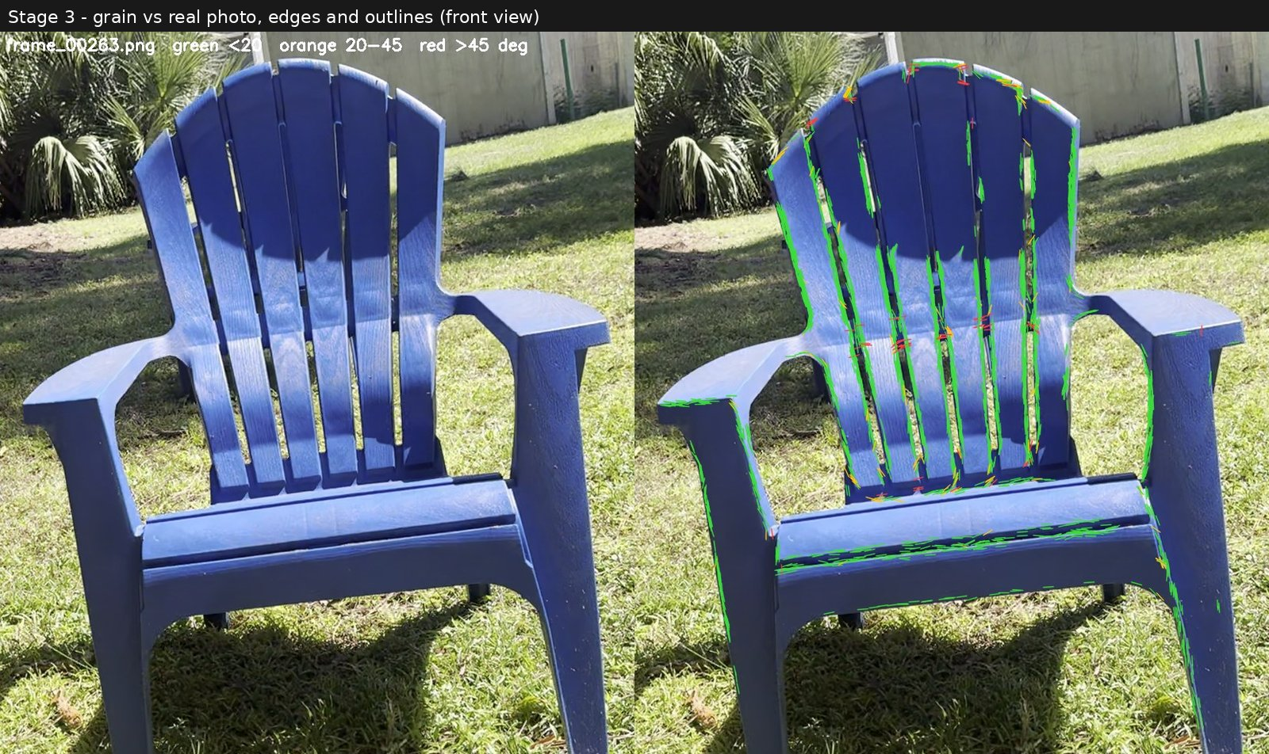
Figure 8. The same check on edges and outlines (front view). Agreement on outlines is partly built into how splats are trained, which is why the flat-surface check above matters more.

5.3 Limits
- Grass does not form clean surfaces (it is not a surface), as expected.
- Many blobs are attached to a surface afterwards without a direction check; these turned out to carry good grain but unreliable surface directions.

6. Stage 4: which parts are in shadow?
In plain words
Three independent methods were used, because each has blind spots. Where they agree, we can trust the answer.
Geometry: with the sun known, check whether the chair blocks the sun from each point, or whether the surface faces away from the sun.
Brightness and colour: shadowed plastic looks much darker and slightly bluer than the sunlit plastic right next to it.
Learning: retrain a shadow detector on labels produced automatically by the first two methods.

6.1 Geometry toward the sun
For each blob, the method looks toward the fitted sun. If another part of the chair is in the way, the blob is in cast shadow. If its surface faces away from the sun, it is in attached shadow; this needs to know which side of each surface faces outward, which was worked out from which cameras can see each blob.
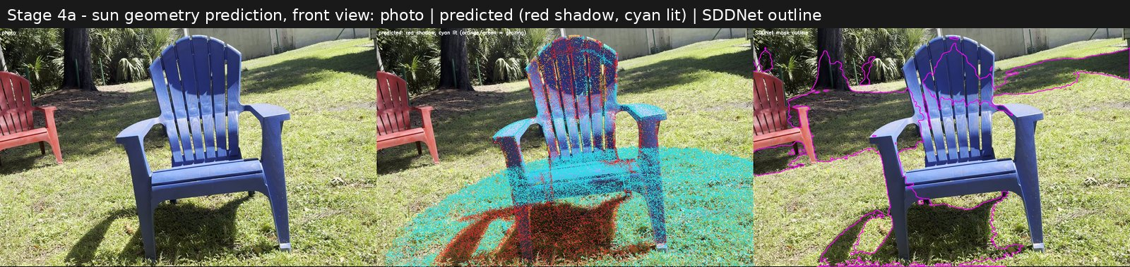
Figure 9. Geometry prediction, front view: photo, prediction (red shadow, cyan lit) and the shadow detector's outline. The predicted ground shadow sits on the real one (98% of it found).
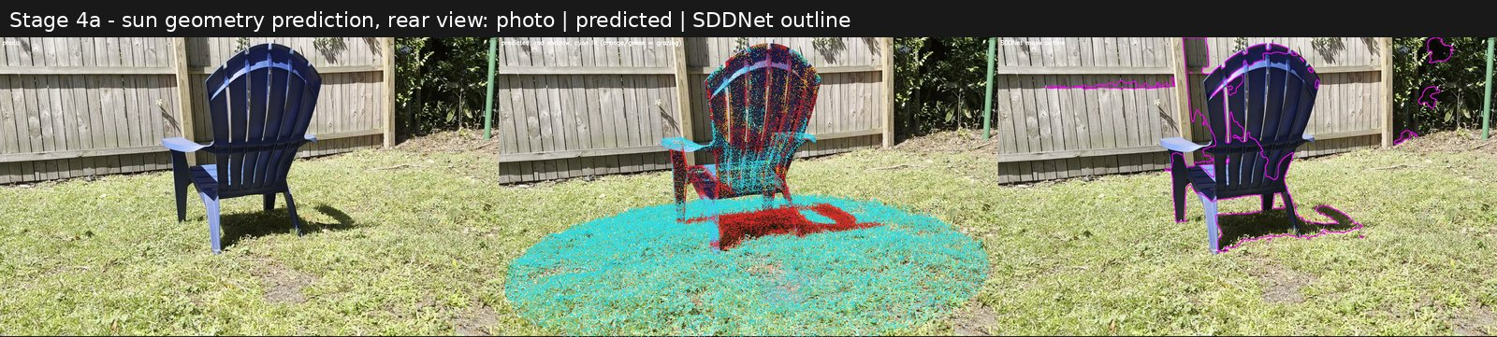
Figure 10. Rear view: the back of the backrest is dark in the photo and predicted as shadow.
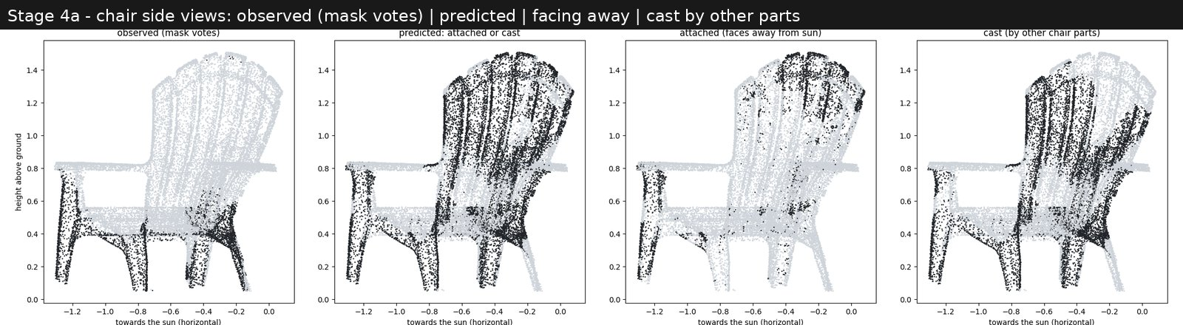
Figure 11. Side views of the chair: observed shadow, full prediction, facing away from the sun, and cast by other parts. Legs and the area under the seat agree; the backrest front, which the sun hits almost edge-on, is over-predicted.

6.2 Brightness: two clear groups
Each chair blob's brightness was read from every photo that sees it directly (about 128 photos per blob). Because the chair is one plastic, brightness differences are almost entirely lighting. The values fall into two clear groups, with sunlit plastic about 13 times brighter than shaded plastic, matching the sun-to-sky ratio measured earlier on the grass.
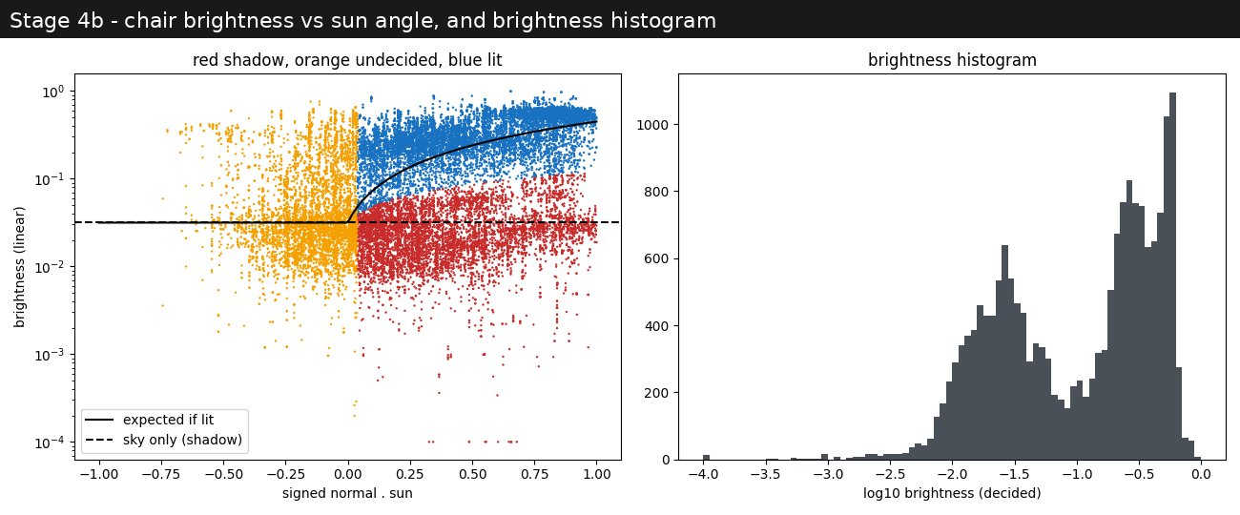
Figure 12. Left: brightness of each chair blob against how directly the sun hits it. Right: histogram of brightness with two clear peaks (shade on the left, sun on the right).
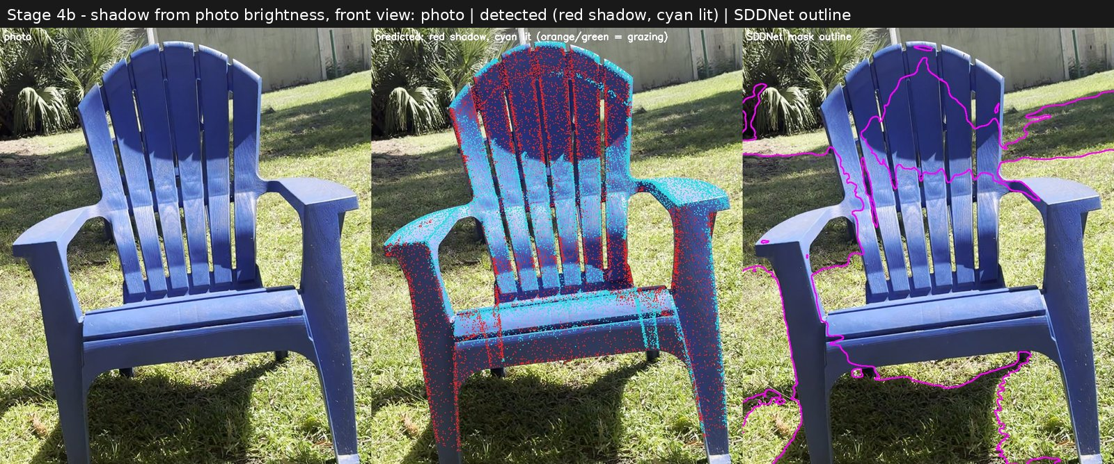
Figure 13. Shadow found from brightness, front view: the dark arc on the upper backrest is detected; the off-the-shelf detector outlines only part of it.
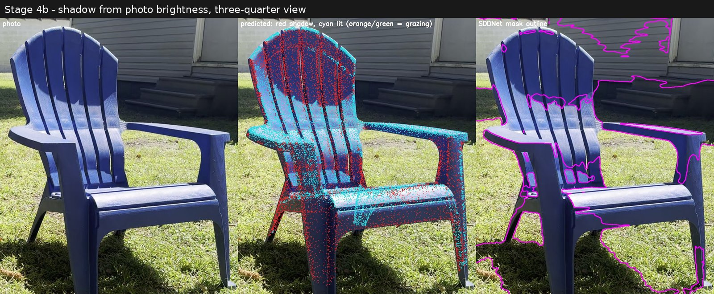
Figure 14. Three-quarter view: shaded upper backrest, sunlit middle band, sunlit arm tops and shaded inner legs all match the photo.

6.3 The adjacent brightness-and-colour method
Rather than one split for the whole chair, each point is compared with the sunlit parts around it (within about 30 cm). It is called shadow if it is less than 0.3 times as bright as its sunlit neighbours and its colour still matches them, so darker paint is not mistaken for shadow. If a whole neighbourhood is dark (for example under the seat), the neighbourhood itself is compared with the sunlit end of the same colour across the chair.
A useful finding: shaded spots differ in colour from their sunlit neighbours about twice as much as sunlit spots do, always shifted toward blue, because shade is lit only by blue sky. That colour shift is a real, measurable signature of shadow. The method finds 44.5% of the chair in shadow and agrees with the geometry method on 69% of points. Its real advantage should show on objects with more than one colour, where a single split for the whole object fails.
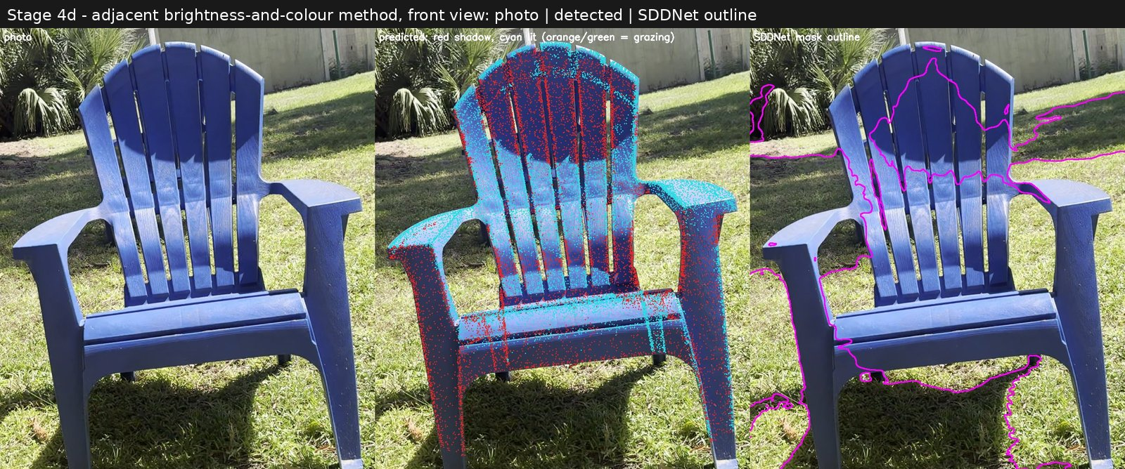
Figure 15. Adjacent brightness-and-colour method, front view: photo, detected shadow (red) and the off-the-shelf detector's outline.
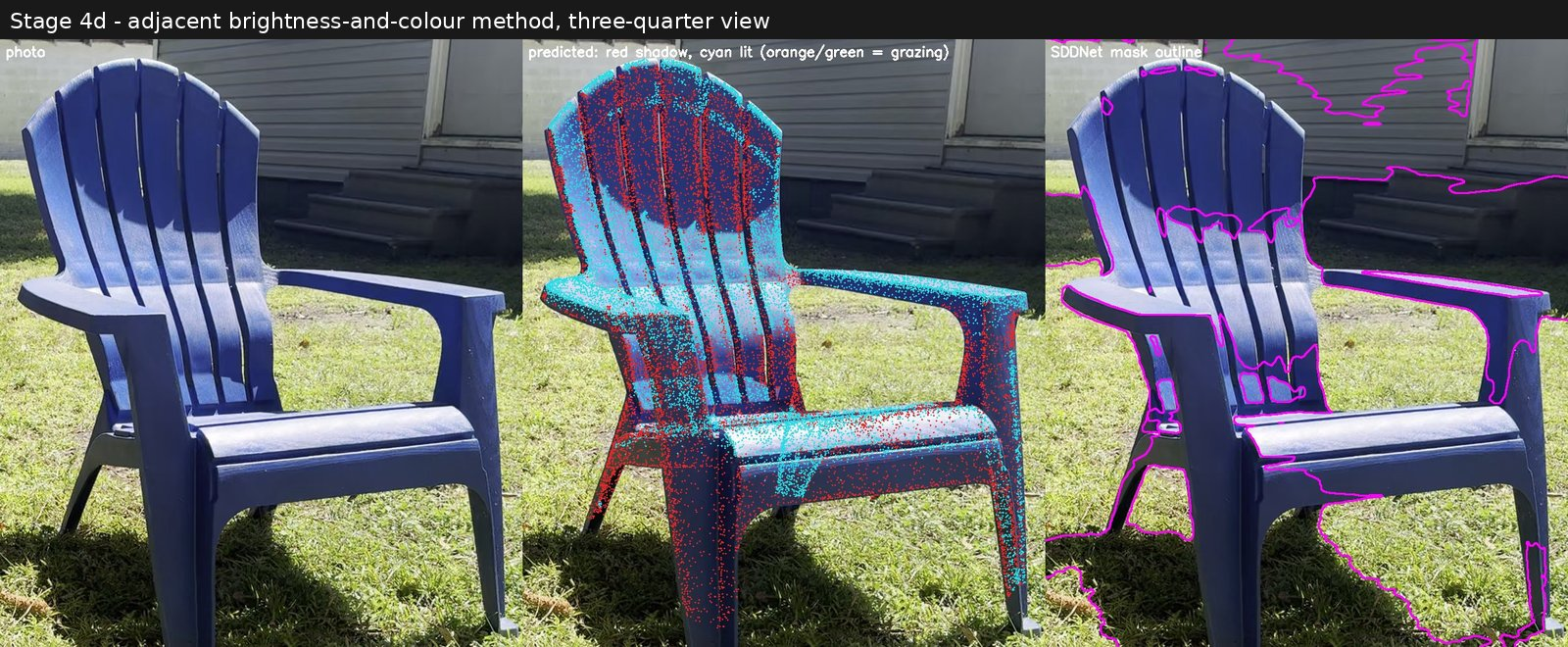
Figure 16. Adjacent method, three-quarter view.
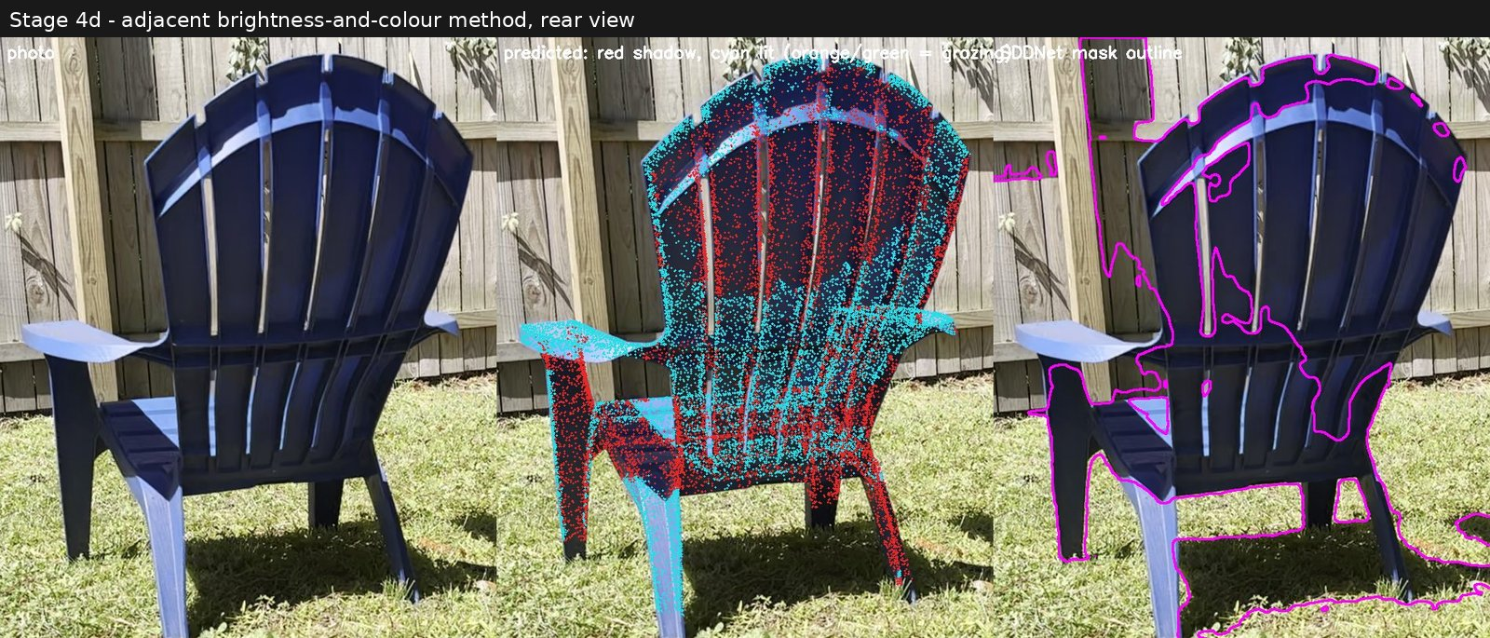
Figure 17. Adjacent method, rear view. Some sunlit front-face points show through the thin slats; this is a display limitation of drawing points on a photo.

6.4 Teaching the shadow detector
The published detector (SDDNet) misses most shadow on the dark navy chair. Training examples were generated automatically, with no hand labelling: the detector's own masks everywhere except the chair, and the 3D chair labels projected onto the chair. A thin ring around the chair outline was excluded from training. The detector was then fine-tuned for about 2.5 minutes on the first 80% of the video and checked on the last part, which it never saw.
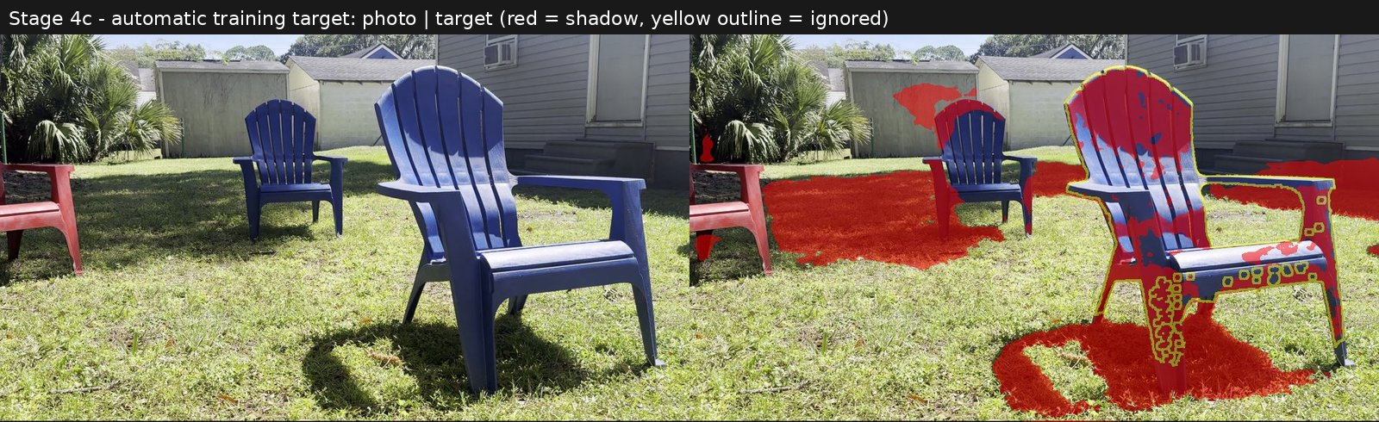
Figure 18. An automatically generated training example: photo and target (red shadow; the yellow outline is excluded from training).
Detector | Chair shadow found | Agreement with brightness labels | Agreement with sun geometry
Original, frames never trained on | 15% | 0.22 | 0.21
Retrained, frames never trained on | 33% | 0.55 | 0.48

Agreement is measured as overlap (intersection over union, 1 = identical). The geometry column is the more convincing one, because the geometry method did not produce most of the training labels; its agreement more than doubled.
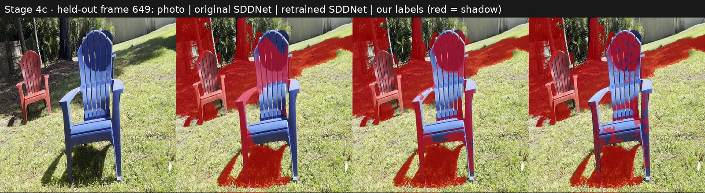
Figure 19. A frame never used in training: photo, original detector, retrained detector, and the 3D labels (red = shadow). The retrained detector marks the whole backrest arc and the shaded inner sides.
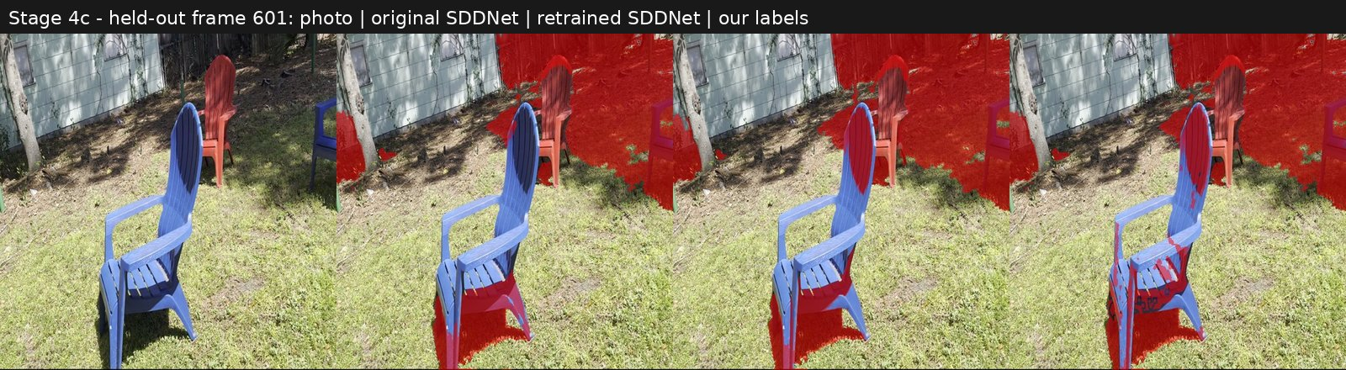
Figure 20. Another frame never used in training, same layout.

7. Stage 5: repainting the shadows (first test)
In plain words
Each shadowed blob takes its colour from sunlit blobs on the same surface, preferring ones that lie along the surface's grain, so stripes and texture keep their direction.
Two ways of applying the colour were compared: copying it outright, or keeping the blob's own texture and brightening it by the sunlit-to-shaded ratio.

7.1 Method
- For each shadowed chair blob (11,287 of 24,445), the 8 nearest sunlit blobs on the same surface are chosen, with sideways steps across the grain counting four times as much as steps along it.
- Very dim "sunlit" blobs (edge-of-shadow and barely lit) are not used as colour sources.
- Copy mode: the blob takes the weighted average colour of its sources. Ratio mode: the blob keeps its own colour variation and is multiplied by the ratio of the sunlit sources to its shadowed neighbours along the grain.
- Two small surfaces under and inside the chair are almost entirely in shadow, so there is no sunlit blob on the same surface; they borrow from the nearest sunlit blobs on any chair part (12.5% of shadowed blobs). This breaks the same-surface rule and is flagged.

7.2 Results
The median brightness of the shadowed blobs rose from 0.026 to about 0.23, against 0.26 for the sunlit parts, so shadows were lifted to about 87% of sunlit brightness. Renders from the real camera positions:
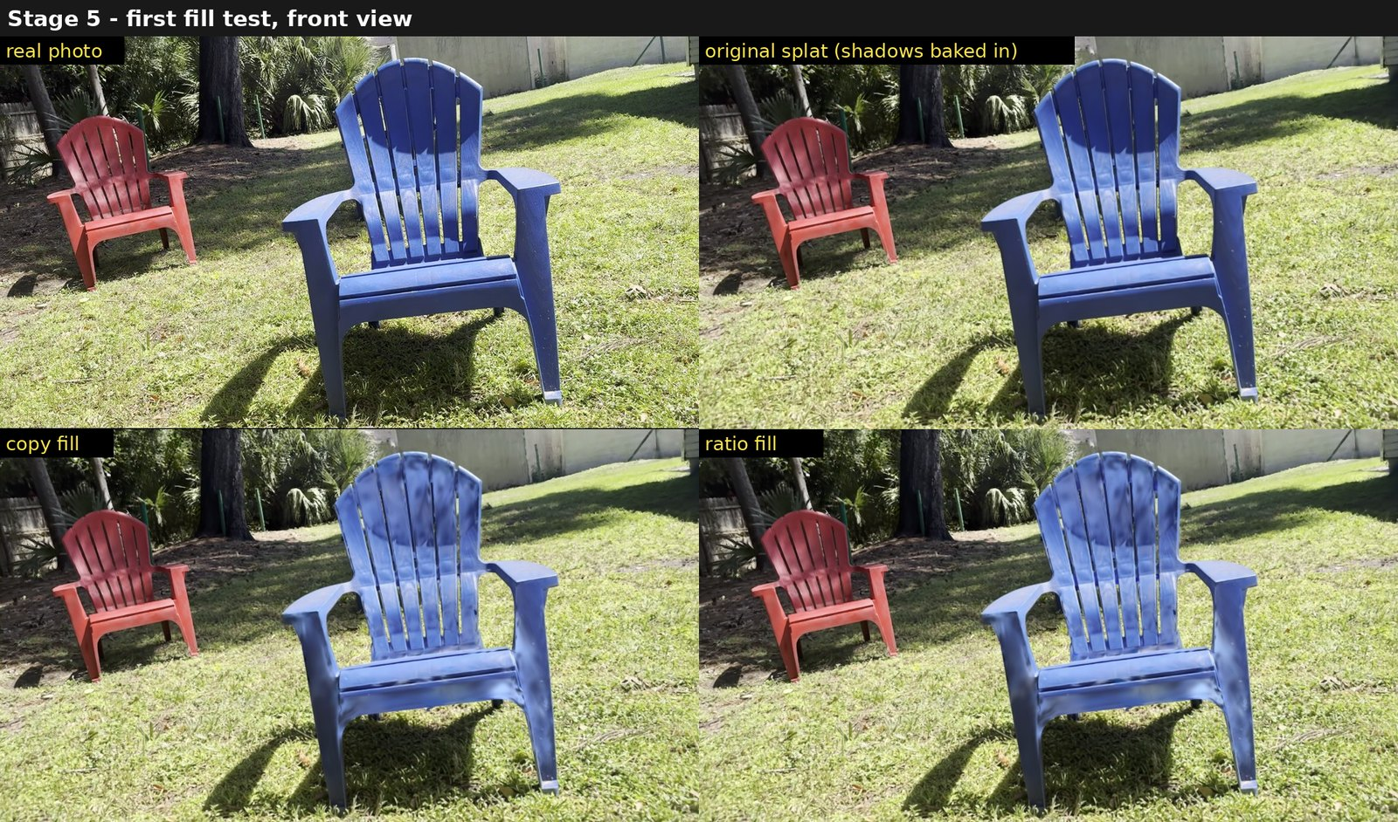
Figure 21. Front view: real photo, original splat, copy fill, ratio fill. The dark arc on the backrest and the shaded inner legs are mostly lifted.
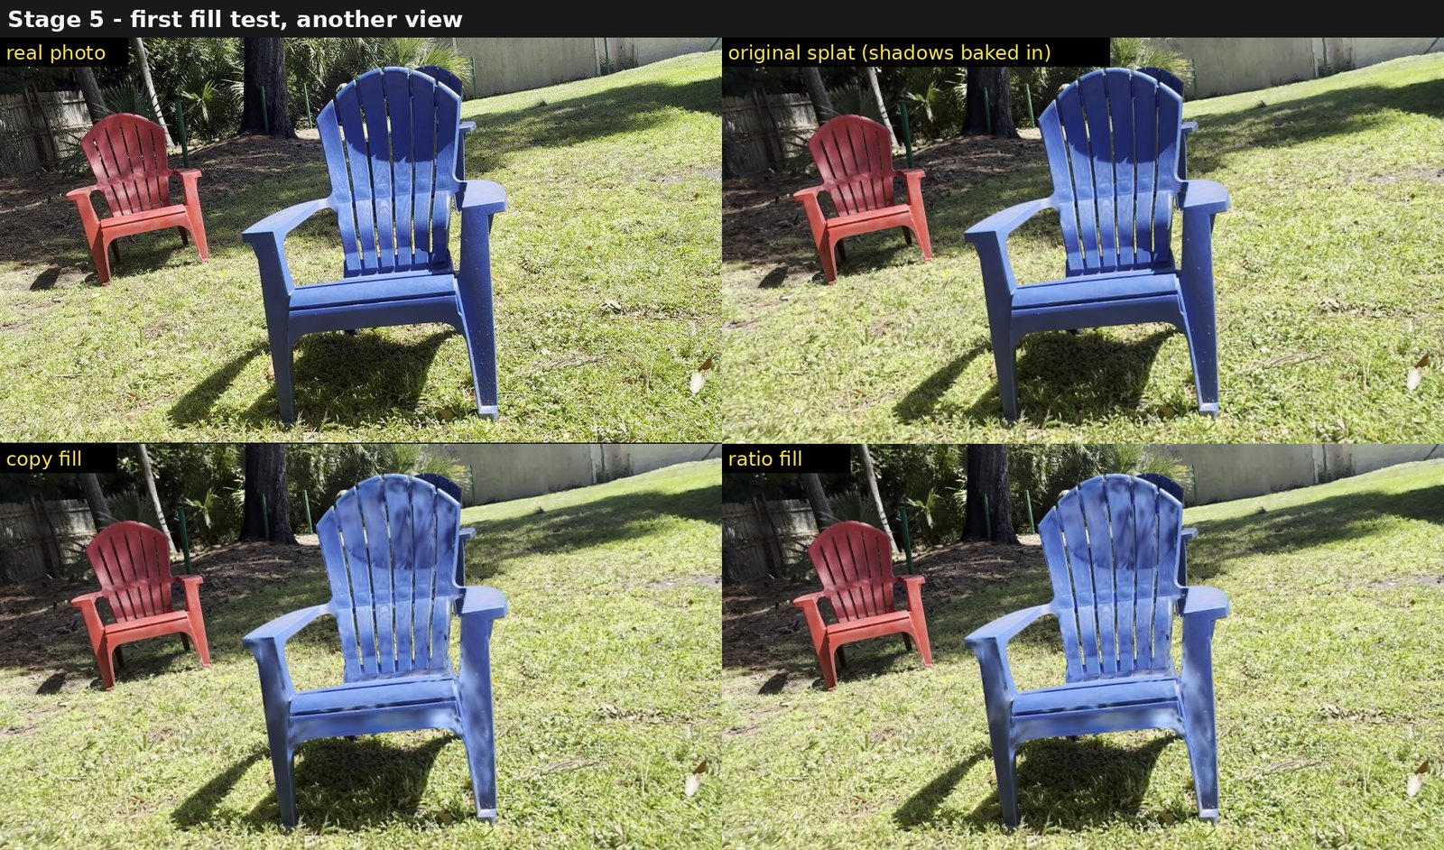
Figure 22. Another view, same layout. Copy mode looks flatter and slightly too light; ratio mode keeps more of the plastic texture.
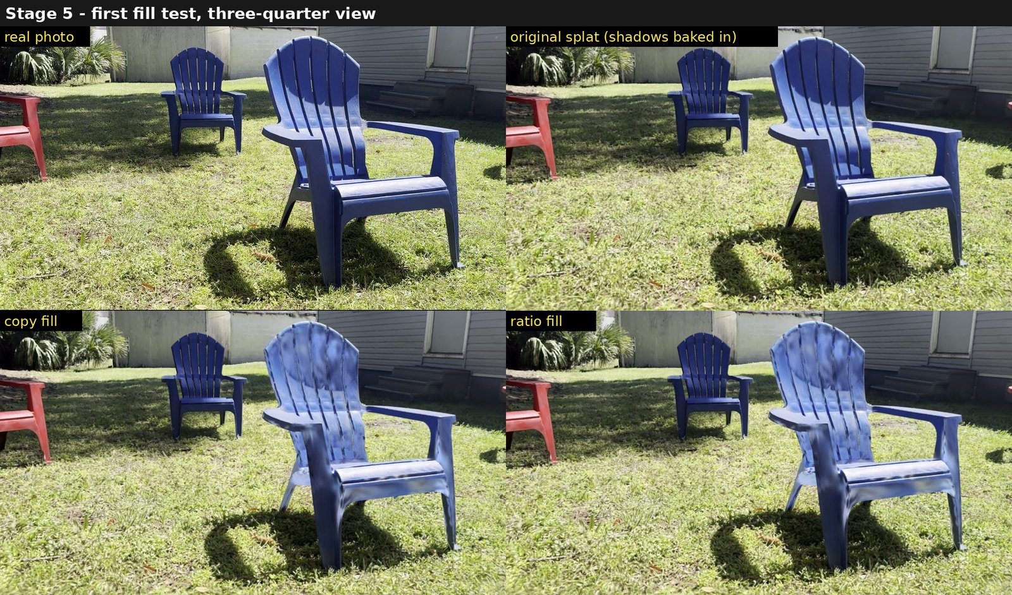
Figure 23. Three-quarter view, same layout.

7.3 What still needs work
- Mottling: the shadow labels are speckled, so neighbouring blobs are filled differently. The labels need smoothing in 3D and the fill needs blending across shadow edges.
- Colour match: brightness and hue are close to, but not exactly, the real sunlit plastic.
- Thin parts: the front and back of 2-3 cm slats interfere with each other.
- Ground shadow: the chair's shadow on the grass is not filled yet; this first test covered the chair only.
- Large or textured regions: the brief suggests a learned or diffusion-based image prior on top of this geometric fill for polish.

8. Limitations and next steps
- One scene: everything was tested on one chair in one capture that was not filmed for these tests (the grass especially). A new capture is the real test.
- Capture quality: about half of the blobs' surface directions were unreliable. Filming in loops at several heights, closer, with straight-on views of each surface and soft light would help every stage.
- Sun from shading: the brief's shading cue is not used yet.
- Next: smooth the 3D shadow labels and blend the fill, test on a new capture, and compare the original and retrained detectors there.

9. Glossary
Term | Meaning
Gaussian splat (3DGS) | A 3D scene made of millions of small, soft, coloured, semi-transparent blobs that blend into an image from any viewpoint.
Blob / Gaussian | One element of the splat: position, size along three axes, orientation, colour, opacity.
Structure from Motion (SfM) | Software (here COLMAP) that recovers where the camera was for each photo, from the photos alone.
Normal | The direction a surface faces, perpendicular to it.
Grain | The dominant direction of the surface texture (for example the moulded lines along a slat).
Cluster / surface | A group of neighbouring blobs that form one continuous surface.
Cast shadow | Shadow caused by another object (or another part of the same object) blocking the sun.
Attached shadow | Shadow on a surface that faces away from the sun.
Elevation | The sun's height above the horizon in degrees.
IoU (intersection over union) | Overlap between two shadow maps: shared area divided by combined area; 1 means identical.
Held-out frames | Frames deliberately not used for training, so that results on them show real generalisation.
SDDNet | A published neural network that marks shadows in photos.
Fine-tuning | Continuing to train an existing neural network briefly on new examples.

