Shadow-Free Gaussian Splatting
Sun estimation from cast-shadow geometry and surface-aware inpainting of 3D Gaussian splats
Bhanu Singh
Research report, 26 October 2026
Experiments: IMG_6556 (chair on grass, 12-13 October 2026) and IMG_6704 (painted bear on concrete, 21-26 October 2026)
Abstract. A 3D Gaussian splat trained from photos taken under one sun stores the cast shadows of that moment in the colours of its Gaussians, so the shadows travel with the model when it is moved or relit. Rather than decomposing the scene into materials and lighting, we treat shadow removal as surface-aware inpainting in 3D. The pipeline (i) reconstructs a splat from a phone video, (ii) estimates the sun direction from the geometry of the object's cast shadow by orthographic shadow mapping and boundary chamfer matching, (iii) groups Gaussians into surfaces and measures each surface's texture direction (grain) with a structure tensor, (iv) labels every Gaussian as sunlit, attached shadow or cast shadow, and (v) repaints shadowed Gaussians from sunlit Gaussians of the same surface, searched along the grain. On the ground, a clone-stamp procedure replaces the shadowed Gaussians with translated copies of nearby sunlit ones, carrying their colour and their geometry. On a chair scene the sun elevation is recovered to 0.43 degrees (55.08 against the true 55.51 from GPS and capture time). On a painted bear figurine it comes out 4.98 degrees high, and the object-side stages fail on multi-coloured, curved surfaces, for reasons we analyse. The ground shadow on concrete, which a per-Gaussian gain lifted only to 63% of the surrounding sunlit brightness, reaches 97% with the clone stamp, with fine-detail contrast restored to 87-101% of the surrounding concrete. We show that the residual smudge of colour-only fills comes from geometry: Gaussians trained on the dark shadow are 1.7 times larger than those on sunlit concrete.
Keywords: 3D Gaussian splatting, shadow removal, sun estimation, shadow mapping, chamfer matching, structure tensor, exemplar-based inpainting, clone stamp.

Contents
1. Introduction 3
2. Background and notation 4
2.1 Gaussian splats 4
2.2 Why shadows are baked in, and the alternative 4
2.3 Coordinates 4
3. Method 4
3.1 Stage 1: capture and reconstruction 4
3.2 Shadow votes: from 2D masks to Gaussians 5
3.3 Notation for the scene region 5
3.4 Stage 3: surfaces and grain 5
3.5 Stage 2: the sun from cast-shadow geometry 6
3.6 Stage 4: visibility toward the sun 7
3.7 Shadow from appearance 7
3.8 Fine-tuning the shadow detector 7
3.9 Stage 5: repainting the object 8
3.10 Ground shadow 8
3.11 Evaluation measures 10
4. Experiment 1: a plastic chair on grass (IMG_6556) 10
4.1 Surfaces and grain 10
4.2 Sun estimation 12
4.3 Shadow on the chair 13
4.4 Fine-tuned detector 16
4.5 Repainting the chair 17
4.6 Ground shadow on grass 19
5. Experiment 2: a painted bear figurine on concrete (IMG_6704) 19
5.1 Surfaces and grain 19
5.2 Sun estimation 20
5.3 Shadow on the bear 21
5.4 Repainting the bear 22
5.5 Ground shadow on concrete 23
6. Discussion and limitations 26
6.1 Chair scene 27
6.2 Bear scene 27
6.3 General 27
7. Conclusion 27
References 27
Appendix A. Main parameters 28
Appendix B. Software 28

1. Introduction
3D Gaussian Splatting (3DGS) [1] represents a scene as millions of anisotropic 3D Gaussians whose colours are fitted so that rendered images match a set of photographs. When the photographs are taken outdoors under direct sun, the Gaussians learn the appearance of the scene under that sun: shaded and shadowed regions are stored as dark colours. The model then cannot be relit, moved to another scene, or viewed under another time of day without carrying its old shadows along.
The standard answer is inverse rendering: decompose each Gaussian's colour into albedo, normal and lighting and re-render. We tried two such methods early in this project (GS-IR [5] and GaussianShader [6]). With a single hard sun and one capture, the hard cast shadows stayed in the recovered albedo. This report therefore follows a different route, set out in the project brief: treat shadow removal as careful retouching in 3D. Find which Gaussians are in shadow and why (which surface, which sun direction), then repaint them from sunlit Gaussians of the same surface, following the direction of the surface texture. The rule is “same surface and lit, not simply the brightest thing nearby”.
Scope. One dominant light (the sun), one hero object per scene, ordinary phone video. The contributions are:
- Sun from cast-shadow geometry: an orthographic shadow-map predictor shared by sun estimation and visibility, scored by boundary chamfer distance with a fitted receiver offset (section 3.5).
- Surfaces and grain from Gaussian shape alone: region growing on agreed normals and a structure tensor of the Gaussians' long axes; colour is never used, so a shadow edge never splits a surface (section 3.4).
- Shadow labels from three independent cues: geometry toward the sun, an adjacent brightness-and-colour rule, and a shadow detector fine-tuned on automatically generated 3D labels (sections 3.6-3.8).
- Fills: along-grain, same-surface repainting on the object (section 3.9); on the ground, a progression from a per-Gaussian gain to a colour clone stamp and finally a geometry clone stamp with crack-aware source selection (section 3.10).
- Evaluation against ground truth where it exists: the true sun from GPS and capture time, and render-based measures of brightness and texture against the sunlit surroundings (section 3.11).
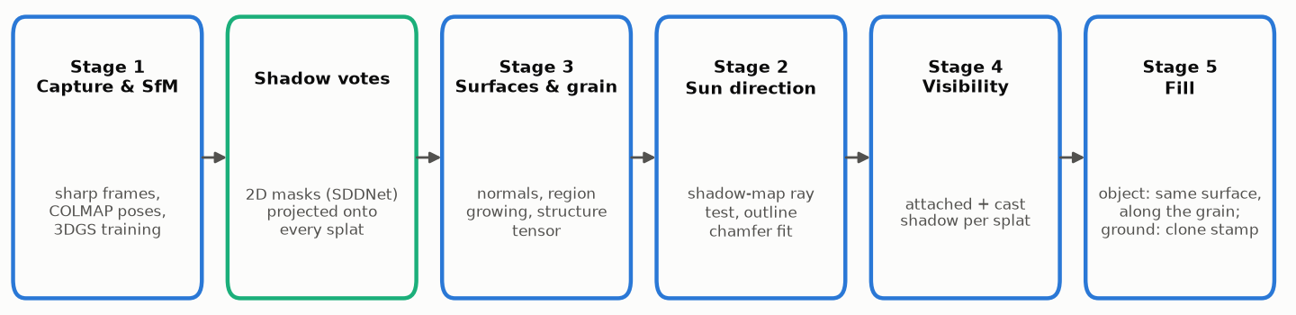
Figure 1. Pipeline overview. The stage numbers follow the project brief; stage 3 is run before stage 2 because the sun fit uses the object's surfaces as shadow casters. The shadow votes (green) are a shared input: 2D shadow masks from every frame, transferred onto the Gaussians.
Section 2 covers the background and notation, section 3 the method with the mathematics of each step, and sections 4 and 5 the two experiments. Each experiment is reported on its own; comparisons between scenes are deferred to a later report, once all planned tests are done (section 6).

2. Background and notation

2.1 Gaussian splats
A splat is a set of Gaussians i = 1..N. Each has a centre μᵢ, a rotation Rᵢ (stored as a quaternion), three scales sᵢ (stored as logarithms), an opacity αᵢ (stored as a logit) and a colour given by spherical-harmonic (SH) coefficients. Its density and covariance are
$$\begin{aligned}G_{i}\left(x\right)=α_{i}\exp\left(-\frac{1}{2}{\left(x-μ_{i}\right)}^{⊤}Σ_{i}^{-1}\left(x-μ_{i}\right)\right), Σ_{i}=R_{i}S_{i}S_{i}^{⊤}R_{i}^{⊤}, S_{i}=\text{diag}\left(s_{i}\right)\#\left(1\right)\end{aligned}$$
An image is formed by projecting the Gaussians into the camera, sorting them by depth and alpha-compositing front to back, where α′ is the projected opacity at pixel p and cᵢ the view-dependent colour [1]:
$$\begin{aligned}C\left(p\right)=\sum_{i}{c_{i}α_{i}^{'}\left(p\right)\prod_{j<i}{\left(1-α_{j}^{'}\left(p\right)\right)}}\#\left(2\right)\end{aligned}$$
The view-independent (base) colour comes from the zeroth SH coefficient, with C₀ = 0.28209. All brightness arithmetic in this work is done in linear light, with luminance Y as the brightness measure:
$$\begin{aligned}c_{i}=\frac{1}{2}+C_{0}f_{dc,i}, c^{lin}={\left(\frac{c+0.055}{1.055}\right)}^{2.4}, Y=0.2126 R+0.7152 G+0.0722 B\#\left(3\right)\end{aligned}$$
Colour changes are applied to the base colour and, with the same per-channel factor, to the higher SH coefficients, so the view-dependent part follows. No step in this work changes a Gaussian's position, shape or opacity, except the geometry clone stamp of section 3.10.3, which deletes and adds whole Gaussians.

2.2 Why shadows are baked in, and the alternative
Training minimises the photometric error to the input photos only. Under one sun, a ground point inside a cast shadow is always seen dark, so its Gaussians are fitted dark; there is no observation of that point in sunlight. Inverse rendering must explain the darkness through visibility and lighting, which is under-determined with one light and one capture. Our approach instead makes the missing observation explicit: it borrows it from a sunlit part of the same surface, in the spirit of exemplar-based image inpainting [12] and patch-based texture synthesis [13], but in 3D and guided by geometry.

2.3 Coordinates
The splat is kept in the coordinate frame of the Structure-from-Motion model, so cameras, Gaussians and the sun share one space. Camera k has rotation Rₖ, translation tₖ and projection πₖ, so a point x maps to the pixel u = πₖ(Rₖx + tₖ) at depth zₖ(x). The ground plane has unit normal u (pointing up) and offset d, so the height of a point is h(x) = u·x + d. Distances are in scene units; their size in metres depends on the scene (about 1.33 units per metre for the chair scene and about 12 units per metre for the bear scene).

3. Method

3.1 Stage 1: capture and reconstruction
Phone video is decoded and split into N equal windows (N = 650); in each, the frame with the highest variance of the Laplacian is kept, a standard focus measure [16]:
$$\begin{aligned}k^{*}=\arg{\max_{k∈W}{}\text{Var}\left(∇^{2}I_{k}\right)}\#\left(4\right)\end{aligned}$$
COLMAP [2] recovers camera poses and intrinsics; only the largest sub-model is kept and the frame count is checked against the input. The splat is trained with nerfstudio's splatfacto-big [3] for 30,000 steps at full resolution, with camera-pose refinement and with nerfstudio's re-orientation and re-centring switched off, so the splat stays in the COLMAP frame.

3.2 Shadow votes: from 2D masks to Gaussians
A published shadow detector, SDDNet [4], gives a binary mask Mₖ for each frame. Each Gaussian i is projected into every frame (every second frame in practice). It counts as visible in frame k (Vᵢₖ = 1) when it is in front of the camera, inside the image and not behind the nearest opaque surface. That surface is a coarse z-buffer Zₖ built from the Gaussians with α > 0.5 at a quarter of the image resolution, with relative tolerance τ = 0.03. Each Gaussian's shadow fraction is the share of its visible views in which it falls inside the mask:
$$\begin{aligned}V_{ik}=\left[z_{k}\left(x_{i}\right)≤\left(1+τ\right)Z_{k}\left(u_{ik}\right)\right], f_{i}=\frac{\sum_{k}{V_{ik}M_{k}\left(u_{ik}\right)}}{\sum_{k}{V_{ik}}}\#\left(5\right)\end{aligned}$$
Gaussians seen in fewer than 5 frames are ignored. A Gaussian is observed in shadow when fᵢ ≥ 0.5. For brightening, a soft weight ramps between two thresholds (lo, hi):
$$\begin{aligned}w_{i}=\text{clip}\left(\frac{f_{i}-lo}{hi-lo},0,1\right)\#\left(6\right)\end{aligned}$$
The ground plane is found by RANSAC [11] over opaque Gaussians. Three random centres define a candidate plane n, which is accepted only if it is roughly perpendicular to the mean camera up direction u_{cam} (|n·u_{cam}| ≥ 0.8). The candidate with the most inliers within a band ε wins and is refined by a least-squares fit (SVD) of its inliers:
$$\begin{aligned} \left(n,d\right)=\arg{\max_{\left|n⋅u_{cam}\right|≥0.8}{}\left|\left\{x:\left|n⋅x+d\right|<ε\right\}\right|}\#\left(7\right)\end{aligned}$$

3.3 Notation for the scene region
The hero object is located as the least-squares focus of the camera viewing rays, and its Gaussians as the opaque column above the plane at that point. Ground receivers are Gaussians with |h(x)| below a tolerance; occluders are opaque Gaussians above a minimum height, restricted to the object's surfaces (section 3.4) so that grass blades and floating Gaussians do not cast shadows.

3.4 Stage 3: surfaces and grain
Normals. For Gaussian i, let its sorted scales be s_{min} ≤ s_{mid} ≤ s_{max} and the matching columns of Rᵢ its axes. A flat Gaussian (s_{min}/s_{mid} < 0.3) is a small disc, and its shortest axis is its normal. A check against the local surface showed that these normals were often 30-45 degrees off, so a second normal is computed from the positions of the 16 nearest Gaussians (principal component analysis), and only Gaussians where both agree within 30 degrees are trusted:
$$\begin{aligned}C_{i}=\sum_{j∈N_{16}\left(i\right)}{\left(x_{j}-\overline{x}\right){\left(x_{j}-\overline{x}\right)}^{⊤}}, n_{i}^{pca}=e_{\text{min}\left(C_{i}\right)}, ∠\left(n_{i}^{axis},n_{i}^{pca}\right)≤30°\#\left(8\right)\end{aligned}$$
Linking and region growing. Trusted Gaussians are linked to neighbours that are close relative to their size and face nearly the same way (ρ = 3). Surfaces are grown from seeds, admitting a neighbour j only if its normal is within 30 degrees of the region's running mean normal m̄_{R}. This stops a region from creeping around a corner in many small steps, which a plain neighbour test allowed (the first version merged almost the whole chair):
$$\begin{aligned}\left\|x_{i}-x_{j}\right\|<ρ\max\left(s_{i}^{\text{max}},s_{j}^{\text{max}}\right), \left|n_{i}⋅n_{j}\right|>\cos{20}°, \left|n_{j}⋅{\overline{m}}_{R}\right|≥\cos{30}°\#\left(9\right)\end{aligned}$$
Regions smaller than a minimum size are dropped; Gaussians without a trusted normal join the nearest surface within the same distance. Colour is never used, so a shadow boundary never splits a surface.
Grain. The longest axis mᵢ of each Gaussian, projected into its tangent plane, is a direction cue, weighted by opacity and in-plane elongation. Because a direction and its opposite are the same line, directions are averaged through the structure tensor [10]; its top eigenvector is the grain and the eigenvalue gap gives a coherence between 0 (no dominant direction) and 1 (all parallel). This is computed per surface and, for the fill, per Gaussian over its same-surface neighbours:
$$\begin{aligned}a_{i}=\frac{m_{i}-\left(m_{i}⋅n_{i}\right)n_{i}}{\left\|m_{i}-\left(m_{i}⋅n_{i}\right)n_{i}\right\|}, w_{i}=α_{i}\left(1-\frac{s_{i}^{\text{mid}}}{s_{i}^{\text{max}}}\right)\#\left(10\right)\end{aligned}$$
$$\begin{aligned}T=\sum_{i}{w_{i}a_{i}a_{i}^{⊤}}, g=e_{\text{max}\left(T\right)}, \text{coh}=\frac{λ_{1}-λ_{2}}{λ_{1}+λ_{2}}\#\left(11\right)\end{aligned}$$
Validation. The grain is projected into real photos and compared with the photo's own texture direction (the along-edge eigenvector of the image gradient structure tensor), in pixels where the image texture is coherent. The score is the median angle between the two. Two baselines are scored on the same pixels: the grain rotated by 90 degrees, and a random direction (expected about 45 degrees). A separate score on interior pixels only (away from edges) avoids the bias that training stretches Gaussians along image edges.

3.5 Stage 2: the sun from cast-shadow geometry
Parameterisation. With e₁, e₂ an orthonormal basis of the ground plane, a sun at elevation θ and azimuth φ has unit direction (pointing toward the sun)
$$\begin{aligned}s\left(θ,φ\right)=\cos{θ}\left(\cos{φ}e_{1}+\sin{φ}e_{2}\right)+\sin{θ}u\#\left(12\right)\end{aligned}$$
Predicting the shadow (orthographic shadow map). Because the sun is effectively at infinity, a shadow test is an orthographic shadow map [7]. Occluders O and receivers are projected onto the plane perpendicular to s, on a grid of cell size Δ. Each cell keeps the largest depth toward the sun among its occluders; the map is dilated by one cell because Gaussians are larger than their centres. Receiver i is predicted in shadow when something in its cell lies further toward the sun by more than a margin ε:
$$\begin{aligned}D\left(c\right)=\max_{o∈O,c\left(o\right)=c}{}o⋅s, P_{i}\left(s\right)=\left[\text{dilate}\left(D\right)\left(c\left(x_{i}\right)\right)>x_{i}⋅s+ε\right]\#\left(13\right)\end{aligned}$$
The same predictor is reused for visibility in stage 4, so stages 2 and 4 agree by construction.
Area score. With Oᵢ the observed label from section 3.2, the first score is the intersection over union on the ground receivers:
$$\begin{aligned}\text{IoU}\left(s\right)=\frac{\left|P\left(s\right)∩O\right|}{\left|P\left(s\right)∪O\right|}\#\left(14\right)\end{aligned}$$
Boundary score. The area score is dominated by the shadow's interior, which says little about the sun; the direction is carried by the outline. Observed and predicted labels are therefore rasterised on the plane, cleaned with a 3×3 median filter, and their boundaries ∂O and ∂P compared by the symmetric mean chamfer distance [8], computed with Euclidean distance transforms d_{A}:
$$\begin{aligned}d_{ch}\left(s\right)=\frac{1}{2}\left(\frac{1}{\left|∂P\right|}\sum_{p∈∂P}{d_{∂O}\left(p\right)}+\frac{1}{\left|∂O\right|}\sum_{q∈∂O}{d_{∂P}\left(q\right)}\right)\#\left(15\right)\end{aligned}$$
Receiver offset. The shadow edge falls on the top of the surface (grass tips, concrete grain), not on the average Gaussian centre. The receivers are therefore moved down by an offset δ that is scanned and fitted together with the sun:
$$\begin{aligned} \left(\hat{θ},\hat{φ},\hat{δ}\right)=\arg{\min_{θ,φ,δ}{}d_{ch}\left(s\left(θ,φ\right);x_{i}-δ u\right)}\#\left(16\right)\end{aligned}$$
Search and uncertainty. A coarse-to-fine grid (5, 1 and 0.25 degrees) is followed by a Nelder-Mead refinement [9]. The uncertainty is the angular radius of all grid directions whose score is within 3% of the best. As a hold-out check, the receivers are split into two halves through the object's footprint, perpendicular to the sun azimuth; each half is fitted separately, and the two fits are compared with each other and on the opposite half.
Ground truth. The video's metadata gives the capture start time and GPS position, from which the true solar elevation and azimuth follow from the standard solar-position equations [15]. The azimuth cannot be checked in scene coordinates, since nothing in the scene is tied to north; the elevation is measured from the ground plane and can.

3.6 Stage 4: visibility toward the sun
Each object Gaussian gets a signed normal: the unsigned surface normal is flipped to face the cameras that actually see it, using a tight absolute depth tolerance so that the two faces of a thin slat are told apart. Gaussians without a trusted normal take the majority of their nearest trusted neighbours. A Gaussian is in attached shadow when it faces away from the sun, and in cast shadow when another surface of the object blocks it (a surface may not shadow itself through its own thickness):
$$\begin{aligned}n_{i}←\text{sgn}\left(n_{i}⋅\sum_{k}{\frac{c_{k}-x_{i}}{\left\|c_{k}-x_{i}\right\|}}\right)n_{i}, {\text{shadow}}_{i}=\left[n_{i}⋅s<0\right]∨P_{i}\left(s\right)\#\left(17\right)\end{aligned}$$
Gaussians with |n·s| < 0.1 sit near the terminator, where a 1-2 degree sun error flips the answer; they are flagged as grazing and scored separately.

3.7 Shadow from appearance
Sun and sky model. For a single material, the brightness of a Gaussian is explained by an albedo ρ, sky light and direct sun, with visibility v ∈ {0, 1}:
$$\begin{aligned}L_{i}=ρ_{i}\left(E_{sky}+E_{sun}\max\left(0,n_{i}⋅s\right)v_{i}\right)\#\left(18\right)\end{aligned}$$
L_{sky} is read from clearly sun-averted Gaussians (n·s < -0.3) and L_{sun} from squarely sun-facing ones, and a Gaussian is labelled shadow when its brightness is closer, in log terms, to L_{sky} than to its expected lit value. On one plastic, the histogram of brightness has two clear modes; Otsu's threshold [14] separates them.
Adjacent brightness-and-colour rule. This rule is the author's own proposal. Instead of one threshold for the whole object, each Gaussian is compared with its neighbourhood N_{r}(i) within radius r (30 cm). The lit reference is the 90th percentile of the neighbours' brightness, and its colour is the median chromaticity χ = (R, G)/(R+G+B) of the bright neighbours. A Gaussian is shadow when it is much darker than that reference and still the same colour, so darker paint is not mistaken for shade:
$$\begin{aligned}r_{i}=\frac{L_{i}}{Q_{90}\left\{L_{j}:j∈N_{r}\left(i\right)\right\}}, {\text{shadow}}_{i}=\left[r_{i}<0.3\right]∧\left[\left\|χ_{i}-{\overline{χ}}_{i}\right\|<0.12\right]\#\left(19\right)\end{aligned}$$
When the whole neighbourhood is dark (for example under a seat), the neighbourhood's reference is compared in the same way with the sunlit end of the same colour across the object. The chromaticity tolerance allows the blue shift of shade: shade is lit only by the blue sky, and that shift turned out to be a measurable signature of shadow.

3.8 Fine-tuning the shadow detector
Targets for each frame are generated with no hand labelling: the detector's own mask everywhere except on the object, and the 3D object labels projected onto the object; a thin ring around the object outline is ignored. With Ω the non-ignored pixels, y_{p} the target and z_{p} the network's logit, the loss is binary cross-entropy:
$$\begin{aligned}L=-\frac{1}{\left|Ω\right|}\sum_{p∈Ω}{\left[y_{p}\log{σ\left(z_{p}\right)}+\left(1-y_{p}\right)\log\left(1-σ\left(z_{p}\right)\right)\right]}\#\left(20\right)\end{aligned}$$
Batch-normalisation statistics are frozen, the first 80% of the video is used for training and the last part, after a gap, is held out for evaluation.

3.9 Stage 5: repainting the object
Donors along the grain. For a shadowed Gaussian i with grain gᵢ and an offset δ = xⱼ - xᵢ to a candidate donor, the anisotropic distance makes steps across the grain κ = 4 times as costly as steps along it. The k = 8 nearest lit Gaussians of the same surface under this distance are the donors, with weights inversely proportional to distance:
$$\begin{aligned}d_{g}\left(i,j\right)=\sqrt{{\left(δ⋅g_{i}\right)}^{2}+κ^{2}\left({\left\|δ\right\|}^{2}-{\left(δ⋅g_{i}\right)}^{2}\right)}, ω_{ij}∝\frac{1}{d_{g}\left(i,j\right)}\#\left(21\right)\end{aligned}$$
Copy and ratio modes. Copy mode replaces all SH coefficients by the donors' weighted mean. Ratio mode keeps the Gaussian's own colour variation and multiplies it, per channel in linear light, by the ratio of the donors' mean colour to the mean colour of its shadowed neighbours along the grain:
$$\begin{aligned}c_{i}^{copy}=\sum_{j}{ω_{ij}c_{j}}, c_{i}^{ratio}=c_{i}⊙\frac{{\overline{c}}_{i}^{lit}}{{\overline{c}}_{i}^{shadow}}\#\left(22\right)\end{aligned}$$
Continuous mode. Without yes/no labels, each Gaussian is raised toward the lit level Rᵢ (the 80th percentile over a wide along-grain neighbourhood) from its local level Lᵢ (the median over the 16 nearest), only where the neighbourhood is clearly darker; the log-gain is then smoothed along the grain:
$$\begin{aligned}q_{i}=\frac{L_{i}}{R_{i}}, \log{g_{i}}=\text{clip}\left(\frac{0.6-q_{i}}{0.6-0.3},0,1\right)⋅\log{\text{clip}\left(\frac{R_{i}}{L_{i}},1,g_{\text{max}}\right)}\#\left(23\right)\end{aligned}$$
Surfaces with no sunlit part have no same-surface donor. They borrow from the object's lit Gaussians nearest along the grain on any surface (copy and ratio modes), or from the object's lit level (continuous mode). This breaks the same-surface rule and is reported as a fallback.

3.10 Ground shadow
The object's cast shadow on the ground is handled separately. Only Gaussians within a band of the ground plane are touched, and a colour gate (rg-chromaticity within 0.13 of the shadowed ground) keeps parts of the object, such as chair legs or the bear's feet, out.

3.10.1 Gain
The sun-to-sky ratio is measured in the photos: in thin bands just inside and just outside each mask edge, skipping a gap of 8 pixels for the penumbra, the per-channel median of linear colour gives a gain G. In target mode, a Gaussian is never brightened past the median lit-ground luminance Y_{ceil}, and the gain is applied with the soft weight of equation (6):
$$\begin{aligned}G=\frac{\text{med}\left(I_{out}\right)}{\text{med}\left(I_{in}\right)}, γ_{i}=\text{clip}\left(\frac{Y_{ceil}}{Y_{i}},1,G_{Y}\right), c_{i}^{'}=c_{i}\left(1+w_{i}\left(γ_{i}-1\right)\right)\#\left(24\right)\end{aligned}$$

3.10.2 Colour clone stamp (texture fill)
A gain only multiplies the colour a Gaussian already has; texture that the shadow never recorded in sunlight cannot come back. The texture fill instead copies colour from sunlit ground. Let pᵢ be the in-plane position of shadowed Gaussian i (set T), and ℒ the sunlit, opaque, ground-coloured Gaussians. For a candidate shift Δ (24 directions, lengths 0.25 to 6 units), the coverage is the share of targets whose shifted position lands within r = 0.1 of a sunlit Gaussian. One shift is used for the whole patch, so the copied pattern stays intact; per-Gaussian nearest neighbours would smear it. The shift chosen is the shortest whose coverage is at least 97% of the best:
$$\begin{aligned}\text{cov}\left(Δ\right)=\frac{1}{\left|T\right|}\sum_{i∈T}{\left[∃j∈L:\left\|p_{i}+Δ-p_{j}\right\|<r\right]}, Δ^{*}=\arg{\min_{\text{cov}\left(Δ\right)≥0.97\max{\text{cov}}}{}\left\|Δ\right\|}\#\left(25\right)\end{aligned}$$
With σ(i) the source Gaussian of i, the colour (base and SH) is blended by the shadow weight. Targets the chosen shift misses try the next shortest shift; the few with no sunlit source keep the gain:
$$\begin{aligned}c_{i}^{'}=\left(1-w_{i}\right)c_{i}+w_{i}c_{σ\left(i\right)}\#\left(26\right)\end{aligned}$$
Blending the outline. Edge Gaussians have partial weights, so equation (26) mixed their copy half and half with their own dark colour, and dim Gaussians just outside the patch were untouched; both drew an outline. Two changes address this. First, inside the patch and in a band of width F outside it, the weight is set by how much darker a Gaussian is than its copy, ramped down with distance dᵢ outside the patch. Second, the copy is matched to the local brightness: it is scaled by the mean colour μ_{K} of the K = 200 nearest sunlit Gaussians around the target, divided by the same around the source:
$$\begin{aligned}w_{i}^{dark}=\text{clip}\left(\frac{1-\frac{Y_{i}}{Y_{σ\left(i\right)}}}{0.6},0,1\right), w_{i}^{band}=w_{i}^{dark}\left(1-\frac{d_{i}}{F}\right)\#\left(27\right)\end{aligned}$$
$$\begin{aligned}c_{σ\left(i\right)}^{match}=c_{σ\left(i\right)}⊙\frac{μ_{K}\left(p_{i}\right)}{μ_{K}\left(p_{σ\left(i\right)}\right)}\#\left(28\right)\end{aligned}$$
More detail. A further variant strengthens each copy's difference from its local mean by a factor γ (1.4), to make up for lost fine contrast:
$$\begin{aligned}c_{σ\left(i\right)}^{detail}=μ_{K}\left(p_{σ\left(i\right)}\right)+γ\left(c_{σ\left(i\right)}-μ_{K}\left(p_{σ\left(i\right)}\right)\right)\#\left(29\right)\end{aligned}$$

3.10.3 Geometry clone stamp
Colour-only fills leave a soft patch. The reason is geometry: Gaussians trained on an almost black, featureless shadow are fewer, larger and more opaque than those on sunlit concrete (Figure 41), and no colour gives them the concrete's fine grain. The geometry clone stamp therefore deletes the shadowed ground Gaussians and inserts translated copies of sunlit ones, with their sizes, rotations, opacities and SH unchanged.
Patch. The ground plane is divided into cells of size h (0.05 units, about 4 mm). A cell is shadow when the mean shadow fraction of its opaque ground Gaussians is at least 0.3. The shadow cells are closed morphologically (2 cells), holes are filled, and only patches that the texture fill touched are kept. Cells under the object's footprint (opaque Gaussians more than 0.15 above the plane, grown by one cell) are left alone:
$$\begin{aligned}{\overline{f}}_{c}=\frac{1}{\left|c\right|}\sum_{i∈c}{f_{i}}, H=\text{fill}\left(\text{close}\left(\left\{c:{\overline{f}}_{c}≥0.3\right\}\right)\right)∖\text{dilate}\left(F_{obj}\right)\#\left(30\right)\end{aligned}$$
Cracks. With one shift, a crack in the source area is copied next to the real crack, a typical clone-stamp artefact. Cracks are found as cells whose sunlit brightness Ȳ_{c} is below 60% of a Gaussian-weighted local mean (σ = 4 cells), computed by normalised convolution over the cells that have sunlit Gaussians (indicator 1_{c}). Only connected runs of at least 8 such cells count, since single dark specks are part of the texture. They are grown by one cell:
$$\begin{aligned}K={\text{run}}_{≥8}\left\{c:{\overline{Y}}_{c}<0.6\frac{G_{σ}*\left(\overline{Y}⋅1\right)}{G_{σ}*1}\right\}\#\left(31\right)\end{aligned}$$
Sources. A source cell must be sunlit (mean shadow fraction below 0.1), not object, not shadow and not crack (set S). Shifts are whole cells, so copies land exactly in the target cells. The first shift is the shortest covering at least 97% of the best single shift; then, as a greedy set cover, each next shift is the one that fills the most cells still empty, up to 6 shifts:
$$\begin{aligned}Δ_{k}=\arg{\max_{Δ}{}\left|\left\{c∈H_{free}:c+Δ∈S\right\}\right|}, x^{'}=x-Δ_{k} \text{ for every ground Gaussian }x∈c+Δ_{k}\#\left(32\right)\end{aligned}$$
Copies are brightness-matched with equation (28); everything outside the filled cells, including the blended rim from the texture fill, is kept unchanged.

3.11 Evaluation measures
Sun: elevation error against the solar-position ground truth, hold-out agreement and uncertainty radius. Shadow labels: precision, recall and IoU between methods. Grain: median angle to the photo texture direction against the rotated and random baselines.
Ground fills are measured on renders of the splat from real camera positions, against the photo's shadow mask. In each view, the core is the mask eroded by 6 pixels, the edge band is the mask outline ± 3 pixels, and the ring is 6 to 20 pixels outside the mask (sunlit ground next to the shadow). Brightness ratios use medians of linear luminance. Fine detail is the standard deviation of the high-pass image (luminance minus its Gaussian blur at σ = 3 pixels) in the core, relative to the ring:
$$\begin{aligned}R_{core}=\frac{{\text{med}}_{core}Y}{{\text{med}}_{ring}Y}, R_{edge}=\frac{{\text{med}}_{edge}Y}{{\text{med}}_{ring}Y}, D=\frac{{\text{std}}_{core}\left(Y-G_{3}*Y\right)}{{\text{std}}_{ring}\left(Y-G_{3}*Y\right)}\#\left(33\right)\end{aligned}$$
A value of 1 means the old shadow matches its sunlit surroundings. Values are reported as the median over five views in which the mask and the rendered shadow line up.

4. Experiment 1: a plastic chair on grass (IMG_6556)
Capture: iPhone 15 Pro Max, 28 September 2026, 12:58 local time, Savannah, Georgia. 650 sharp frames, all posed by COLMAP; the splat has 2,889,332 Gaussians (about 24,000 on the chair). True sun elevation from GPS and time: 55.51 degrees. The chair is one navy plastic, which makes brightness on it a direct measure of light.

4.1 Surfaces and grain
With agreed normals and region growing at 30 degrees, the chair splits into seat, backrest slats, arms and legs; the grass forms no clean surface, as expected (Figure 2). On interior pixels the grain is 9.1 degrees from the photo's texture direction, against 43.6 for a random direction and 79.7 for the rotated grain (Table 1, Figures 3-4).
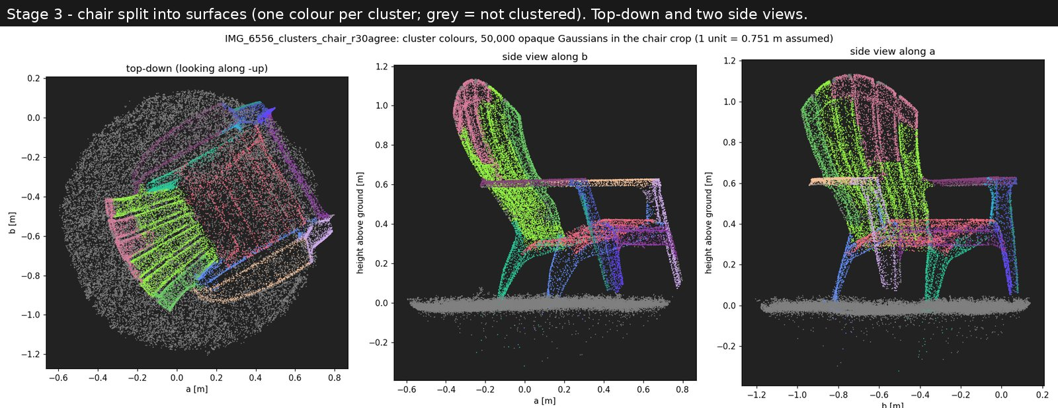
Figure 2. Chair surfaces, one colour per surface; grey Gaussians belong to no surface (mostly grass). Seat slats, backrest slats, each arm and each leg are separate.
Table 1. Grain against the photo's texture direction (median angle, chair).
Pixels compared | Grain | Random direction | Grain rotated 90°
Edges and outlines | 5.5° | 43.5° | 81.8°
Interior texture only | 9.1° | 43.6° | 79.7°

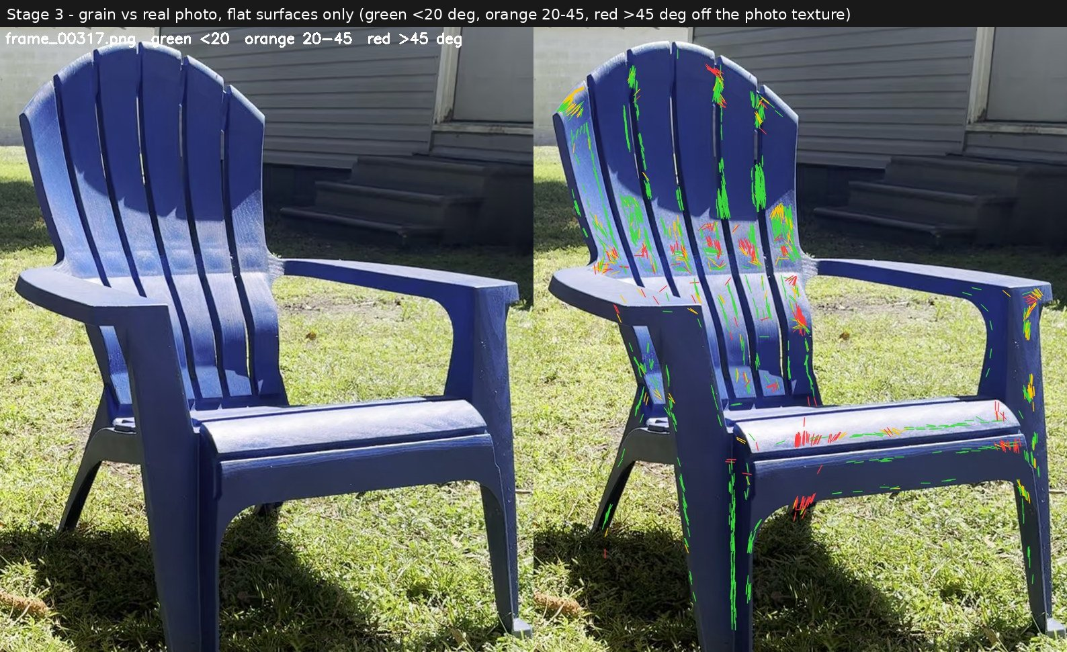
Figure 3. Grain against the photo on interior pixels: green within 20 degrees, orange 20-45, red over 45. Most red sits on the shadow edge, where the photo texture follows the shadow rather than the plastic.
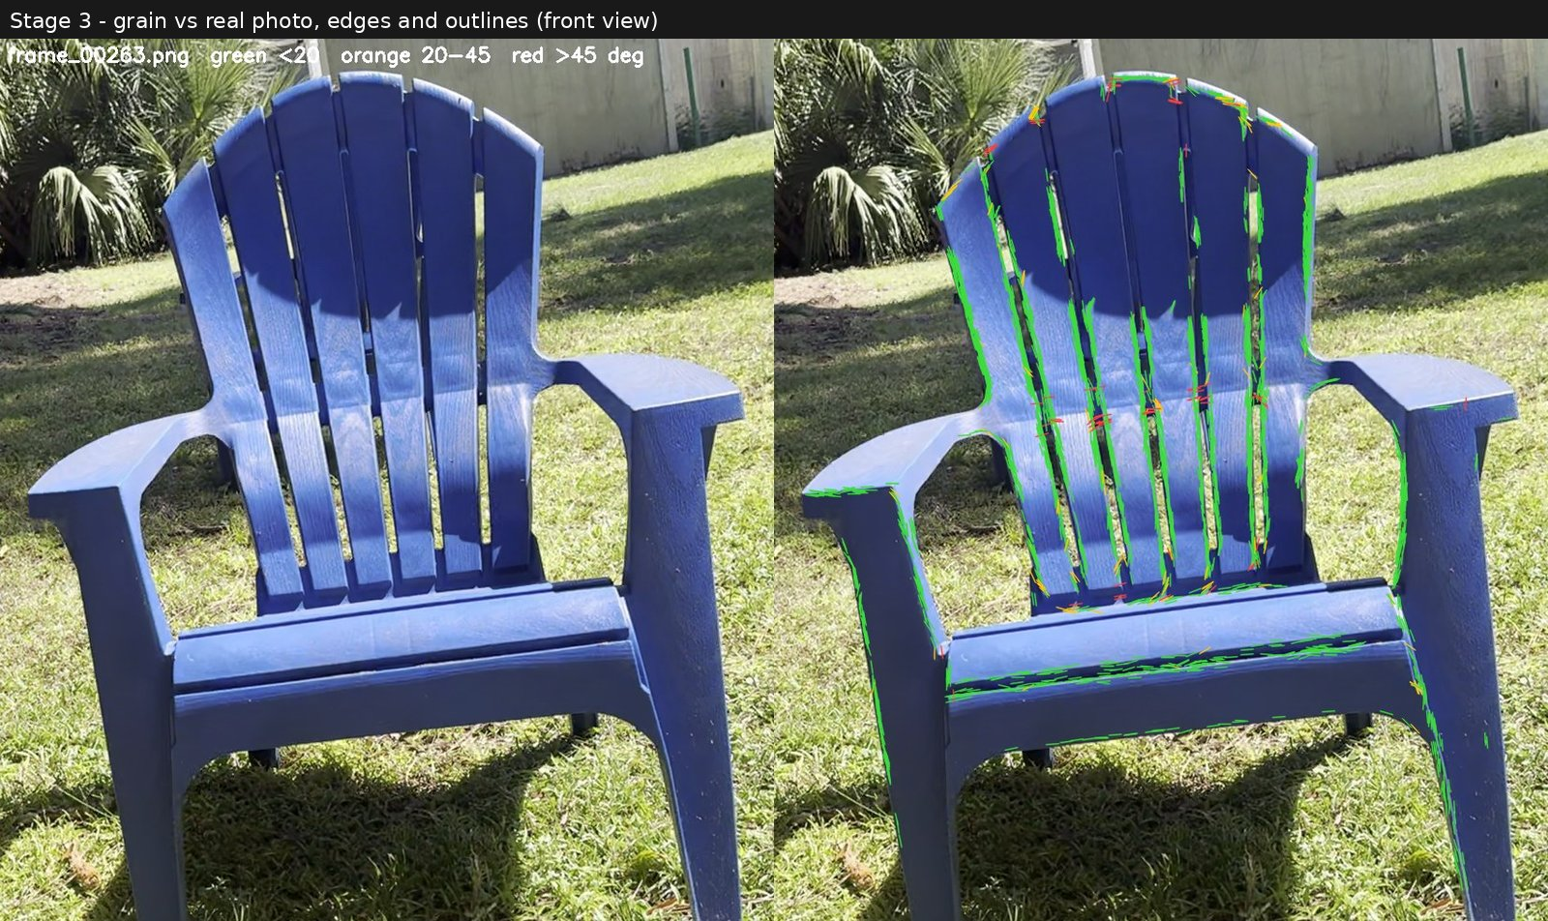
Figure 4. The same check on edges and outlines. Agreement there is partly built into training, which is why the interior check matters more.

4.2 Sun estimation
Five versions were tested, changing one thing at a time (Table 2). Restricting the casters to the chair's surfaces removed false shadows from grass blades; scoring the boundary instead of the area made the fit stable; fitting the receiver offset brought the error to -0.43 degrees, with a fitted offset that places the shadow edge on the grass tops, about 2 cm above the mean grass Gaussian.
Table 2. Sun elevation on the chair scene (true 55.51°).
Version | Change | Elevation | Error
1 | Everything above the ground casts shadow (area IoU) | 57.0° | +1.5°
2 | Only the chair's surfaces cast shadow | 55.0° | -0.5° (unstable)
3 | Also the chair's shadow on itself | 55.5° | ≈ 0 (± 2.5°)
4 | Boundary chamfer instead of area | 56.3° | +0.8° (stable)
5 | Also fit the receiver offset δ | 55.08° | -0.43°

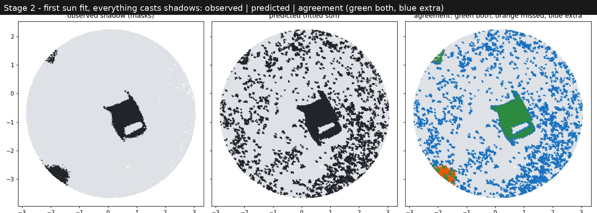
Figure 5. Version 1: observed shadow, predicted shadow and agreement (green both, blue predicted only, orange observed only). Grass blades cast false shadows across the lawn (blue).
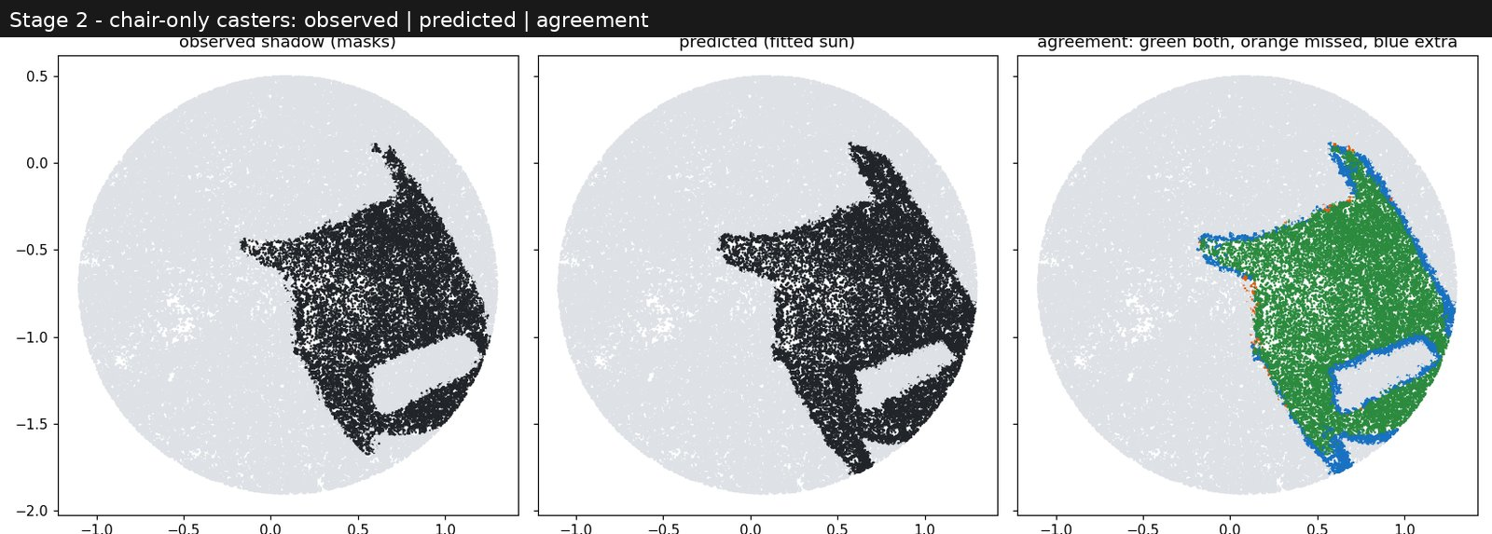
Figure 6. Version 2: only the chair casts. The predicted shadow, including the lit gap under the seat, matches the observed one closely.
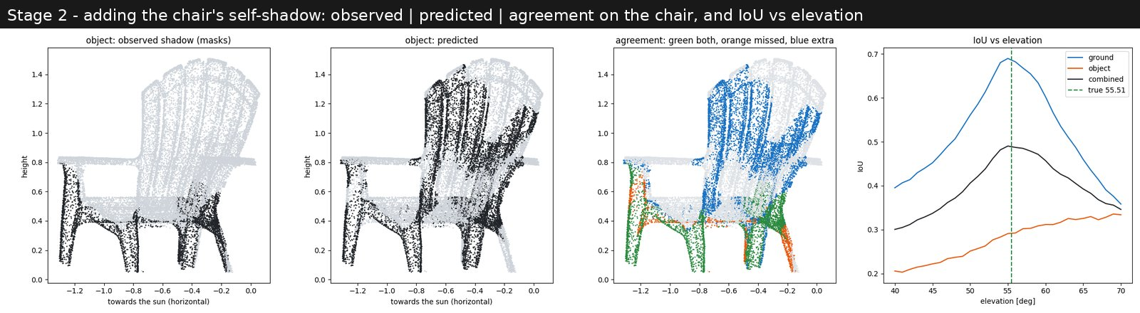
Figure 7. Version 3: adding the chair's shadow on itself. On its own this evidence did not find the sun, because the thin slats confuse the votes.
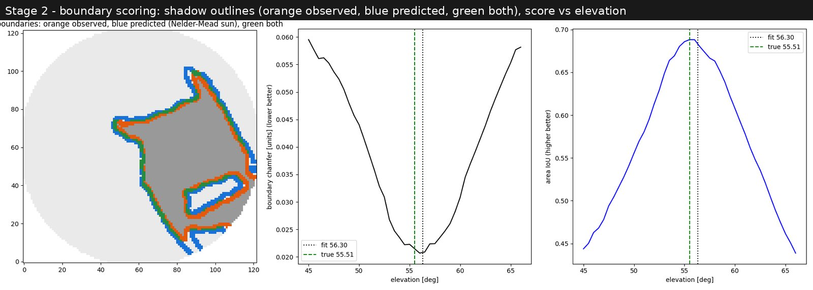
Figure 8. Version 4: boundary score. Observed (orange) and predicted (blue) outlines overlap almost everywhere (green), to about 1.5 cm.
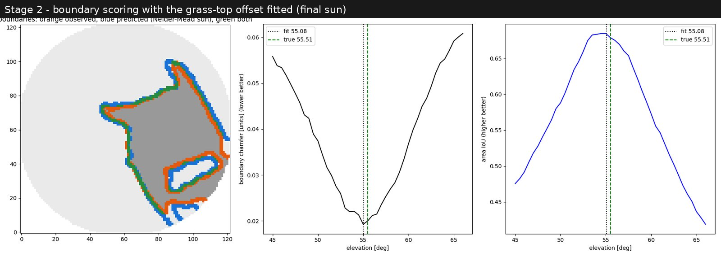
Figure 9. Version 5: final sun, 55.08 degrees against the true 55.51. The fitted offset puts the shadow edge on the grass tops.

4.3 Shadow on the chair
Geometry with the fitted sun predicts the ground shadow well (98% of it found, Figure 10). On the chair, brightness read from about 128 photos per Gaussian falls into two clear groups, sunlit about 13 times brighter than shaded, matching the sun-to-sky ratio measured on the grass (Figure 13). The adjacent brightness-and-colour rule labels 44.5% of the chair as shadow and agrees with geometry on 69% of Gaussians. Shaded spots differ in chromaticity from their sunlit neighbours about twice as much as sunlit spots do, always toward blue.
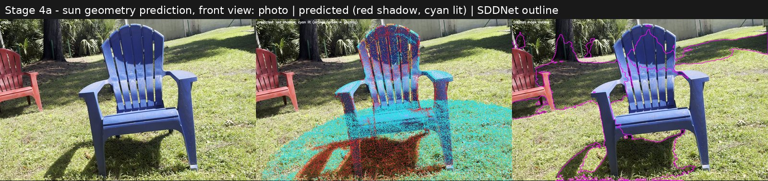
Figure 10. Geometry prediction, front view: photo, prediction (red shadow, cyan lit) and the detector's outline. The predicted ground shadow sits on the real one.
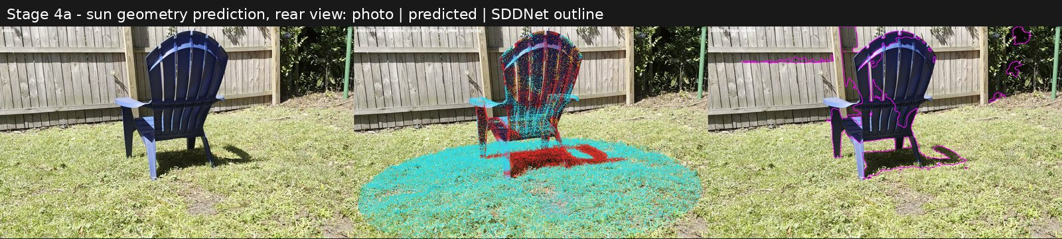
Figure 11. Rear view: the back of the backrest is dark in the photo and predicted as shadow.
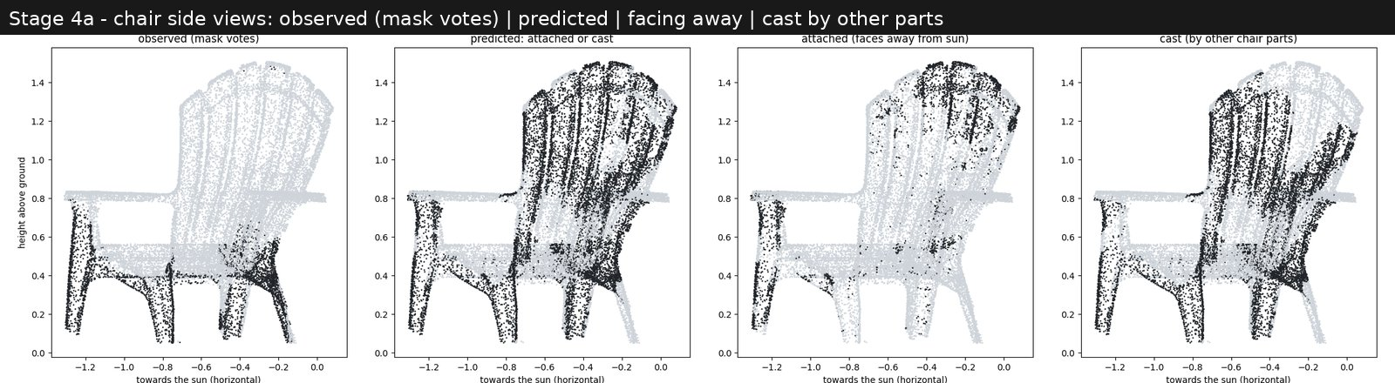
Figure 12. Side views: observed, full prediction, attached (facing away) and cast by other parts. The backrest front, hit almost edge-on, is over-predicted.
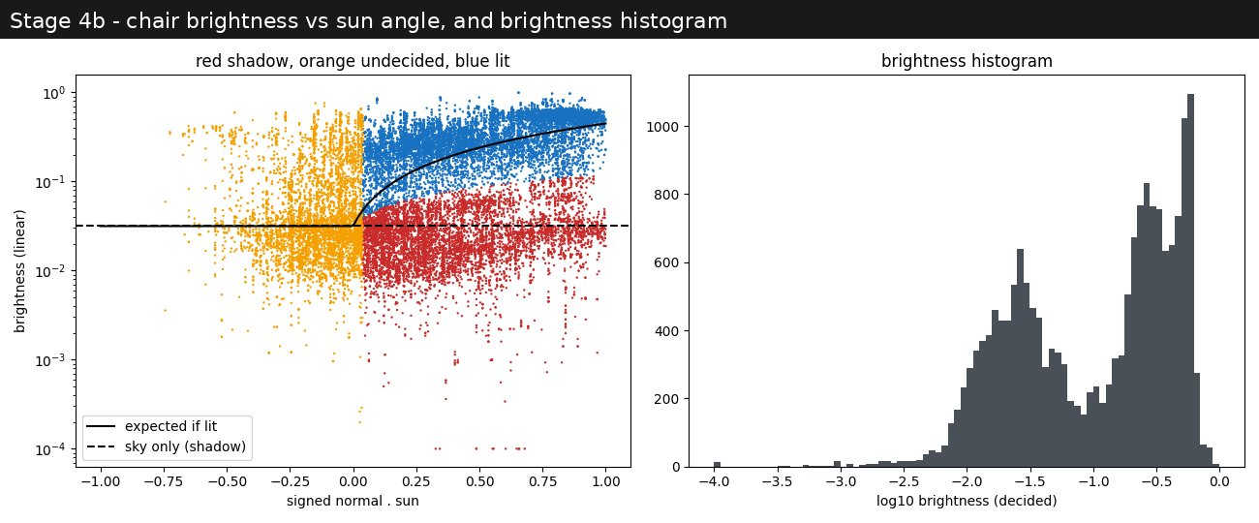
Figure 13. Brightness of each chair Gaussian against n·s (left) and its histogram (right): two clear modes, shade and sun.
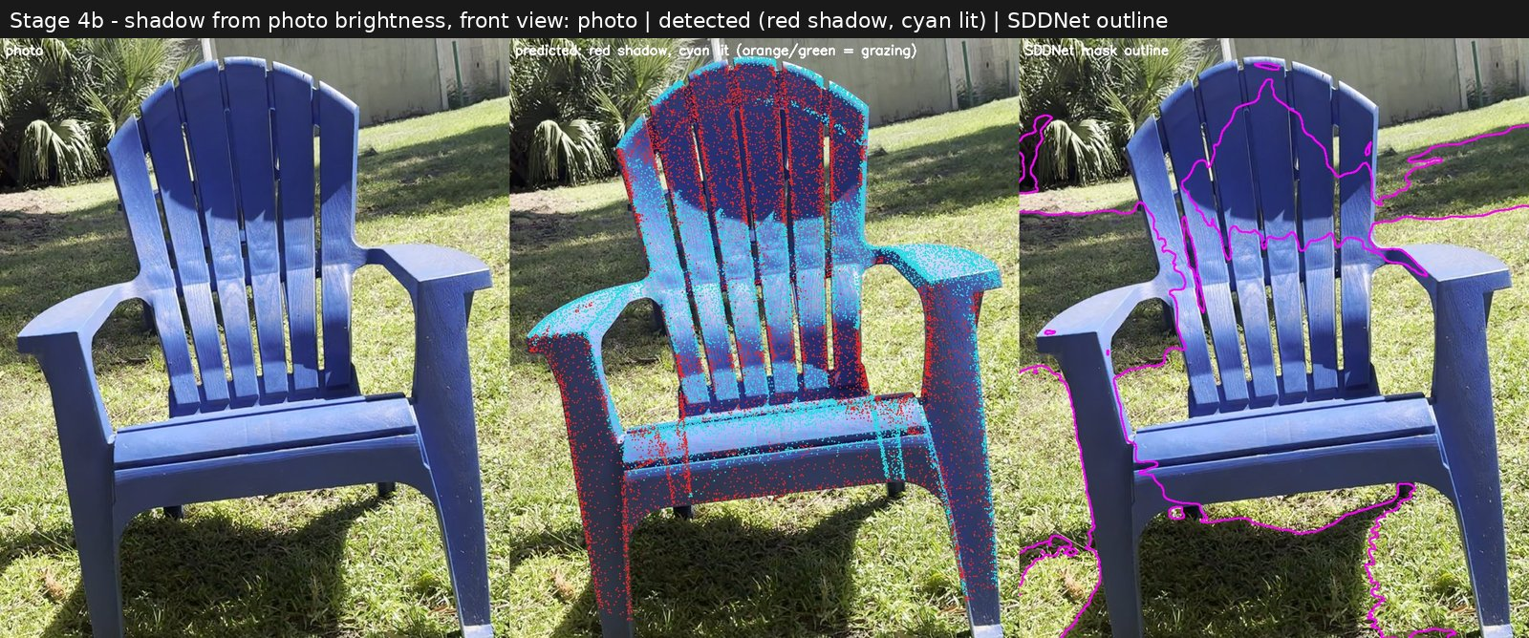
Figure 14. Shadow from brightness, front view: the dark arc on the upper backrest is detected; the off-the-shelf detector outlines only part of it.
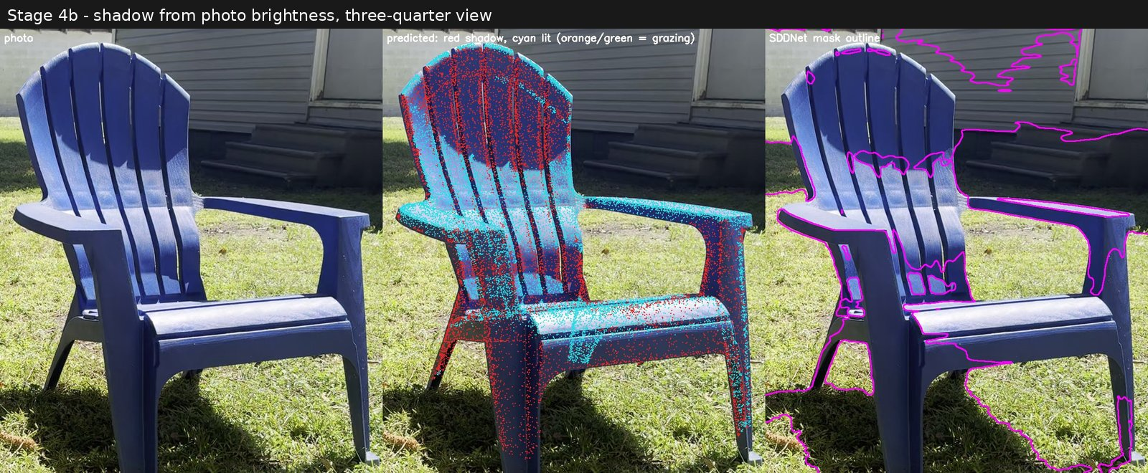
Figure 15. Three-quarter view: shaded upper backrest, sunlit middle band, sunlit arm tops and shaded inner legs all match the photo.
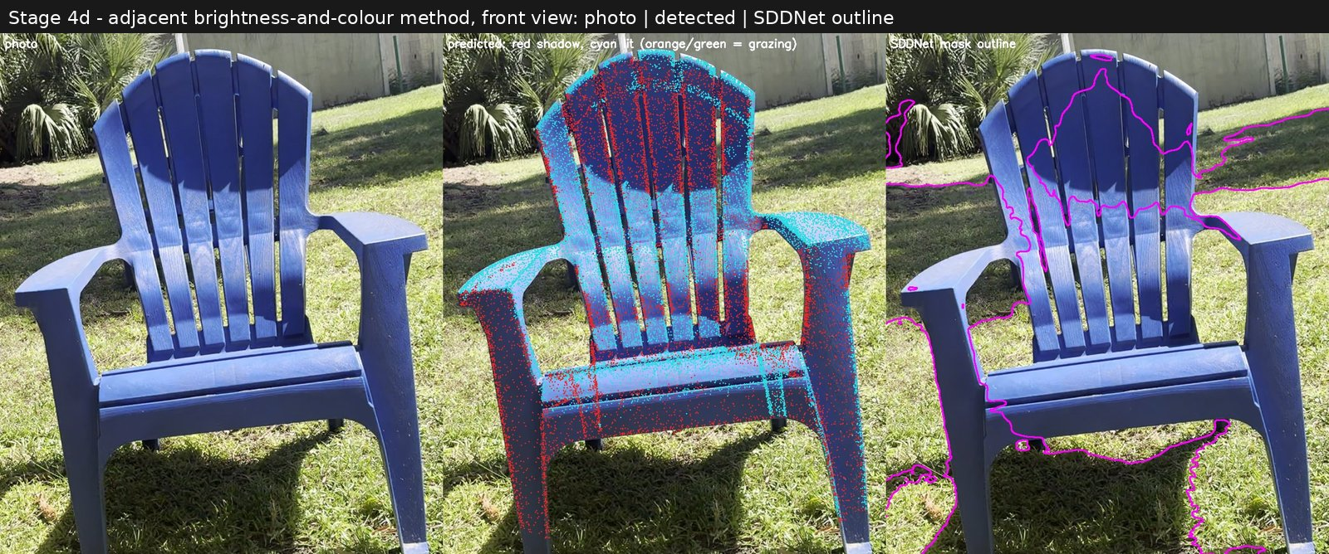
Figure 16. Adjacent brightness-and-colour rule, front view: photo, detected shadow (red) and the detector's outline.
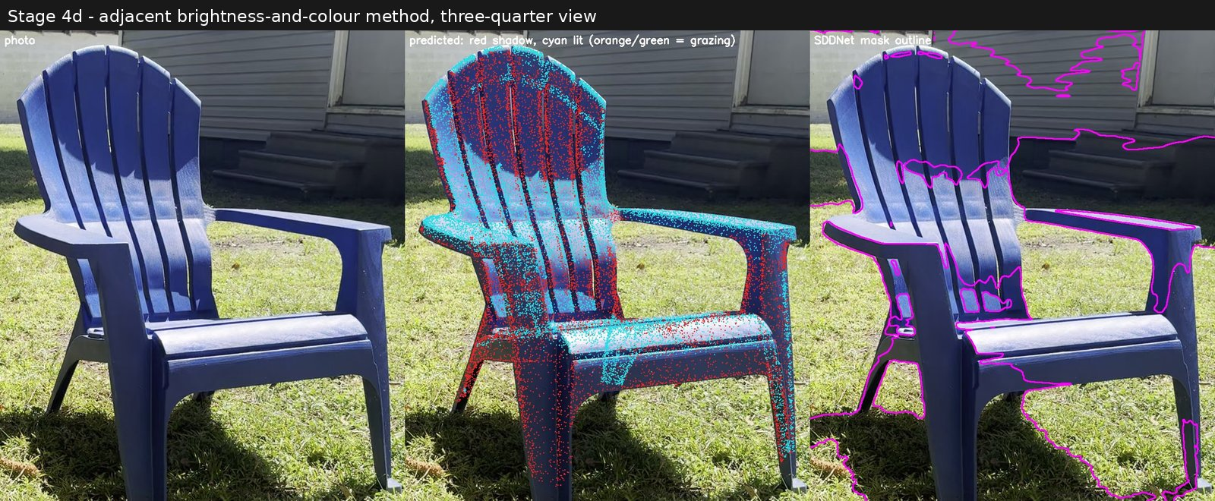
Figure 17. Adjacent rule, three-quarter view.
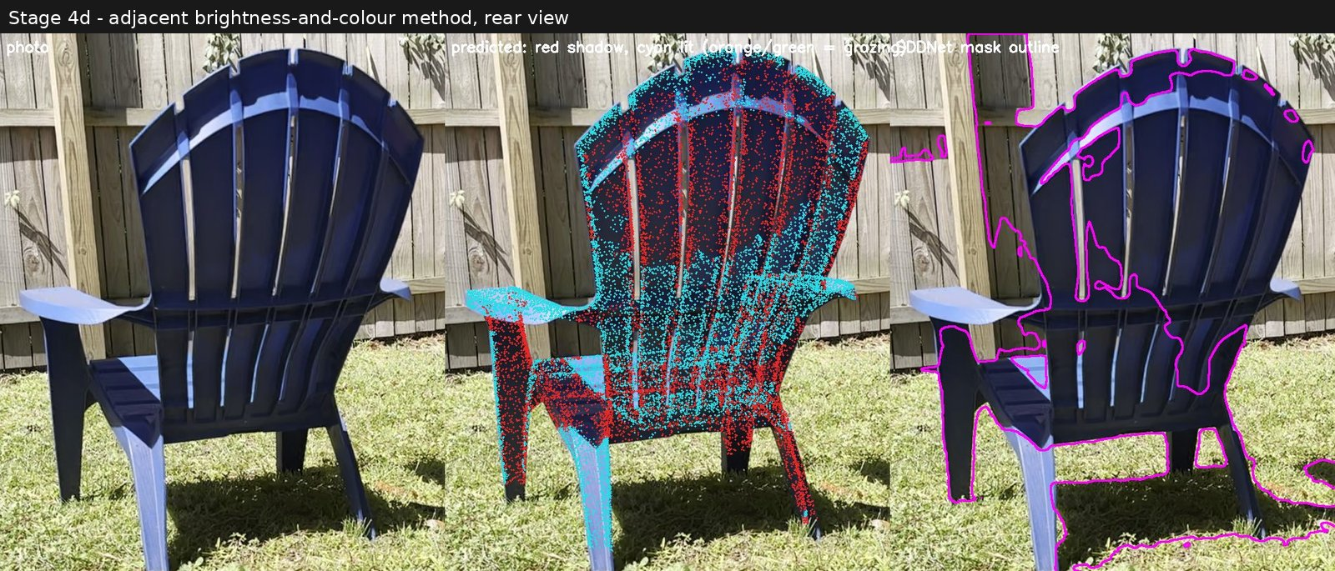
Figure 18. Adjacent rule, rear view. Some sunlit front-face points show through the thin slats when drawn on the photo.

4.4 Fine-tuned detector
SDDNet misses most shadow on the dark navy chair. After about 2.5 minutes of fine-tuning on automatic targets (Figure 19), agreement with the geometry labels on held-out frames more than doubles (Table 3). The geometry column is the more convincing, because geometry did not produce most of the training labels.
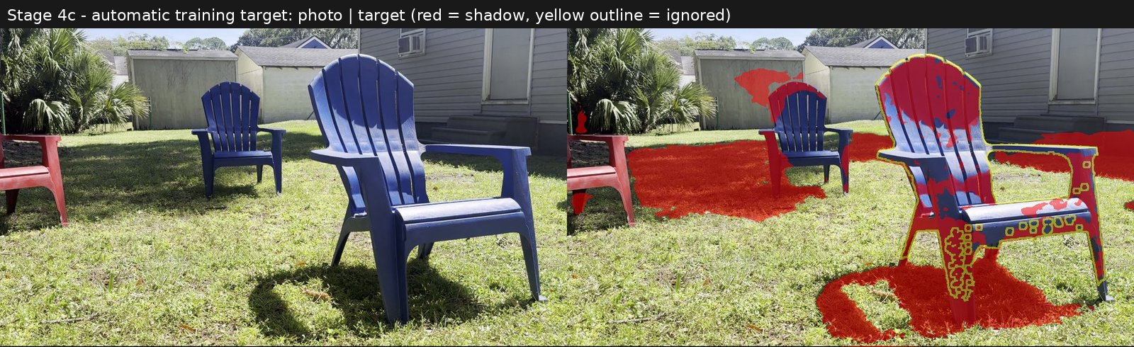
Figure 19. An automatically generated training target: photo and target (red shadow; the yellow ring is ignored).
Table 3. Shadow detector on held-out frames (chair).
Detector | Chair shadow found | IoU with brightness labels | IoU with sun geometry
Original SDDNet | 15% | 0.22 | 0.21
Fine-tuned | 33% | 0.55 | 0.48

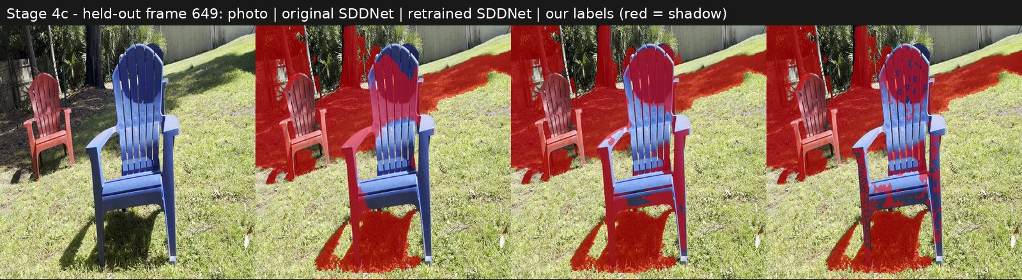
Figure 20. A held-out frame: photo, original detector, fine-tuned detector and 3D labels. The fine-tuned detector marks the whole backrest arc and the shaded inner sides.
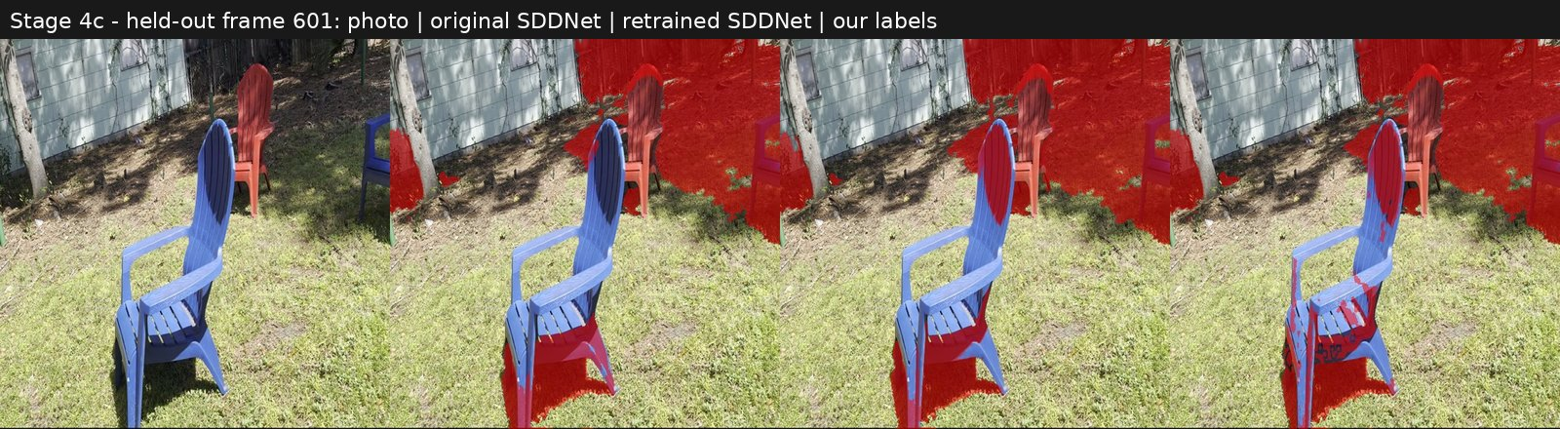
Figure 21. Another held-out frame, same layout.

4.5 Repainting the chair
11,287 of 24,445 chair Gaussians were filled. The median brightness of the shadowed Gaussians rose from 0.026 to about 0.23, against 0.26 for sunlit plastic (87%). Copy mode looks flatter; ratio mode keeps more of the plastic texture (Figures 22-24). Two small surfaces under the seat have no sunlit part and used the fallback (12.5% of shadowed Gaussians). The remaining defect is mottling: the per-Gaussian labels are speckled, so neighbours are filled differently.
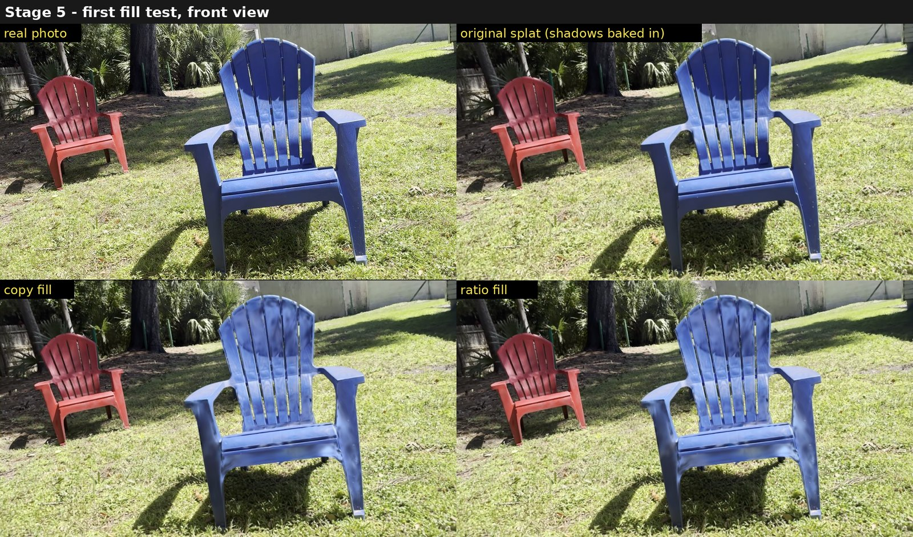
Figure 22. Front view: photo, original splat, copy fill, ratio fill.
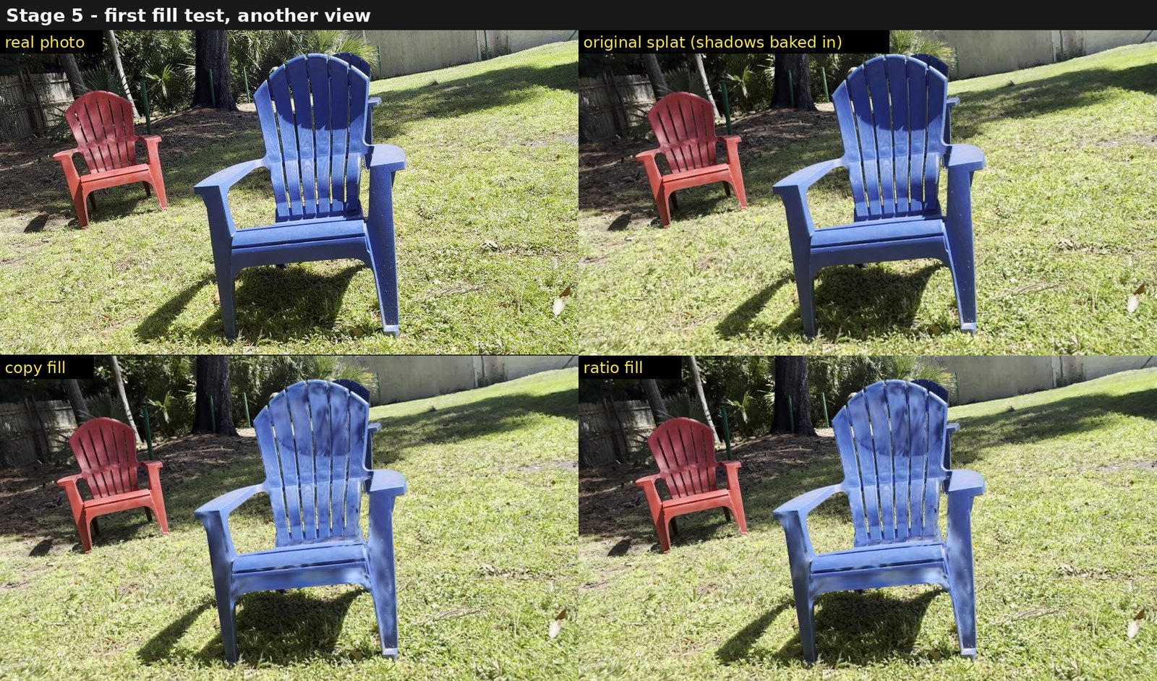
Figure 23. Another view, same layout. Copy mode looks flatter and slightly too light.
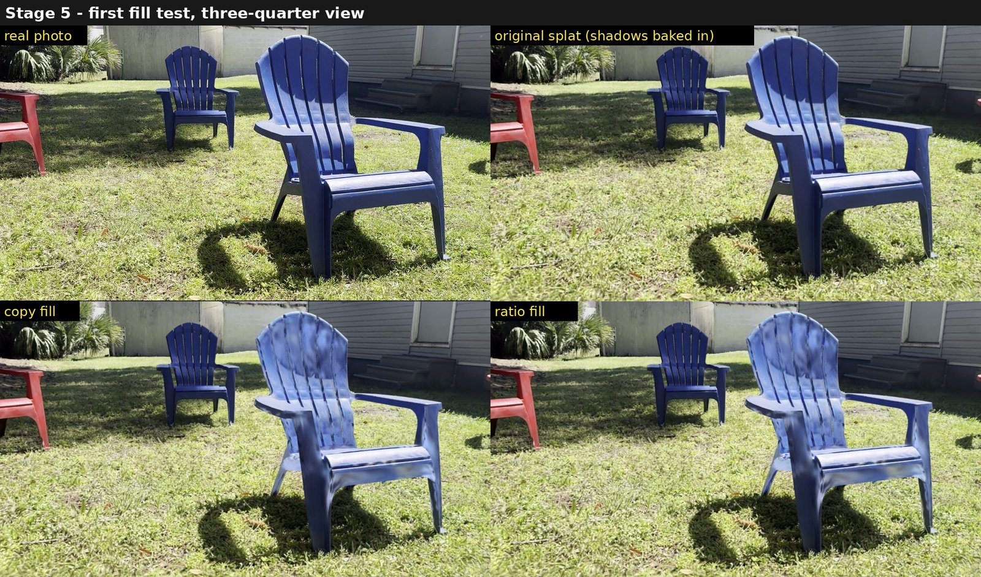
Figure 24. Three-quarter view, same layout.

4.6 Ground shadow on grass
The gain of section 3.10.1 (settings O: thresholds 0.15 and 0.45, gain capped at 12, colour gate 0.13, ground band 0.045, darkness gate) lifts the chair's cast shadow from 0.38-0.48 of the sunlit grass to 0.76-0.82 over three views, with the shadow cores lagging (0.64-0.79). Grass texture under the shadow stays flat, which motivated the fills tested on the second scene.

5. Experiment 2: a painted bear figurine on concrete (IMG_6704)
A new capture made for these tests: a painted resin bear holding a pumpkin, 15-20 cm tall, on a concrete driveway. iPhone 15 Pro Max, 21 October 2026, 12:01-12:03 EDT, 32.0481 N 81.0601 W; true sun elevation 44.27 degrees (44.18 to 44.35 during the clip), azimuth 157 degrees. 650 frames at 1920×1080, all posed in one COLMAP model; splatfacto-big, 30,000 steps, 782,433 Gaussians. The bear is about 2.13 units tall, so about 12 units per metre.
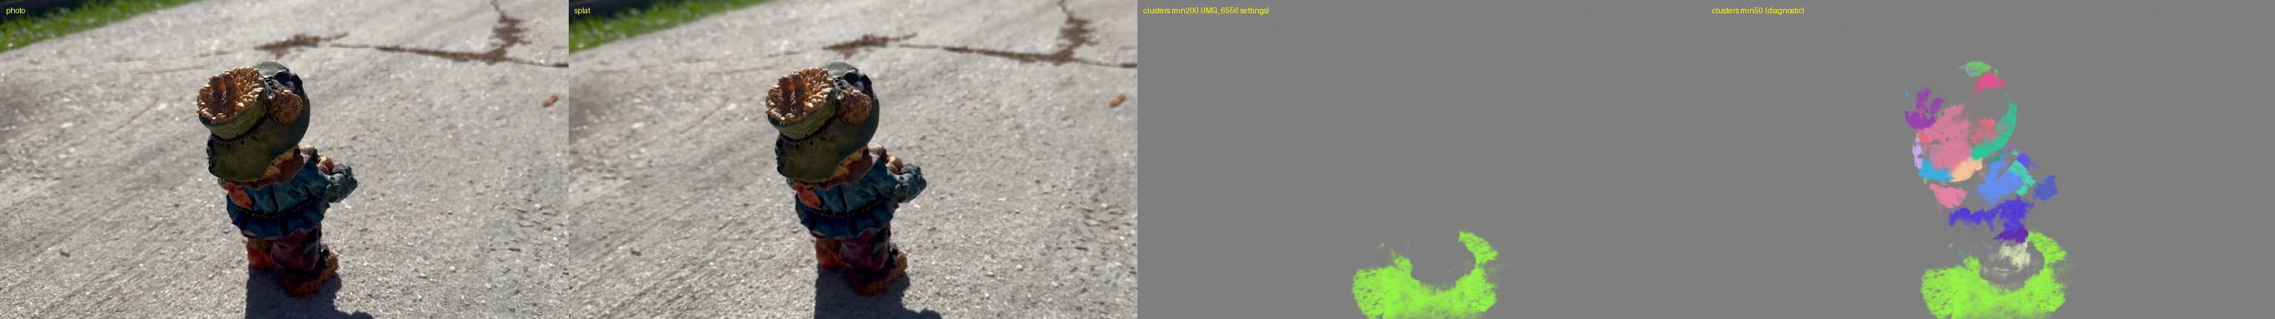
Figure 25. Bear 1: photo, splat, surfaces with minimum size 200 (only the ground patch) and with minimum size 50 (hat, head and torso split into small patches; legs mostly none).

5.1 Surfaces and grain
Only 14,257 of 80,190 bear Gaussians are flat enough for a normal, and on those the shortest-axis and PCA normals disagree by a median 43 degrees. With the chair's settings (minimum 200 Gaussians per surface) the bear gets no surface at all; at 50 it gets 26 small ones. The grain is weak and only somewhat better than random (Table 4, Figure 26).
Table 4. Surfaces and grain on bear 1.
Measure | Bear 1
Surfaces on the object | 0 at minimum 200; 26 at minimum 50
Gaussians in surfaces | 22,396
Normal spread per surface, median (range) | 18.2° (15.8-19.9)
Grain coherence, median | 0.23
Grain vs photo, interior (random 44.3°, rotated 53.1°) | 32.9° (34% within 20°)
Grain vs photo, edges (random 44.8°, rotated 58.6°) | 28.6° (40% within 20°)
Share of the bear in a surface, by height | legs 16%, body 29%, head 51%, hat 37%

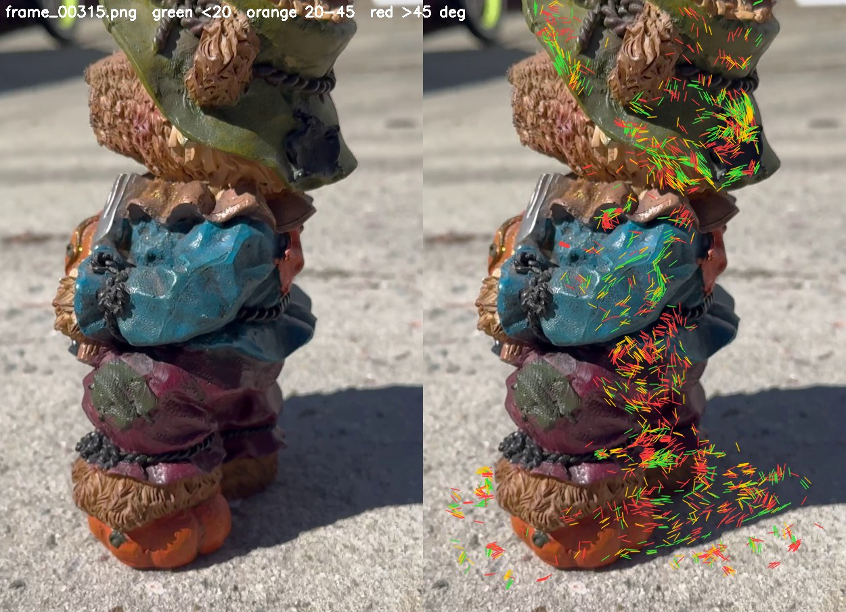
Figure 26. Grain on the bear against a photo (interior pixels): mostly orange and red. A sculpted, curved figurine has little dominant direction.

5.2 Sun estimation
By simple geometry the clean, 2.4-unit shadow behind the 2.13-unit bear implies about 42 degrees. The area score fails (14.75-15 degrees): with the legs mostly outside any surface, they are missing from the casters, and a long, low-sun shadow from the head scores as well as the right one. The boundary score with fitted offset gives 49.25 degrees, +4.98 above the truth. Settings that are physical sizes were converted with the scene scale; converting them with the measured bear height made the result worse (+10.98), because the grid becomes coarse relative to the object (the whole outline traced by 80 cells). Both runs chose the end of the offset scan (Table 5).
Table 5. Sun elevation on bear 1 (true 44.27°).
Score | Estimated scale (×5.6) | Measured size (×9.1)
Area IoU | 15.0° (-29.3) | 14.75° (-29.5)
Boundary chamfer + fitted offset | 49.25° (+4.98) | 55.25° (+10.98)
Hold-out halves | 48.0 / 49.5° | 48.5 / 46.75°
Range over the offset scan | 40.8-49.3° | 44.8-55.3°

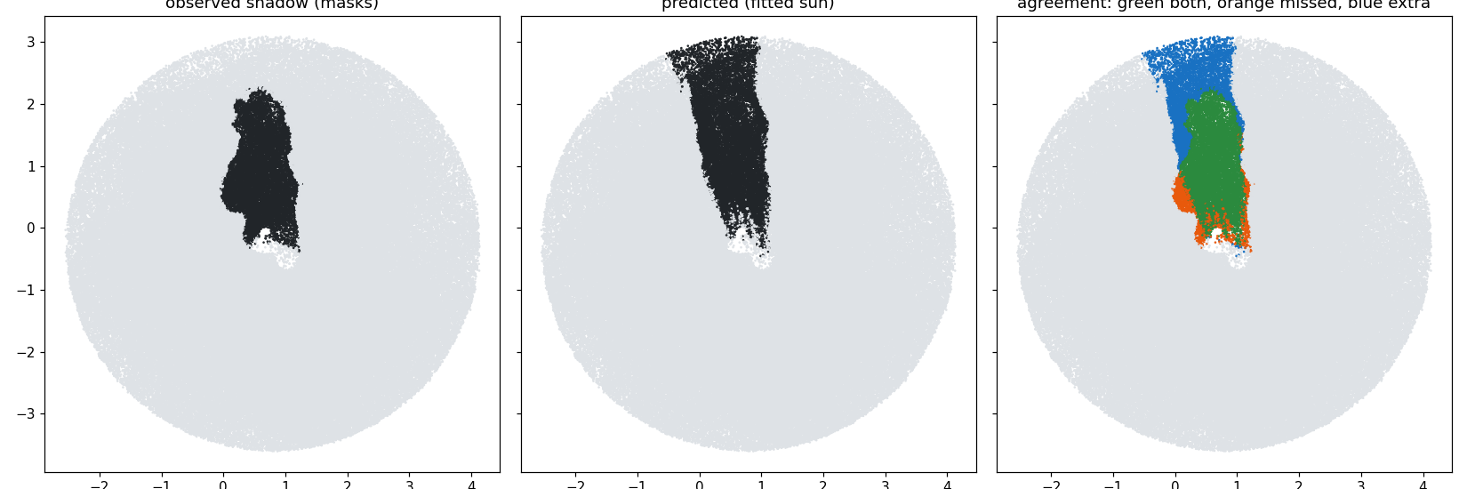
Figure 27. Area score: observed shadow, prediction for the best sun, and agreement (green both, orange missed, blue extra).
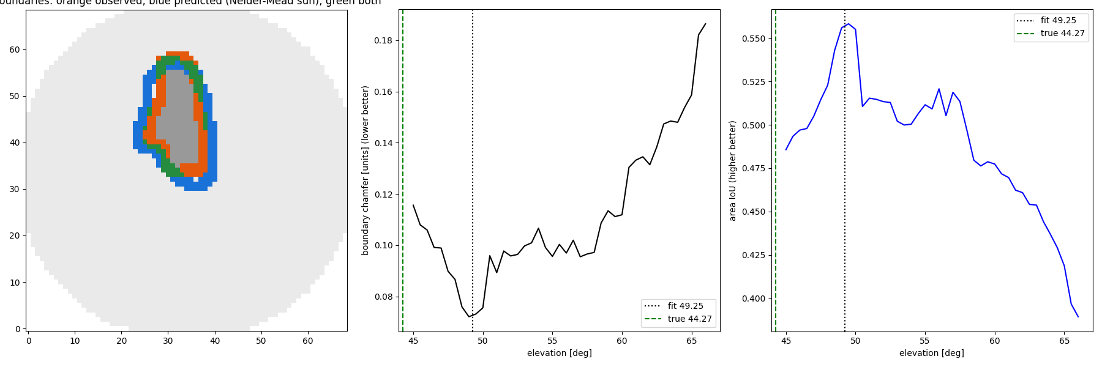
Figure 28. Boundary score at the estimated scale: observed (orange) and predicted (blue) outlines, and the score against elevation, with a clear minimum at 49.25 degrees (truth: green line).
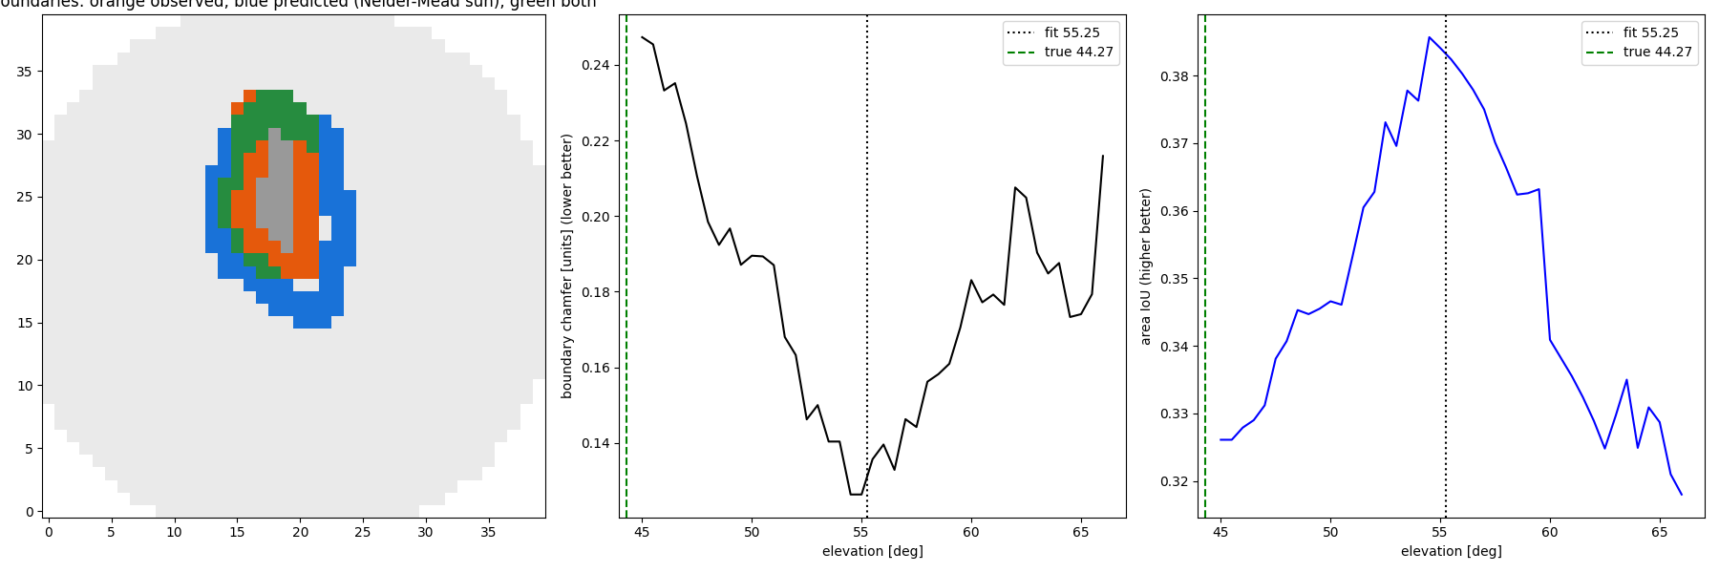
Figure 29. Boundary score with the measured size: a 1.5 cm grid traces the outline with only 80 cells and the fit moves to 55.25 degrees.

5.3 Shadow on the bear
The single-material assumption fails. The sun and sky fit gives a sunlit-to-shaded ratio of 1.5 with the sunlit level below the shaded one, which is not physical: on a painted object, brightness is mostly paint. The adjacent rule labels 29.5% of the bear as shadow, SDDNet 0.4%, and geometry 70% (26% attached, 58% cast); brightness and geometry overlap with an IoU of 0.35.
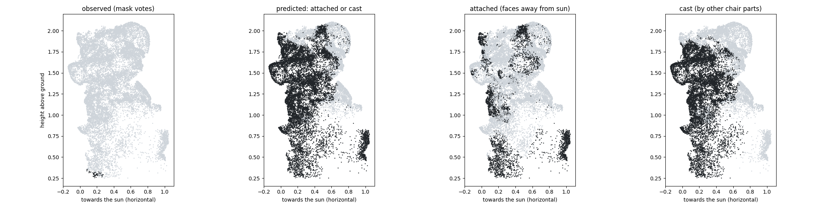
Figure 30. Geometry on the bear, side view with the sun to the right: observed (almost none), predicted, and the attached and cast parts.
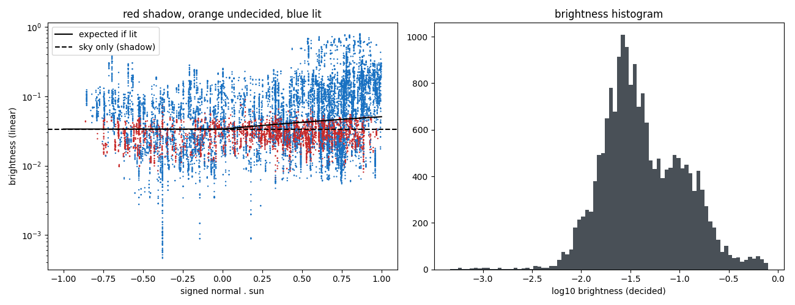
Figure 31. Brightness of each bear Gaussian against n·s and its histogram: no lighting structure, paint dominates.

5.4 Repainting the bear
The continuous fill raised the shadowed Gaussians from a median 0.022 to 0.118, against 0.075 for the sunlit ones (an overshoot of about 60%); two thirds of the bear were raised more than 1.5 times and 20% of shadowed Gaussians used the fallback. Because the gain moves colour toward neighbouring sunlit colour across paints, shaded red, blue and green turn purple and over-saturated (Figures 32-33).
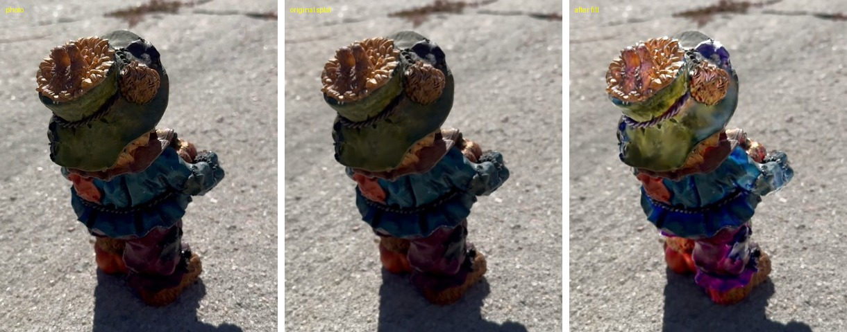
Figure 32. Close-up: photo, original splat, after the fill. Shaded hat, jacket and trousers turn purple and blue.
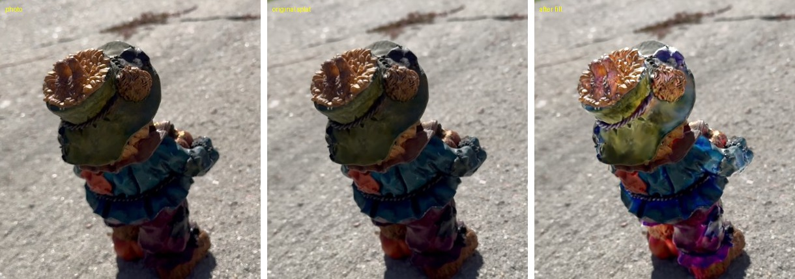
Figure 33. Another view, same layout.

5.5 Ground shadow on concrete
The concrete shadow is very dark: 5-7% of the sunlit concrete in the photos. This makes it a hard test for the fills of section 3.10. Table 6 and Figure 44 give the results for all variants with the measures of section 3.11.
Gain (O, B, C). Settings O from the chair lift the shadow to 58% of the surroundings but leave a flat, blue-grey patch (Figures 34-36). Per-channel gains remove the blue cast (B), and a gain 1.55 times higher (C) reaches 0.63 at the core. Detail stays at 0.44: the patch is uniform.
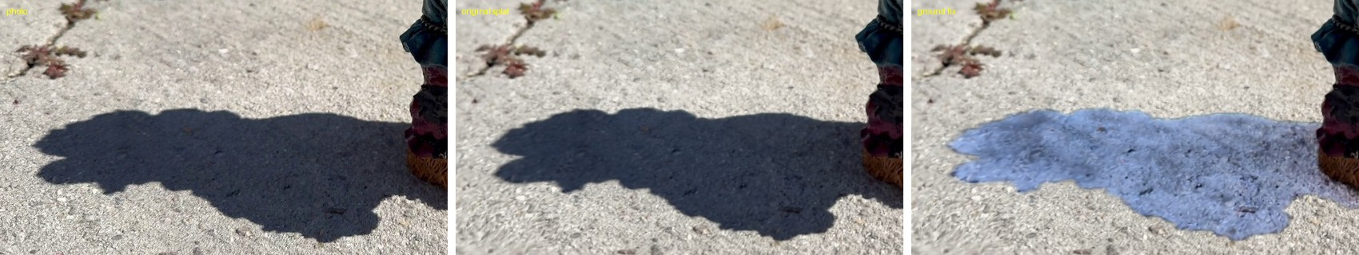
Figure 34. Ground shadow, gain O: photo, original splat, after the fix.
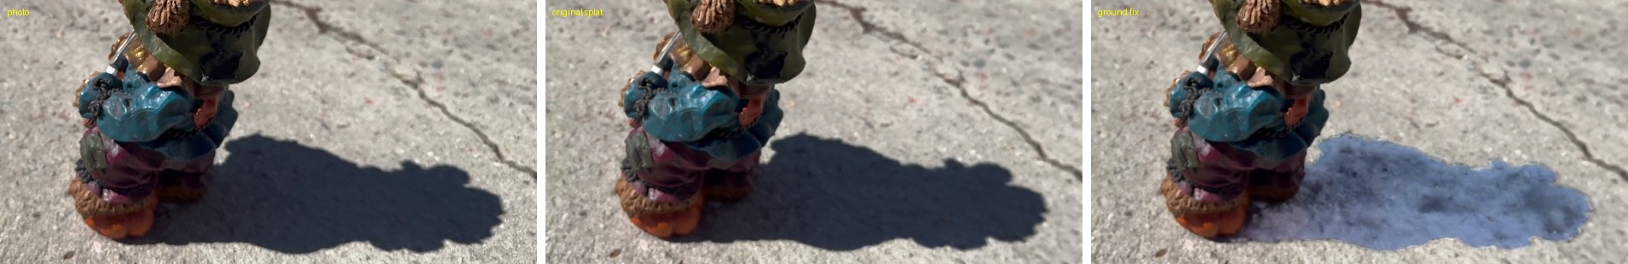
Figure 35. Another view, same layout.
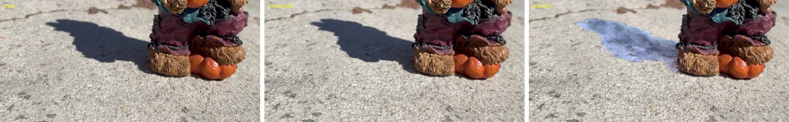
Figure 36. A low view, same layout.
Colour clone stamp (T, U, V). The texture fill finds the shift Δ* = (-1.08, 0.63), 1.25 units or about 10 cm, that covers 92.5% of the 11,920 shadowed ground Gaussians (best single shift 94.9%). In total 11,757 are filled and 163 keep the gain. The concrete's grain now continues through the patch (Figure 37), but its edge stays darker (0.87). Blending the outline (U: F = 0.2, K = 200) raises the edge to 0.96 and the core to 0.96; the match ratio is small (median 1.0, 10th-90th percentile 0.86-1.17). The patch remains soft (detail 0.70). Strengthening detail (V, γ = 1.4) restores detail to 0.93 at the cost of a darker blotch near the feet (Figures 38-39).
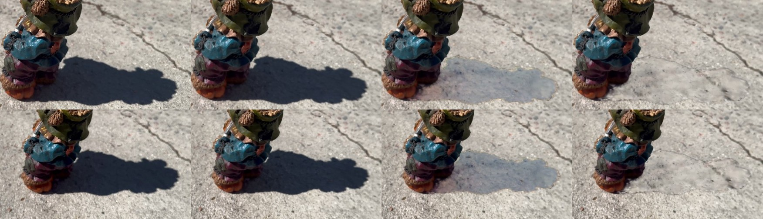
Figure 37. Gain against colour clone stamp. Columns: photo, original splat, C (flat and pale), T (the concrete's grain continues through the old shadow).
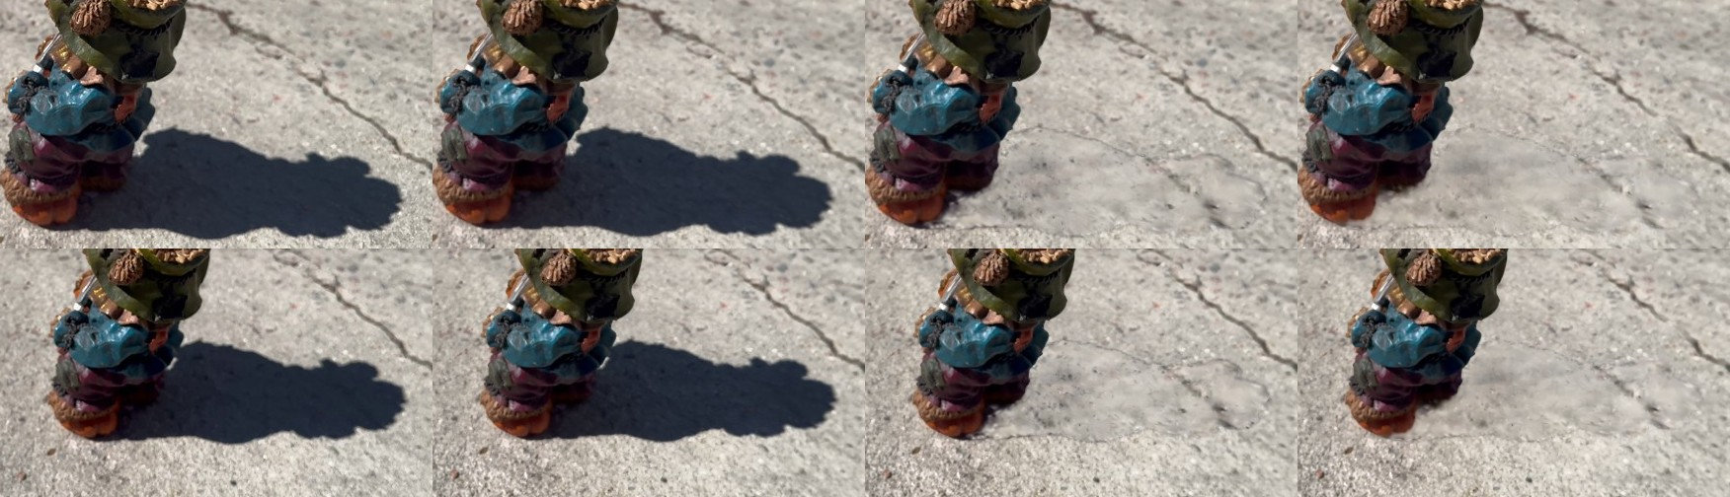
Figure 38. Blending the outline. Columns: photo, original splat, T, U. The thin outline of the old shadow in T is mostly gone in U.
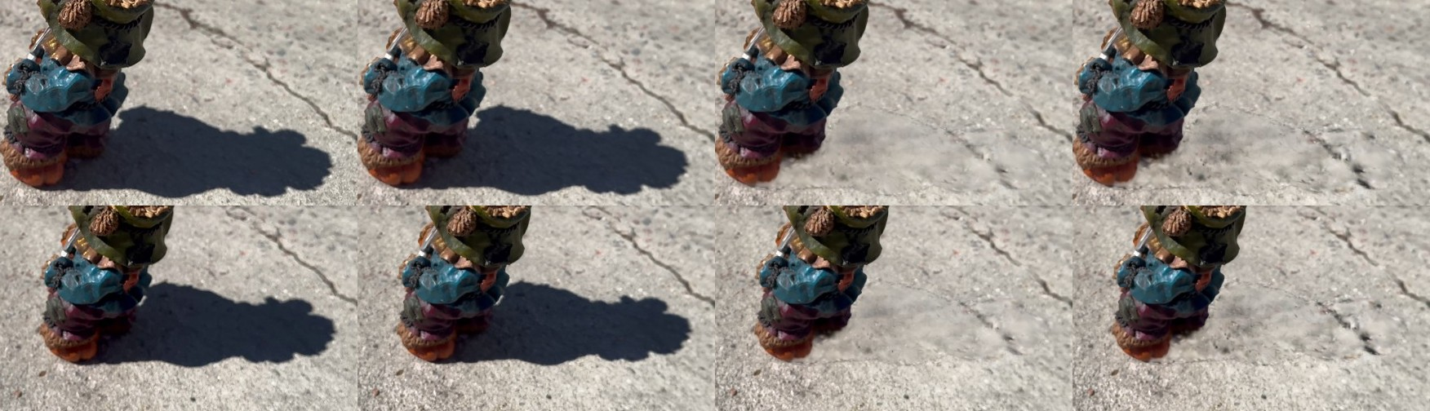
Figure 39. More detail. Columns: photo, original splat, U, V. V has more speckle, but a darker, blotchy area remains near the feet.
Why colour is not enough. Figure 41 compares the Gaussians of the shadowed patch with the sunlit concrete around it. The shadowed ones have a median longest axis of 0.0203 against 0.0117 (1.7 times larger) and a median opacity of 0.91 against 0.72, and there are fewer of them per cell (15 against about 25). Training had no texture to fit in the dark patch, so densification never split these Gaussians. A colour assigned to a large, opaque Gaussian is spread over its whole footprint, which is the smudge.
Geometry clone stamp (W, Y). W replaces 11,213 shadowed Gaussians with 11,875 copies, using the texture fill's shift. It reaches centre 0.97, edge 0.98 and detail 1.01, and looks like sunlit concrete (Figure 40), but it copies a piece of the real crack into the patch. Y adds crack-aware sources: 1,524 crack cells, a first shift of (-24, -6) cells (1.24 units) filling 732 cells, five more shifts filling 25, and 171 cells near the feet with no clean source keeping U. It replaces 11,436 Gaussians with 19,311 copies whose sizes match the sunlit concrete (median 0.0120, Figure 41), and the splat grows from 782,433 to 790,308 Gaussians. The repeated crack is gone in every view (Figure 42). Detail is 0.87, lower than W's because the crack-free source area is plainer concrete. A mild stain from the source area shows in the middle, and a lighter rim remains at the feet in close views.
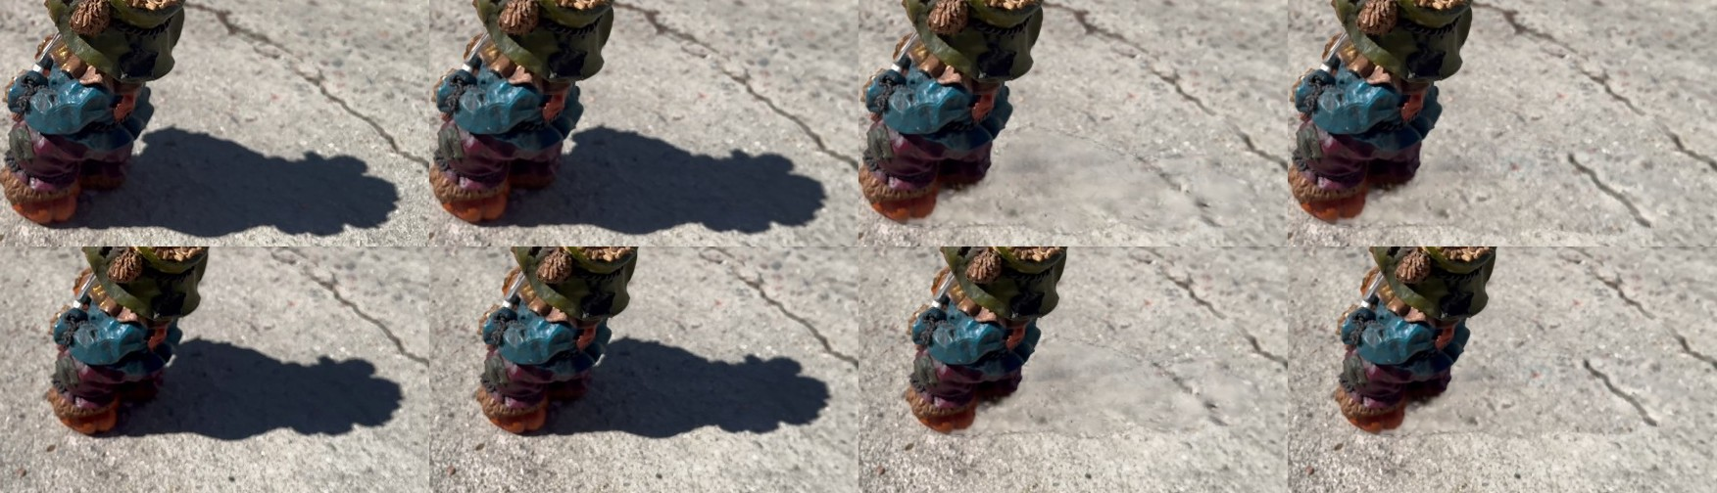
Figure 40. Colour against geometry clone stamp. Columns: photo, original splat, U, W. W has the crisp grain of sunlit concrete.
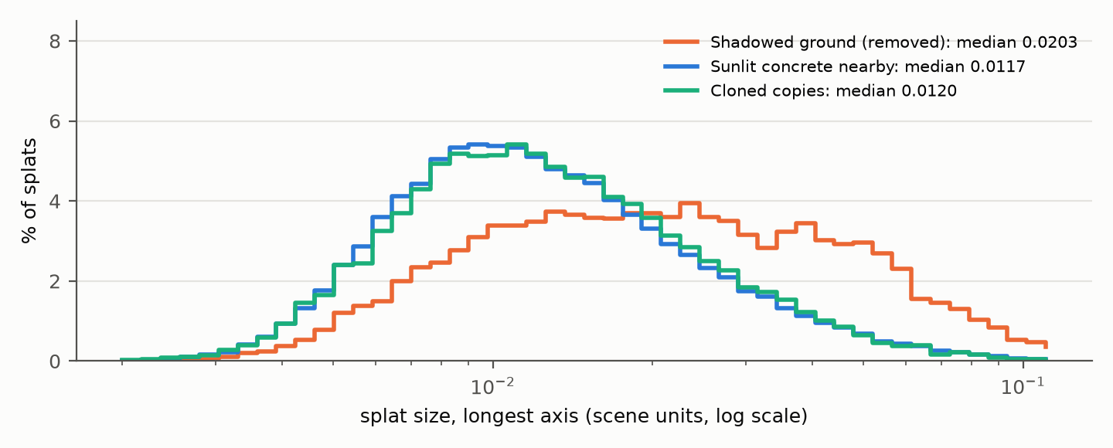
Figure 41. Size of the Gaussians on the ground: shadowed patch (removed), sunlit concrete within 1 unit of it, and the cloned copies (longest axis, log scale). The shadowed Gaussians are 1.7 times larger; the copies match the sunlit concrete.
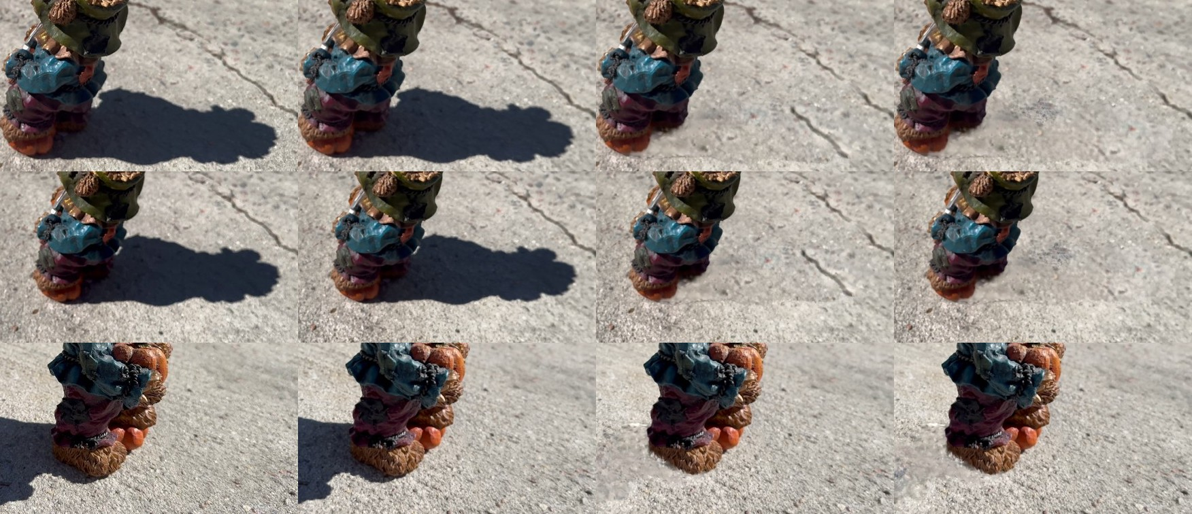
Figure 42. Crack-aware sources. Columns: photo, original splat, W, Y; rows: three views. The crack segment copied into W (top rows) is gone in Y; in the close view (bottom) a lighter rim remains at the feet.
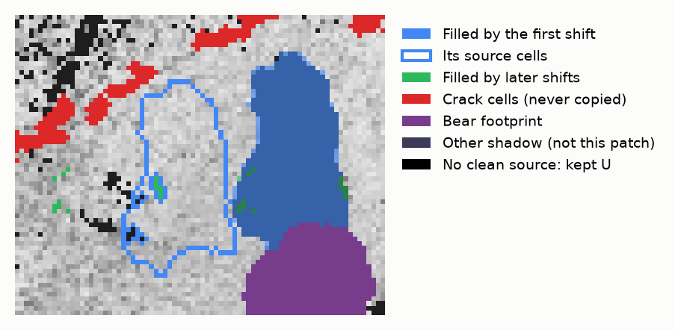
Figure 43. Top view of the geometry clone stamp Y, one block per 4 mm cell. The patch is filled almost entirely by one shift from plain concrete above it (outlined), away from the cracks (red).
Table 6. Bear 1 ground shadow, median of 5 rendered views (1.00 = matches the sunlit ring).
Variant | What it changes | Centre | Edge | Detail
Original splat | - | 0.06 | 0.56 | 0.37
C | Gain, per channel, 1.55× stronger | 0.63 | 0.85 | 0.44
T | Colour clone stamp, one shift | 0.90 | 0.87 | 0.73
U | T + outline blend + brightness match | 0.96 | 0.96 | 0.70
V | U + detail ×1.4 | 0.91 | 0.95 | 0.93
W | Geometry clone stamp, one shift | 0.97 | 0.98 | 1.01
Y | W + crack-aware sources, up to 6 shifts | 0.97 | 0.98 | 0.87

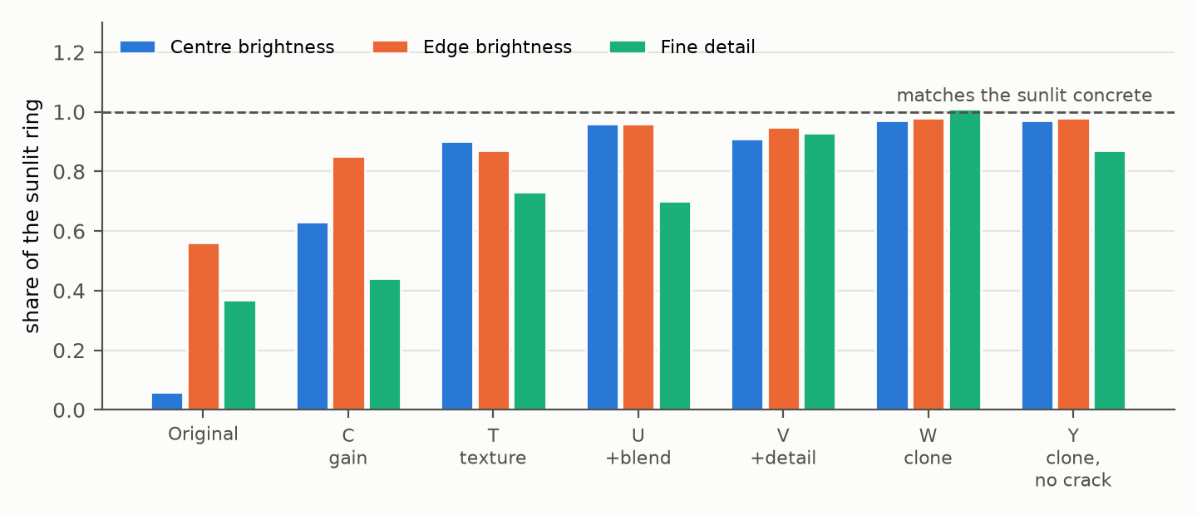
Figure 44. Ground-shadow measures for every variant on bear 1 (median of 5 rendered views). The colour fills fix brightness; only the geometry clone stamp restores both brightness and fine detail.

6. Discussion and limitations
Each scene is discussed on its own here. A comparison between scenes is deferred to a closing report once all planned tests are done (bear 2, IMG_6705, is next).

6.1 Chair scene
- The geometric pipeline works when its assumptions hold: one material, flat surfaces, a clean cast shadow. The sun elevation came to within half a degree, and three independent shadow cues largely agree.
- The object fill lifts shadows to 87% of sunlit brightness but leaves mottling from speckled labels; smoothing the labels in 3D and blending across shadow edges are needed.
- The capture was not filmed for these tests. About half of the Gaussians' own normals were unreliable, and filming in loops at several heights would help every stage.

6.2 Bear scene
- Settings that are physical sizes (grid cells, distances, minimum surface size) must follow the object's size, not metres: the same 1.5 cm grid that suits a chair is coarse for a 17 cm figurine.
- Missing casters bias the sun high: the legs, mostly outside any surface, are absent from the shadow map. Robust occluders from the opaque column, not only clustered surfaces, are a direct next step.
- Brightness-based shadow labels and fills assume one material. A painted object needs paint and shade separated, for example by comparing each spot with itself across views and sun angles, or by the shading cue with known geometry.
- On the ground, colour-only fills cannot recover texture that was never observed in sunlight, because the geometry under a dark shadow is coarser. Cloning geometry from sunlit ground solves this. Its remaining artefacts (a copied stain, a lighter rim at the feet where no clean source exists) are typical of clone stamps. Seam-aware blending such as Poisson editing [17], or a learned texture prior, are natural refinements.

6.3 General
- Ground truth exists only for the sun elevation. Shadow-free reference captures (the same scene under overcast sky or with the object removed) would allow direct error measurement of the fills.
- The geometry clone stamp works on planar ground and texture that repeats; ground that is curved, sloped or strongly patterned would need the shift generalised to a mapping along the surface.
- All steps except SfM, splat training and the detector fine-tuning are training-free and run in seconds to a few minutes on a laptop GPU.

7. Conclusion
Treating shadow removal in a Gaussian splat as surface-aware inpainting works where its assumptions hold, and fails in ways we can explain where they do not. The sun direction can be recovered from cast-shadow geometry to within half a degree on a favourable scene. Surfaces and their grain can be found from the Gaussians' shapes alone, and on one material, shadowed Gaussians can be repainted from sunlit ones of the same surface. On a multi-coloured, curved figurine, the object-side steps need a material-aware shadow model. On the ground, the clone stamp shows that removing a deep shadow needs new geometry as well as new colour: copying sunlit Gaussians themselves brings a 5-7% concrete shadow to 97% of the surrounding brightness, with 87-101% of its fine detail.

References
[1] B. Kerbl, G. Kopanas, T. Leimkühler, G. Drettakis. 3D Gaussian Splatting for Real-Time Radiance Field Rendering. ACM Transactions on Graphics 42(4), 2023.
[2] J. L. Schönberger, J.-M. Frahm. Structure-from-Motion Revisited. CVPR 2016.
[3] M. Tancik et al. Nerfstudio: A Modular Framework for Neural Radiance Field Development. SIGGRAPH 2023 Conference Proceedings.
[4] R. Cong et al. SDDNet: Style-guided Dual-layer Disentanglement Network for Shadow Detection. ACM Multimedia 2023.
[5] Z. Liang et al. GS-IR: 3D Gaussian Splatting for Inverse Rendering. CVPR 2024.
[6] Y. Jiang et al. GaussianShader: 3D Gaussian Splatting with Shading Functions for Reflective Surfaces. CVPR 2024.
[7] L. Williams. Casting Curved Shadows on Curved Surfaces. SIGGRAPH 1978.
[8] H. G. Barrow, J. M. Tenenbaum, R. C. Bolles, H. C. Wolf. Parametric Correspondence and Chamfer Matching: Two New Techniques for Image Matching. IJCAI 1977.
[9] J. A. Nelder, R. Mead. A Simplex Method for Function Minimization. The Computer Journal 7(4), 1965.
[10] J. Bigün, G. H. Granlund. Optimal Orientation Detection of Linear Symmetry. ICCV 1987.
[11] M. A. Fischler, R. C. Bolles. Random Sample Consensus: A Paradigm for Model Fitting with Applications to Image Analysis and Automated Cartography. Communications of the ACM 24(6), 1981.
[12] A. Criminisi, P. Pérez, K. Toyama. Region Filling and Object Removal by Exemplar-Based Image Inpainting. IEEE Transactions on Image Processing 13(9), 2004.
[13] A. A. Efros, W. T. Freeman. Image Quilting for Texture Synthesis and Transfer. SIGGRAPH 2001.
[14] N. Otsu. A Threshold Selection Method from Gray-Level Histograms. IEEE Transactions on Systems, Man, and Cybernetics 9(1), 1979.
[15] J. Meeus. Astronomical Algorithms. Willmann-Bell, 1991 (solar position equations as used by the NOAA solar calculator).
[16] J. L. Pech-Pacheco, G. Cristóbal, J. Chamorro-Martínez, J. Fernández-Valdivia. Diatom Autofocusing in Brightfield Microscopy: A Comparative Study. ICPR 2000.
[17] P. Pérez, M. Gangnet, A. Blake. Poisson Image Editing. SIGGRAPH 2003.

Appendix A. Main parameters
Table 7. Parameters used in both experiments unless stated (distances in scene units; the bear converts physical sizes by the scene scale).
Step | Parameter | Value
Frames | windows / sharpness | 650 / variance of the Laplacian
Shadow votes | z-buffer scale, τ, min views | 0.25, 0.03, 5
Surfaces | flatness, k, ρ, link angle, region angle, agree | 0.3, 16, 3, 20°, 30°, 30°
Surfaces | minimum size | 200 (chair), 50 (bear)
Sun | cell, dilation, ε, raster | 0.02, 1 cell, 0.02, 0.02 (chair; bear scaled)
Sun | grid / tie / refinement | 5°, 1°, 0.25° / 3% / Nelder-Mead
Adjacent rule | radius, ratio, chromaticity, percentile | 30 cm, 0.3, 0.12, 90
Object fill | donors k, across-grain cost κ | 8, 4
Ground gain (O) | lo, hi, gain cap, colour gate, band | 0.15, 0.45, 12, 0.13, 0.045
Ground gain (C) | lo, hi, gain (R, G, B), band | 0.10, 0.35, (20, 15, 9.4), 0.1
Colour clone (T) | directions, lengths, r, coverage | 24, 0.25-6, 0.1, 97%
Outline blend (U) | feather F, match K | 0.2, 200
Detail (V) | γ | 1.4
Geometry clone (Y) | cell, hole, close, object height | 0.05, 0.3, 2 cells, 0.15
Geometry clone (Y) | crack ratio, σ, run, margin, shifts | 0.6, 4 cells, 8 cells, 1, up to 6

Appendix B. Software
All steps are scripts in the project repository: select_sharp_frames.py, fix_colmap_model.py (stage 1); sddnet_masks.py, finetune_sddnet.py (detector); cluster_surfaces.py, check_grain.py (stage 3); fit_sun.py, fit_sun_edges.py (stage 2); shadow_visibility.py, detect_object_shadow.py (stage 4); fill_shadows.py (stage 5); fix_splat_shadows.py (ground gain and colour clone stamp); clone_ground_splats.py (geometry clone stamp); render_splat_compare.py (renders for evaluation). Full run logs and parameters are in docs/lab-notes.md.

