FROM CAPTURE TO CUT | THESIS II
Refine Your Direction
Experimental design sprint: from phone video to a relightable Gaussian splat
Bhanu Singh | MFA Game Development / Interactive Media, SCAD | Advisor: Dr. Rajasagi
Sprint dates: September 23 to 29, 2026
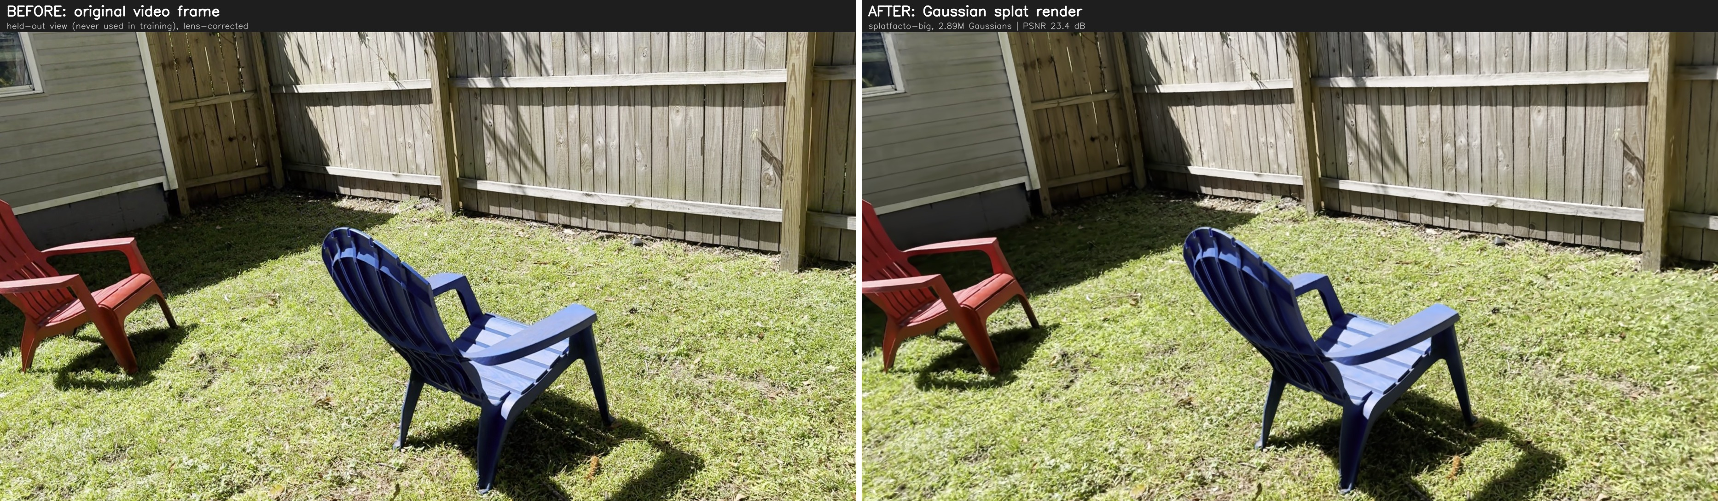
IMG_6556, best held-out view. Left: a real video frame the model never saw during training. Right: the Gaussian splat rendered from the same camera (23.4 dB PSNR).

Sprint at a glance
Item | Summary
Goal | Build a reliable pipeline that turns one iPhone video into a crisp, correctly aligned Gaussian splat on my 8 GB laptop, then take a first step toward relighting (Method A).
Scenes | Three phone videos (1080p, 60 fps, 90 to 104 seconds each). Main test scene: IMG_6556, blue and red Adirondack chairs on grass with a fence, sun and shade.
Best result | IMG_6556: 2.89 million Gaussians, 717 MB, trained at full resolution.
Bigger GPU test | IMG_6557 retrained on the school workstation (96 GB): 4.15M Gaussians and visibly sharper detail, but a lower raw PSNR, which exposed a flaw in how I was measuring.
Accuracy on unseen views | Median held-out PSNR of 21.2 dB for IMG_6556 and 22.5 dB for IMG_6557, measured on frames the model never trained on.
Relighting test | GaussianShader trained on IMG_6556 (PSNR 25.06), relit with studio and sunset HDRs. Only reflections changed; sun and shadows stayed baked in.
Main lesson | Silent failures were a bigger risk than crashes, and a BRDF method built for shiny objects does not truly relight an outdoor diffuse scene.

1. Sprint goal and context
My thesis asks whether a location captured as a 3D Gaussian Splat can be relit to match the lighting of a virtual production stage, so it can sit on an LED volume and still look like it belongs in the shot. In Sprint 1 I set up the research questions, chose the two relighting methods I will compare (Method A: BRDF decomposition, Method B: a mesh proxy in Unreal Engine 5), and planned the plugin architecture.
This sprint moved to the front of the pipeline, the “capture” end of “From Capture to Cut.” Every relighting method depends on the splat underneath it. If the splat is blurry, trained on the wrong frames, or sitting in the wrong coordinate space, no amount of relighting will fix it. So the sprint had two goals:
- Goal 1: a dependable capture-to-splat pipeline. Turn a single phone video into a sharp, full-resolution splat that lines up with the camera tracking data, and do it reliably on my home laptop (RTX 4070 Laptop GPU with 8 GB of video memory, 15.5 GB of usable system memory).
- Goal 2: a first relighting experiment. Train a relightable (BRDF) version of one scene and try swapping in new lighting, to learn where the real difficulty lies before committing to Method A.
What I developed during the sprint:
- A high-quality pipeline script (make_splat_hq.sh) that picks the sharpest frames, solves camera positions, repairs the camera solve, trains, and exports.
- Two guardrail tools: a sharp-frame selector and a camera-model fix that stops the pipeline from quietly training on the wrong data.
- A monitoring setup so I could run long jobs from school: progress updates every five minutes, instant crash alerts, and a read-only live terminal.
- A working install of GaussianShader, a relightable splat method, plus a render script that swaps its lighting for new HDR environments.
- A lab notebook (lab-notes.md) and quick-reference file that log every change, run, and problem with dates and numbers.
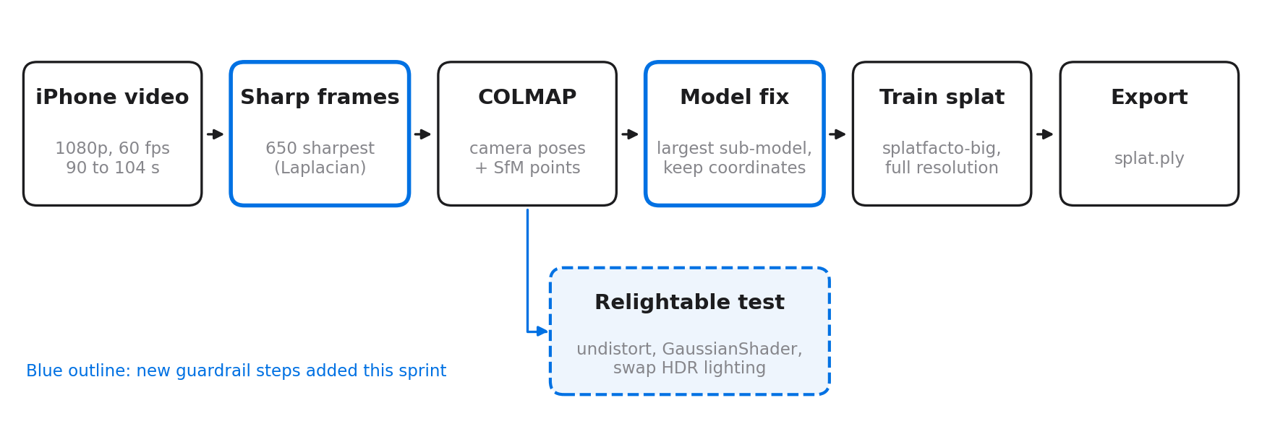
Figure 1. The capture-to-splat pipeline built this sprint, with the relightable test branching off after the camera solve.

2. What is and is not innovative

Not innovative (established tools and patterns)
- Gaussian Splatting itself, and nerfstudio’s splatfacto and splatfacto-big trainers.
- COLMAP for structure from motion (solving where the camera was for each frame).
- GaussianShader, a published method for shading reflective surfaces on splats.
- Picking sharp frames by measuring blur (Laplacian variance) is common practice in photogrammetry.
- Lighting scenes with HDR environment maps (I used free CC0 maps from Poly Haven).

What is different about my artifact
- Aimed at virtual production, built on consumer gear. The pipeline starts from an ordinary phone video and a laptop, not a camera array or a render farm. That matches the budget reality of student and indie film crews, who are the intended users.
- Guardrails against silent failure. Standard tools can fail without stopping. My pipeline automatically uses the complete camera solve, checks the frame count, and keeps the splat in the same coordinate space as the tracking data. I verified the alignment with a number (median distance of 0.058 units in a scene about 5 to 7 units across), which matters when the splat has to line up with a real stage in Unreal.
- Measured evidence of where BRDF relighting breaks outdoors. I showed that GaussianShader only changes reflections, while sun, shade, and cast shadows stay baked in. This gives concrete support to the zero-shadow normalization pass that I proposed as a key contribution of the thesis.
- A documented, reproducible process across two machines. I ran the laptop remotely from school, using an AI coding agent as the operator and a shared lab notebook as its memory. A second machine at school then rebuilt the setup from the notes and found problems a single machine would never show.

3. The most challenging aspect
The hardest part of the artifact is relighting a real outdoor capture. It has two layers.
Layer 1: getting a splat good enough to relight, within tight hardware limits. Crisp detail needs full-resolution frames and a large model, but the large model filled the 8 GB of video memory before step 15,000, and 650 full-resolution frames used 10 to 11.6 GB of the 15.5 GB system memory. Much of the week went into making quality fit inside those limits.
Layer 2: separating light from surface color. To relight a scene, the model has to know which part of a pixel is the object’s own color and which part is the light falling on it. In an outdoor capture the sun and its shadows are recorded into every frame. Grass is especially hard, because its surface direction (the normals) changes constantly, so the model cannot tell reliably how it should reflect light. This layer is the core of the thesis and it remains the most uncertain part.

4. Experiments to address the challenge
I tried more than one approach at almost every stage. The table below lists what I compared and what I kept.
Area | Approaches compared | Outcome
Frame selection | Evenly spaced frames (ffmpeg) vs. the sharpest frame in each window | Sharpest frame kept. Motion-blurred frames were the main cause of soft detail.
Resolution | nerfstudio default vs. full resolution | Found that nerfstudio quietly shrinks images to 1600 px wide. Full resolution kept.
Coordinates | nerfstudio re-orienting the scene vs. keeping COLMAP’s coordinates | Kept COLMAP coordinates. Splat now sits on the tracking points (median error 0.058 units). Side effect: viewer needs “Reset Up Direction.”
Model size | splatfacto vs. splatfacto-big | Big model gave the most detail (2.89M Gaussians) but does not reliably fit in 8 GB. Automatic fallback to splatfacto added.
Memory | Frames on GPU vs. cached in system memory; stopping new points early; resuming from a checkpoint | Caching in system memory plus stopping new points at step 10,000 and resuming dropped GPU use from 7.2 to 6.1 GB and step time from 562 to 144 ms.
Camera solve speed | COLMAP 3.10 (incremental) vs. COLMAP 4.1 with the built-in GLOMAP global mapper | Installed COLMAP 4.1, but it cannot open databases from 3.10. Parked for now.
Hardware | RTX 4070 Laptop (8 GB, splatfacto 30k) vs. RTX PRO 6000 (96 GB, splatfacto-big 60k) | The workstation splat has almost 3x the Gaussians and much finer detail. Confirms that the 8 GB limit, not the pipeline, was capping quality.
Relighting training | GaussianShader default settings vs. limited point growth | Default ran out of memory before its first save. Limiting point growth made it fit (3.1 GB) and finish overnight.
Relighting render | Raw HDR maps vs. exposure-matched HDR maps | Raw maps were 3.8 to 5.4 times brighter than the learned light and washed out the scene. Matched maps looked clean but almost unchanged.

5. Developing the challenging aspect for testing

The splat pipeline
I built the full pipeline into one command that takes a video, a scene name, the number of frames (650 by default), and the number of training steps (30,000). It skips the slow camera solve if the scene has already been solved, and it stops immediately if any step fails, so one bad run cannot roll into the next video.
Scene | Method and settings | Gaussians | File size
my_scene_600f | splatfacto, 7k steps, half resolution (quick test) | not recorded | 92 MB
my_scene_600f_hq | splatfacto, 30k steps, full res, COLMAP-aligned, 54 min | 595k | 148 MB
IMG_6556 | splatfacto-big, 40k steps (resumed at 10k), full res | 2.89M | 717 MB
IMG_6557 | splatfacto (big model crashed), 30k steps, full res, 51 min | 1.45M | 359 MB
IMG_6557 (school) | splatfacto-big, 60k steps, uncapped, RTX PRO 6000 96 GB | 4.15M | not recorded

How close is the splat to reality?
To test quality honestly, I compared renders against held-out frames: real video frames that were set aside and never used in training. The splat has to predict what the camera would see from that position. I measured the match with PSNR (peak signal-to-noise ratio, where higher means closer to the real frame) and saved the median, best, and worst frame for each scene.
My first comparison scored only about 15 dB, which looked like a failure. The cause was the test, not the splat: the real frames still had phone lens distortion while the renders did not, so the corners were misaligned by about 12 pixels. After correcting the lens distortion on the real frames with the same camera settings, the scores became fair: IMG_6556 median 21.2 dB (range 19.7 to 23.4) and IMG_6557 median 22.5 dB (range 20.0 to 24.5). Grass and leaves score low on PSNR even when they look right, because every blade is a tiny, slightly shifted detail.
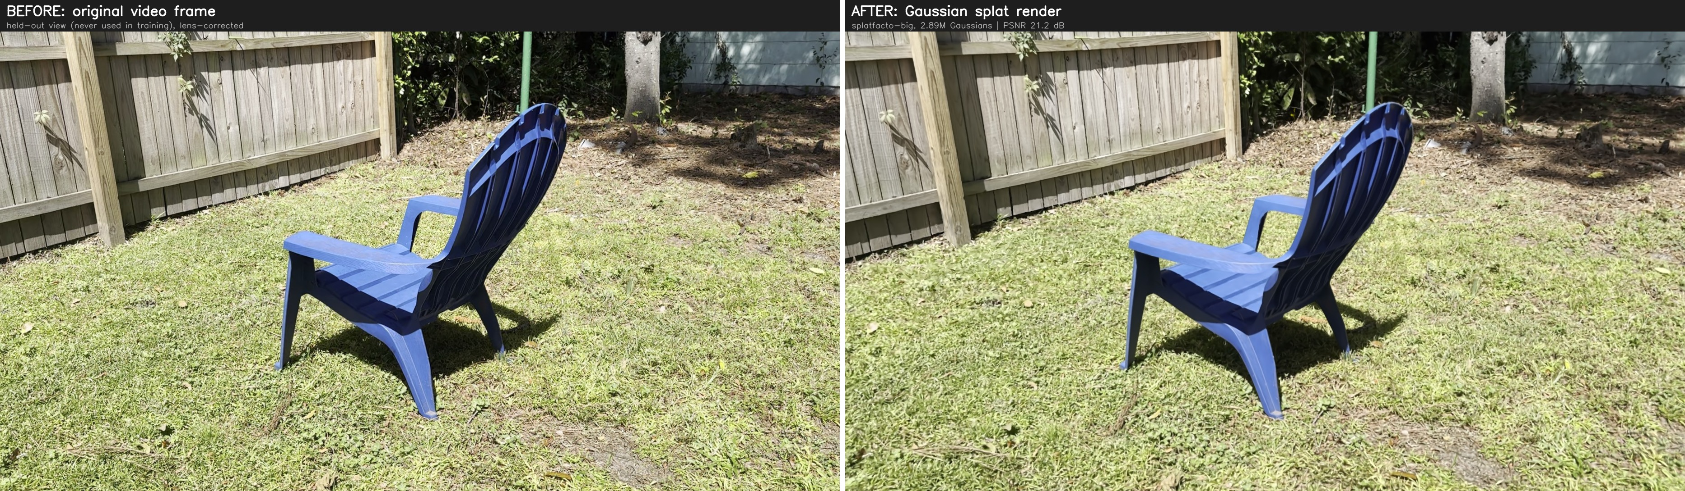
Figure 2. IMG_6556, median held-out view (21.2 dB). Chair shape, slats, cast shadow, and the fence grain all carry through. The grass is slightly softer than the real frame.
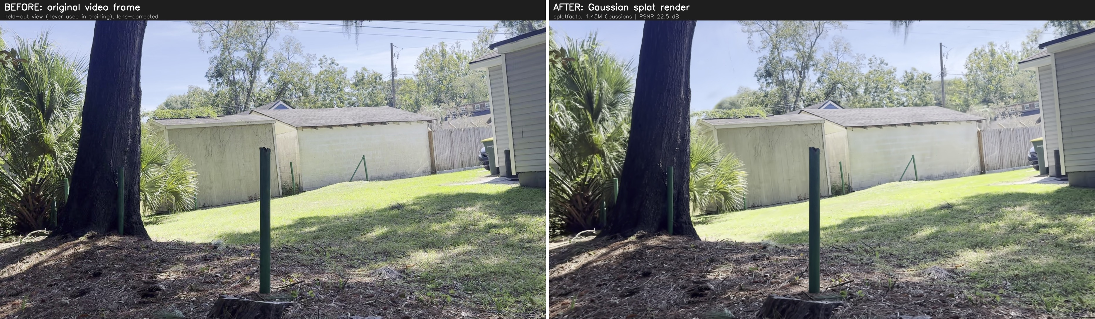
Figure 3. IMG_6557, median held-out view (22.5 dB). Sheds, house siding, fence, and the shadow edge on the lawn are all in place; small softness appears in the distant trees and sky.
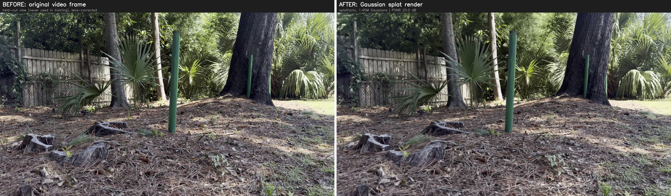
Figure 4. IMG_6557, hardest held-out view (20.0 dB). Dense palm fronds, pine straw, and fine foliage are the toughest material for a splat, yet the overall structure still holds.

Same scene, bigger GPU: laptop vs. school workstation
To see how much the 8 GB limit was holding the splat back, I retrained IMG_6557 on the school workstation (RTX PRO 6000 Blackwell, 96 GB of video memory). With that much room, splatfacto-big could run uncapped for 60,000 steps, and it grew to 4.15 million Gaussians, almost three times the laptop’s 1.45 million. I then compared both splats against the same held-out frames, with a 2x zoom on the hardest areas.
By eye, the school splat is clearly sharper. Palm fronds keep their individual blades, pine straw and pine cones hold their texture, and bark detail survives where the laptop version smears into soft blur. Yet its PSNR came out lower, 16.1 to 19.7 dB against the laptop’s 20.0 to 24.5 dB on the same views.
The reason is the test, not the splat. Training also fine-tunes the camera positions (pose refinement), but the held-out frames keep their original, unrefined positions, so a render can be a pixel or two off from the real frame. PSNR compares pixels one to one, so a sharp image that is slightly shifted scores worse than a blurry one, because blur averages out small misalignments. To fix this I wrote an evaluation script (eval_heldout.py) that corrects the lens distortion and then applies a small alignment step before scoring. On the laptop’s IMG_6557 it raises the median from 22.7 to 24.7 dB. Running the same script on the school splat is the next step, so both are measured on equal terms.
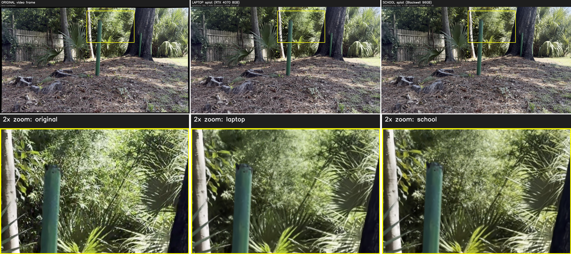
Figure 5. IMG_6557 foliage, original vs. laptop (splatfacto, 1.45M Gaussians, 20.0 dB) vs. school (splatfacto-big 60k, 4.15M Gaussians, 16.1 dB). The school splat recovers far more leaf and frond detail despite its lower score.
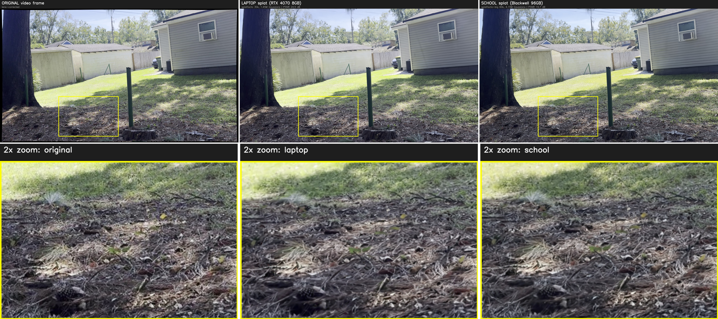
Figure 6. Pine straw on the ground. The laptop render blurs the needles together; the school render keeps the needles and the pine cone. Laptop 24.5 dB, school 19.7 dB: the sharper image scores lower.

The relighting prototype
For the relighting test I trained GaussianShader on IMG_6556. Its original setup files date from 2022 and could not be installed, so I rebuilt its environment with current versions, a compatible compiler, and undistorted camera images (the only kind it accepts). Training took 3 hours 12 minutes overnight at half resolution and reached a PSNR of 25.06.
GaussianShader has no built-in option to change the lighting, so I made one: the model stores its learned lighting as an HDR image, and my render script swaps that file for a studio HDR and a sunset HDR, then renders the same camera path for each. I rendered side-by-side comparison videos to review the results.

How I tested it
- Does it reproduce the original? With its own learned lighting, the render matched the real footage closely (average brightness 122.8 vs. 123.8 on frame 300).
- Does new light change the scene? I split one frame (570) into its diffuse part (the surface’s own color and shading) and its specular part (reflections). Under the studio HDR the specular value changed from 0.179 to 0.439, but the diffuse value stayed exactly 0.441, the same as under the original light.
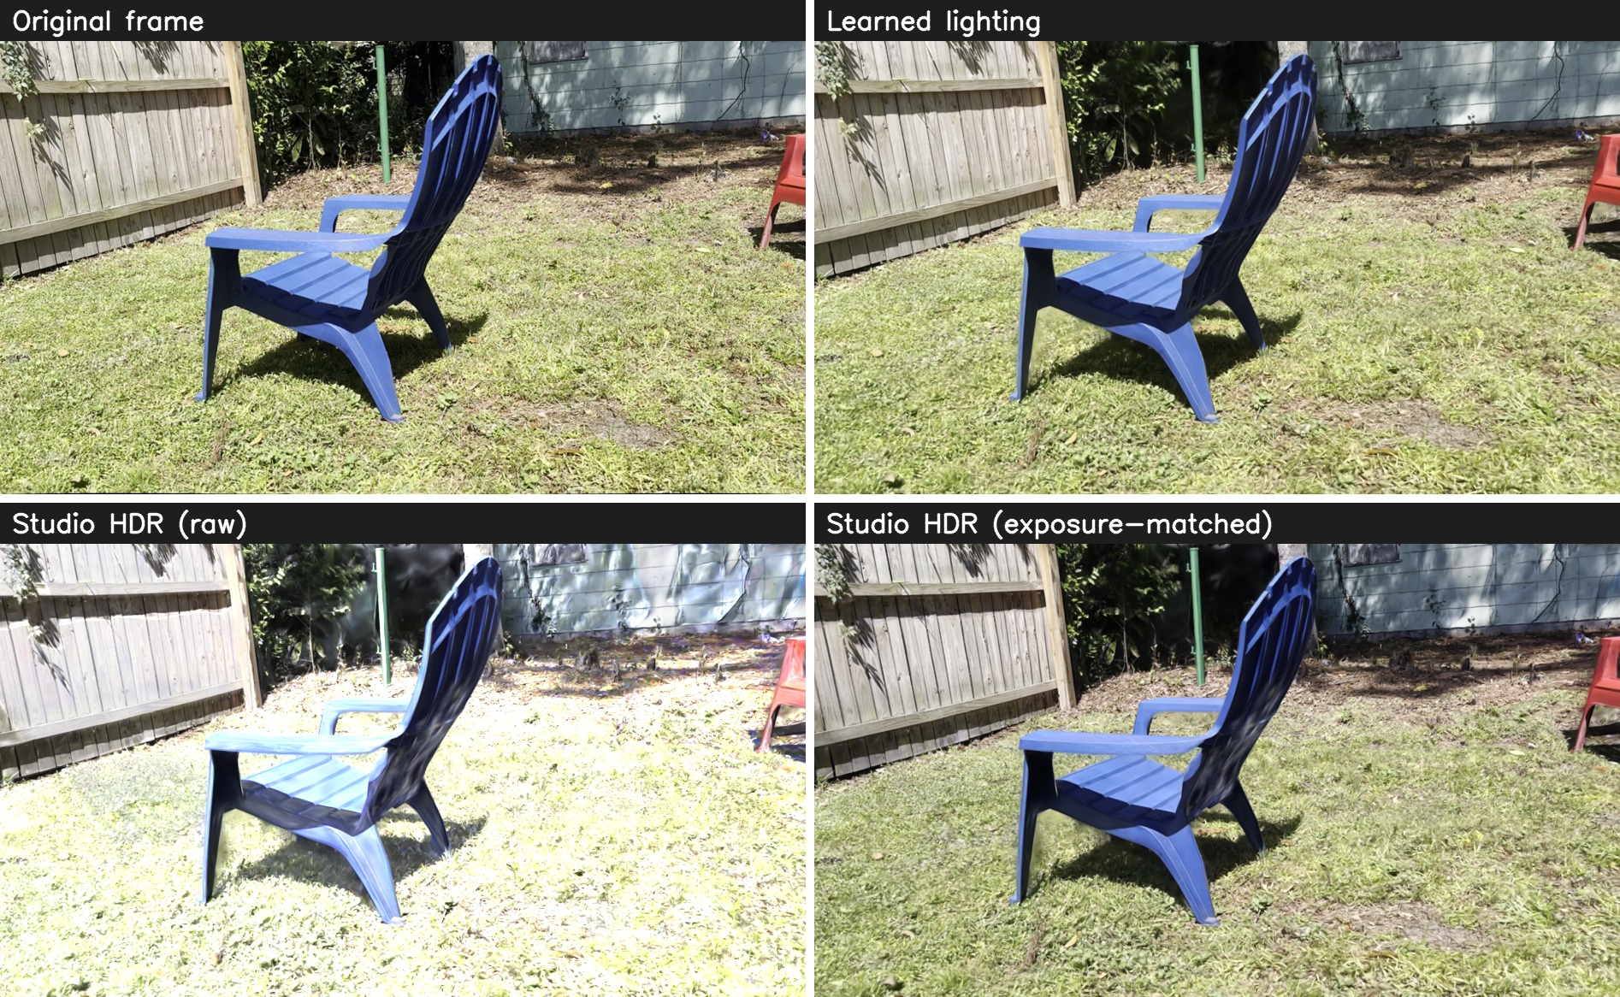
Figure 7. Relighting panel, side view of the blue chair. Learned lighting matches the original. The raw studio HDR washes the grass out with purple haze. The exposure-matched studio HDR is clean but looks almost the same as the original, and the sun and the chair’s shadow do not move.
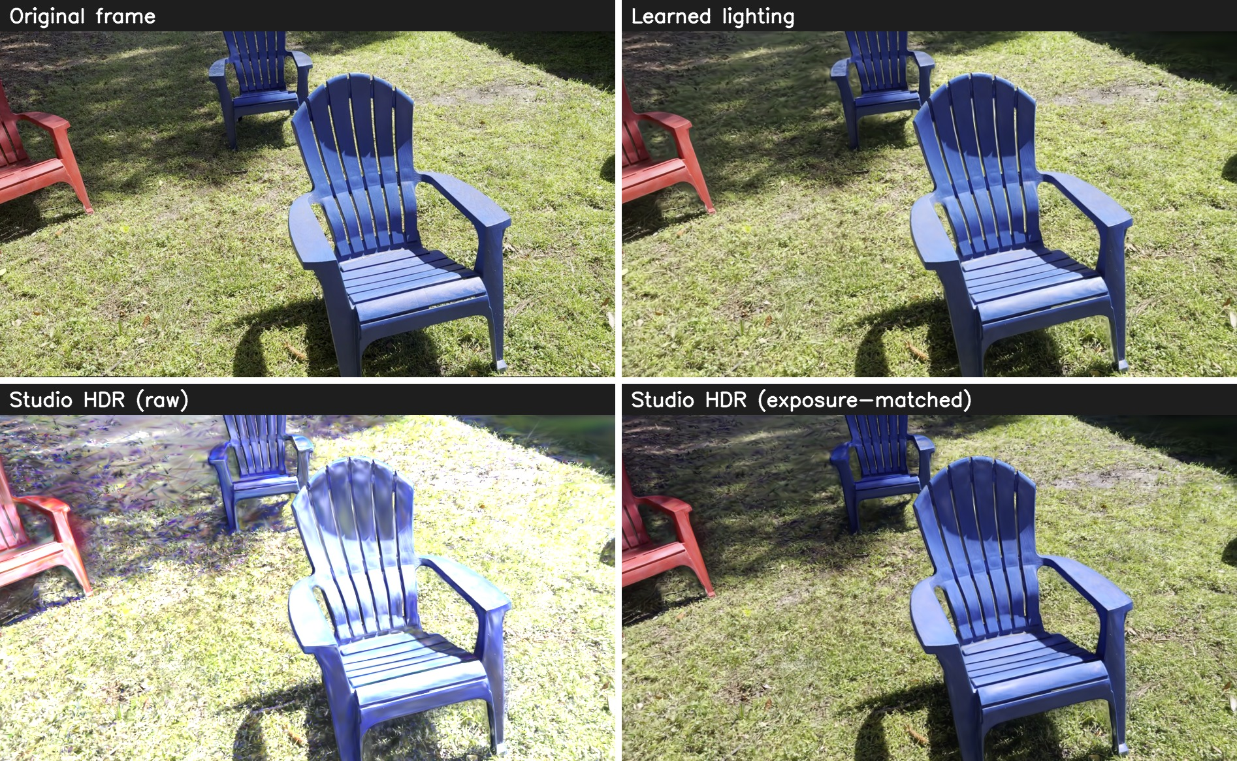
Figure 8. Relighting panel, front view. The same pattern: raw HDR causes cloudy streaks in the shaded grass (noisy normals scattering reflected light), while the matched HDR changes very little. Proof that only reflections are being relit.

6. Critical technical checkpoints and constraints

Constraints
Constraint | Effect on the work
8 GB of video memory | The large model runs out of room around steps 7,000 to 15,000. On this laptop the driver spills into system memory instead of failing cleanly, so training slows to a crawl or crashes.
15.5 GB of system memory | 650 full-resolution frames take 10 to 11.6 GB. Adding a second copy of the frames for evaluation nearly crashed the system.
Camera solve time | COLMAP takes 37 to 50 minutes per scene and runs mostly on the CPU, so a faster GPU does not help.
Heat and power | The GPU reached 86 °C during feature matching, right at its throttle point. The laptop also slept overnight once when the lid or power policy kicked in.
Remote-only visibility | I drove the laptop from school and could not see its screen, so every result had to be reported in chat or through a live view I set up.
Software versions | COLMAP 3.13 renamed an option that nerfstudio still uses. New Ubuntu ships a compiler too new for CUDA 12.4. GaussianShader cannot resume from checkpoints.

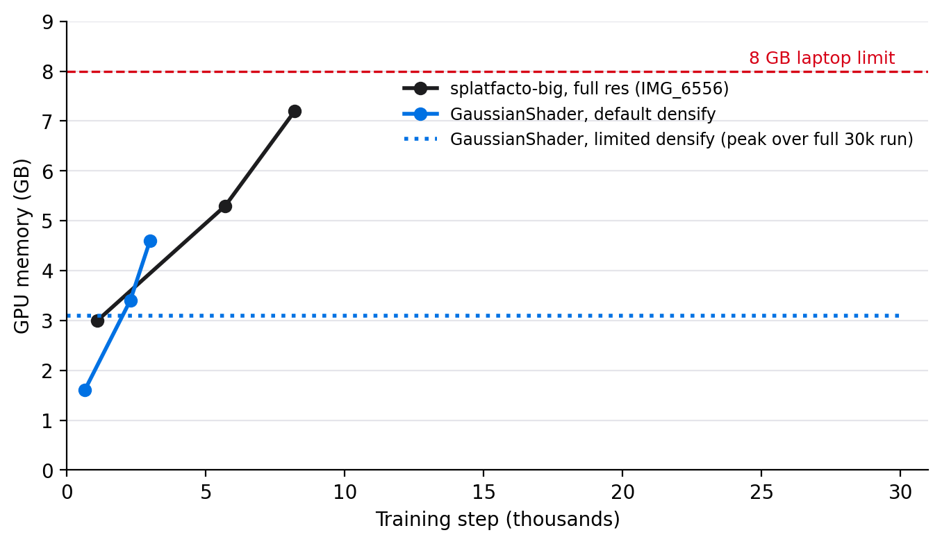
Figure 9. GPU memory as training progressed. Both uncapped runs headed for the 8 GB limit; limiting point growth kept GaussianShader at about 3.1 GB for the whole run.

Checkpoints I now run on every scene
- Frame count check: the number of frames with camera positions must match the number of frames extracted. This caught a run that was training on only 2 of 659 frames.
- Alignment check: measure the distance from splat points to the tracking points.
- Memory trend check: watch GPU and system memory over time, not just for errors, and stop early if the trend points at the limit.
- Held-out comparison check: render frames the model never saw, correct the lens distortion, correct small camera offsets, then compare with PSNR and by eye with zoomed crops. Never trust PSNR alone.
- Lighting split check: for relighting, confirm that both the diffuse and specular parts respond to new light.
- Second-machine check: rebuild the setup on a different computer to expose version problems.

7. Failures and breakthroughs

Failures and what I learned
What went wrong | What I learned
COLMAP split the scene into two pieces, and nerfstudio trained on the piece with 2 of 659 frames. It only printed a warning. | Always check the frame count. The fix is now automatic: the pipeline uses the largest piece.
The splat did not line up with the tracking points. | nerfstudio re-centers and re-scales scenes by default. For virtual production the original coordinates must be kept.
Adding an evaluation option doubled memory use and nearly crashed the system. | On this laptop, memory is the ceiling for how many frames I can use. Never cache the frames twice.
Resuming training failed twice: once on a security default in PyTorch 2.11, and once because it resumed while the model was still adding points. It also trained 10,000 extra steps by mistake. | Resume only after point growth has stopped, and count the remaining steps, not the total.
The large model crashed on IMG_6557 at step 7,390, and the crash was reported 45 minutes late because the monitor had expired. | splatfacto-big is not reliable at full resolution on 8 GB. Monitoring needs its own safety check.
The relit renders came out “too bright with cloudy artifacts,” with purple streaks in shaded grass. | Raw HDR maps need exposure matching. More importantly, GaussianShader only relights reflections, and noisy grass normals scatter those reflections into haze.
The first before/after comparison scored about 15 dB, which made the splat look broken. | The real frames still had lens distortion and the renders did not. Test data has to go through the same corrections as the model, or the numbers lie.
The sharper school splat scored 3 to 5 dB lower PSNR than the softer laptop splat. | PSNR punishes sharp images that are slightly shifted. Refined camera poses leave held-out views a pixel or two off, so scoring needs an alignment step, and it has to be read next to visual comparisons.
A second machine at school could not run the pushed code: COLMAP had renamed an option. | Pin software versions. One machine hides version drift.

Breakthroughs
- Detail: sharp-frame selection, full resolution, and the large model together produced the most detailed splat so far, 2.89 million Gaussians for IMG_6556.
- Hardware ceiling confirmed: on the 96 GB workstation the same pipeline produced 4.15 million Gaussians with far finer detail, proving the pipeline scales and the laptop was the bottleneck.
- Alignment: the splat now sits in the same space as the camera tracking data, which is what Unreal and an LED stage need.
- Fitting quality into 8 GB: stopping point growth and resuming from a checkpoint cut GPU memory from 7.2 to 6.1 GB and made training about four times faster.
- A relightable model that finishes: limiting point growth let GaussianShader train overnight without running out of memory.
- The key finding: GaussianShader leaves the diffuse light and shadows untouched. It is designed for shiny objects and is not true relighting for an outdoor diffuse scene. This tells me exactly what Method A must handle and why the zero-shadow normalization pass matters.

8. Re-scoping continued development
This sprint showed that capture quality is now solid, and that the real open problem is separating baked-in sunlight and shadow from the surface itself. The next stage shifts effort toward that problem and moves heavy training off the laptop.
Decision | What and why
Continue | The high-quality pipeline as the standard way to make every scene. The held-out before/after comparison as the standard quality test, and as the baseline every relighting method must keep. The lab notebook, which let a fresh session and a second machine pick up the work without the chat history.
Change | Move full-scale training to the school workstation (RTX PRO 6000, 96 GB), which the IMG_6557 retrain showed gives much sharper splats. Score every scene with eval_heldout.py so laptop and workstation results are comparable. Move the relighting tests from GaussianShader to methods that relight the diffuse part too: R3DGS, which is my planned Method A, with GS-IR as an alternative.
Simplify | Keep the laptop for quick tests and UE5 plugin development. Drop the large model on the laptop, or cap it early. Pin software versions so the pipeline behaves the same everywhere.
Expand | Develop the zero-shadow normalization pass, now backed by evidence that shadows stay baked in. Test captures in even, overcast light to reduce baked shadows. Bring an exported splat into UE5 and start the Method B mesh-proxy comparison.
Remove | GaussianShader as a candidate for the final method. The COLMAP 4 / GLOMAP detour for now. Public tunnel links, replaced by local viewing on the school machine.

A note on process
I ran this sprint largely from school, directing an AI coding agent (Claude Code) on my home laptop through remote control. The agent handled installs, scripts, and monitoring, and it logged its own mistakes in the lab notes as it corrected them. I supplied the direction and domain knowledge it lacked, for example that GLOMAP had been merged into COLMAP and that my two new videos were separate scenes rather than one. Two lessons carry forward: checking outputs (frame counts, memory trends, renders against real footage) caught problems the logs did not, and asking before large or irreversible actions worked better than acting first.

