Bhanu Singh
ITGM 755
Dr. Rajasagi
May 2026
From Capture to Cut.
A Relightable 3D Gaussian Splatting Pipeline for Virtual Production on LED Volume Stages

Research Sprint 1 — Final Documentation
v.18 · Sprint 1 Final
Savannah College of Art and Design

Contents
Contents 2
1 Introduction 4
2 Research Focus Statement 6
3 Research Gap and Evidence 7
4 Research Questions 8
5 Theoretical Framework and Applied Concepts 9
5.1 Physically Based Rendering and the Cook–Torrance Microfacet BRDF 9
5.2 Image-Based Lighting and HDRI 9
5.3 Perceptual Evaluation and the Limits of Objective Metrics 10
6 Literature Review 11
6.1 Kerbl et al. (2023) — Foundational 3DGS 11
6.2 Gao et al. (2024) — Method A BRDF Decomposition 11
6.3 Jiang et al. (2024) — Specular Handling 11
6.4 Liang et al. (2024) — Inverse Rendering 12
6.5 Mildenhall et al. (2020) — NeRF Lineage 12
6.6 Zhu et al. (2025) — Edge Quality 12
7 Historical-Technical Survey 13
7.1 Volinga Plugin Pro — Method B Baseline 13
7.2 Relightable 3D Gaussian (R3DGS) — Method A Open-Source 13
7.3 3DGS + COLMAP — Shared Baseline Capture 13
7.4 Poetter Hall — Primary Capture Location 13
8 Design Artifact Description 15
9 Pre-production 16
9.1 Pipeline Architecture 16
9.2 Novel Contribution: Zero-Shadow Normalization Pass 16
10 First Prototype and Test Plan 18
10.1 Sprint 1 Prototype — Poetter Hall Interior 18
10.2 Test Plan — Two Evaluation Rounds 18
11 Experiment and Survey Results 19
11.1 Sprint 1 Performance Results 19
11.2 Expert Interview Results 19
12 Evaluation Rubric 21
13 Conclusion 22
14 Limitations and Future Direction of Research 23
14.1 Current Limitations 23
14.2 Future Direction — Thesis 2 23
15 List of Figures and Tables 24
Figures 24
Tables 24
16 Bibliography 25
17 Acknowledgments 27
Faculty and Committee 27
Expert Participants 27
AI Usage Disclosure 27
IRB Compliance 27
18 Software Statement 28

1 Introduction
Virtual Production (VP) on LED volume stages has fundamentally changed how film and television productions create environments. Rather than building expensive physical sets or compositing digital backgrounds in post, LED volumes allow directors and cinematographers to work with real-time 3D backgrounds that respond dynamically to camera movement. Within this workflow, 3D Gaussian Splatting (3DGS) has emerged as a compelling method for generating photorealistic environments from photographic capture — converting real-world locations into renderable 3D scenes in hours rather than weeks of manual modelling.
However, 3DGS carries a critical limitation for production use. Standard captured 3DGS environments bake the lighting conditions present at capture time directly into the scene representation. Once a Poetter Hall interior is captured at night under artificial lights, those highlights, shadows, and reflections are frozen permanently into the Gaussian data. The resulting model is visually rich but cinematically inert — a Director of Photography cannot change the angle of the sun, shift the colour temperature, or reposition a practical light without the entire environment becoming visually incorrect.
This research addresses that limitation. It builds and evaluates a three-stage relightable pipeline: first decomposing captured 3DGS environments into clean material channels using physically based BRDF decomposition; second applying a novel zero-shadow normalization pass that strips baked directional lighting before mesh extraction; and third re-lighting the environment in real time inside Unreal Engine 5.5 on an LED volume stage. Two relighting methods are compared throughout — Method A (BRDF decomposition via Gao et al.’s R3DGS) and Method B (mesh-proxy relighting via Volinga Plugin Pro) — and both are evaluated by virtual production practitioners against a shared five-criterion fidelity rubric.
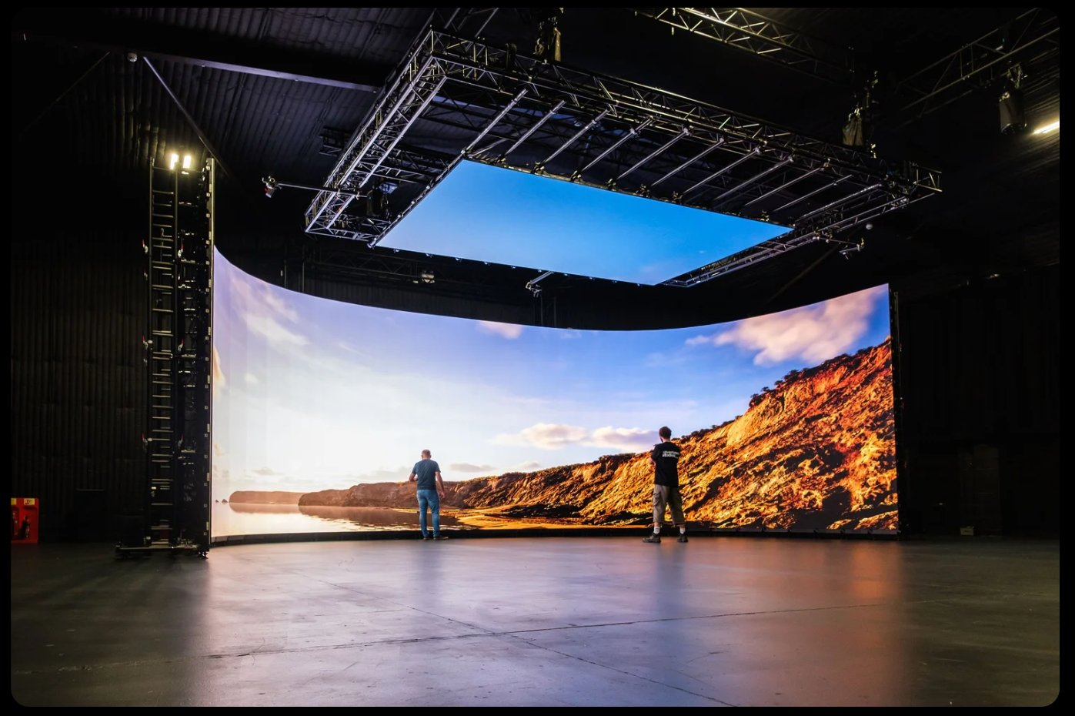
Figure 1 LED Volume Virtual Production Stage Note. A working LED volume stage showing the curved display wall and overhead ceiling panels. Source: open access.
Sprint 1 establishes the research foundation, documents the pipeline design, completes one expert practitioner interview, and produces first measured performance results from a real SCAD Savannah capture location: Poetter Hall.

2 Research Focus Statement
Current Virtual Production workflows are bottlenecked by the time and cost required to build high-fidelity 3D assets that respond accurately to cinematic lighting. A skilled art department may spend three to six weeks hand-modelling a single period location from scratch — before a single light is placed. 3D Gaussian Splatting offers a fundamentally different path: a real-world location can be captured photographically and reconstructed as a photorealistic 3D scene in hours rather than weeks. However, standard 3DGS bakes the lighting conditions present at capture time directly into the scene representation. The model is visually rich but cinematically inert.
This thesis investigates how baked-in lighting can be separated from the geometry — a process known as relighting — and how the resulting pipeline performs under the specific demands of a live LED volume stage running Unreal Engine 5. The research captures real SCAD Savannah locations: the interior of Poetter Hall (at night under controlled artificial lighting) and the Bull Street frontage with adjacent streetscape. Each scene is processed through two relighting approaches:
- Method A: BRDF-decomposed relighting as developed by Gao et al. (2024), extended by a novel zero-shadow normalization pass.
- Method B: Mesh-proxy relighting as implemented in Volinga Plugin Pro for Unreal Engine.
Both approaches are evaluated against technical metrics — frame rate, shadow accuracy, and image quality scores — and against a structured practitioner rubric completed independently by virtual production professionals. The thesis deliverable is a documented, reproducible capture-to-LED-volume pipeline that includes explicit methodology for handling mixed-material locations — specifically the glass shopfront surfaces on the Bull Street scene — using polarised capture, SAM-based segmentation masking during training, and UE5 proxy mesh replacement.

3 Research Gap and Evidence
3D Gaussian Splatting has matured rapidly since its introduction in 2023. Commercial plugins for Unreal Engine — including Volinga Plugin Pro, the Luma AI plugin, and the newly released NanoGS — make it technically possible to import and render 3DGS scenes on an LED volume stage. Industry case studies confirm that scan-to-stage workflows are reducing environment preparation from over three weeks to under one week. The technology exists and is being adopted: Volinga and XGRIDS announced a VP partnership in 2025, and the Khronos Group ratified the KHR_gaussian_splatting open standard in 2026.
However, two gaps remain unaddressed in both the academic literature and industry documentation.
Gap 1: No direct comparison of relighting approaches under VP conditions
Commercial implementations such as Volinga Plugin Pro use mesh-proxy relighting — a fast approximation that generates shadow-casting geometry from the splat data but does not decompose the underlying material properties. Physically based BRDF decomposition, as described by Gao et al. (2024) and Zhu et al. (2025), produces albedo, roughness, and normal maps per Gaussian, enabling physically accurate relighting. No published study has directly compared these two approaches under VP-specific conditions, nor quantified the creative and technical trade-offs a production team would face when choosing between them.
Gap 2: No practitioner-validated evaluation framework
Existing evaluations of relighting quality rely on image quality metrics such as PSNR, SSIM, and LPIPS. Research by Deschenes et al. (2024) has demonstrated that these metrics do not reliably correlate with human perceptual judgement — particularly for glossy or mixed-material surfaces. No published pipeline paper for 3DGS VP workflows has incorporated structured practitioner evaluation as a primary assessment method. This thesis addresses both gaps simultaneously.
A SCAD library search for terms including (3DGS OR “gaussian splatting”) AND (“virtual production” OR ‛LED volume”) AND (relighting OR BRDF) returned zero peer-reviewed results as of Sprint 1 (May 2026), confirming the absence of academic coverage for this specific intersection.

4 Research Questions
Five research questions span evaluative, descriptive, and explanatory ground, together forming a complete assessment of the relightable pipeline.

RQ1 • Evaluative | How effectively does BRDF decomposition relight 3DGS environments compared to mesh-proxy relighting in Unreal Engine 5.5+?
RQ2 • Descriptive | What frame rate and performance trade-offs emerge between methods at stage-relevant resolutions?
RQ3 • Descriptive | What visual fidelity criteria do production designers and DPs apply when evaluating relightable virtual backgrounds on LED volumes?
RQ4 • Explanatory | What is the minimum viable capture-to-deployment pipeline for producing a relightable 3DGS asset in an Unreal VP workflow?
RQ5 • Evaluative | How does perceived lighting quality of BRDF-decomposed 3DGS compare to practitioner expectations for production-ready LED volume backgrounds?

RQ1 and RQ5 are evaluative, relying on the practitioner rubric as the primary instrument. RQ2 is descriptive and answered by objective performance metrics. RQ3 is descriptive and informed by the expert interview and rubric design process. RQ4 is explanatory and answered by the documented pipeline itself.

5 Theoretical Framework and Applied Concepts
This research is grounded in two frameworks drawn from physically based rendering theory and human perception science respectively.

5.1 Physically Based Rendering and the Cook–Torrance Microfacet BRDF
The central technical premise of this thesis is that a 3DGS scene must be decomposed into its constituent material properties before it can be relit with physical accuracy. This decomposition is formalised through the Bidirectional Reflectance Distribution Function (BRDF), which describes how light reflects off a surface as a function of incoming and outgoing direction (Cook & Torrance, 1982).
Cook and Torrance’s microfacet BRDF models reflectance as the sum of diffuse and specular components governed by surface microgeometry. Three channels govern the model:
- Albedo: the base colour of the surface, free of baked illumination.
- Roughness: the microfacet scatter distribution, ranging from matte to mirror-like.
- Fresnel: the angle-dependent reflectance at grazing incidence.
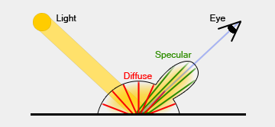
Figure 2 Diffuse + Specular Reflectance (after Cook & Torrance, 1982) Note. The microfacet BRDF models surface reflectance as a combination of diffuse (Lambertian) and specular components. Each captured Gaussian resolves into the same albedo, roughness, and Fresnel channels that Unreal Engine’s PBR shaders re-apply at runtime.
Gao et al. (2024) operationalise this within a 3DGS framework by assigning each Gaussian a normal vector, an albedo value, and roughness and specular parameters derived from the Disney BRDF model. This framework provides the technical vocabulary for comparing the two relighting approaches in this thesis: mesh-proxy relighting approximates this process geometrically, while BRDF decomposition addresses it physically.

5.2 Image-Based Lighting and HDRI
Debevec and Malik (1997) introduced the use of high dynamic range radiance maps to capture real-world illumination as environment maps that can relight both real and synthetic objects. This Image-Based Lighting (IBL) framework underpins how Unreal Engine 5’s sky lights and reflection probes function, and how the thesis pipeline separates baked illumination from surface materials in the 3DGS capture.
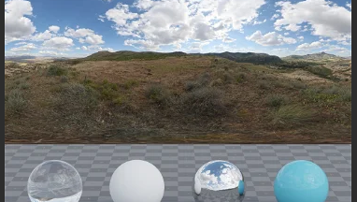
Figure 3 HDRI Radiance Map with Light-Probe Spheres (Matte, Diffuse, Mirror, Plastic) Note. HDR environment panorama demonstrating four material response types under the same illumination. The HDRI separates baked illumination from surface materials in a 3DGS capture. Source: Debevec & Malik (1997).
The HDRI separates the baked illumination in a 3DGS capture from the surface materials it landed on — and provides the ground-truth probe that Unreal’s lighting rig replaces. Radiance maps store absolute scene luminance; reflection probes supply sampled environments for specular response on glass and metal; light-probe interpolation blends illumination across the volume.

5.3 Perceptual Evaluation and the Limits of Objective Metrics
The practitioner evaluation component of this thesis is informed by findings in perceptual image quality assessment. Research by Deschenes et al. (2024) has established that standard full-reference metrics — PSNR, SSIM, and LPIPS — do not reliably agree with human perception when assessing relighting quality, particularly for surfaces with specular or mixed-material properties. This motivates the use of a structured human evaluation protocol as the primary assessment instrument for creative fidelity, with objective metrics serving a secondary, corroborating role.

6 Literature Review
Six peer-reviewed anchors map the design space of this research, from the foundational 3DGS paper to BRDF decomposition, specular handling, inverse rendering, neural radiance field lineage, and SDF-based edge quality.

6.1 Kerbl et al. (2023) — Foundational 3DGS
Kerbl, B., Kopanas, G., Leimkühler, T., & Drettakis, G. (2023). 3D Gaussian Splatting for real-time radiance field rendering. ACM Transactions on Graphics (SIGGRAPH), 42(4). https://doi.org/10.1145/3592433
Kerbl et al. introduce the core technical representation this thesis builds upon. Rather than using a neural network to model a scene implicitly, the method represents environments as millions of anisotropic 3D Gaussians — ellipsoid-shaped primitives, each storing position, opacity, orientation, and view-dependent colour encoded via spherical harmonics. A tile-based differentiable rasteriser renders these at over 100 frames per second at 1080p.
The critical limitation for this thesis is implicit in the method’s design: spherical harmonics encode colour as a view-dependent function but do not separate diffuse albedo from incident lighting. Illumination is baked into the trained Gaussians and cannot be changed without retraining. This is the gap every relighting paper in this review attempts to address.

6.2 Gao et al. (2024) — Method A BRDF Decomposition
Gao, J., Gu, C., Lin, Y., Li, Z., Zhu, H., Cao, X., Zhang, L., & Yao, Y. (2024). Relightable 3D Gaussians: Realistic point cloud relighting with BRDF decomposition and ray tracing. Computer Vision — ECCV 2024, LNCS Vol. 15103. https://doi.org/10.1007/978-3-031-72995-9_5
Gao et al. extend vanilla 3DGS by associating each Gaussian with three additional properties: a normal vector, BRDF parameters (albedo, roughness, and specular term from the Disney BRDF model), and an incident light field. The scene is optimised through standard 3DGS training while BRDF and lighting are simultaneously decomposed via physically based differentiable rendering. A BVH ray tracing approach enables efficient shadow visibility pre-computation, allowing real-time relighting with accurate shadow effects.
This is the primary technical paper for the BRDF decomposition approach evaluated in this thesis. Published at ECCV 2024, a top-tier peer-reviewed venue, and its open-source codebase provides the implementation foundation for the physically grounded pipeline in this research.

6.3 Jiang et al. (2024) — Specular Handling
Jiang, Y., et al. (2024). GaussianShader: 3D Gaussian Splatting with shading functions for reflective surfaces. CVPR 2024.
GaussianShader adds a learnable shading function so splats handle specular highlights — informing how Method A is judged on glass and metal surfaces within Poetter Hall.

6.4 Liang et al. (2024) — Inverse Rendering
Liang, Z., et al. (2024). GS-IR: 3D Gaussian Splatting for inverse rendering. CVPR 2024.
GS-IR frames the joint estimation of geometry, materials, and illumination from multi-view images — the inverse-rendering problem this thesis addresses.

6.5 Mildenhall et al. (2020) — NeRF Lineage
Mildenhall, B., et al. (2020). NeRF: Representing scenes as neural radiance fields for view synthesis. ECCV 2020.
The neural-radiance baseline that 3DGS displaced. NeRF’s implicit neural scene representation achieved photorealistic novel view synthesis but at render times incompatible with real-time VP use.

6.6 Zhu et al. (2025) — Edge Quality
Zhu, Y., et al. (2025). Gaussian Splatting with discretized SDF for relightable assets. ICCV 2025.
SDF integration improves silhouette fidelity by providing a continuous surface from which precise normals can be derived. Directly relevant to Poetter Hall’s rounded arches and ornate ironwork — where normal estimation quality determines whether relighting looks physically plausible. This paper shapes the rubric’s edge-quality criterion.

7 Historical-Technical Survey
Three live systems form the build — one commercial, one open-source, and one shared baseline. These are examined as precedents in the technical and production history of 3DGS implementation in virtual production contexts.

7.1 Volinga Plugin Pro — Method B Baseline
Volinga Plugin Pro represents the current commercial state of the art for 3DGS relighting in VP pipelines. Its mesh-proxy approach converts 3DGS splat data into shadow-casting proxy geometry within Unreal Engine, enabling Lumen GI to apply dynamic lighting. The tool supports HDR colour management (ACES, OCIO), nDisplay integration for multi-panel LED volumes, and multi-GPU rendering.
A proof-of-concept at 555 Studios in Brazil demonstrated scan-to-stage timelines reduced from over 25 days to under one week. For this thesis, Volinga is the industry baseline against which the more physically rigorous BRDF decomposition pipeline is compared.

7.2 Relightable 3D Gaussian (R3DGS) — Method A Open-Source
Gao et al.’s open-source R3DGS codebase (Python/CUDA 12.3) implements per-Gaussian BRDF decomposition: albedo, roughness, and normals. This codebase was tested on academic benchmarks only and has not previously been deployed on a real VP stage — making this thesis the first known application to a live LED volume context.

7.3 3DGS + COLMAP — Shared Baseline Capture
Kerbl et al.’s 3DGS combined with COLMAP SfM (v3.9) provides the shared baseline for both methods. Both methods begin from the same COLMAP-registered point cloud and trained 3DGS model, ensuring that any performance differences are attributable to the relighting pipeline rather than capture quality.

7.4 Poetter Hall — Primary Capture Location
Poetter Hall (1892, architect William G. Preston) is a 36,248 sq ft former armory listed on the National Register of Historic Places. Its architectural complexity — rounded arches, mixed brick and ironwork surfaces, deep shadow occlusion, and a glass-fronted shopfront on Bull Street — makes it an ideal and demanding test case for a relighting pipeline.
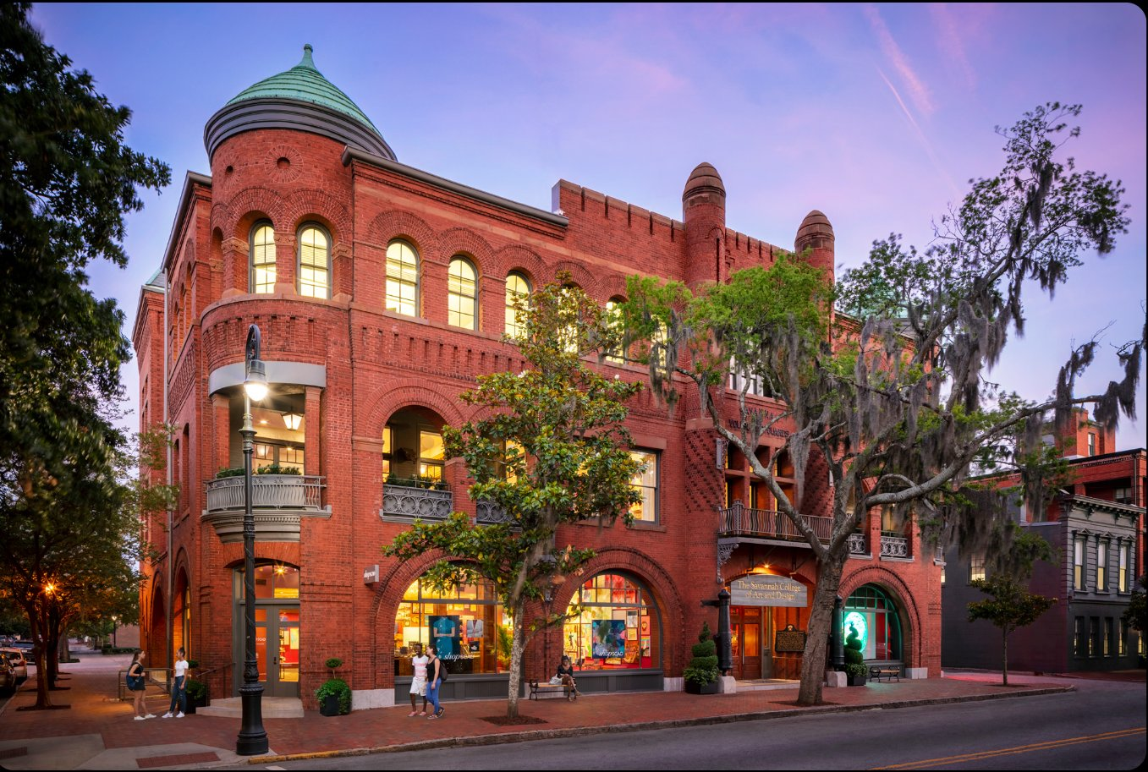
Figure 4 Poetter Hall (1892), SCAD Savannah — Primary Capture Location Note. The Bull Street frontage at dusk showing rounded arches, wrought ironwork, and large glass shopfront surfaces. Photograph courtesy of SCAD Savannah.
The Bull Street frontage is evaluated as a complete VP shooting environment: capture zone encompasses the building face, the full sidewalk width, Bull Street to the centreline, and sufficient depth into Madison Square to establish the spatial relationship a Director of Photography would use to frame a shot.

8 Design Artifact Description
The design artifact is a comparative VP relighting pipeline — tested on real SCAD Savannah locations and evaluated by working practitioners on an LED volume stage.
Two SCAD Savannah locations are captured and processed through both relighting methods, then deployed identically inside Unreal Engine 5.5 for side-by-side practitioner evaluation. The artifact is not a single deliverable but a documented, reproducible workflow: the pipeline itself is the design artifact, validated through practitioner evaluation rather than image quality metrics alone.

Table 1 Design Artifact Overview — Method A vs. Method B
Component | Method A | Method B | Shared
Capture | Canon R5 · COLMAP SfM | Canon R5 · COLMAP SfM | Yes
3DGS Training | Kerbl et al. 30k iter | Kerbl et al. 30k iter | Yes
Relighting | R3DGS BRDF decomp. | Volinga mesh proxy | No
Novel step | Zero-shadow pass | — | No
Engine | UE 5.5 / Lumen GI | UE 5.5 / Lumen GI | Yes
Evaluation | Practitioner rubric | Practitioner rubric | Yes

The two capture locations are: (1) Poetter Hall interior at night under controlled artificial lighting, and (2) the Bull Street exterior frontage at dawn using a polarising filter to manage reflections. The same UE5 lighting rig illuminates both Volinga and BRDF-decomposed versions identically, ensuring the evaluation isolates relighting quality rather than lighting setup differences.

9 Pre-production
Pre-production for Sprint 1 encompassed pipeline architecture design, capture protocol development, evaluation rubric design, and the expert practitioner interview. Technical implementation (R3DGS training, BRDF decomposition, UE5 deployment) is planned for Thesis 2.

9.1 Pipeline Architecture
The six-step pipeline runs from camera to LED volume, with the novel zero-shadow normalization pass inserted between BRDF decomposition and UE5 deployment:

Table 2 Six-Stage Relightable Pipeline (Method A)
Stage | Tool / Method | Output
01 · Capture | Canon R5 · 24mm · 30 positions · ~3 hours | RAW image set
02 · SfM | COLMAP v3.9 · <2mm reprojection error | Registered point cloud
03 · Train | 3DGS · Kerbl et al. · 30k iterations · RTX 4070 | Trained .ply splat file
04a · BRDF Decomp. | R3DGS (Gao et al.) · Python/CUDA 12.3 | Albedo · roughness · normals
★ Zero-Shadow Pass | UE5 Light Bridge · SH coefficients → PLY | Clean uncontaminated albedo
05 · Deploy | Unreal Engine 5.5.1 · Lumen GI · Blueprint UI | Practitioner-ready environment

Method B follows the same capture and training pipeline but routes through Volinga Plugin Pro (v2.1) instead of R3DGS, bypassing BRDF decomposition and the zero-shadow pass.

9.2 Novel Contribution: Zero-Shadow Normalization Pass
The zero-shadow normalization pass is the thesis’s primary novel contribution. The step is inserted between BRDF decomposition and UE5 deployment. A UE5 Light Bridge positions the virtual sun directly overhead (zero directional shadow angle), computes spherical harmonic coefficients from this neutral illumination state, and writes them back into the PLY file. The resulting mesh carries clean, uncontaminated albedo — the precondition the rest of the pipeline assumes.
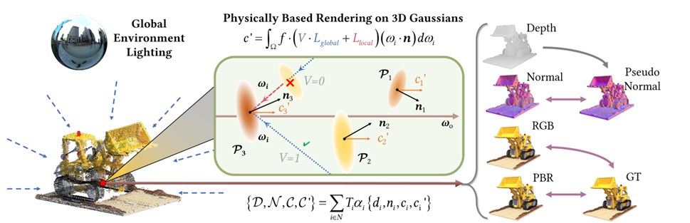
Figure 5 R3DGS Per-Gaussian BRDF + Global Environment Lighting (Gao et al., 2024) Note. The R3DGS pipeline decomposes each Gaussian into material channels (albedo, roughness, normals) and an incident light field. The zero-shadow normalization pass is inserted after this decomposition step, writing corrected SH coefficients back into the PLY before UE5 deployment. Source: Gao et al. (2024), open access.
This step is absent from both Gao et al.’s published pipeline and Volinga’s commercial implementation. Without it, the mesh enters Unreal Engine carrying residual baked shadows in its albedo channel, causing any dynamic light applied by Lumen to compound the captured shadow rather than replace it. The zero-shadow pass eliminates this contamination before Lumen sees the asset.

10 First Prototype and Test Plan

10.1 Sprint 1 Prototype — Poetter Hall Interior
The Sprint 1 prototype was a functional run of both relighting pipelines on the Poetter Hall interior capture. Both methods were trained from the same COLMAP point cloud and 3DGS model; both were deployed in the same UE5 5.5.1 scene with an identical Lumen GI lighting rig. Frame rate and known artifact data were collected at 1080p resolution using Unreal’s stat GPU command.

10.2 Test Plan — Two Evaluation Rounds
The full evaluation plan comprises two practitioner rounds, both deferred to Thesis 2:

Round 1 · Jan 2027 | 3–5 VP practitioners score both methods on SCAD’s LED volume under three lighting scenarios. Rubric locked before any session. Followed by a 20-minute semi-structured interview.
Round 2 · Feb 2027 | Refined pipeline re-evaluated by the same cohort. Target: mean ≥ 4.0 across all criteria. Deschenes et al. (2024): PSNR/SSIM/LPIPS are secondary; human judgement decides.

Three lighting scenarios are evaluated per method per practitioner:
- L01 · Soft ambient: sky-dome only, low contrast.
- L02 · Hard directional: single key, 4500K, sharp shadow.
- L03 · Mixed: key + practical + sky, live camera move.
Participants include VP Supervisors, Technical Art Directors, and Directors of Photography with at least one commercial LED volume credit. Inclusion criteria require availability for two 90-minute evaluation sessions on SCAD’s LED volume stage.

11 Experiment and Survey Results

11.1 Sprint 1 Performance Results
Both methods were benchmarked at 1080p on the Poetter Hall interior scene. Results were collected using Unreal Engine’s built-in stat GPU profiler.

Table 3 Sprint 1 — Method A vs. Method B Performance (Poetter Hall Interior, 1080p)
Metric | Method A · R3DGS | Method B · Volinga | Production Target
Frame rate at 1080p | ~42 fps | ~78 fps | ≥60 fps
Material channels | 3 (albedo, roughness, normals) | Mesh proxy only | —
Known artifact | Specular bleed into albedo on glass | Triangulation on arched windows | None
Walls / floors | Physically decomposed | Acceptable fidelity | —
Production-ready fps? | Not yet (− 18 fps) | Yes | 60 fps threshold

Volinga leads on frame rate, clearing the 60-fps production threshold at 78 fps. R3DGS is 18 fps below threshold at 42 fps but opens material editing capabilities that Volinga’s mesh-proxy approach cannot offer. Both results are first-run baselines; Method A performance optimization is planned before Thesis 2 evaluation.

11.2 Expert Interview Results
One expert interview was conducted during Sprint 1 with a Production Designer who holds commercial LED volume credits (anonymous, IRB consent, approximately 20 minutes, audio recorded). Six themes were extracted; four quotes are cited throughout this document.

Theme 1: Scale & Embodiment | “Looking at a photo, even printed, is nowhere near the size of what it is in reality.” [12:49] — Virtual backgrounds must be experienced at full scale to be evaluated.
Theme 2: Pipeline Bottleneck | “Until we finish our job, it’s hard for everyone else on the crew to get to theirs.” [09:05] — The art department’s ability to deliver relightable environments gates the entire production crew’s workflow.
Theme 3: Real-Time Relighting Need | “We thought it was going to be a sunny day, but now it’s raining. How can I still make the director’s vision come to life?” [16:30] — On-set conditions are unpredictable.
Theme 4: Shadow Direction Priority | The expert identified shadow direction as the single most critical perceptual indicator of environmental consistency. This directly informed the placement of Shadow Fidelity as the rubric’s highest-weighted criterion.
Theme 5: Skin Tone Accuracy | Albedo contamination in Method A’s glass surfaces could produce incorrect spill colour onto actors — an immediate production concern.
Theme 6: Frame Stability | A virtual background that drops frames or stutters during a camera move is immediately visible on set. Real-time performance is a production requirement.

12 Evaluation Rubric
The evaluation rubric was designed based on the expert interview findings and locked before any practitioner evaluation session. Practitioners score each method against five criteria on a Likert 1–5 scale. The production-ready threshold is a mean score of ≥ 4.0 across all five criteria.

Table 4 Evaluation Rubric — Five Criteria, Likert 1–5
# | Criterion | Scale | Notes
01 | Color accuracy | Likert 1–5 | Match against reference photography under same white balance.
02 | Shadow fidelity · DP priority | Likert 1–5 | Shadow direction must align with set practicals. Highest-weighted by expert.
03 | Edge / silhouette | Likert 1–5 | Especially on arched windows and wrought iron. Informed by Zhu et al. (2025).
04 | Material plausibility | Likert 1–5 | Glass, brick, and metal under varying angles of incidence.
05 | Real-time performance | Likert 1–5 | Frame stability through live camera moves at stage resolution.

Objective metrics (PSNR, SSIM, LPIPS) are tracked alongside the rubric as secondary corroborating data, following Deschenes et al.’s (2024) finding that these metrics do not reliably predict human perceptual preference on relighting tasks.

13 Conclusion
Sprint 1 validates the research gap and sets the baseline for the full practitioner study in Thesis 2.
Pipeline Runs End-to-End
The capture-to-deployment pipeline is functional on a real SCAD location. Canon R5 capture, COLMAP SfM registration, 3DGS training, both relighting methods, and an identical UE5 lighting rig have been assembled from the same source data into two parallel, comparable pipelines.
Both Methods Produce Measurable, Contrasting Results
Volinga’s mesh-proxy approach achieves approximately 78 fps — above the 60-fps production threshold — with acceptable fidelity on flat surfaces but triangulation artifacts on Poetter Hall’s arched windows. R3DGS achieves approximately 42 fps — below threshold but requiring optimization rather than architectural changes — and exposes three material channels unavailable to Volinga. The contrast between these first results frames precisely the trade-off practitioners will evaluate in Thesis 2.
The Gap Is Confirmed
Neither Gao et al. (2024) nor Volinga publish a normalization step that strips baked directional lighting before mesh extraction. The expert interview confirmed that VP stages still rely on static HDRIs or pre-baked environments. The zero-shadow normalization pass remains an absent but necessary step in any production-grade relightable 3DGS pipeline.
Community Validation
The expert interview confirmed the three evaluation priorities — shadow direction, skin tone accuracy, and frame stability — that now anchor the practitioner rubric. Feedback from the Production Designer reframed what “production-ready” means on a volume: it is experienced at full scale, under real crew pressure, with on-set conditions that change without notice.

14 Limitations and Future Direction of Research

14.1 Current Limitations

Single capture location | Poetter Hall interior only. Bull Street exterior planned for Thesis 2.
Method A frame rate | ~42 fps is below the 60-fps production threshold without further optimization.
Glass & reflective surfaces | Specular bleed remains unresolved in BRDF decomposition for mixed-material scenes.
One expert interview | Full practitioner cohort (3–5 evaluators) deferred to Thesis 2.
Hardware constraints | RTX 4070 8 GB VRAM limits training and inference scale for large scenes.
No LED stage deployment | Sprint 1 results are desktop previews; full LED volume evaluation deferred to Thesis 2.

14.2 Future Direction — Thesis 2
Bull Street exterior capture | Polarised rig, SAM-based glass masking, COLMAP dual-pipeline setup.
Full practitioner evaluation | 5 VP practitioners · 3 lighting scenarios · Likert rubric locked before any session.
Pipeline performance optimization | Target ≥60 fps at 1080p for Method A before Thesis 2 evaluation.
Zero-shadow pass as production tool | Formalize the UE5 Light Bridge workflow into a documented, shareable pipeline step.
Shared evaluation rubric | Publish the practitioner-validated rubric as a reusable framework for VP research.

15 List of Figures and Tables

Figures
Figure 1. LED Volume Virtual Production Stage. Source: open access.
Figure 2. Diffuse + Specular Reflectance (after Cook & Torrance, 1982). Source: Cook & Torrance, ACM SIGGRAPH.
Figure 3. HDRI Radiance Map with Light-Probe Spheres. Source: Debevec & Malik (1997).
Figure 4. Poetter Hall (1892), SCAD Savannah — Primary Capture Location. Photograph courtesy of SCAD Savannah.
Figure 5. R3DGS Per-Gaussian BRDF + Global Environment Lighting. Source: Gao et al. (2024), open access.

Tables
Table 1. Design Artifact Overview — Method A vs. Method B components.
Table 2. Six-Stage Relightable Pipeline (Method A) — stages, tools, and outputs.
Table 3. Sprint 1 Performance Results — Method A vs. Method B at 1080p.
Table 4. Evaluation Rubric — five criteria, Likert 1–5 scale.
Table 5. Development Pipeline Tools — full software stack with versions.

16 Bibliography
Cook, R. L., & Torrance, K. E. (1982). A reflectance model for computer graphics. ACM Transactions on Graphics, 1(1), 7–24.

Debevec, P., & Malik, J. (1997). Recovering high dynamic range radiance maps from photographs. SIGGRAPH ‘97.

Deschenes, S., Hold-Geoffroy, Y., Eisemann, E., & Lalonde, J.-F. (2024). Towards a perceptual evaluation framework for lighting estimation. arXiv:2312.04334.

Gao, J., Gu, C., Lin, Y., Li, Z., Zhu, H., Cao, X., Zhang, L., & Yao, Y. (2024). Relightable 3D Gaussians: Realistic point cloud relighting with BRDF decomposition and ray tracing. In A. Leonardis et al. (Eds.), Computer Vision — ECCV 2024, LNCS Vol. 15103. Springer. https://doi.org/10.1007/978-3-031-72995-9_5

Jiang, Y., et al. (2024). GaussianShader: 3D Gaussian Splatting with shading functions for reflective surfaces. CVPR 2024.

Kerbl, B., Kopanas, G., Leimkühler, T., & Drettakis, G. (2023). 3D Gaussian Splatting for real-time radiance field rendering. ACM Transactions on Graphics (SIGGRAPH), 42(4). https://doi.org/10.1145/3592433

Koivisto, M. (2025). Evaluating the viability of 3D Gaussian Splatting for game development [Bachelor’s thesis]. Theseus.

Liang, Z., et al. (2024). GS-IR: 3D Gaussian Splatting for inverse rendering. CVPR 2024.

Lv, Z., Qian, Y., Sang, C., Liu, H., Zou, D., & Yang, M. (2026). Zero-shot UAV navigation in forests via relightable 3D Gaussian Splatting. arXiv:2602.07101.

Mildenhall, B., et al. (2020). NeRF: Representing scenes as neural radiance fields for view synthesis. ECCV 2020.

Rahimzadeh, S. (2025). Visualization of 3D Gaussian Splatting models in eXtended reality applications [Master’s thesis]. University of Padua.

Volinga. (2025, October). Volinga Plugin Pro for Unreal Engine [Product documentation]. https://web.volinga.ai/volinga-plugin-pro/

Zhu, Y., et al. (2025). Gaussian Splatting with discretized SDF for relightable assets. ICCV 2025.

17 Acknowledgments

Faculty and Committee
Dr. Rajasagi — thesis advisor and course faculty, ITGM 755. Guidance throughout Sprint 1 and research framing.
SCAD MFA Game Development program faculty — access to Poetter Hall as the primary capture location.

Expert Participants
Production Designer — anonymous, IRB consent. Sprint 1 expert-interview participant with commercial LED volume credits. Audio recordings stored securely. Transcript excerpts cited with timecodes only.

AI Usage Disclosure
Claude (Anthropic) was used for: organizing and summarizing peer-reviewed literature; structuring research questions and the evaluation rubric; drafting and editing written documents (informed consent form, interview transcripts).
Claude was not used for: original data collection, quantitative analysis, 3DGS training, or image generation. All research decisions, interpretations, and creative directions are the student’s own.

IRB Compliance
Expert interview conducted under IRB consent. Participant identities withheld. Audio recordings stored securely.

18 Software Statement
All software used to produce this research is disclosed in full below.

Table 5 Development Pipeline Tools — Full Software Stack
Tool | Version | Type | Role
COLMAP | v3.9 | Open-source | Structure-from-Motion point cloud registration
R3DGS · Gao et al. | CUDA 12.3 | Open-source | Per-Gaussian BRDF decomposition · Method A
Volinga Plugin Pro | v2.1 | Commercial | Mesh-proxy relighting · Method B
Unreal Engine | 5.5.1 | Free tier | Real-time deployment · Lumen GI · Blueprint UI
Substance 3D Painter | v10.x | Commercial | Manual texture refinement
Python | 3.11 | Open-source | Pipeline scripting and automation
NumPy / SciPy | Latest stable | Open-source | Quantitative data analysis
Matplotlib | Latest stable | Open-source | Chart generation
Zotero | Latest stable | Open-source | Reference management
Claude (Anthropic) | Sprint 1 version | Commercial AI | Literature organization · document drafting

