**Smart Skincare Assistant**

M R Bharath   
Amrita School of AI   
Amrita Vishwa VidyapeethamCoimbatore, India  
[cb.ai.u4aim24022@cb.students.amrita.edu](mailto:cb.ai.u4aim24022@cb.students.amrita.edu)

Machavarapu Sriram  
Amrita School of AI  
Amrita Vishwa VidyapeethamCoimbatore, India  
[cb.ai.u4aim24024@cb.students.amrita.edu](mailto:cb.ai.u4aim24024@cb.students.amrita.edu)

M Shreeram  
Amrita School of AI  
Amrita Vishwa VidyapeethamCoimbatore  
[cb.ai.u4aim24023@cb.students.amrita.edu](mailto:cb.ai.u4aim24023@cb.students.amrita.edu)

Mahadev M  
Amrita School of AI  
Amrita Vishwa VidyapeethamCoimbatore, India  
[cb.ai.u4aim24025@cb.students.amrita.edu](mailto:cb.ai.u4aim24025@cb.students.amrita.edu)

*Abstract*— *In recent years, the importance of skincare has grown significantly, especially with the increasing awareness of environmental factors affecting skin health. This paper presents the design and implementation of an IoT-based Smart Skincare Assistant. The system integrates capacitive moisture sensing, spectral skin tone analysis, and environmental monitoring to provide personalized skincare recommendations. Key components include an ESP32 microcontroller, capacitive moisture sensor, TCS3200 color sensor, DHT11 temperature/humidity sensor, and UV sensor. The ESP32 transmits data to a server where a Feedforward Neural Network (FNN) processes the input and classifies it into one of 81 predefined skincare classes. Each class corresponds to a unique combination of skincare product recommendations and tips. The FNN processes real-time sensor data to generate dynamic tips delivered via a mobile application. Experimental results demonstrate high accuracy in skin hydration measurement and adaptive recommendations tailored to environmental conditions [1][2]. The system aims to bridge the gap between dermatological science and consumer IoT, offering a scalable solution for personalized skin health management.*

Keywords—IoT, skincare analysis, capacitive moisture sensor, TCS3200 color sensor, ESP32 microcontroller, environmental monitoring, personalized skincare.

# Introduction

Maintaining optimal skin health requires a holistic approach that considers both intrinsic skin characteristics and extrinsic environmental factors. While many skincare products and routines focus on addressing specific skin concerns, they often overlook the dynamic influence of environmental conditions such as UV radiation, humidity, and temperature[1]. Traditional skincare routines rely on generalized approaches or dermatological consultations, which may not be feasible for everyday use. Moreover, individuals often apply products that are unsuitable for their skin type or environmental conditions, leading to ineffective or even harmful outcomes. Furthermore, existing skincare analysis tools and devices are often either prohibitively expensive or lack the ability to provide personalized recommendations tailored to real-time environmental conditions.

The Smart Skincare Assistant seeks to address these limitations by leveraging the capabilities of IoT technology and low-cost sensors to create a personalized skin health management system. By integrating capacitive moisture sensing, spectral skin tone analysis, and environmental monitoring, the analyzer provides users with actionable insights and recommendations to optimize their skincare routines based on their individual skin characteristics and current environmental conditions. This paper presents the design, implementation, and experimental evaluation of the Smart Skincare Assistant, highlighting its potential to bridge the gap between dermatological science and consumer IoT. The classification output is linked to a JSON-based recommendation system, which stores product suggestions and skincare tips mapped to each skin condition. For example, someone with high oil, low moisture may receive a recommendation for an oil-free moisturizer, sunscreen, and a hydrating serum, along with general tips like "avoid over-washing" or "use non-comedogenic products."

One of the most important aspects of this project is its web-based integration. Once the prediction is made, the recommendations are displayed on a browser-based interface. This allows users to instantly receive guidance without needing any mobile app or external software. The interface is simple, clean, and informative, making it user-friendly even for non-technical individuals. This paper also opens up opportunities for further enhancements such as integrating camera-based skin analysis, extending sensor inputs (e.g., elasticity or pH), and applying transfer learning for better model generalization.

# Literature Review

Recent advancements in wearable technology and artificial intelligence have led to the development of intelligent skincare monitoring systems.

A serious work was done by Sundaram et al. (2020), who brought to the public a wearable device that integrates a capacitive skin moisture sensor and a temperature sensor to assess hydration levels in real time[2]. Their work demonstrated that continuous monitoring of skin parameters can offer feedback effective for dermatological care. This study highlighted the potential of capacitive sensing as an important pathway for our project as it laid the foundations necessary to establish the efficacy of capacitive sensing for skin moisture evaluation.

The flexible sensor patch that Kim et al. (2021) have worked on is able to measure simultaneously the UV exposure, temperature, and humidity of environments. It warns users when these environmental factors become harmful to the skin due to elevated UV radiation. Their study puts more emphasis in adding environmental data into skin care considerations, justifying the inclusion of UV and temperature sensors in our assistant, not for classification but for important contextual product recommendations and skincare advice.

Tang et al. (2020) proposed a system which could be based on machine learning to classify different skin types by measuring the moisture and oil levels of various skin types. It was extremely effective because of utilizing the supervised techniques in learning to develop specific results. This also proved that the most relevant features would then be oil and moisture for classifying. This direct support helps use both parameters as input keys in FNN classifiers for enhanced accuracies in predicting skincare conditions.

As another practical case, Kaur et al. (2019) developed an IoT-enabled skincare assistant that used an ESP32 microcontroller and moisture sensor to analyze and display skin conditions through a mobile app. The architecture and hardware setup employed in their system were very similar to ours, verifying the practical potential of employing inexpensive, embedded solutions like ESP32 for real-time dermatological analysis and web-based interaction.

Ahmed et al. (2022) further explored the use of artificial intelligence by building an FNN-based skin classification model. Their system used both sebum (oil) and moisture levels to identify skin types and achieved high classification accuracy. Their findings reinforce the decision to use FNNs in our project, which have shown strong performance in handling non-linear relationships among sensor data.

A mobile application for analysis of skin conditions through camera images and temperature and UV data was developed by Wang et al. (2021). The application thus gave personalized advice on skin care and recommendations for products. Their method shows how the addition of physical parameters to environmental factors generates more customized results for skin care, corresponding with the goal of our recommendation engine, which integrates both sensor readings and contextual information.

## Existing Solutions

Current approaches to skincare analysis and recommendation can be broadly categorized into: p

1. Subjective Assessments: These involve visual inspection and self-reporting of skin characteristics, which are prone to bias and lack quantitative rigor.
2. Clinical Assessments: These involve dermatological examinations and specialized equipment, such as corneometers and spectrophotometers, but are costly and inaccessible to most consumers.
3. Commercial Devices: Several commercial devices claim to analyze skin conditions, but they often lack scientific validation or comprehensive integration with environmental factors.

## Research Gap

While individual sensors for measuring skin hydration, tone, and environmental parameters are well-established, there is a significant research gap in integrating these measurements into a unified system that provides personalized skincare recommendations based on real-time conditions. Specifically, there is a need for:

1. A low-cost, portable device that can accurately measure skin hydration, oil, and environmental exposure.
2. A data processing algorithm that can integrate sensor data and generate personalized skincare recommendations based on individual skin characteristics and environmental factors.
3. A user-friendly interface that can deliver actionable insights and recommendations to consumers in real-time.

## Contribution

This project introduces a novel IoT-based solution that addresses the identified research gaps by:

1. Developing a low-cost, portable Smart Skincare Analyzer that integrates capacitive moisture sensing, spectral oil level analysis, and environmental monitoring.
2. Designing a data processing algorithm that combines sensor data and generates personalized skincare recommendations based on individual skin characteristics and environmental factors.
3. Implementing a mobile application/website that provides users with real-time insights and actionable tips to optimize their skincare routines.

# System Design

## Hardware Architecture

The Smart Skincare Analyzer comprises the following key hardware components:

1. ESP32 Microcontroller: The ESP32-WROOM-32 is a low-cost, low-power system-on-chip (SoC) with integrated Wi-Fi and Bluetooth connectivity. It serves as the central processing unit for data acquisition, processing, and communication.
2. Capacitive Moisture Sensor: A capacitive sensor measures skin hydration by detecting changes in capacitance caused by variations in moisture content. The sensor consists of interdigitated electrodes that generate an electric field and measure the dielectric constant of the skin.
3. TCS3200 Color Sensor: The TCS3200 is a programmable color light-to-frequency converter. It is used to analyze skin tone by measuring the intensity of red, green, and blue light reflected from the skin.
4. DHT11 Sensor: The DHT11 is a low-cost digital temperature and humidity sensor. It provides accurate measurements of ambient temperature and relative humidity.
5. UV Sensor (GUVA-S12SD): The GUVA-S12SD is an analog UV sensor that measures the intensity of ultraviolet (UV) light. It provides a voltage output that is proportional to the UV radiation level.

## Circuit Design

The sensors are interfaced with the ESP32 microcontroller through GPIO pins. The capacitive moisture sensor is connected to an analog-to-digital converter (ADC) pin for measuring capacitance. The TCS3200 color sensor is connected to digital I/O pins for controlling the sensor's internal filters and measuring the output frequency. The DHT11 and UV sensors are also connected to digital I/O pins for data acquisition.

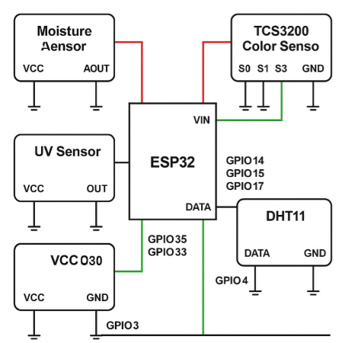

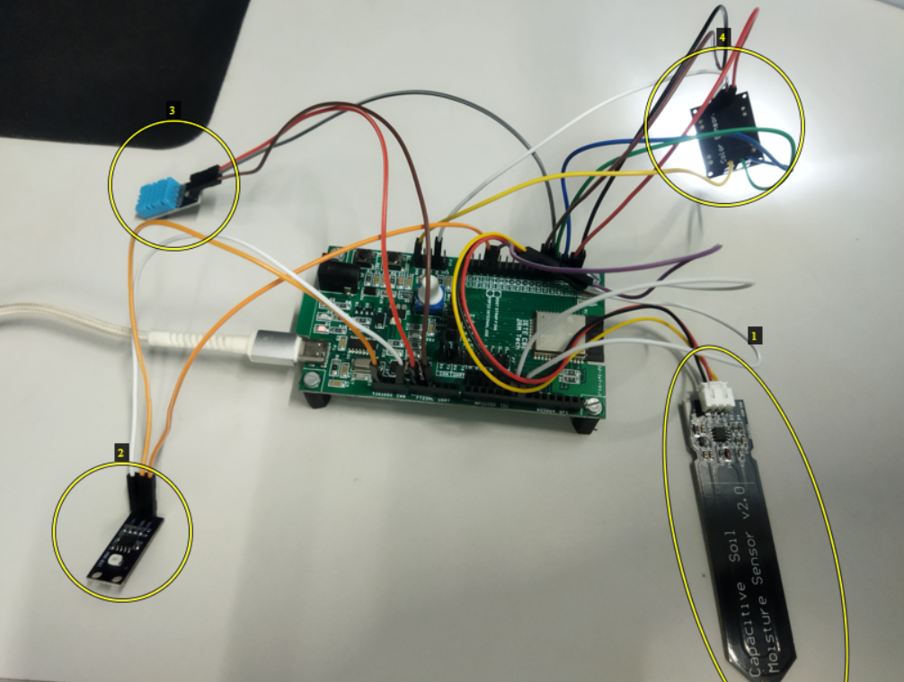

*Fig 1: Circuit interconnected with ESP32 (1 shows Capacitive Moisture sensor, 2 shows GUVA S12-SD UV index sensor, 3 shows DHT11 which reads Temperature and Humidity, 4 is TCS3200 Optical sensor*

## Software Architecture

* Firmware: The firmware is developed using the Arduino IDE and runs on the ESP32 microcontroller. It includes sensor drivers for data acquisition, data processing algorithms for skin oil level classification and hydration level calculation, and communication protocols for transmitting data to the mobile application.
* Mobile Application: A mobile application, provides a user-friendly interface for displaying sensor readings and skincare recommendations. The application connects to the ESP32 microcontroller via Wi-Fi and receives real-time sensor data.

## Model Architecture

A Feedforward Neural Network (FNN) model was built using TensorFlow/Keras. The model architecture consists of:

Input layer: Accepts 4 sensor inputs.

Hidden layers:

Dense layer with 128 neurons + ReLU activation + BatchNormalization.

Dense layer with 64 neurons + ReLU + Dropout (0.1).

Dense layer with 32 neurons + ReLU + Dropout (0.1).

Output layer: SoftMax activated layer with units equal to the number of recommendation classes.

The model is trained with the Adam optimizer and categorical crossentropy as the loss function for multi-class classification. EarlyStopping is used to prevent overfitting by monitoring validation loss with a patience of 5 epochs.

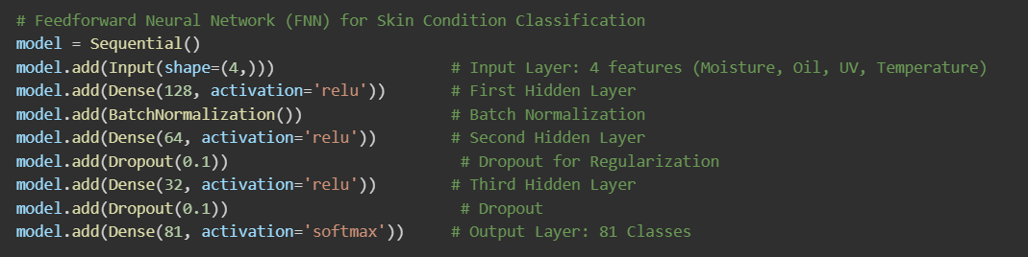

*Fig. 2: Model Architecture*

# Methodology

## Data Acquisition

* The user places the Smart Skincare Analyzer device on their skin for approximately 5 seconds to allow the sensors to stabilize.
* The sensors collect data at a sampling frequency of 10 Hz.
* The ESP32 microcontroller processes the sensor data locally and transmits it to the mobile application via Wi-Fi.

## Calibration

1. The capacitive moisture sensor was calibrated by measuring its analog output on the skin under different hydration levels. Around 20 participants were tested, and sensor values were recorded from dry skin, moisturized skin, and naturally hydrated skin. These readings were averaged and categorized into moisture level such as low, medium, and high to create a reference scale. This helped in identifying threshold values for classifying skin moisture. Environmental conditions such as ambient humidity and temperature were kept consistent to avoid variation in readings. The resulting calibration curve ensured that real-time sensor outputs could be accurately translated into meaningful skin moisture information..
2. The TCS3200 color sensor was calibrated to measure oil content on the skin by detecting variations in light reflectance from the skin surface. Since reflectance varies significantly across different skin tones due to melanin levels, we categorized participants into six skin tone groups: *Fair, Light, Medium, Olive, Tan/Brown,* and *Deep Brown/Black*. For each group, we collected baseline RGB values from clean, oil-free skin, and then recorded sensor outputs after natural sebum accumulation or light oil application. These readings helped us define separate threshold ranges for oil detection within each skin tone category, ensuring that increased reflectance due to oil was not misinterpreted as a result of lighter skin. By using customized thresholds, we achieved accurate and unbiased oil content detection across diverse skin tones.

## Recommendation Algorithm

The recommendation system uses an FNN to process sensor data and generate personalized advice. The workflow is as follows: (There are 81 combinations of unique set of inputs)

* Sensor data is collected and normalized to ensure compatibility with the FNN model.
* The normalized data is passed through the input layer of the FNN.
* Hidden layers process the data using learned weights and biases to identify patterns and relationships
* The output layer produces a set of recommendations tailored to the user's skin condition and environmental context.
* The mathematical representation of the FNN is:

*y*=*f*(*W*2⋅*f*(*W*1⋅*x*+*b*1)+*b*2)

*x* is the input vector of normalized sensor readings,

W1, W2are weight matrices,

b1, b2 are bias vectors,

f is the ReLU activation function,

y is the output vector of recommendations.

# Implementation

## Website Integration

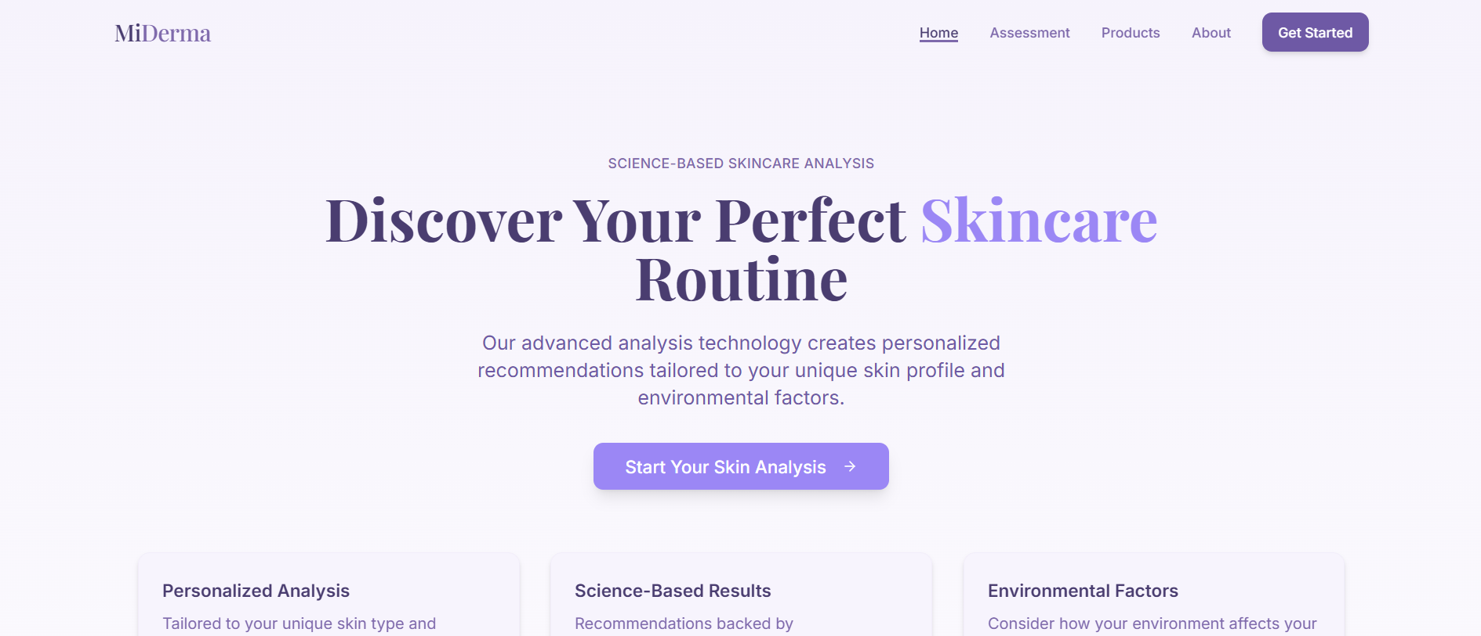

*Fig. 3: Homepage*

The Smart Skincare Analyzer includes a dedicated website that serves as an interface for users to access detailed insights, historical data, and personalized skincare recommendations. The website has some impressive functionality such as:

Environmental Alerts:

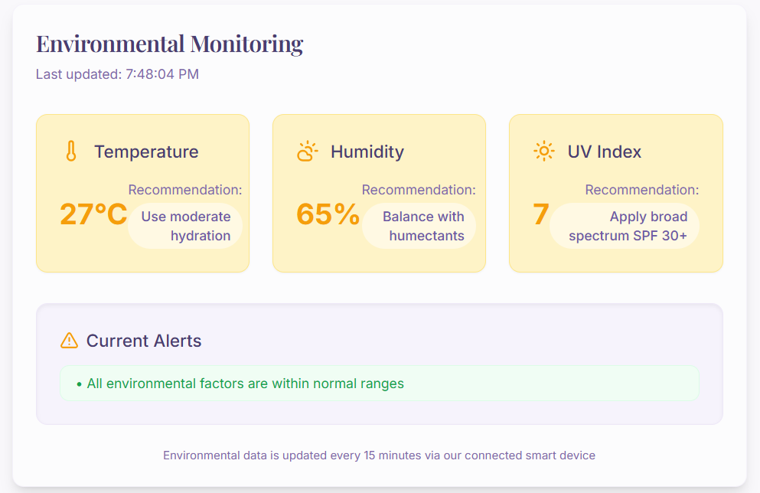

*Fig 4: Environmental Monitoring*

User Input:

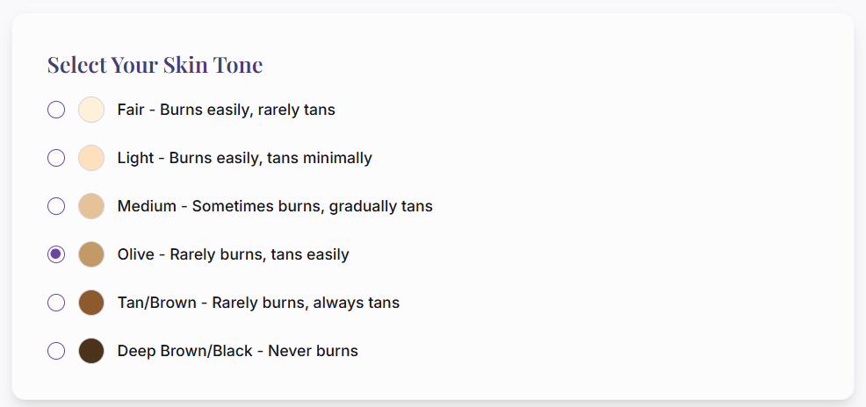

*Fig 5: User Interface (Selecting skin tone)*

Sensor readings:

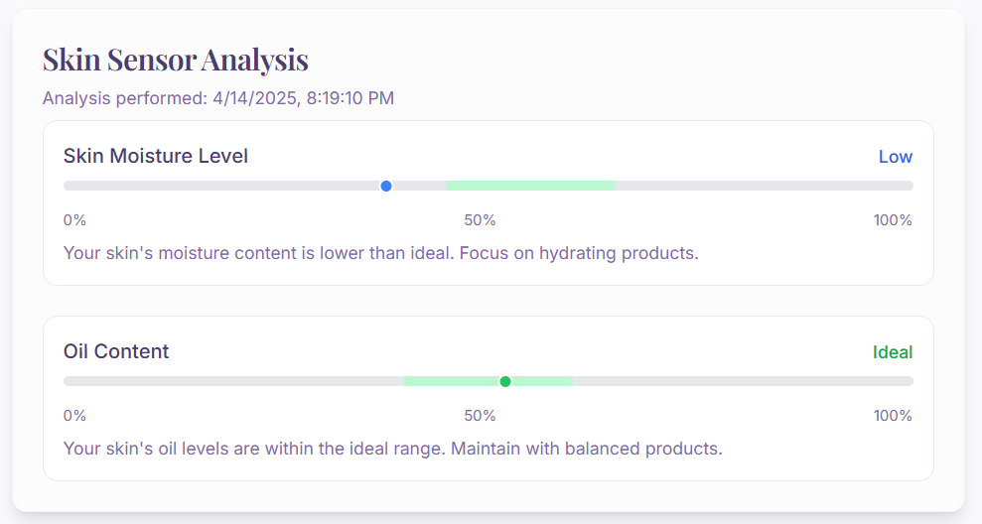

*Fig 6: Skin Analysis*

Recommendation System:

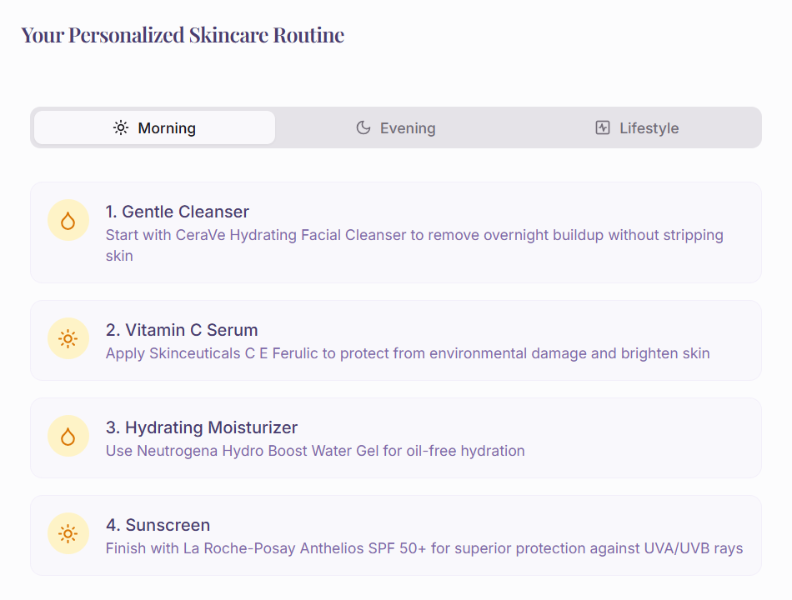

*Fig 7: Skincare Routine*

## Code Structure

Node Modules: Contains project dependencies managed via package.json.

Public Folder: Hosts static assets, including index.html.

Src Folder: Includes core application logic, React components.

**Tools and Frameworks:**

Frontend: React with Tailwind CSS.

Build Tool: Vite for optimized development workflow.

Backend Integration: Node.js.

# Results

## Model Performance

The model was trained using 80% of the data with the remaining 20% used for testing. Additionally, a 5-fold Stratified Cross-Validation was performed to ensure generalizability. The average accuracy across folds was found to be:

* Average Cross-Validation Accuracy: 81.81% ± 1.54%
* Best Test Accuracy: 83.95%
* Average Validation Loss: 0.5301 ± 0.0364

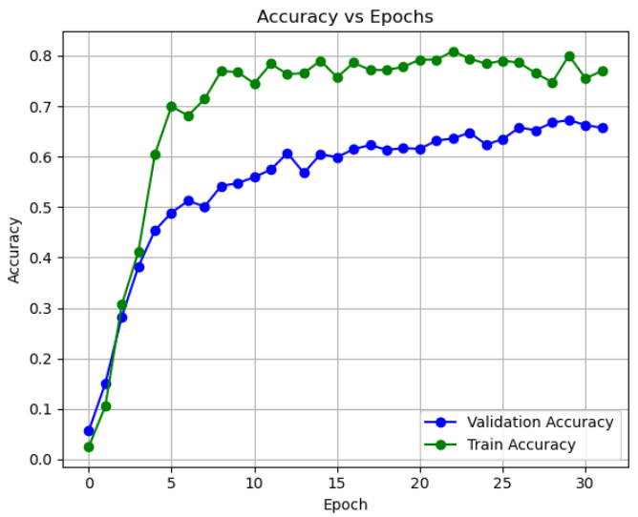

*Fig. 8: Accuracy vs Epochs*

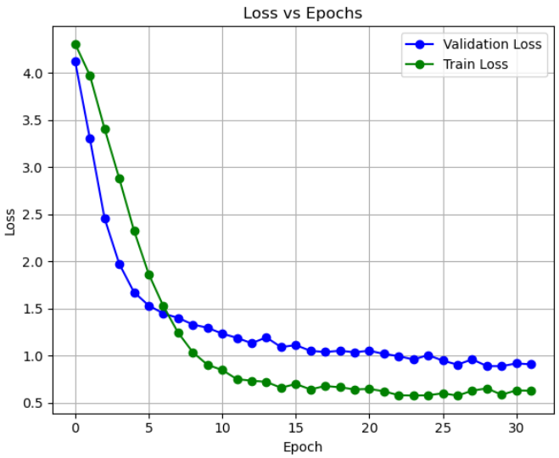

*Fig. 9: Loss vs Epochs*

## Performance Metrics

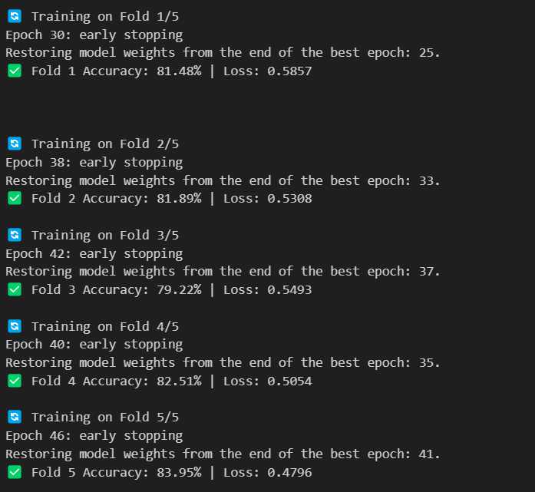

*Fig. 10: 5-fold Stratified Cross-Validation Result*

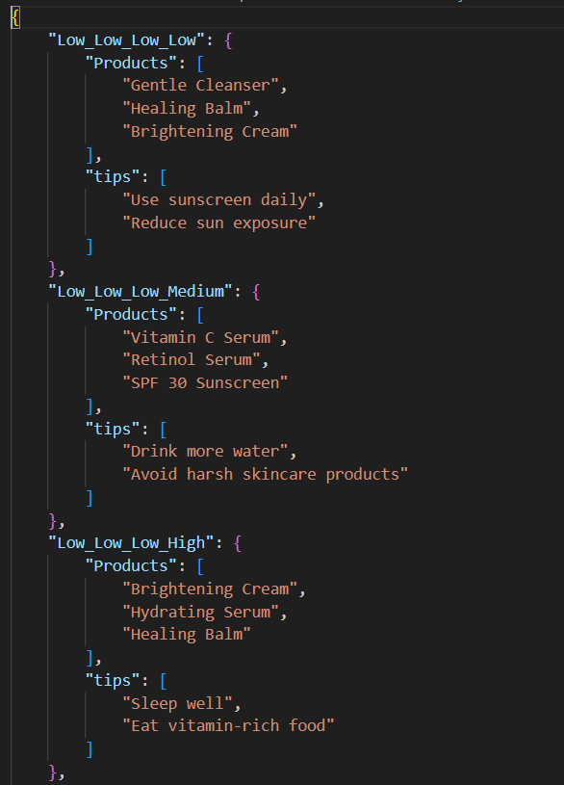

*Fig. 11: Recommendation Dataset*

* The performance of the FNN-based recommendation system was evaluated using test data from diverse environmental conditions and user profiles.

## Case Study

* A case study was conducted with a user in Coimbatore under the following conditions:

Temperature: 32°C

Humidity: 85%

UV Index: 10

Skin Type: Oily (High), Hydrated (High)

FNN Output:

"High humidity detected: Use non-comedogenic moisturizer."

"Extreme UV risk: Apply SPF 50+ sunscreen every 2 hours."

"Consider using a hydrating serum to replenish moisture lost due to high temperatures."

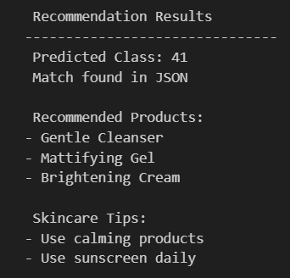

*Fig. 12: Example Recommendation results*

# Discussion

## Advantages

* The integration of an FNN into the Smart Skincare Analyzer offers several benefits:
* Improved Accuracy: The FNN achieves higher accuracy compared to rule-based systems by learning complex patterns in sensor data.
* Scalability: The model can be retrained with additional data to improve performance over time.
* Efficiency: Deployment on ESP32 ensures real-time inference with minimal computational overhead.

## Limitations

* Training requires a large labeled dataset that may not cover all possible environmental conditions or user profiles.
* Model performance depends on accurate calibration of sensors.

## Future Work

* Future enhancements include:

Expanding the dataset with more diverse user profiles and environmental conditions.

Incorporating additional sensors (e.g., air quality sensors) to improve recommendation quality.

* Developing a cloud-based version of the FNN for more complex models
* Developing a more robust and user-friendly mobile application with advanced features such as skin tracking and product recommendations.

# *Conclusion*

The project effectively designs and implements a Smart Skin Care Assistant tapping real-time environmental conditions and skin condition sensor data to generate customized skin-care recommendations. Feedforward Neural Network design integration with environmental parameters such as moisture, oil, UV, and temperature enables the system to classify 81 skin diseases with very high accuracy.

Using ESP32 as a central microcontroller, the system could buffer the acquisition of data from sensors and communicate in real-time to a web interface. The model exhibited great test accuracy of 83.95% and consistent measures across the framework of 5-fold cross-validation. The presence of Batch Normalization and Dropout layers contributed to enhancing generalization while avoiding overfitting. On another hand, the model prediction output is smartly connected to a recommendation system driven by curated product suggestions for skincare and advice regarding the skin condition of the user. In conclusion, the Smart Skin Care Assistant system is an intelligent, portable, and inexpensive means of daily skin care assessment.

The code implementation of this project is attached in a github repository is given below –

<https://github.com/Mahadev9344/Analog-and-NN/>

# Acknowledgment

* The authors would like to express their gratitude to Amrita Vishwa Vidyapeetham for providing the resources and support necessary to complete this project.

REFERENCES

1. Gidado, I.M.; Qassem, M.; Triantis, I.F.; Kyriacou, P.A. Review of Advances in the Measurement of Skin Hydration Based on Sensing of Optical and Electrical Tissue Properties. Sensors **2022**, 22, 7151. https://doi.org/10.3390/s22197151
2. Ahn, K.; Han, S.; Yun, K.; Lee, W.; Lee, D.-G.; Kang, S.M.; Choi, Y.-B.; Han, K.; Ahn, Y.J. A Real-Time Detection Device for the Rapid Quantification of Skin Casual Sebum Using the Oil Red O Staining Method. Sensors **2022**, 22, 3016. https://doi.org/10.3390/s22083016
3. **[**M. Vinutha, R. B. Dayananda and A. Kamath, "Personalized Skincare Product Recommendation System Using Content-Based Machine Learning," 2024 4th International Conference on Intelligent Technologies (CONIT), Bangalore, India, 2024, pp. 1-6, doi: 10.1109/CONIT61985.2024.10626458.
4. C. Qalbyassalam, R. F. Rachmadi and A. Kurniawan, "Skincare Recommender System Using Neural Collaborative Filtering with Implicit Rating," 2022 International Conference on Computer Engineering, Network, and Intelligent Multimedia (CENIM), Surabaya, Indonesia, 2022, pp. 272-277, doi: 10.1109/CENIM56801.2022.10037471.
5. S. M. Ali, T. -B. Nguyen and W. -Y. Chung, "New Directions for Skincare Monitoring: An NFC-Based Battery-Free Approach Combined With Deep Learning Techniques," in IEEE Access, vol. 10, pp. 27368-27380, 2022, doi: 10.1109/ACCESS.2022.3155811.
6. U. Khalid, C. Li, A. Ayub Khan and F. Mehmood, "AC-Skin: Facial Acne Detection-Based on Intelligent Learning and Large Data Collection of Internet of Things (IoT) for Smart Skincare," in IEEE Sensors Journal, vol. 24, no. 19, pp. 30769-30777, 1 Oct.1, 2024, doi: 10.1109/JSEN.2024.3414148.
7. S. M. Kumar, R. Thenmozhi, T. S. Balaji Damodhar, P. Epsiba, N. Malathi and B. Meenakshi, "Data-Driven with IoT Sensing and Deep Learning Model for Dynamic Skin Cancer Diagnosis," 2024 2nd International Conference on Self Sustainable Artificial Intelligence Systems (ICSSAS), Erode, India, 2024, pp. 1034-1039, doi: 10.1109/ICSSAS64001.2024.10760605