男生9组，女生七组。
男生身高最小160，最大187，
男生身高频率直方图：（非正态分布）
male_height<-c(185, 173, 175, 182, 173, 181, 184, 179, 181, 187, 169, 178,
183, 168, 181, 175, 175, 186, 186, 182, 178, 177, 172, 168,
173.5, 184, 183, 175, 168, 174, 181, 170, 166, 178, 177, 181,
163, 172, 160, 173, 185, 172, 183, 180, 175, 178, 169, 175,
165, 169, 170, 183, 184, 174, 170, 173, 170, 182, 178, 170,
179)
break1<-seq(min(male_height), max(male_height), 3)
hist( male_height, breaks=break1,
xlim=c(min(male_height),max(male_height)), probability=F, col='lightblue')
频数：2, 2, 6, 8, 13, 7, 8, 10, 5
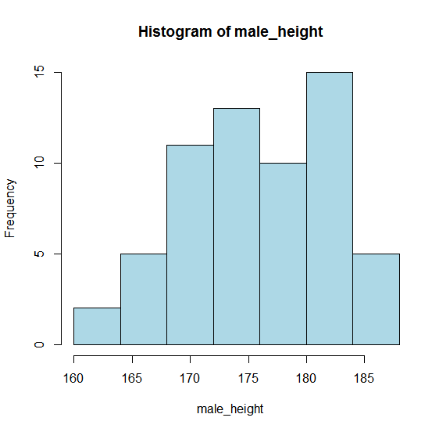(12.22分成7组)
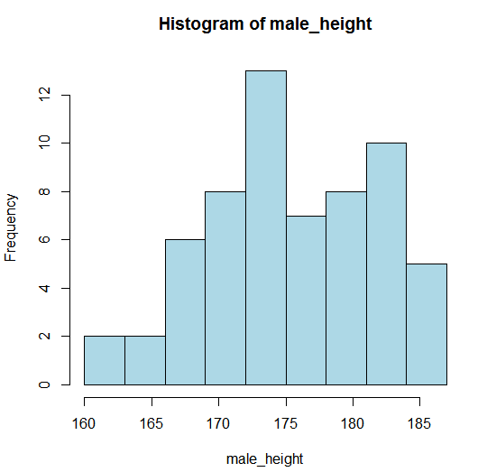

男生体重：（非正态分布）
[1] 46.0 47.5 48.0 53.0 55.0 55.0 55.7 56.0 56.0 57.0 58.0 58.0 58.8 59.0
[15] 59.0 59.0 60.0 60.0 60.0 60.5 61.0 62.0 62.0 63.0 63.0 64.0 64.0 64.0
[29] 65.0 65.0 65.0 65.0 65.0 65.0 65.0 65.5 67.0 69.0 70.0 70.0 71.0 71.0
[43] 72.0 73.0 73.0 74.3 75.0 75.0 75.0 75.0 75.6 79.0 80.0 80.3 85.0 87.0
[57] 88.0 91.0 92.0 94.5 99.0
最小值46，最大值99，均值67.32295，中位数65，方差134.7618，标准差11.60869

> male_weight<-c(65, 62, 80.3, 74.3, 55.7, 60, 59, 79, 62, 80, 56, 60.5,
+ 73, 46, 65, 91, 64, 88, 63, 64, 65, 75.6, 64, 65.5,
+ 58.8, 59, 71, 75, 60, 61, 75, 58, 56, 94.5, 87, 71,
+ 47.5, 59, 57, 65, 67, 60, 85, 65, 73, 70, 55, 75,
+ 55, 65, 65, 72, 99, 75, 53, 70, 58, 63, 92, 48,
+ 69)
> break1<-seq(46, 100, 6)
> hist( male_weight, breaks=break1,
+ xlim=c(min(male_weight),max(male_weight)), probability=F, col='lightblue')
> for(i in 1:9)
+ {b=46+6*i
+ c=46+6*(i-1)
+ p[i]<-(pnorm((b-67.3)/11.61)- pnorm((c-67.3)/11.61))
+ print(p[i])}
[1] 0.06049976
[1] 0.1177757
[1] 0.176558
[1] 0.2038336
[1] 0.1812303
[1] 0.1240922
[1] 0.06543215
[1] 0.02656614
[1] 0.008304213
> v<-c(3, 9, 16, 12, 11, 3, 3, 2, 2)
> s<-0
> for(i in 1:9)
+ {print(v[i]*v[i]/(61*p[i]))
+ s<-s+v[i]*v[i]/(61*p[i])}
[1] 2.438704
[1] 11.27455
[1] 23.76965
[1] 11.58129
[1] 10.94522
[1] 1.188962
[1] 2.25487
[1] 2.468322
[1] 7.896446
> print(s-61)
[1] 12.81802
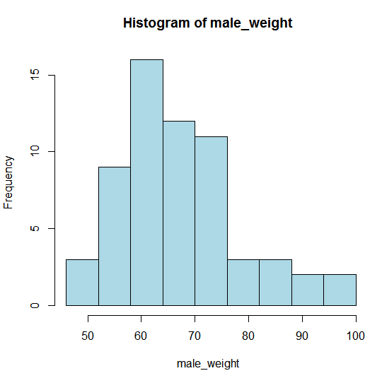
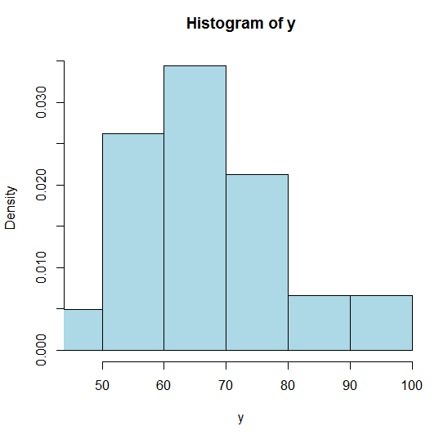（无用）
男生臂展：
y<-c(188, 182, 183, 189, 185, 170, 179, 165, 171, 196, 168, 177,
179, 167, 175, 171, 170, 183, 180, 182, 180, 177, 176, 170,
167, 179, 186, 168, 160, 171.5, 181, 172, 146, 177, 168, 183,
162, 170.5, 166.7, 173, 176, 167, 188, 178, 178, 175, 169, 171,
164, 175, 161, 174, 188, 171, 166.6, 171, 169, 160, 175, 164,
169)
hist(y, xlim=c(min(y),max(y)), probability=T, col='lightblue')

[1] 146.0 160.0 160.0 161.0 162.0 164.0 164.0 165.0 166.6 166.7 167.0 167.0
[13] 167.0 168.0 168.0 168.0 169.0 169.0 169.0 170.0 170.0 170.0 170.5 171.0
[25] 171.0 171.0 171.0 171.0 171.5 172.0 173.0 174.0 175.0 175.0 175.0 175.0
[37] 176.0 176.0 177.0 177.0 177.0 178.0 178.0 179.0 179.0 179.0 180.0 180.0
[49] 181.0 182.0 182.0 183.0 183.0 183.0 185.0 186.0 188.0 188.0 188.0 189.0
[61] 196.0
最小值146，最大值196，均值173.8246，中位数173，方差75.37789，标准差8.682044
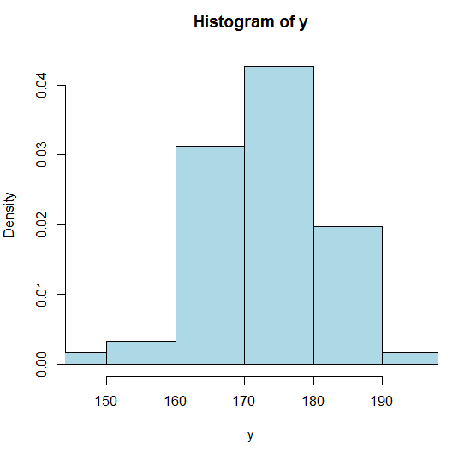
男生腿长：
male_leglength<-c(102, 93, 107, 114, 107, 101, 98, 99, 98, 119, 97, 101,
102, 99, 103, 97, 82, 101, 95, 97, 91, 95.5, 95, 82,
83, 98, 98, 105, 93, 96.5, 104.5, 85, 77, 105, 94, 102,
77, 95.8, 83.5, 89, 106, 98, 102, 93, 98, 90, 86, 98,
99, 99, 92, 100, 108, 102, 83, 101, 102, 80, 85, 92,
98)
hist(male_leglength, xlim=c(min(male_leglength), max(male_leglength)),
probability=T, col='lightblue')
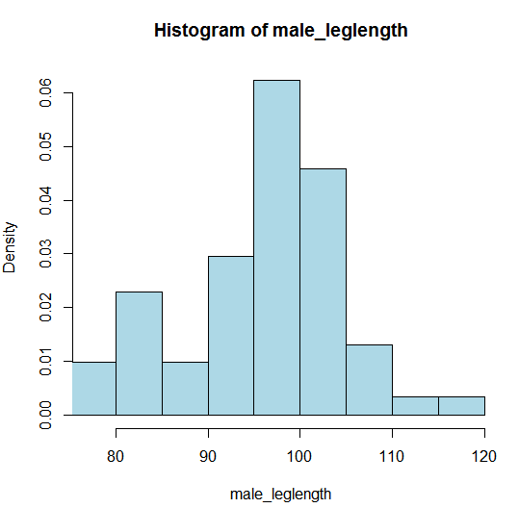
男生脚长：
male_footlength<-c(25.1, 23.5, 26.5, 26, 26, 25, 26.5, 26, 26, 29, 26, 26.5,
27, 24.5, 25.5, 22, 24, 28, 26.5, 26.5, 26.5, 27, 25, 25.5,
24, 26.5, 26, 27, 22, 23.4, 25.5, 25.4, 22, 26.5, 22, 26,
23.8, 23, 22.8, 25.5, 25.8, 24.5, 26.5, 24, 26.5, 29, 23, 26,
22, 23, 22, 27.5, 26.5, 26, 20, 25.5, 24.5, 24, 25.5, 23,
25)
hist(male_footlength, xlim=c(min(male_footlength), max(male_footlength)),
probability=T, col='lightblue')
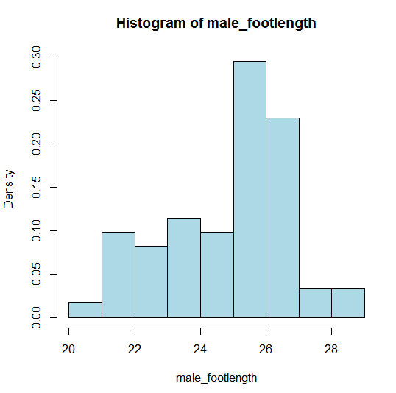
女生身高：
fem_height<-c(159, 172, 163, 165, 168, 165, 163, 165, 160, 158, 168, 162,
161, 172, 168, 168, 174, 161, 162, 166, 162, 162, 170, 168,
159, 168, 164, 155, 166)
hist(fem_height, xlim=c(min(fem_height), max(fem_height)),
probability=T, col='lightblue')
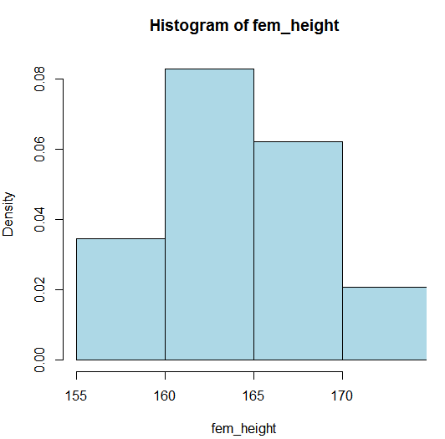
女生体重：
fem_weight<-c(47.9, 54, 60, 53, 52, 53, 58.5, 55, 50, 46.5, 58, 46,
51, 63, 66.5, 52, 56, 44, 57.5, 54.5, 53, 48, 60, 59,
54.5, 68, 55, 42, 51)
hist(fem_weight, xlim=c(min(fem_weight), max(fem_weight)),
probability=T, col='lightblue')
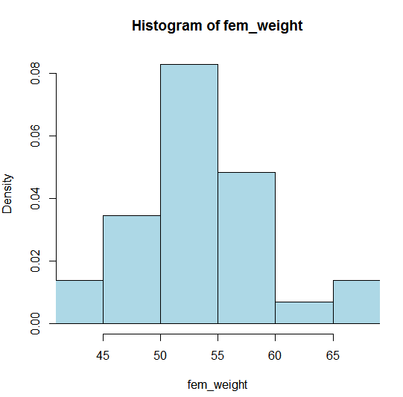
女生臂展：
fem_armspan<-c(158.8, 173, 163, 164, 169, 166, 156, 165, 161, 152, 166, 148,
152, 174, 162, 166, 179.5, 160, 164, 159, 160, 155, 169, 168,
136.6, 149, 158, 155, 165)
hist(fem_armspan, xlim=c(min(fem_armspan), max(fem_armspan)),
probability=T, col='lightblue')
