Tabblad 1

Dragonfire Relay
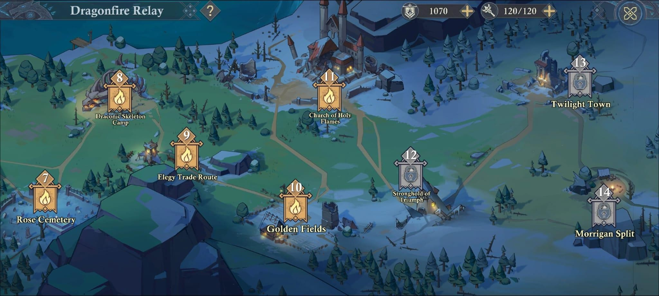

Author: K15147.Hamlet the Pygmy.MOD, K15170.Selle the Gracious.MOD
Disclaimer: the following guide is created by MODs using game data and observations. Please be aware that contents are subject to change. Check-in regularly and if you have any issue or questions, please contact KoA moderators.

Last update for this guide: 2025-5-6

General info
Dragonfire Relay is a mini-game that gives rewards like resources, recruitment scrolls, hero fragments, speedups, hero skill scrolls, and gold. It consists of 25 chapters, each with 6 stages, which is rather time-consuming.

When is this available?
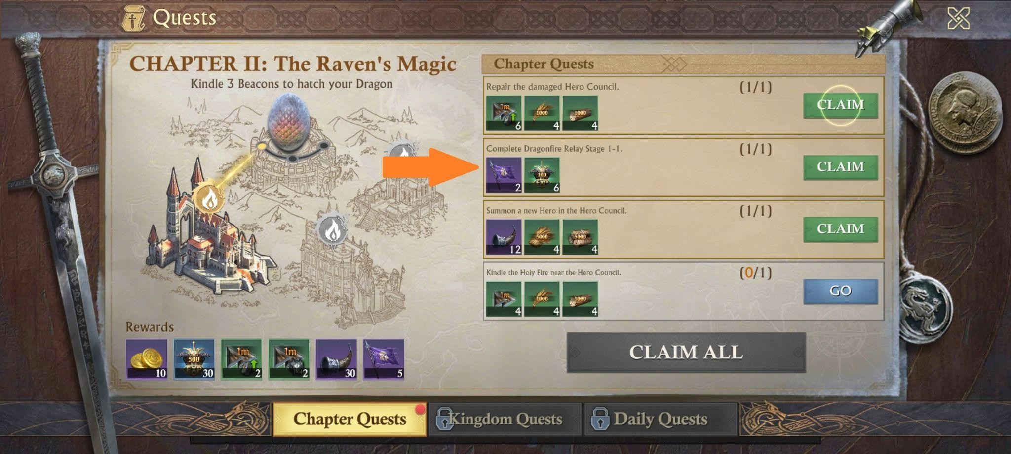
This will open up as part of a chapter quest in the beginning of the game. And stays available throughout the rest of the game.

Where do I find this?
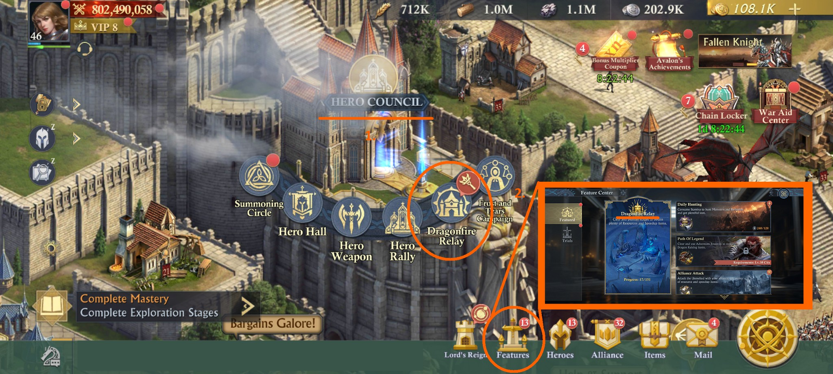
you can find Dragonfire Relay in the Hero Council or in the Features tab at the bottom of your screen.

Plunder vs challenge
- You can choose between plunder or challenge if you have cleared the stage. If it is the first time you play a level, you can only choose to challenge.
- With the option “Plunder”, you get rewards automatically. You just have to fill in how many times you want to plunder it. And you get the corresponding rewards.
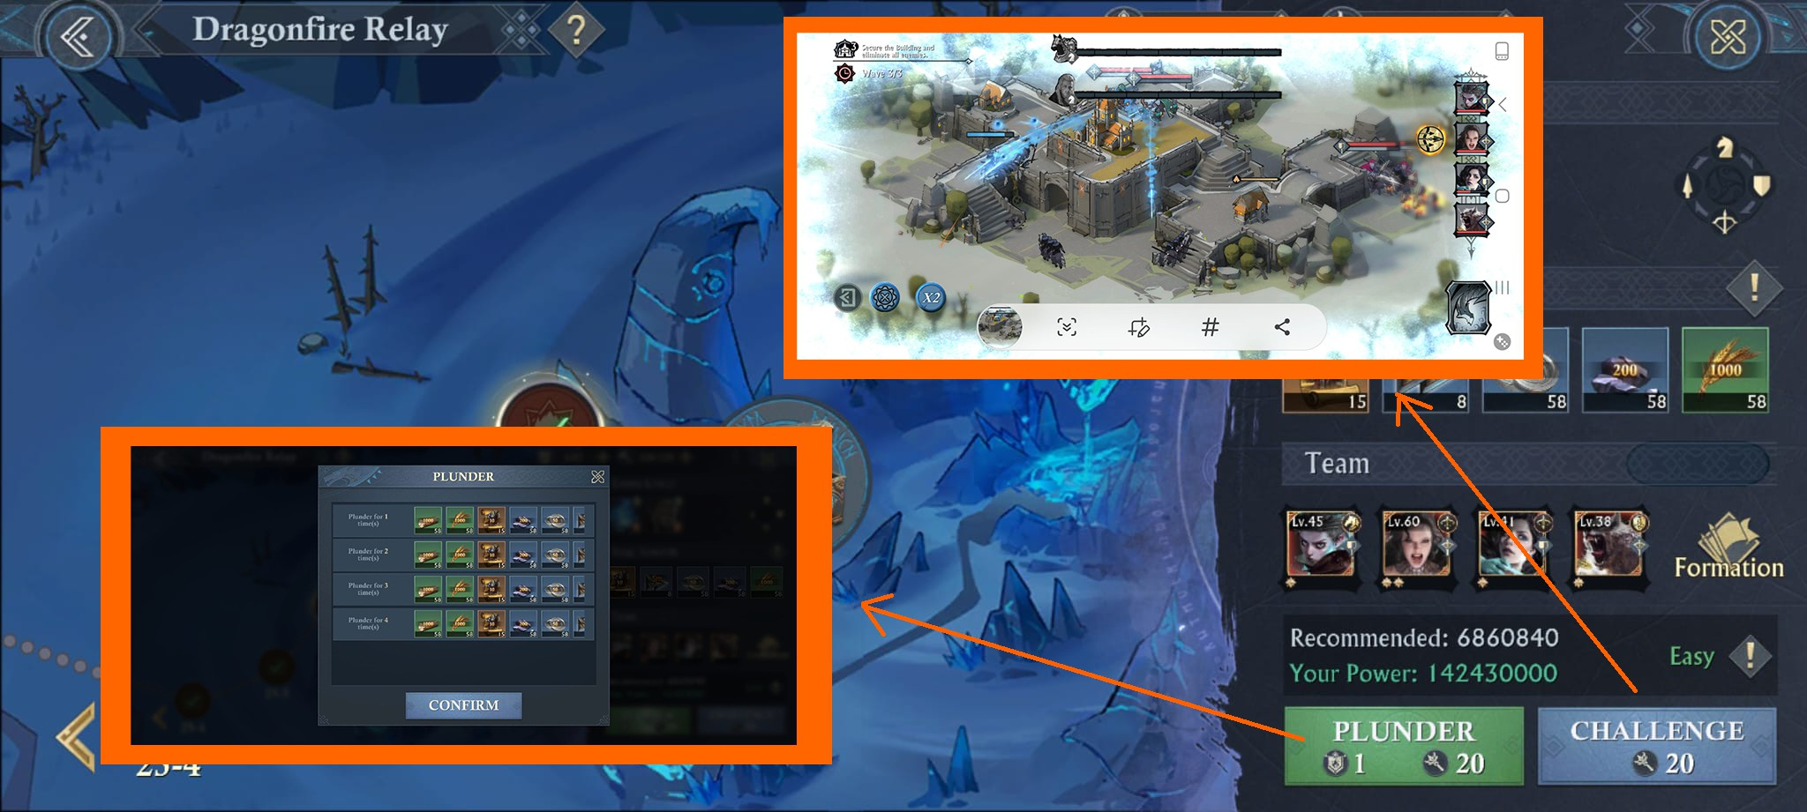
- With the option “Challenge”, you have to choose heroes by clicking on the formation icon. You can only change heroes, you can’t choose troop formation. A combination of certain types of heroes (Gallantry, Freedom, Glory and Prosperity) gives benefit throughout the stage. For example 3 Gallantry heroes give a basic attack of +33%. Start the challenge, and play to protect the buildings.

Autoplay and Double speed
- Two features will help you speed up the challenge: “Autoplay” and “Double speed”. Autoplay is available after clearing Chapter 2, and double speed is available after clearing Chapter 11. These features make this mini-game less time consuming.
- When you unlock these features in Dragonfire Relay, they are also available in the Frost and Tears Campaign, Lord's Reign—explore battle (tower) and Shadow Sanctuary.

How to play a stage
- You will need a Dragonfire pass to challenge and plunder. This is sometimes given as a first clear reward. Mostly when you have finished a chapter. More passes will be accumulated over time.
- Pioneer pass is only needed to plunder. You get this when you complete daily quests.
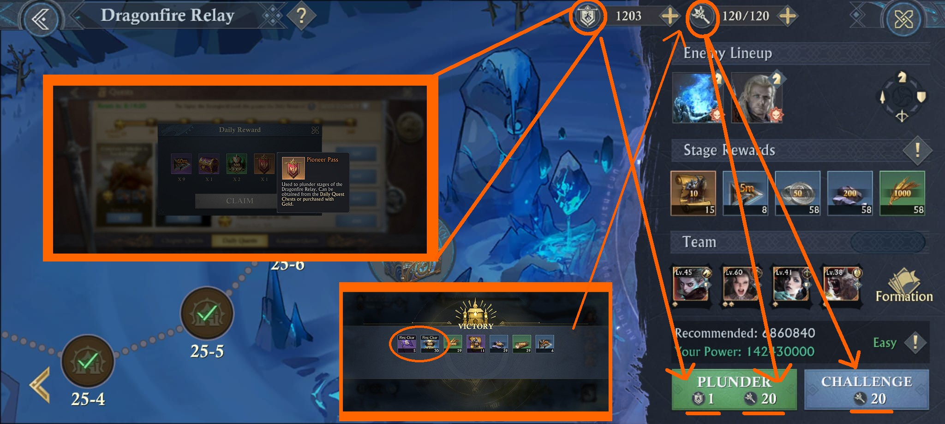

Rewards
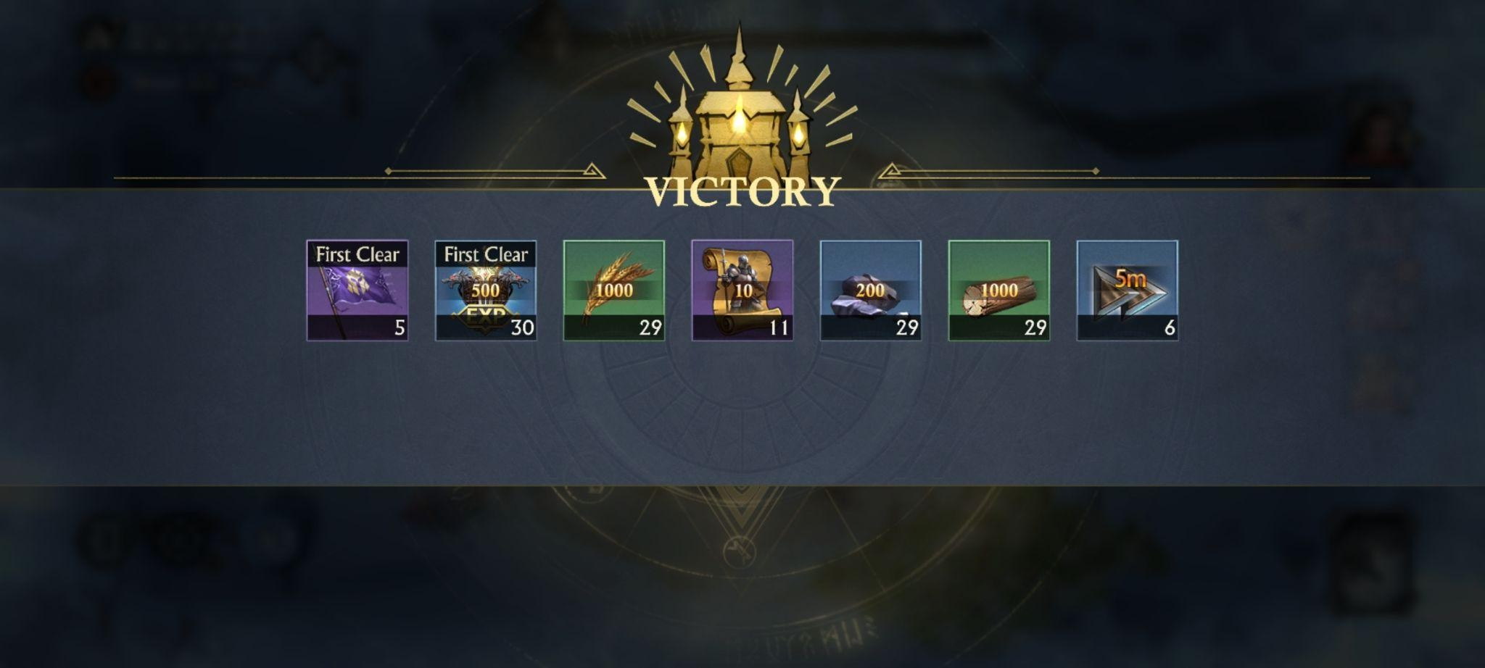
You have first clear rewards. Depending on the stage, you get flags, hero fragments, gold, dragonfire passes… And stage rewards. These are recruitment scrolls, resources, and speedups. It doesn’t matter if you choose plunder or challenge, rewards will come either way.

Strategy
The rewards can be useful early in the game, so we advise doing Dragonfire Relay at that stage. After clearing chapter 11, you will have the double speed feature, which comes in handy for Frost and Tears Campaign, Lord's Reign—explore battle (tower) and Shadow Sanctuary.

As the game progresses, investing time in it is optional. However, you can choose to do plunder daily, get the rewards and use them when needed. The recruitment scrolls come in very handy as it allows you to obtain free troops, which can be opened up for example during the troop training stage of the Gold Event-Kingdom Raid (it gives points), and then upgrade them to higher-level troops.

Additional Information
- FAQ - Dragonfire Relay

