

New Combat Heroes
Guide by: K5359.Arawila Frostguard, K5097.Giso Brown, K5309.Alson Of The Forest K5363.The Planet Grower, K5100.The Cosmos Groomer
Created: 2023-06-14; Last Update: 2026-07-27

From Lunar Updates 16.3.0, 16.7.0, 17.1.0, 17.5.0, 17.8.0, 18.3.0, 18.7.1, 19.0.0, 19.2.0, 19.4.0, 19.8.0, 20.0.0, 20.3.0, 20.6.0, 20.8.0, 21.2.0, 21.6.0, 22.0.0, 22.3.0, 22.6.0, 22.9.0, 23.2.0, 23.5.0, 23.8.0

New combat heroes: Starting from update 16.3.0, new types of heroes were released, starting with Maledisant and Sir Marrok. A Combat Hero tab was also added in the Hero Roster. You can now switch between the Appointed Hero tab and Combat Hero tab.
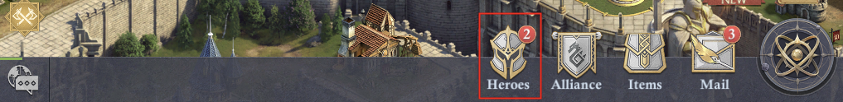

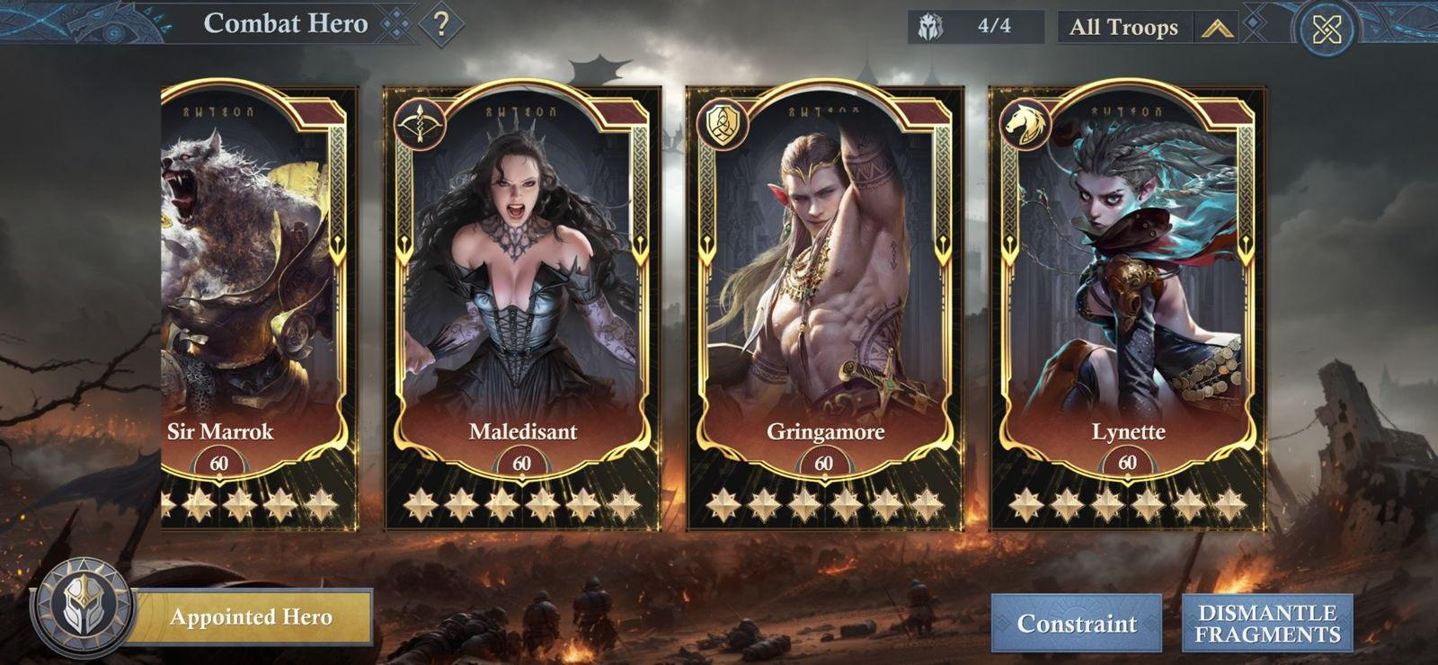

Combat heroes have mostly march skills, along with 6 combat support skills. All skills can be used in marches or garrisons. Deploying Combat Heroes won't trigger Resonance and they won’t be part of the appointed council, so will remain in this separate category.
Each Combat Hero is associated with a troop type, and their skills are tailored accordingly. Top-left corner of the hero card will make it even easier to identify what troop type that hero is for.

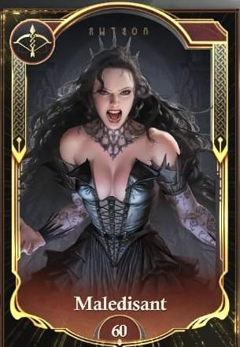

Bowmen Hero: Maledisant
Skills:
- Banner bearer - Maledisant: March capacity
- Shriek Echo: Additional Attack Chance based on the unique skill*
- Bowmen Defense - Maledisant: Bowmen Defense
- Bowmen Health - Maledisant: Bowmen Health
- Bowmen Attack - Maledisant: Bowmen Attack
- Shriek Round: Triggering Chance for the unique skill*

*Unique skill: Evil Shriek
2. Shriek Echo grants Bowmen led by Maledisant a chance (in %) for additional attack, each dealing damage of x% Attack and reducing the enemy’s health (by a certain %). Chance to trigger "Evil Shriek."
6. Shriek Round grants a triggering change of an increase of a certain % for Evil Shriek to Troops led by Maledisant for 20 rounds after the battle starts.

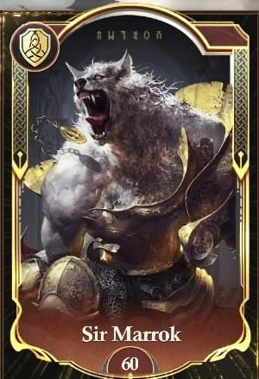

Infantry Hero: Sir Marrok
Skills:
- Banner bearer - Sir Marrok: March capacity
- Fury Claw: Counterattack Damage based on the unique skill*
- Infantry Attack - Sir Marrok: Infantry Attack
- Infantry Defense - Sir Marrok: Infantry Defense
- Infantry Health - Sir Marrok: Troop Damage Received
- Shadow of the Full Moon: Chance to trigger the unique skill*

*Unique skill: Fury Barrier
2. Fury Claw grants Counterstrike Damage equal to a certain % of total Fury Shield to the enemy after the shield is broken. If fury shield is destroyed by Counterattack Damage, no further counter attack damage will be triggered.
6. Shadow of the Full Moon grants the highest rank of infantry an extra % chance to trigger Fury Barrier when Sir Marrok is with your troops, for 20 rounds after the battle starts.

Update 16.7 Gringamore and Lynette

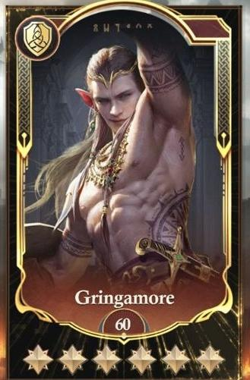

Infantry Hero: Gringamore
Skills:
- Mercenary Magnetism - March capacity, Infantry Damage Received
- Punishing Parry - Damage Chance based on the unique skill*
- Swordsmen’s Legacy - Infantry Attack, Infantry Damage
- Blazing Shields - Infantry Defense, Infantry Damage Received
- Cheerful Resolve - Infantry Health, Troop Damage Received
- Rogue's Rally: Chance to trigger the unique skill*

*Unique skill: Swaggering Challenge
2. Punishing Parry grants a chance (in %) for damage equal to a certain % of infantry health, the damage caused will not trigger the same skill effect on your enemy.
6. Rogue's rally when Gringamore is with your troop's infantry health is increased by a certain % after the taunt is triggered.

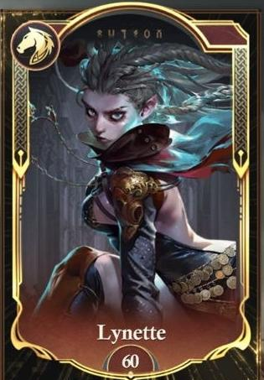

Cavalry Hero: Lynette
Skills:
- Swift Vanguard - March capacity
- Venom Blade - Damage Chance based on the unique skill*
- Shadow Tactics - Cavalry Defense, Cavalry Damage Received
- Ruthless Command - Cavalry Health, Cavalry Damage
- Precision Strike - Cavalry Attack, Troop Damage
- Phantom Rush: Chance to trigger the unique skill*

*Unique skill: Ambush Mastery
2. Venom Blade grants a critical chance of cavalry in the charging state to a certain %
6. Phantom Rush Grants a triggering chance to reset the charging state cooldown led by Lynette for the first 20 rounds.

Update 17.1.0 Laudine: The Silent Storm and Great Yvain: The Dragon Lord
Note: the information below is for the combat heroes, and not the appointed heroes with the same name

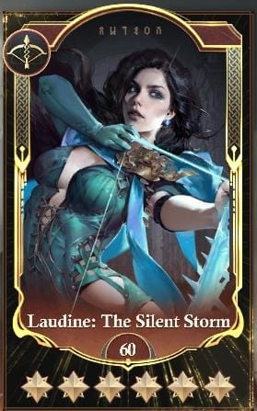

Bowman Hero: Laudine: The Silent Storm
Skills:
- Whirlwind Resolve - March capacity, Bowmen Damage
- Undercurrent: Damage Chance based on the unique skill*
- Windstorm Protector - Bowmen Defense, Bowmen Damage Received
- Life essence - Bowmen health, Bowmen Damage
- Millennium War - Bowmen attack, Bowmen Damage
- Spring Tranquility: Chance to trigger the unique skill*

*Unique Skill: Tempest Thrust
2. Undercurrent grants a critical chance of bowman in the charging state to a certain %
6. Spring Tranquility grants the chance of triggering the primary skill is increased by up to 30% for the first 30 rounds

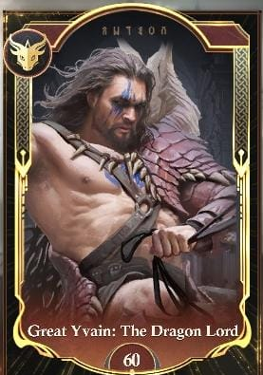

Dragonspell Knight Hero: Great Yvain: The Dragon Lord
Skills:
- Dragons Leader - March capacity, Dragon Knight Damage
- Dragons Might: Damage Chance based on the unique skill*
- Dragons Armour - Dragon Knight Defense, Damage Received
- Dragons Diet - Dragon Knight health, Dragon Knight Damage
- Dragons Formation - Dragon knight attack, Troop Damage Received
- Hunting Nature: Chance to trigger the unique skill*

*Unique skill: Dragon's Fury
2. Dragons Might - Dragons knights have a % chance to take less damage for the next 2 rounds.
6. Hunting Nature grants the chance of triggering Dragons fury is increased by up to 30% for the first 30 rounds of the battle

Update 17.5.0 Cavalry Combat Hero "Oriana and Orin” & Infantry Combat Hero "Erik"

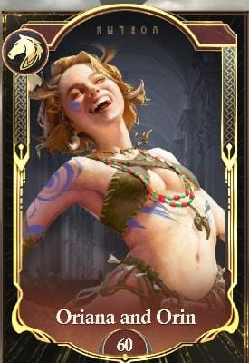

Cavalry Hero: Oriana and Orin
Skills:
- Roaring Bear-Riding Girl - March capacity, Cavalry Damage
- The Fury of the Bear - Damage Chance based on the unique skill*
- Beast's Body - Cavalry Defense, Cavalry Damage Received
- Forest Maiden - Cavalry health, Cavalry Damage
- Bear Collision - Cavalry attack, Troop Damage
- The Power of Honey - Chance to trigger the unique skill*

*Unique skill: Raging Bear's Sharp Claws
2. The Fury of the Bear grants a critical chance of cavalry in the charging state to a certain %
6. The Power of Honey grants a chance of triggering the primary skill is increased by up to 30% for the first 30 rounds.

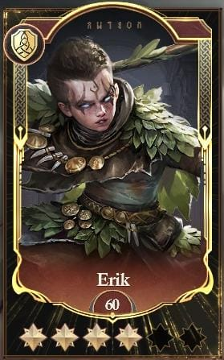

Infantry Hero: Erik
Skills:
- Warrior of the Wildwood - March capacity, Infantry Damage Received
- Bloody Claws - Damage Chance based on the unique skill*
- Spear Master - Infantry Attack, Infantry Damage
- Spirit Guardian - Infantry defense, infantry damage received
- Life Ward - Infantry health, troop damage received
- Fox Spirit’s Cunning - Chance to trigger the unique skill*

*Unique skill: Fear of the Fox Spirit
2. Bloody Claws grants the highest rank of infantry to inflict the primary skill, there's a % chance to activate the primary skill. Deals damage equal to a % of the highest-rank Infantry’s Attack for 6 rounds.
6. Fox Spirit's Cunning grants a chance of triggering the primary skill increased by up to 30% for the first 30 rounds.

Update 17.8.0 Bowmen Combat Hero “Ignatia” & Infantry Combat Hero “Brandt”
These new heroes have an additional feature, that is Elements. Both Heroes carry the Fire Element, which can grant additional benefits, and will follow the Element countering system
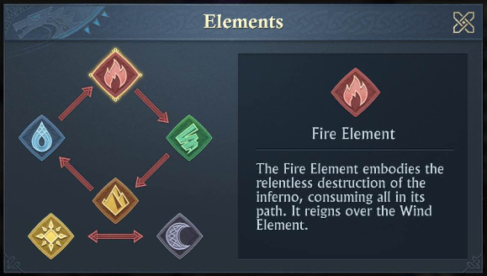

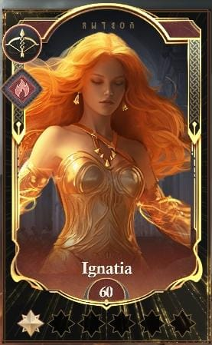

Bowman Hero: Ignatia
Skills:
- Flame Longbow - March capacity, Bowmen Damage
- Intense Burning - Damage Chance based on the unique skill*
- Flame Ward - Bowmen Defense, Bowmen Damage Received
- Passion - Bowmen health, Bowmen Damage
- Deadly Sparks - Bowmen attack, Troop Damage
- Highly Flammable - Chance to trigger the unique skill*

*Unique skill: Midsummer Blessing
2. Intense Burning grants a critical chance of bowman in the charging state to a certain %
6. Highly Flammable grants the chance of triggering the primary skill increased by up to 30% for the first 30 rounds

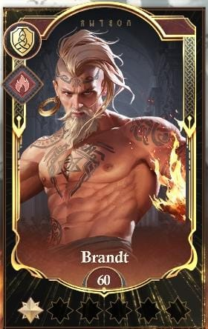

Infantry Hero: Brandt
Skills:
- Guardian Flame - March capacity, Infantry Damage Received
- Fury of the Flames -: Damage Chance based on the unique skill*
- Blazing Fist: Infantry Attack, Infantry Damage
- Flame shield - Infantry Defense, Infantry Damage Received
- Wall of Flame - Infantry Health, Troop Damage Received
- Blazing Aura - Chance to trigger the unique skill*

*Unique skill: Fire God's Blessing
2. Fury of the Flames grants a % chance for damage equal to a certain % of infantry health, the damage caused will not trigger the same skill effect on your enemy.
6. Blazing Aura grants the chance of triggering the primary skill increased by up to 30% for the first 30 rounds

Update 18.3.0 Water Element Combat Heroes - Bowman “Serenisa”, Infantry “Edrick” and Cavalry “Helena”

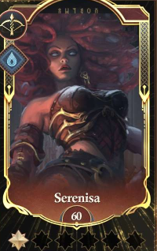

Bowman Hero: Serenisa
Skills:
- Surging Tide - March capacity, Bowman Damage
- Furious Strike - Damage Chance based on the unique skill*
- Frost Surge - Bowman Defense, Bowman Damage Received
- Raging Tide - Bowman Health, Bowman Damage
- Drowning- Bowman Attack, Troop Damage
- Deadly Entanglement - Chance to trigger the unique skill*

*Unique skill: Raging Tidal Arrows
2. Furious Strike grants a Critical Strike Damage increase in your highest-ranked Bowman and reduces damage dealt by the highest-ranked enemy Cavalry.
6. Deadly Entanglement grants the chance of triggering the primary skill increased by up to 30% for the first 30 rounds.

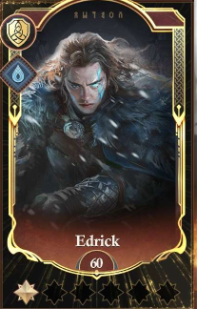

Infantry Hero: Edrick
Skills:
- Power of the Frozen Ones - March capacity, Infantry Damage Received
- Winter’s Wrath - Damage Chance based on the unique skill*
- Iron Will - Infantry Attack, Infantry Damage
- Frostbane Calamity - Infantry Defense, Infantry Damage Received
- Corrode - Infantry Health, Troop Damage Received
- Icy Resolve - Chance to trigger the unique skill*

*Unique skill: Winter’s Shield
2. Winter’s Wrath grants a chance to have an extra attack when Winter’s Shield ends, dealing 100% damage with a chance at extra Water Element Damage.
6. Icy Resolve grants the chance of triggering the primary skill increased by up to 30% for the first 25 rounds.

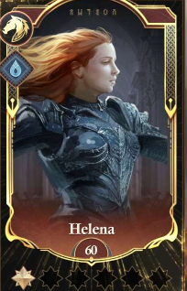

Cavalry Hero: Helena
Skills:
- Raging Tidal Charge - March capacity, Cavalry Damage
- Furious Charge - Damage Chance based on the unique skill*
- Water March - Cavalry Defense, Cavalry Damage Received
- Aquaflow Barrier - Cavalry Health, Cavalry Damage
- Flood Surge - Cavalry Attack, Troop Damage
- Giant Wave Assault - Chance to trigger the unique skill*

*Unique skill: Aquatic Impact
2. Furious Charge increases the Critical Chance of your highest-ranked Cavalry, damage dealt by the enemy Bowman is reduced.
6. Giant Wave Assault grants a % chance to reset the cooldown of the primary skill for the first 25 rounds.

Update 18.7.1 Earth Element Combat Heroes - Bowman “Ze’ir”, Infantry “Helgur” and Cavalry “Manya”

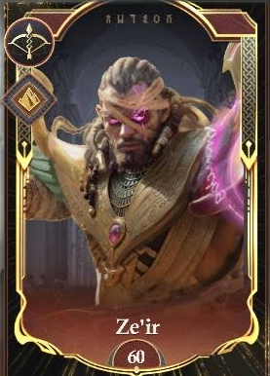

Bowman Hero: Ze’ir
Skills:
- Ancient Blessing - March capacity, Bowman Damage
- Stone Shot - Damage Chance based on the unique skill*
- Sandstorm Protection - Bowman Defense, Bowman Damage Received
- Dunestrike Arrow - Bowman Health, Bowman Damage
- Eye of Shan’al - Bowman Attack, Troop Damage
- Fury of the Sandstorm - Chance to trigger the unique skill*

*Unique skill: Sandstorm Blessing
2. Stone Shot grants a Critical Strike Damage increase in your highest-ranked Bowman. If Bowmen are protected by Magnet effect, their damage is reduced.
6. Fury of the Sandstorm grants the chance of resetting the cooldown time of the primary skill.

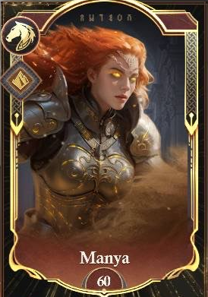

Cavalry Hero: Manya
Skills:
- Shelter of the Sands - March capacity, Cavalry Damage
- Sandstorm Assault - Damage Chance based on the unique skill*
- Quicksand Protection - Cavalry Defense, Cavalry Damage Received
- Sandstorm Charge - Cavalry Health, Cavalry Damage
- Fury of the Sands - Cavalry Attack, Troop Damage
- Resolute Will - Chance to trigger the unique skill*

*Unique skill: Quicksand Trap
2. Sandstorm Assault increases the Critical Chance in your highest-ranked Cavalry. If Cavalry are protected by Magnet effect, their damage is reduced.
6. Resolute Will grants a chance to reset the cooldown of the primary skill when the remaining troops are lower than or equal to 80% of their initial count.

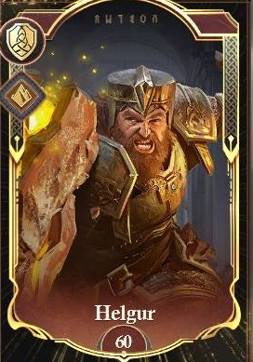

Infantry Hero: Helgur
Skills:
- Seasoned Fighter - March capacity, Infantry Damage Received
- Shield Rush - Damage Chance based on the unique skill*
- Mercenary Tatics - Infantry Attack, Infantry Damage
- Dwarven Resilience - Infantry Defense, Infantry Damage Received
- Shield Wall - Infantry Health, Troop Damage Received
- Might of the Mountains - Chance to trigger the unique skill*

*Unique skill: Earth-Shaker
2. Shield Rush grants the chance for your highest ranked Infantry to deal damage. If Infantry has a Magnet effect, there is a chance of dealing Earth Elemental Damage.
6. Might of the Mountain grants a chance to reset the cooldown of the primary skill when the remaining troops are more than 30% of their initial count.

Update 19.0.0 Shadow Element Combat Heroes - Bowman “Alwyn” and Cavalry “Roland”

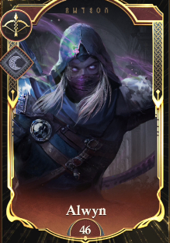

Bowman Hero: Alwyn
Skills:
- Shadow of the Kingdom - March capacity, Bowman Damage
- Vital Strike - Damage Chance based on the unique skill*
- Cover of Darkness - Bowman Defense, Bowman Damage Received
- Rogue Tactics - Bowman Health, Bowman Damage
- Enchanted Arrows - Bowman Attack, Troop Damage
- Deadly Instinct - Chance to trigger the unique skill*

*Unique skill: Flying Blades
2. Vital Strike grants a Critical Chance increase in your highest-ranked Bowman. Targets marked by the Dark Seal, each layer increases the Attack of your highest-ranked Bowman.
6. Deadly Instinct increases the chance of triggering Flying Blades, increasing Damage for the first 30 rounds of the battle.

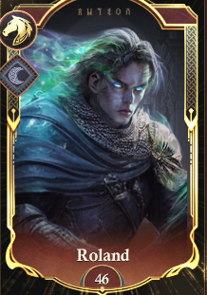

Cavalry Hero: Roland
Skills:
- Spectral Knight - March capacity, Cavalry Damage
- Spectral Wrath - Damage Chance based on the unique skill*
- Cover of the Unseen - Cavalry Defense, Cavalry Damage Received
- Spirit of the Dead - Cavalry Health, Cavalry Damage
- Blade of the Netherworld - Cavalry Attack, Troop Damage
- Hateful Charge - Chance to trigger the unique skill*

*Unique skill: Deathly Trample
2. Spectral Wrath increases the Critical Strike Damage of your highest-ranked Cavalry, Targets marked by the Dark Seal increase the Attack of your highest-ranked Cavalry.
6. Hateful Charge grants a % chance to trigger Deathly Trample, increasing damage for the first 30 rounds of battle.

Update 19.2.0 Wind Element Combat Heroes - Bowman “Amara”, Cavalry “Leon” and Infantry “Goneril”

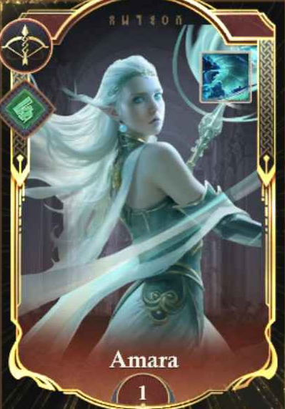

Bowmen Hero: Amara
Skills:
- Wind of Joy - March capacity, Bowmen Damage
- Eye of the Storm - Damage Chance based on the unique skill*
- Wind of Healing- Bowmen Defense, Bowmen Damage Received
- Wind of Resolve - Bowmen Health, Bowmen Damage
- Wind of Rage - Bowmen Attack, Troop Damage
- Relentless Gale - Chance to trigger the unique skill*

*Unique skill: Tornado
2. Eye of the Storm increases the Attack of your highest-ranked Bowmen. For paralyzed targets, Critical Strike Damage of your highest-ranked Bowmen is increased.
6. Relentless Gale increases the chance of resetting the cooldown time of Tornado of each round for the first 40 rounds of the battle.

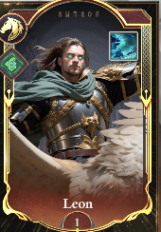

Cavalry Hero: Leon
Skills:
- Knight of the Order - March capacity, Cavalry Damage
- Talon Slash - Damage Chance based on the unique skill*
- Wing Shield - Cavalry Defense, Cavalry Damage Received
- Born for Battle - Cavalry Health, Cavalry Damage
- Death from Above - Cavalry Attack, Troop Damage
- Shrieking Assault - Chance to trigger the unique skill*

*Unique skill: Diving Strike
2. Talon Slash increases the Attack of your highest-ranked Cavalry. For paralyzed targets, Critical Chance of your highest-ranked Cavalry is increased.
6. Shrieking Assault increases the chance of resetting the cooldown time of Diving Strike of each round for the first 40 rounds of the battle.

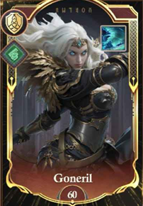

Infantry Hero: Goneril
Skills:
- Iron March - March capacity, Infantry Damage Received
- Swift Scythes - Damage Chance based on the unique skill*
- Fury of the Betrayed - Infantry Attack, Infantry Damage
- Unyielding Defense - Infantry Defense, Infantry Damage Received
- Thirst for Vengeance - Infantry Health, Troop Damage Received
- Storm Surge - Chance to trigger the unique skill*

*Unique skill: Wall of Storms
2. Swift Scythes grants the chance to increase damage to random enemy troops. For paralyzed targets, there is a chance to deal extra Wind Element Damage.
6. Storm Surge increases the chance of resetting the cooldown time of Wall of Storms each round for the first 40 rounds.

Update 19.4.0 Shadow Element Combat Heroe - Infantry “Alrad”

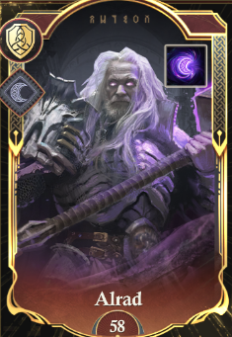

Infantry Hero: Alrad
Skills:
- Eternal March - March capacity, Infantry Damage Received
- Doomhammer - Damage Chance based on the unique skill*
- Immortal Fury - Infantry Attack, Infantry Damage
- Undying Defense - Infantry Defense, Infantry Damage Received
- Honor Guard - Infantry Health, Troop Damage Received
- Eternal Wrath - Chance to trigger the unique skill*

*Unique skill: Dark Presence
2. Doomhammer grants the chance to increase damage to random enemy troops. For targets marked by the Dark Seal, there is a chance to deal extra Dark Element Damage.
6. Eternal Wrath increases the chance of resetting the cooldown time of Dark Presence each round for the first 30 rounds.

Update 19.6.0 Fire Element Combat Heroes - Infantry “Grigor”, Bowmen “Regan” and Cavalry “The Inferno Knight”

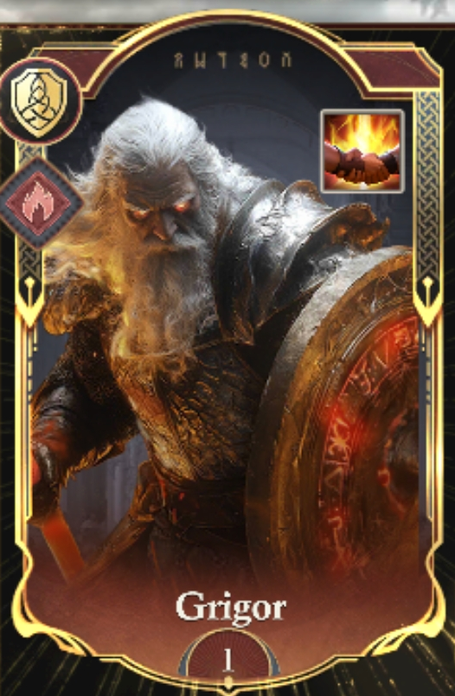

Infantry Hero: Grigor
Skills:
- Implacable March - March capacity, Infantry Damage Received
- Flaming Blades - Damage Chance based on the unique skill*
- Flaming Strikes - Infantry Attack, Infantry Damage
- Fire Shields - Infantry Defense, Infantry Damage Received
- Burning Courage - Infantry Health, Troop Damage Received
- Hellish Wrath - Chance to trigger the unique skill*

*Unique skill: Burning Stance
2. Flaming Blades grants the chance to increase damage to random enemy troops. For Burned targets, there is a chance to deal extra Fire Element Damage.
6. Hellish Wrath increases the chance of resetting the cooldown time of Burning Stance each round for the first 30 rounds.

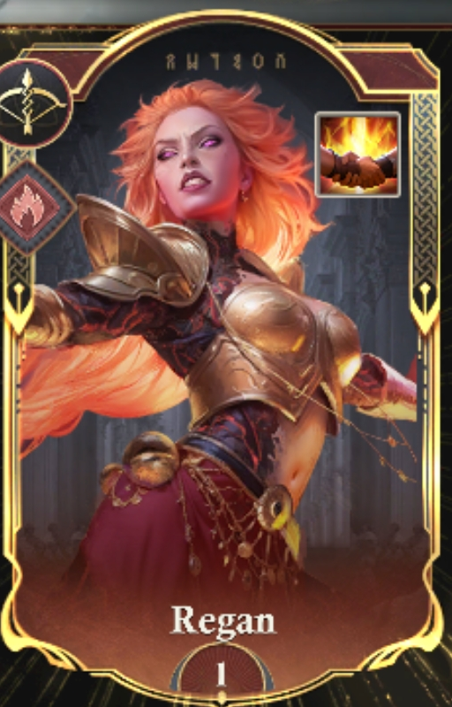

Bowmen Hero: Regan
Skills:
- Call of the Flame- March capacity, Bowmen Damage
- Burning Impact - Damage Chance based on the unique skill*
- Cosmic Barrier - Bowmen Defense, Bowmen Damage Received
- Burning Armor - Bowmen Health, Bowmen Damage
- Blazing Arrows - Bowmen Attack, Troop Damage
- High Mage - Chance to trigger the unique skill*

*Unique skill: Meteor Shower
2. Burning Impact increases the Critical Strike Damage of your highest-ranked Bowmen. For Burned targets, Critical Strike Damage of your highest-ranked Bowmen is increased by an additional 10%.
6. High Mage increases the chance of resetting the cooldown time of Meteor Shower of each round for the first 30 rounds of the battle.

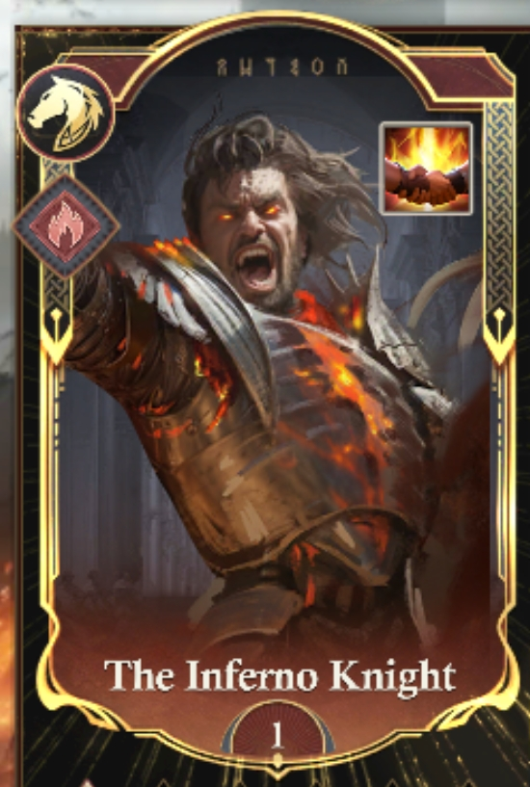

Cavalry Hero: The Infernal Knight
Skills:
- Flaming Vanguard - March capacity, Cavalry Damage
- Fearsome Neigh - Damage Chance based on the unique skill*
- Molten Fire Mane - Cavalry Defense, Cavalry Damage Received
- Burning Saddle - Cavalry Health, Cavalry Damage
- Hellfire Charge - Cavalry Attack, Troop Damage
- Unbridled Fire - Chance to trigger the unique skill*

*Unique skill: Hellish Trample
2. Fearsome Neigh increases the Critical Chance of your highest-ranked Cavalry. For Burned targets, Critical Chance of your highest-ranked Cavalry is increased and additional 5%.
6. Unbridled Fire increases the chance of resetting the cooldown time of Hellish Trample of each round for the first 30 rounds of the battle.

Update 19.8.0 Light Element Combat Heroes - Infantry “Fergus”, Cavalry “Ostara” and Bowmen “Sylvia”

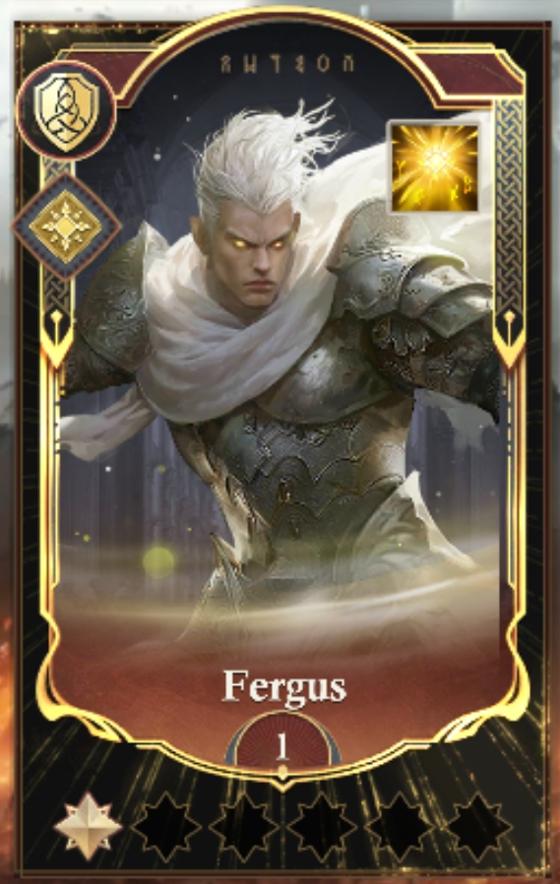

Infantry Hero: Fergus
Skills:
- Oath of Resolve - March capacity, Infantry Damage
- Dazzling Shield Strike - Damage Chance based on the unique skill*
- Blade of the Dawn - Infantry Attack, Infantry Damage
- Holy Light Protection - Infantry Defense, Infantry Damage Received
- Lineage of Light - Infantry Health, Troop Damage Received
- External Light - Chance to trigger the unique skill*

*Unique skill:
2. Dazzling Shield Strike - when the highest rated launches Radiant Shield there is a chance to trigger Dazzling Shield strike dealing damage to random enemies, if you have Light emblem there is a chance to deal extra light element damage
6. External Light - there is a chance to reset the cooldown time of Radiant Shield each round for the first 30 rounds

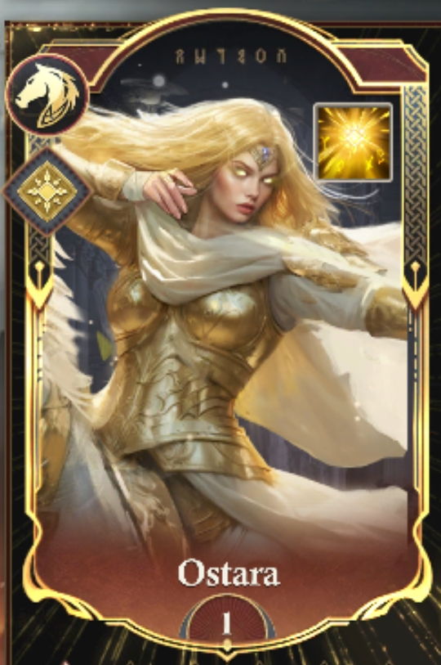

Cavalry Hero: Ostara
Skills:
- Light Ranger - March capacity, Cavalry Damage
- Swift Arrow of Light - Critical Chance based on the unique skill*
- Dazzling Cover - Cavalry Defense, Cavalry Damage Received
- Blessing of the Divine Beast - Cavalry Health, Cavalry Damage
- Teachings of the Witch - Cavalry Attack, Troop Damage
- Soul Scorch - Chance to trigger the unique skill*

*Unique skill:
2. Swift Arrow of Light - When Arrow of Light is triggered the critical chance of your highest rated cavalry is increased, if you have Light emblem this is increased
6. Soul Scorch - a chance to reset the cooldown time of Arrows of the Dawn
each round for the first 30 rounds

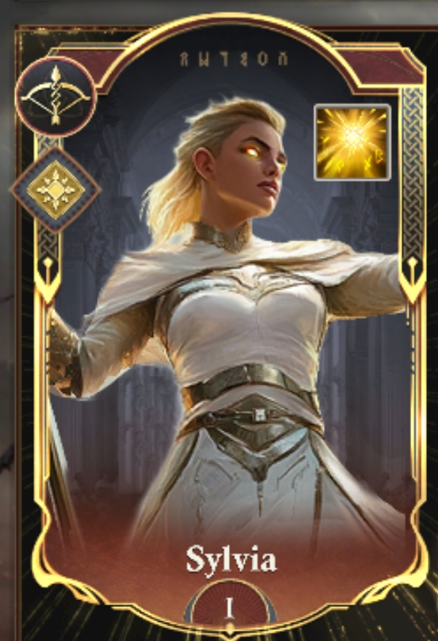

Bowmen Hero: Sylvia
Skills:
- Hymn of Light - March Capacity, Bowman Damage
- Wrath of the Light - Critical Chance based on the unique skill*
- Light Cascade - Bowman Defense, Bowman Damage Received
- Banner of Light - Bowman Health, Bowman Damage
- Unstoppable Holy Light - Bowman Attack, Troop Damage
- illumination - Chance to trigger the unique skill*

*Unique skill:
2. Hymn of Light when Divine Descent is triggered the critical strike damage of your highest rated bowman is increased, if you have Light Emblem this is increased
6. illumination - A chance to reset the cooldown time of Divine Descent each round for the first 30 rounds

Update 20.0.0 Water Element Combat Heroes - Infantry “Sir Caelan”, Bowmen “Nashira” and Cavalry “Ceryn”

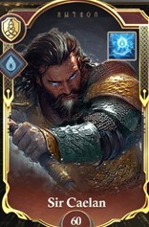

Infantry Hero: Sir Caelan
Skills:
- Whitewater March - March capacity, Infantry Damage Received
- Torrent Blade - Damage Chance based on the unique skill*
- Surge of Valor - Infantry Attack, Infantry Damage
- Flowing Defense - Infantry Defense, Infantry Damage Received
- Waters of Vitality - Infantry Health, Troop Damage Received
- River’s Renewal - Chance to trigger the unique skill*

*Unique skill: River’s Embrace
2. Torrent Blade - grants the chance to increase damage to random enemy troops. For Frozen targets, there is a chance to deal extra Water Element Damage.
6. River’s Renewal - there is a chance to reset the cooldown time of River’s Embrace each round for the first 30 rounds

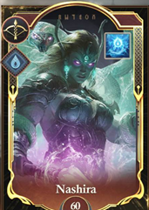

Bowman Hero: Nashira
Skills:
- Deep Surge - March Capacity, Bowman Damage
- Sea’s Fury - Critical Chance based on the unique skill*
- Tidal Barrier - Bowman Defense, Bowman Damage Received
- Power of the Abyss - Bowman Health, Bowman Damage
- Crashing Waves - Bowman Attack, Troop Damage
- Tidebreaker’s Boon - Chance to trigger the unique skill*

*Unique skill: Tidebreaker Arrow
2. Sea’s Fury increases the Critical Strike Damage of your highest-ranked Bowmen. For Frozen targets, Critical Strike Damage of your highest-ranked Bowmen is increased by an additional 8.4%.
6. Tidebreaker’s Boon increases the chance of resetting the cooldown time of Tidebreaker Arrow of each round for the first 30 rounds of the battle.

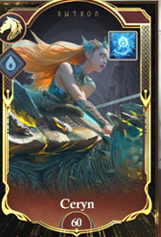

Cavalry Hero: Ceryn
Skills:
- Abyssal March - March capacity, Cavalry Damage
- Ripetide’s Wrath - Critical Chance based on the unique skill*
- Tideguard Resolve - Cavalry Defense, Cavalry Damage Received
- Merfolk Spirit - Cavalry Health, Cavalry Damage
- Trident Charge - Cavalry Attack, Troop Damage
- Ancestral Blessing - Chance to trigger the unique skill*

*Unique skill: Tidal Command
2. Ripetide’s Wrath - increases the Critical Chance of your highest-ranked Cavalry. For Frozen targets, Critical Chance of your highest-ranked Cavalry is increased an additional 5%.
6. Ancestral Blessing - a chance to reset the cooldown time of Tidal Command
each round for the first 30 rounds

Update 20.3.0 Dark Element Combat Heroes - Infantry “Lucan”, Bowmen “Vivian” and Cavalry “Vespera”

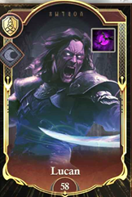

Infantry Hero: Lucan
Skills:
- Dark Dominion - March capacity, Infantry Damage Received
- Shadow Blades - Damage Chance based on the unique skill*
- Fury of the Morgaths - Infantry Attack, Infantry Damage
- Wall of Shadows - Infantry Defense, Infantry Damage Received
- Shadow Embrace - Infantry Health, Troop Damage Received
- Thirst for Vengeance - Chance to trigger the unique skill*

*Unique skill: Shadows of Vengeance
2. Shadow Blades grants the chance to increase damage to random enemy troops. For targets with the Dark Seal, there is a chance to deal extra Dark Element Damage.
6. Thirst for Vengeance increases the chance of resetting the cooldown time of Shadows of Vengeance each round for the first 30 rounds.

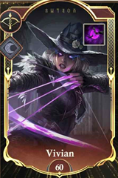

Bowmen Hero: Vivian
Skills:
- Blood Hunter - March capacity, Bowmen Damage
- Heartseeker Archery - Damage Chance based on the unique skill*
- Arcane Shield - Bowmen Defense, Bowmen Damage Received
- Hunter’s Instinct - Bowmen Health, Bowmen Damage
- Arrow of Extermination - Bowmen Attack, Troop Damage
- Hunting Frenzy - Chance to trigger the unique skill*

*Unique skill: Withered Arrow
2. Heartseeker Archery increases the Critical Strike Damage of your highest-ranked Bowmen. For targets with the Dark Seal, Critical Strike Damage of your highest-ranked Bowmen is increased by an additional 10%.
6. Hunting Frenzy increases the chance of resetting the cooldown time of Withered Arrow of each round for the first 30 rounds of the battle.



Cavalry Hero: Vespera
Skills:
- What’s Dead May Never Die - March capacity, Cavalry Damage
- Bloodthirsty Charge - Damage Chance based on the unique skill*
- Bloodborne Vitality - Cavalry Defense, Cavalry Damage Received
- Frenzied Strike - Cavalry Health, Cavalry Damage
- Blood Moon Oath - Cavalry Attack, Troop Damage
- Vampiric Wrath - Chance to trigger the unique skill*

*Unique skill: Crimson Calvary
2. Bloodthirsty Charge increases the Critical Chance of your highest-ranked Cavalry. For targets with the Dark Seal, Critical Chance of your highest-ranked Cavalry is increased an additional 5%.
6. Vampiric Wrath increases the chance of resetting the cooldown time of Crimson Calvary of each round for the first 30 rounds of the battle.

Update 20.6.0 Earth Element Combat Heroes - Infantry “Akanda”, Bowmen “Asara” and Cavalry “Bharok”

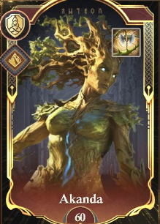

Infantry Hero: Akanda
Skills:
- Guardian’s Resolve - March capacity, Infantry Damage Received
- Piercing Thorns - Damage Chance based on the unique skill*
- Thorn Strike - Infantry Attack, Infantry Damage
- Stalwart Bark - Infantry Defense, Infantry Damage Received
- Blessing of the Spring - Infantry Health, Troop Damage Received
- Nature’s Wrath - Chance to trigger the unique skill*

*Unique skill: Shield of Thorns
2. Piercing Thorns - grants the chance to increase damage to random enemy troops. If you have Magnet, there is a chance to deal extra Earth Element Damage.
6. Nature’s Wrath - there is a chance to reset the cooldown time of Shield of Thorns each round for the first 30 rounds

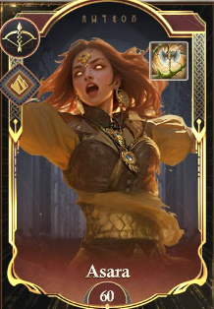

Bowman Hero: Asara
Skills:
- Whispers of the Dunes - March Capacity, Bowman Damage
- Sandsight - Critical Chance based on the unique skill*
- Desert Aegis - Bowman Defense, Bowman Damage Received
- Heart of the Storm - Bowman Health, Bowman Damage
- Wrath of Shan’al - Bowman Attack, Troop Damage
- Blessing of the Sands- Chance to trigger the unique skill*

*Unique skill: Desert Storm
2. Sandsight increases the Critical Strike Damage of your highest-ranked Bowmen. If you have Magnet, Critical Strike Damage of your highest-ranked Bowmen is increased by an additional percentage.
6. Blessing of the Sands increases the chance of resetting the cooldown time of Desert Storm of each round for the first 30 rounds of the battle.

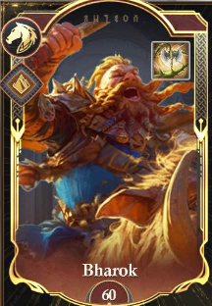

Cavalry Hero: Bharok
Skills:
- Savage Instinct - March capacity, Cavalry Damage
- Earthshaking Slam - Critical Chance based on the unique skill*
- Will to Survive - Cavalry Defense, Cavalry Damage Received
- Thunderous Stomp - Cavalry Health, Cavalry Damage
- Furious Charge - Cavalry Attack, Troop Damage
- Unstoppable Advance - Chance to trigger the unique skill*

*Unique skill: Boar Stampede
2. Earthshaking Slam - increases the Critical Chance of your highest-ranked Cavalry. If you have Magnet, Critical Chance of your highest-ranked Cavalry is increased an additional percentage.
6. Unstoppable Advance - a chance to reset the cooldown time of Boar Stampede
each round for the first 30 rounds

Update 20.8.0 Wind Element Combat Heroes - Infantry “Vierra”, Bowmen “Lorien” and Cavalry “Elaris”

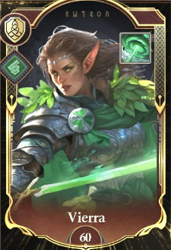

Infantry Hero: Vierra
Skills:
- Steadfast Advance - March capacity, Infantry Damage Received
- Sacred Strike - Damage Chance based on the unique skill*
- Razorleaf Stance - Infantry Attack, Infantry Damage
- Vine Wall - Infantry Defense, Infantry Damage Received
- Lifebloom - Infantry Health, Troop Damage Received
- Glade Warden’s Resolve - Chance to trigger the unique skill*

*Unique skill: Glade Warden’s Vow
2. Sacred Strike - grants the chance to increase damage to random enemy troops. If the target is Paralyzed, there is a chance to deal extra Wind Element Damage.
6. Glade Warden’s Resolve - there is a chance to reset the cooldown time of Glade Warden’s Vow each round for the first 30 rounds

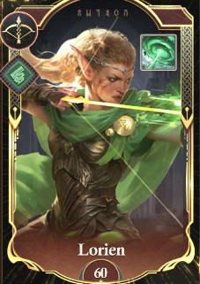

Bowman Hero: Lorien
Skills:
- Thornguard March - March Capacity, Bowman Damage
- Sylvan Strike - Critical Chance based on the unique skill*
- Ironbark Aegis - Bowman Defense, Bowman Damage Received
- Sylvan Resolve - Bowman Health, Bowman Damage
- Relentless Hunt - Bowman Attack, Troop Damage
- Chosen Guardian - Chance to trigger the unique skill*

*Unique skill: Bloodwind Arrow
2. Sylvan Strike increases the Critical Strike Damage of your highest-ranked Bowmen. If the target is Paralyzed, Critical Strike Damage of your highest-ranked Bowmen is increased by an additional percentage.
6. Chosen Guardian increases the chance of resetting the cooldown time of Bloodwind Arrow of each round for the first 30 rounds of the battle.

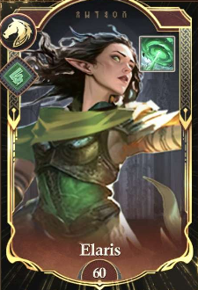

Cavalry Hero: Elaris
Skills:
- Gale Rider - March capacity, Cavalry Damage
- Arcane Precision - Critical Chance based on the unique skill*
- Gladescale Defense - Cavalry Defense, Cavalry Damage Received
- Sylvan Endurance - Cavalry Health, Cavalry Damage
- Spellcaster’s Charge - Cavalry Attack, Troop Damage
- Wildwood’s Blessing - Chance to trigger the unique skill*

*Unique skill: Feywild Temple
2. Arcane Precision - increases the Critical Chance of your highest-ranked Cavalry. If the target is Paralyzed, Critical Chance of your highest-ranked Cavalry is increased an additional percentage.
6. Wildwood’s Blessing - a chance to reset the cooldown time of Feywild Temple
each round for the first 30 rounds

Update 21.2.0 Light Element Combat Heroes - Infantry “Nerina”, Bowmen “Orion” and Cavalry “Valorian”

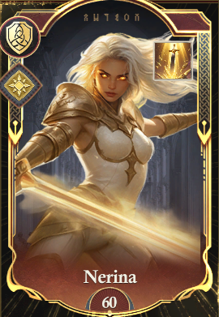

Infantry Hero: Nerina
Skills:
- Guardian’s Strike - March capacity, Infantry Damage Received
- Guardian’s Embrace - Damage Chance based on the unique skill*
- Shielded March - Infantry Attack, Infantry Damage
- High Guardian’s Wrath - Infantry Defense, Infantry Damage Received
- Bastion of Light - Infantry Health, Troop Damage Received
- Eternal Spirit - Chance to trigger the unique skill*

*Unique skill: Wings of Vigilance
2. Guardian’s Embrace - grants the chance to increase damage to random enemy troops. If you have Light Emblem, there is a chance to deal extra Light Element Damage.
6. Eternal Spirit - there is a chance to reset the cooldown time of Wings of Vigilance each round for the first 30 rounds.

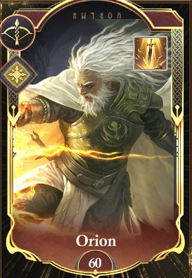

Bowman Hero: Orion
Skills:
- Astral Mark - March Capacity, Bowman Damage
- Celestial Resurgence - Critical Chance based on the unique skill*
- Heavenly Aegis - Bowman Defense, Bowman Damage Received
- Eternal Radiance - Bowman Health, Bowman Damage
- Solar Onslaught - Bowman Attack, Troop Damage
- Luminous Dominion - Chance to trigger the unique skill*

*Unique skill: Astral Arrows
2. Celestial Resurgence - increases the Critical Strike Damage of your highest-ranked Bowmen. If you have Light Emblem, Critical Strike Damage of your highest-ranked Bowmen is increased by an additional percentage.
6. Luminous Dominion - increases the chance of resetting the cooldown time of Astral Arrows of each round for the first 30 rounds of the battle.

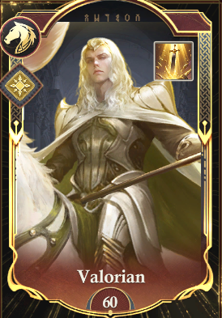

Cavalry Hero: Valorian
Skills:
- Radiant Quivers - March capacity, Cavalry Damage
- Gift of the Stag - Critical Chance based on the unique skill*
- Stag Charge - Cavalry Defense, Cavalry Damage Received
- Blazing Phalanx - Cavalry Health, Cavalry Damage
- Lyrian Valor - Cavalry Attack, Troop Damage
- Radiant Rider - Chance to trigger the unique skill*

*Unique skill: Spear of the Dawn
2. Gift of the Stag - increases the Critical Chance of your highest-ranked Cavalry. If you have Light Emblem, Critical Chance of your highest-ranked Cavalry is increased an additional percentage.
6. Radiant Rider - a chance to reset the cooldown time of Spear of the Dawn
each round for the first 30 rounds.

Update 21.6.0 Dark Element Combat Heroes - Infantry “Leonidas”, Bowmen “Sybil” and Cavalry “Blackthorne”

Leonidas can also be favoured by the Deity. When upgraded, deploying all three Heroes together with the Deity can activate the Divine Skill “Wrath of Sparta”.

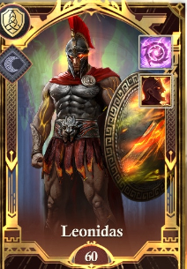

Infantry Hero: Leonidas
Skills:
- Brand of War - March capacity, Infantry Damage Received
- Unbroken Spirit - Damage Chance based on the unique skill*
- Ember Legion - Infantry Attack, Infantry Damage
- Ash-Forged - Infantry Defense, Infantry Damage Received
- Shield of Sparta - Infantry Health, Troop Damage Received
- Heart of Thermopylae - Chance to trigger the unique skill*

*Unique skill: Burning Phalanx
2. Unbroken Spirit - grants the chance to increase damage to random enemy troops. For targets marked by the Black Sigil, there is a chance to deal extra Dark Element Damage.
6. Heart of Thermopylae - there is a chance to reset the cooldown time of Burning Phalanx each round for the first 30 rounds.

Leonidas also has an upgrade path in Divine Favor.

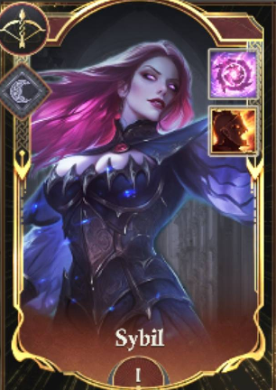

Bowman Hero: Sybil
Skills:
- Darkshot - March Capacity, Bowman Damage
- Shadow Curse - Critical Chance based on the unique skill*
- Black Sigil - Bowman Defense, Bowman Damage Received
- Waneveil - Bowman Health, Bowman Damage
- Deathbloom- Bowman Attack, Troop Damage
- Severing Grace - Chance to trigger the unique skill*

*Unique skill: Corrosive Arrow
2. Shadow Curse - increases the Critical Strike Damage of your highest-ranked Bowmen. For targets marked by the Black Sigil, Critical Strike Damage of your highest-ranked Bowmen is increased by an additional percentage.
6. Severing Grace - increases the chance of resetting the cooldown time of Corrosive Arrow of each round for the first 30 rounds of the battle.

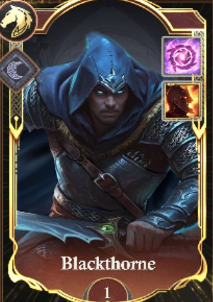

Cavalry Hero: Blackthorne
Skills:
- Umbral Bloodlust - March capacity, Cavalry Damage
- Stalker’s Hex - Critical Chance based on the unique skill*
- Panther’s Stride - Cavalry Defense, Cavalry Damage Received
- Cloak of Dread - Cavalry Health, Cavalry Damage
- Heart of the Hunt - Cavalry Attack, Troop Damage
- Fang Formation - Chance to trigger the unique skill*

*Unique skill: Shadowfang Strike
2. Stalker’s Hex - increases the Critical Chance of your highest-ranked Cavalry. For targets marked by the Black Sigil, Critical Chance of your highest-ranked Cavalry is increased an additional percentage.
6. Fang Formation - a chance to reset the cooldown time of Shadowfang Strike
each round for the first 30 rounds.

Update 22.0.0 Fire Element Combat Heroes - Infantry “Magni”, Bowmen “Icarus” and Cavalry “Morian”

Icarus also can be favored by the Deity. When upgraded, deploying all three Heroes together with the Deity can activate the Divine Skill “Fire of the Gods”.

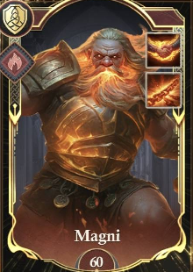

Infantry Hero: Magni
Skills:
- Hammerstrike - March capacity, Infantry Damage Received
- Flame Mastery - Damage Chance based on the unique skill*
- Iron Host - Infantry Attack, Infantry Damage
- Burlock’s Wrath - Infantry Defense, Infantry Damage Received
- Forge Guard - Infantry Health, Troop Damage Received
- Heart of a King - Chance to trigger the unique skill*

*Unique skill: Molten Phalanx
2. Flame Mastery - grants the chance to increase damage to random enemy troops. For Burned targets, there is a chance to deal extra Fire Element Damage.
6. Heart of a King - there is a chance to reset the cooldown time of Molten Phalanx each round for the first 30 rounds.

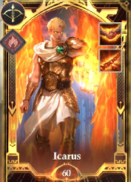

Bowman Hero: Icarus
Skills:
- Inferno Strike - March Capacity, Bowman Damage
- Burning Onslaught - Critical Chance based on the unique skill*
- Wings of Fury - Bowman Defense, Bowman Damage Received
- Flameguard - Bowman Health, Bowman Damage
- Divine Spirit - Bowman Attack, Troop Damage
- Eagle Eye - Chance to trigger the unique skill*

*Unique skill: Burning Volley
2. Burning Onslaught - increases the Critical Strike Damage of your highest-ranked Bowmen. For Burned targets, Critical Strike Damage of your highest-ranked Bowmen is increased by an additional percentage.
6. Eagle Eye - increases the chance of resetting the cooldown time of Burning Volley of each round for the first 30 rounds of the battle.

Icarus also has an upgrade path in Divine Favor.
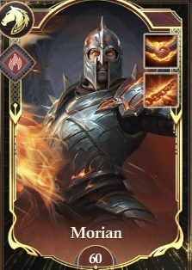

Cavalry Hero: Morian
Skills:
- Blazing Precision - March capacity, Cavalry Damage
- Fiery Burst - Critical Chance based on the unique skill*
- Noble Vanguard - Cavalry Defense, Cavalry Damage Received
- Shield of the De Vaux - Cavalry Health, Cavalry Damage
- Ancestral Vitality - Cavalry Attack, Troop Damage
- Crushing Onslaught - Chance to trigger the unique skill*

*Unique skill: Burning Lance
2. Fiery Burst - increases the Critical Chance of your highest-ranked Cavalry. For Burned targets, Critical Chance of your highest-ranked Cavalry is increased an additional percentage.
6. Crushing Onslaught - a chance to reset the cooldown time of Burning Lance
each round for the first 30 rounds.

Update 22.3.0 Water Element Combat Heroes - Infantry “Vargan”, Bowmen “Caelum” and Cavalry “Achilles”

Achilles also can be favored by the Deity. When upgraded, deploying all three Heroes together with the Deity can activate the Divine Skill “Fire of the Gods”.

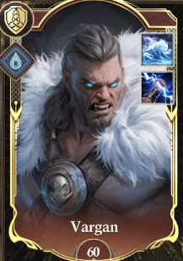

Infantry Hero: Vargan
Skills:
- Frostwyrm Fang - March capacity, Infantry Damage Received
- Ironbound Endurance - Damage Chance based on the unique skill*
- Frostwyrm Fury - Infantry Attack, Infantry Damage
- Stoneborn Shield - Infantry Defense, Infantry Damage Received
- Mountain’s Bastion - Infantry Health, Troop Damage Received
- Runes of Renewal - Chance to trigger the unique skill*

*Unique skill: Mountain’s Resilience
2. Ironbound Endurance - grants the chance to increase damage to random enemy troops. For Burned targets, there is a chance to deal extra Water Element Damage.
6. Runes of Renewal - there is a chance to reset the cooldown time of Mountain’s Resilience each round for the first 30 rounds.

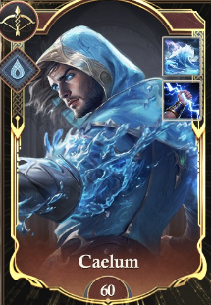

Bowman Hero: Caelum
Skills:
- Silent Arrow - March Capacity, Bowman Damage
- Surging March - Critical Chance based on the unique skill*
- Wave Wall - Bowman Defense, Bowman Damage Received
- Breath of the Sea - Bowman Health, Bowman Damage
- Command of the Deep - Bowman Attack, Troop Damage
- Echoing Shot - Chance to trigger the unique skill*

*Unique skill: Arrowtide
2. Surging March - increases the Critical Strike Damage of your highest-ranked Bowmen. For Burned targets, Critical Strike Damage of your highest-ranked Bowmen is increased by an additional percentage.
6. Echoing Shot - increases the chance of resetting the cooldown time of Arrowtide of each round for the first 30 rounds of the battle.

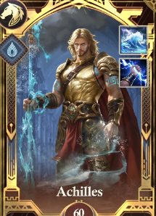

Cavalry Hero: Achilles
Skills:
- Achaen Might - March capacity, Cavalry Damage
- Myrmidon Vanguard - Critical Chance based on the unique skill*
- Achaen Shieldwall - Cavalry Defense, Cavalry Damage Received
- Chariot Charge - Cavalry Health, Cavalry Damage
- Chariot Onslaught - Cavalry Attack, Troop Damage
- Surging Chariot - Chance to trigger the unique skill*

*Unique skill: Rage of Achilles
2. Myrmidon Vanguard - increases the Critical Chance of your highest-ranked Cavalry. For Burned targets, Critical Chance of your highest-ranked Cavalry is increased an additional percentage.
6. Surging Chariot - a chance to reset the cooldown time of Rage of Achilles
each round for the first 30 rounds.

Update 22.6.0 Light Element Combat Heroes - Infantry “Vargan”, Bowmen “Caelum” and Cavalry “Achilles”

Hippolyta also can be favored by the Deity. When upgraded, deploying all three Heroes together with the Deity can activate the Divine Skill “First Dawn’s Blessing”.

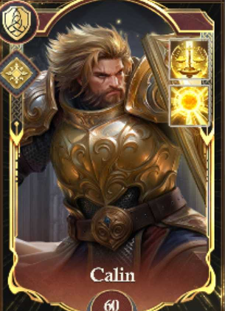

Infantry Hero: Calin
Skills:
- Warhammer of Light - March capacity, Infantry Damage Received
- Dawn Sigil - Damage Chance based on the unique skill*
- Luminous March - Infantry Attack, Infantry Damage
- Dawnbringer Vanguard - Infantry Defense, Infantry Damage Received
- Wall of Light - Infantry Health, Troop Damage Received
- Radiant Revival - Chance to trigger the unique skill*

*Unique skill: Dawnbringer’s Vow
2. Dawn Sigil - grants the chance to increase damage to random enemy troops. If you have Light Emblem, there is a chance to deal extra Light Element Damage.
6. Radiant Revival - there is a chance to reset the cooldown time of Dawnbringer’s Vow each round for the first 30 rounds.

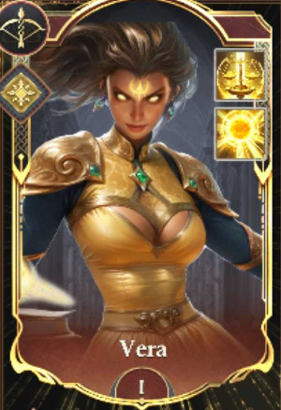

Bowman Hero: Vera
Skills:
- Mark of Radiance - March Capacity, Bowman Damage
- Blazing Recharge - Critical Chance based on the unique skill*
- Archmage March - Bowman Defense, Bowman Damage Received
- Lumina Veil - Bowman Health, Bowman Damage
- Inner Glow - Bowman Attack, Troop Damage
- Shining Volley - Chance to trigger the unique skill*

*Unique skill: Lightborn Blast
2. Blazing Recharge - increases the Critical Strike Damage of your highest-ranked Bowmen. If you have Light Emblem, Critical Strike Damage of your highest-ranked Bowmen is increased by an additional percentage.
6. Shining Volley - increases the chance of resetting the cooldown time of Lightborn Blast of each round for the first 30 rounds of the battle.

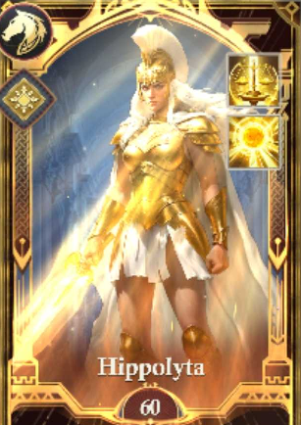

Cavalry Hero: Hippolyta
Skills:
- Radiant Rage - March capacity, Cavalry Damage
- Amazon Spirit - Critical Chance based on the unique skill*
- Amazon March - Cavalry Defense, Cavalry Damage Received
- Piercing Justice - Cavalry Health, Cavalry Damage
- Queen’s Might - Cavalry Attack, Troop Damage
- Shield of Dawn - Chance to trigger the unique skill*

*Unique skill: Sunblade
2. Amazon Spirit - increases the Critical Chance of your highest-ranked Cavalry. If you have Light Emblem, Critical Chance of your highest-ranked Cavalry is increased an additional percentage.
6. Shield of Dawn - a chance to reset the cooldown time of Sunblade
each round for the first 30 rounds.

Update 22.9.0 Earth Element Combat Heroes - Infantry “Perseus”, Bowmen “Selene” and Cavalry “Mina”

Perseus also can be favored by the Deity. When upgraded, deploying all three Heroes together with the Deity can activate the Divine Skill “Primordial Earth”.

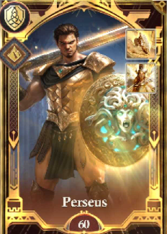

Infantry Hero: Perseus
Skills:
- Gorgon’s Gaze - March capacity, Infantry Damage Received
- Aegis Renewal - Damage Chance based on the unique skill*
- Heroic Resolve - Infantry Attack, Infantry Damage
- Petrifying Fury - Infantry Defense, Infantry Damage Received
- Reflective Defense - Infantry Health, Troop Damage Received
- Spirit of a Legend - Chance to trigger the unique skill*

*Unique skill: Divine Aegis
2. Aegis Renewal - grants the chance to increase damage to random enemy troops. If you have Magnet, there is a chance to deal extra Earth Element Damage.
6. Spirit of a Legend - there is a chance to reset the cooldown time of Divine Aegis each round for the first 30 rounds.

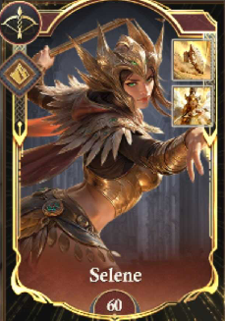

Bowman Hero: Selene
Skills:
- Shockwave - March Capacity, Bowman Damage
- Renewed Conviction - Critical Chance based on the unique skill*
- Desert Endurance - Bowman Defense, Bowman Damage Received
- Imperial Discipline - Bowman Health, Bowman Damage
- Mirage - Bowman Attack, Troop Damage
- Rebel’s Valor - Chance to trigger the unique skill*

*Unique skill: Sands of Conviction
2. Renewed Conviction - increases the Critical Strike Damage of your highest-ranked Bowmen. If you have Magnet, Critical Strike Damage of your highest-ranked Bowmen is increased by an additional percentage.
6. Rebel’s Valor - increases the chance of resetting the cooldown time of Sands of Conviction of each round for the first 30 rounds of the battle.

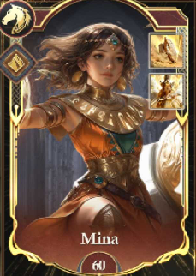

Cavalry Hero: Mina
Skills:
- Spirit of the Dunes - March capacity, Cavalry Damage
- Golem Regeneration - Critical Chance based on the unique skill*
- Juggernaut March - Cavalry Defense, Cavalry Damage Received
- Golem Block - Cavalry Health, Cavalry Damage
- Sandstorm Shield - Cavalry Attack, Troop Damage
- Duneblast - Chance to trigger the unique skill*

*Unique skill: Desert Juggernaut
2. Golem Regeneration - increases the Critical Chance of your highest-ranked Cavalry. If you have Magnet, Critical Chance of your highest-ranked Cavalry is increased an additional percentage.
6. Duneblast - a chance to reset the cooldown time of Desert Juggernaut
each round for the first 30 rounds.

Update 23.2.0 Wind Element Combat Heroes - Infantry “Liora”, Bowmen “Paris” and Cavalry “Kaelith”

Paris can also be favored by the Deity. When upgraded, deploying all three Heroes together with the Deity can activate the Divine Skill “Boon of Aphrodite”.

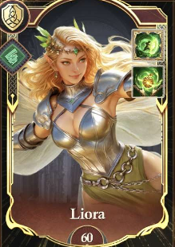

Infantry Hero: Liora
Skills:
- Fairy Strike - March capacity, Infantry Damage Received
- Sylvan Protection - Damage Chance based on the unique skill*
- Fairy Advance - Infantry Attack, Infantry Damage
- Pixie Fury - Infantry Defense, Infantry Damage Received
- Glimmering Guard - Infantry Health, Troop Damage Received
- Faye Fortitude - Chance to trigger the unique skill*

*Unique skill: Fairy Armor
2. Sylvan Protection - grants the chance to increase damage to random enemy troops. If the target is Paralyzed, there is a chance to deal extra Wind Element Damage.
6. Faye Fortitude - there is a chance to reset the cooldown time of Fairy Armor each round for the first 30 rounds.

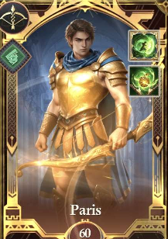

Bowman Hero: Paris
Skills:
- Glorious Marksman - March Capacity, Bowman Damage
- Helen’s Love - Critical Chance based on the unique skill*
- Trojan March - Bowman Defense, Bowman Damage Received
- Graceful Bow - Bowman Health, Bowman Damage
- Golden Armor - Bowman Attack, Troop Damage
- Trojan Spirit - Chance to trigger the unique skill*

*Unique skill: Trojan Storm
2. Helen’s Love - increases the Critical Strike Damage of your highest-ranked Bowmen. If the target is Paralyzed, Critical Strike Damage of your highest-ranked Bowmen is increased by an additional percentage.
6. Trojan Spirit - increases the chance of resetting the cooldown time of Trojan Storm of each round for the first 30 rounds of the battle.



Cavalry Hero: Kaelith
Skills:
- Glade Lion Fury - March capacity, Cavalry Damage
- Glade Lion Rally - Critical Chance based on the unique skill*
- Lion Knight March - Cavalry Defense, Cavalry Damage Received
- Sylvan Armor - Cavalry Health, Cavalry Damage
- Lionhearted - Cavalry Attack, Troop Damage
- Lion’s Roar - Chance to trigger the unique skill*

*Unique skill: Glade Lion
2. Glade Lion Rally - increases the Critical Chance of your highest-ranked Cavalry. If the target is Paralyzed, Critical Chance of your highest-ranked Cavalry is increased an additional percentage.
6. Lion’s Roar - a chance to reset the cooldown time of Glade Lion
each round for the first 30 rounds.

Update 23.5.0 Dark Element Combat Heroes - Infantry “Kelgar”, Bowmen “Pandora” and Cavalry “Morvane”

Pandora can also be favored by the Deity. When upgraded, deploying all three Heroes together with the Deity can activate the Divine Skill “Boon of Chaos”.

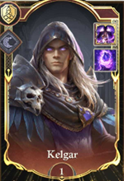

Infantry Hero: Kelgar
Skills:
- Ravenstrike - March capacity, Infantry Damage Received
- Dark Revival - Damage Chance based on the unique skill*
- Wings of Shadow - Infantry Attack, Infantry Damage
- Darktalon Rend - Infantry Defense, Infantry Damage Received
- Grimwing Phalanx - Infantry Health, Troop Damage Received
- Taste of Ravenblood - Chance to trigger the unique skill*

*Unique skill: Ravenshroud
2. Dark Revival - grants the chance to increase damage to random enemy troops. If targets are marked by the Black Sigil, there is a chance to deal extra Dark Element Damage.
6. Taste of Ravenblood - there is a chance to reset the cooldown time of Ravenshroud each round for the first 30 rounds.

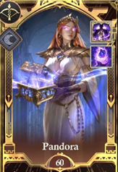

Bowman Hero: Pandora
Skills:
- Devouring Miseries - March Capacity, Bowman Damage
- Surge of Annihilation - Critical Chance based on the unique skill*
- Advance of Doom - Bowman Defense, Bowman Damage Received
- Chaotic Barrier - Bowman Health, Bowman Damage
- Cursed Beauty - Bowman Attack, Troop Damage
- Ruinous Strength - Chance to trigger the unique skill*

*Unique skill: Box of Annihilation
2. Surge of Annihilation - increases the Critical Strike Damage of your highest-ranked Bowmen. If targets are marked by the Black Sigil, Critical Strike Damage of your highest-ranked Bowmen is increased by an additional percentage.
6. Ruinous Strength - increases the chance of resetting the cooldown time of Box of Annihilation of each round for the first 30 rounds of the battle.

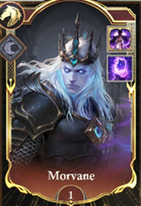

Cavalry Hero: Morvane
Skills:
- Unholy Wrath - March capacity, Cavalry Damage
- Veythar’s Curse - Critical Chance based on the unique skill*
- March of the Damned - Cavalry Defense, Cavalry Damage Received
- Nightmarish Armor - Cavalry Health, Cavalry Damage
- Knights of Doom - Cavalry Attack, Troop Damage
- Spectral Lances - Chance to trigger the unique skill*

*Unique skill: Unholy Bolt
2. Veythar’s Curse - increases the Critical Chance of your highest-ranked Cavalry. If targets are marked by the Black Sigil, Critical Chance of your highest-ranked Cavalry is increased an additional percentage.
6. Spectral Lances - a chance to reset the cooldown time of Unholy Bolt
each round for the first 30 rounds.

Update 23.8.0 Fire Element Combat Heroes - Infantry “Vulcanian”, Bowmen “Jex” and Cavalry “Hector”

Hector can also be favored by the Deity. When upgraded, deploying all three Heroes together with the Deity can activate the Divine Skill “Blazing Legacy”.

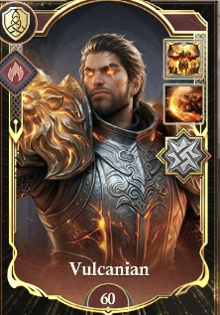

Infantry Hero: Vulcanian
Skills:
- Soul Burn - March capacity, Infantry Damage Received
- Boon of Mor’guk - Damage Chance based on the unique skill*
- March of Conquest - Infantry Attack, Infantry Damage
- Lust for Blood - Infantry Defense, Infantry Damage Received
- Demonic Armor - Infantry Health, Troop Damage Received
- Impervious Flesh - Chance to trigger the unique skill*

*Unique skill: Demonic Eye
2. Boon of Mor’guk - grants the chance to increase damage to random enemy troops. If the target is Burned, there is a chance to deal extra Fire Element Damage.
6. Impervious Flesh - there is a chance to reset the cooldown time of Demonic Eye each round for the first 30 rounds.

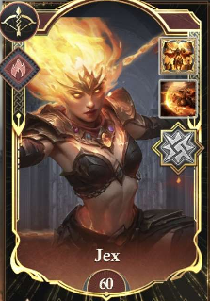

Bowman Hero: Jex
Skills:
- Soulchain Wrath - March Capacity, Bowman Damage
- Ancient Flame - Critical Chance based on the unique skill*
- Infernal March - Bowman Defense, Bowman Damage Received
- Soulbound Defense - Bowman Health, Bowman Damage
- Spirit of Ifrit - Bowman Attack, Troop Damage
- Searing Strikes - Chance to trigger the unique skill*

*Unique skill: Soulchain Bolt
2. Ancient Flame - increases the Critical Strike Damage of your highest-ranked Bowmen. If the target is Burned, Critical Strike Damage of your highest-ranked Bowmen is increased by an additional percentage.
6. Searing Strikes - increases the chance of resetting the cooldown time of Soulchain Bolt of each round for the first 30 rounds of the battle.

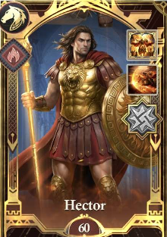

Cavalry Hero: Hector
Skills:
- Fiery Gore - March capacity, Cavalry Damage
- Divine Glory - Critical Chance based on the unique skill*
- Trojan Advance - Cavalry Defense, Cavalry Damage Received
- Breaker of Horses - Cavalry Health, Cavalry Damage
- Rugged Horseman - Cavalry Attack, Troop Damage
- Ilian Warcry - Chance to trigger the unique skill*

*Unique skill: Lance of Apollo
2. Divine Glory - increases the Critical Chance of your highest-ranked Cavalry. If the target is Burned, Critical Chance of your highest-ranked Cavalry is increased an additional percentage.
6. Ilian Warcry - a chance to reset the cooldown time of Lance of Apollo
each round for the first 30 rounds.

Water element heroes - infantry “Theseus”, bowman “marina”, Cavalry “Lyanna
Theseus can be favoured by the deity, When upgraded, deploying all three Heroes together with the Deity can activate the Divine Skill “Hearts of the sea”

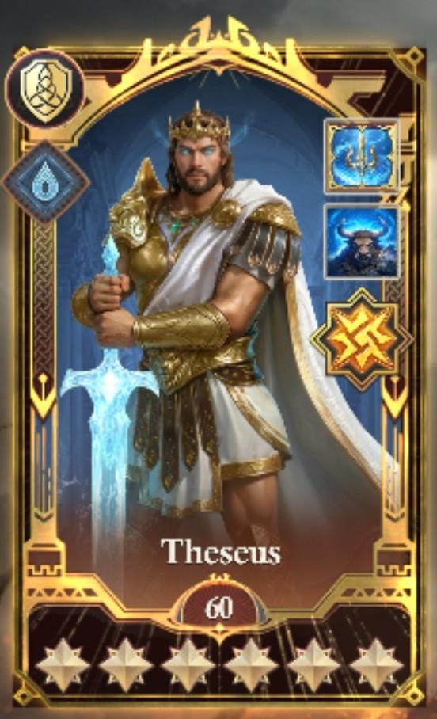
Infantry hero: Theseus
Skills:
- Living Blade - march capacity, damage received
- Legendary Battle Fury - Chance to trigger the unique skill*
- Labyrinthine Navigation - infantry attack, infantry damage
- Crushing Blow - Infantry Defense, Infantry Damage Received
- Strength of the Minotaur - infantry health, troop damage received
- Olympician Aid - Chance to trigger the unique skill*

*Unique skill: Minotaur slayer
2. Legendary Battle Fury - grants the chance to increase damage to random enemy troops. If the target is frozen, there is a chance to deal extra water Element Damage.
6. Olympician Aid - there is a chance to reset the cooldown time of Minotaur slayer each round for the first 30 rounds.

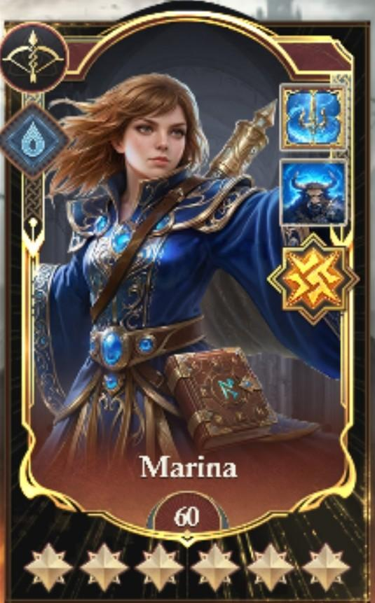
Bowman hero: Marina
Skills:
Water Mage - March Capacity, Bowman Damage
Arcane Flow - Critical Chance based on the unique skill*
Walk On Water - Bowman Defense, Bowman Damage Received
Seawall - Bowman Health, Bowman Damage
Hydro Pillar - Bowman Attack, Troop Damage
Liquid Swords - Chance to trigger the unique skill*

*Unique skill: Typhoon Blast
2. Arcane Flow - increases the Critical Strike Damage of your highest-ranked Bowmen. If the target is Frozen, Critical Strike Damage of your highest-ranked Bowmen is increased by an additional percentage.
6. Liquid - increases the chance of resetting the cooldown time of typhoon Blast each round for the first 30 rounds of the battle.

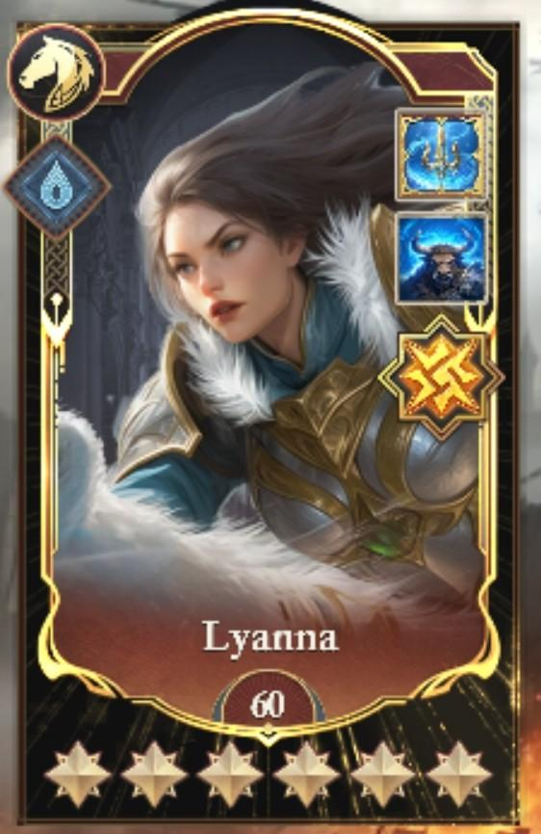
Cavalry Hero: Lyanna
Skills:
Frostbite - March capacity, Cavalry Damage
Spirit of the Bear - Critical Chance based on the unique skill*
Bear Mount - Cavalry Defense, Cavalry Damage Received
Northern Heartiness - Cavalry Health, Cavalry Damage
Rampaging Charge - Cavalry Attack, Troop Damage
Icy Maul - Chance to trigger the unique skill*

*Unique skill: Freezing Blade
2. Spirit of the Bear - increases the Critical Chance of your highest-ranked Cavalry. If the target is frozen, Critical Chance of your highest-ranked Cavalry is increased an additional percentage.
6. Icy Maul - a chance to reset the cooldown time of Freezing Blade
each round for the first 30 rounds.

Light element heroes - infantry “Jason”, bowman “Lucien”, Cavalry “Thera”
Jason can be favoured by the deity, When upgraded, deploying all three Heroes together with the Deity can activate the Divine Skill “Divine King”

Infantry hero: Jason
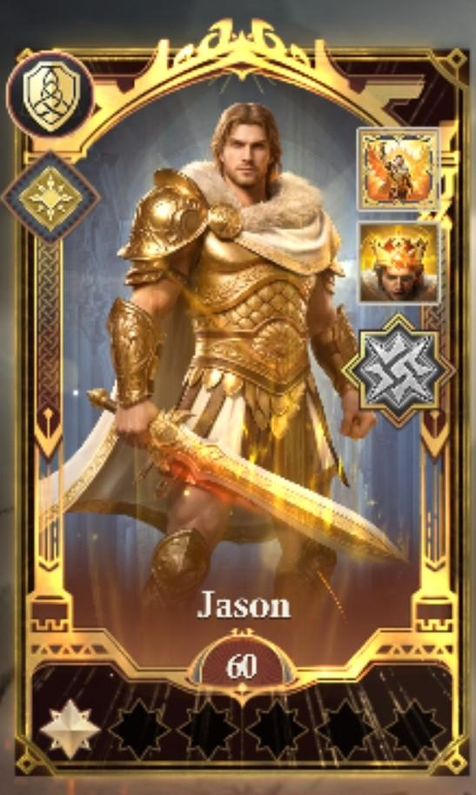
Skills:
- Sword of the Argonauts - march capacity, damage received
- Blessing of the Fleece - Chance to trigger the unique skill*
- Will of the Argonauts - infantry attack, infantry damage
- Phalanx of Heroes - Infantry Defense, Infantry Damage Received
- Bond of Brothers - infantry health, troop damage received
- Strength of Colchis - Chance to trigger the unique skill*

*Unique skill: Shield of the Golden Fleece
2. Blessing of the Fleece - grants the chance to increase damage to random enemy troops. If the target is marked with the light emblem, there is a chance to deal extra light Element Damage.
6. Strength of Colchis - there is a chance to reset the cooldown time of Shield of the Golden Fleece each round for the first 30 rounds.

Bowman hero: Lucien
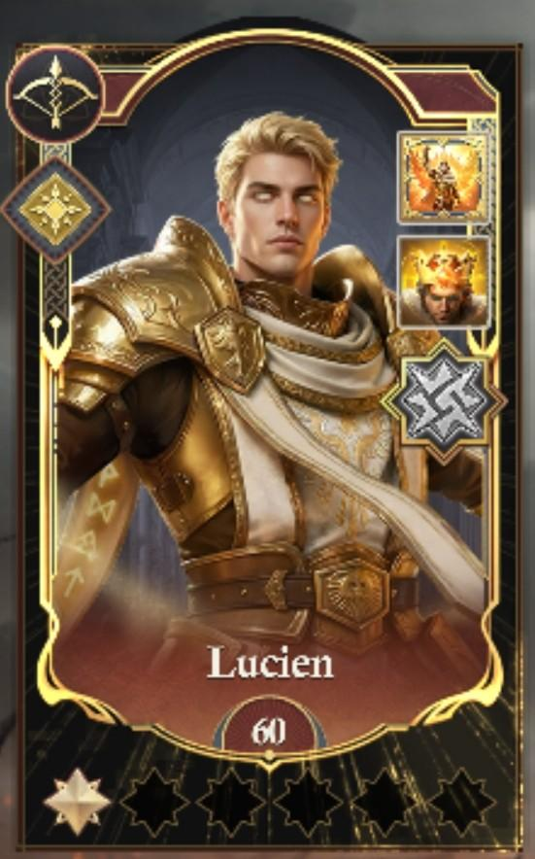
Skills:
Light of the Ancients - March Capacity, Bowman Damage
Strength of the Sun - Critical Chance based on the unique skill*
March of the Golden Sun - Bowman Defense, Bowman Damage Received
Radiant Barrier - Bowman Health, Bowman Damage
Blazing Bodies - Bowman Attack, Troop Damage
Shining Beams - Chance to trigger the unique skill*

*Unique skill: Eviscerating Beam
2. Strength of the Sun - increases the Critical Strike Damage of your highest-ranked Bowmen. If the target is marked with the light emblem, Critical Strike Damage of your highest-ranked Bowmen is increased by an additional percentage.
6. Shiny Beams - increases the chance of resetting the cooldown time of Eviscerating Beam each round for the first 30 rounds of the battle.

Cavalry Hero: Thera
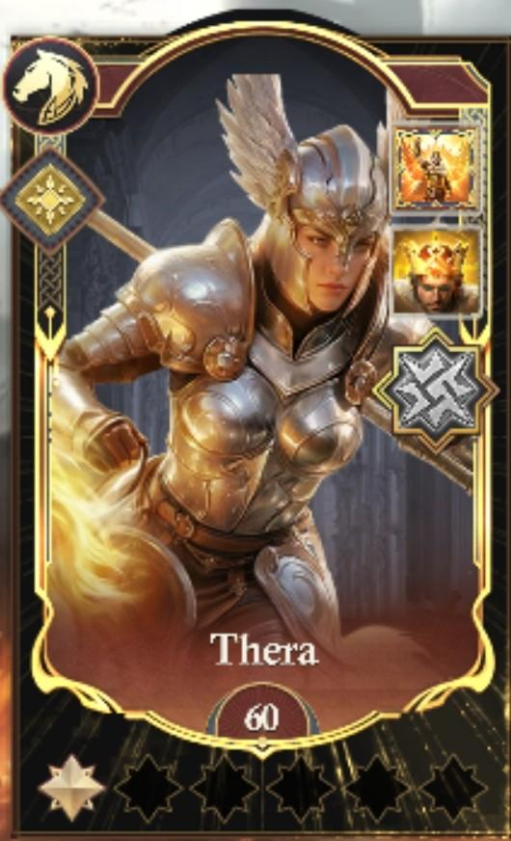
Skills:
Radiant Rage - March capacity, Cavalry Damage
Radiant Renewal - Critical Chance based on the unique skill*
March of the Pegasus - Cavalry Defense, Cavalry Damage Received
Pegasus Shield - Cavalry Health, Cavalry Damage
Sky guard Fortitude - Cavalry Attack, Troop Damage
Soaring Charge - Chance to trigger the unique skill*

*Unique skill: Lance of the Light
2. Radiant Renewal - increases the Critical Chance of your highest-ranked Cavalry. If the target is marked with the light emblem, Critical Chance of your highest-ranked Cavalry is increased an additional percentage.
6. Soaring Charge - a chance to reset the cooldown time of Lance of the Light
each round for the first 30 rounds.

Raising Combat Heroes
Heroes can be enhanced with fragments and Hero EXP.
1* = 20 fragments (unlocking the hero)
2* = 120 fragments
3* = 180 fragments
4* = 350 fragments
5* = 450 fragments
6* = 650 fragments

Hero skills are increased 10 levels at a time with Hero Fragments and Hero Skill Scrolls at each interval from 0-10-20-30-40-50 all the way to 60.

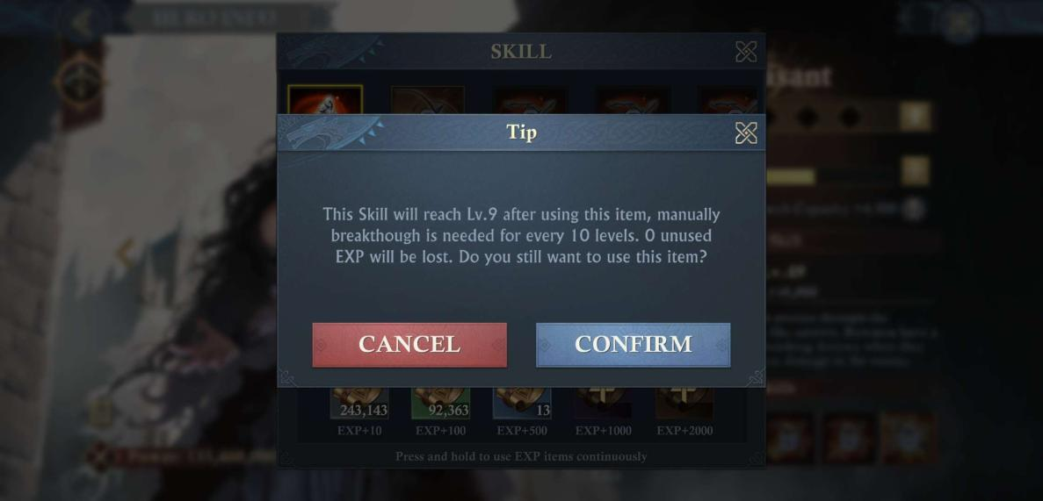
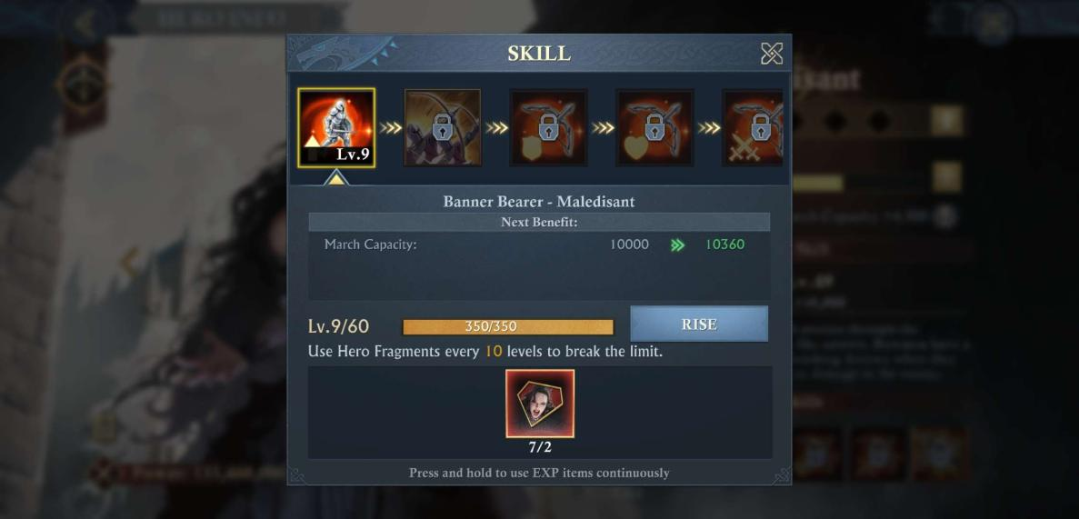

A Fragment is available by way of a Combat Hero Choice Card in the 6th chest of daily rewards. These cards work like any choice chest and they can be found in your inventory. Also, keep an eye on events to get extra.
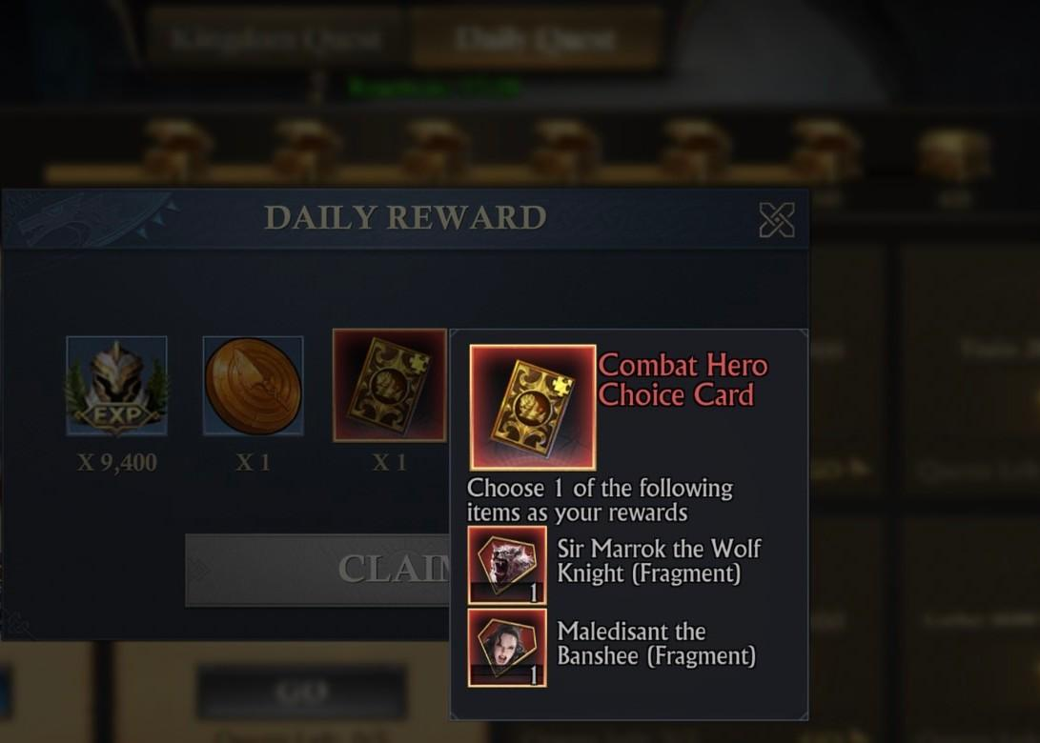

Please note that Aid Skills must be unlocked one by one in a left-to-right sequence. Each skill must meet the unlocking conditions before the next can be unlocked.

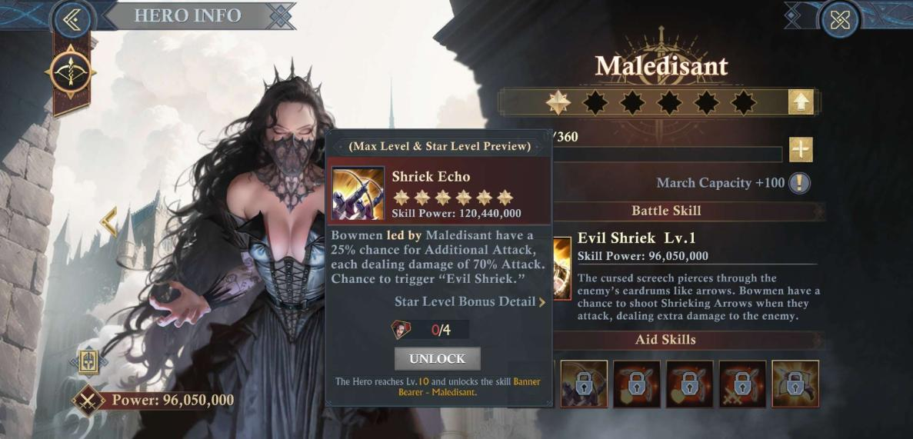

Hero kills are visible in the battle report, showing the number of kills made by heroes on both sides.
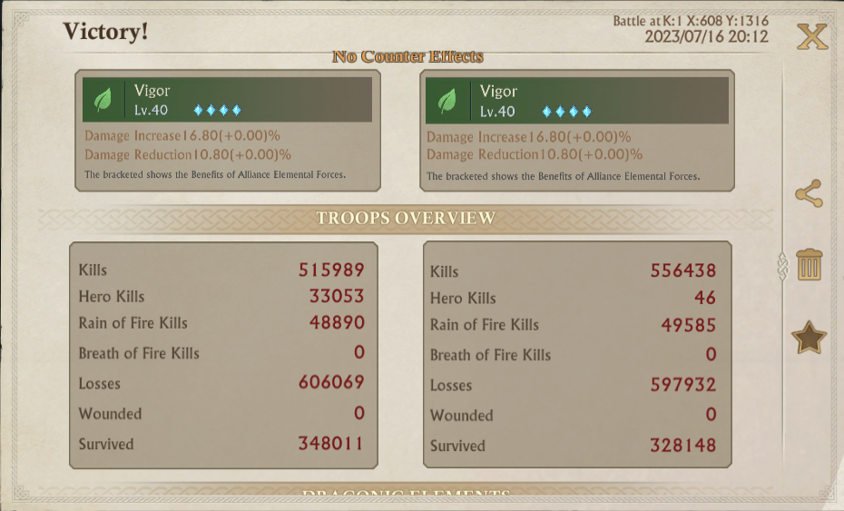
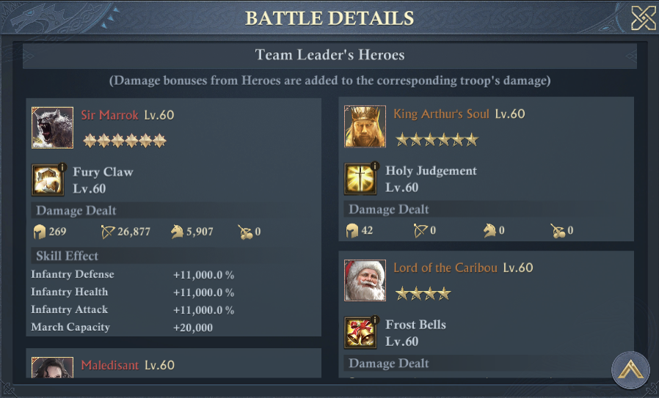

Heroes Pact
Update 16.7.0 introduced a Heros pact system which includes benefits depending on which heroes you have unlocked, and their star level;
This is similar to how the heroes pact system works for your appointed heroes.

Below shows the benefit from having unlocked Maledisant, and Sir Marrok.
NOTE: only Call of the Moon has been unlocked, Wrath of the Night, would get unlocked when the star level of both heroes reaches 2 stars.
You can see the requirements by going to the Combat Hero screen, and in the bottom right clicking on Constraint.
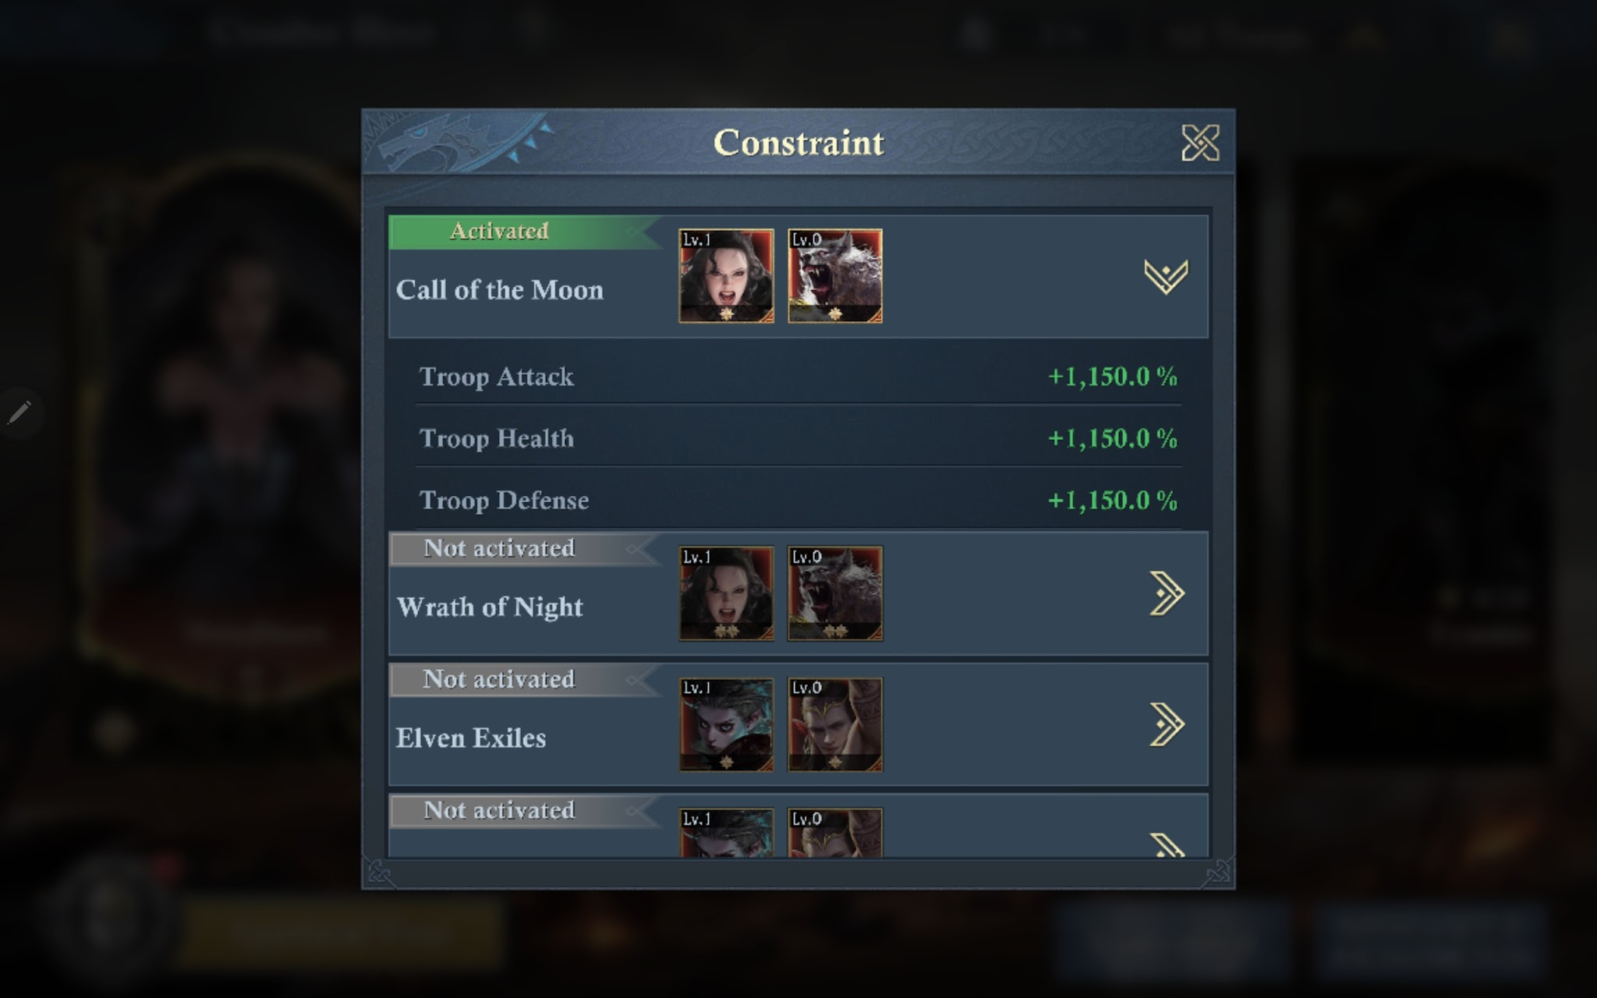

*Note:
Since update 16.7, along with the new combat heroes came a new "combat hero score" which you can view by tapping your avatar and going through 'more info' and scrolling down. This new score only counts the highest scores of your combat heroes and not the overall power they add.
