KING OF AVALON
FRONTIER ALLIANCE EXPEDITION
SEASON 19: MYSTERY OF THE DUNES
THE GOLD EDITION FIELD GUIDE
Final Edition v2.0 • Complete Screenshot Set
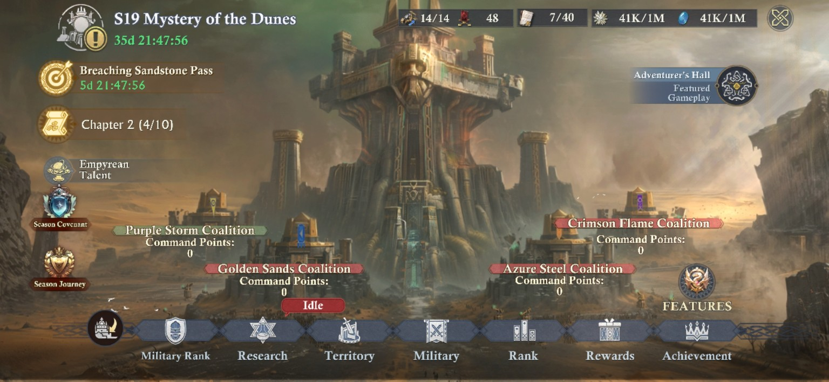
The Season 19 home screen ties the major systems together: Military Rank/Store, Research, Territory, Military, Rank, Rewards, Achievements, Covenant, and the Adventurer’s Hall.
[CREATOR’S NOTE] Built from the game, not from guesswork
Every hard number in this edition is either visible in an official in-game screenshot, explicitly moderator-confirmed from live play/testing, or clearly labeled as a derived calculation. When screenshots disagree, the conflict is preserved. When the evidence stops short of an answer, the guide says so… No Fluff!!!

BEFORE WE MARCH
How to Use This Edition

Season 19 has a lot of moving parts, but they are not random systems stacked on top of each other. The season has a clear chain: take territory, unlock Guild tools, feed those tools with Dunestone and special Castles, use that infrastructure to win tougher Castle fights, and keep your research and Curse/Illusion Resistance ahead of the map. Once you see that chain, the season gets much easier to read.

Evidence labels
Label | What it means
SCREENSHOT-VERIFIED | The value or rule appears directly in an official in-game screenshot.
DERIVED | Simple math or a practical conclusion calculated from screenshot-verified values.
MODERATOR-CONFIRMED | A live-play rule or behavior supplied directly by the project moderator; kept distinct when a confirming screenshot is not yet captured.
OPEN QUESTION | Not enough information to state the correct answer, safely.

[MODERATOR’S PRO-TIP] Read the season in layers
If you are new to this season, read Parts I-V first. If you are already fighting over Castles, jump to the Guild Battletower and Curse/Illusion Resistance chapters. If you are managing a Guild, keep the Guild progression, Smelting Workshop, and Battletower construction sections close at hand.

Field guide contents
Section | Coverage
Part I | The season map, regions, and stage roadmap
Part II | Season currencies, Research, Research plaudit plan, Daily/Weekly/Main Quests, Military Orders, Covenant, and Achievements
Part III | Castle zones, four contested-neutral victory paths, weaker-coalition strategy, durability math, and special Castles
Part IV | Guilds: creation, membership, logistics, rallying, and territory
Part V | Guild levels, EXP, and the Lv.2 evidence conflict
Part VI | Relic Expedition, Relic Peddler, Adventure achievements, and the Adventurer’s Hall loop
Part VII | Mines, Lv.1-18 production/Curse curve, advanced-Mine Empyrean EXP, looting, garrisons, capacity, and Curse/Illusion Resistance
Part VIII | Dunestone Smelting and the material economy
Part IX | Mining Battletower: Ore Drill and Season featured Research
Part X | Guild Battletowers: all six towers, Fortifier math, garrison efficiency, and battle rules
Part XI | Secret Bounties, Bandit Camps, Popular Support, Endless Trials, and reward examples
Part XII | Final evidence boundaries, build-sensitive values, and unresolved items
Appendix | Derived math, battlefield formulas, and evidence caveats

FIVE REGIONS, ONE FORWARD PUSH
Part I - The Map Is the Campaign

The opening days can feel quiet because the map is still fenced off. Do not mistake that for downtime. Season 19 is built like a campaign map from an old strategy game: each region opens the tools needed for the next one, and the Coalitions that prepare before the gate opens are the ones that hit the new stage at full speed.
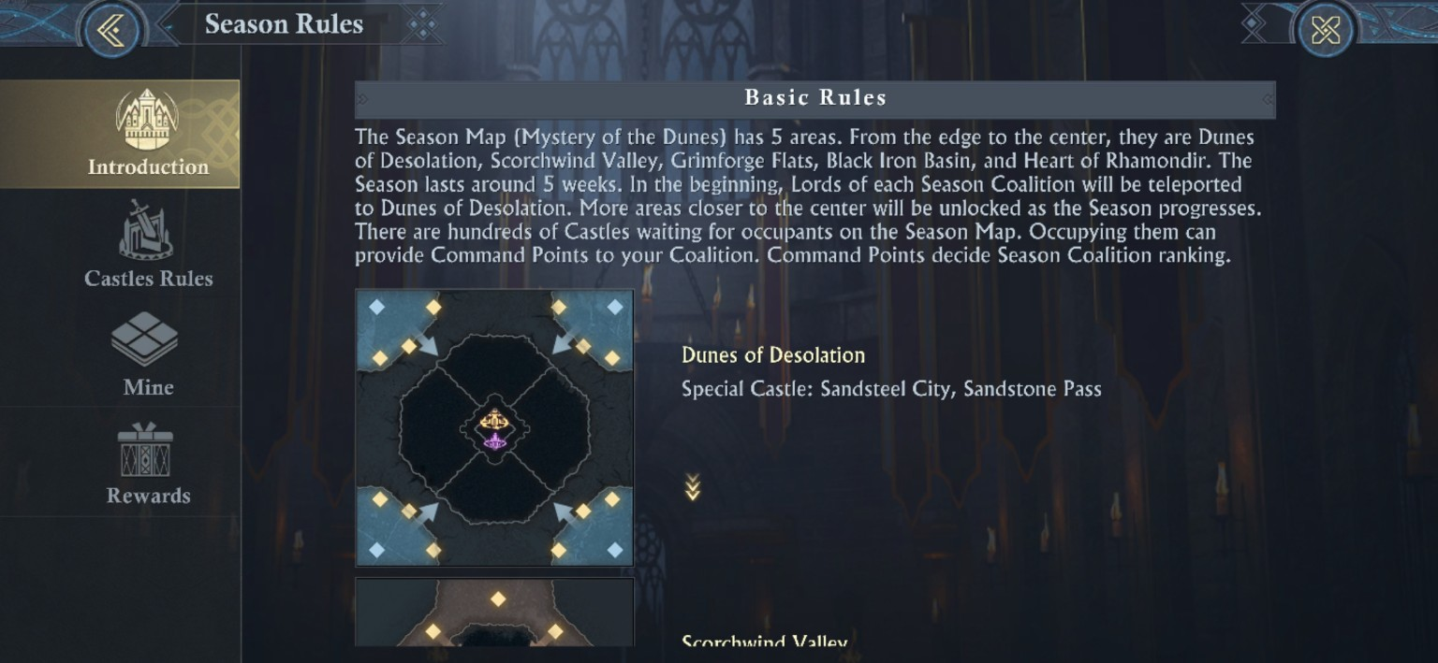

The five regions
Order | Region | What it means
1 | Dunes of Desolation | Starting region. Every Lord begins here inside the Coalition’s protected opening area.
2 | Scorchwind Valley | First major expansion zone; Scorchwind Fortresses and broader Castle competition appear.
3 | Grimforge Flats | Higher-level Castles and Guild Medium Sword Towers enter the campaign.
4 | Black Iron Basin | Higher-level Castles, Black Iron Fortresses, and Coalition-level Sword Tower pressure.
5 | Heart of Rhamondir | Endgame region containing Dunestone Tower and the Capital objectives.

[MODERATOR’S PRO-TIP] Your real clock, is the next unlock
Do not plan only around what you can attack today. Plan around what becomes available next. Stock Guild Logistics, finish the Research that matters for the next Curse/Illusion Defense tier, and get Battletower materials ready before the map opens. The best time to PREPARE for Grimforge Fortress is while everyone is still fighting for Scorchwind Fortress. This includes but is not limited to: planning ahead to future captures (possibly to cut another coalition off from the fortress completely), pushing your allies to develop their season research or personal stats/gear enough to combat the other coalitions properly, monitoring enemy troop counts, monitoring enemy activity and recording activity patterns, etc.

Observed Season 19 stage calendar
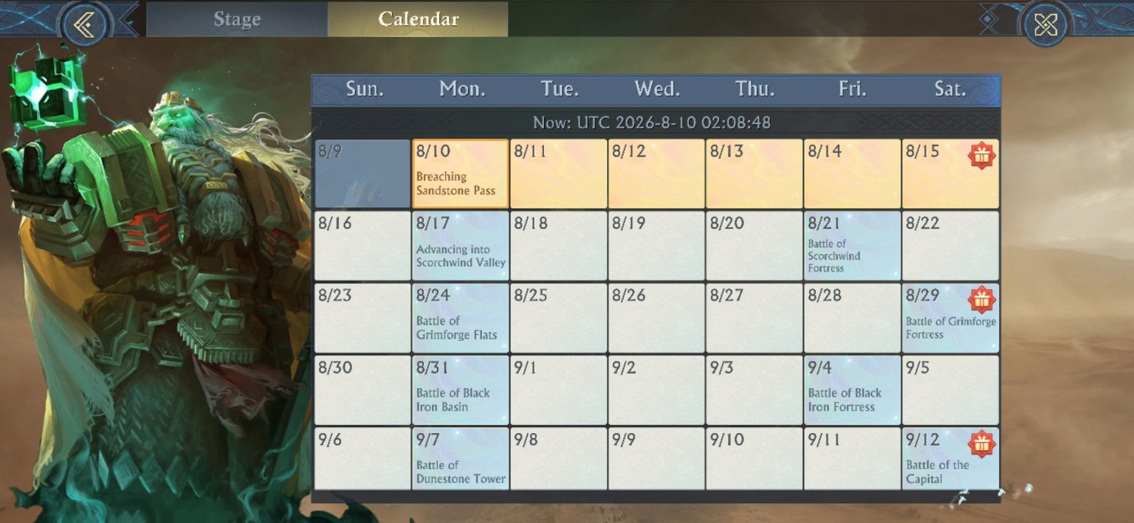
The in-game calendar captured at UTC 2026-08-10. Treat these dates as the observed schedule for this screenshot set, not as a promise that every future run uses the same calendar dates.
Observed start | Stage | Practical focus
Aug 10 | Breaching Sandstone Pass | Finish the Dunes and break through the Pass.
Aug 17 | Advancing into Scorchwind Valley | Scorchwind Fortresses, Castle Scramble, higher Castle limit, Mine looting.
Aug 21 | Battle of Scorchwind Fortress | Wider Scorchwind competition.
Aug 24 | Battle of Grimforge Flats | Grimforge opens; Medium Sword Towers enter.
Aug 29 | Battle of Grimforge Fortress | Fortress contest in Grimforge.
Aug 31 | Battle of Black Iron Basin | Black Iron opens; Coalition Sword Tower pressure increases.
Sep 4 | Battle of Black Iron Fortress | Black Iron Fortress contest.
Sep 7 | Battle of Dunestone Tower | Take the gatekeeper to the Capital.
Sep 12 | Battle of the Capital | Final contest for Anvilheart objectives.

Stage-by-stage unlocks
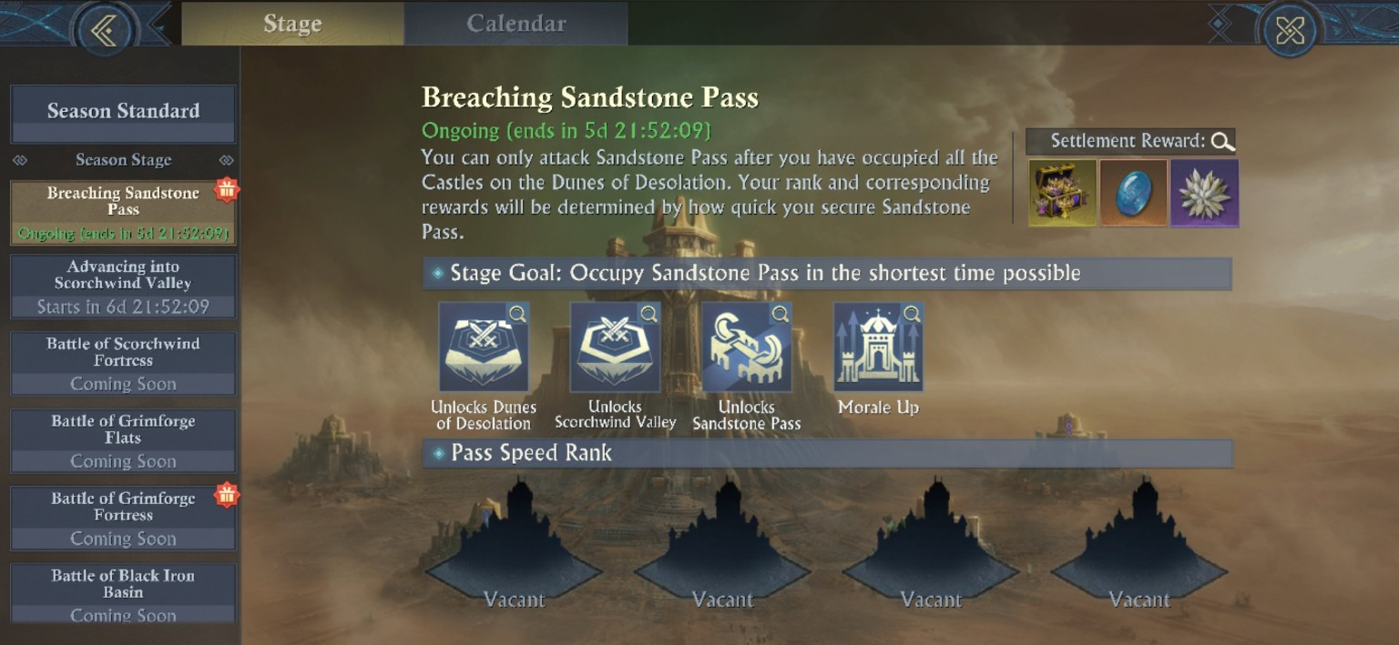
Breaching Sandstone Pass: finish the Dunes first.
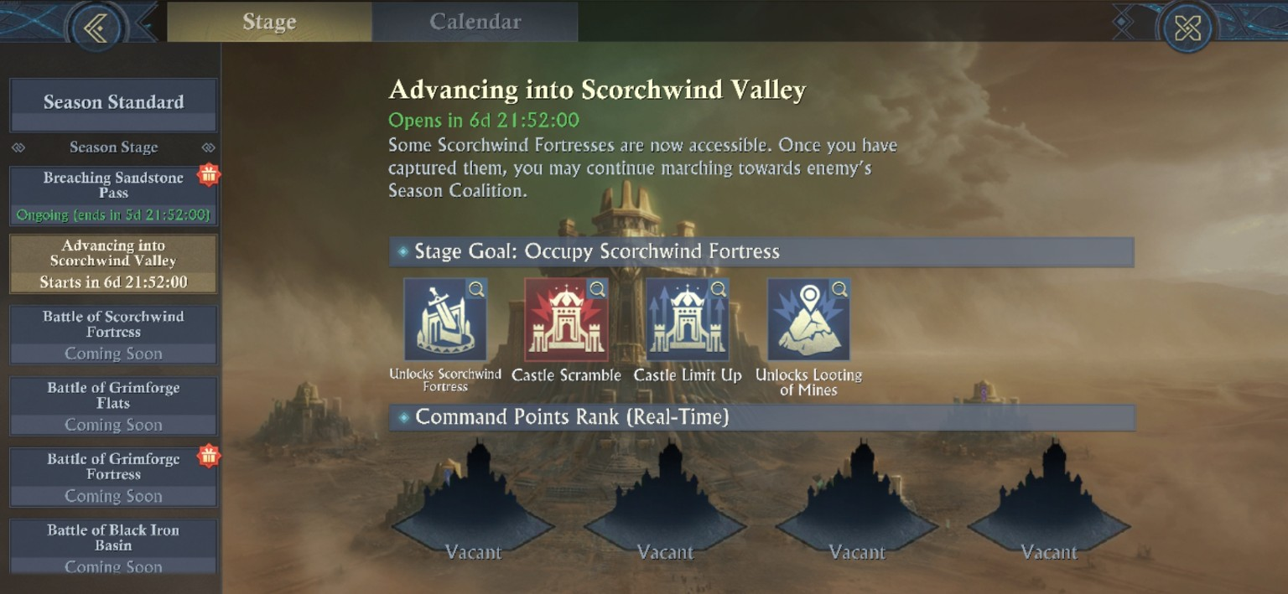
Scorchwind: Fortresses, Castle Scramble, Castle Limit Up, and Mine looting appear.

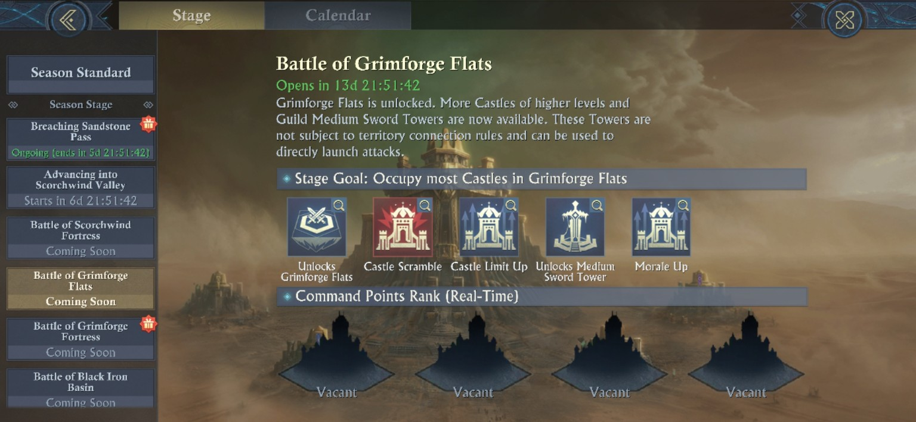
Grimforge: higher-level Castles plus Medium Sword Towers.
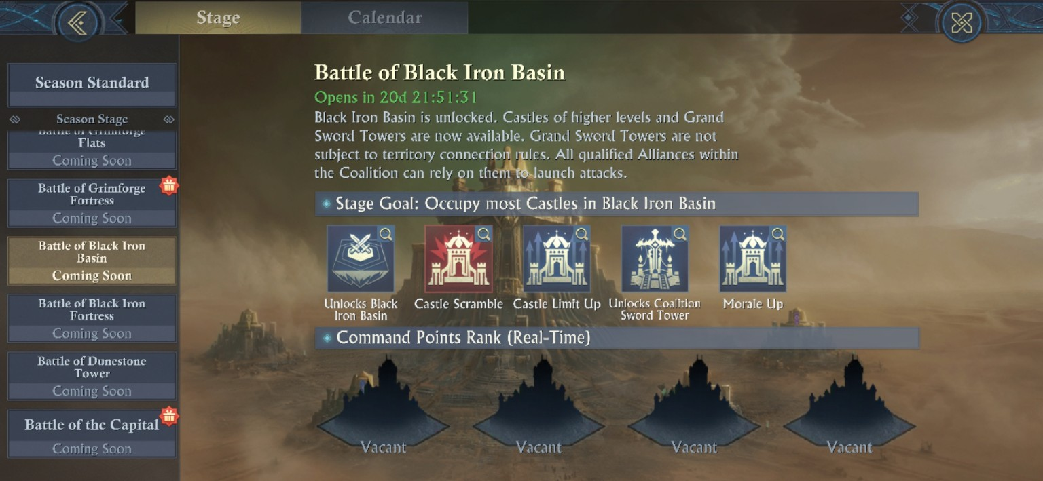
Black Iron: higher-level Castles plus Coalition Sword Tower pressure.

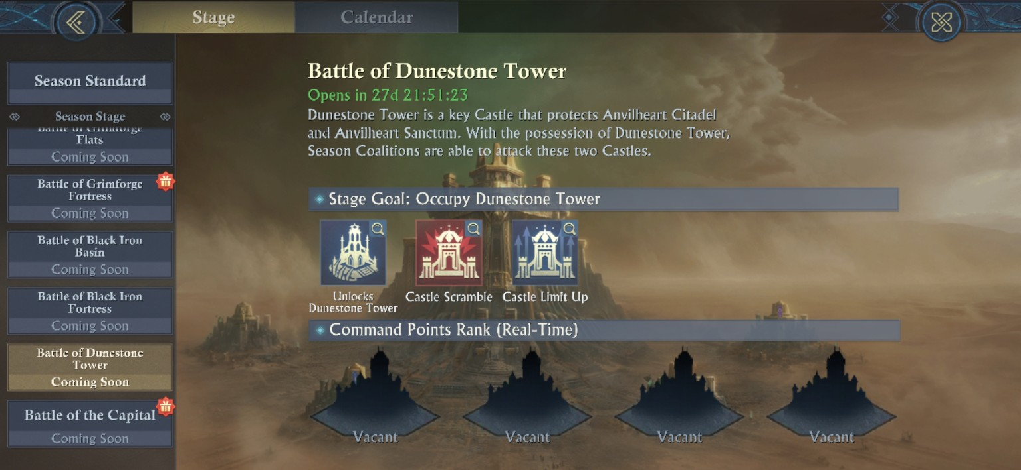
Dunestone Tower: possession opens the road to the Capital.
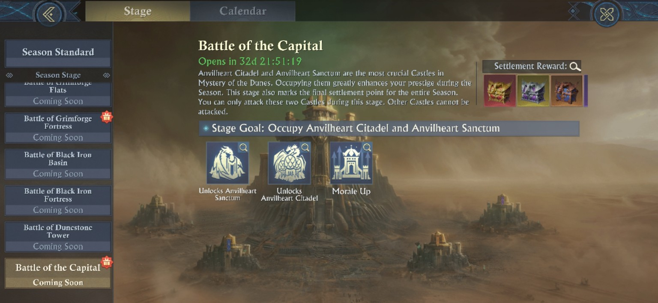
Battle of the Capital: only the two Capital objectives can be attacked during the final stage.

RESOURCES, RESEARCH, ORDERS, COVENANT, ACHIEVEMENTS
Part II - Build the Engine Before You Spend It

Season 19 is generous with things to click on, and surprisingly unforgiving about the few resources that actually gate or limit action. The trick is separating permanent-looking noise from the season-only currencies that determine whether you can research, heal, loot, or deploy troops when it matters.

Season resources and progression currencies
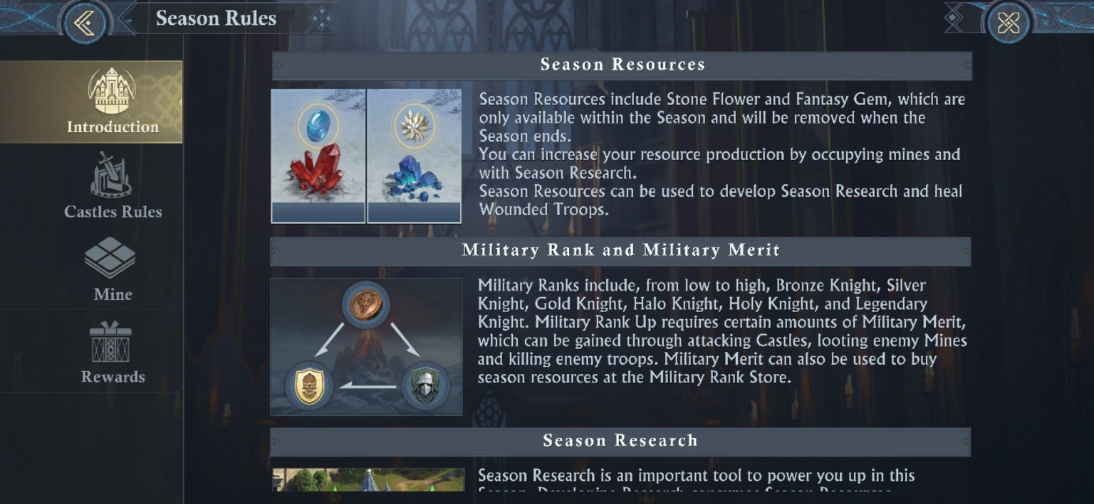
The Basic Rules define the season resources and Military Rank / Merit loop.
Resource / system | USE:
Stone Flower | Season-only resource from Stone Flower Mines; used for Season Research and healing/revival-related season costs.
Fantasy Gem | Season-only resource from Fantasy Gem Mines; also used for Season Research.
Military Merit | Earned through Castle attacks, Mine looting, and enemy troop kills; used for Military Rank progression/store.
Healing Coins | Used by the Season Hospital to heal/revive season Wounded/Lost Troops.
Military Orders | Regenerating currency used for certain spells, exploiting mines, mine renovation, obtaining healing coins, healing looted mines, and mine looting.
Dunestone | Feeds Dunestone Smelting, which turns into Mining Drills and Guild Battletower materials.
Dwarven Coin | Relic Expedition currency used at the Relic Peddler for expedition modification items.

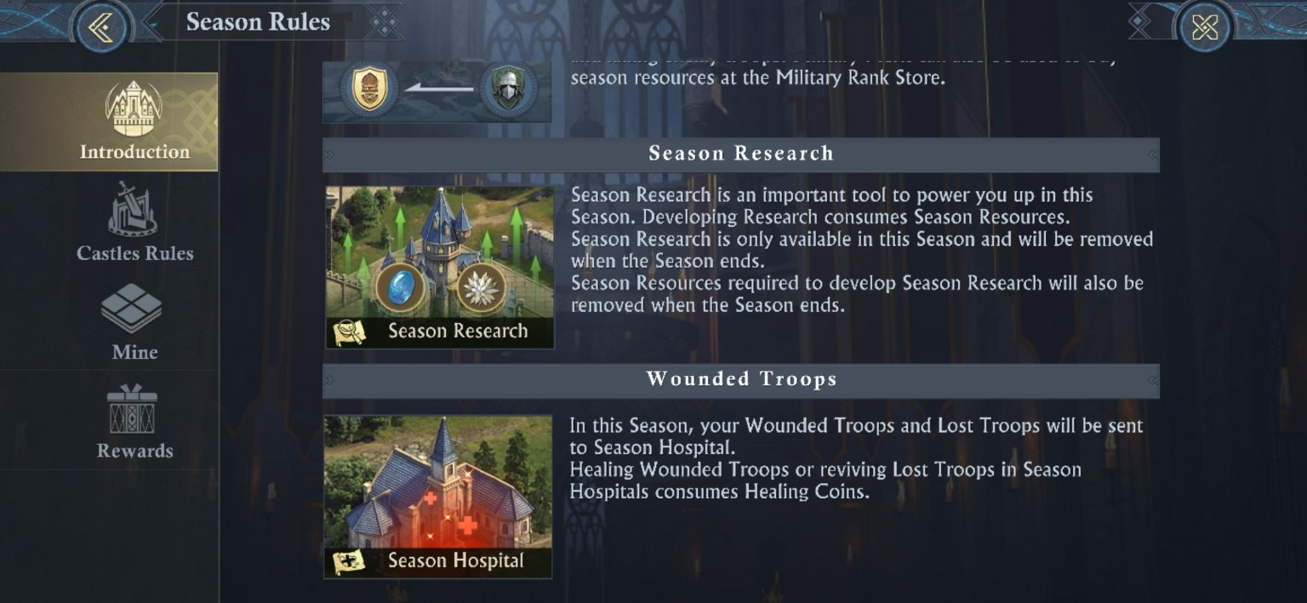
Season Research and the Season Hospital are temporary season systems; their special progression is cleared at season end.

Season Research: the race that pays you back
Research is the season’s main compounding engine. It raises production, Mine capacity, Military Order efficiency, Curse/Illusion Resistance, looting survivability, and combat performance - and the Achievement tab directly rewards how far you push it. The important distinction is that Season 19 has both Regular Season Research and a separate Special Season Research branch called Desert Research: Adventure.
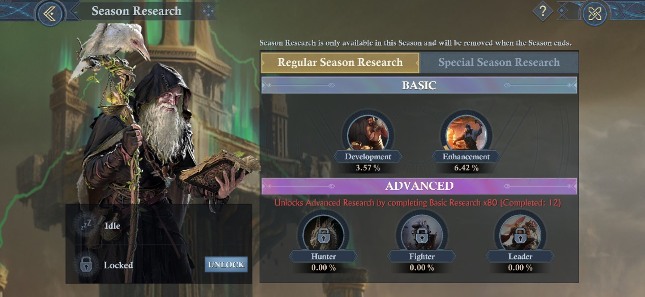
Regular Season Research is split into Basic Development/Enhancement and Advanced Hunter/Fighter/Leader. Advanced Research unlocks after 80 Basic Research completions; the captured screen shows 12 completed at that moment.
Research layer | What the screenshots verify | Planning consequence
Basic - Development | One of the two Regular Basic branches. | Early economy and progression work here also helps build the 80 Basic completions needed for Advanced Research.
Basic - Enhancement | The second Regular Basic branch. | Do not starve it completely: its own Achievement target is 40%.
Advanced - Hunter / Fighter / Leader | Locked until Basic Research has been completed 80 times. | The advanced branches have their own 40% Achievement targets, so opening them early creates more ways to score Research rewards.
Special - Desert Research: Adventure | A separate Special Season Research tree. | Contains Mine economy, active season skills, looting/revival tools, Mirage Defenders, and late compounding production boosts.
[MODERATOR’S PRO-TIP] Unlock Advanced Research without wrecking your economy
The first hard gate is 80 completed Basic Research levels. Favor efficient Development and Enhancement levels that keep Stone Flower/Fantasy Gem income growing while you build that count. Once Hunter, Fighter, and Leader open, you can spread progress across more branches instead of overpaying for a single deep line. If you are below the season-map average (which changes based on who’s in it), start with Hunter so that you can keep up with mines. If above, push hunter for better combat outcomes.

Research Achievements: the Lord of Desert path
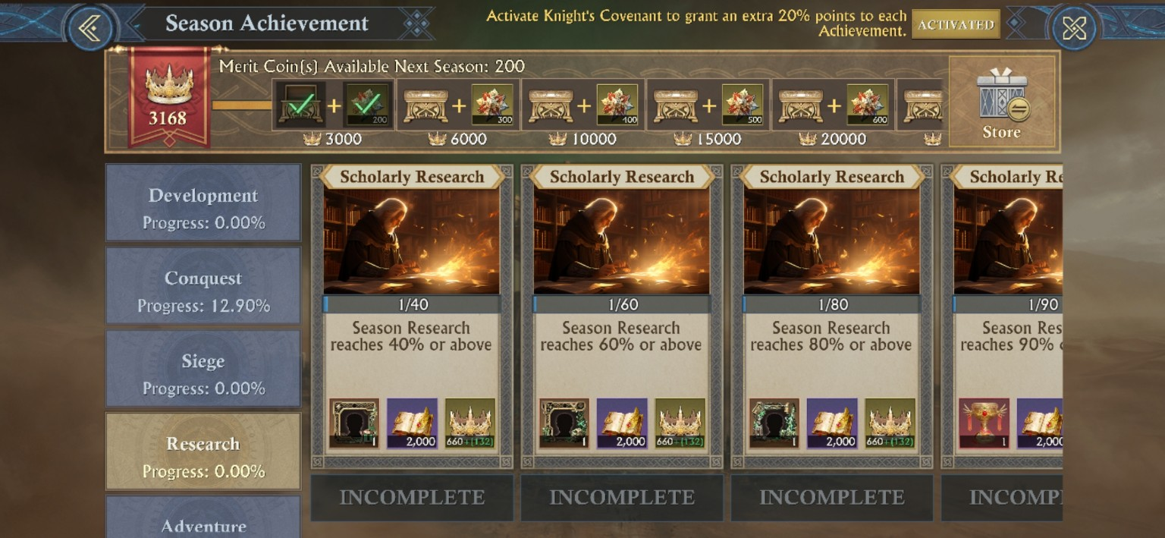
The Research Achievement tab shows the four Scholarly Research thresholds: 40%, 60%, 80%, and 90% total Season Research.
Total Season Research | Reward milestone shown | Why it matters
40% | Desert Drifter Accolade (28 days): Stone Flower + Fantasy Gem production +100/hour | First compounding production milestone.
60% | Desert Lord Accolade (28 days): Stone Flower + Fantasy Gem production +150/hour | Second production step; reach it early enough to fund the next push.
80% | Desert King Accolade (28 days): Stone Flower + Fantasy Gem production +200/hour | Strong final economy boost before the permanent target.
90% | Lord of Desert - S19 permanent Plaudit Skin | Permanent unlock: Troop Attack +500.0%, Troop Defense +500.0%, Troop Health +500.0%.
Each Scholarly Research achievement also shows 2,000 of the Battle Formation book reward and 660 Season Merit points; with Knight’s Covenant active, the screen displays an additional +132 points. The accolade tooltips state that the combined production increase from multiple Season Accolades is capped at +900/hour.
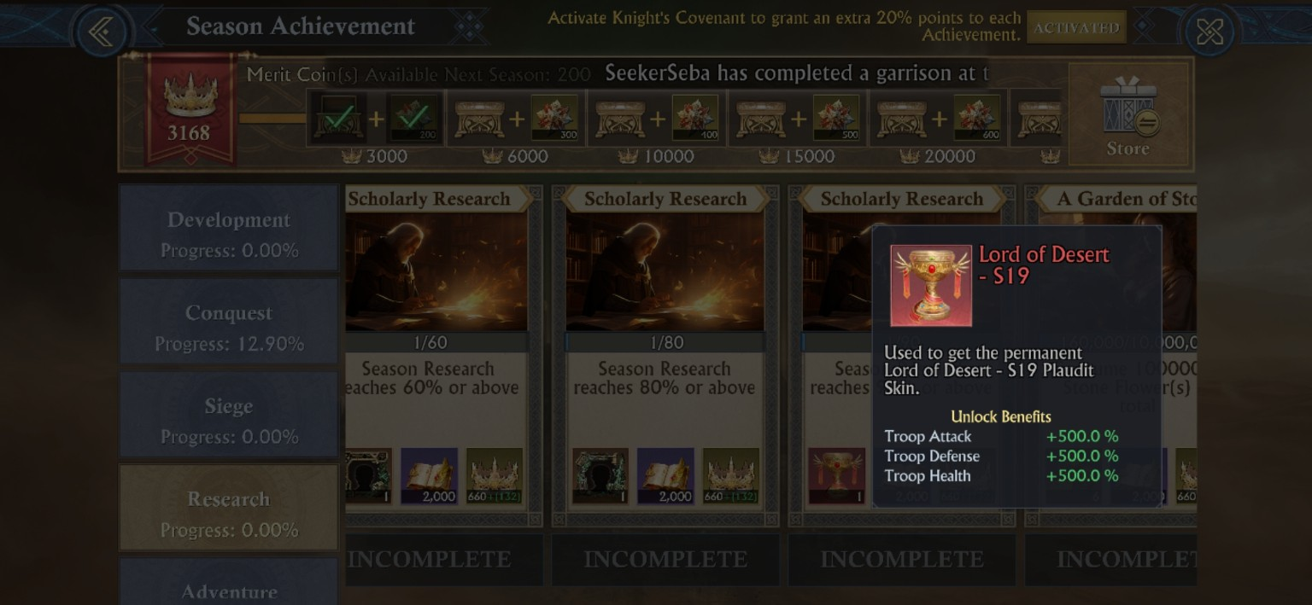
The 90% Scholarly Research reward is the permanent Lord of Desert - S19 plaudit; the tooltip shows +500.0% to Troop Attack, Defense, and Health.

The minimum weekly game plan for the permanent plaudit
[DERIVED] The mathematical floor is about 18.53 Season Research percentage points, per 7 days.
The observed S19 calendar runs from Aug 10 through the Sep 12 Battle of the Capital: 34 calendar days. 90% / 34 = 2.647 percentage points per day, or 18.53 points per 7 days. Because the game does not expose the weighting formula behind the overall Research percentage, the live Research % meter - not a guessed number of nodes - must be treated as the authority.
Checkpoint | Absolute minimum pace | Recommended moderator target | Milestone logic
End of Day 7 | 19% | 20% | Small safety buffer while you build Basic completions and production.
End of Day 14 | 38% | 40% | Collect Desert Drifter and begin earning its +100/hour production bonus.
End of Day 21 | 56% | 60% | Collect Desert Lord; the extra production helps finance the expensive middle tree.
End of Day 28 | 75% | 80% | Collect Desert King before the final week.
Checkpoint | Absolute minimum pace | Recommended moderator target | Milestone logic
End of Day 34 / Capital window | 90% | 90%+ | Claim Lord of Desert - S19. Any delay beyond this point risks missing the permanent plaudit.
[MODERATOR’S PRO-TIP] Use 20 / 40 / 60 / 80 / 90 as your dashboard
The exact mathematical minimum is slightly lower, but the round-number route is easier to police and aligns the middle weeks with the 40%, 60%, and 80% reward breakpoints. Those temporary accolades increase the two Research resources, so hitting them early has a compounding payoff.
ALSO, the only way to be sure to get the plaudit, is to either spend the majority of your Orders looting, or by continually buying all the 499 and 999 diamond season resource packs throughout the season, in addition to specializing your talents for stone/gem production and using Fast Exploitation on your own mines… While making sure your own are not looted often or are healed quickly. One path leverages your own power, while the other leverages the purse.
FOR BEST RESULTS: Focus your talents into stone production and +stone flower drop, during ALL non-combat times and leverage the ‘Eroder’ talent at every opportunity. Branch to gem mines only after getting level 16 mines without the eroder, and only to keep up on research goals.
[CAUTION - PITFALL] “90% Research” is not the same thing as “90% of the visible nodes”
KoA does not reveal the formula that converts completed levels across Regular and Special Season Research into the global percentage. Different nodes also have different rank caps and costs. Do not plan the plaudit by counting icons; check the live Season Research percentage every day.
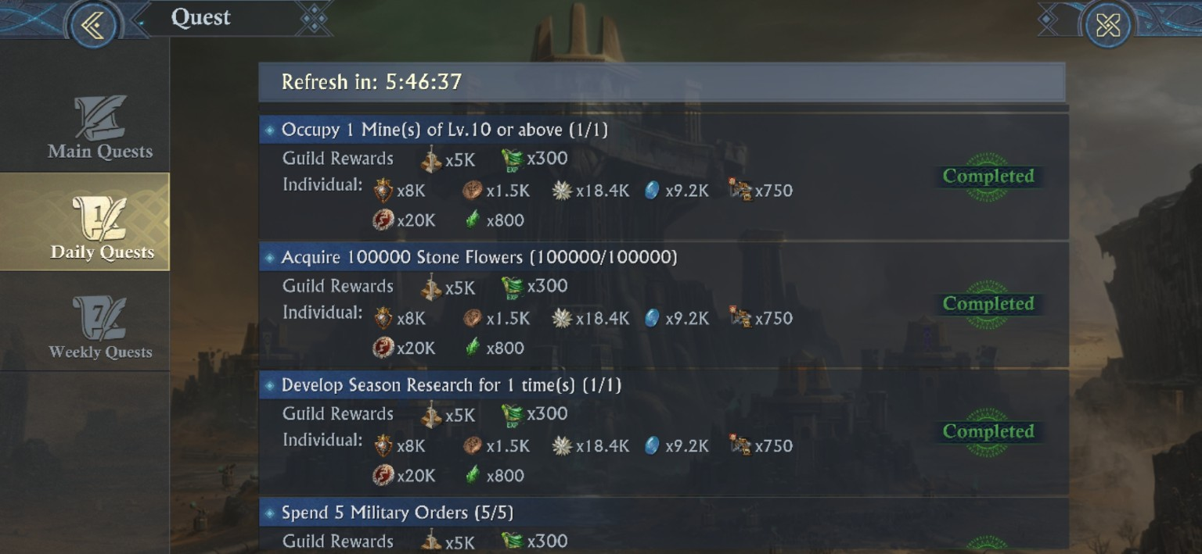
Captured Daily Quest examples: Lv.10+ Mine occupation, 100,000 Stone Flowers, one Season Research development, and Military Order spending all share the same visible individual research-resource bundle.
Captured Daily objective | Requirement shown | Stone Flowers | Fantasy Gems
Ancient Wraiths | Defeat in Endless Trials 1 time | 18.4K | 9.2K
Daily Login | Login 1 time | 18.4K | 9.2K
Dune Raider / Leader | Defeat 3 | 18.4K | 9.2K
Mine occupation | Occupy 1 Mine of Lv.10 or above | 18.4K | 9.2K
Stone Flower acquisition | Acquire 100,000 Stone Flowers | 18.4K | 9.2K
Season Research | Develop Season Research 1 time | 18.4K | 9.2K
Military Orders | Spend 5 | 18.4K | 9.2K
Ore Drill | Use Ore Drill 3 times | 18.4K | 9.2K
Relic Expedition | Conduct 1 time | 18.4K | 9.2K
Secret Bounties | Submit 3 completed Bounty Quests | 18.4K | 9.2K
[DERIVED - QUEST ECONOMY] Captured Daily set = 184K Stone Flowers + 92K Fantasy Gems per day
Ten unique Daily objectives, and every one in the screenshot above shows 18.4K Stone Flowers + 9.2K Fantasy Gems. If all ten are available and completed in the same daily cycle, that is 184,000 Stone Flowers and 92,000 Fantasy Gems before Mine production, Accolades, Fast Exploitation, looting, or Main/Weekly quest rewards. These rewards increase over the course of the season, but are essential, due to the Dunestone you receive.
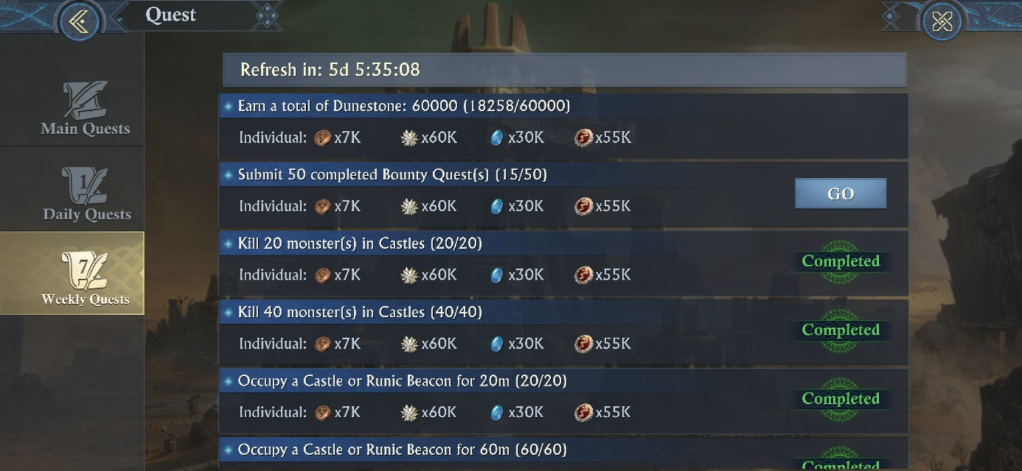
Week objectives directly reward Castle participation: 20/40 Castle-monster kills and 20/60 minutes occupying a Castle or Runic Beacon sit in the same Weekly reward track as economy tasks.
Weekly objective group | Captured thresholds | Stone Flowers / task | Fantasy Gems / task
Attendance / exploration | 4 logins; Sacred Tree Antiquity x2 | 60K | 30K
Mine economy | Loot Mines x5; build Ore Drills x180; Smelt x55; earn 60,000 Dunestone | 60K | 30K
Secret Bounties | Submit 50 completed Bounty Quests | 60K | 30K
Castle monsters | Kill 20; kill 40 | 60K | 30K
Castle / Beacon duty | Occupy 20m; occupy 60m | 60K | 30K
Season-map PvP | Defeat 5K / 10K / 40K / 80K / 120K / 240K / 480K troops | 60K | 30K
[DERIVED - WEEKLY QUEST ECONOMY] Captured Week set = 1.08M Stone Flowers + 540K Fantasy Gems ---But not all week quest rewards provide the same amount.
Then, there are 18 unique Week objectives. At the visible 60K Stone Flowers + 30K Fantasy Gems per objective, the captured set totals 1,080,000 Stone Flowers and 540,000 Fantasy Gems. The war tasks are especially valuable because the same actions also advance neutral-Castle victory engines: monster kills feed durability, Castle/Beacon occupation feeds occupation demolition, and troop defeats reward active PvP.
[MODERATOR’S PRO-TIP] Stack quest progress onto the fights you already need to win
Do not treat the Week List as eighteen separate chores to be done whenever. Faster completion is best, but saving time is good too, especially when running multiple accounts. Schedule the 20/40 Castle-monster kills and 20/60 minutes of Castle/Beacon duty during real Castle windows; do Mine looting when your War Preparation/Military Order plan can absorb it; use planned Drill construction and Smelting to satisfy both Guild logistics and the Weekly counters. The weaker-coalition strategy gets better when participation is being paid twice: once in battle impact, and once in research resources.
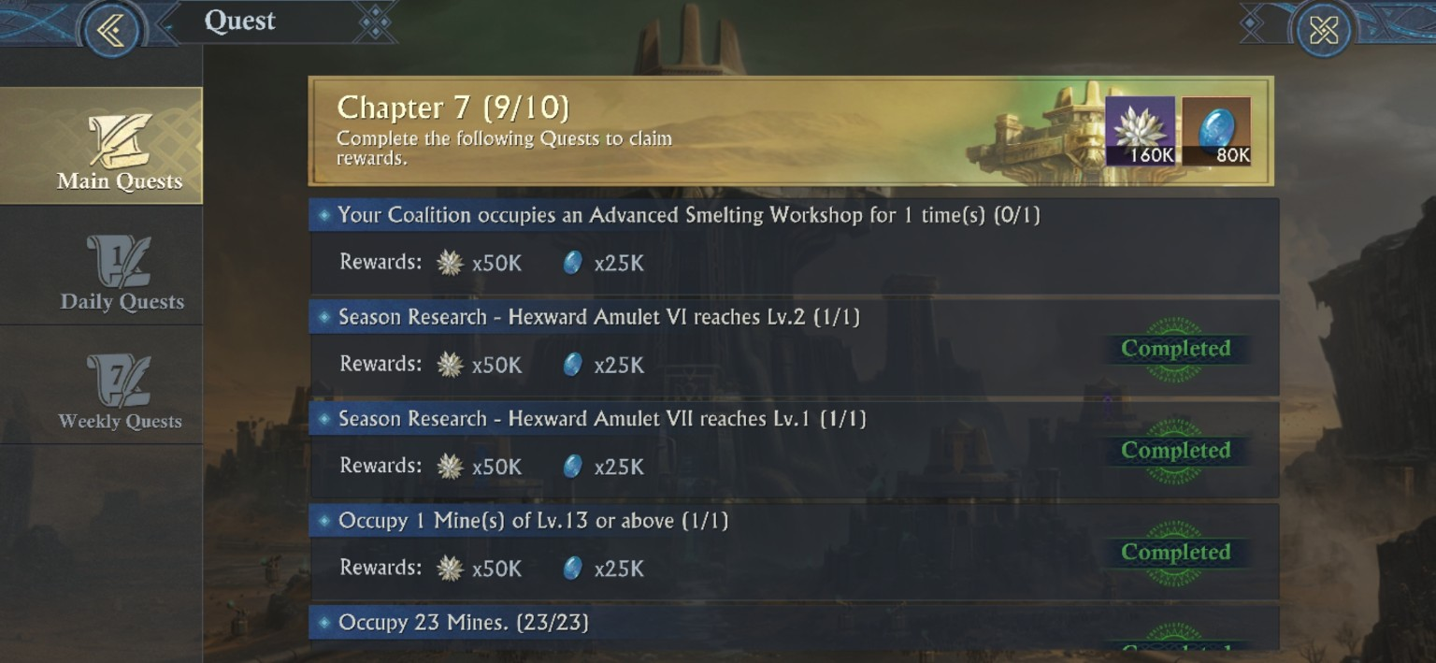
Chapter 7 links strategic map progress directly to Research: Advanced Smelting Workshop occupation, Hexward Amulet VI/VII thresholds, high-level Mine occupation, etc.
Chapter 7 objective | Requirement shown | Stone Flowers | Fantasy Gems
Strategic Castle | Coalition occupies an Advanced Smelting Workshop x1 | 50K | 25K
Season Research | Hexward Amulet VI reaches Lv.2 | 50K | 25K
Season Research | Hexward Amulet VII reaches Lv.1 | 50K | 25K
High-level Mine | Occupy 1 Mine of Lv.13 or above | 50K | 25K
Mine count | Occupy 23 Mines | 50K | 25K
Dune Raiders | Defeat 130 Raiders / Leaders | 50K | 25K
Military Orders | Spend 200 | 50K | 25K
Ore Drill | Construct 240 Ore Drills total | 50K | 25K
Smelting | Conduct Dunestone Smelting 120 times total | 50K | 25K
Secret Bounties | Submit 120 completed Bounty Quests | 50K | 25K
[DERIVED - MAIN QUEST ECONOMY] Chapter 7 visible total = 660K Stone Flowers + 330K Fantasy Gems
All ten visible Chapter 7 objectives show 50K Stone Flowers + 25K Fantasy Gems, and the Chapter completion banner shows another 160K + 80K. That makes the Chapter 7 package 660K Stone Flowers and 330K Fantasy Gems if all ten objectives use the shown bundle. More important than the sum is the sequencing clue: the Main Quest itself requires Hexward Amulet VI Lv.2 and Hexward Amulet VII Lv.1, so Curse/Illusion Resistance is not really optional.
[MODERATOR’S PRO-TIP] Recurring quest budget can finance the 20 / 40 / 60 / 80 / 90 Research dashboard
If the captured 10-task Daily set recurs unchanged for seven days, it yields 1.288M Stone Flowers + 644K Fantasy Gems. Add the captured 18-task Weekly set and the visible recurring-week budget becomes 2.368M Stone Flowers + 1.184M Fantasy Gems before Mines, Main Quests, Accolades, Fast Exploitation, looting, or purchases. That does not tell us how many global Research percentage points the resources buy, but it gives the weekly plaudit plan a concrete economy target: finish routine quests first, then spend the resulting resources toward the live 20/40/60/80/90 pace meter.

Branch-specific Research achievements
Achievement card | Threshold shown | Strategic use
Rapid Development | Development reaches 50% or above | A reason to keep the economy/basic branch moving instead of rushing only combat lines.
Advanced Enhancement | Enhancement reaches 40% or above | Pairs naturally with the 80-Basic-completion unlock push.
Rogue Tactics | Hunter reaches 40% or above | Advanced branch objective after the 80-Basic gate.
Technological Power | Fighter reaches 40% or above | Advanced branch objective after the 80-Basic gate.
Glorious Leader | Leader reaches 40% or above | Advanced branch objective after the 80-Basic gate.

Research timing versus the War Preparation Contest
The War Preparation Contest (achievement) opens with Development Research Progress in Round 1, repeats Development in Round 2, then shifts to Enhancement Research in Rounds 3 and 4 before an Exploration Points round. Tier rewards are issued when the displayed progress threshold is met, while rank rewards are settled at the end of the event.
[MODERATOR’S PRO-TIP] Bank only the Research you can safely delay
If you care about War Preparation ranking, hold finished-but-not-urgent Development or Enhancement upgrades for the matching round. Do not let event timing drag you below the 20/40/60/80/90 plaudit pace or leave critical Curse/Illusion Resistance unfinished before a new map/mine tier becomes available. Ultimately, your resistance/mine level will force faster hunter/fighter research to happen as the season progresses, but you should try to keep up on the hunter/fighter research in order to help your coalition capture key castles/fortresses.

Combat Research: the Castle-race multipliers
The Advanced Fighter, Hunter, and Leader branches contain the Research that changes Castle Scramble math directly. These are not just account-strength bonuses: they increase occupation output, monster contribution, Military Merit, or the staying power of the Leaders doing the heavy lifting… Especially the United Attack/United Defense research which stack and scale.
Research | Captured progression | Castle-war impact
Strong Garrison I | Joining a Castle, Beacon of Illusion, or Illusion Tower garrison: Occupation Points +2% / +4% / +6% / +8% / +10%. The effect is stackable by garrison joiners. | The key manpower multiplier for Castle/Beacon occupation. More qualifying joiners means a larger occupation engine.
Strategic Mind I | Leading the garrison of a Castle, Beacon of Illusion, or Illusion Tower: Occupation Points +4% / +8% / +12% / +16% / +20%. | Leader-side occupation Research. It can operate alongside Strong Garrison joiners; use a researched lead and researched joiners together.
Achieved Leader I | Military Merit from garrisoning Beacons of Illusion and Castles +4% / +8% / +12% / +16% / +20%. | Does not replace durability pressure, but improves the personal Merit return for Lords assigned to objective duty.
Veteran Hunter I | Castle Monster Occupation Points +10% / +20% / +30% / +40% / +50%; Military Merit +5% / +10% / +15% / +20% / +25%. | Turns active monster hunters into a direct durability engine. The live Lv.20 and Lv.30 captures below match the max +50% durability effect exactly.
Deadly Arms I | Damage dealt when attacking Castle and Mine monsters +3% / +6% / +9% / +12% / +15%. | Shortens monster kill cycles, making the Veteran Hunter path easier to sustain with many active players.
United Attack/Defense I | While joining rallies or garrisoning Castles/Beacons, troop damage received -0.4% / -0.8% / -1.2% / -1.6% / -2.0%; the panel shows a 20% maximum decrease (Defense); or increase, on the Attack side . | Survivability Research for the people feeding rallies and garrisons; it helps keep the occupation engine staffed.
[MODERATOR’S PRO-TIP] Research is a manpower multiplier
A coalition with more active Lords can convert participation into durability pressure. Strong Garrison (SG) rewards populated Castle/Beacon garrisons; Strategic Mind rewards the lead; Veteran Hunter (VH) rewards every successful monster kill. A stat-stronger opponent can still be out-produced, if the weaker side has enough researched people continuously filling those jobs. This is where DISCIPLINE and COMMUNICATION matters. You have to make sure those with SG are getting in, while also sending just the right amount of troops so that all of the people with SG can get in.
--The same is true for United Attack/Defense. The more people who have it, the stronger a garrison or rally will be, but this requires everyone being forthcoming with this info and a leader strong enough to force compliance when others inevitably do not listen or care.
[CAUTION] Do not wait until the fight happens (or right before it) in order to gain player research info or inform of the battle plan and compliance expectations.

Special Season Research: Adventure tree - captured utility and active skills
Research | Captured levels / effect | Operational note
Hexward Amulet I | 3 ranks: Curse Resistance +1 / +2 / +3 | The first explicit Research source of Curse/Illusion Resistance captured.
Fast Exploitation | 1 rank: immediately gains resources equal to 20h of the selected controlled Mine’s Basic Production; 5 Military Orders; 5m cooldown | A major burst-economy button.
Speed Up Exploitation I | 2 ranks: Fast Exploitation cooldown -30s / -60s | Directly increases how often the burst can be used.
Speed Up Exploitation III | 4 ranks: Fast Exploitation cooldown -30s / -60s / -90s / -120s | Later cooldown tier; the captured rank table reaches a 120-second reduction within this node.
Extra Queue | 1 rank: Season Research queue +1 | One of the highest-leverage tempo unlocks because it lets two Season Research jobs run.
Rapid Healing | 1 rank: instantly obtain 200,000 Healing Coins; 3 Military Orders; 23.5h cooldown | Daily-ish Healing Coin injection.
Extra Healing | 3-rank node shown; Rank 1 preview: +30% Healing Coins when using Rapid Healing; first-rank cost 848K Fantasy Gems | Requires Fantasy Gem Finder Boost III Lv.5 in the captured prerequisite panel.
Mine Recovery | 1 rank: instantly repairs a looted Mine and restores production efficiency; 1 Military Order; 5m cooldown | Lets an important Mine return to full output immediately.
Mine Renovation | 1 rank: instantly levels an owned Mine by 1; each Mine can only be upgraded to Lv.15 and cannot exceed the max level of your owned Mine; 5m cooldown | Military Order cost rises with Mine level.
Mirage Defenders | 1 rank: garrison a non-garrisoned Individual Mine; 3 Military Orders; 24h duration; 23.5h cooldown | Mirage Defenders take an extra 35% damage during combat.
Mirage Shield I | 1 rank: reduces the extra damage received by Mirage Defenders by 10% | Mitigates the Mirage Defender penalty.
Mirage Shield II | 1 rank: reduces the extra damage received by Mirage Defenders by 10%; first-rank cost 4.3M Stone Flowers | Second captured Shield node; prerequisite panel points back to the preceding Hexward Amulet branch at Lv.3.
Kickoff Party | 1 rank: immediately gain 4h of production from occupied Mines; 20 Military Orders; 23.5h cooldown | Late-tree bulk collection skill.
Mobilization Boost I | 1 rank: Kickoff Party Military Order consumption -10 | Cuts the captured 20-Order Kickoff Party cost in half.

Special Season Research: Mine production, storage, and capacity
Research | Captured progression | Notes
Stone Flower Finder I | +400 / +600 / +800 / +1,200 / +1,600 per hour | Flat production progression.
Fantasy Gem Finder I | +400 / +600 / +800 / +1,200 / +1,600 per hour | Mirrors Stone Flower Finder I.
Stone Flower Storage I | +500,000 / +5,000,000 / +10,000,000 / +20,000,000 storage | Four captured ranks.
Fantasy Gem Storage I | +500,000 / +5,000,000 / +10,000,000 / +20,000,000 storage | Mirrors Stone Flower Storage I.
Land Manager I | Mine limit +1 / +2 / +3 | Direct Mine-cap growth.
Fast Exploitation Boost I | Fast Exploitation Production +4% / +8% / +12% / +16% / +20% | Five ranks.
Fast Exploitation Boost III | Fast Exploitation Production +5% / +10% / +15% / +20% / +25% | Five captured ranks; a stronger later boost tier than Boost I.
Fantasy Gem Finder Boost I | +5% / +10% / +15% / +20% / +25% | Applies only to production from Mine, Research, and Empyrean Talent.
Fantasy Gem Finder Boost III | +5% / +10% / +15% / +20% / +25% | Five captured ranks; applies only to production from Mine, Research, and Empyrean Talent.
Stone Flower Finder Boost I | +5% / +10% / +15% / +20% / +25% | Same source restriction as the Fantasy Gem version.
Stone Flower Finder V / Fantasy Gem Finder V | +800 / +1,600 / +2,400 / +3,200 / +4,000 per hour | Late flat-production tier.
Stone Flower Finder VI / Fantasy Gem Finder VI | +1,000 / +2,000 / +3,000 / +4,000 / +5,000 per hour | Higher late flat-production tier.

Special Season Research: Mine looting, revival, and protection
Research | Captured progression | What it changes
Looting License | Unlocks Mine Looting; grants 40% Basic Revival Value to troops wounded while looting | Follow-up Looting Will research raises revival further.
Looting Will I | 6% / 12% of troops wounded while looting Mines are revived | Two ranks.
Looting Will II | 6% / 12% / 18% / 24% revived | Four-rank later tier.
Defending Will I | 6% / 12% of troops wounded defending against Mine looters are revived | Two ranks.
Defending Will II | 6% / 12% / 18% / 24% revived | Four-rank later tier.
Looting Morale I | Loot Attacker’s Morale +10 / +20 | Two ranks.
Looting Morale II | Loot Attacker’s Morale +8 / +16 | Two-rank later tier; do not assume the values stack identically with Morale I without the live stat panel.
Secret Storehouse I | Mine production cut caused by looting reduced by 5% / 10% / 15% | Three ranks.
Secret Storehouse II | 5% / 10% / 15% reduction | Another three-rank tier.
Loot Spoils I | Resources gained from successful Mine looting +30% / +60% | Two ranks.
Loot Expansion I | Daily max resources looting limit +40% / +80% / +120% / +160% / +200% | Five ranks.

Late-tree cost markers and the economy wall
Research node | First-rank cost shown | First-rank effect / prerequisite clue
Extra Healing | 848K Fantasy Gems | 3-rank node; Rank 1 adds +30% Healing Coins from Rapid Healing; requires Fantasy Gem Finder Boost III Lv.5.
Land Manager IV | 944K Fantasy Gems | Mine limit +1; requires Extra Healing Lv.3.
Fast Exploitation Boost IV | 1.0M Fantasy Gems | Fast Exploitation Production +5%; requires Land Manager IV Lv.3.
Fantasy Gem Finder Boost IV | 1.2M Fantasy Gems | Fantasy Gem Production +8%; requires Fast Exploitation Boost IV Lv.5.
Stone Flower Finder Boost IV | 1.2M Fantasy Gems | Stone Flower Production +8%; requires Fast Exploitation Boost IV Lv.5.
Hexward Amulet VII | 1.6M Stone Flowers | 3-rank node shown; Rank 1 preview Curse Resistance +1; requires Fantasy Gem Finder V Lv.5.
Mirage Defenders | 2.0M Stone Flowers | 1 rank; garrisons an un-garrisoned Individual Mine for 24h; 3 Military Orders; 23.5h cooldown; defenders take +35% damage.
Looting Will II / Looting Morale II / Defending Will II | 2.1M Stone Flowers each | First ranks shown: 6% looting revival / Loot Attacker Morale +8 / 6% defending revival; each branch requires Mirage Defenders Lv.1.
Mirage Shield I | 3.2M Stone Flowers | 1 rank; reduces the extra damage received by Mirage Defenders by 10%.
Kickoff Party / Secret Storehouse II / Mirage Shield II | 4.3M Stone Flowers each | Captured first-rank effects: gain 4h occupied-Mine production / reduce loot production cut by 5% / reduce Mirage Defender extra damage by 10%.
Hexward Amulet X | 4.7M Stone Flowers | 3-rank node shown; Rank 1 preview Curse Resistance +1; requires Kickoff Party Lv.1 and Secret Storehouse II Lv.1.
Loot Spoils II | 1.6M Fantasy Gems | Resources from successful Mine looting +30%; requires both Finder Boost IV branches Lv.5.
Land Manager V | 1.8M Fantasy Gems | Mine limit +1; requires Loot Spoils II Lv.3.
Fast Exploitation Boost V | 1.8M Fantasy Gems | Fast Exploitation Production +6%; requires Land Manager V Lv.3.
Fantasy Gem / Stone Flower Finder Boost V | 2.0M Fantasy Gems each | Rank 1 is +10%; each branch opens at Fast Exploitation Boost V Lv.1.
Extra Healing II | 3.2M Fantasy Gems | 5 ranks: Rapid Healing bonus +30% / +60% / +90% / +120% / +150%.
Mobilization Boost I | 5.9M Fantasy Gems | Kickoff Party Military Order cost -10; requires Extra Healing II Lv.5.
[MODERATOR’S PRO-TIP] Finder Boost V breaks the earlier “finish the middle node first” pattern
Both Finder Boost V branches show Fast Exploitation Boost V Lv.1 as their prerequisite, not Lv.5. If Fantasy Gem or Stone Flower income is the bottleneck, you can open the appropriate production branch after only one level of Fast Exploitation Boost V and return to finish the middle node later… But, don’t ignore it, especially if you are not a daily looter of enemy mines, as you will need the extra boost to get the season plaudit.
[PLEASE NOTE] Additional Special Research nodes are visible, but their effect panels are not included in the tables above.
Many late Special Research completions reward Empyrean EXP +20K. The table above records first-rank costs only; it is not a total cost estimate for maxing each node.

Military Orders: the quiet action gate
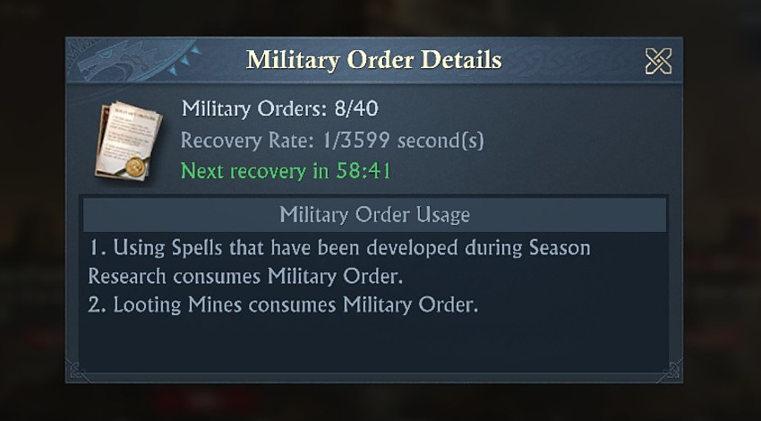
Observed Military Order panel: 8/40, recovering one Order in roughly one hour. Order recovery time can shorten based on Season Research.
[MODERATOR’S PRO-TIP] A full Order bar means WASTED ACTIONS. Avoid this!
Players start with an initial 40-Order cap, and about one Order recovered per hour. If you sit capped for hours, the game will not bank/store those lost orders for you. Spend with purpose, but do not let the bar live at 40 while valuable loot or season spells are available.

Season Covenant: Convenience That Changes the Pace
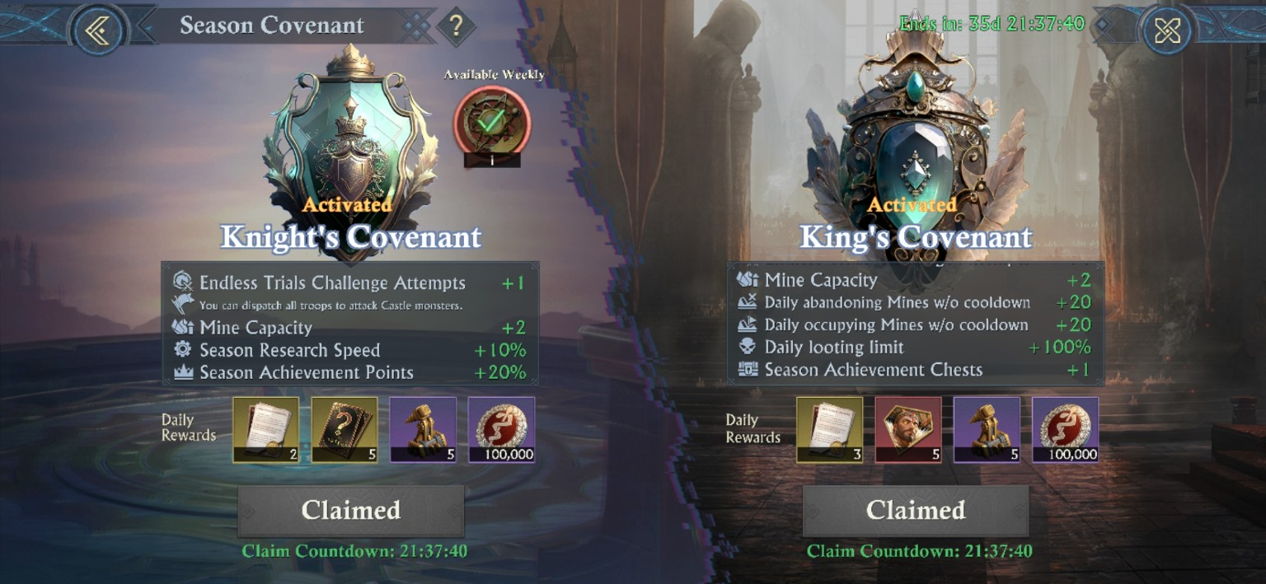
Season Covenant benefits shown as activated; the captured Knight’s and King’s benefits are summarized below.
Covenant | Visible benefits (in screenshots)
Knight’s Covenant | +1 Endless Trials attempt; all troops can be dispatched against Castle monsters; Mine Capacity +2; Season Research Speed +10%; Season Achievement Points +20%.
King’s Covenant | +1 Endless Trials attempt; Mine Capacity +2; +20 daily Mine abandons without cooldown; +20 daily occupations without cooldown; daily looting limit +100%; Season Achievement Chests +1.

Why the achievement numbers look boosted after getting the Covenants:
The Achievement screen itself says Knight’s Covenant grants an extra 20% points to each Achievement, so the +132 bonus shown beside a 660-point objective is internally consistent.

Season Achievements are not side content
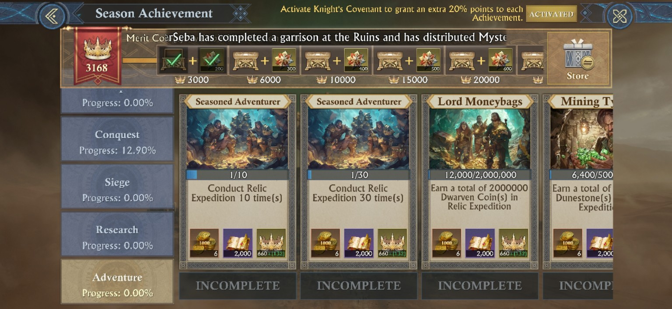
Season Achievement categories: Development, Conquest, Siege, Research, and Adventure. The milestone track is visible at 3,000 / 6,000 / 10,000 / 15,000 / 20,000 points.
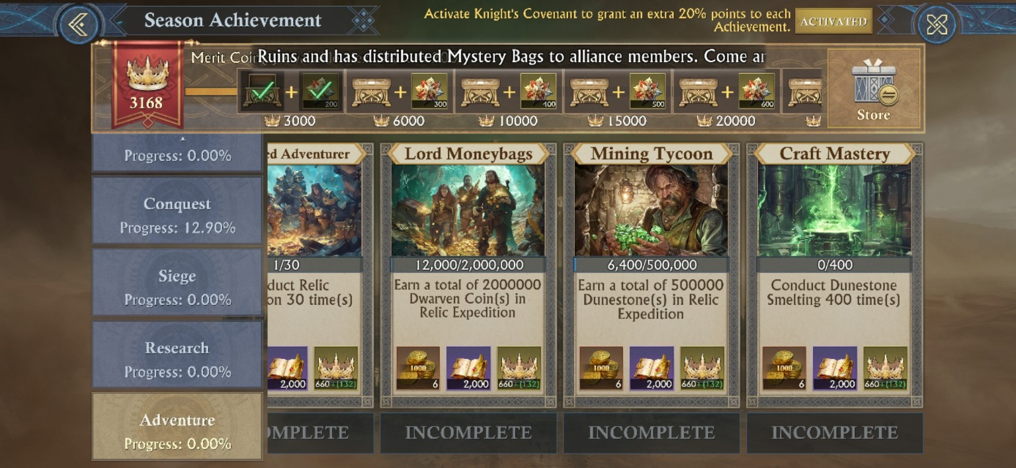
Adventure objectives visibly track Relic Expedition, Dwarven Coins, Dunestone, and Smelting.
Visible Adventure objective | Requirement shown
Seasoned Adventurer | Conduct Relic Expedition 10 times; a later tier shows 30 times.
Lord Moneybags | Earn a total of 2,000,000 Dwarven Coins in Relic Expedition.
Mining Tycoon | Earn a total of 500,000 Dunestones in Relic Expedition.
Craft Mastery | Conduct Dunestone Smelting 400 times.

[MODERATOR’S PRO-TIP] Do not wait until the last week to “do achievements”
Several Adventure objectives are simply counters for things you already need to do: Expeditions, coin collection, Dunestone collection, and Smelting. Start those loops early and the Achievement track becomes a by-product of good season play, instead of a late grind… And let’s be honest… NOONE likes ‘The Grind’!

ZONES, WALLS, DEFENDERS, DURABILITY
Part III - Castle Warfare Is a Sequence

Castle fights make more sense when you think of them as a chain of permissions/events. First you place a Sword Tower, then you break the outer layer, then you win the troop fight (castle PvE or PvP), and then durability decides ownership (within the Sword Tower timer). Skip one link and the game simply will not let you do the next thing.

The battlefield zones
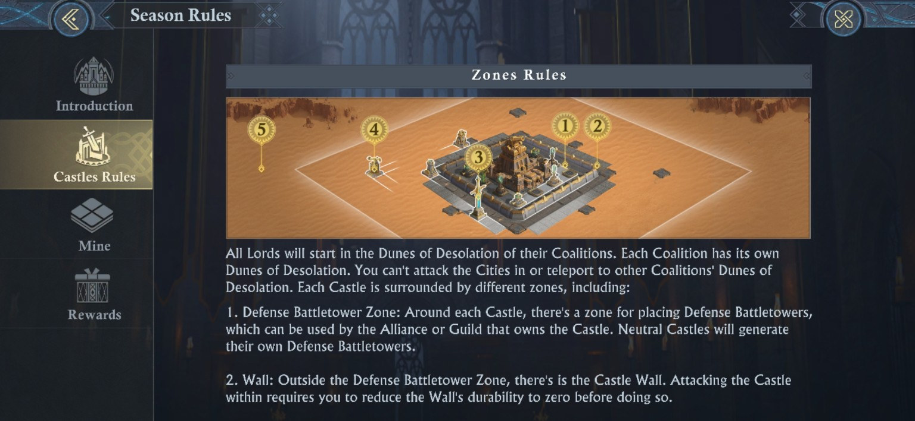
The Castle area is divided into Defense Battletower, Wall, Outpost, War, and Safe-zone logic. Neutral Castles generate their own Defense Battletowers.
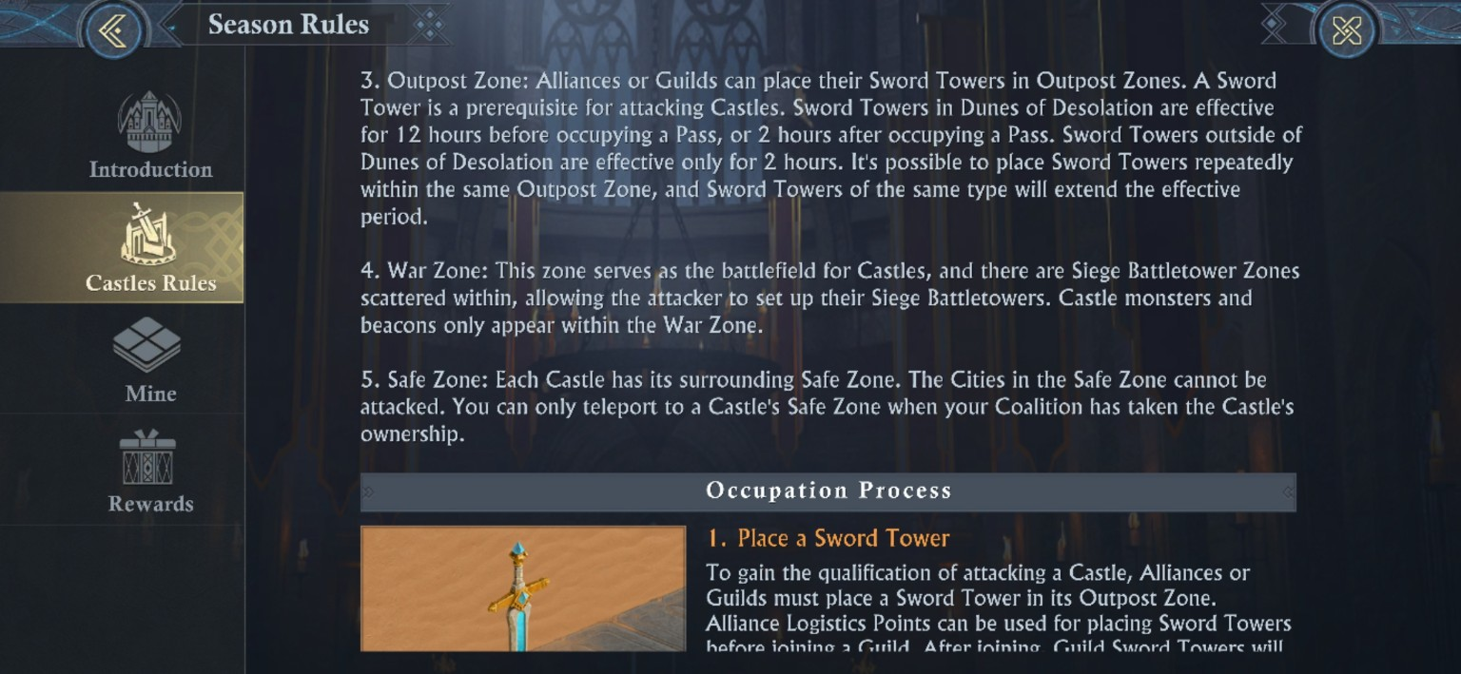
Outpost Zones host Sword Towers; War Zones host Siege Battletower grids and Castle combat objects. Safe Zones protect Cities.
Zone / layer | What happens there
Outpost Zone | Place Alliance or Guild Sword Towers to create attack eligibility. Sword Tower duration rules differ between the Dunes and later regions.
Wall | Must be reduced to zero before the interior Castle can be attacked.
Defense Battletower Zone | Defense Battletowers protect the Castle and allied structures. Neutral Castles generate their own.
War Zone | Main battlefield. Siege Battletower grids, monsters, and beacons appear here.
Safe Zone | Cities cannot be attacked. Teleport access depends on Coalition Castle ownership.

Occupation flow - the four-step checklist
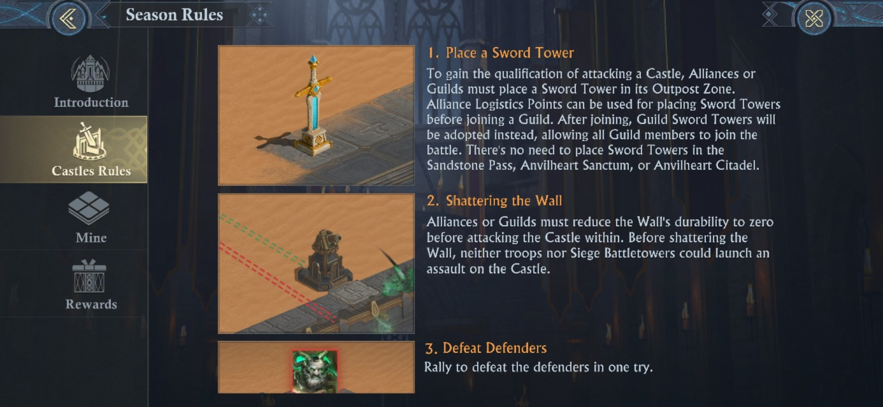
Occupation Process: Sword Tower -> Wall -> one-Rally defender clear. Certain Capital/Pass objectives are exceptions to the Sword Tower prerequisite.
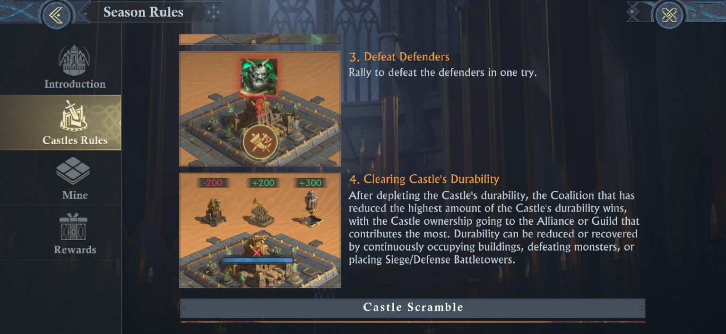
After defenders fall, Castle durability becomes the race. The Coalition contributing the most durability reduction wins, with Alliance/Guild ownership resolved by contribution rules.
Step | What your group must accomplish
1. Establish access | Place the required Sword Tower in the Outpost Zone unless the objective is one of the stated exceptions.
2. Break the Wall | Reduce Wall durability to 0. Siege Battletowers and troops cannot assault the Castle interior before this.
3. Beat defenders | The defender force must be defeated in one Rally.
4. Win durability | Reduce Castle durability. Coalition and Alliance/Guild contribution determines final ownership.

[MODERATOR’S PRO-TIP] Assign jobs before the first march lands
A clean Castle hit has somebody watching Sword Tower time, somebody directing wall pressure, somebody building Siege Battletowers, and somebody calling the defender Rally. If everybody waits for the red march line before deciding roles, you are already too late. Set your roles ahead of time, make sure everyone knows who to look to for LEGIT rallies, and that everyone knows what the battle-plan(s) is/are before fighting!

Contested Neutral Castles: Four Paths to Zero Durability!
Once the neutral defenders are cleared, the fight stops being a single-garrison contest and becomes a durability race. The Castle falls when its durability reaches zero; when more than one attacking Coalition is involved, demolition contribution determines which Coalition wins the neutral Castle. In practice, there are four tactical engines that can drive that race. The game records them in three accounting buckets because Castle occupation and Beacon occupation are both counted as occupation. The live map labels the four side objectives Runic Beacons, while the Research panels refer to the same garrison objective class as Beacons of Illusion.
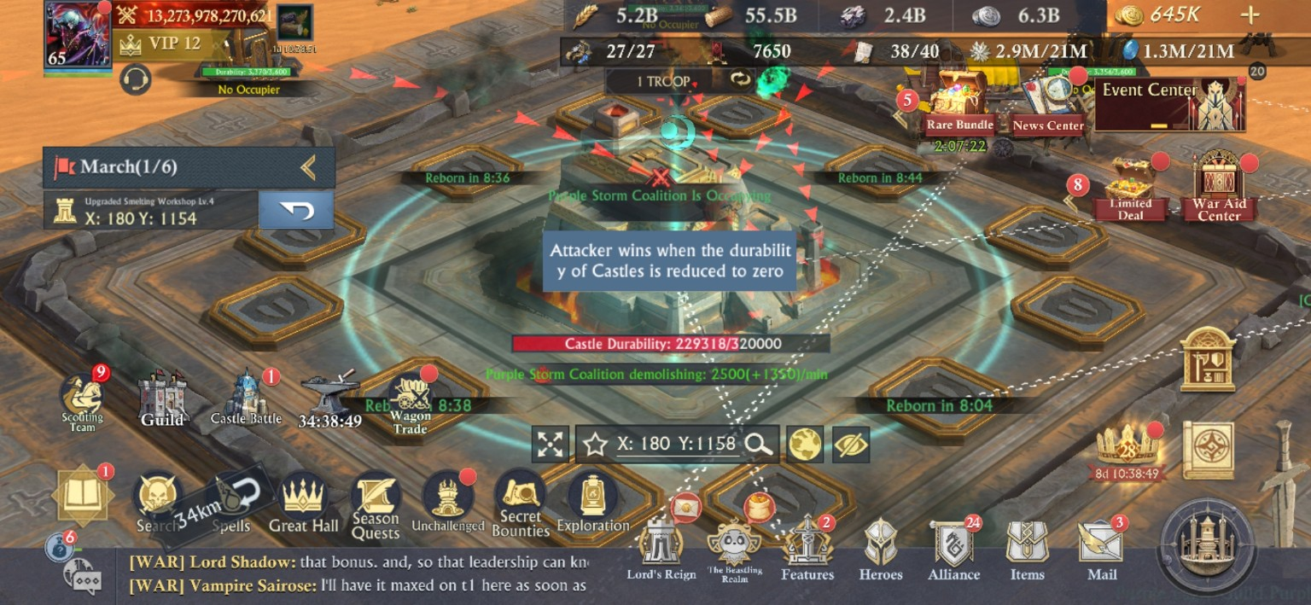
Live Castle occupation snapshot: 320,000 total durability in this Castle, 2,500/min base occupation, and a +1,350/min occupation-Research bonus for 3,850/min total Castle occupation pressure.

Victory path | Direct durability engine | How to run it
1. Castle-Hold Anchor | Hold the Castle itself. Captured base: 2,500 durability/min before garrison bonus or defensive suppression. | Put the best leader on the objective, fill with Strong Garrison joiners, and keep the position alive with coordinated rallies. Strategic Mind boosts the lead; Strong Garrison multiplies the joiners.
2. 3 or 4-Beacon Net | Three or Four Runic Beacons surround the Castle, depending on castle level. Captured base: 500/min each | Spread enough researched players to hold multiple Beacons without abandoning the Castle. Strong Garrison applies to Beacon garrison joiners too. A manpower-rich coalition can win this layer even when it cannot dominate every direct troop clash.
3. Siege Battletower Supremacy | Rumblebomb Launchers, Rockthrowers, and Dunestone Cannons add a separate Siege Battletower demolition stream. | Keep Siege towers alive, clear defensive towers, and staff tower garrisons. Two or more friendly players per Battletower provide +20.0% Effect Efficiency (damage or healing).
4. Monster-Hunter Swarm | Every Castle Monster kill is a discrete durability event. Kills by members of the Guild that owns the Castle recover durability; kills by other players remove durability. | Run high-volume hunters with Veteran Hunter and Deadly Arms. Each Castle has Lv.20 and Lv.30 monster targets. The Lv.20 Sentry Cannon is 80 base durability effect; Lv.30 Mechanical Skullcrusher is 110. Max Veteran Hunter I raises those captured examples to 120 and 165 respectively. Each Lord has a 15-attempt pool, with 1 attempt restored every 20 minutes.
[MODERATOR’S PRO-TIP] The strongest plan is a hybrid, not a lane choice
Castle occupation, Beacons, Siege Battletowers, and monster kills can all operate at the same time. Assign people by role before the fight starts: rally lead, Strong Garrison joiners, Beacon teams, tower crews, monster hunters, and a caller watching recovery/defensive towers and the timings. The side that keeps all four engines running at the same time, forces the opponent to answer four different problems at once. This continuous pressure can force a win to a weaker coalition, provided the communication and leadership is present, and the weaker coalition has enough players online for each fight to out-perform the stat-stronger coalition.

Best plan for a weaker Coalition: split the battlefield
A weaker Coalition should not turn the battle into one giant center-garrison stat check. The best default is to anchor on the four Beacons (MOST contested castles will have 4), use Castle Monsters as a participation-driven burst engine, keep Siege Battletowers producing a separate demolition stream, and contest the Castle itself opportunistically. That forces the stronger side to defend five occupation objectives while also answering towers and monster pressure.
Priority | Assignment | Why it favors the weaker side
1. Four-Beacon anchor | Treat the four Beacons as the default occupation network. Staff them with Strong Garrison joiners and researched leaders where possible. | Four clean Beacons total 2,000/min versus the Castle's 2,500/min base, while forcing the enemy to split across four side objectives instead of one Mega Garrison fight.
2. Monster burst | Start Castle windows with hunters at 15/15 attempts; prefer Lv.30 monsters when Curse/Illusion Resistance and combat strength make it reliable. This is why all should focus on stone production, to keep resistance high.  Max Veteran Hunter I makes the captured Lv.30 effect 165 durability per kill. Every kill made by a weaker coalition, more than the stronger, helps close the durability gap between Castle/Beacons. | Participation scales linearly. Twenty full-pool Lv.30 hunters represent 49,500 durability before any recharge ticks, so active-player depth can offset a large occupation-rate disadvantage.
3. Siege stream | Keep Rumblebomb / Rockthrower / Dunestone towers alive and activate the +20% efficiency state with at least two same-Coalition Lords in each tower crew. This aides in closing the Castle/Beacon durability gap as well. | Siege Battletowers are scored separately from occupation. A Coalition can lose the center garrison and still lead total demolition if its tower network survives.
4. Castle steals | Take the center when/if the enemy: rotates, overextends, or loses its garrison; do not feed repeated bad rallies just to say you are contesting the Castle, unless troop deaths are in your favor, or pressure must be maintained in order to keep the opposing enemy ‘whale’ stationary. Don’t underestimate the mental strain of a constantly-flashing red screen. | Every minute of center control adds the Castle base plus leader/joiner occupation Research and simultaneously denies that stream to the opponent.
[ DERIVED - WEAKER COALITION MATH ] Beacons + hunters can erase a clean center-only occupation deficit!
Four clean Beacons produce 2,000/min, only 500/min behind a clean 2,500/min Castle. With max Veteran Hunter I, a full 15-attempt Lv.30 pool is 15 x 165 = 2,475 durability per player. Twenty active hunters therefore provide 49,500 durability immediately - equal to 99 minutes of a 500/min deficit. After five 20-minute recharge ticks (100 minutes), those same 20 players can have used 20 attacks each, for 66,000 total Lv.30 monster durability.
This is a planning model, not a guarantee: monster availability, Curse/Illusion breakpoints, Fortifiers, occupation Research, Castle ownership, tower survival, and actual player execution all change the live result.
[MODERATOR - PRO TIP] If your coalition is weaker, have more players online than your enemy!
Castle vs Beacon stratagem REQUIRES you to have more players online and active than your enemy. While the hard math says that you need 20 more people actively hunting monsters than your enemy at a minimum, you should shoot for 40+ more online and actively hunting. This means that most of the monsters hunted will be done by your team, building a better safety net for the durability war.

How the ranking screen accounts for the damage
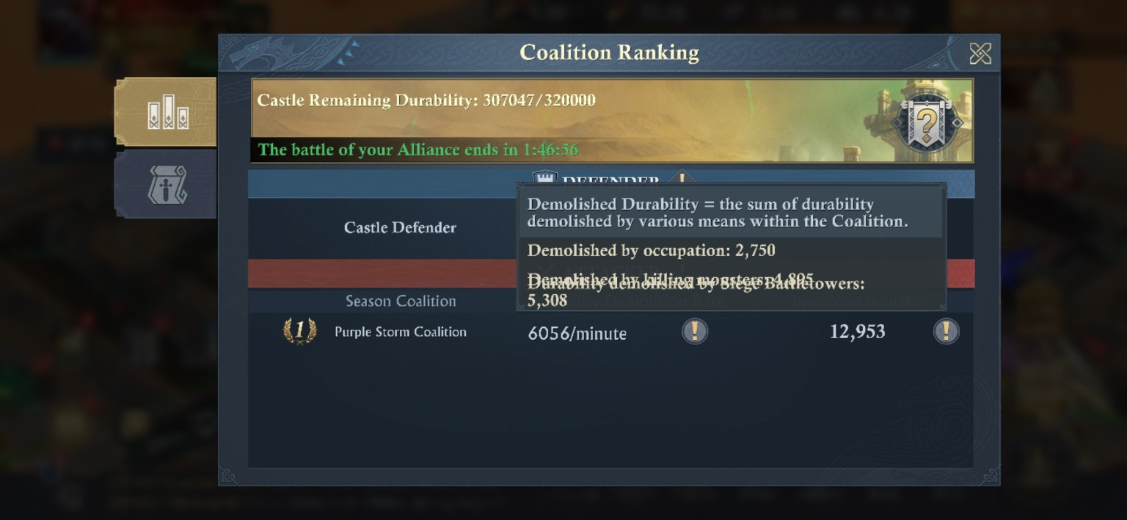
Coalition Ranking cumulative breakdown: 12,953 total demolished durability = 2,750 by occupation + 4,895 by killing monsters + 5,308 by Siege Battletowers.
That 12,953-point snapshot is the cleanest accounting proof in the current evidence set: 2,750 + 4,895 + 5,308 = 12,953 exactly. It also explains why four tactical paths appear as three ranking buckets: both Castle-hold and Beacon-hold pressure are occupation.

Live snapshot | Occupation rate | Siege Battletower rate | Total shown
A | 3,000/min | 3,056/min | 6,056/min
B | 3,850/min | 3,213/min | 7,063/min
C | 3,850/min | 39/min | 3,889/min

These live snapshots below show why the total demolition rate can swing sharply even while the Castle garrison remains steady. The occupation engine can hold at 3,850/min while the Siege contribution collapses from thousands per minute to only 39/min as towers die, retarget, or leave the Castle as their active target.

Castle durability math: Fortifiers, truncation, and the parenthetical bonus
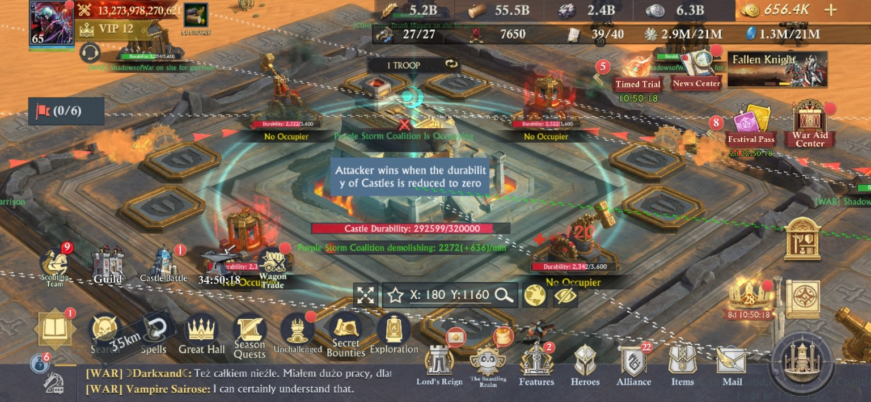
Observed Fortifier state on the Castle: the 2,500/min nominal Castle occupation base is reduced to 2,272/min, with a separate +636/min parenthetical occupation bonus.
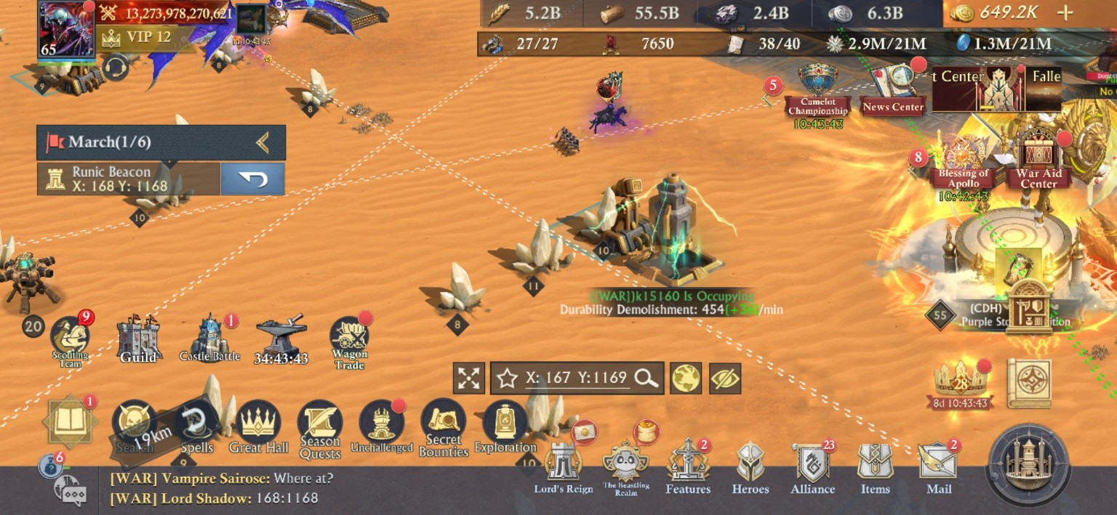
Observed Beacon in the same defensive environment: the 500/min nominal Beacon base is reduced to 454/min, with +36/min shown separately in parentheses.
The Castle and Beacon reductions independently fit the same divisor-style resistance formula. With two 5.0% Wall Fortifier effects covering the objective, the displayed resistance stat is +10%:
[DERIVED] Observed occupation formula
Defended Base = floor(Nominal Base / (1 + Fortifier resistance stat)). Then the displayed parenthetical occupation bonus is calculated from that already-reduced integer base and truncated again: Final Occupation = Defended Base + floor(Defended Base x displayed bonus rate).
Fortifiers affecting objective | Resistance stat |  | Castle occupation base | Beacon occupation base
0 | 0% |  | 2,500 | 500
1 | +5% |  | 2,380 projected | 476 projected
2 | +10% |  | 2,272 SCREENSHOT-VERIFIED | 454 SCREENSHOT-VERIFIED
3 | +15% |  | 2,173 projected | 434 projected
4 | +20% |  | 2,083 projected | 416 projected
[CAUTION] +20% Fortifier resistance is not the same as subtracting 20% directly!
The captured +10% state behaves as division by 1.10, not multiplication by 0.90. Under the same model, four 5% Fortifiers would produce a +20% resistance stat and an incoming multiplier of 1 / 1.20 = 83.33%, an effective 16.67% reduction. Only the two-Fortifier state is directly screenshot-verified; the one-, three-, and four-Fortifier rows are projections from that formula. This is why you must pay close attention, so that you can truly define the underlying formula.
Captured state |  | Calculation |  | Displayed result
Castle with two Fortifiers |  | floor(2,500 / 1.10) |  | 2,272/min
Beacon with two Fortifiers |  | floor(500 / 1.10) |  | 454/min
Castle parenthetical +28% |  | floor(2,272 x 0.28) = 636; 2,272 + 636 |  | 2,908/min
Beacon parenthetical +8% |  | floor(454 x 0.08) = 36; 454 + 36 |  | 490/min
Clean Castle combined occupation-Research bonus |  | 1,350 / 2,500 = 54%; 2,500 + 1,350 |  | 3,850/min
The 2,272(+636) case is also evidence of intermediate truncation. If the game carried the decimals through one combined equation, the result would be roughly 2,909. Instead, it first truncates 2,500 / 1.10 to 2,272, then truncates 2,272 x 28% to 636, and finally adds them to reach 2,908.
[DERIVED – HOW TO VERIFY STRONG GARRISON HEADCOUNT] Verified I-tier math gives a four-joiner minimum only if the leader supplies max Strategic Mind I.
The clean Castle snapshot above shows +1,350 on a 2,500 base, exactly +54%. Strategic Mind I can contribute up to +20% from the garrison leader, while Strong Garrison I contributes up to +10% per qualifying joiner. To minimize the Strong Garrison headcount under the verified I-tier values, assume the leader is max Strategic Mind I: 54% - 20% = 34% -which must then come from Strong Garrison joiners. Three maxed joiners can supply only 30%, so at least four Strong Garrison I joiners are required. Because at least two joiners were known to have mastered Strong Garrison I, at least two additional Strong Garrison I users are required in that minimum case. A four-joiner combination such as 10 + 10 + 8 + 6 reaches the needed 34%. If the leader has less than +20% Strategic Mind I, the minimum rises to five or six joiners. Strong Garrison II and Strategic Mind II are visible but their effect panels are still uncaptured, so higher-tier values could revise this lower bound.

Monster durability: live validation of Veteran Hunter I
Castle Monster | Captured base effect | Captured bonus | Veteran Hunter check
Lv.20 Sentry Cannon | Affected Castle Durability 80; Military Merit 98 | +40 durability; +24 Merit | 80 x 50% = 40. 98 x 25% = 24.5, displayed as +24 after truncation. Curse Intensity 6.
Lv.30 Mechanical Skullcrusher | Affected Castle Durability 110; Military Merit 140 | +55 durability; +35 Merit | 110 x 50% = 55. 140 x 25% = 35. Curse Intensity 8.

The Lv.30 monster is the higher-value target in the captured Castle, but it also carries the higher Curse/Illusion Intensity. Each player has a 15-attempt Castle-monster pool and restores 1 attempt every 20 minutes. Each Castle has two monster tiers, Lv.20 and Lv.30. Kills by members of the Guild that owns the Castle recover durability; kills by other players demolish durability. The Lv.30 target therefore gives more durability impact per attempt, but only if the player(s) can clear its higher Curse/Illusion requirement reliably.
Hunter planning item | Math | Result
Lv.20 full opening pool at max Veteran Hunter I | 15 x 120 | 1,800 durability per player
Lv.30 full opening pool at max Veteran Hunter I | 15 x 165 | 2,475 durability per player
Recharge throughput after the pool is spent | 3 attempts/hour x 120 or 165 | 360 durability/hour at Lv.20; 495/hour at Lv.30 per player
Twenty-player Lv.30 opening burst | 20 x 2,475 | 49,500 durability before recharge ticks

Defense changes the net monster rate:
If you are defending, you MUST make sure your players do not kill monsters unless the castle durability is no where near the maximum. This will require discipline and communication, but it is what MUST be done. Otherwise, the monster kills will not have the needed effect.
[DERIVED] GOAL: Net continuous durability loss/gain
For a castle with a continuously updating rate, Net Castle loss/gain per minute = Occupation Demolition + Siege Battletower Demolition - Castle Recovery. Monster kills are discrete durability events and should be calculated separately. This does not make them any less important.

Ownership after durability reaches zero:
The Alliance Rank screen states that the top demolition organization in the winning Coalition gains ownership. If that organization is a Guild, ownership resolves to the Alliance ranked first within it. A lower-ranked Alliance can take ownership automatically when a member creates the qualifying Mega Garrison on the Castle before durability reaches zero.

Each Castle fight is part of the Season War:
[MODERATOR’S PRO-TIP] Sometimes the right Castle objective is to make the stronger coalition overspend!
A neutral Castle does not exist in isolation. If the statistically stronger coalition must spend more Sword points/Guild Logistics/Troops to answer every contest, the weaker coalition can trade local (morale difference) losses, for a better season result. Force expensive responses, preserve your own Sword economy, take uncontested or cheaper Castles elsewhere, and build the Command Point lead before the final stage.
AND: If you can make them run out of troops before you, YOU WIN!
[DERIVED - SEASON STRATEGY SCENARIO] A 201+ Command Point lead can make the final 200-point swing insufficient
The final objective can swing (at most) an extra 200 Command Points. A coalition entering that battle 201+ points ahead cannot be passed by that single capture alone. That means a weaker coalition can win the season by accumulating enough earlier Castle value and forcing the stronger side to burn Sword points, even if the stronger coalition wins the higher-value final fight.

Special Castles: Infrastructure is the real prize
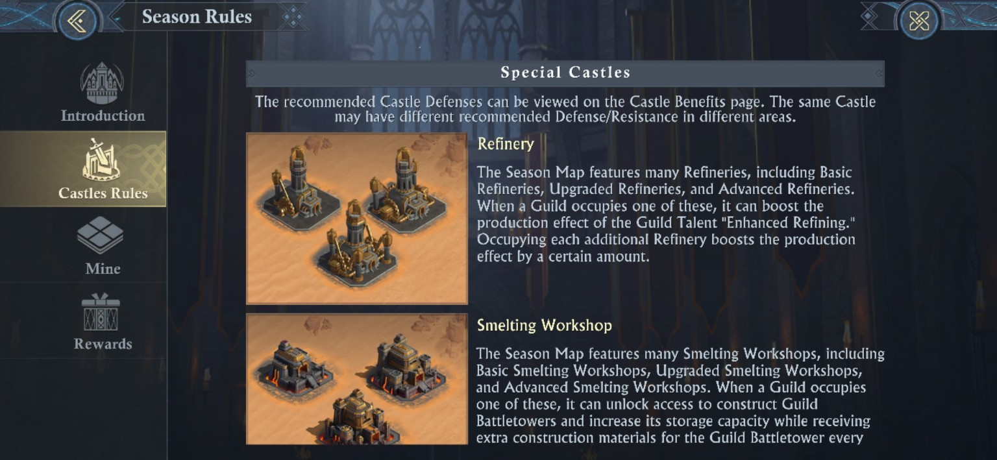
Refineries improve the Guild Talent “Enhanced Refining.”
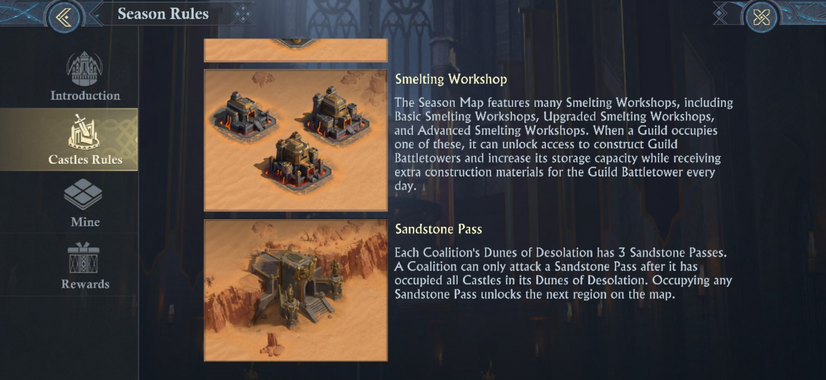
Smelting Workshops unlock Guild Battletower construction, increase storage, and provide daily construction materials.

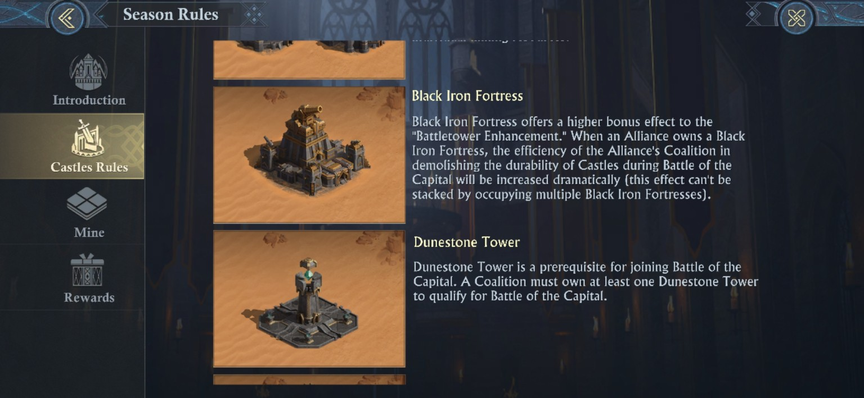
Fortresses strengthen the Guild Talent “Battletower Enhancement.”
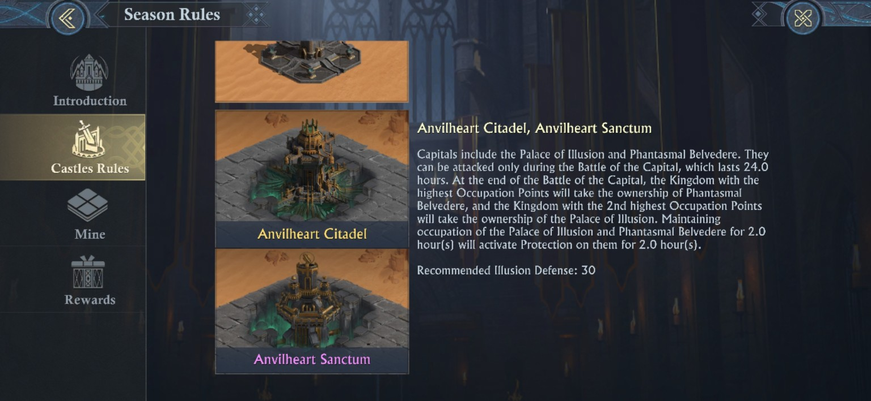
Black Iron Fortress, Dunestone Tower, and Capital objectives drive the endgame.

Special Castle | Why it matters
Refinery | Boosts Enhanced Refining; additional Refineries increase the production effect.
Smelting Workshop | Unlocks Battletower construction, expands tower storage, and supplies daily Battletower crafting materials. Higher grades unlock more.
Dwarven / Sentry Fortress | Improves Battletower Enhancement.
Scorchwind / Grimforge Fortress | Higher Battletower Enhancement bonus plus stronger territorial value.
Black Iron Fortress | Improves Battletower Enhancement and increases Coalition efficiency when demolishing Capital Castle durability; the special Capital-demolition effect does not stack across multiple Black Iron Fortresses.
Dunestone Tower | Prerequisite gate to the final Capital contest.
Anvilheart Capital objectives | Final settlement battle objectives with special occupation/protection rules.

CREATE IT, FEED IT, USE IT
Part IV - The Guild Is Your Season War Machine

An Alliance can play on the map, but a Guild can run a campaign. That’s the difference. The Guild system pools access, logistics, Castles, rally information, Battletowers, and settlement rewards across multiple Alliances from the same Coalition. If your Coalition treats Guilds as a menu feature instead of an operating structure, it leaves a lot of power/utility on the table.

Creating and joining a Guild
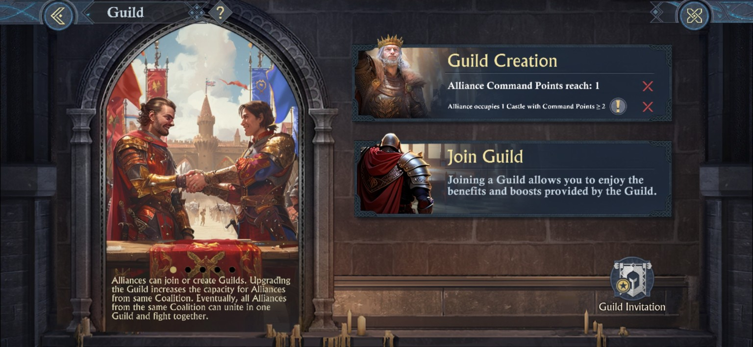
Guild Creation screen: the shown requirements are Alliance Command Points 1 and occupation of one Castle worth at least 2 Command Points.
Rule | How it applies
Who can create | An Alliance meeting the requirements can create a Guild; R4+ can perform the creation action.
Coalition restriction | Other Alliances from the same Coalition can join.
One per Alliance | Each Alliance can create only one Guild during the season.
No disband | Guilds cannot be disbanded during the season, though member Alliances can leave. A Guild does not need to have anyone in it. It can sit empty.
Why join | Guilds provide settlement rewards, Tier/Talent bonuses, Guild Rally, more looting visibility, Guild Sword Towers, Guild Battletowers, and shared Castle utility.
Season reset | Guild data is cleared at season end.

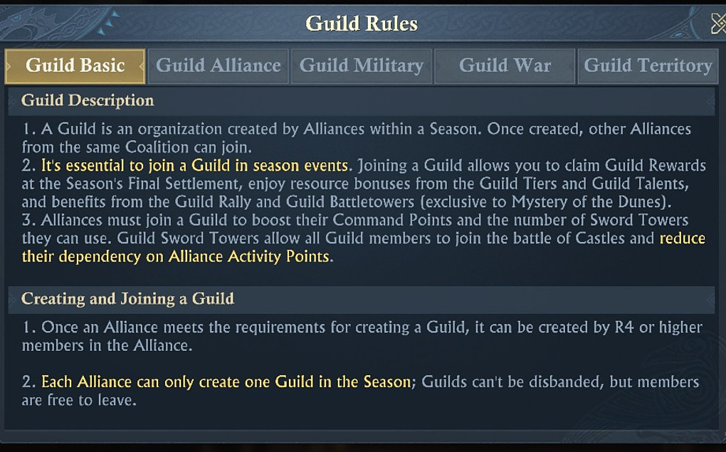
Guild Basic rules: the system is designed as a same-Coalition organization above the Alliance level.

What changes when an Alliance joins
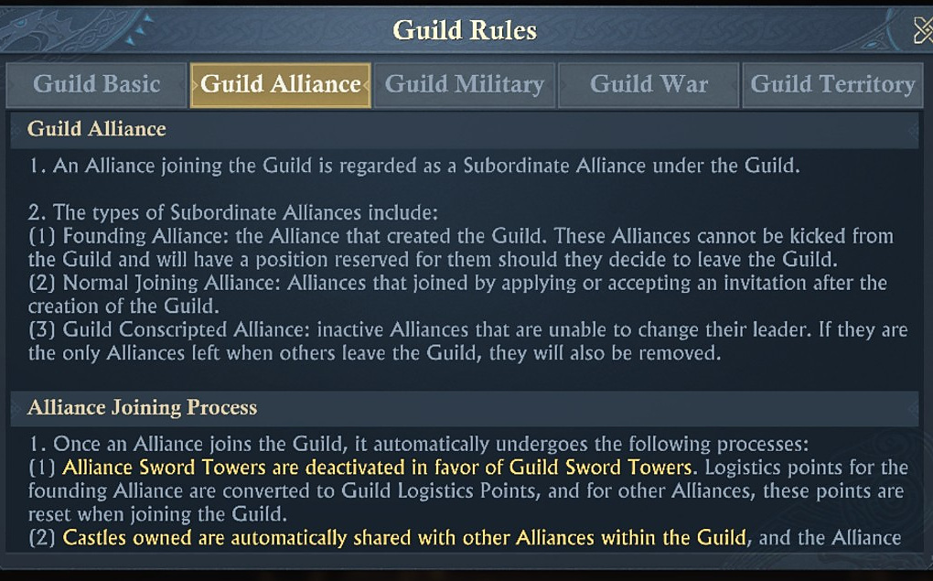
Joining a Guild changes Sword Tower / logistics behavior and turns the Alliance into a subordinate Alliance inside the larger Guild structure.
Joining effect | Practical result
Sword Towers | Alliance Sword Towers are deactivated in favor of Guild Sword Towers while in a Guild. The Guild Master can change the Sword Tower allotment.
Logistics | Founding Alliance logistics/sword points convert to Guild Logistics; other joining Alliances reset their relevant state when they join. This means an Alliance can contribute more than its regular allotment per day, if timed right.
Castles | Alliance-owned Castles are shared into Guild territory while ownership remains with the Alliance. They can be manually shared or shared automatically.
Leadership | The joining Alliance Leader becomes a Deputy Guild Master.
Battletowers | Alliances gain access to Guild Battletower construction/deployment systems in a Guild.
Rewards / Talents | Members gain Guild Tier daily rewards and Guild Talent benefits.
Supply capacity | Guild Logistics cap, storage, and earning capacity grow as subordinate Alliances contribute; the displayed daily Desert Supplies cap gains +100,000 points.

Guild Sword Towers and Guild Logistics
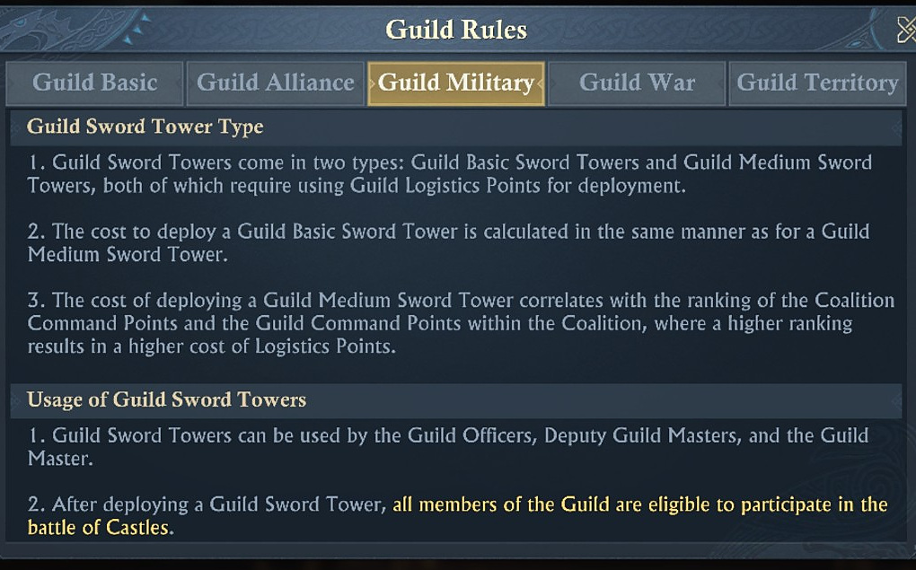
Guild Sword Towers come in Basic and Medium forms; the Medium version uses rank-sensitive Guild Logistics costs.
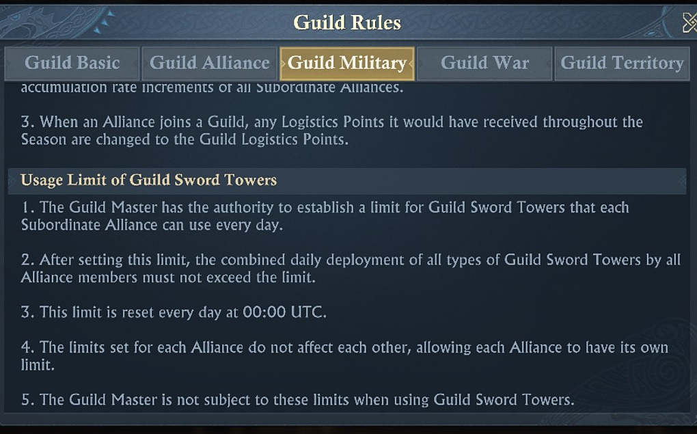
The Guild Master can set daily Guild Sword Tower deployment limits for each subordinate Alliance; those limits reset at UTC 00:00.
[MODERATOR’S PRO-TIP] Guild Logistics is a command resource!
Once Alliances are inside the Guild, Sword Tower access becomes a shared strategic budget. Agree on who is allowed to spend it, where, and for which objectives. The Guild Master is exempt from the per-Alliance deployment limits shown in the rules, which makes leadership discipline even more important.

Guild Rally, War interface, and territory
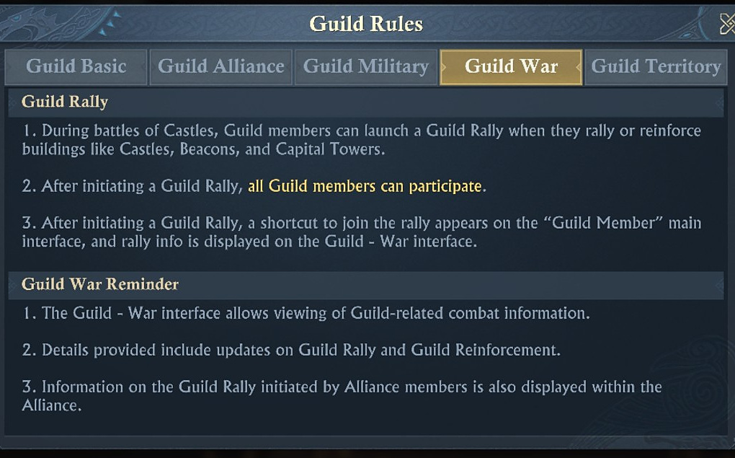
Guild Rally allows all Guild members to join Castle / Beacon / Capital Tower rally and reinforcement actions.
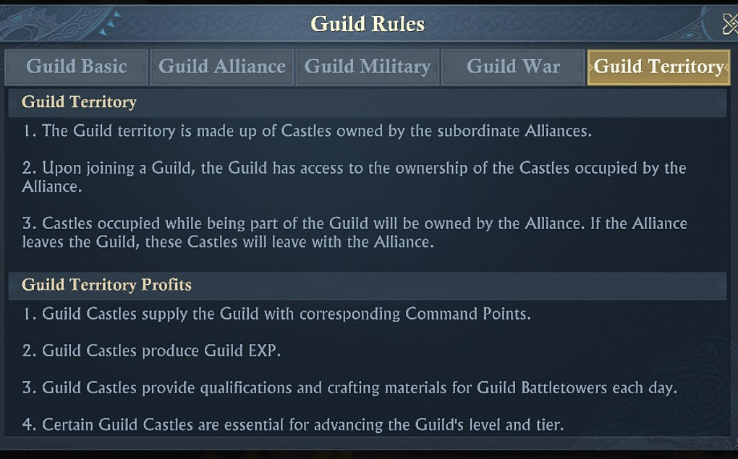
Guild territory is the combined Castle footprint of subordinate Alliances, while underlying ownership remains Alliance-based.

Territory rule | Meaning
Alliance first | Castle ownership always resolves to an Alliance before it contributes to Guild territory.
Capture inside Guild | If the Guild captures a Castle, the Alliance ranked #1 in Castle durability reduction within that Guild receives ownership, unless a lower-ranked Alliance has a member create a mega garrison on the Castle. If that happens, it goes to the Alliance of the mega-garrisoning player.
Leaving Guild | The Alliance keeps its own Castles when it leaves; the Guild loses the associated territory / Command Point contribution.
Shared rights | Subordinate Alliances share Castle rights by default while in the Guild; after exit, sharing must be manually deactivated where applicable.
Guild benefits from Castles | Command Points, Guild EXP, Battletower qualifications/materials, and some Guild level/Tier requirements come from Guild territory.

LV.1 THROUGH LV.8
Part V - Guild Levels: Grow the Organization, Not Just the Number

The Guild level screen is one of the best planning tools in the season because it shows both the EXP wall and the territorial requirement. The catch is that one official screenshot disagrees with another at Lv.2, so this is also the clearest example of why we are keeping evidence conflicts visible instead of quietly choosing the prettier number. This was likely due to a live change performed by KoA after season start.
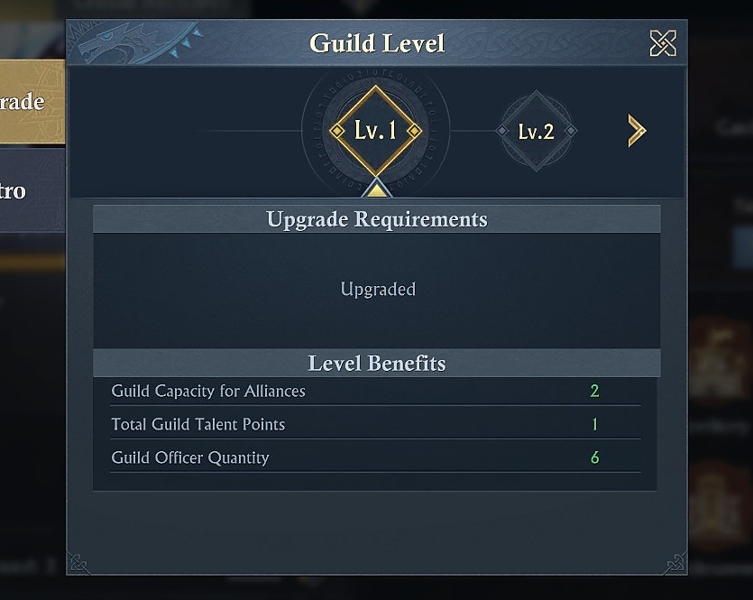
Guild Lv.1: 2 Alliance capacity, 1 total Guild Talent Point, 6 Guild Officers.

Level | Upgrade requirement | Alliance cap | Talent pts | Officers
Lv.1 | Already upgraded | 2 | 1 | 6
Lv.2 | 130,000 EXP + 1 Castle CP >=4 | 3 in one screenshot; 6 in another | 2 | 9
Lv.3 | 430,000 EXP + 1 Castle CP >=5 | 4 in one screenshot; 6 in another | 2 | 12
Lv.4 | 880,000 EXP + 1 Castle CP >=5 | 5 in one screenshot; 6 in another | 2 | 15
Lv.5 | 1,330,000 EXP + 1 Castle CP >=5 | 6 | 2 | 18
Lv.6 | 1,780,000 EXP + 1 Castle CP >=5 | 7 | 2 | 21
Lv.7 | 2,280,000 EXP + 1 Castle CP >=5 | 8 | 2 | 24
Lv.8 | 2,780,000 EXP + 1 Castle CP >=5 | 8 | 2 | 27

The Lv.2 conflict is real
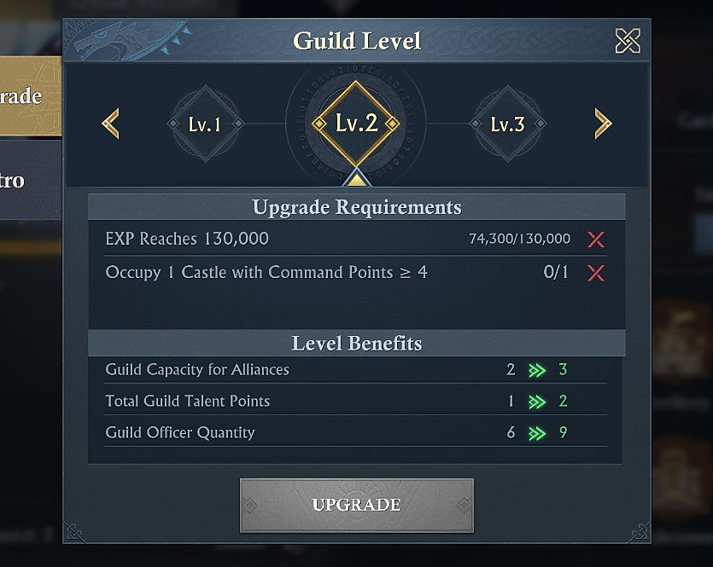
Lv.2 screenshot A: Alliance capacity changes 2 -> 3.
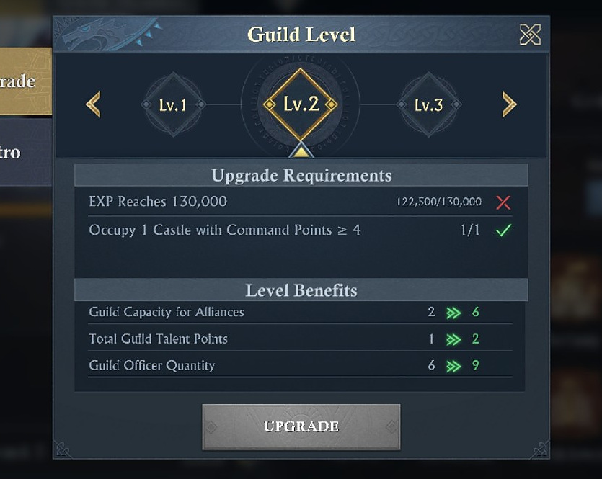
Lv.2 screenshot B: same requirements, but Alliance capacity changes 2 -> 6.

[CAUTION - BUILD CONFLICT] Do not rely on the initial Lv.2 Alliance-capacity value
Both official in-game screenshots show the same Lv.2 EXP / Castle requirement but different Alliance-capacity benefits (2 -> 3 in one capture; 2 -> 6 in another). The evidence establishes a live build/configuration conflict, but not its cause. Use the current in-game Guild Level screen as the authority for your kingdom/build. This was likely due to a live change performed by KoA after season start.

Where Guild EXP comes from
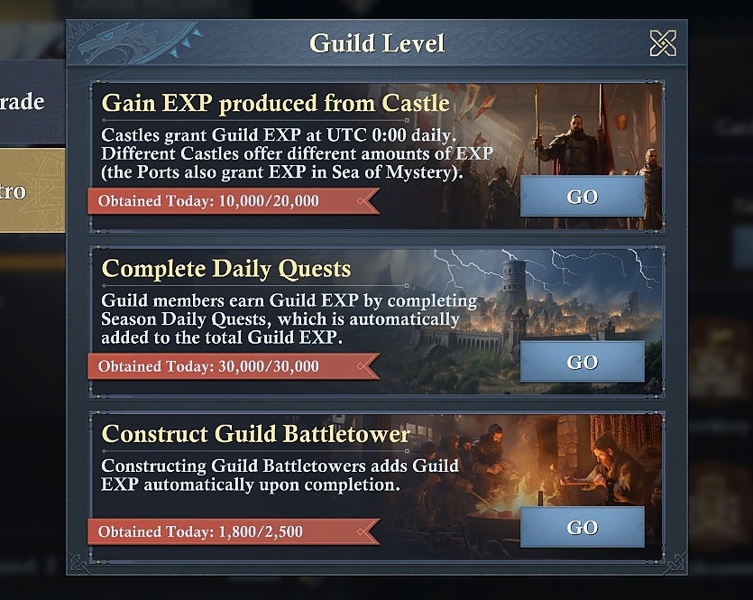
Visible Guild EXP sources: daily Castle EXP, Season Daily Quests, and completed Guild Battletowers.
Displayed source | Visible daily cap / behavior
Castles | 20,000/day displayed; Castle EXP is granted at UTC 00:00, with different Castles producing different amounts. The limit for this increases over the course of the season.
Season Daily Quests | 30,000/day displayed; members’ quest EXP is added automatically.
Construct Guild Battletower | 2,500/day displayed; each completed Battletower page shows 100 Guild EXP per Battletower.
Visible total of those three lines | 52,500/day.

[DERIVED] Battletower EXP target
At 100 Guild EXP per completed Battletower, 25 completed towers would fill the displayed 2,500-point Battletower EXP line for that day - assuming the 100-EXP rate applies to the completed towers being used.

GUILDS, RELICS, TOWERS, SMELTING
Part VI - The Adventurer’s Hall Connects the Side Systems

The Adventurer’s Hall is the menu screen that gives away the season’s design. Guilds, Relic Expedition, Guild Battletowers, Mining Battletowers, and Dunestone Smelting are all sitting together because they feed one another. This is not five unrelated minigames. It is one resource loop with different doors.
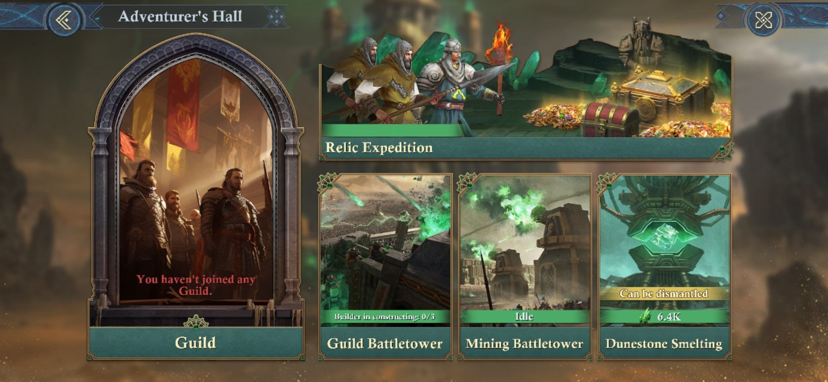
Adventurer’s Hall: Guild, Relic Expedition, Guild Battletower, Mining Battletower, and Dunestone Smelting sit in one featured-gameplay hub.

Relic Expedition: the five sites
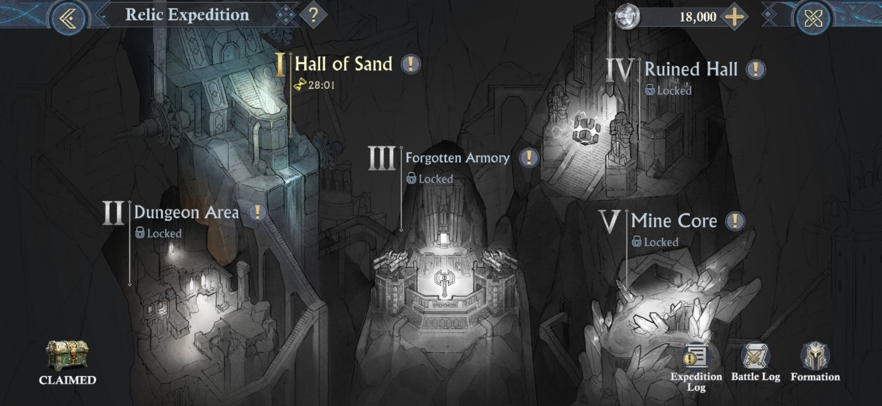
Relic Expedition map: I Hall of Sand, II Dungeon Area, III Forgotten Armory, IV Ruined Hall, V Mine Core.
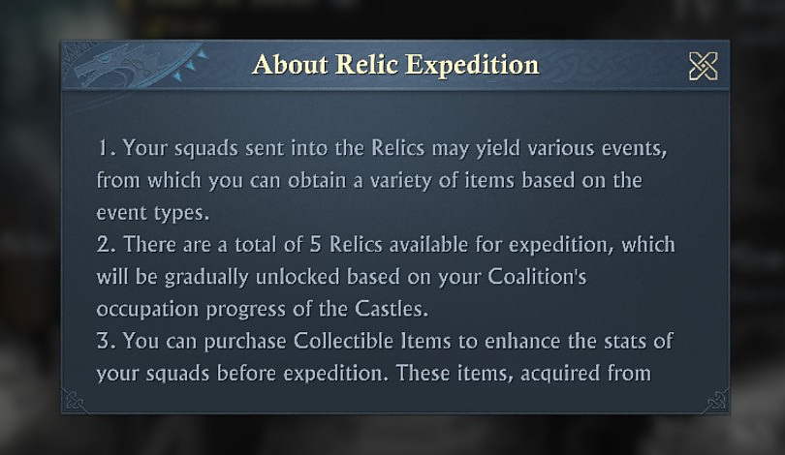
About Relic Expedition: squads encounter events and rewards; the five Relics unlock gradually according to the Coalition’s Castle occupation progress.
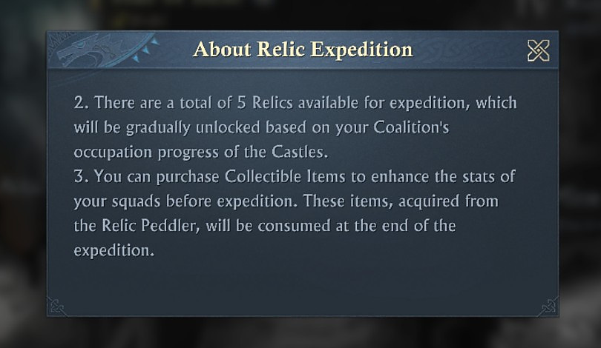
Collectible Items can boost expedition squads before departure. They come from the Relic Peddler and are consumed when the expedition ends.
[MODERATOR’S PRO-TIP] Relic progression is also Achievement progression.
The Adventure Achievement tab explicitly counts Expeditions, Dwarven Coins, Dunestone earnings, and Dunestone Smelting. That means Relic Expedition is feeding both the material economy and the season reward track. Ignoring it leaves value on the table twice.

Relic unlock roadmap
Relic | Captured unlock evidence | Guide status
I - Hall of Sand | Available in the captured opening state. | Exact prerequisite is not stated in the supplied unlock popup.
II - Dungeon Area | Relics unlock as Coalition Castle occupation progresses. | Exact Castle level threshold still not captured.
III - Forgotten Armory | Relics unlock as Coalition Castle occupation progresses. | Exact Castle level threshold still not captured.
IV - Ruined Hall | Unlocks when your Coalition occupies a Lv.6 Castle. | SCREENSHOT-VERIFIED.
V - Mine Core | Unlocks when your Coalition occupies a Lv.7 Castle. | SCREENSHOT-VERIFIED.
[MODERATOR’S PRO-TIP] Castle progress is Adventure progress.
Relic areas are hard-linked to Coalition Castle occupation. That means a Coalition that stalls territorially, is also delaying its Adventure economy. Treat the next Castle tier as a Relic unlock objective, not only a PvP objective, and same your exploration teams for the next unlock, if it comes later in the day.

Relic Peddler: build the run you actually need
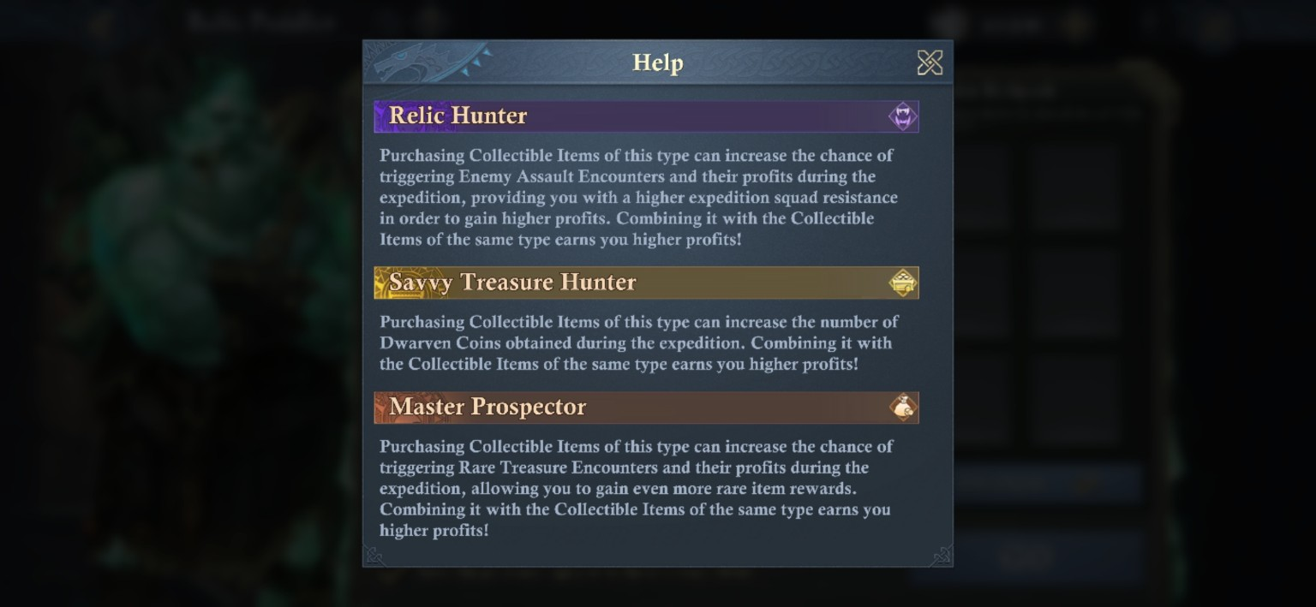
The Relic Peddler groups Collectibles into Relic Hunter, Savvy Treasure Hunter, and Master Prospector. Same-type combinations are explicitly described as producing higher profits.
Collectible archetype | Screenshot-described purpose | Best use case
Relic Hunter | Raises the chance/profit of Enemy Assault Encounters; stronger opportunities require higher expedition squad resistance. | Use when combat encounters are the target and the squad can survive the higher resistance requirement.
Savvy Treasure Hunter | Raises Dwarven Coins obtained during the expedition. | Direct route toward the Lord Moneybags Adventure achievement.
Master Prospector | Raises the chance/profit of Rare Treasure Encounters. | Use when resource/rare-treasure yield matters more than raw Dwarven Coin output.

Relic Peddler catalogue
Item | Dwarven Coin cost | Captured effect
Prospector’s Lantern | 5,400 | Rare Treasure Encounter trigger chance +0.25%.
Guiding Compass | 5,400 | Treasure Encounter trigger chance +2%.
Leather Satchel | 5,400 | Chance to obtain Treasure Resources +10%.
Prospector’s Key | 5,400 | Chance to obtain Rare Treasure Resources +10%.
Miner’s Candle | 9,900 | Rare Treasure Encounter trigger +0.25%; Rare Treasure Resources +10%.
Treasure Hunter’s Compass | 9,900 | Treasure Encounter trigger +2%; Treasure Resources +10%.
Simple Vault Map | 5,400 | Chance to trigger Coin Encounters +10%.
Banker’s Spectacles | 5,400 | Chance to obtain Dwarven Coins +20%.
Dwarven Horn | 5,400 | Troop Attack +50,000%; Troop Defense +50,000%; Troop Health +50,000% for the expedition.
Expanded Vault Map | 9,900 | Coin Encounter trigger +10%; Dwarven Coins obtained +20%.
War Horn | 9,900 | Troop Attack +75,000%; Troop Defense +75,000%; Troop Health +75,000% for the expedition.
Spirit-Banishing Torch | 5,400 | Chance to trigger Enemy Assault +1%.
Wrench of Dismantling | 5,400 | Enemy Assault Resources +10%.
Pendant of Courage | 5,400 | Defense +3.
Dunestone Ring | 5,400 | Chance to trigger Dangerous Enemy Assault +0.25%.
Dunestone Staff | 14,400 | Enemy Assault trigger +1%; Enemy Assault Resources +10%; Defense +3.
Relic Peddler rules say purchased Collectibles are valid only for the current expedition and are consumed when it ends..

Adventure Achievement game plan
Adventure objective | Captured threshold | Practical plan
Seasoned Adventurer | Conduct Relic Expedition 10 times; a later tier shows 30 times. | Do not skip daily/available expedition windows; the counter is simple volume.
Lord Moneybags | Earn 2,000,000 Dwarven Coins in Relic Expedition. | When behind, bias the Peddler build toward Savvy Treasure Hunter / Coin Encounter tools.
Mining Tycoon | Earn 500,000 Dunestones in Relic Expedition. | Favor treasure/resource yield and keep higher Relics unlocked through Castle progress.
Craft Mastery | Conduct Dunestone Smelting 400 times. | Start early; every Smelt also feeds Battletower materials, so this should be normal season production rather than a last-week dump.
[MODERATOR’S PRO-TIP] Build to the Adventure achievement you are still missing.
The Peddler is not a generic “best item” shop. If you are short on Dwarven Coins, buy toward Coin Encounters and coin yield. If you are short on Dunestone/treasure, shift toward Prospector tools. If an expedition is failing on combat, use the Horn/Defense/Relic Hunter side instead. The efficient loadout changes with the counter you still need.
[CAUTION] The items DO NOT guarantee an outcome!
If you buy with an expected outcome in mind as a requirement, that is foolish. It’s like buying a lottery ticket, expecting a win of a certain amount… Or like investing in something, counting on a positive outcome. Just don’t.

OCCUPY, LOOT, GARRISON, DEFEND
Part VII - Mines: Your Economy Can Be Attacked

Mines are where season economy can turn into PvP. They produce the Research resources you need, they can be shared through Alliance/Guild territory, and they can be looted hard enough to change your day/season. The good news is, the rules are very readable once you know what the buttons actually cost.

Mine qualification and resource types
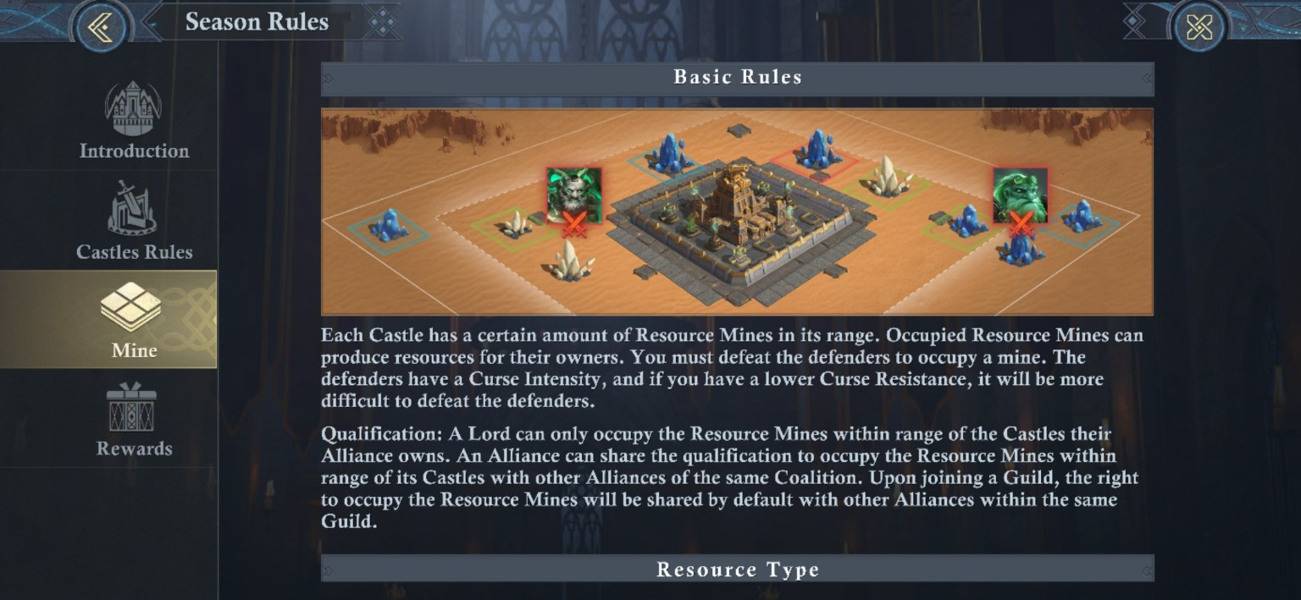
Mine qualification is tied to Castles. Alliances can share mine rights inside the Coalition, and Guild membership shares those rights by default among member Alliances.
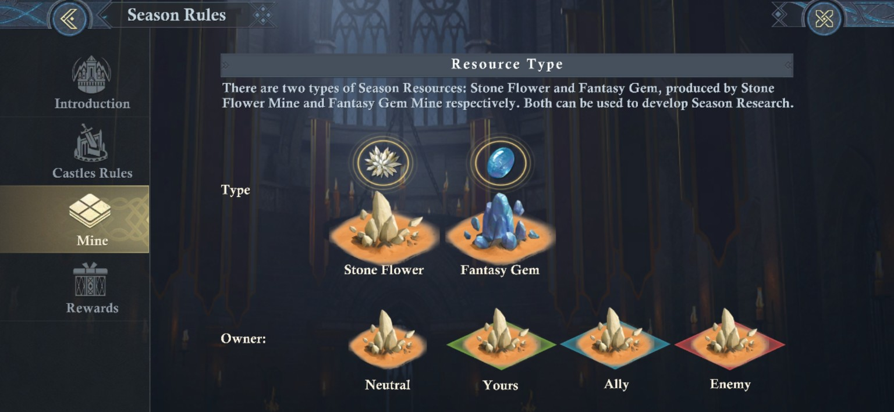
Stone Flower and Fantasy Gem are the two Mine resource types used for Season Research. Mine ownership states are color-coded in the interface.

Occupy, abandon, loot
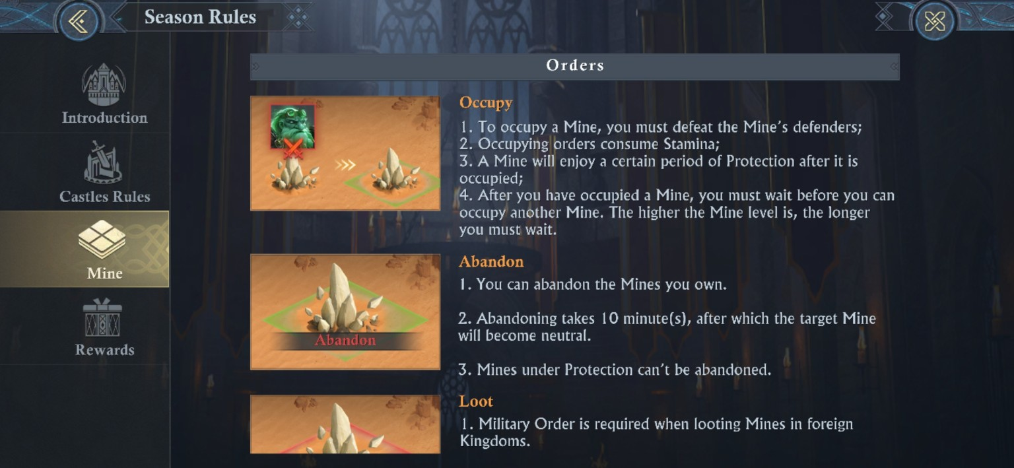
Occupation costs Stamina, defeating the Mine defender grants ownership/looting, and protection / cooldown/recovery behavior scales with Mine level.
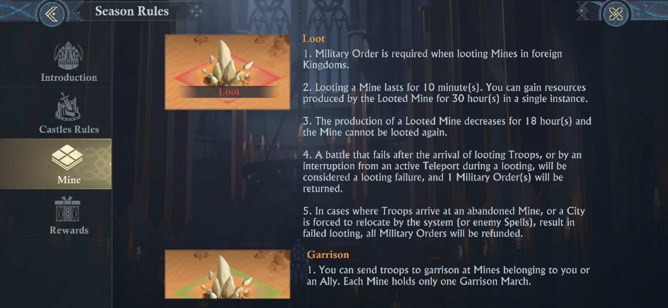
Looting lasts 10 minutes (unless affected by talents) and one successful loot can take resources equal to 30 hours of production. The looted Mine suffers reduced production for 18 hours and cannot be looted again during that or the recovery state.

Action | Key rule
Occupy | Defeat the defender, spend Stamina, then the Mine receives occupation protection. Higher Mine levels carry longer occupation cooldown.
Abandon | Owned Mines can be abandoned; after 10 minutes they turn neutral, unless you have a ‘free abandon’ granted from a Covenant or Royal Certificate. Protected Mines cannot be abandoned.
Loot | Foreign-Kingdom Mine looting consumes Military Orders. One loot is worth 30 hours of production and applies an 18-hour production penalty to the victim.
Refund cases | The rules describe Military Order refunds for failed/invalid looting situations such as arrival after abandonment or certain system relocations. (Portable Looting research skill applies here as well)

[MODERATOR’S PRO-TIP] Looting is a production swing, not just a raid reward.
A successful loot is not merely “some resources”, it’s 30 hours of production, and the victim then eats an 18-hour production reduction. That makes Mine security a strategic economic issue, especially around Advanced Mines.

Garrisons and Looting Expulsion
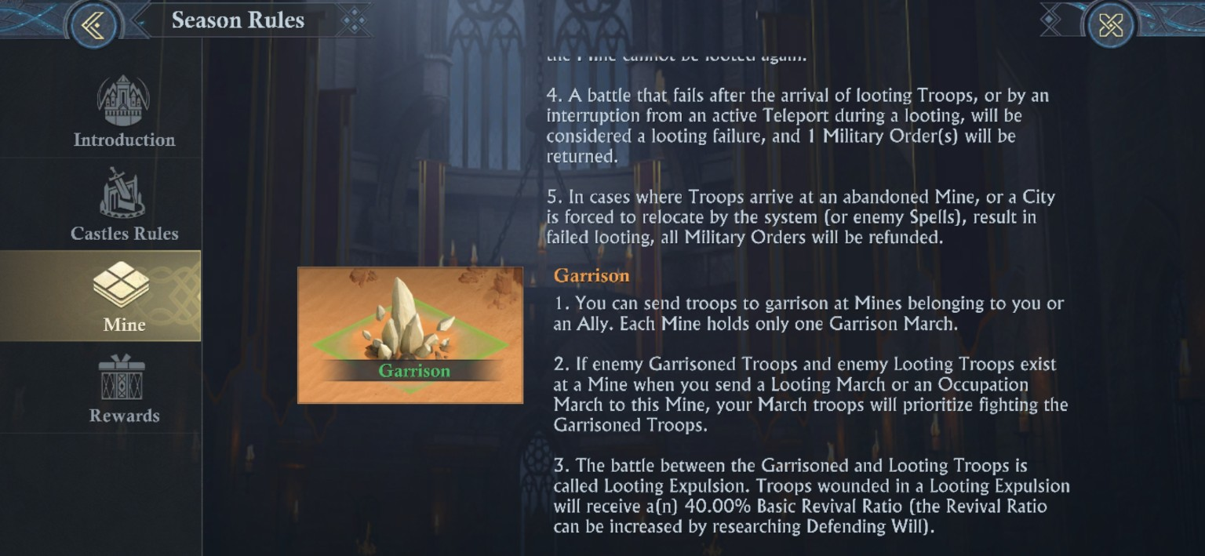
Only one garrison march can occupy a Mine. Incoming looting / occupation fights the garrison first. Looting Expulsion wounded troops receive a 40% Basic Revival Ratio before research improvements.

Mine Capacity is its own progression system
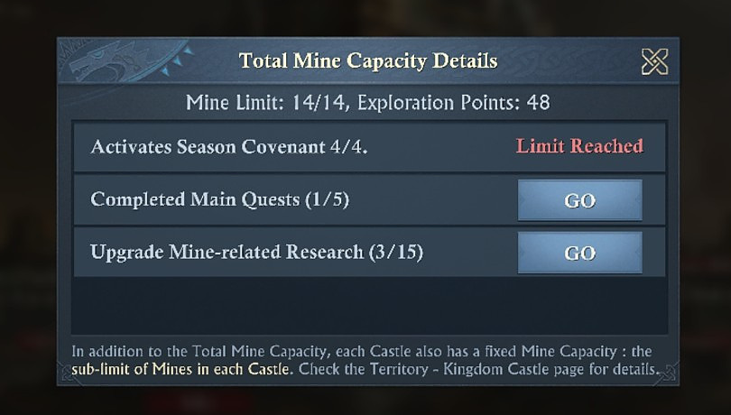
Two captured Mine-capacity states are now available. An earlier panel shows 14/14 with Exploration Points 48. The final Territory capture shows 27/27 Individual Mines at Exploration Points 8,350 and Rank 4, with Stone Flower/Fantasy Gem storage caps at 21M in that account state. The panels reference Season Covenant, Main Quests, Mine-related Research, and Castle-specific sub-limits as contributors, but neither screen exposes a single closed-form slot formula.

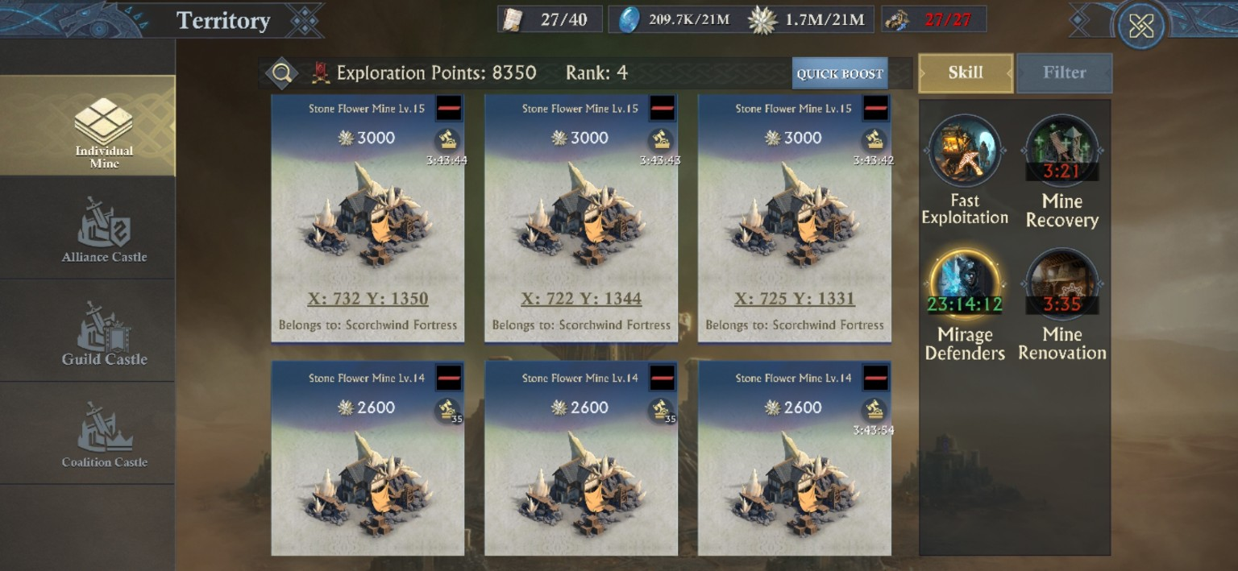
Late-season Territory capture: Exploration Points 8,350, Rank 4, 27/27 Individual Mines, Lv.14-15 Stone Flower Mines, and the active Fast Exploitation / Mine Recovery / Mirage Defenders / Mine Renovation skill panel.

Mine level curve: production, Stamina, and Curse breakpoints
The final upload finally makes the Mine progression curve readable as a single table. Stone Flower and Fantasy Gem examples share the same production values at the same Mine level in the captured screens. Levels 1-10 cost 5 Stamina to occupy in the supplied captures; Levels 11-20 cost 10. The last column below is not a generic stat table: it is the exact target-stat multiplier shown when the account had Current Curse Resistance (CR) 21.
Mine Lv. | Production / h | Curse Intensity | Occupy Stamina | Target stats at CR 21
1 | 140 | 0 | 5 | 1%
2 | 210 | 2 | 5 | 1%
3 | 280 | 4 | 5 | 1%
4 | 350 | 6 | 5 | 1%
5 | 500 | 8 | 5 | 1%
6 | 700 | 10 | 5 | 1%
7 | 900 | 11 | 5 | 1%
8 | 1,100 | 13 | 5 | 1%
9 | 1,300 | 15 | 5 | 1%
10 | 1,500 | 17 | 5 | 1%
11 | 1,750 | 19 | 10 | 5%
12 | 2,000 | 20 | 10 | 10%
13 | 2,300 | 22 | 10 | 100%
14 | 2,600 | 23 | 10 | 300%
15 | 3,000 | 25 | 10 | 2,000%
16 | 3,400 | 27 | 10 | 6,000%
17 | 3,800 | 28 | 10 | 10,000%
18 | 4,200 | 30 | 10 | 10,000%
[MODERATOR PRO-TIP] Lv.13 is the captured break-even point for Curse Resistance (CR) 21, a moderate mid-game resistance.
At CR 21, Lv.12 (Intensity 20) still suppresses the defender to 10% of baseline. Lv.13 (Intensity 22) crosses to the -1 breakpoint and returns the defender to 100% of baseline; Lv.14 jumps to 300%, Lv.15 to 2,000%, Lv.16 to 6,000%, and Lv.17-18 to 10,000%. This is the clearest live demonstration in the guide of why one or two points of Curse/Illusion Resistance can matter more than large amounts of ordinary combat stats, and why focusing +resistance is valuable.
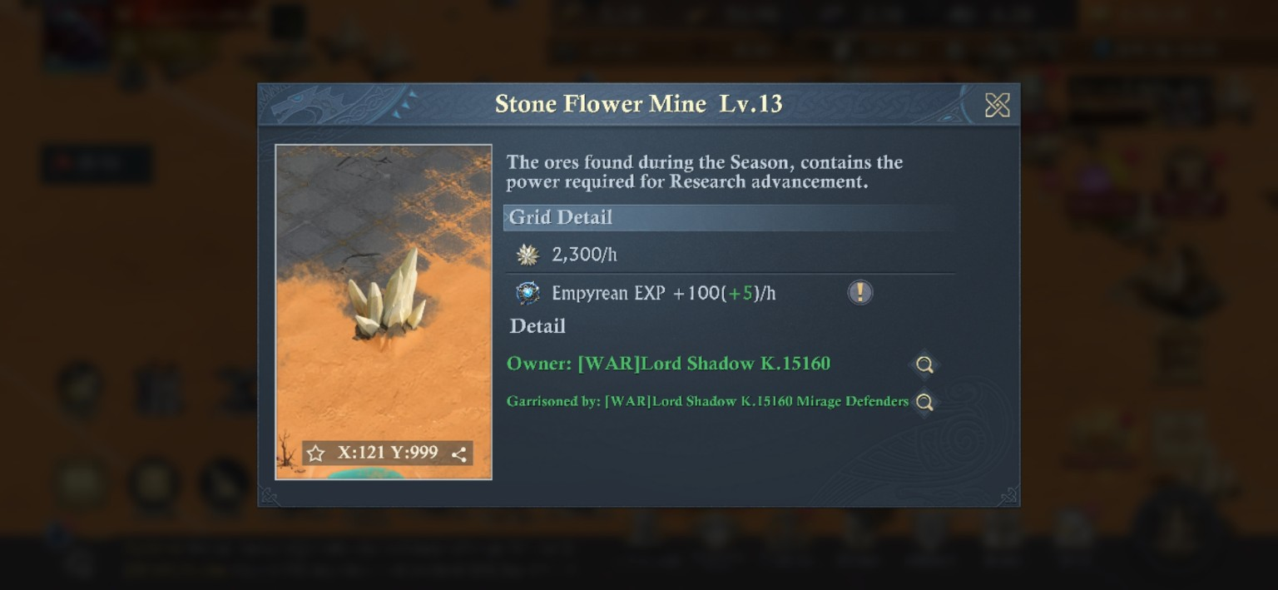
Captured Lv.13 Stone Flower Mine grid detail: 2,300/hour plus Empyrean EXP +100(+5)/hour; the Mine is owned and garrisoned by Mirage Defenders in this state.

Advanced-Mine Empyrean EXP: a second reason to hold high-level Mines
Grid-detail captures for Lv.11, Lv.13, and Lv.15 Stone Flower Mines show Empyrean EXP +100(+5)/hour in addition to the Mine’s normal research-resource production. The Empyrean EXP tooltip states that the currency is used to activate Empyrean Effects and directs the player to The Observatory for details. The +5/hour is an account-state bonus, provided thanks to Empyrean Talents.
[MODERATOR’S PRO-TIP] Do not value a high-level Mine only by Stone Flowers or Fantasy Gems!
Once the advanced Mine detail panels begin showing Empyrean EXP, holding the Mine is feeding two progression systems at once. A Lv.13 Stone Flower Mine is 2,300 Stone Flowers/hour in the captured build, but its grid detail also shows 100(+5) Empyrean EXP/hour. That makes Mine defense, Mine Recovery, Mirage Defenders, and anti-looting Research more strategically important than a simple “resource per hour” comparison suggests.

Curse/Illusion Resistance: the breakpoint that decides whether a Mine feels easy, or absurd
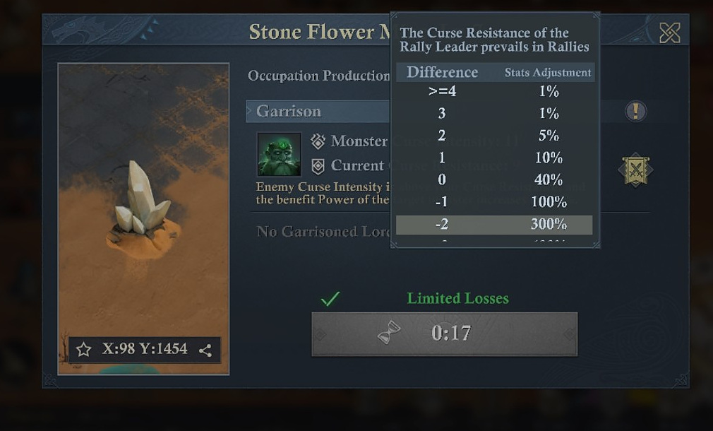
Curse/Illusion Resistance adjustment table. The Rally Leader’s Curse/Illusion Resistance is the value that prevails in rallies.
Resistance - Curse/Illusion Intensity | Target stat adjustment shown
>= +4 | Reduction to 1% of base stats
+3 | Reduction to 1% of base stats
+2 | Reduction to 5% of base stats
+1 | Reduction to 10% of base stats
0 | Reduction to 40% of base stats
-1 | 100% = no change to base stats
-2 | Increased to 300% of initial stats
-3 | Increased to 600% of initial stats
-4 | Increased to 2,000% of base stats
-5 | Increased to 4,000% of base stats
-6 | Increased to 6,000% of base stats
<= -7 | Increased to 10,000% of base stats
[MODERATOR’S PRO-TIP] Monster baseline also depends on Kingdom Rank!
Kingdom Ranks are divided into A, B, C, and D. Monster baseline stats for mines, camps, and single monsters depend on this. Monsters in a Rank-A FAE season will be significantly stronger than those in a Rank-B FAE season. The difference is (roughly) equal to 1.5-2 illusion levels… or 150%-300% of base stats. Exact numbers are impossible to discern without game developer info being provided.
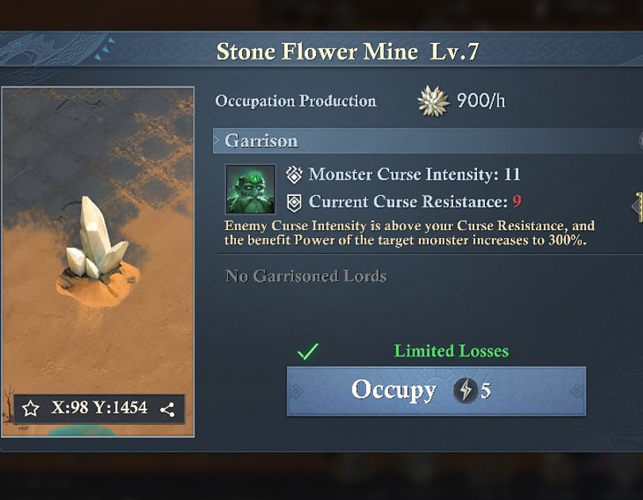
Example: a Lv.7 Stone Flower Mine with Curse/Illusion Intensity 11 versus Current Curse/Illusion Resistance 9 is a -2 difference, and the screen states the target monster Power rises to 300%.
[MODERATOR’S PRO-TIP] Two points can be the difference between “fine” and “why is this impossible?”
The penalty curve is brutally nonlinear. A -2 gap is already 300%; -4 jumps to 2,000%; <=-7 reaches 10,000%. For rallies on camps or The Dark Spire, the Rally Leader’s Curse/Illusion Resistance controls the check, so choose the leader for the resistance level first, and raw combat power second, when the gap is large. Season Research screens include a visible Amulet line that increases Curse/Illusion Resistance, with the first shown tier reaching +1 / +2 / +3 across its levels. Higher related nodes are visible elsewhere, but the complete maximum has not yet been transcribed into this edition. That said, each Amulet rank provides up to +3 resistance.

THE SEASON’S CONVERSION ENGINE
Part VIII - Dunestone Smelting: Turn Exploration Into War Material

This is one of the cleanest loops in the whole season. Dunestone comes in, two kinds of construction material come out, and the extra-reward pool can throw in long-term account items on top. If your Guild wants Ore Drills and Battletowers ready before the next Castle window, this is where the supply chain starts.
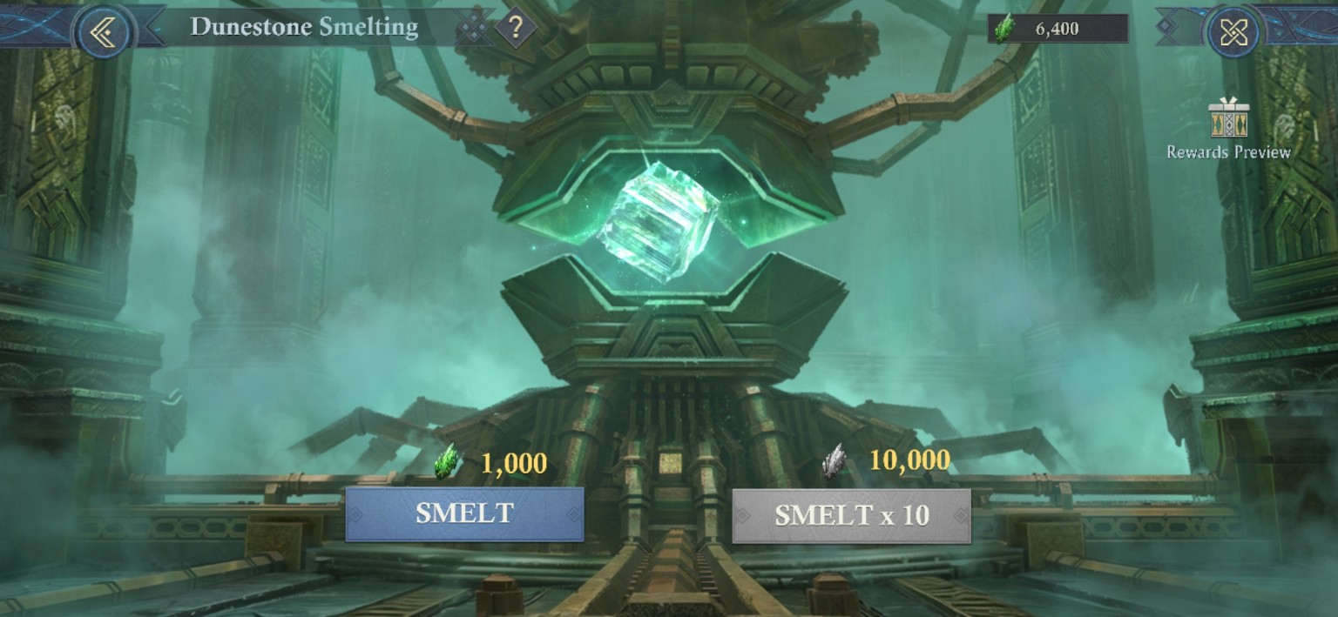
Dunestone Smelting UI: one Smelt costs 1,000 Dunestone; Smelt x10 costs 10,000.
[MODERATOR’S PRO-TIP] Use Smelt x10 for throughput, and better odds!
Smelt x10 performs 10 consecutive smelts when you have enough Dunestone. The rules do not show a better per-smelt drop rate for the x10 option, but after extensive moderator testing, the x10 option does provide better permanent rewards for player progression -over the x1 option.
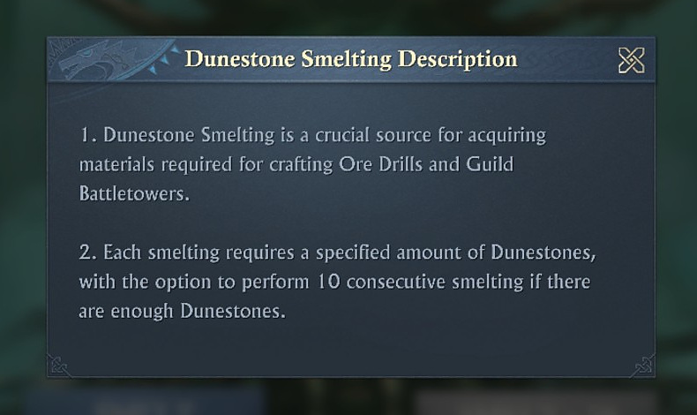
The game explicitly calls Dunestone Smelting a crucial source of Ore Drill and Guild Battletower materials.
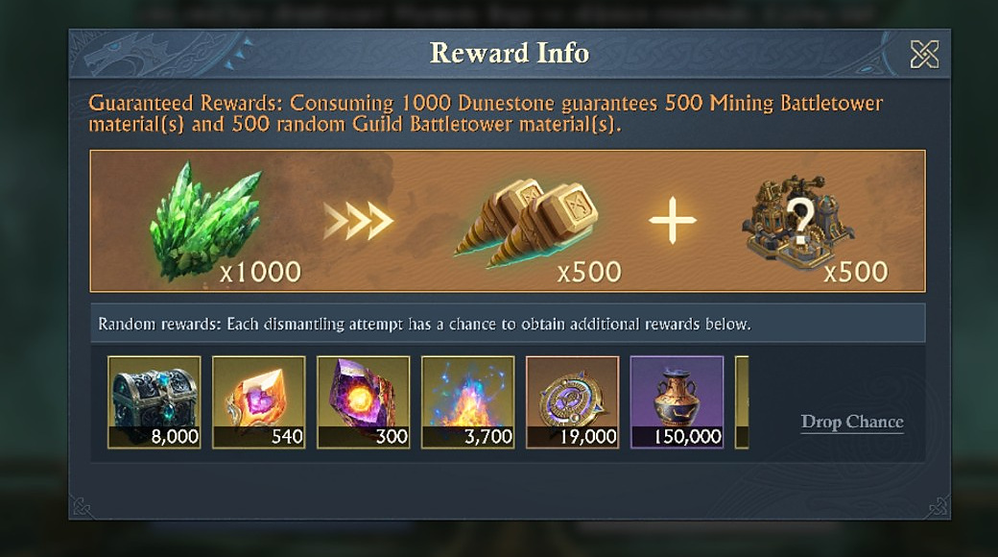
Guaranteed return per 1,000 Dunestone: 500 Mining Battletower materials + 500 random Guild Battletower materials, before extra random rewards.
[SCREENSHOT-VERIFIED] What x10 guarantees
Because 1,000 Dunestone guarantees 500 + 500 materials, a 10,000-Dunestone x10 Smelt guarantees 5,000 Mining Battletower materials and 5,000 random Guild Battletower materials before any bonus drops.

Visible random-drop chances - partial pool
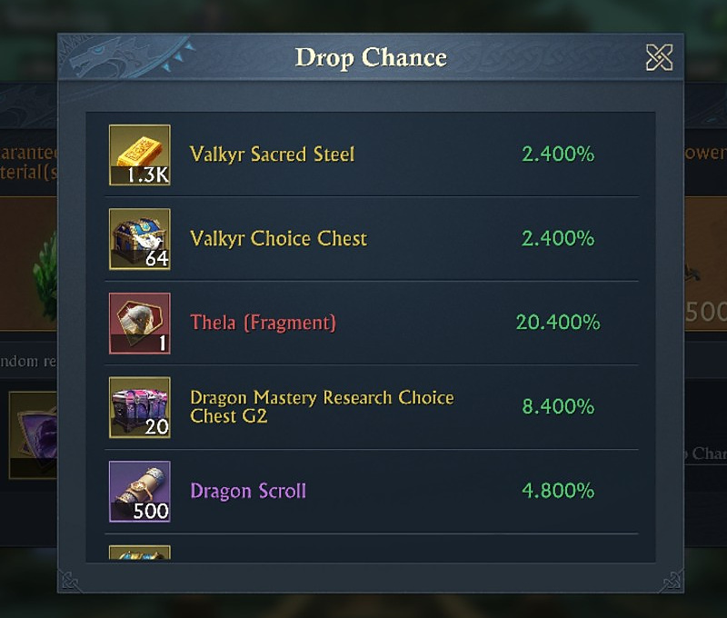
Drop Chance list, upper portion.
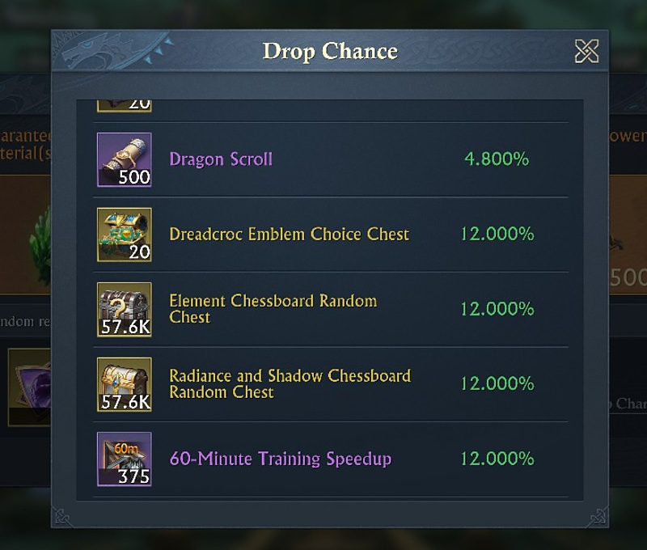
Drop Chance list, continued.

Reward visible in screenshots | Drop chance
Valkyr Sacred Steel | 2.400%
Valkyr Choice Chest | 2.400%
Thela (Fragment) | 20.400%
Dragon Mastery Research Choice Chest G2 | 8.400%
Dragon Scroll | 4.800%
Dreadcroc Emblem Choice Chest | 12.000%
Element Chessboard Random Chest | 12.000%
Radiance and Shadow Chessboard Random Chest | 12.000%
60-Minute Training Speedup | 12.000%

[CAUTION - REWARD TABLE VARIANCE] Reward table may change!
Reward pools can change by season, Kingdom Rank, and progression. Treat the live Drop Chance panel—not this captured list—as the authority for your current build.

A FOUR-HOUR PRODUCTION TOOL - IF NOBODY TOUCHES IT
Part IX - Mining Battletower: Ore Drill

The Ore Drill is wonderfully straightforward: place it on a Mine, get a flat +100 per hour, and watch its durability tick down. The useful part is doing the durability math, because that tells you exactly what a clean Drill is worth and what every loot hit costs you in remaining life.
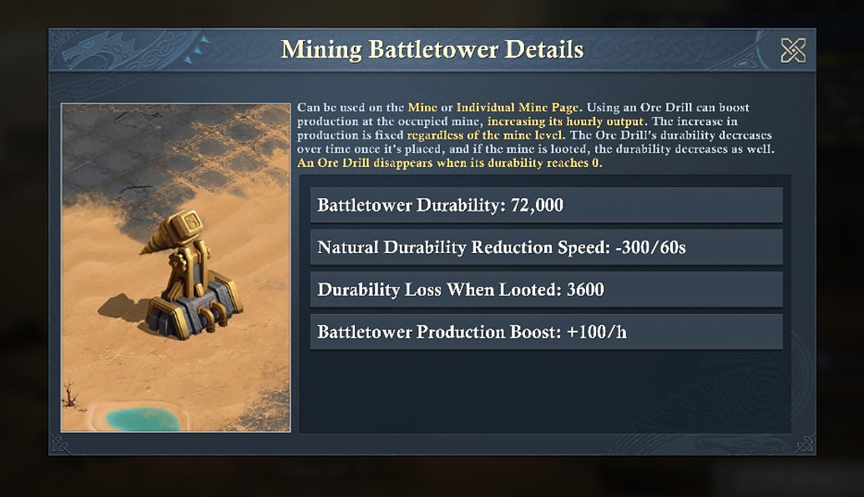
Ore Drill / Mining Battletower stats: 72,000 durability, -300 durability per 60 seconds, 3,600 durability lost when looted, +100 production per hour.
Stat | Screenshot value | What it means
Durability | 72,000 | The Drill disappears at 0.
Natural decay | -300 / 60s | 300 durability per minute.
Loot durability loss | 3,600 | A loot hit removes 5% of full durability.
Production boost | +100 / hour | Flat increase regardless of Mine level.

Note: Untouched lifespan = 4 hours
72,000 durability divided by 300 durability per minute = 240 minutes, or 4 hours. At +100/hour, a completely untouched Drill can contribute up to +400 production before natural decay destroys it.

Note: Every loot hit costs about 12 minutes of Drill life
3,600 durability divided by 300 per minute = 12 minutes. At +100/hour, 12 minutes represents up to 20 units of remaining production potential, before considering any other battle or timing effects.

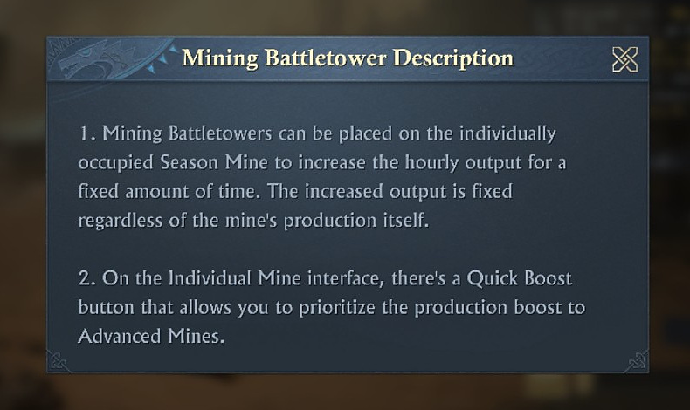
Mining Battletower rules: the production bonus is fixed regardless of Mine production, and the Individual Mine screen provides a Quick Boost option that prioritizes Advanced Mines.
[MODERATOR’S PRO-TIP] Put the flat bonus where the Mine itself matters most.
Because the Drill’s +100/hour is fixed, it does not scale upward with Mine level. The game’s own Quick Boost prioritizes Advanced Mines, though, which makes sense operationally: those are the Mines you are most likely to care about defending and keeping productive.

Season featured Research: Protecting and Killing Ore Drills
The Relic Scroll-powered featured Research branch directly changes Ore Drill durability and continues into later exploration/raid nodes. The captured tree state below shows Frequent Adventures I 5/5, Prospector’s Privilege I 5/5, Instant Mining 1/1, Demolition Master I 4/5, and Tower Durability I 4/5. Farther right, Raid Count 0/5, Fortune’s Favor II 0/5, and Deep Exploration II 0/5 are visible but locked/unresearched in the capture.
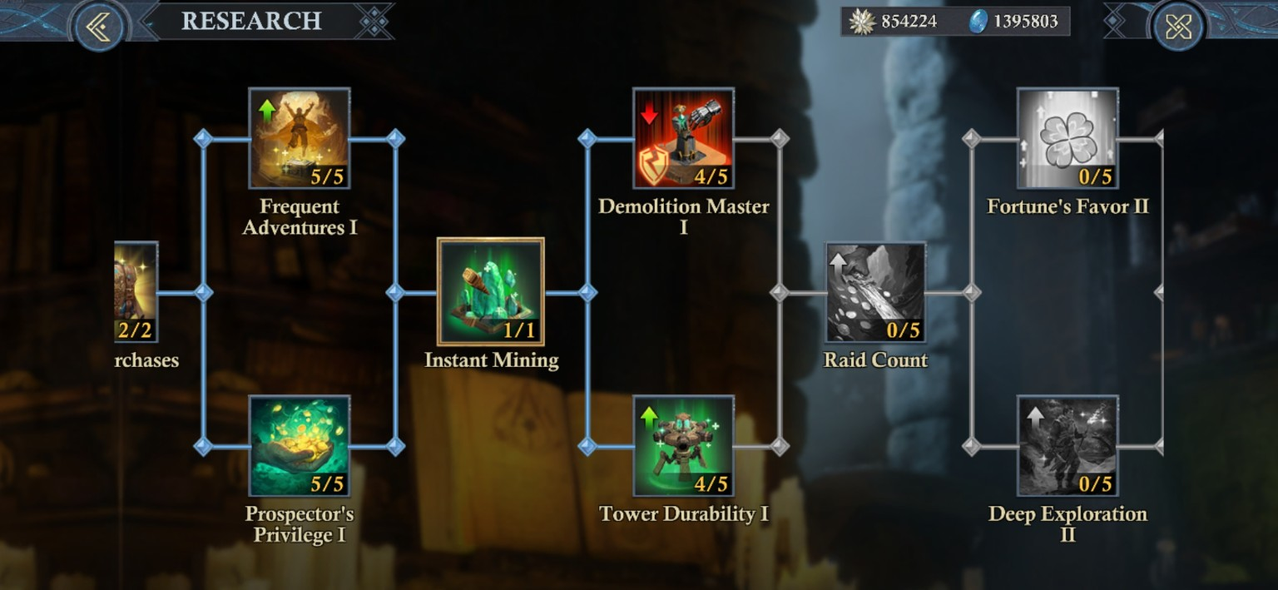
Season featured Research tree capture: Demolition Master I and Tower Durability I are both at 4/5, with additional featured nodes visible beyond them.
Research | Ranks 1-5 | Captured operational meaning
Tower Durability I | Ore Drill durability loss speed over time -2% / -4% / -6% / -8% / -10%; durability reduction when its grid is successfully looted -2% / -4% / -6% / -8% / -10%. | Defensive Drill research: slows natural durability loss and reduces the durability removed by a successful loot.
Demolition Master I | After successfully looting another player's grid, durability reduction on that grid's Ore Drill +2% / +4% / +6% / +8% / +10%. | Offensive Drill research: makes each successful loot hit remove more enemy Ore Drill durability.
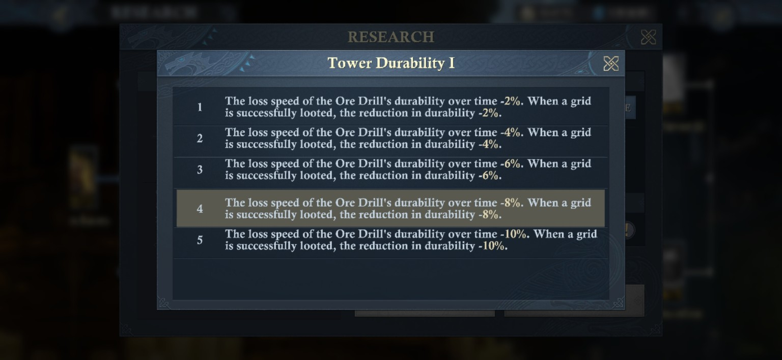
Tower Durability I level panel: the five captured ranks scale from -2% to -10% for both natural durability-loss speed and loot-triggered durability reduction.
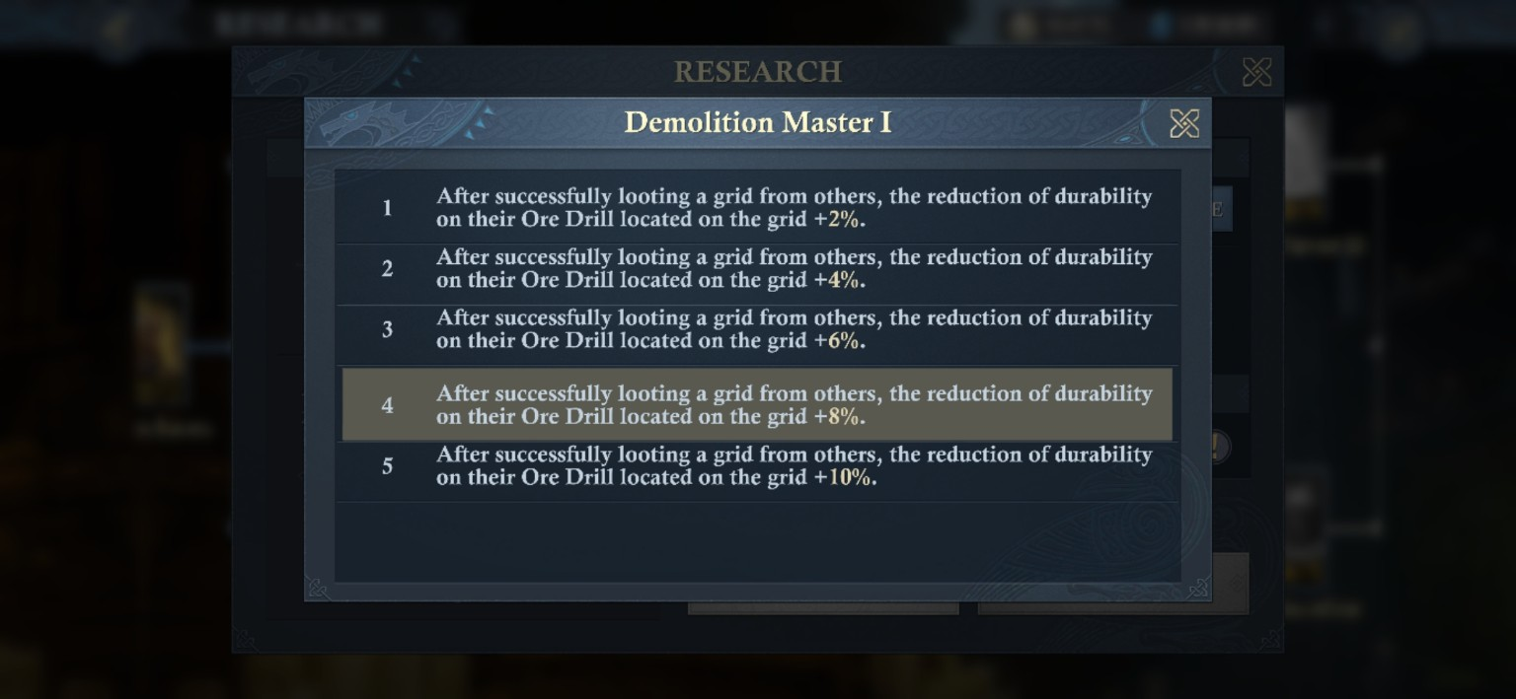
Demolition Master I level panel: the five captured ranks add +2% through +10% Ore Drill durability reduction after a successful loot.
Both 4/5 research-detail captures show the Lv.4 -> Lv.5 requirement at 150,000 Relic Scrolls, reward Empyrean EXP +4K, research time 3:45:00, and an Instant cost of 1,125 gold. Those are captured next-rank values, not a full cost table for all five ranks.
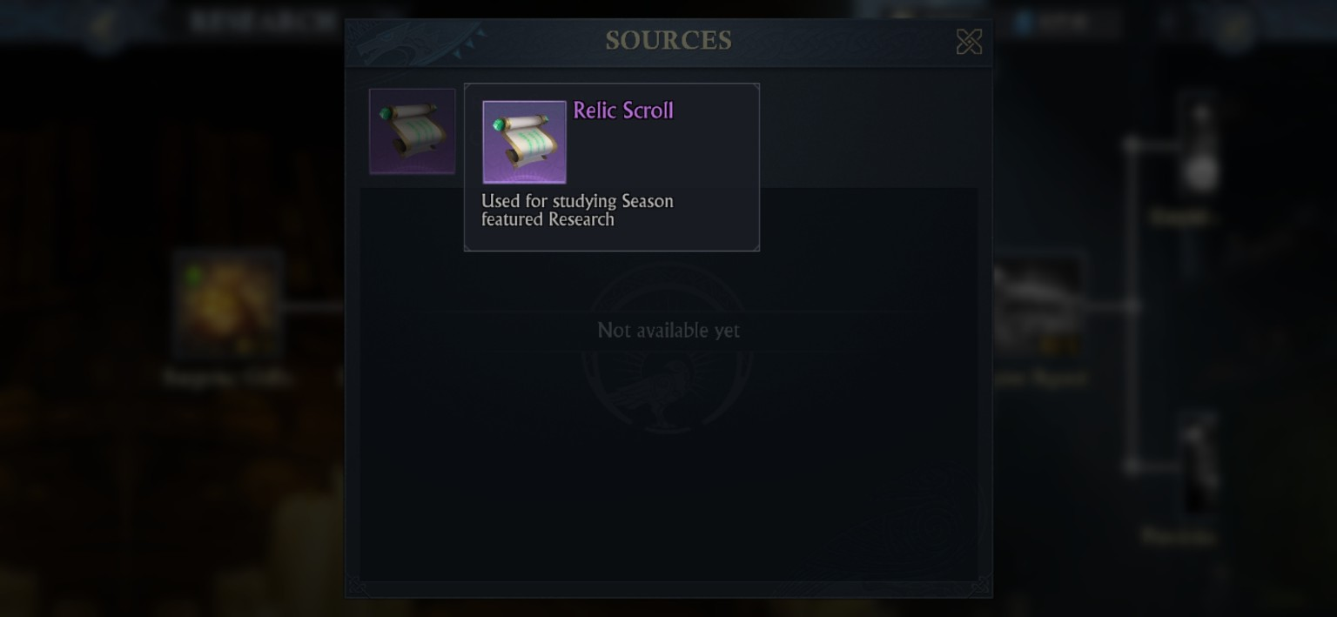
Relic Scroll source panel: the item is used for Season featured Research
[CAUTION - FORMULA NOT YET ISOLATED] Do not simply cancel +10% Demolition Master against -10% Tower Durability
Both modifiers are explicit, but the screenshots do not yet show their internal order of operations when attackers and defenders have them simultaneously. A controlled loot test with both players' research levels recorded is still needed before publishing a real, verified, combined Ore Drill damage formula.

SIEGE IS A LOADOUT PROBLEM
Part X - Guild Battletowers: Six Tools, Six Jobs

This is the section I would keep open during a Castle call. The Battletowers look similar in the menu, but their jobs are not interchangeable. One cracks walls, one pressures the Castle from range, one harasses garrisons, two keep the defense alive, and one actively punishes attacking Siege towers while reducing Adjusted Morale Damage.

The six-tower roster
Tower | Type | Primary job | Dur. | Freq. | Key verified effect
Rumblebomb Launcher | Siege - close | Wall / Defense Battletower breaker | 3,600 | 10s | Wall/Castle -100; Tower -100
Dunestone Cannon | Siege - mid | Anti-garrison / random target pressure | 3,600 | 5s | Wall/Castle -15; Tower -100; 20% chance to deal 0.20% to 1 garrison march
Rockthrower | Siege - long | Wall -> Castle pressure with splash | 3,600 | 10s | Wall/Castle -100; Tower -15; splash -15
Wall Fortifier | Defense | Damage reduction aura | 3,600 | Persistent | Building durability damage reduction +5.0%; stacks; max 4 one-time placements. Live +10% state follows the divisor formula detailed below.
Mender’s Hammer | Defense | Durability recovery aura | 3,600 | 10s | Building durability recovery +50/time; stacks; max one-time placements 4
Bulwark Cannon | Defense | Kills nearest Siege tower / morale debuff | 3,600 | 5s | Tower -100; Adjusted Morale DMG -1.4% (max 7%)

Note: Most shown Guild Battletowers have a 30-minute natural life.
The individual tower cards show 3,600 durability and natural decay of -120 per 60 seconds. 3,600 / 120 = 30 minutes if the tower takes no enemy damage and the battle does not end first. Placement timing matters too.

If an attacker garrisons a tower, or an opposing tower attacks a tower, that natural life decreases and becomes unreliable. Since demolition rate varies WIDELY based on the amount of attackers/damage sources, I will not attempt to put examples here regarding it.

Suffice it to say, the more towers you have garrisoned with friendly players than your enemy does, the stronger you will win the tower war. This is why ‘whales’ need to garrison at least 2 defensive towers, and attack other towers with their remaining marches.

Rumblebomb Launcher - close-range demolition
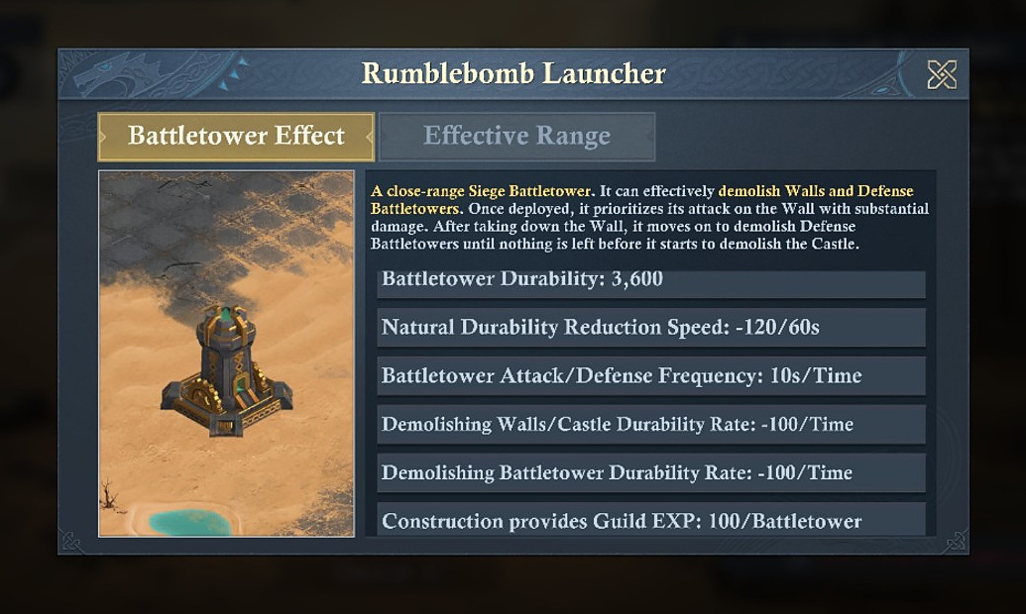
Rumblebomb Launcher: prioritizes the Wall, then Defense Battletowers, then the Castle. 3,600 durability; 10-second frequency; -100 per action to Wall/Castle and Battletowers.
[MODERATOR’S PRO-TIP] Use Rumblebombs when the close grid can stay alive.
The Rumblebomb does not nibble at the Wall - it is built to be there for the dirty work. Its weakness is obvious: close-range placement exposes it to defending cannon attacks first. If your Guild cannot protect the grid, the paper stats do not matter. IN A PINCH, this tower could sway the flow of battle when fighting another Guild/Alliance for a neutral castle, IF you can keep it up AND place it faster than the opposing Guild/Alliance.

Dunestone Cannon - mid-range anti-garrison pressure
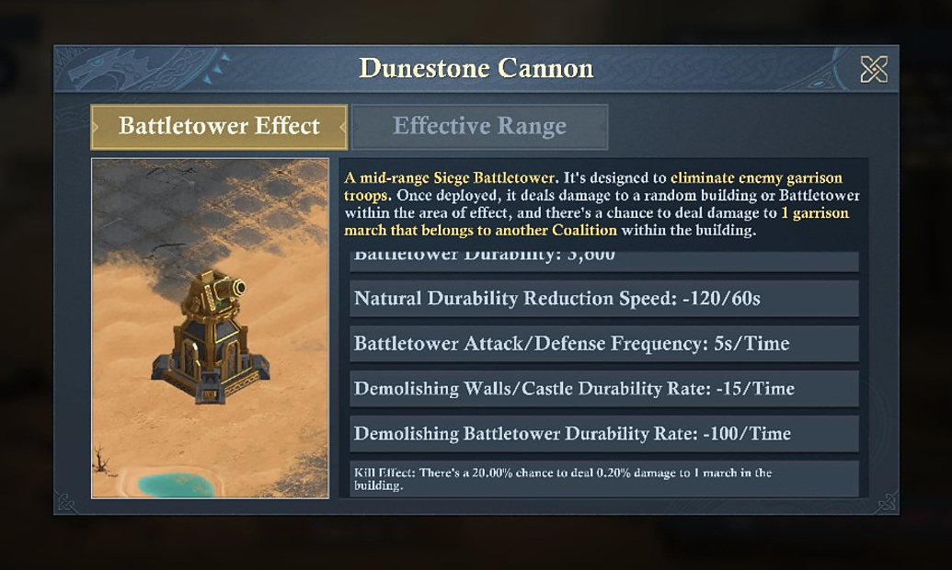
Dunestone Cannon: 5-second action frequency, -100 Battletower durability per action, and a 20.00% chance to deal 0.20% damage to one garrison march in the building.
[MODERATOR’S PRO-TIP] This tower attacks the human problem, not just the structure.
When the defender’s garrison is the thing slowing you down, the Dunestone Cannon is the one tower in this set whose description explicitly reaches into the garrison march itself. So, if you want to take the Castle but you are weaker than the opposing Guild/Alliance, having an excess of these in use against them can help make the difference, or at least keep the pressure on them.

Rockthrower - long-range Castle pressure
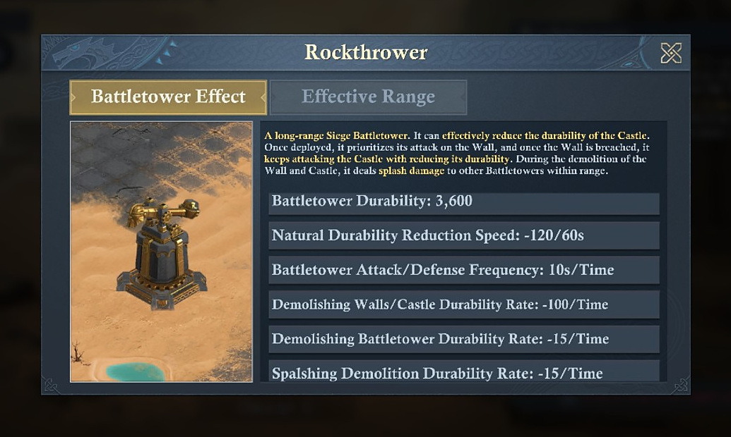
Rockthrower: long-range Wall -> Castle priority with splash damage to other Battletowers during demolition.
[MODERATOR’S PRO-TIP] Rockthrower is the safer durability pressure tool
Its long-range placement and -100 Wall/Castle action make it the natural choice when the objective is persistent structure damage, rather than clearing Defense Battletowers first. Since this does splash damage to other defensive battletowers, this one is important, but you are limited to only using up to 4 at a time.

Wall Fortifier - damage reduction
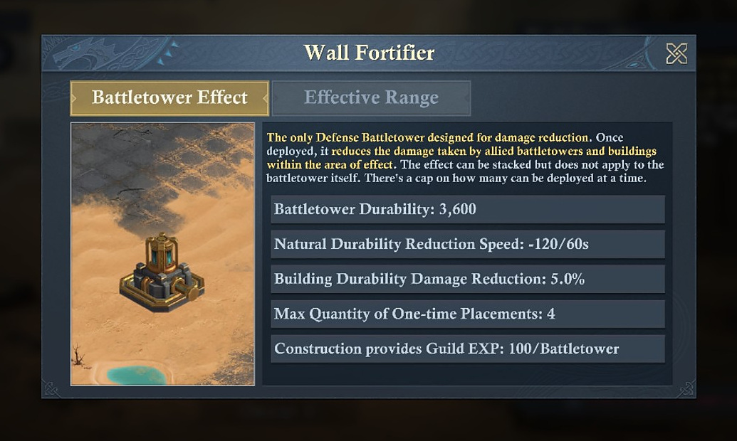
Wall Fortifier: 5.0% Building Durability Damage Reduction, stacking effect, does not protect itself, max 4 one-time placements.
[DERIVED - WALL FORTIFIER FORMULA] The stack is additive as a resistance stat, but divisor-style in the live damage result.
Each Wall Fortifier supplies +5.0% Building Durability Damage Reduction and the effect stacks. The live two-Fortifier state is +10% resistance: 2,500 / 1.10 -> 2,272 Castle occupation and 500 / 1.10 -> 454 Beacon occupation after truncation. Four Fortifiers therefore represent +20% resistance stat; if the same formula continues, that corresponds to an 83.33% incoming multiplier rather than a flat 20% subtraction. See Part III for the full observed/projection table.

[MODERATOR’S PRO-TIP] Layer Wall Fortifier coverage over the Bulwark Cannon
If you are looking to maximize defensive tower placement, overlap Wall Fortifier coverage onto the Bulwark Cannon. The Bulwark is a priority enemy target, so protecting it extends the life of the tower that is actively killing Siege Battletowers and reducing Adjusted Morale Damage.

Mender’s Hammer - durability recovery
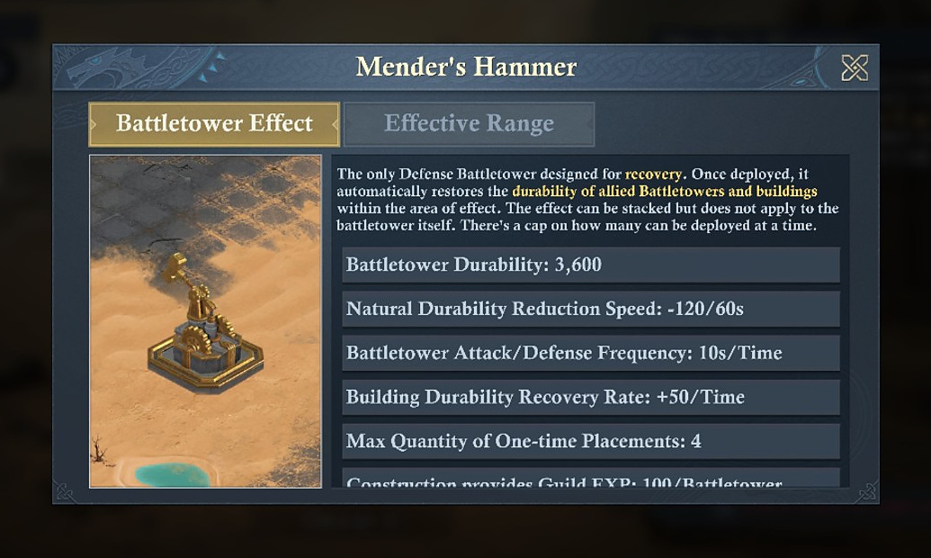
Mender’s Hammer: automatically restores allied Battletower / building durability in its area, +50 per action at 10-second frequency, stacking effect, max 4 placements at a time.

Bulwark Cannon - anti-Siege defense plus morale pressure
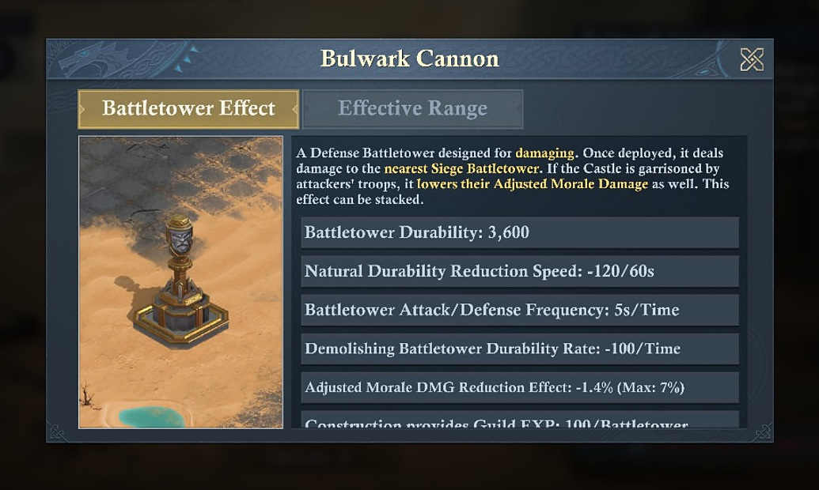
Bulwark Cannon: attacks the nearest Siege Battletower for -100 durability per 5-second action and reduces attackers’ Adjusted Morale Damage by 1.4%, up to a displayed maximum of 7%.

[MODERATOR’S PRO-TIP] Garrison the Bulwark first when the field is under pressure!
If you are looking to maximize your defensive tower placement, you should overlap the effective range of the Wall Fortifier towers on the Bulwark Cannon. If the opposing Guild/Alliance is stronger than you, having more of these on the field CAN and WILL help you defend your castle more effectively, but should always be combined with fortifiers for maximum anti-battletower effectiveness. Smart enemies will attack and demolish these buildings first, so your strongest allies should focus on garrisoning these defensive towers FIRST.

Range and grid logic
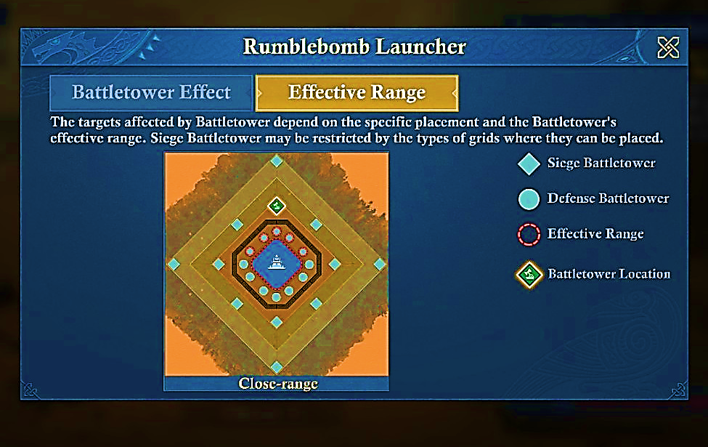
Rumblebomb: close-range Siege grid.
[MODERATOR’S PRO-TIP] Pay careful attention to the Effective Range.
The image is blown up and sharpened, with higher saturation, but the effective range is still hard to see. The small circles around the center castle are where enemy defensive towers will be. The image is showing a possible placement of a Rumblebomb Launcher, on the north corner of the castle. The three circles in front of it have a red-dotted circle around them, as well as the next circle on either side. This is its effective range. Therefore, each Rumblebomb Launcher can overlap 2 defensive structures on each side, for a total of 4 overlapping defensive structures within its range.

WHEN IN PVP: It is best to focus these on their Bulwark Cannons, as they deal the most damage. However, your best defenders should garrison these first, since they do the most damage, and will likely be targeted by the enemy first. There is no limit to how many enemy defensive structures can be attacked at the same time, but there is a limit to how many allied structures can be defended… which is 2.
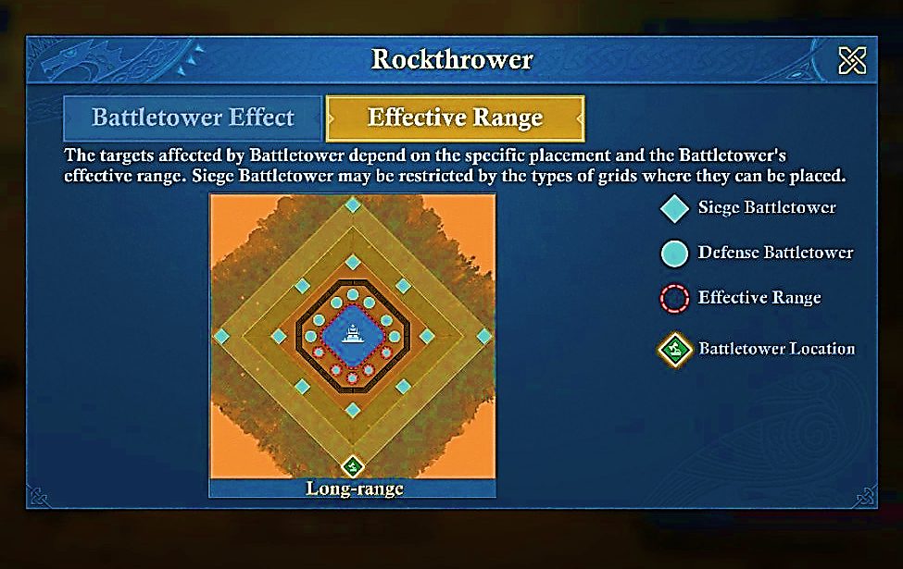
Rockthrower: long-range Siege grid.
[MODERATOR’S PRO-TIP] Pay careful attention to the Effective Range.
The image is blown up and sharpened, with higher saturation, but the effective range is still hard to see. The small circles around the center castle are where enemy defensive towers will be. The image is showing a possible placement of a Rockthrower, on the far-south corner of the castle. The three circles in front of it have a red-dotted circle around them, as well as the next circle on either side. This is its effective range. Therefore, each Rockthrower can overlap 2 defensive structures on each side, for a total of 4 overlapping defensive structures within its range.

WHEN IN PVP: It is best to focus these on their Bulwark Cannons, as they deal the most damage. However, your best defenders should garrison these second, since they do the second-most damage, and will likely be targeted by the enemy second -unless they are just looking to get into something quickly, or if it is ungarrisoned. There is no limit to how many enemy defensive structures can be attacked at the same time, but there is a limit to how many allied structures can be defended… which is 2, so plan accordingly.

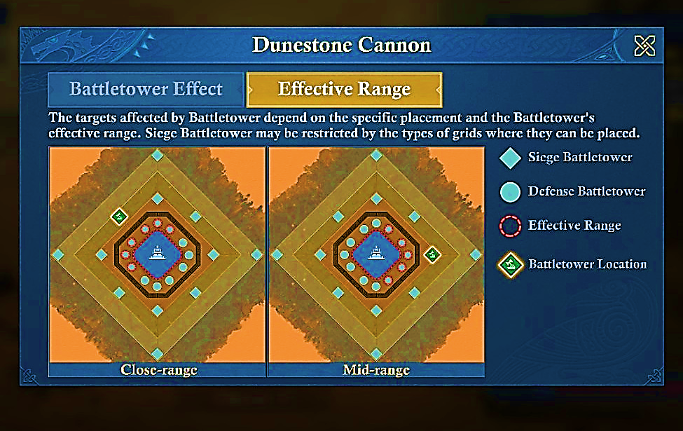
Dunestone Cannon: effective target area depends on the permitted grid / placement.
[MODERATOR’S PRO-TIP] Pay careful attention to the Effective Range.
The image is blown up and sharpened, with higher saturation, but the effective range is still hard to see. The small circles around the center castle are where enemy defensive towers will be. The image is showing a possible placement of a Dunestone Cannon, on the northwest/middle of the castle for close-range; the eastern corner of the castle for mid-range. For mid-range use: the three circles in front of it have a red-dotted circle around them, as well as the next circle on either side, meaning it can attack up to 5 spots. For close-range: you can attack the defensive buildings on an entire side of the castle, or up to 6 targets. If you only use close-range, you will have each tower overlapping every tower.

WHEN IN PVP: While these are able to help destroy defensive structures, their REAL value is in their ability to sway the fight in your favor, especially in longer battles. This is because of the damage they inflict on enemy troop counts in defensive buildings and the castle itself. If the field is flooded with these instead of Rumblebomb Launchers, durability will decrease at a slower rate, but enemy troop count will decline faster. This is especially useful when launching rallies against a (technically) stronger enemy garrison.
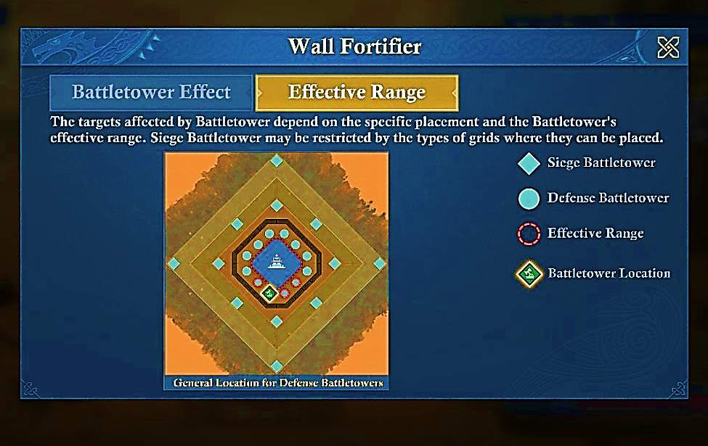
Defense towers use the central Defense Battletower locations around the Castle.
[MODERATOR’S PRO-TIP] Pay careful attention to the Effective Range.
The image is blown up and sharpened, with higher saturation, but the effective range is still hard to see. The small circles around the center castle are where defensive towers will be. The image is showing a possible placement of a Wall Fortifier, on the south side of the castle for close-range support; the two circles to the right of it have a red-dotted circle around them, as well as the one circle on the other side, meaning it can boost defense for those 3 spots. If placed in the defensive spot to the right of the current projected spot, the effective range circles would be flipped.

WHEN IN PVP: The best place to put a Bulwark Cannon would be on the second circle away from the Fortifier on the right side, and on the circle next to the Fortifier on the left side. A healing tower should go in the circle spot immediately to the right of the Fortifier, in this image -unless you need more Morale reduction or to kill the enemy cannons faster. Doing so, however, weakens the overall strength of the defense -but is nevertheless useful in some circumstances.

Construction: Workshops decide what your Guild can build
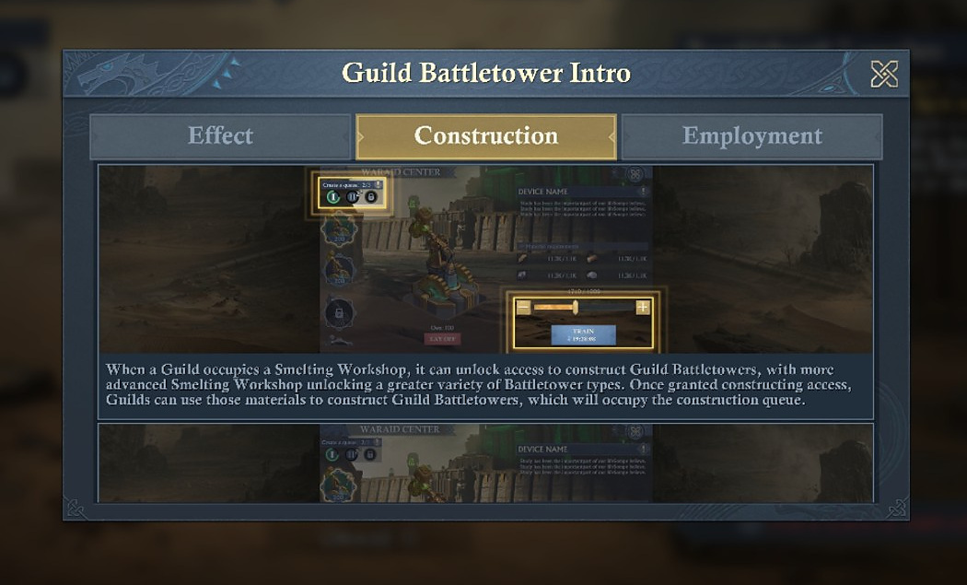
Battletower Construction intro: occupying a Smelting Workshop grants construction access; more advanced Workshops unlock a wider tower selection.
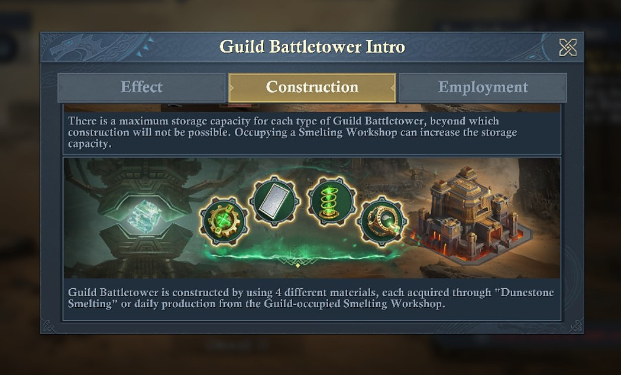
Guild Battletowers use four different crafting materials. Materials come from Dunestone Smelting and daily production from Guild-occupied Smelting Workshops.
Construction rule | Screenshot-verified behavior
Queue | Battletower crafting occupies a construction queue.
Automatic completion | Each tower is obtained as soon as its own construction finishes; a batch does not need to finish before collection.
Cancel | Construction can be canceled; materials for items still under construction are refunded.
Swift Hammering | Guild Talent “Swift Hammering” can instantly complete all Guild Battletowers currently being crafted.
Storage | Each tower type has a storage limit; occupying Smelting Workshops can increase that limit.
Materials | Four different Guild Battletower materials are used; Dunestone Smelting and Workshop daily production supply them.

[CAUTION - BUILD VARIANCE] 40 and 21 are not universal hard caps for Battletowers.
Earlier images show Siege/Defense storage values such as 30 / 15. Later Workshop-state screenshots show 40 / 21. That is exactly what the construction rules say: Smelting Workshop occupation can increase storage capacity for battletowers. Use the live Guild Battletower screen for your current cap.

Battletower - Workshop unlock requirements
Tower | Unlock text visible in supplied screenshots
Rockthrower | Guild occupies Upgraded Smelting Workshop Lv.4.
Wall Fortifier | Guild occupies Upgraded Smelting Workshop Lv.4.
Mender’s Hammer | Guild occupies Upgraded Smelting Workshop Lv.4.
Bulwark Cannon | Guild occupies Advanced Smelting Workshop Lv.6.
Rumblebomb Launcher | Guild occupies Basic Smelting Workshop Lv.2.
Dunestone Cannon | Guild occupies Basic Smelting Workshop Lv.2.

Employment/Deployment: What happens once the Castle enters battle?
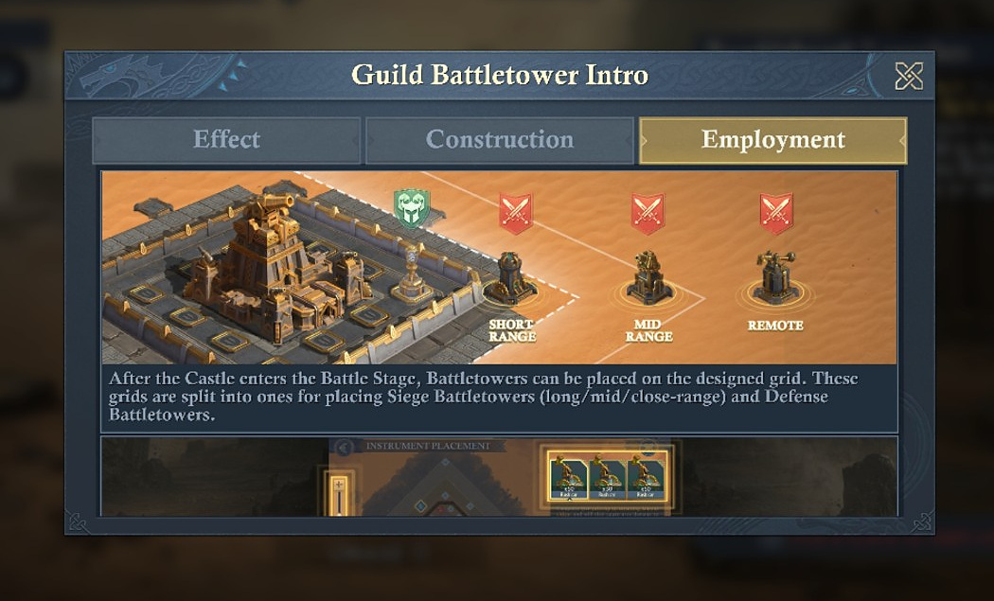
Battletowers are placed on designated grids divided between Siege ranges and Defense positions.
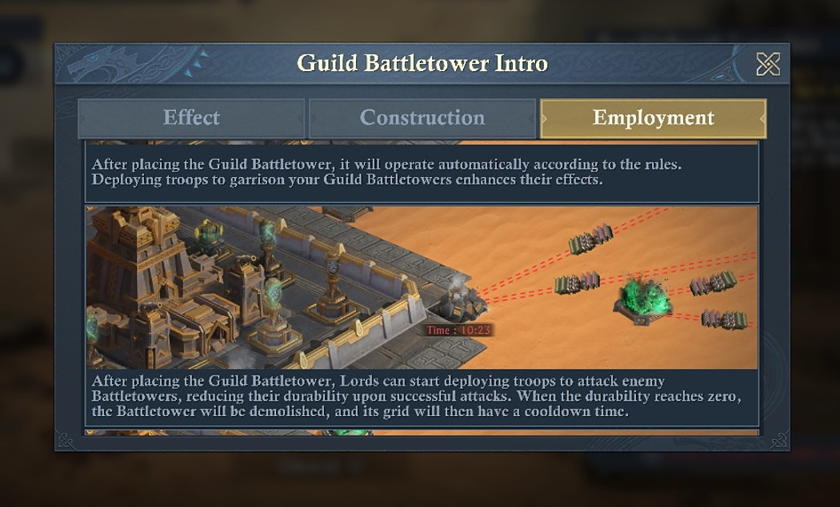
Once deployed, Battletowers operate automatically. Enemy Lords can attack them; successful attacks reduce tower durability.
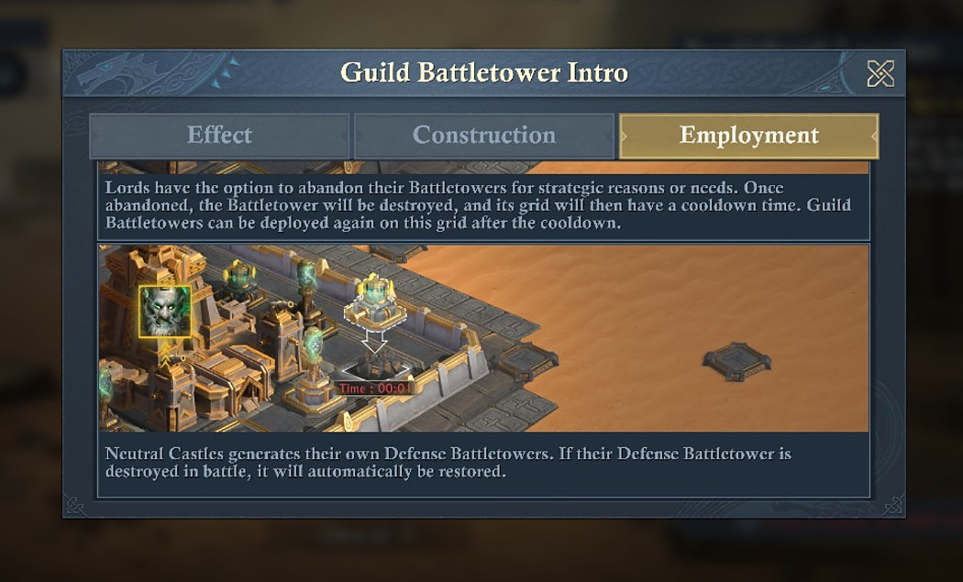
Neutral Castles generate their own Defense Battletowers, and a destroyed neutral Defense Battletower is automatically restored.
Battle Aspect | What it means/does:
Placement | Eligible Guilds choose a permitted grid and tower; the interface previews the tower’s effective area.
Automatic operation | Once placed, the tower performs its role automatically.
Garrison | At least 2 Lords from the same Coalition must garrison a Guild Battletower to activate the captured efficiency benefit. Rumblebomb Launcher and Dunestone Cannon captures show Battletower Effect Efficiency +20.0% when Activated.
Destruction | At 0 durability the tower is destroyed and that grid enters cooldown.
Abandon | A Lord can give up a Battletower deliberately; it is destroyed and the grid cools down.
Sword Tower expiry | If all attacker Sword Towers expire, the Castle battle stops and all Guild Battletowers are destroyed.
Siege timer end | All Guild Battletowers are destroyed when the Castle Siege Battle Time ends.
Neutral defense | Neutral Castle Defense Battletowers regenerate automatically after destruction.

Battletower garrisons: two Lords unlock the captured +20% efficiency state
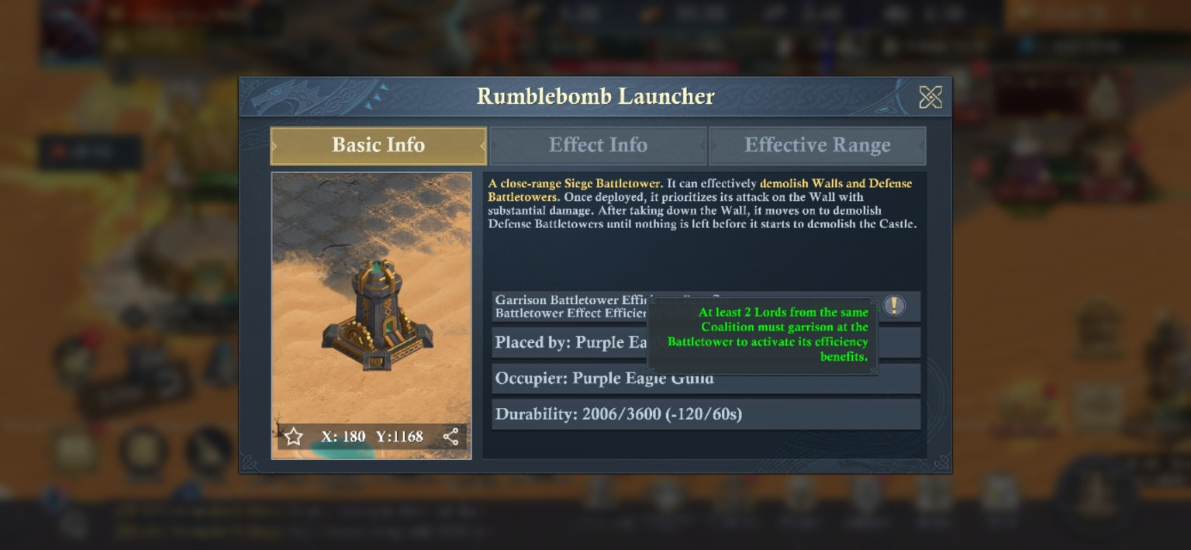
Rumblebomb Launcher garrison tooltip: at least 2 Lords from the same Coalition must garrison the Battletower to activate its efficiency benefits.
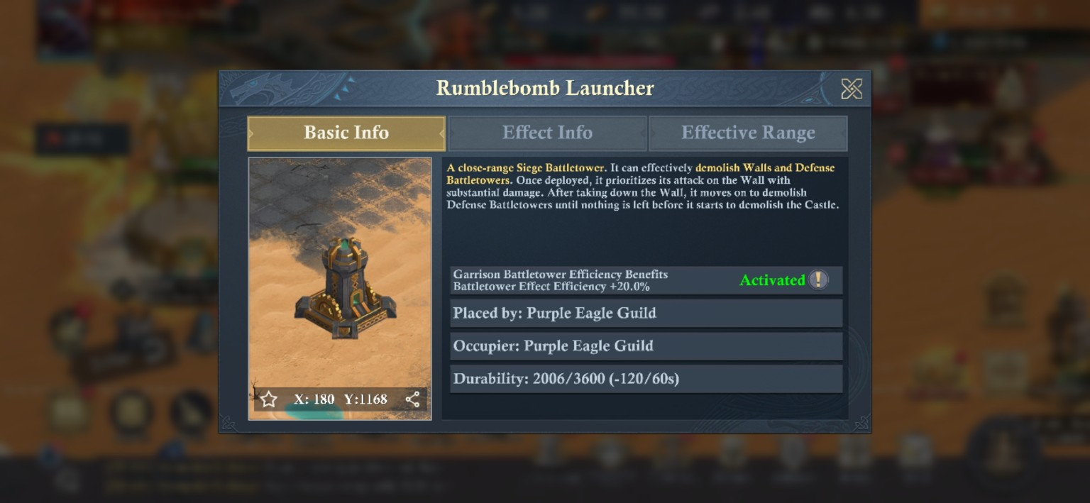
Activated Rumblebomb Launcher state: Battletower Effect Efficiency +20.0%. The Dunestone Cannon capture shows the same +20.0% activated value.
[MODERATOR’S PRO-TIP] Staff the tower crews separately from the objective teams
A coalition with strong participation can run two-Lord tower crews while still filling Castle/Beacon garrisons and cycling monster hunters. Leaving a Siege Battletower ungarrisoned sacrifices the captured +20% efficiency state, and over a long durability race… that is a real opportunity cost.

BOUNTIES, TRIALS, POPULAR SUPPORT
Part XI - World Activities: Small Screens, Real Value

Not every useful season activity sits inside the war plan. A few world-map systems hand out direct rewards or feed season progression in the background, like Secret Bounties!

Treasure Troves - A Change from the Norm
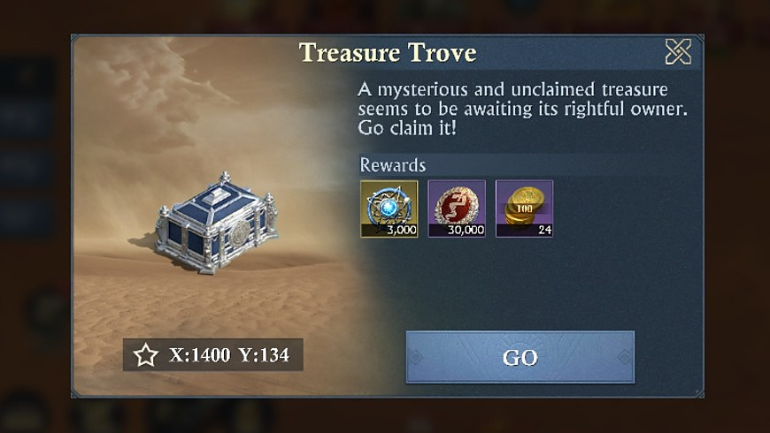
Treasure Trove example: the game provides coordinates and a direct GO button. Reward bundles vary between captured examples.
[MODERATOR’S PRO-TIP] Not all Secret Bounties are created equal!
The image shows an example of ‘Treasure Trove’, which used to provide hero shards and other things, but now some provide healing coins -when only the Bandit Camps provided those before. It is possible that this is also a part of the new Kingdom-specific changes, dependent upon Kingdom Rank at the time the season started.

Secret Bounty board: quality, stamina, and fixed march time
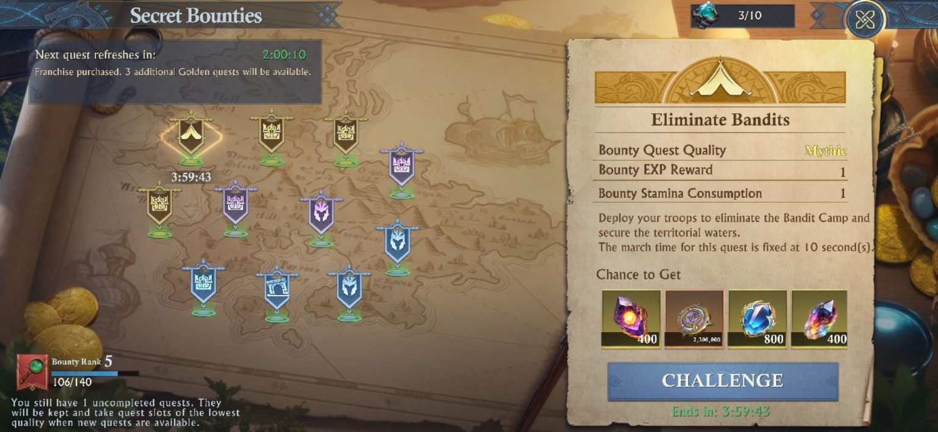  Mythic Eliminate Bandits example |  | 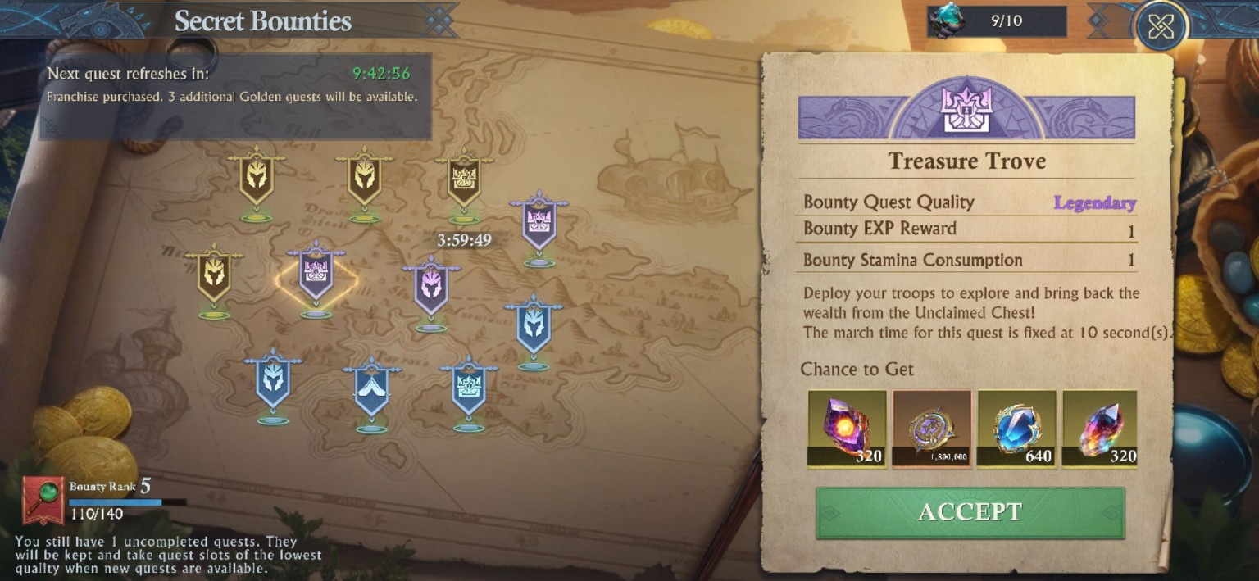  Legendary Treasure Trove example
[NOTE:] The Secret Bounty board reveals more than the two reward examples.
The captured board is at Bounty Rank 5 (106/140 in one capture and 110/140 in another), shows a visible quest-refresh countdown, and warns that unfinished quests are kept and occupy the lowest-quality quest slots when new quests become available. The top-right icon counter was captured at 3/10 and 9/10, and represents how many of the daily 10 are left.
Captured example | Quality | Shared rules visible
Eliminate Bandits | Mythic | Bounty EXP Reward 1; Bounty Stamina Consumption 1; fixed 10-second march.
Treasure Trove | Legendary | Bounty EXP Reward 1; Bounty Stamina Consumption 1; fixed 10-second march.
The captured board also states: “Franchise purchased. 3 additional Golden quests will be available.” Reward bundles differ by quest quality/type; the visible Mythic example shows larger quantities than the captured Legendary example, but these two screens are examples, not a universal reward table.

Bandit Camps
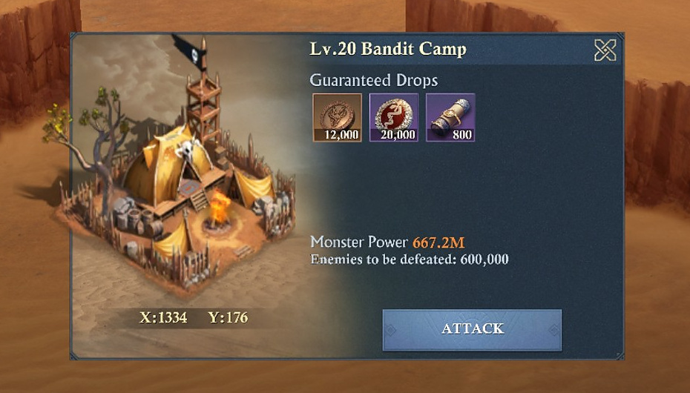
Lv.20 Bandit Camp example: Monster Power 667.2M, 600,000 enemies to defeat, and three guaranteed reward icons including 800 Dragon Scrolls.

Endless Trials/ The Dark Spire: 1 base attempt, 3 with Covenants, no Stamina needed
The Endless Trials help screen shows the Dark Spire / Ancient Wraith challenge loop. A successful monster kill immediately issues rewards and consumes a challenge attempt; the captured screen shows Daily Attempts 3/3. Monster challenges do not cost Stamina, and each rally can contain up to the rally max of the player initiating the rally.
[MODERATOR’S PRO-TIP] Spend Trials attempts on the highest Wraith level you can reliably clear yourself, or with a friend in the alliance.
The help text explicitly says higher monster levels give greater rewards. Covenants adds +2 Endless Trials attempt, so Covenant players should account for the extra daily clear in their routine… helping non-covenant players to do ones at higher level – since they will naturally be able to do higher level Dark Spires.
[CREATOR’S NOTE] A final guide can still contain known unknowns.
The point of the Gold Edition is not to pretend every hidden formula has been reverse-engineered. It is to make the verified rules, the moderator-confirmed live behavior, the cleanly derived math, and the remaining boundaries obvious enough that a player can plan without being misled.

Appendix - How to read derived numbers in this guide
Derived item | Math / reasoning
Ore Drill natural life | 72,000 / 300 per minute = 240 minutes = 4 hours.
Ore Drill untouched bonus | 4 hours x 100/hour = +400 maximum theoretical production.
Ore Drill loot-time loss | 3,600 / 300 per minute = 12 minutes of natural life; 3,600 is 5% of 72,000.
x10 Smelting guarantee | 10 x (500 Mining + 500 random Guild material) = 5,000 + 5,000.
Guild Battletower natural life | 3,600 / 120 per minute = 30 minutes for tower cards showing those shared values.
Visible Guild EXP caps | 20,000 + 30,000 + 2,500 = 52,500/day for the three displayed lines.
Battletowers to fill visible construction EXP | 2,500 / 100 = 25 completed Battletowers if each completion contributes the shown 100 EXP.
Why visible EXP is incomplete | 2,780,000 / 52,500 ≈ 52.95 days, longer than the ~5-week season description.
Castle base occupation | Captured clean base = 2,500 durability/min.
Beacon base occupation | Captured clean base = 500/min. Four Beacons = 2,000/min raw if one coalition controls all four.
Castle + four Beacons raw occupation | 2,500 + (4 x 500) = 4,500/min before garrison bonuses, Fortifiers, Siege Battletowers, monsters, or recovery.
Two-Fortifier Castle base | floor(2,500 / 1.10) = 2,272/min, matching the live screenshot.
Two-Fortifier Beacon base | floor(500 / 1.10) = 454/min, matching the live screenshot.
Observed +28% Castle bonus after Fortifiers | floor(2,272 x 0.28) = 636; 2,272 + 636 = 2,908/min.
Observed +8% Beacon bonus after Fortifiers | floor(454 x 0.08) = 36; 454 + 36 = 490/min.
Combined clean Castle occupation-Research bonus | 1,350 / 2,500 = 54%; 2,500 + 1,350 = 3,850/min. The parenthetical can include Strategic Mind leader bonus plus Strong Garrison joiners.
Strong Garrison I minimum headcount | With max Strategic Mind I: 54% - 20% leader bonus = 34% from joiners; ceil(34% / 10% max Strong Garrison I per joiner) = 4 joiners minimum. Two are known maxed, so at least two additional joiners are needed in that minimum case.
Coalition cumulative demolition proof | 2,750 occupation + 4,895 monster kills + 5,308 Siege Battletowers = 12,953 total demolished durability.
Live demolition-rate proof A | 3,000 occupation + 3,056 Siege = 6,056/min.
Live demolition-rate proof B | 3,850 occupation + 3,213 Siege = 7,063/min.
Live demolition-rate proof C | 3,850 occupation + 39 Siege = 3,889/min.
Veteran Hunter I Lv.20 validation | 80 base Castle durability x 50% = +40; 98 Military Merit x 25% = 24.5, displayed as +24 after truncation.
Veteran Hunter I Lv.30 validation | 110 base Castle durability x 50% = +55; 140 Military Merit x 25% = +35.
Mender base rate | +50 durability every 10 seconds = 300/min per covered Mender before other modifiers. 600/min is consistent with two full-rate Menders, but the captured 100/min state is not yet decomposed.
Conditional final-battle lead threshold | If the only remaining final objective can swing 200 Command Points, a 201+ lead cannot be erased by that single capture.
Castle-monster attempt recharge | 15-attempt pool; moderator-confirmed +1 attempt every 20 minutes = 3 attempts/hour while below cap.
Lv.20 max-Veteran-Hunter opening pool | 15 x (80 + 40) = 15 x 120 = 1,800 durability per full-pool player.
Lv.30 max-Veteran-Hunter opening pool | 15 x (110 + 55) = 15 x 165 = 2,475 durability per full-pool player.
Twenty-player Lv.30 opening burst | 20 x 2,475 = 49,500 durability before any 20-minute recharge ticks.
Captured Daily quest research-resource total | 10 x 18.4K Stone Flowers = 184K/day; 10 x 9.2K Fantasy Gems = 92K/day.
Captured Week 7 research-resource total | 18 x 60K Stone Flowers = 1.08M; 18 x 30K Fantasy Gems = 540K.
Captured recurring weekly quest budget | 7 x Daily set + Week 7 set = 2.368M Stone Flowers + 1.184M Fantasy Gems, if the captured Daily set repeats unchanged for seven days.
Captured Chapter 7 research-resource total | 10 x (50K Stone Flowers + 25K Fantasy Gems) + chapter chest (160K + 80K) = 660K Stone Flowers + 330K Fantasy Gems.
Observed Mine-capacity growth between two captures | 27 - 14 = 13 additional Mine slots between the earlier 14/14 state and late-season 27/27 state; attribution among Research/Quests/Covenant/Castles is not isolated.

[CAUTION - DERIVED DOES NOT MEAN GUARANTEED] Math is only as universal as the inputs
These calculations are clean arithmetic from screenshot values. If the game changes a value by stage, Workshop level, build, or future patch, the result changes with it. That is why every derived number stays tied to the image that supplies its inputs.

