Solar Damage Stats
Disclaimer: The following guide is created by MODs using game data and observations. Please be aware that event content and rewards are subject to change. Check in regularly and if you have any issue or questions, please contact KOA moderators. Please also visit our FAQ section on the KOA Discord server.

Compiled by: K10228.Beneger the Fair & K10300.The Templars of Glory

Last Updated: 2023–12-1

Introduction
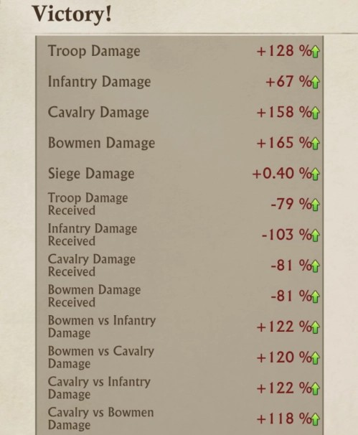
Damage stats can have a large impact on the PvP battleﬁeld. In solar, there are a variety of ways to increase your various damage stats including but not limited to, research, dragon upgrades, hero upgrades and prestige levels. The following methods require a certain stronghold level to unlock:

- Prestige is unlocked at stronghold 15 and further unlocked for each applicable building once they reach level 15, as well. For the cost of each level of Prestige, please check out the Prestige Banner Sheet and select the Solar tab.

- The Elder Dragons are unlocked at stronghold 25. Each Elder Dragon will acquire your regular dragon’s abilities and statistics, including draconic and emblems. However, you can then upgrade your Elder Dragon’s body parts to further increase stats.

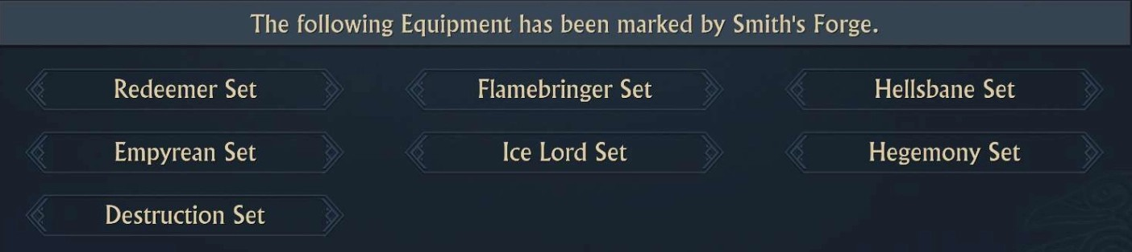
The remaining methods unlock through natural progression of the game, or procurement of items/equipment, and are not solely tied to stronghold level. For example, “Smith’s Mark” is activated by equipping an entire set of equipment bearing Smith’s Mark. Icelord Equipment (R5) and above bear the “Smith’s Mark” and can be combined with other tiers (R5+) to complete a full set and earn stat beneﬁts.
To learn about the other methods through which damage stats can be increased, please see the table below.

Damage Stat | Prestige Skills | Smith's Mark* | Research | Dragon Skills & Benefits | Elder Dragon | Hero Bonds | Skyloft Garden
Bowmen Damage | Range | Y | Alliance | Flaming Arrows (Against Cavalry) | Dragon Claw (Fire) Dragon Claw (Water) | Rise of Glory | The Oak of Tintagel
Bowmen Damage Received  Reduction | Siege Workshop | Y |  |  | Dragon Scale (Fire) Dragon Scale (Water) | Rise of Glory | The Oak of Tintagel
Bowmen vs Cavalry Damage | Embassy
Bowmen vs Cavalry Damage Reduction | Forge
Bowmen vs Infantry Damage | Trading Post |  |  | Flaming Arrows (Against Infantry)
Cavalry Damage | Stable | Y | Alliance | Cavalry Claw (Against Bowmen) | Dragon Claw (Storm) Dragon Claw (Water) | Monarch Strike | The Bell Tower of Tintagel
Cavalry Damage Received  Reduction | Trap Factory | Y |  |  | Dragon Scale (Storm) Dragon Scale (Water) | Monarch Strike | The Bell Tower of Tintagel
Cavalry vs  Bowmen Damage | Watchtower |  |  | Cavalry Claw (Against Bowmen)
Cavalry vs  Bowmen Damage Reduction | Dragon Lair
Cavalry vs Infantry Damage | Hall of War |  |  | Cavalry Claw (Against Infantry)
Infantry Damage |  | Y | Alliance |  | Dragon Claw (Earth) Dragon Claw (Water) | Champions of the Dragon | Statue of the Lady
Infantry Damage Received  Reduction | Barracks | Y |  |  | Dragon Scale (Earth) Dragon Scale (Water) | Champions of the Dragon | Statue of the Lady
Infantry vs  Bowmen Damage Reduction | University |  |  | Infantry Backbone (Against Bowmen)
Infantry vs Cavalry Damage Reduction | Storehouse |  |  | Infantry Backbone (Against Cavalry)
March Capacity** | Wishing Well |  | Individual | March of Fury |  | Rise of Glory Monarch Strike

Damage Stat | Prestige Skills | Smith's Mark* | Research | Dragon Skills & Benefits | Elder Dragon | Hero Bonds | Skyloft Garden
Troop Damage | Stronghold | Y |  | Rain of Fire Dragon Star Evolution | Dragon Heart Dragon Claw (Fire, Storm &  Earth) | Rise of Glory, Monarch Strike Champions of the Dragon | Christmas Carousel Christmas Hot Air Balloon Dazzling Christmas Tree Frostflame Citadel Frostflame Hall Frostflame Sanctuary
Troop Damage Received  Reduction | Wall | Y |  | Dragon Star Evolution | Dragon Scale (Fire, Storm & Earth) | Rise of Glory, Monarch Strike, Champions of the Dragon | Christmas Carousel Christmas Hot Air Balloon Dazzling Christmas Tree Frostflame Citadel Frostflame Hall Frostflame Sanctuary
*Smith’s Mark: Equipping an entire set of equipment bearing Smith’s Mark will activate the Smith’s Mark beneﬁts. Icelord Equipment (R5) and above bear the Smith’s Mark and can be combined with other tiers (R5+) to complete a full set.
** March Capacity can also be increased by increasing the level of the stronghold, increasing hero levels, activating the city buff, temporary relics (i.e Crown of Command, Superior Sword from Corgi Race Event, etc.), and Lord Talents.

