Which measurement next? A pattern proposer for the Δ-probed IR pipeline
Standout module of the Udacity capstone (plan 05) — report generated from the executed notebook
Frederic Petrignani — results of 2026-09-30 12:48; proxy-level (DFT against DFT) throughout

Overview
Every molecule of the pipeline has a table of vibrational couplings that we can only afford to know in part: each entry costs an expensive coupled-cluster energy. The recovery reconstructs the table from a small number of pattern responses and stops when its held-out residual is low enough. This module asks whether a network that has only seen other molecules can choose the order of measurement better than the fixed recipe, and, once the first experiment was read, whether the recipe's candidate list should reach every pair of modes at all. It is a simulation with no new quantum chemistry: the corpus's cheap-against-cheap Hessians give the full table for 289 molecules, hence the exact response of any pattern.
On the band pool the learned order reaches the halfway point with 0.17 (parents) / 0.17 (substituted) of the fixed order's energies (oracle 0.06 / 0.07); on the all-pairs pool the fixed order itself ends at ρ_off 0.08 where the band deck ends at 0.53, and the learned order reaches 0.3 at 1.35× the whole band deck (oracle 0.45×). Feedback during measurement helps the blind order and not the scorer's halfway point; the gap to the oracle is knowledge. Stages 1–3 of the fair-chance search moved the validation Spearman from 0.611 to 0.648 (P1 0.582); nothing about the learned representation is licensed before stage 5.
Data
289 molecules of the plan-05 corpus (layers A, A2, B; ωB97X − B3LYP couplings), exported once per molecule with their modes, frequencies, atomic participations, low-level Hessian, the full coupling difference (the answer, used only for the oracle and the truth-based read-outs) and the probe deck's patterns with their exact responses. Splits are hashed and were fixed before the first run: the parents (unsubstituted aromatics, larger than any training molecule) are evaluation only; substituted molecules 70/10/20 train / validation / evaluation. Nothing is chosen on the evaluation molecules.
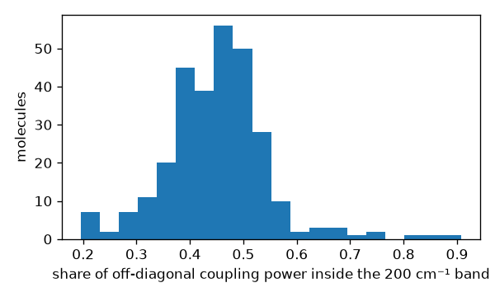
Figure 1. Share of the off-diagonal coupling power that lies inside the 200 cm⁻¹ band the fixed recipe covers, per molecule (289 molecules; mean ≈ 0.45). The other half lies between modes of different frequency that move the same atoms.
Method
The recovery consumes the single-mode block, then the off-diagonal patterns in a given order; after every stride it solves the banded-ℓ₁ reconstruction (FISTA, warm-started, λ chosen on held-out patterns) and records the held-out residual ρ_off — the pipeline's own stopping quantity, which needs no truth. Orders compared: P0, the deck's hashed order (the fixed recipe); P1, a small network on 21 hand-made pair features; P2, a learned molecular representation (the equivariant body of module 05, unchanged, feeding a per-mode embedding and a pair head); P12, their z-score average; P3, the oracle that knows the answer (a ceiling, never available in practice). A pattern's score is the mean over the pairs it touches. Adaptive variants (P0+A, P1+A, P2+A) re-rank the remaining patterns after every checkpoint by the current reconstruction, with optimism for pairs no measured pattern has touched — a correction that the planted dry run forced before any real molecule ran.
Pass lines, predictions and the reading order were written before each run (pre-registration of 26 September 2026 with dated amendments). The learned representation is protected by a fair-chance rule: no sentence about it before a five-stage search (recipe, loss, capacity, data growth, pretraining), each stage read on the validation split by the ordering metric with a margin fixed before the numbers.
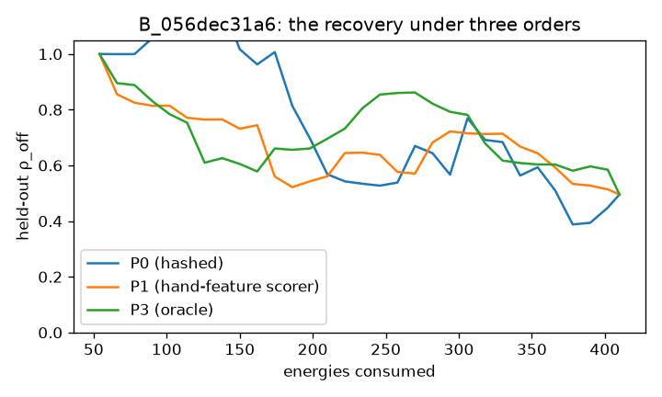
Figure 2. The recovery replayed live on one small molecule (B_056dec31a6, 27 modes) under the fixed order, the hand-feature scorer and the oracle: held-out ρ_off against energies consumed.
Results
E1, band pool (97 evaluation molecules). The learned order reaches the halfway point between the single block and the fixed order's end point with 0.17 (parents) / 0.17 (substituted) of the fixed order's energies; the combined order P12 0.16 / 0.17; the oracle 0.06 / 0.07. The registered pass line (≤ 0.80 on ≥ 70 % of molecules) is met by a factor of about four; the gain is the same on the parents as on the substituted molecules (transfer to size holds).
E2, all pairs. With a two-mode pattern for every pair the fixed order itself ends at ρ_off 0.08 / 0.14 where the band deck, consumed in full, ends at 0.53 / 0.47: the candidate list matters more than the order. On that list ordering still pays: energies to ρ_off 0.3, median, parents / substituted — fixed order 2,951 / 3,528, P12 1,831 / 2,560, oracle 608 / 1,120; the whole band deck is 1,360 / 1,686 energies.
Table 1. The band deck against the all-pairs candidate set (medians over molecules; deck_cost_2026-09-27.json).
split | band deck: energies | band deck: final ρ_off | all pairs: final ρ_off | to ρ_off 0.3: P0 | P1 | P12 | oracle | P12 / band deck
eval_parents | 1,360 | 0.53 | 0.08 | 2,951 | 2,232 | 1,831 | 608 | 1.35
eval | 1,686 | 0.47 | 0.14 | 3,528 | 2,928 | 2,560 | 1,120 | 1.52

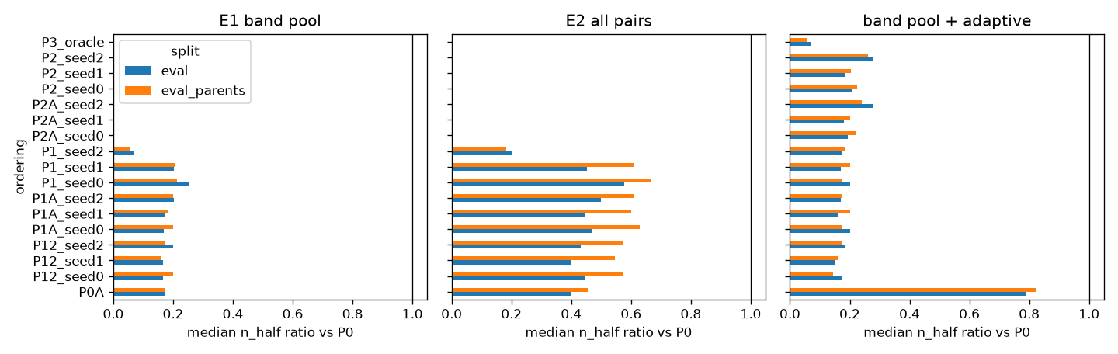
Figure 3. Median n_half ratio against the fixed order for every ordering, per experiment and split (a ratio below 1 is a saving).
Adaptive ordering (band pool, paired per molecule). Feedback alone helps the blind order: P0+A is strictly better than P0 on 71 % of the parents with a median ratio of 0.82. On top of a scorer it improves the whole curve (AUC better on 100 % of molecules, median ratio 0.91) but not the halfway point (strictly better on 24 %, equal on 63 %). The registered pass line fails on n_half and passes on the AUC; the prediction that feedback would close a third of the gap to the oracle fails. The gap is knowledge the scorer lacks, not feedback it is denied.
Adaptive ordering, wide pool (follow-up of 28 September 2026). On the all-pairs candidate set the same paired test gives: P0+A against P0 a median ratio of 0.73 on the parents (strictly better on 78 %) and 0.72 on the substituted molecules; P1+A against P1 a median of 1.00, strictly better on 24–29 % of the parents (pass line 70 %: fails), and the AUC gain of the band pool is gone (median AUC ratio 0.99). Feedback closes 12 % of the log-gap from P1 to the oracle on the parents against a predicted third. What the adaptive loop can learn from the reconstruction, the scorer already knows before the first measurement; the lever is a better scorer, not an adaptive campaign, and the adaptive variants stay in the code as a measured negative.
The fair-chance search. Validation Spearman of predicted against true log₁₀|Δ| — hand features 0.582; learned representation at stage 0 0.611, after the recipe stage 0.636, largest capacity variant 0.648. Loss and capacity stayed within the margins fixed before the numbers; stage 4 repeats at 300 molecules with a paired per-molecule test; nothing about the learned representation is licensed before stage 5.
What changes in plan 05
The deck's candidate list. The band deck, however ordered, cannot buy a held-out ρ_off below about 0.5 on this proxy; a candidate list that reaches every pair, with the learned order and a stop rule on the held-out ρ_off, reaches 0.3 at 1.35× the whole band deck on the parents. The change is pre-registered for after the supervisor conversation (W1–W3), together with two routes to the missing knowledge: pretraining on a public force-constant set and a cheap estimate of the answer as an input.
Ethics and responsible use
The module proposes which calculation to run next, never a molecule or a claim about it. Its failure mode is wasted compute, not a wrong spectrum, because the stopping quantity is measured, not predicted. Every number is proxy-level and labelled so; the oracle column is a ceiling, not an achievable order. The data are the project's own corpus. The fair-chance rule protects the learned representation from a premature negative verdict and the reader from a premature positive one.
Limitations and what follows
Proxy level: the tables are two density functionals against each other, not against coupled cluster; the test on real responses (the anchor's naphthalene deck) comes after the 28th. The band pool's factor of five was largely the fixed recipe's blindness; on the pool that matters the ordering gain is 1.3–1.6×. The learned representation has not beaten the hand features at 175 training molecules; the next stages (data growth, pretraining, the cheap-estimate input) are registered with their pass lines.
References
Pre-registration 2026-09-26 (standout pattern proposer), with dated amendments and outcome sections — GoalGathering/notes/.
Pre-registrations 2026-09-27 (wide-candidate deck with stop rule; cheap proxy-of-the-answer input) — GoalGathering/notes/.
Read-outs: out/sim/band_p2_readout.md, all_p2_readout.md, band_p2s1A_readout.md, deck_cost_2026-09-27.md; validation reads out/stage2_readout_2026-09-26.md, stage3_readout_2026-09-26.md.
Code: pp/core.py, pp/scorer.py, pp/embed_scorer.py, run_export.py, run_simulation.py, readout.py, stage_readout.py, deck_cost_readout.py; tests/test_pp_planted.py.
Module 05 (the equivariant body): modules/05_support_predictor/m05/rungC_equivariant.py.

