Generative AI Analysis and Ethics Report
A character-level Transformer that proposes fused-aromatic molecules for infrared spectroscopy

Frederic Petrignani
Udacity AI Mastery Capstone — Module 06 (Generative AI Applications)
Generative_AI_Analysis_Report.pdf
Overview
The generative task is to propose new fused-aromatic molecules, written as SMILES strings, that resemble a frozen set of 160,972 PubChem molecules with at least two fused aromatic rings, so that a spectroscopy pipeline built earlier in this capstone has candidates to compute next. The model is a character-level decoder-only Transformer (3,201,024 parameters) written in PyTorch without pretrained weights and trained with next-token cross-entropy — the autoregressive language-model formulation of molecular generation (Segler et al., 2018; Vaswani et al., 2017). Outputs are judged by the standard validity–uniqueness–novelty trio of the MOSES and GuacaMol benchmarks (Polykovskiy et al., 2020; Brown et al., 2019), by the match of their size and composition distributions to a held-out set, and by a project-specific fit criterion; all metrics and their expected values were fixed in a pre-registration before training.
For a reader without chemistry: This module is a language model for molecules. A molecule can be written as a line of text, a SMILES string (c1ccccc1 is benzene), and the 'fused aromatic' molecules — flat carbon-ring systems whose rings share edges, the family the project's spectroscopy pipeline serves — are its sentences. Input: 161,000 such strings of real, deposited molecules from the public PubChem database. The model learns their grammar character by character, the way a language model learns from sentences, and then writes new strings. Output: proposals that look like the real ones but are not among them; chemistry software checks each one (a valid molecule? new? similar in size and composition to the real ones?). The purpose is a list of candidates for the pipeline to compute next, never a claim about any molecule. The proposals have not entered the pipeline or the Spectrum Atlas yet: the route that would take them there — an exported, gated list as a new layer of the corpus — is TASKS row 22. Terms are defined in ../../GLOSSARY.md.
Dataset or Prompt Description
The data are public-domain PubChem records (Kim et al., 2025): the union of fast-substructure searches for nine fused-aromatic cores, filtered with RDKit to neutral molecules of C, H, N, O, S, F and Cl with at most 30 heavy atoms and at least two fused aromatic rings — 160,972 molecules, one canonical SMILES each with its CID, formula, heavy-atom and aromatic-ring counts, frozen on 24 September 2026 with its query, per-step counts and SHA-256 in the data README. The character vocabulary has 33 tokens; 0 molecules exceed the 96-token context and are dropped. Splits are by Murcko scaffold through a hash (125,065 training, 15,434 validation, 20,473 test), so that a scaffold never straddles training and test — the split that makes 'novelty' mean something (Bemis & Murcko, 1996). The set supports the task because it is exactly the chemical class the downstream pipeline is licensed for, and it is large enough for a small Transformer to learn the grammar of SMILES and the statistics of ring fusion without memorising individual records.
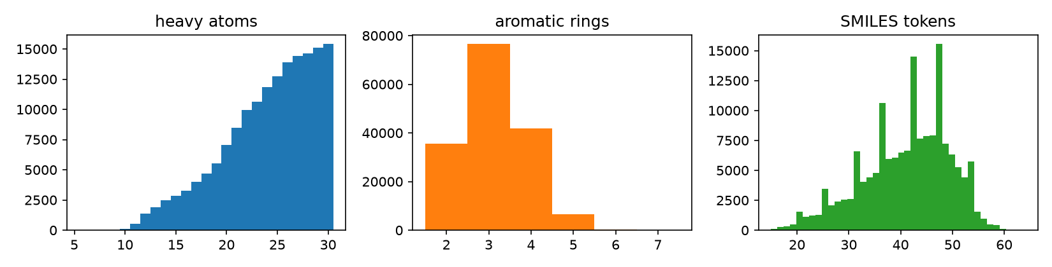
Figure 1. Heavy-atom, aromatic-ring and token-length distributions of the frozen set.
Model Design and Training Approach
The model is a decoder-only Transformer over characters: token and learned position embeddings (context 96), four pre-norm blocks of causal four-head self-attention and a 256→1024→256 GELU feed-forward layer with dropout 0.1, a final LayerNorm and a linear head (Vaswani et al., 2017; Radford et al., 2019, for the decoder-only recipe). It is trained with next-token cross-entropy, AdamW with a linear warm-up and cosine decay (Loshchilov & Hutter, 2019), gradient clipping at 1.0, batch 128, and early stopping on validation loss with patience 3; sampling is autoregressive and multinomial at a temperature. Design decisions and their reasons: the character level because the vocabulary is small and every SMILES is representable; a decoder-only model because a sampler is needed, not an encoder; pre-normalisation and warm-up for stable small-model training (Xiong et al., 2020); scaffold splitting for honest novelty. The pre-registered run trains 3 seed(s) for up to 20 epochs; seed 0 stopped after 20 epoch(s) at a best validation loss of 0.553 nats per token, its raw samples reaching 96 % validity at temperature 1.0. Alternatives were considered and set aside: a GAN on discrete strings trains unstably and gives no likelihood (Guimaraes et al., 2017), a SMILES VAE trades validity for a latent space the task does not need (Gómez-Bombarelli et al., 2018), and graph diffusion is heavier than the question.
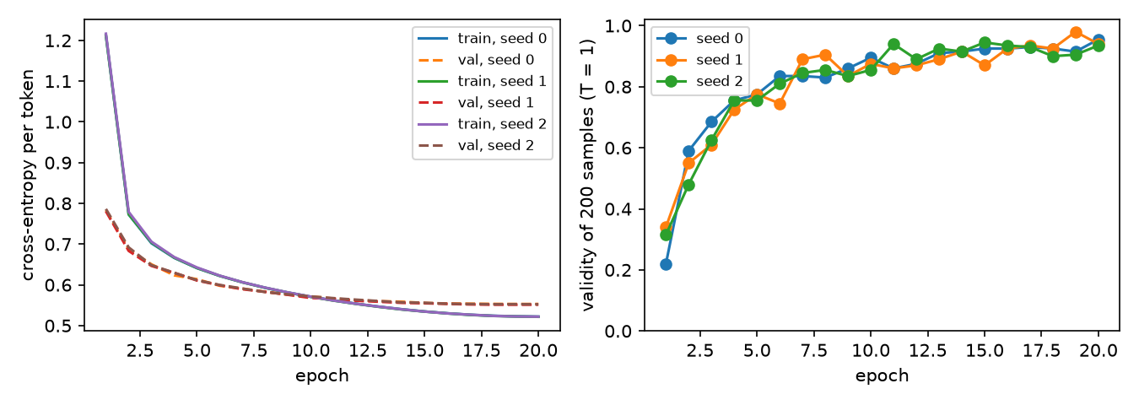
Figure 2. Training and validation cross-entropy per epoch, and the validity of 200 raw samples per epoch.
Output Evaluation and Interpretation
Table 1. The pre-registered metrics against their predictions.
metric (T = 1.0, seed mean) | measured | pre-registered | verdict
validity | 83 % | ≥ 0.85 | not met
uniqueness | 99 % | ≥ 0.95 | met
novelty | 92 % | ≥ 0.5 | met
scaffold novelty | 58 % | ≥ 0.3 | met
memorisation | 8 % | ≤ 0.1 | met
project fit | 93 % | 0.3–0.6 | not met
conditioning obedience | 87 % | ≥ 0.8 | met

At temperature 1.0 the samples are 83 % valid, 99 % unique among the valid and 92 % novel (58 % with a scaffold unseen in training); 8 % of valid samples are verbatim training molecules. Lowering the temperature to 0.7 raises validity to 94 % and lowers novelty to 87 % — the usual trade between fluency and exploration in autoregressive samplers. The heavy-atom, ring and heteroatom distributions of the samples sit 0.9, 0.13 and 0.13 (Wasserstein-1) from the held-out set. The project-fit share — valid, novel, neutral, within the corpus's element set, at most 30 heavy atoms and fused-aromatic — is 93 %. Failure cases are shown in the notebook rather than hidden: unparsable strings (typically unclosed rings or mismatched brackets), verbatim training molecules, charged outputs, and novel molecules outside the project's families. Conditioning on ring-count and heteroatom classes, the one measured design change, is obeyed in 87 % of valid samples, with the per-request table showing where PubChem has too few examples for the request to be learned.
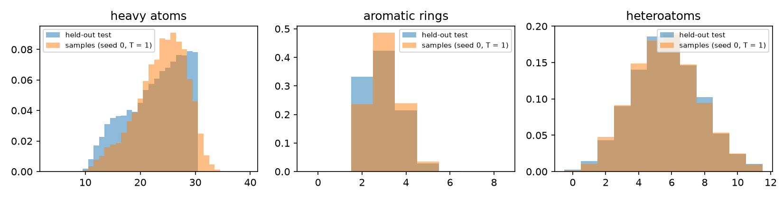
Figure 3. Sample distributions against the held-out test set.
Baseline control (added to the pre-registration on 25 September 2026, before any full training). A 5-gram token Markov model fitted on the same training split and sampled 10,000 times reaches validity 0.030, uniqueness 0.855, novelty 0.996 and project fit 0.024, with Wasserstein-1 distances of 13.37 (heavy atoms), 2.59 (aromatic rings) and 3.32 (heteroatoms) to the test split. The registered rule asks the Transformer to beat it by at least 0.25 in validity and 0.15 in project fit with smaller distances on all three descriptors; the primary seed gives margins of +0.894 and +0.922 with all distances smaller: True — the model has learned more than token statistics.
Ethical Considerations and Responsible Use
Three concerns are tied to this system's own data, model and outputs. Misuse: a generator of aromatic structures is a generator of candidates for spectroscopy, not of syntheses; polycyclic aromatics include carcinogens and persistent pollutants, so the outputs are labelled as spectroscopic targets, no synthesis routes or toxicity-directed property predictions are produced, and the model card released with the notebook says so (Mitchell et al., 2019). Creative ownership and attribution: the training data are public-domain PubChem depositions; generated strings are not attributed to depositors, and the memorisation rate above is the measurement that the model does not return depositor records (the pre-registered bound is 10 %). Bias: PubChem over-represents what chemists have made or patented — medicinal-chemistry decorations rather than the bare polycyclic systems of the interstellar medium — and the generator inherits that; the project-fit metric and the distribution figures are where it shows, and the astrochemical species list of the NASA Ames PAH database is used only as a comparison set, never as training data (Boersma et al., 2014). The societal impact is modest and positive — cheaper triage of which molecules to compute for astronomical spectroscopy — and the report claims nothing about properties, safety or synthesis.
Limitations and Future Improvements
Limitations: one data source with its own bias; SMILES as the representation, which makes validity a learned property rather than a guarantee (SELFIES would make every string decodable, at the cost of a less transparent vocabulary — Krenn et al., 2020); a small model trained on a CPU, so the held-out loss is not at its floor; evaluation by two-dimensional descriptors and a project-fit rule, not by the spectroscopy the candidates are meant for. Realistic next steps, in order: feed the project-fit samples to the spectroscopy pipeline as a separately labelled 'candidate' source and let its licensed correction rank them; condition on the pipeline's own family labels instead of ring and heteroatom classes; compare a SELFIES variant on the same pre-registered metrics; and replace the temperature trade-off by a reward-guided fine-tuning towards project fit, measured against the same trio so that gains in fit are not bought with memorisation.
References
Bemis, G. W., & Murcko, M. A. (1996). The properties of known drugs. 1. Molecular frameworks. Journal of Medicinal Chemistry, 39(15), 2887–2893. https://doi.org/10.1021/jm9602928
Boersma, C., Bauschlicher, C. W., Ricca, A., Mattioda, A. L., Cami, J., Peeters, E., Sánchez de Armas, F., Puerta Saborido, G., Hudgins, D. M., & Allamandola, L. J. (2014). The NASA Ames PAH IR spectroscopic database version 2.00: Updated content, web site, and on(off)line tools. The Astrophysical Journal Supplement Series, 211(1), 8. https://doi.org/10.1088/0067-0049/211/1/8
Brown, N., Fiscato, M., Segler, M. H. S., & Vaucher, A. C. (2019). GuacaMol: Benchmarking models for de novo molecular design. Journal of Chemical Information and Modeling, 59(3), 1096–1108. https://doi.org/10.1021/acs.jcim.8b00839
Gómez-Bombarelli, R., Wei, J. N., Duvenaud, D., Hernández-Lobato, J. M., Sánchez-Lengeling, B., Sheberla, D., Aguilera-Iparraguirre, J., Hirzel, T. D., Adams, R. P., & Aspuru-Guzik, A. (2018). Automatic chemical design using a data-driven continuous representation of molecules. ACS Central Science, 4(2), 268–276. https://doi.org/10.1021/acscentsci.7b00572
Guimaraes, G. L., Sanchez-Lengeling, B., Outeiral, C., Farias, P. L. C., & Aspuru-Guzik, A. (2017). Objective-reinforced generative adversarial networks (ORGAN) for sequence generation models. arXiv. https://doi.org/10.48550/arXiv.1705.10843
Kim, S., Chen, J., Cheng, T., Gindulyte, A., He, J., He, S., Li, Q., Shoemaker, B. A., Thiessen, P. A., Yu, B., Zaslavsky, L., Zhang, J., & Bolton, E. E. (2025). PubChem 2025 update. Nucleic Acids Research, 53(D1), D1516–D1525. https://doi.org/10.1093/nar/gkae1059
Krenn, M., Häse, F., Nigam, A., Friederich, P., & Aspuru-Guzik, A. (2020). Self-referencing embedded strings (SELFIES): A 100% robust molecular string representation. Machine Learning: Science and Technology, 1(4), 045024. https://doi.org/10.1088/2632-2153/aba947
Loshchilov, I., & Hutter, F. (2019). Decoupled weight decay regularization. In International Conference on Learning Representations. https://openreview.net/forum?id=Bkg6RiCqY7
Mitchell, M., Wu, S., Zaldivar, A., Barnes, P., Vasserman, L., Hutchinson, B., Spitzer, E., Raji, I. D., & Gebru, T. (2019). Model cards for model reporting. In Proceedings of the Conference on Fairness, Accountability, and Transparency (pp. 220–229). ACM. https://doi.org/10.1145/3287560.3287596
Polykovskiy, D., Zhebrak, A., Sanchez-Lengeling, B., Golovanov, S., Tatanov, O., Belyaev, S., Kurbanov, R., Artamonov, A., Aladinskiy, V., Veselov, M., Kadurin, A., Johansson, S., Chen, H., Nikolenko, S., Aspuru-Guzik, A., & Zhavoronkov, A. (2020). Molecular Sets (MOSES): A benchmarking platform for molecular generation models. Frontiers in Pharmacology, 11, 565644. https://doi.org/10.3389/fphar.2020.565644
Radford, A., Wu, J., Child, R., Luan, D., Amodei, D., & Sutskever, I. (2019). Language models are unsupervised multitask learners. OpenAI.
Segler, M. H. S., Kogej, T., Tyrchan, C., & Waller, M. P. (2018). Generating focused molecule libraries for drug discovery with recurrent neural networks. ACS Central Science, 4(1), 120–131. https://doi.org/10.1021/acscentsci.7b00512
Vaswani, A., Shazeer, N., Parmar, N., Uszkoreit, J., Jones, L., Gomez, A. N., Kaiser, Ł., & Polosukhin, I. (2017). Attention is all you need. In Advances in Neural Information Processing Systems 30 (pp. 5998–6008). Curran Associates.
Xiong, R., Yang, Y., He, D., Zheng, K., Zheng, S., Xing, C., Zhang, H., Lan, Y., Wang, L., & Liu, T.-Y. (2020). On layer normalization in the Transformer architecture. In Proceedings of the 37th International Conference on Machine Learning (pp. 10524–10533). PMLR.

