Exam Memory Report

**Exam Title:** PCPP-32-101

**Date of Exam:** May 01, 2024

|  |  |
| --- | --- |
| Question | Answer (Options) |
| Tkinter – How to import tkinter? (select 2) | * import tk * import TkInter * irom TkInter import * * import tkinter |
| Tkinter window square 200 pixel, left uppercorner coordinates? | * 0,0 🡪 correct * 0,200 * 200,0 * 200,200 |
| Tkinter – unbindall() method | * Raise from where? * Arguments? * Function? |
| Tkinter - When does the window become visible? | * Running mainloop() |
| Tkinter - Destroy() | * Closes application window |
| Tkinter – Button, set font and fontsize  Select two. | * button = tk.Button(root, text="Button 1", font=("Arial", 12)) * button.configure(font=("Arial", 12)) |
| Tkinter – Set title of main window | * root = tk.Tk() * root.title("Main Window Title") |
| XML – enclosed in? | * Tags * <<< >>> |
| XML – first row printed when using XML.etree… module?  tree.write(file, encoding='utf-8') 🡪 Output | * First row? '<?xml version="1.0" encoding="UTF-8"?>' |
| Select the correct HTTP Request | * POST * PUT * GET * … |
| Sqlite – execute() | * Executes only one statement ? |
| Sqlite – Code example: Missing c.commit() after execution of statement  How many entries will there be in DB? | * One * Three * Code has Error * None 🡪 Correct |
| CSV File: write rows with Dictwriter (flowername and color), and missing dict entry value for color.  How does the output CSV file look like?  e.g. Flower, Color: {name: “Tulip”} | * Tulip, None 🡪 wrong * Tulip, “” * Tulip, |
| CSV File, write content which has a “,”  Content: one, two, three | * “one, two, three” ?? |
| PEP 8: Docstrings (multiselect 2) | * Two types of docstrings: single line and multiline docstrings * …. |
| PEP - Naming Conventions | * Exception Name |
| PEP – Spaces (Select 2) | * Multiple choice, select 2 * 4 code examples were given * # Correct, Wrong |
| PEP: Typecheck | * Isinstance(obj, class) * Is not … ?? |
| Sockets – What is socket programming? | * … |
| Sockets – c.close() | * Like in os, closing connection * Closing connection but keeping ? running * Takes parameters? |
| ConfigParser – How to read config? | * read() 🡪 config.read(‘config.ini’) * readstr() * readconf() |
| json.dumps() | * Takes python object * Returns json formatted string |
| How to escape unicode character in json? | * \u: This is the correct escape sequence for representing Unicode characters in JSON. * \x * x’ * u’ |
| Networking: Which exception is the one you should check for? | * ConnectionRefusedError * socket.gaierror * … |
| Pickle – What is the expected behavior when using pickle on a class? | * pickle and unpickle should work without errors when using the same Python version (?) |
| Code raising a custom exception: Not inheriting from any Exception…  (#2 examtopics.com) | * Error (Custom Exception needs to inherit from some exception) * The code is erroneous as the OwnMath class does not inherit from any Exception type class |
| Select the true statement about composition.  (#1 examtopics.com) | * Composition allows a class to be projected as a container of different classes * You can use inheritance AND composition at the same time ? |
| Dunder: __bases__ ? | * tuple of references to the parent classes from which the class inherits (correct) * returns dict |
| Dunder: __ne__ ? | * inequality comparison operator (correct) * there is no special method __ne__ |
| What is cls? | * Parameter for class methods |
| What is the name of the private variable? | * __my_var * my_var |
| Code Example  Which methods in class should be static and needs the decorator? | * Both * Method1 * Method2 * None |
| OOP: MRO Error: What should you do? | * Simplify the class hierachy |
| Questions from [www.examtopics.com](http://www.examtopics.com) (BUT questions or code slightly changed) | |

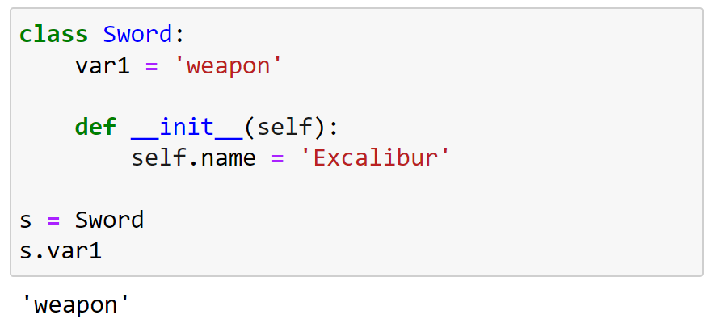

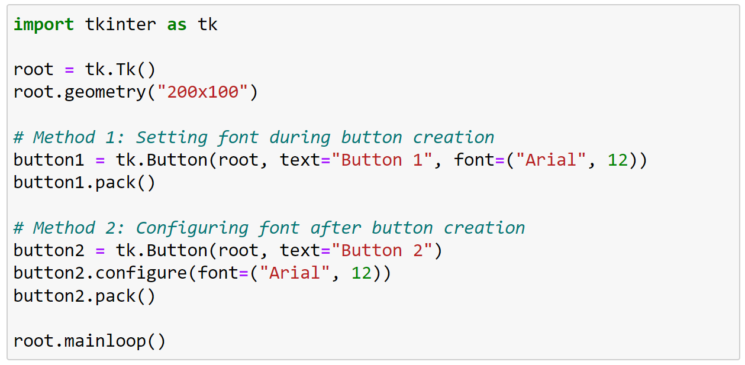

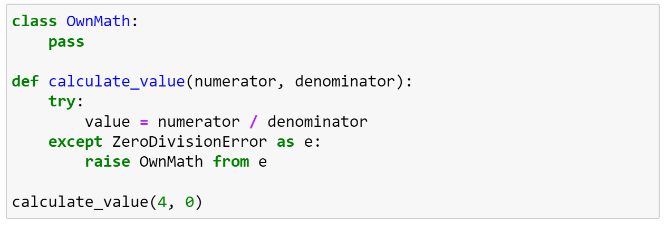

TypeError: exceptions must derive from BaseException

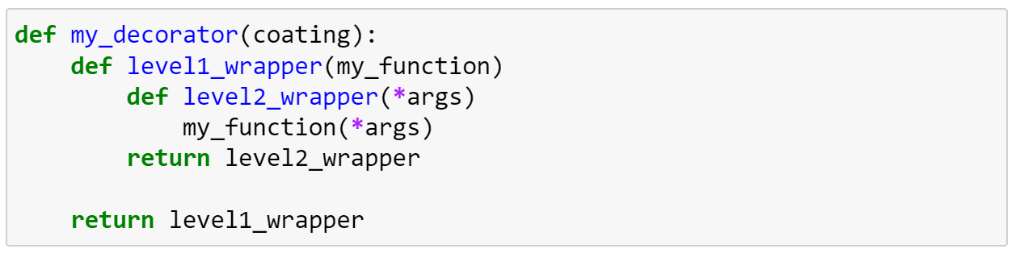

It is an example of a decorator that accepts its own arguments.

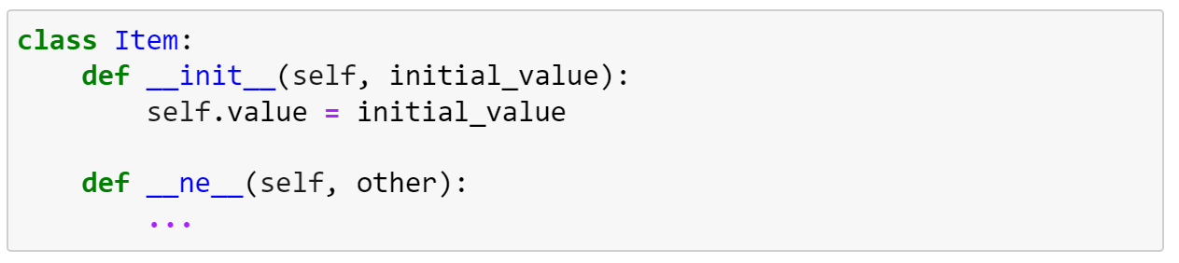

* A. __ne__() is not a built-in special method.
* B. The code is erroneous
* C. The code is responsible for the support of the negation operator, e.g. a = - a
* **D. The code is responsible for the support of the inequality operator, i.e. != (CORRECT)**

# Useful Links

* **Exam Content:** [**https://pythoninstitute.org/assets/628def5091da2303121759.pdf**](https://pythoninstitute.org/assets/628def5091da2303121759.pdf)
* **Udemy:** [**6 Practice Exams by Paweł Krakowiak: Become a Certified Professional in Python Programming 1 with PCPP1™**](https://www.udemy.com/course/pcpp1-certified-professional-in-python-programming/?couponCode=ST2MT43024)
* **Courses Aligned:** [**https://pythoninstitute.org/pcpp1**](https://pythoninstitute.org/pcpp1)
* **YouTube:** [**Tkinter Course - Create Graphic User Interfaces in Python Tutorial**](https://www.youtube.com/watch?v=YXPyB4XeYLA)
* **examtopics.com:** [**PCPP1**](https://www.examtopics.com/exams/python-institute/pcpp-32-101/)

