Comprehensive System Design & Architecture:
C1RCLE Platform Backend-for-Frontend (BFF) Migration

1. Executive Summary
This comprehensive System Design Document outlines the architectural blueprint, transition strategy, and technical implementations for the C1RCLE platform. Specifically, it details the migration from a monolithic, direct-to-database legacy structure to a modernized, resilient Backend-for-Frontend (BFF) architecture. Historically, the platform's various portals (Guest, Partner, and Admin) relied heavily on thick client-side logic. This approach forced the frontend applications to aggregate data directly from primary datastores like Firebase, introducing severe performance bottlenecks, tight coupling between UI presentation and database schemas, and significant security vulnerabilities.
To rectify these historical debts, we are implementing a robust thin UI layer supported by localized BFF read-models. This architectural pivot ensures that our core API Gateway remains the single source of truth for business logic and state mutation, while optimizing payloads exclusively for the frontend consumers. This document delves deeply into our constraints, data modeling strategies, security enforcement, failure modes, and the phased rollout plan required to achieve zero-downtime migration.
The scope of this document encompasses all primary domains of the application: Event Discovery, Ticketing, Checkout and Payments, Partner Management, Authentication and Identity, and the core Gateway infrastructure. It serves as the definitive source of truth for engineering teams implementing features across the stack. The decisions documented herein are non-negotiable architectural invariants designed to ensure platform stability during hyper-growth.

2. Business Drivers & Problem Statement
The C1RCLE platform operates in a high-concurrency, transaction-heavy domain. The legacy architecture presented several critical business risks that necessitated this redesign. As the user base expanded, the limitations of the thick-client model became painfully apparent.
- Security Exposure: Direct database access from the client required overly permissive Firestore security rules, increasing the surface area for unauthorized data exposure. By pushing logic to the client, we inadvertently exposed domain rules to anyone inspecting the network tab.
- Client-Side Bloat: Fetching disjointed data and aggregating it in the browser led to massive JavaScript bundle sizes, increasing Time-to-Interactive (TTI) on mobile devices. A typical checkout flow required 14 distinct round trips to the database.
- Lost Updates & Race Conditions: Concurrent ticket reservations often suffered from 'lost updates' because the legacy implementation relied on read-check-write patterns outside of strict database transactions. Two users attempting to buy the last ticket could both succeed, leading to overbooking.
- Fragmented Error Handling: Error responses were wildly inconsistent across different endpoints, making frontend error boundary implementation nearly impossible. A 404 could return an empty object, a success flag set to false, or an HTML page depending on the route.
The business requirement is clear: we must achieve a scalable, secure, and predictable backend architecture that allows feature teams to iterate rapidly without risking platform stability. This migration minimizes technical debt and paves the way for advanced analytics, machine learning integrations, and dynamic pricing models.

3. Architectural Goals & Constraints
Every engineering decision documented herein is bound by the following unyielding constraints, formed in collaboration with product and engineering leadership:
- Zero Downtime Migration: The transition must occur incrementally. Legacy UI paths and direct database queries must remain operational until parity logging and QA sign-off confirm the new BFF routes are functionally equivalent. We cannot pause feature development to execute a 'big bang' release.
- Strict Boundary Enforcement: BFF handlers must never bypass the core API gateway. They act strictly as adapters. The gateway is the sole arbiter of business rules. If a calculation involves money, permissions, or inventory, it happens on the Gateway.
- Repository-First Storage: Nothing in the shipped code may depend on a concrete storage implementation. The domain must depend on abstract repository interfaces (e.g., IOrderRepository), enabling a future migration from Firestore to PostgreSQL without altering application logic. This abstraction layer is enforced at compile time.
- Single-Sourced Contracts: The packages/contracts library acts as the single source of truth for Data Transfer Objects (DTOs) and Response Envelopes. A parity script strictly prevents divergence between frontend consumers and the backend. If a schema changes, both sides of the boundary fail compilation until reconciled.
Adherence to these constraints is monitored automatically via CI/CD pipelines incorporating architectural linter rules.

4. System Design: The BFF Pattern & Gateway Architecture
The new topology isolates concerns. The localized BFF layer is built directly into the Next.js applications using standard API route handlers under the app/api/app/* namespace. We strictly enforce this namespace isolation to prevent ad-hoc business routes from scattering across the repository.
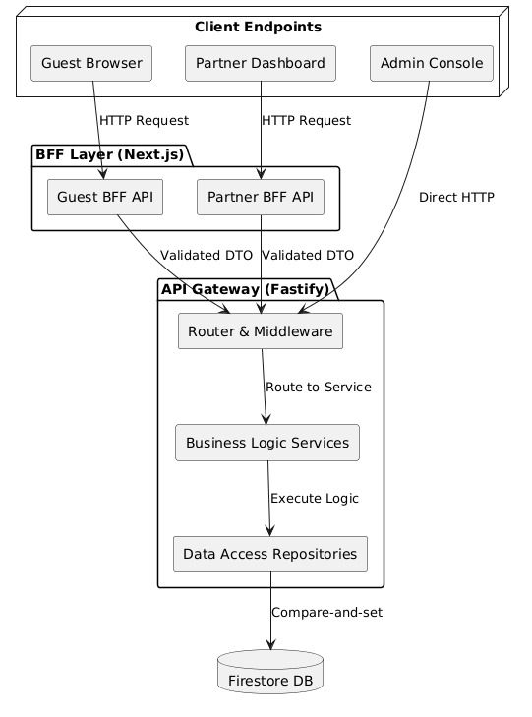
Figure 1: High-Level Architecture featuring BFF API Gateways and the Central Fastify Router.
When a user requests an event detail page, the frontend calls its BFF (`/api/app/events/[eventId]/detail`). The BFF validates the incoming request DTO, orchestrates calls to multiple upstream API Gateway endpoints, filters sensitive fields, and maps the data into a view-ready model. The Fastify API Gateway handles all complex processing, ensuring the UI remains exceptionally thin.
This architecture allows us to version the Gateway independently from the UI. The BFF serves as an anti-corruption layer, protecting the frontend components from underlying changes in the microservices or database schemas. It also enables localized caching; the BFF can cache static event data while allowing real-time inventory checks to pass through to the Gateway.

5. Core Architectural Principles

5.1 Flat Error Envelopes
Historically, error envelopes were nested inconsistently. This required the frontend to write complex, brittle parsing logic. We have mandated a strictly flat error envelope for all Gateway and BFF responses:
{
ok: boolean,
data: any,
code?: string,
message?: string,
requestId: string,
meta?: any
}
This flat shape is enforced at the outermost layer of the Fastify application. Global error handlers and route-specific handlers share the exact same serialization utility from packages/contracts. 404s, 500s, and validation errors all return this exact shape.

5.2 Policy Ordering (Rate-Limit -> Validate -> Authorize)
The order of execution for middleware is non-negotiable to maintain security and efficiency:
- Rate Limiting: Executes first. It is computationally cheap and protects the system from volumetric DDoS attacks and brute-force attempts. Rate limit thresholds are defined per-route.
- Validation (Zod): Executes second. Ensures all parameters and payloads conform to expected schemas. For example, a missing organization ID results in a 422 Unprocessable Entity rather than a misleading 403 Forbidden. This prevents bad data from ever touching the database.
- Authorization (ABAC/RBAC): Executes third. Evaluates if the authenticated identity possesses the necessary permissions for the validated resource. By placing this after validation, we prevent authorization engines from failing on malformed input.

5.3 Page-Based Pagination
While the underlying repositories utilize cursor-based pagination for performance, the API Gateway adapts this into a standard page-based response (PageInfo { page, pageSize, total, hasNextPage }) for the frontend. This prevents cursor leakage and eliminates hidden offset discrepancies on the client. It standardizes the UI experience.

6. Data Flow, Transactional Integrity & Outbox
Maintaining data consistency across aggregate roots (e.g., Orders, Tickets, and Ledger) is the most critical function of the API Gateway. We rely heavily on the Transactional Outbox pattern paired with Compare-and-Set mechanisms.

6.1 The Transactional Outbox Pattern
Fulfillment operations (order creation, entitlement issuance, promo redemption, and ledger updates) must succeed or fail as a single atomic unit. Dual confirmation paths—such as a user redirecting back from a payment gateway while a webhook is simultaneously received—historically resulted in duplicate fulfillments. This costs real money.
We resolve this via the Outbox pattern. The primary business write and the corresponding domain event (e.g., OrderCreated) are written into the database within the exact same transaction block. Background consumers then read from the outbox to project data into read-models or trigger side-effects like sending confirmation emails. This guarantees exactly-once processing semantics and ensures downstream systems are eventually consistent.

6.2 Compare-and-Set Durability
To eliminate lost updates during concurrent writes, all state mutations require an expectedVersion parameter. The Firestore adapter enforces this constraint inside a runTransaction block. If two requests attempt to mutate a record sitting at version N, both will supply expectedVersion=N. The first transaction succeeds and increments the version to N+1. The second transaction observes the version mismatch and aborts, yielding an HTTP 409 Conflict.
This effectively implements Optimistic Concurrency Control (OCC) at the application layer, crucial for high-demand ticket drops where thousands of users compete for limited inventory within seconds.
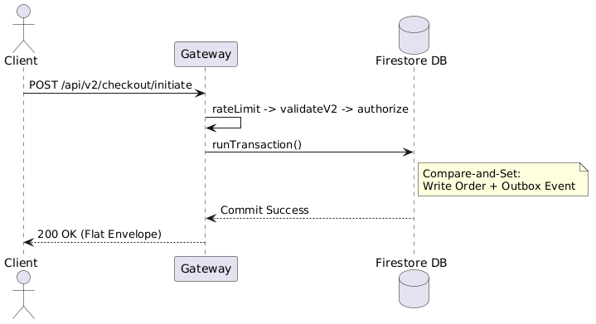
Figure 2: Sequence diagram illustrating the Compare-and-Set mechanism alongside the Transactional Outbox implementation.

7. Security, Authentication & Identity
Security represents a massive overhaul in this architecture. We have deprecated raw Firebase JWT verification in favor of a robust authentication library ('better-auth').

7.1 Cookie-Based Sessions
The system relies on cookie-based sessions (httpOnly, SameSite=Strict, Secure in production). The durable credential is never exposed to JavaScript. A short-lived access token is returned to the client and kept strictly in memory. This eliminates Cross-Site Scripting (XSS) risks related to token theft.
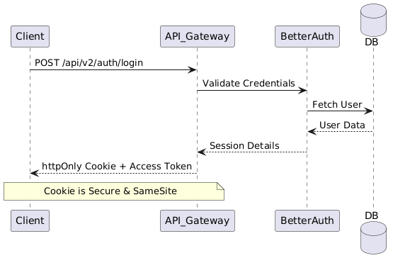
Figure 3: BetterAuth Sequence Flow demonstrating Secure Cookie issuance.
Upon navigating to a new tab or reloading, the browser automatically sends the secure cookie to the `/api/v2/auth/refresh` endpoint to silently acquire a fresh in-memory token. This ensures a seamless user experience while maintaining an aggressive security posture.

7.2 Razorpay Webhook HMAC Verification
Payment webhooks from Razorpay are the authoritative source for transaction confirmations. To prevent spoofing, the webhook endpoint enforces strict HMAC-SHA256 signature verification using the RAZORPAY_WEBHOOK_SECRET. We utilize a deterministic JSON.stringify parser to ensure the raw body signature matches exactly. Furthermore, processing is locked via an idempotent 'settling' status to prevent double-capture.

7.3 Platform Authority vs. Organization Authority
We explicitly separate Platform Admin roles from Organization Owner roles. A user may own a tenant organization, but that grants zero platform-wide privileges. Platform authority is governed by a distinct aggregate (PlatformAdmin), preventing severe escalation-of-privilege vulnerabilities.

8. State Machine & Event Lifecycle
Complex domain entities, such as Events and Organization Invitations, rely on strict State Machines to dictate lifecycle transitions. The Event lifecycle prevents a Draft from being published directly without administrative review. Bypassing this review exposes the platform to fraud.
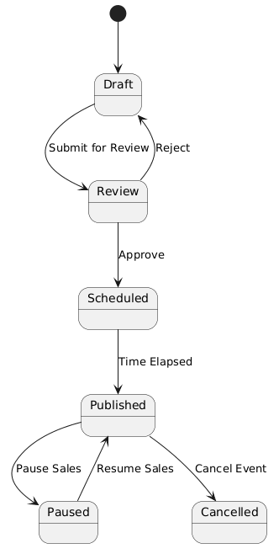
Figure 4: Event entity State Machine lifecycle transitions.
The EventService.publish() method does not simply flip a boolean flag. It walks the FSM explicitly (Review -> Scheduled -> Published) within the same service call, validating the transition matrix at every step. This guarantees that invariants are never violated, regardless of how the API is invoked. If a manual database edit forces an invalid state, the application refuses to act upon the entity, effectively quarantining corrupted data.

9. Edge Cases & Resiliency
Designing a resilient distributed system requires intentional handling of failure modes.
- Partial Failures in Aggregation: BFF endpoints often aggregate data from multiple backend services. If a non-critical downstream service (e.g., Notification Counts) times out, the BFF must support partial success. It returns the critical payload while marking the notification data as 'unavailable' in the meta tag, allowing the UI to render gracefully.
- Idempotent Retries: Network partitions happen. To safely support client retries, all mutating endpoints accept an Idempotency-Key header. The FirestoreIdempotencyStore caches responses for 24 hours. A retried request with a known key simply receives the cached response, circumventing duplicate processing. This is vital for operations like ticket allocation where a dropped connection could trick a user into paying twice.

10. Data Modeling & Database Schemas
To ensure performance at scale, data is denormalized appropriately. Below are the core schemas used across the platform:

10.1 Event Schema
{
"id": "evt_12345",
"name": "Summer Music Festival",
"status": "PUBLISHED",
"hostId": "org_789",
"capacity": 5000,
"pricing": {
"min": 1500,
"max": 5000,
"currency": "INR"
},
"version": 4
}
Notice the `version` field. This is the cornerstone of our OCC (Optimistic Concurrency Control) implementation.

10.2 Order & Entitlement Schema
Orders and Entitlements (tickets) are stored in separate collections to allow decoupled querying, yet created in a single outbox transaction.
{
"id": "ord_999",
"userId": "usr_444",
"eventId": "evt_12345",
"amountTotal": 3000,
"status": "CONFIRMED",
"paymentId": "pay_555",
"createdAt": "2026-08-27T10:00:00Z"
}
The Entitlement record stores the cryptographic hash used for the QR code, which is signed by the backend and verified offline via public keys on scanner devices.

11. Migration Strategy & Phased Rollout
The migration is structured to minimize risk through a phased, incremental rollout utilizing LaunchDarkly feature flags.

Phase 1: Shadow Mode
The new BFF endpoints are deployed to production but not wired to the UI. They receive asynchronous, mirrored traffic from active user sessions. This allows us to validate payload parity and monitor latency without impacting real users.

Phase 2: Fractional Shifting
Once shadow mode proves stable (error rates < 0.1%), we shift 5% of production traffic to the new BFF layer. Over two weeks, this is gradually ramped to 100%. Legacy routes are preserved as a fallback mechanism throughout this period.

Phase 3: Deprecation & Deletion
After 30 days of 100% stable traffic on the new architecture, the legacy direct-to-DB codebase and runtime bridges are formally deprecated and deleted from the repository.

12. Observability & Monitoring
We employ structured logging (via Pino in Fastify) utilizing standardized request IDs. The x-request-id header is generated at the ingress (Cloudflare), passed through the BFF, into the Gateway, and logged alongside every database query. This distributed tracing allows rapid debugging of complex aggregate failures across boundaries.

13. API Client Enforcement
The frontend is strictly forbidden from manually constructing `fetch()` requests. All interactions must go through the `@c1rcle/api-client` package. This package automatically handles:
- Request ID generation (UUID v4)
- Silent token refresh upon receiving a 401 response
- Standardized retry logic with exponential backoff for 5xx errors
- Telemetry and timing metrics pushed to Datadog
This enforcement ensures that the backend team can update wire formats (like deprecating API versions) without manually hunting down disjointed fetch calls across the frontend monolith.

14. Conclusion
This architectural transformation equips the C1RCLE platform with the durability, security, and developer ergonomics required for its next phase of hyper-growth. By strictly enforcing boundaries, standardizing contracts, and eliminating client-side data fetching, we are laying a foundation capable of supporting massive scale. The BFF pattern isolates our presentation logic from complex aggregate roots, while the Transactional Outbox ensures we never drop a payment confirmation.

