C1RCLE System Design
  - Guest portal and partner platform architecture | Final design brief
Document purpose | Audience | Decision status
Define the target backend boundary, request flows, data consistency model, and rollout plan for C1RCLE's modernized platform. | Engineering leads, product owners, security reviewers, and operators responsible for launch and incident response. | Approved direction: thin UI, BFF adapters, API Gateway ownership of business decisions, and durable event processing.

Design principle - Frontend asks. Backend decides. Database remembers. The browser should never be the place where money, inventory, or authority is decided.

1. Executive Summary
C1RCLE is moving from a client-heavy application model to a service-owned backend boundary. The current product spans ticket discovery, checkout, partner operations, event management, and internal administration. Those workflows share the same core risk: a small inconsistency in authorization, inventory, payment confirmation, or event state can turn into a financial or trust incident.
The target design makes the API Gateway the owner of authenticated product APIs and business decisions. Next.js BFF routes remain useful, but only as view adapters: they validate request shape, call the gateway, map the response into a screen-ready model, and remove fields the browser should not see. Shared domain services live in core packages, and durable facts remain in Firebase-backed repositories.
This document is intentionally written as an execution brief rather than a survey. It states the design, the trade-offs we accept, the failure modes we must handle, and the conditions required before the old direct-to-database paths can be retired.

What changes
Area | Before | Target
Frontend data access | Pages and components aggregate Firestore data directly or through scattered route handlers. | Pages call a small BFF surface that returns typed view models and a consistent response envelope.
Business decisions | Some decisions are split between browser code, web routes, and shared helpers. | Gateway owns money, inventory, permission checks, lifecycle transitions, and idempotency.
Errors | Different endpoints serialize different error shapes. | All external product APIs return one flat envelope with request IDs and stable error codes.
Async work | Side effects can run inline with checkout or webhook handling. | Primary writes and outbox records commit together; workers process side effects after commit.
Rollout | Legacy and new paths compete without a clear exit rule. | Shadow, compare, fractional traffic, then remove legacy paths after objective health gates pass.

2. Problem Statement
The legacy shape created three recurring classes of risk.
- Security drift: browser-facing code accumulated knowledge of tenant boundaries, role decisions, and datastore shape. That made Firestore rules harder to reason about and increased the chance of exposing fields such as QR payloads, credentials, internal notes, or platform-only flags.
- Checkout fragility: ticket reservation, payment confirmation, and fulfillment were vulnerable to duplicate callbacks, retry storms, and read-check-write races when two actors touched the same order at the same time.
- Operational opacity: inconsistent error envelopes and scattered backend paths made support work slower. A failed checkout should be traceable by request ID across BFF, gateway, repository, outbox, and webhook logs without special-case parsing.
The redesign is therefore not just a performance cleanup. It is a control-plane change: one product API boundary, one authorization model, one envelope, and one auditable flow for financially meaningful changes.

3. Goals and Non-Goals
Goals | Non-goals
Reduce browser responsibility; make all privileged decisions server-side; standardize response envelopes; make checkout and webhook processing idempotent; give operators enough telemetry to explain failures quickly; migrate without downtime. | Rewrite every domain service at once; turn the BFF into a second product backend; expose gateway internals to pages; remove all legacy routes before parity is measured; optimize for theoretical multi-cloud portability before launch reliability is proven.

4. Target Architecture
The architecture has four layers. Each layer is allowed to know less than the one beneath it.
Layer | Owns | Must not own
Web apps | Presentation, user intent, optimistic UI, and calling approved BFF endpoints. | Inventory math, payment truth, tenant authority, platform roles, raw Firebase Admin usage.
BFF routes | Request validation, session forwarding, view-model mapping, cache headers, and response normalization. | New business rules, mutation orchestration, privileged repository access, long-running side effects.
API Gateway | Authenticated product APIs, authorization, lifecycle transitions, checkout, payment confirmation, idempotency, and rate limits. | Screen-specific rendering decisions or app-specific component concerns.
Core services and repositories | Reusable domain logic, Firestore adapters, outbox writes, ledger consistency, and integration helpers. | Direct browser contracts or UI-only data formatting.

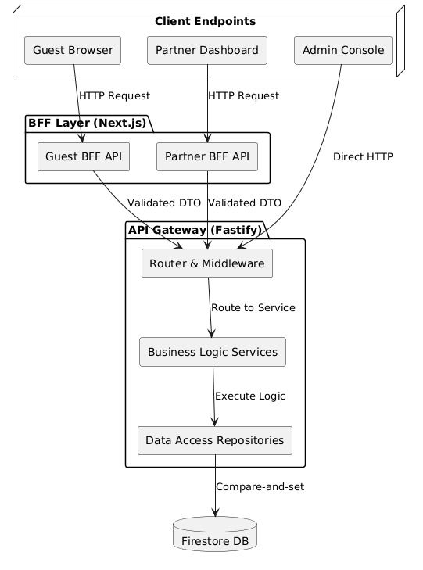
Figure 1. Target request boundary: web app to BFF to API Gateway to durable services.

5. API and Envelope Standard
Every product-facing route should return a flat, predictable envelope. The exact fields may vary by route type, but the caller should always be able to tell whether the request succeeded, inspect data, render a stable error, and provide a request ID to support.
Field | Meaning | Rule
ok | Boolean success marker. | True only when the requested operation completed as intended.
data | Typed payload. | Present on success; absent or null on failure.
error | Stable machine-readable error code. | Use codes the UI can branch on; do not leak internal exception names.
message | Human-readable explanation. | Safe for users and support agents; no secrets or stack traces.
requestId | Trace key shared across services. | Required on every response and log line for product APIs.
meta | Pagination or partial-data metadata. | Optional; used for page state, warnings, and degraded reads.

Policy order
- Rate limit first. This is cheap and protects expensive validation, auth, and database work from volumetric abuse.
- Validate second. Malformed resource IDs should fail before authorization logic tries to interpret them.
- Authenticate third. The route establishes identity from the session or service credential.
- Authorize fourth. Permission checks run against validated resources and normalized identity claims.
- Mutate last. Database locks, version checks, ledger writes, and outbox writes happen only after the request has passed the boundary checks.

6. Checkout Flow and Transactional Integrity
Checkout is the highest-risk path because it crosses inventory, money, ticket issuance, promotion redemption, ledger entries, and customer communication. The gateway treats checkout as a state transition, not as a set of independent writes.
Step | Action | Failure handling
1 | Client submits cart with idempotency key and selected payment method. | Missing or reused key is rejected or replayed from the idempotency cache.
2 | Gateway validates event state, ticket availability, pricing, fees, and promotion constraints. | Validation failures return stable 4xx errors without acquiring long-lived locks.
3 | Transaction writes order, reservations, ledger intent, and outbox event together. | Any failed write aborts the whole transaction.
4 | Payment provider confirms asynchronously through a signed webhook. | Client redirects are treated as UX signals, not financial authority.
5 | Webhook transitions order from pending to paid or failed and emits fulfillment work. | Duplicate callbacks exit idempotently after observing the existing terminal state.

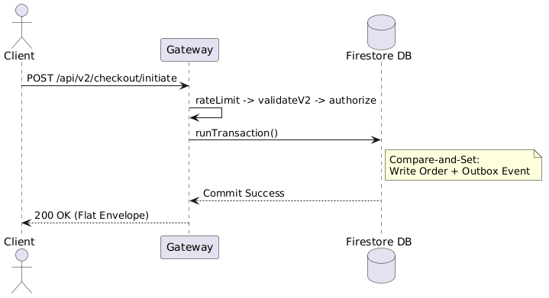
Figure 2. Checkout sequence: validation before locks, one transactional write, async fulfillment after commit.

7. Outbox, Events, and Read Models
The outbox pattern is the durability bridge between the synchronous product API and asynchronous side effects. When a business transaction commits, the corresponding domain event commits in the same transaction. Workers then process the outbox to send emails, update denormalized read models, call integrations, or emit analytics.
Property | Design choice | Reason
At-least-once delivery | Workers may retry the same event. | Network failures are normal; retry is safer than dropping work.
Idempotent consumers | Consumers key work by event ID or deterministic domain key. | Retries must not send duplicate tickets, double-credit accounts, or overwrite newer projections.
Poison handling | After repeated failure, mark the event blocked and alert operations. | A bad payload should not stop the entire queue.
Projection lag | Read models are eventually consistent and expose freshness metadata where needed. | User-facing pages stay fast without pretending projections are always current.

8. Concurrency and Idempotency
C1RCLE must handle multiple users attempting to buy the same inventory and multiple systems reporting the same payment event. The design combines optimistic concurrency with idempotency keys.
- Optimistic version checks protect aggregate updates. A writer must provide the expected version; stale writers receive a conflict and retry against fresh state.
- Idempotency keys protect client retries. A repeated mutation with the same key returns the original response instead of creating a second order or redemption.
- Webhook deduplication protects provider retries. The webhook handler stores the provider event ID and order transition result before triggering fulfillment.
- Deterministic document IDs are preferred for redemption and fulfillment records where a natural uniqueness constraint exists.

9. Security and Access Control
Security is enforced by separating identity, tenant authority, and platform authority. A user who owns an organization can manage that tenant, but that role does not imply platform-wide privilege. Internal administration uses a separate authority path.
Control | Implementation | Why it matters
Session model | Secure, HTTP-only cookies for durable browser sessions; short-lived access state for API calls. | Reduces token theft risk from client-side JavaScript.
Tenant isolation | Organization permissions are evaluated against the requested tenant and resource. | Prevents lateral access across venues, events, and partner accounts.
Platform admin isolation | Admin authority is a separate aggregate and repository path. | Avoids treating tenant owners as internal operators.
Payment authenticity | Webhook signatures are verified against the raw deterministic payload before processing. | Stops spoofed financial confirmations.
Field minimization | BFF responses remove privileged fields such as QR payloads, credentials, and internal flags. | Limits damage if a browser route is inspected or cached.

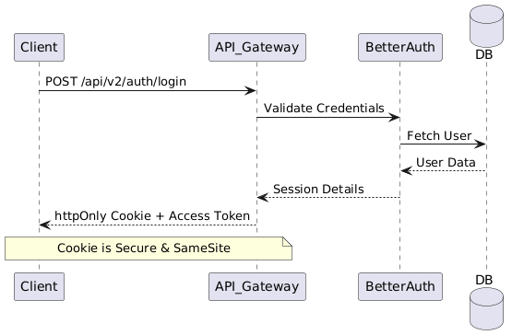
Figure 3. Identity and authority boundaries: tenant roles and platform roles remain separate.

10. Event Lifecycle State Machines
Events, invitations, orders, and tickets should move through explicit state machines. The service layer owns the transition matrix; callers request intent, not arbitrary field changes.
Entity | Allowed examples | Blocked examples
Event | draft -> review -> scheduled -> published -> completed | draft -> published without review; completed -> draft
Order | pending_payment -> paid -> fulfilled; pending_payment -> expired | paid -> pending_payment; fulfilled -> paid by duplicate webhook
Invitation | created -> accepted; created -> revoked; expired -> archived | revoked -> accepted; accepted -> revoked without audit trail
Ticket | issued -> checked_in; issued -> refunded; refunded -> voided | checked_in -> refunded without operator review

11. Data Modeling and Denormalized Reads
The platform optimizes read-heavy user journeys with denormalized documents. Event cards, partner summaries, and ticket inventories should be readable without forcing the browser to join venues, organizations, artists, pricing rules, and inventory records.
The trade-off is projection maintenance. Source-of-truth repositories emit outbox events when canonical data changes, and projection workers update the read models. Any screen that uses a projection must tolerate short-lived staleness and, where the consequence matters, perform a gateway validation before mutation.
Read model | Source facts | Freshness expectation
Guest event detail | Event, venue, organization, ticket tiers, availability summary. | Fast page load; final inventory and price revalidated at checkout.
Partner dashboard overview | Orders, payouts, scans, campaign metrics, event state. | Eventually consistent; show last refreshed timestamp for operational confidence.
Admin review queue | Event submissions, risk flags, tenant status, moderation notes. | Current enough for review workflow; irreversible actions call gateway directly.

12. Resiliency and Degraded Behavior
The platform should fail closed for authority and money, but degrade gracefully for optional read-side data.
Failure | User-visible behavior | System behavior
Recommendation or analytics service unavailable | Page renders without optional insight cards. | BFF returns partial data metadata and logs the skipped dependency.
Inventory validation conflict | User sees a clear sold-out or refresh message. | Gateway rejects the stale mutation and preserves the existing reservation state.
Webhook provider retry | No duplicate ticket or receipt is created. | Handler observes processed provider event ID and exits idempotently.
Projection worker lag | Dashboard shows stale timestamp or temporarily unavailable metric. | Worker retries with backoff; alert fires if lag crosses threshold.
Auth service uncertainty | Privileged action is denied or requires re-authentication. | No fail-open path for platform or tenant authority.

13. Observability and Operations
- Every product API response includes a request ID, and every service log line carries the same ID.
- Checkout logs must include order ID, event ID, idempotency key hash, payment provider event ID, and state transition result. Do not log raw credentials, webhook secrets, QR payloads, or full request bodies.
- Dashboards should track gateway latency, BFF latency, validation failure rate, auth failure rate, conflict rate, webhook duplicate rate, outbox lag, projection freshness, and checkout completion rate.
- Alerts should page on money-path failures, outbox backlog growth, webhook signature failures above baseline, and sustained authorization errors after a deploy.

14. Migration and Rollout Plan
Phase | What happens | Exit criteria
Inventory | List existing direct database calls and route handlers by product workflow. | Every path has an owner, target gateway route, and migration priority.
Shadow | Deploy BFF and gateway paths behind flags; mirror safe read traffic where possible. | Payload parity measured; no material latency regression; logs prove traceability.
Fractional traffic | Route a small percentage of users to the new path with immediate fallback. | Error rate, latency, checkout completion, and support tickets remain within threshold.
Ramp | Increase traffic by cohort and workflow rather than flipping the whole platform. | No unresolved P0/P1 defects; outbox lag and webhook duplicates remain stable.
Retire | Remove legacy direct paths and tighten guardrails. | Thirty days of stable traffic and architecture guardrails passing in CI.

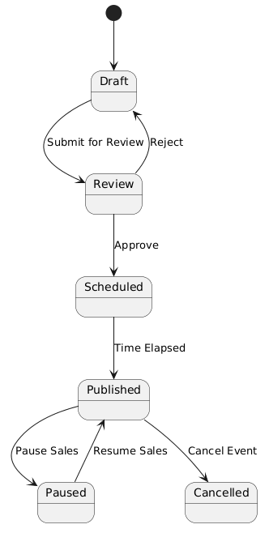
Figure 4. Migration posture: old and new paths coexist only while parity and health gates are measured.

15. Quality Bar for This Design
The design should be judged by whether an engineer can operate it during a real incident, not by whether the diagram looks elegant.
Baseline | What we actually want
A route returns the right data in a happy-path demo. | The route validates input, enforces authority, emits a request ID, and returns a stable envelope under success and failure.
Checkout writes an order and shows a receipt. | Checkout survives retries, duplicate webhooks, stale inventory, payment uncertainty, and worker failures without double fulfillment.
A BFF endpoint aggregates several records. | The BFF returns only screen-needed fields, tolerates optional dependency failures, and never owns product decisions.
Permissions are checked somewhere in the stack. | Tenant and platform authority are separate, auditable, and tested against escalation paths.
A migration plan exists. | Each phase has objective gates, rollback behavior, and owners for support and observability.

16. Open Risks and Decisions
Risk / decision | Current position | Owner
Partner dashboard still has transitional direct backend usage. | Do not expand it. Migrate workflow by workflow through gateway-backed routes. | Platform engineering
Read-model freshness can confuse operators. | Expose last-updated metadata for dashboards and alert on projection lag. | Partner experience
Feature flags can become permanent complexity. | Every flag must have a retirement ticket and a measurable exit gate. | Release owner
Webhook and redirect races are hard to reproduce manually. | Keep regression tests around duplicate confirmations, retries, and idempotent fulfillment. | Payments owner

Appendix: Boundary Rules
- No Firebase Admin usage in frontend runtime routes.
- No new direct database reads from guest or partner screens when a gateway-backed path is available.
- No business decisions in BFF routes. BFFs adapt, map, and normalize responses.
- No raw secrets, credentials, QR payloads, or privileged flags in browser responses.
- No money-path mutation without validation, authorization, idempotency, and an auditable state transition.

