System Design: Guest Portal BFF Architecture and Incremental Migration Strategy

1. Executive Summary & Context
This document outlines the architectural transition of the Guest Portal from a monolithic direct-to-database pattern to a modernized Backend-for-Frontend (BFF) approach. Historically, the Guest Portal relied on thick client-side logic to aggregate data directly from our primary datastores. To resolve this, we are introducing a thin UI layer supported by localized BFF read-models.

2. Architectural Goals & Constraints
- Strict Boundary Enforcement: The Guest Portal's BFF handlers must not bypass the core API gateway. The gateway remains the single source of truth.
- Standardized Flat Envelopes: Every new BFF endpoint must strictly adhere to our unified response envelope: { ok, data, error, meta }. All error envelopes are flat across the entire stack.
- Compare-and-Set Durability: All state mutations implement compare-and-set transactions (e.g., verifying expectedVersion) to prevent lost updates during concurrent checkout flows.

3. System Design: The BFF Pattern
The localized BFF layer is built directly into the Next.js application using standard API route handlers under app/api/app/*. Behind the scenes, the BFF handler validates the incoming request DTO using Zod. Once validated, it orchestrates calls to the backend API Gateway.
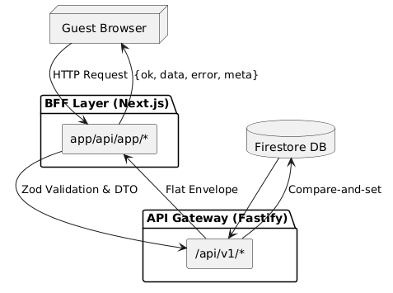
Figure 1: High-level request flow through the BFF and API Gateway layers.

4. Data Flow & Transactional Integrity
For complex flows such as guest checkout and ticket reservation, we implement a Transactional Outbox pattern alongside Compare-and-Set lock TTLs. Every order creation runs strictly inside a Firestore runTransaction block, persisting the business write and outbox event atomically.
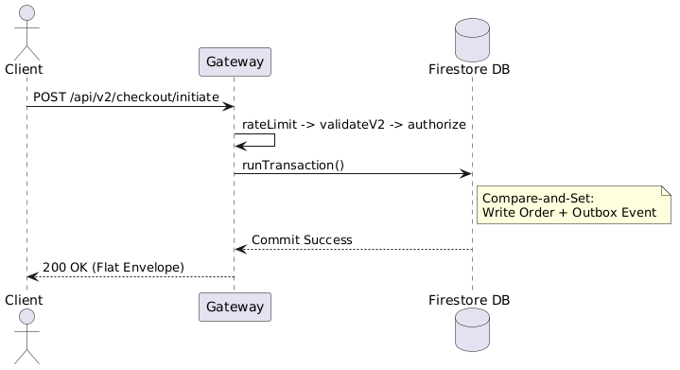
Figure 2: Transactional Checkout Flow.

5. Edge Cases, Failure Modes, and Mitigation
- Policy Ordering: Middleware strictly executes in order: rate-limit -> validate -> authorize -> cache. This ensures malformed DTOs are rejected with 422 before ABAC authorization logic wastes DB reads.
- Gateway Latency Spikes: If the upstream API Gateway experiences degraded performance, the BFF layer enforces strict 5-second timeout policies for read operations.

6. Migration Strategy & Rollout Plan
During Phase 1, the new BFF endpoints will be deployed to production in 'shadow mode'. Once parity is achieved and error rates drop below our 0.1% threshold, Phase 2 will involve a gradual traffic shift, starting with 5% of users.

