

National University of Computer and Emerging Sciences



OS Lab Project Phase 03
Robo OS

Project Team
Muhammad Bilal (22F-3309)
Faeiz tariq (22F-3873)

Instructed by
Ms. Mahzaib Younus

Department of Computer Science
National University of Computer and Emerging Sciences
Chiniot-Faisalabad, Pakistan
May 2024

- Introduction of Robo OS
Robo OS: The Future of AI-Powered Computing
Welcome to the world of Robo OS, a revolutionary operating system built on the foundation of artificial intelligence. Robo OS is designed to push the boundaries of computing, offering an intuitive and intelligent experience for users of all levels.

Key Features:
- AI-powered Interface: Robo OS learns your preferences and adapts to your needs, making it easier than ever to navigate and complete tasks.
- Personalized Experience: Get recommendations, automate tasks, and enjoy an interface that evolves with you.
- Enhanced Security: AI-powered threat detection and prevention keep your data safe from cyberattacks.
- Seamless Integration: Works with your existing hardware and software for a smooth transition.
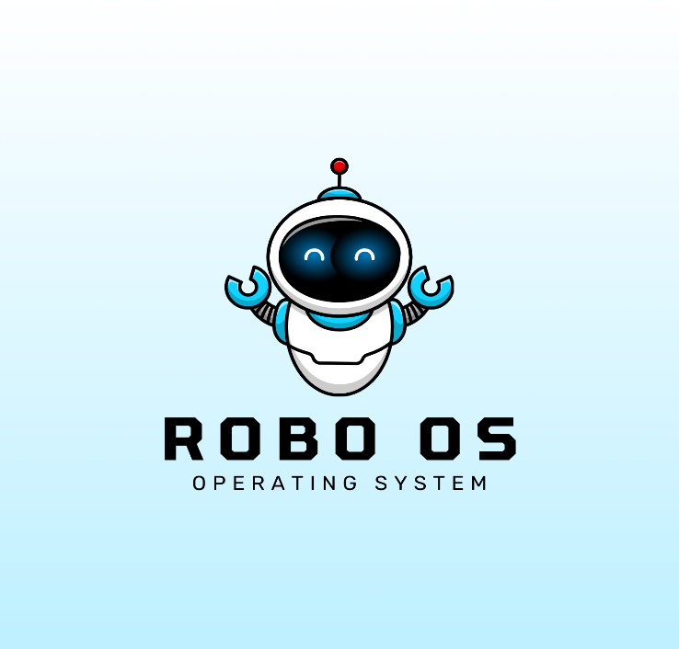
- Constant Evolution: Robo OS is always learning and improving, ensuring you have the latest features and functionalities.
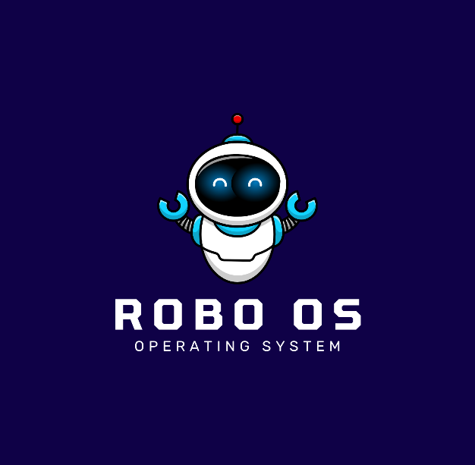

- Objectives

- Boost Productivity: AI-powered automation and personalized recommendations for efficient workflows.
- Personalization: Adapts to individual needs and preferences for a truly personal experience.
- Enhanced Security: AI-powered threat detection and prevention for secure data protection.
- Seamless Integration: Works with existing hardware and software for a smooth transition.
- Constant Evolution: AI-driven continuous improvement and new features.
- Democratize AI: Accessible to all, empowering everyone with AI-powered computing.
- Thriving Community: Fosters collaboration and innovation among users and developers.
- Shape the Future: Pioneering AI in operating systems, setting new standards for computing.

- Flowchart

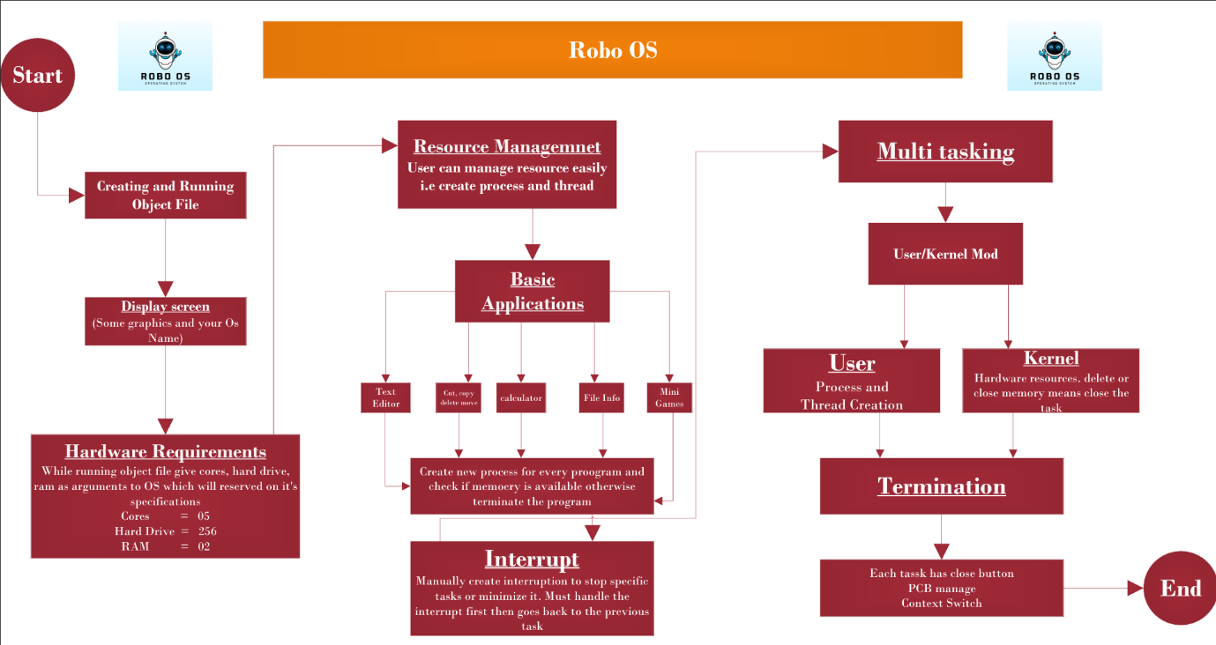

- Functionalities

- Process Management
- Memory Management
- File System Management
- Device Management
- User Interface
- Networking and Communication
- Security
- Error Handling and Fault Tolerance
- System Utilities
- Multitasking and Multithreading

- Concept
- Message passing
- Process Creation
- Threading
- Multi-Tasking
- Multi-Threading
- Process control block (PCB)
- Memory Allocation/Deallocation
- Application/ Termination

- Medium Blog
https://medium.com/@metheBilalAshiq/robo-os-operating-system-project-5b8267c85731

- Final Output Screenshots

Starting

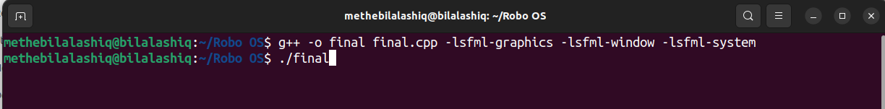

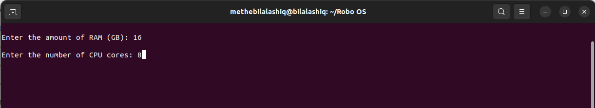

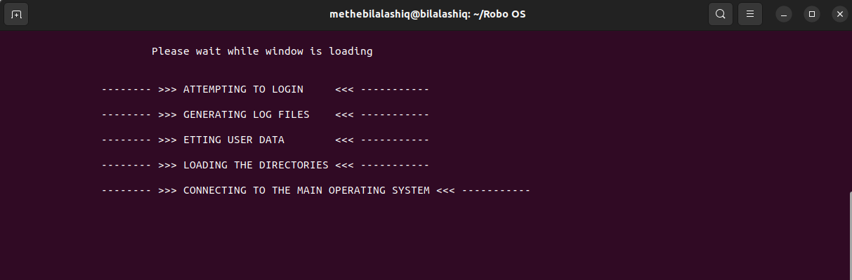

Display

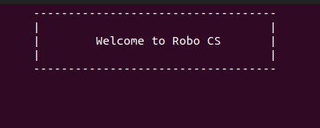

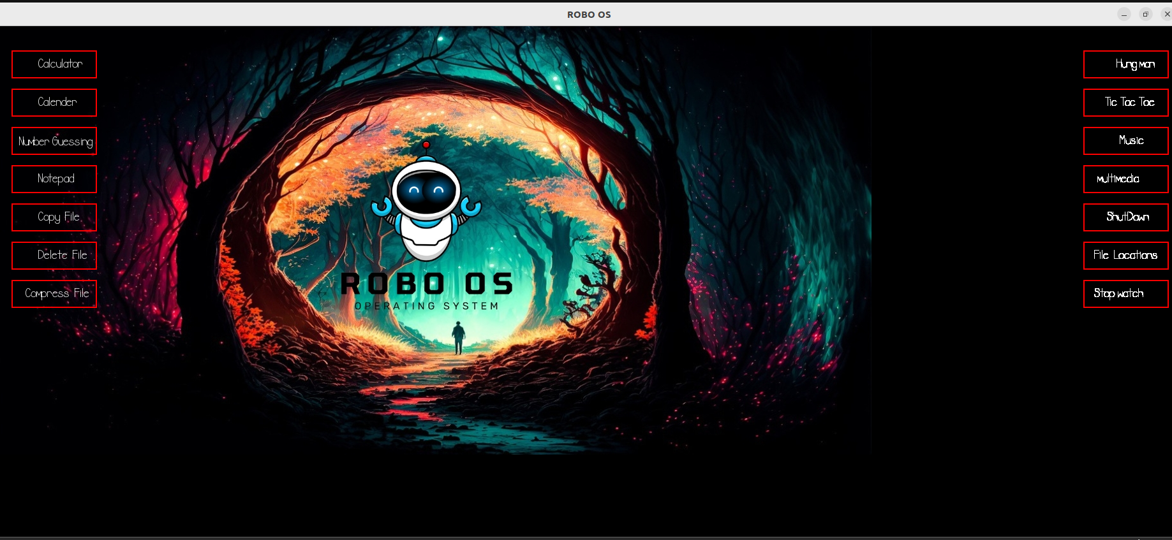

Time
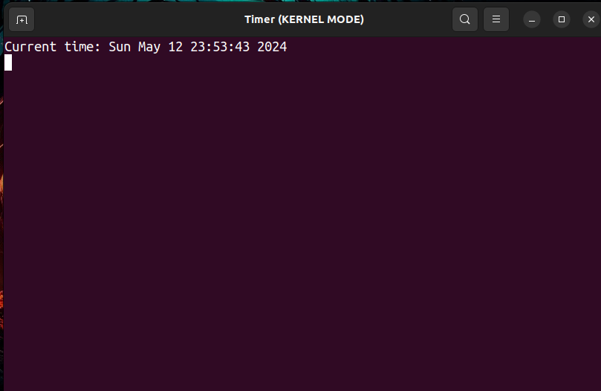
Process Runing
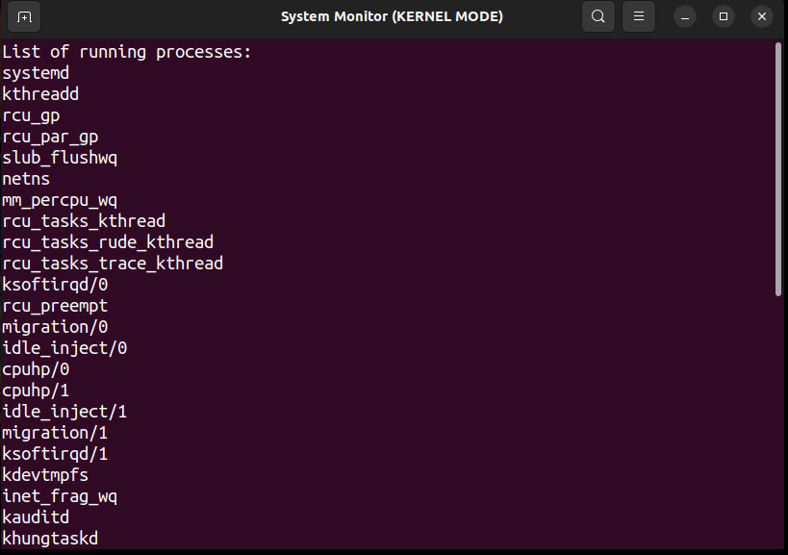
Tic Tac Toe
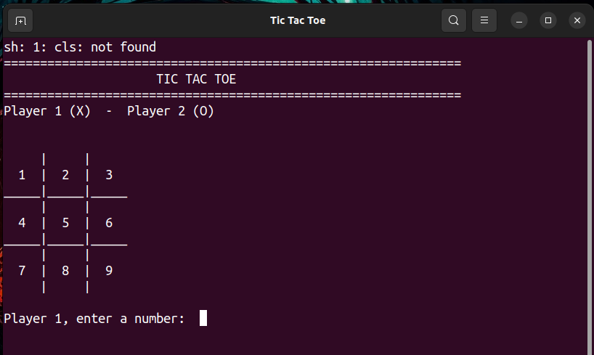

Multi Media
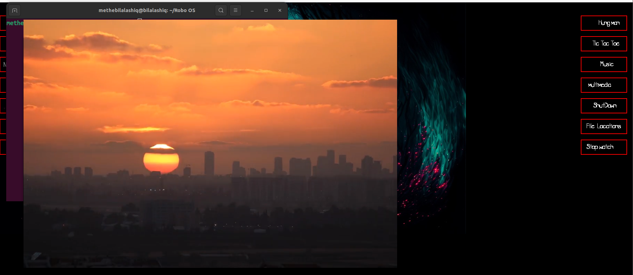

Stop watch
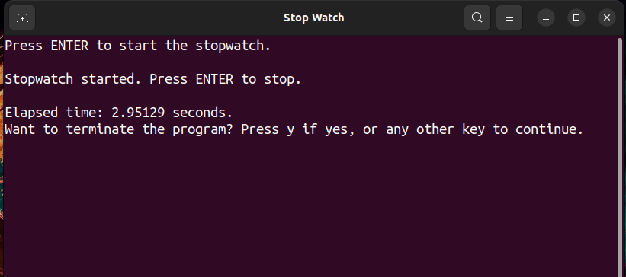

Shut Down

