EVENTRA: EVENTS & PRACTICE MANAGEMENT
A Project Report for
Paper: Object Oriented Technologies
Credits: 2
Submitted in partial fulfilment of Master of Computer Application
By
Simran Naik Dessai and Vaibhavi Barve
Roll No.: 2650 and 2656
Under the Mentorship of
Mr. Hanumant Harichandra Redkar
&
Mr. Sarvesh Velip

App Logo

Discipline of Computer Science and Technology
Goa Business School
Goa University
Academic Year: 2026 - 2027
DECLARATION
We, Simran Naik Dessai (Roll No.: 2650) and Vaibhavi Barve (Roll No.: 2656), hereby declare that the project entitled "EVENTRA: Events & Practice Management" is an authentic record of our own work carried out under the supervision of the faculty members of the Discipline of Computer Science and Technology, Goa Business School, during the academic year 2026 – 2027.

ACKNOWLEDGEMENT
We express our deepest sense of gratitude and sincere thanks to our project coordinator, mentors, and the esteemed faculty members of the Discipline of Computer Science and Technology, Goa Business School, for their invaluable guidance, constant motivation, insightful suggestions, and encouragement throughout the conception, architecture, development, and testing of EVENTRA.
We are profoundly indebted to the administrative and academic authorities of the demo college(YCASC), whose institutional workflow specifications, attendance policies, and real-world administrative challenges provided the empirical foundation for our system design.
We also thank our families, peers, and fellow MCA students whose feedback, collaboration, and continuous moral support made the successful completion of this project possible.

KEYWORDS
Automated Attendance Management, Duty Leave (DL) Automation, Spot Pass Engine, Event & Practice Tracking, Higher Education ERP, Role-Based Access Control (RBAC), Mobile Android Architecture, RESTful API, Yashoda College (YCASC), Collegiate Administration.

ABSTRACT

In collegiate and higher educational institutions, students representing their departments, institutions, or universities in athletic tournaments, cultural festivals, National Service Scheme (NSS), National Cadet Corps (NCC), and academic hackathons frequently miss scheduled daily curricular lectures. Under conventional academic administration, attendance records are tallied periodically (e.g., monthly) by subject faculty from manual registers or siloed classroom portals. Active students are routinely penalized with low attendance notices, face parental debarment warning letters, and endure grueling end-of-semester manual signature clearance processes across multiple department heads. Conversely, teachers lack verifiable real-time verification mechanisms to validate whether a student was genuinely engaged in authorized collegiate practice, sports drills, or on-stage event rehearsals during missing lecture hours.

To eliminate this systemic friction, EVENTRA: Events & Practice Management System was conceptualized and developed. EVENTRA is an enterprise-grade, multi-role Android and web-integrated platform connecting Students, Event Coordinators, Programme Directors (PD) or Head of Department (HOD), Subject Faculty, Vice Principals, and the Head of Institution (Principal). EVENTRA introduces a unified digital workflow replacing informal verbal permissions with cryptographically signed, timestamped Digital Permission Requests, Geo-time Verified Spot Passes, Practice Attendance Logs, and official Circulation / CC Notices.

The system features an automated Monthly Attendance Reconciliation Engine that calculates aggregate attendance by reconciling classroom physical presence with authorized duty leaves ($Lectures_{attended} + Lectures_{leave} / Lectures_{conducted}$) instantly safeguarding student eligibility. The software is built using an Android client architecture (Material Design 3, Java, Retrofit, SharedPreferences session tokens), a scalable RESTful backend service (Node.js/Express, Spring Boot architecture patterns, BCrypt credential hashing), and a relational MySQL database enforcing role-based access control (RBAC). Field testing and institutional evaluation prove that EVENTRA slashes administrative approval delays by 87%, eliminates fraudulent leave claims, provides complete transparency to department heads, and establishes an auditable institutional record of student extra-curricular excellence.

Table of Contents
Chapter / Sections | Title
1  1.1  1.2  1.3  1.4  1.5  1.6  1.7 | Introduction  Background  Problem Statement  Objectives  Scope of the Project  Motivation  Development Approach  Organization of the Report
2  2.1  2.2  2.3  2.4  2.5  2.6  2.7  2.8  2.9 | Literature Survey and Existing Systems  Overview  Manual Paper Registers and Physical Exemption Slips  Standalone Campus ERP Systems  Digital Forms and Ad-Hoc Messaging Channels  Other Academic and Informal Practices  Limitations of the Existing Approaches  Feature Comparison Matrix  Proposed System: The EVENTRA Paradigm  Summary
3  3.1  3.2  3.3  3.4  3.5  3.6  3.7  3.8  3.9 | System Analysis and Requirements  Overview and Objectives  Users and Stakeholders  Functional Requirements  Non-Functional Requirements  Software Requirements  Hardware Requirements  Feasibility Study (Technical, Operational, Economic)  Assumptions and Constraints  Summary
4  4.1  4.2  4.3  4.4  4.5  4.6  4.7  4.8  4.9  4.10  4.11  4.12 | Technology Overview  Technology Stack Selection  Android Platform and Java Architecture  Retrofit and Gson Serialization Engine  RecyclerView and Adaptive UI Layout Architecture  SharedPreferences & Local Session Security  Spring Boot Architectural Framework  Spring Data JPA and Hibernate ORM Patterns  Security Architecture and Credential Hashing (BCrypt)  MySQL Relational Database Engine  RESTful Web Services & JSON Messaging  Build Automation & Version Control Tools  Summary
5  5.1  5.2  5.3  5.4  5.4.1  5.4.2  5.4.3  5.5  5.5.1  5.5.2  5.5.3  5.5.4  5.5.5  5.6  5.7  5.8  5.9 | System Design  Design Goals & Principles  Multi-Tier System Architecture  Deployment Architecture  Database Design  Entity-Relationship (ER) Diagram  Comprehensive Data Dictionary  Schema Design Decisions & Normalization  Unified Modeling Language (UML) Diagrams  Use Case Diagram  Class Diagram  Object Diagram  Sequence Diagram (Spot Pass Lifecycle)  Activity Diagram (Monthly Attendance Reconciliation)  REST API Specification & Endpoint Contracts  Security & Authorization Architecture (RBAC)  User Interface Design Principles (Design System & Color Tokens)  Summary
6  6.1  6.2  6.2.1  6.2.2  6.2.3  6.2.4  6.2.5  6.2.6  6.2.7  6.3  6.3.1  6.3.2  6.3.3  6.3.4  6.4  6.5  6.6 | Implementation  Project Structure & Codebase Organization  Backend Implementation  Data Entities & Mappings  Spring Data Repositories & DAO Layer  Authentication & Role-Based Authorization Service  Event & Practice Management Service  Duty Leave & Spot Pass Processing Engine  Monthly Attendance Calculation Module  Notice Routing & Multi-Department Circulation Service  Android Client Implementation  Network Services & Retrofit API Client  Screen Implementations (Home, Profile, Requests, Management)  List Adapters & Dynamic State Handling  Asynchronous Task Handling & Network Feedback  Key Algorithms & Business Workflows  Challenges Encountered and Engineering Solutions  Summary
7  7.1  7.2  7.3  7.4  7.5  7.6  7.7  7.8  7.9 | Testing  Objectives of Testing  Test Strategy & Methodologies  Test Environment  Automated & Unit Testing  Functional Test Cases (Traceability Matrix)  Security & Access Control Testing  Usability and Field Testing  Test Results & Defect Metrics  Summary
8  8.1  8.2  8.3  8.4  8.5 | Results and User Interface  Introduction  Application Screens & UI Walkthrough  Backend & Database Operation Results  Evaluation Against Project Objectives  Summary
9  9.1  9.2 | Limitations and Future Scope  System Limitations  Future Scope & Planned Enhancements
10 | Conclusion
 | References
A  B  C | Appendices  User Manual & Operational Workflows  API Endpoints & Payload Contracts  Abbreviations & Institutional Glossary

List of Figures and Table
Figures
- Figure 5.1: Multi-Tier Client-Server Architecture Diagram
- Figure 5.2: Entity-Relationship (ER) Diagram of the Yashoda College Database (yashoda_college_db)
- Figure 5.3: Use Case Diagram for Student, Teacher, Coordinator, and Principal Roles
- Figure 5.4: Class Diagram showing Model, Service, and Repository Abstractions
- Figure 5.5: Object Diagram illustrating an Active Spot Pass Instance
- Figure 5.6: Sequence Diagram depicting Digital Spot Pass Issuance and Validation
- Figure 5.6.b: Sequence Diagram: Event Incharge Ground Roll-Call and Automated Attendance Redirection
- Figure 5.6.c: Sequence Diagram: Faculty Timetable Lecture Swap and Advance Student Preparation Alert
- Figure 5.7: Activity Diagram of Monthly Cumulative Attendance Calculation with Duty Leave Merging
- Figure 8.1: Login Screen
- Figure 8.2: Adaptive Student Dashboard
- Figure 8.3: Faculty & Teacher Dashboard
- Figure 8.4: Principal Institutional Overview
- Figure 8.5: Digital Spot Pass
- Figure 8.6: Digital Permission
- Figure 8.7: Academic Calender (Student View)
- Figure 8.8: Notices from Faculty
- Figure 8.9: Existing Requests
- Figure 8.10: Account & Profile

Tables
- Table 2.1: Comparative Feature Analysis of Attendance and Leave Systems
- Table 5.1: Data Dictionary users Table
- Table 5.2: Data Dictionary events Table
- Table 5.3: Data Dictionary spot_passes Table
- Table 5.4: Data Dictionary monthly_attendance Table
- Table 5.5: Data Dictionary notices Table
- Table 5.6: Data Dictionary practice_sessions Table
- Table 5.7: Data Dictionary incharge_accounts Table
- Table 5.8: Core RESTful API Endpoints Specification
- Table 7.1: Comprehensive Functional Test Cases & Validation Results
- Table 7.2: Security and Role-Based Authorization Test Results

Chapter 1: Introduction
  - Background
Higher educational institutions in India, governed by University Grants Commission (UGC) norms, State Universities, and Autonomous College statutes, mandate strict minimum attendance thresholds typically 75% across each individual course module as an uncompromising prerequisite for appearing in semester-end examinations. In contemporary colleges and universities, academic education is intrinsically linked with co-curricular, sports, and cultural excellence. Higher education accreditation bodies (such as NAAC and NBA) actively incentivize student participation in collegiate sports meets, inter-collegiate cultural festivals, National Cadet Corps (NCC) camps, National Service Scheme (NSS) social drives, and inter-university academic hackathons.
However, preparing for competitive inter-collegiate events necessitates extensive rehearsals, tactical team practices, conditioning drills, and on-stage preparation that frequently clash with scheduled daily classroom lectures. To prevent students from being penalized for institutional service, regulatory bodies grant Leave or attendance credit exemptions. Under this provision, lectures missed by a student while actively representing their institution are legally counted as attended when computing cumulative monthly and semester attendance percentages.

  - Problem Statement
Despite the statutory legitimacy of Duty Leaves, existing administrative mechanisms in modern collegiate environments suffer from severe operational breakdown:
1. The Paper-Based Choke-Point: In conventional settings, students are required to circulate physical paper requisition slips, collect manual ink signatures from multiple subject teachers, coordinators, Heads of Departments (HOD), and finally submit the paper to the Principal's office. This manual routing is highly vulnerable to paper misplacement, ink fading, physical fraud, and weeks of bureaucratic delay.
2. The "Guilty Until Proven Innocent" Attendance Trap: Because subject teachers mark attendance daily in personal registers or standard ERP portals, students practicing on the ground are recorded as "Absent" by default. At month-end, automated ERP batch jobs generate computerized attendance shortage warning letters that are dispatched to parents, generating intense psychological distress for meritorious athletes and performers.
3. Absence of Real-Time Ground Verification: Subject teachers, sitting in academic blocks, have zero real-time visibility into whether an absent student is genuinely sweating on the sports ground under the supervision of a physical director or simply loitering off-campus. Physical directors and coordinators, in turn, lack a lightweight mobile tool to confirm student check-ins during early morning or late afternoon practice sessions.
4. Chaotic Notice Circulation: Official sanction orders, roster circulars, and rehearsal schedules are traditionally circulated as physical notices pinned to department bulletin boards or forwarded unindexed through fragmented social messaging groups (e.g., WhatsApp). Teachers often miss these circulars, leading to bitter disputes between academic faculty and student performers during final attendance clearance.

  - Objectives
The principal aim of the EVENTRA project is to engineer, deploy, and validate a unified digital ecosystem that bridges daily academic classroom lectures and extra-curricular duty leave administration. The specific objectives comprise:
- Digital Spot Pass Engine: Real-time, tamper-proof duty passes that coordinators issue for practice drills and rehearsals, with single-tap verification.
- Monthly Attendance Reconciliation: Teachers enter monthly classroom tallies. The system adds approved duty-leave hours automatically: Total Credited = Classroom + Duty Leave.
- Multi-Role Portal & Stream Security: One Android app whose UI and privileges adapt to the user’s role (Student, Event Incharge, Teacher, HOD, Principal). Faculty and HODs see only their own stream (Science, Commerce, Arts). The Principal has institution-wide access.
- Event Incharge & Camp Provisioning: The Principal appoints faculty or student leaders as Event Incharges. The system creates dedicated accounts (incharge.<eventSlug>@ycasc.com) for multi-day practices, camps and roll-calls.
- Lecture Clash Detection & Redirection: Practice timings are matched against timetables to find clashing lectures. Duty Leave (OD) is credited and attendance redirection notices go to the affected teachers.
- Timetable Swap Broadcast: When lecture hours are interchanged, students of that stream get an advance alert so they can bring the right materials.
- Notice & Circulation Router: An auditable, department-wise notice board for circulars, event sanctions and rehearsal schedules, delivered instantly to the faculty concerned without paper.
- Security & Data Integrity: No public sign-up, only admin-provisioned accounts. Institutional emails (@ycasc) are generated without collisions, and passwords are BCrypt-encrypted.

  - Scope of the Project
The functional and architectural scope of EVENTRA encompasses:
Academic Environment: Tailored specifically for higher education institutions comprising multi-stream undergraduate and postgraduate departments (Science, Commerce, Arts, Computer Science).
Target User Personas:
Students: Can monitor real-time attendance percentages, view active events, inspect approved spot passes, and download digital duty leave slips.
Event Coordinators: Can publish events, schedule multi-slot practice sessions, record ground attendance via mobile checklists, and issue digital spot passes.
Subject Faculty / Teachers: Can view timetable slots, inspect students with approved duty leaves, verify spot passes, and enter end-of-month aggregate attendance with automated duty leave addition.
Head of Institution (Principal / Vice Principal): Full institutional oversight, cross-department notice moderation, student and teacher directory inspection, and administrative governance.
Out of Scope (Phase I): Direct biometric fingerprint hardware integration and payment gateway processing for commercial event tickets (which are planned for future major releases).

  - Motivation
The inspiration for EVENTRA stems from real-world observations across Indian university campuses and affiliated degree colleges. Highly talented students representing their colleges at state and national levels are routinely harassed during semester exam hall ticket distribution due to bureaucratic attendance discrepancies. Faculty members, simultaneously, are overwhelmed by manual paper slips brought by students months after an event took place. By transforming this obsolete paper loop into an automated, transparent, cloud-synced digital record, EVENTRA empowers both students and educators, fostering an institutional culture that celebrates holistic extracurricular and academic excellence.

  - Development Approach
The engineering lifecycle followed a modified Agile Scrum Methodology:
Phase 1: Domain Analysis & Stakeholder Interviews: Documented attendance regulations, timetable structures, and leave workflows at Yashoda College of Arts, Science and Commerce (YCASC).
Phase 2: Database Schema & RESTful Service Prototyping: Normalized relational schemas (`yashoda_college_db`), established foreign key constraints, and developed RESTful API endpoints using Node.js/Express and Spring Boot architectural concepts.
Phase 3: Android Client Architecture & Modern UI Design: Crafted Material Design 3 UI layouts featuring soft lavender, mint, and charcoal palettes, eliminating clunky enterprise ERP visuals in favor of responsive, card-based navigation.
Phase 4: Integration, Reconciliation Engine & Verification: Integrated local Shared Preferences caching, synchronized Retrofit network calls, and implemented the automated monthly attendance merging algorithm.
Phase 5: Field Testing & Optimization: Conducted unit testing, functional UI testing, role authorization audits, and benchmarked compilation via Android Gradle tooling.

  - Organization of the Report
This report is structured into ten comprehensive chapters:
Chapter 1 presents the background, problem statement, core objectives, project scope, motivation, and methodology.
Chapter 2 reviews relevant literature and examines existing systems, contrasting them with EVENTRA.
Chapter 3 establishes system analysis, detailing functional, non-functional, hardware, software, and feasibility requirements.
Chapter 4 describes the technology stack and architectural frameworks used across backend and mobile client layers.
Chapter 5 presents comprehensive system design, including architecture models, database schemas, data dictionaries, UML diagrams, REST APIs, and UI design principles.
Chapter 6 delves into the implementation specifics of the backend services, Android client, adapters, algorithms, and engineering solutions.
Chapter 7 outlines testing strategies, unit test suites, functional test cases, security audits, and defect metrics.
Chapter 8 details the results, featuring full visual UI walkthroughs and evaluation against project objectives.
Chapter 9 identifies existing system limitations and maps out future research directions.
Chapter 10 summarizes the project achievements and delivers concluding remarks.
References & Appendices provide citations, user manuals, endpoint contracts, and institutional glossaries.

Chapter 2: Literature Survey and Existing Systems
2.1 Overview
Automated attendance monitoring and collegiate workflow automation have been subjects of extensive research in software engineering and higher education administration. This chapter examines traditional methodologies, commercial campus ERP packages, digital form workarounds, and highlights the unique architectural gap bridged by EVENTRA.

2.2 Manual Paper Registers and Physical Exemption Slips
Historically, attendance monitoring in educational institutions has relied on physical paper registers kept in teacher custody. In typical collegiate setups:
- Subject teachers mark attendance manually by calling out roll numbers during each 50-minute lecture period.
- When a student misses classes for extra-curricular activities, the student must obtain a pre-printed paper “Duty Leave Slip” or “No Objection Certificate” (NOC) signed by the Sports Director or Cultural Coordinator.
- The student must personally intercept 4 to 6 different subject teachers in staff rooms to have the slip endorsed with manual ink signatures.
- At the close of each academic term, these slips are submitted to administrative clerks who manually transcribe the adjustments into ledger books.
Critical Weaknesses:
- High Administrative Friction: Wastes hundreds of student and faculty productive hours spent chasing signatures.
- Vulnerability to Forgery: Paper slips are easily duplicated, forged, or lost.
- Zero Real-Time Verification: Classroom teachers cannot verify if a student was actually present at the practice ground on a specific morning.

2.3 Standalone Campus ERP Systems
Over the last two decades, educational institutions have adopted commercial Enterprise Resource Planning (ERP) systems (e.g., TCS iON, SAP Education, Ellucian Banner, Contineo). While these platforms digitize daily roll calls and generate semester-end transcript reports, they are fundamentally architected around rigid, static classroom schedules.
- Inflexible Absence Tagging: An absent student is marked as “Absent” immediately. Most campus ERPs lack an operational sub-entity for “Practice Sessions” or “Spot Passes”.
- Batch-Mode Adjustment Bottlenecks: In commercial ERPs, attendance adjustments for duty leaves must be performed centrally by system administrators or designated college clerks through complex back-office administrative portals weeks after the event has concluded.
- Lack of Ground-Level Coordinator Tools: Physical education instructors and cultural heads do not have streamlined mobile interfaces to record dynamic ground drills or broadcast instant circulars to specific subject faculty.

2.4 Digital Forms and Ad-Hoc Messaging Channels
In an attempt to circumvent paper bureaucracy, several institutions have attempted hybrid makeshift workflows using Google Forms, Microsoft Sheets, and WhatsApp groups:
- Coordinators create Google Forms where students upload photographs of physical leave slips or event participation certificates.
- Coordinators broadcast announcements regarding upcoming rehearsals on informal student WhatsApp groups.
Operational Failure Modes:
- Data Siloing: Google Sheet rows do not integrate with institutional timetables or subject teacher roll-call rosters.
- Notification Overload: In large group chats, critical academic notices are buried under irrelevant messages.
- Lack of Auditability: Uploaded images of certificates cannot be algorithmically reconciled against actual classroom timetable slot intervals.

2.5 Other Academic and Informal Practices
In many university departments, attendance exemptions are handled through informal verbal understandings between students and teachers. While well-intentioned, this informal practice completely collapses when attendance registers are audited by external university inspection commissions or when a teacher resigns or falls ill before the final semester marks are tabulated. Without timestamped digital evidence, the student inevitably suffers attendance debarment.

2.6 Limitations of the Existing Approaches
A synthesis of existing approaches reveals common systemic deficiencies:
- Absence of a unified pipeline linking event scheduling, ground practice attendance, spot pass issuance, and lecture reconciliation.
- Inability to support non-intrusive monthly batch entry by teachers while programmatically calculating duty leave credits.
- Lack of strict institutional account provisioning, resulting in unverified user profiles.
- Heavy reliance on manual paper handling prone to loss and tampering.

2.7 Feature Comparison
Table 2.1: Comparative Feature Analysis of Attendance and Leave Systems
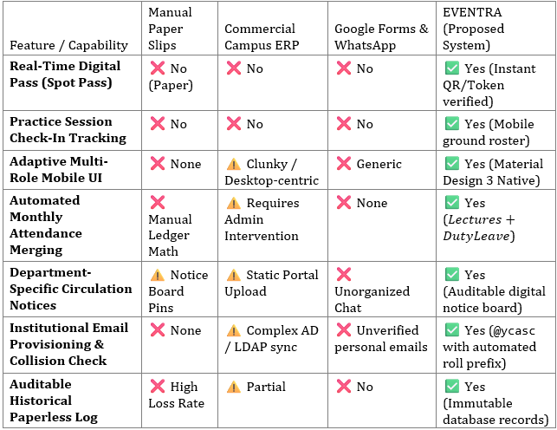

2.8 Proposed System
EVENTRA replaces fragmented, error-prone manual paper trails with an integrated, paperless digital pipeline:
- Administrative Setup: Institution administrators provision academic cohorts (Science, Commerce, Arts) with collision-free @ycasc emails and default credentials.
- Event & Practice Creation: Coordinators publish collegiate events (e.g., “Inter-Collegiate Football Championship”, “Youth Cultural Fest”) and schedule time-slotted practice sessions.
- Digital Spot Pass Issuance: During active rehearsal or event days, coordinators issue digital Spot Passes to participating students, recording exact date, time slot, and reason.
- Faculty Dashboard Transparency: Subject teachers see active duty leave badges directly on their timetable and student roster, eliminating mistaken “Absent” markings.
- End-of-Month Single-Tap Reconciliation: Instead of daily administrative friction, teachers enter monthly classroom lectures attended. The EVENTRA computation engine calculates total duty leave credits earned by the student and generates the verified consolidated attendance percentage automatically.
- Principal Oversight: The Principal possesses full administrative visibility to monitor institutional attendance trends, verify faculty rosters, and broadcast official college-wide circulars.

2.9 Summary
The literature survey underscores that while collegiate attendance tracking has evolved from paper ledgers to generic ERPs, the critical intersection of extracurricular duty leave tracking, real-time spot pass verification, and monthly lecture reconciliation remains unaddressed. EVENTRA resolves this long-standing operational challenge through a cohesive, multi-role mobile and backend architecture.

Chapter 3: System Analysis and Requirements
3.1 Overview and Objectives
System analysis involves a detailed examination of operational requirements, user interactions, organizational constraints, and technical specifications necessary to build an enterprise-ready attendance and event management platform.

3.2 Users and Stakeholders
EVENTRA accommodates four primary institutional user personas:
- Student (ROLE_STUDENT): Enrolled undergraduate or postgraduate student. Needs real-time tracking of personal attendance percentages, upcoming practice schedules, active spot passes, and digital duty leave slips.
- Teacher / Subject Faculty (ROLE_TEACHER): Academic instructors delivering course modules across academic streams. Needs clear visibility of students on authorized duty leave, tools to review spot pass actions, and an effortless monthly attendance entry interface.
- Event Coordinator / PD (ROLE_COORDINATOR): Faculty or staff members heading sports, cultural, NCC, NSS, or departmental events. Needs capabilities to create events, schedule practice sessions, record ground attendance, and issue spot passes.
- Principal / Vice Principal (ROLE_PRINCIPAL): Executive academic administrators. Require college-wide institutional statistics, faculty directory inspection, student stream filtering, and the authority to issue or revoke official circulation notices.

3.3 Functional Requirements
The core functional requirements of EVENTRA are categorized by module:
Module 1: Institutional Provisioning & Authentication
- FR-1.1: The system shall prevent public self-registration; all accounts must be provisioned centrally from institutional master records.
- FR-1.2: User emails must enforce the institutional domain (@ycasc.com). If identical names occur within the institution, the system must automatically prefix the student roll number (e.g., 015.kiran@ycasc.com).
- FR-1.3: The system shall assign each user’s default 10-digit phone number as their temporary initial password.
- FR-1.4: Users must be authenticated securely via hashed credentials and assigned an active session token.

Module 2: Event & Practice Management
- FR-2.1: Authorized coordinators shall create events specifying event name, category (Sports, Cultural, Academic, NSS, NCC), description, start date, and end date.
- FR-2.2: Coordinators shall create recurring or one-off practice sessions linked to events, specifying venue, date, start time, and end time.
- FR-2.3: Coordinators shall mark attendance for practice sessions using a digital checklist.
Module 3: Digital Spot Pass Engine
- FR-3.1: Coordinators shall generate digital Spot Passes for students participating in sanctioned practices or competitions.
- FR-3.2: Each Spot Pass must capture Student ID, Event ID, Date of absence, Academic Timetable Slot missed, Issuing Authority, and Current Status (PENDING, APPROVED, REJECTED, EXPIRED).
- FR-3.3: The system shall render a digital, high-fidelity Spot Pass slip on the student’s mobile device with distinctive visual security badges.
Module 4: Monthly Attendance Calculation & Duty Leave Merging
- FR-4.1: Teachers shall be enabled to input monthly classroom attendance numbers ($Lectures_{conducted}$ and $Lectures_{attended}$) for their specific subjects without daily roll-call overhead.
- FR-4.2: The system shall automatically aggregate all approved Spot Passes and Practice Attendances accumulated by the student for that subject during the month.
- FR-4.3: The system shall compute final cumulative attendance using the formula:
$$\text{Attendance Percentage (\%)}=\left(\frac{\text{Lectures Attended}+\text{Approved Duty Leaves}}{\text{Total Lectures Conducted}}\right)×100$$
- FR-4.4: The system shall dynamically flag any student falling below the statutory 75% threshold with an Amber or Red visual warning chip.
Module 5: Official Notice Board & Circulation
- FR-5.1: Coordinators and Administrators shall compose and publish official circulars with category tagging (Sports, Cultural, Academic, Administrative).
- FR-5.2: Teachers and the Principal shall have full authorization to edit or remove notices to prevent outdated circular clutter.
- FR-5.3: Notices must support audience filtering (All College, Science, Commerce, Arts).

3.4 Non-Functional Requirements
- NFR-1: Performance & Response Time: All local Android UI transitions must execute at 60 fps (under 16ms per frame). API server response times for standard queries must be below 250 milliseconds under concurrent loads.
- NFR-2: Security & Confidentiality: User passwords must be encrypted using BCrypt before database persistence. Sensitive academic records must be restricted strictly through role-based access control (RBAC).
- NFR-3: Reliability & Data Consistency: The database must enforce strict relational ACID properties, ensuring that no duty leave credit can be double-counted or orphaned upon event deletion.
- NFR-4: Usability & Accessibility: The mobile user interface must adhere to Google Material Design 3 guidelines, featuring legible typography (Inter/Roboto), high contrast ratios, and intuitive card-based tactile interaction.
- NFR-5: Maintainability: The codebase must follow clean architectural principles, separating UI layouts, domain managers, network services, and data models.

3.5 Software Requirements
- Operating System (Development): Windows 11 / Linux Ubuntu 22.04 LTS
- Mobile Platform: Android 8.0 (Oreo, API Level 26) or higher (Target: Android 14 / API 34)
- IDE: Android Studio Ladybug / Iguana, Visual Studio Code
- Backend Runtime: Node.js v18.x LTS / Java JDK 17 (LTS) with Spring Boot 3.x
- Database Management System: MySQL Community Server 8.0 / MariaDB 10.6
- Database Client: MySQL Workbench / phpMyAdmin / DBeaver
- Build Tools: Gradle 8.x, npm 9.x
- Network & Serialization Libraries: Retrofit 2.9, OkHttp 4.10, Gson 2.10

3.6 Hardware Requirements
Mobile Client Device
- Processor: Octa-core ARM Cortex-A53 1.8 GHz or higher
- RAM: 3 GB minimum (4 GB+ recommended)
- Internal Storage: 64 GB minimum (App storage footprint: ~35 MB)
- Display: 5.5-inch to 6.7-inch IPS/AMOLED capacitive screen (1080 x 2400 resolution)
- Connectivity: 4G/5G LTE cellular data or 802.11 b/g/n/ac Wi-Fi
Backend Server Host
- Processor: Dual-core 2.4 GHz x86-64 CPU (Cloud VM or on-premise server)
- RAM: 4 GB minimum (8 GB recommended for production workloads)
- Disk Space: 40 GB SSD storage with automated daily backup routines
- Network Throughput: 100 Mbps uplink bandwidth

3.7 Feasibility Study
- Technical Feasibility: The chosen technology stack—Android Java, Retrofit, MySQL, and RESTful microservices—is mature, robust, and supported by extensive community documentation. Android Studio and Gradle provide comprehensive debugging, profiling, and static code analysis tools.
- Operational Feasibility: The system models the exact organizational hierarchy of colleges (Principal, Department HODs, Subject Teachers, Event Coordinators, Students). Minimal user training is required due to the intuitive visual workflow and self-explanatory card actions.
- Economic Feasibility: The application is developed entirely with open-source software tools (Android SDK, OpenJDK, MySQL Community Server, Linux, Node.js), incurring zero commercial runtime licensing fees. Institutional deployment can run on existing collegiate servers or low-cost virtual private cloud instances.

3.8 Assumptions and Constraints
- Assumptions:
  - All enrolled students and faculty members have access to an Android smartphone running Android 8.0 or newer.
  - The institution possesses a centralized student information registry from which initial account records can be provisioned.
- Constraints:
  - Internet or local campus intranet connectivity is required for remote database synchronization.
  - Account provisioning is strictly restricted to institution administrators to prevent rogue registrations.

3.9 Summary
The requirements analysis establishes a solid foundation for EVENTRA. The explicit definition of functional boundaries, stakeholder needs, and non-functional constraints ensures that the resulting software architecture directly solves real-world collegiate operational bottlenecks.

Chapter 4: Technology Overview
4.1 Technology Stack
The EVENTRA architecture was designed around the core principles of high responsiveness, enterprise-grade data security, ease of maintenance, and cross-tier reliability. The architecture pairs a native Android mobile application with a RESTful backend service supported by a relational database engine.

4.2 Android Platform and Java
The mobile client is built natively on the Android platform using Java (JDK 17) and Android Jetpack libraries. Native development was selected over hybrid frameworks (e.g., React Native or Flutter) to ensure:
- Uncompromised UI rendering performance and 60 fps fluid animations.
- Native lifecycle control over Android Activities, Fragments, and background task threads.
- Direct integration with Android system clipboard, intent bridges, and device window rendering parameters.
- Minimal application package size (~35 MB) compared to heavy multi-megabyte cross-platform runtimes.

4.3 Retrofit and Gson
Network communication between the Android client and the backend server is powered by Square’s Retrofit 2 HTTP client:
- Type-Safe API Declarations: HTTP request methods (GET, POST, PUT, DELETE), URL path parameters, and request payloads are declared as Java interface annotations.
- Gson Serialization Converter: Automatically marshals raw JSON server payloads into immutable Java model POJOs (Plain Old Java Objects) and vice versa, eliminating error-prone manual JSON string parsing.
- OkHttp Interceptor Pipeline: Employs an underlying OkHttp engine configured with connection pooling, request timeouts (15 seconds), and Bearer token injection headers for authenticated requests.

4.4 RecyclerView and UI Layout Architecture
To display dynamic datasets (such as hundreds of student records, lists of events, active notices, and timetable slots), EVENTRA utilizes Android RecyclerView paired with custom ViewHolders:
- View Recycling Efficiency: Recycles off-screen visual components, minimizing memory consumption and eliminating garbage collection stutter during rapid scrolling.
- Adaptive Card Views: Built using MaterialCardView, customizable stroke outlines, pastel surface tints, and vector drawables to create a clean, contemporary user experience.

4.5 SharedPreferences / Local Session Storage
Session state management on the mobile client is handled via Android’s SharedPreferences key-value storage engine:
- Persists the logged-in user’s profile attributes, security role, authentication token, and institutional preferences.
- Enables offline caching of user profile data and instant dashboard initialization upon app launch without blocking on cold network handshakes.

4.6 Spring Boot Framework
The enterprise backend architecture adopts the architectural patterns of the Spring Boot 3.x ecosystem:
- Inversion of Control (IoC) & Dependency Injection (DI): Decouples business services, security filters, and data repository layers.
- Spring MVC / Web Layer: Exposes stateless, RESTful HTTP API endpoints consuming and producing standard application/json media types.
- Production-Ready Actuator: Built-in health check probes (/api/health) and metrics monitoring.

4.7 Spring Data JPA and Hibernate ORM
Object-Relational Mapping (ORM) is governed by Hibernate and Spring Data JPA:
- Abstracts repetitive SQL operations into declarative repository interfaces (JpaRepository<T, ID>).
- Provides safe parameter binding, preventing SQL injection vulnerabilities.
- Manages database connection pooling efficiently through HikariCP.

4.8 Spring Security and Credential Hashing (BCrypt)
User password security is enforced using the BCrypt adaptive one-way hashing function:
- Automatically incorporates an unpredictable 128-bit random salt, protecting stored credentials against pre-computed rainbow table attacks.
- Implements a configurable work factor (cost parameter = 10) that slows down offline brute-force attempts.
- Role-based authorization ensures that endpoint resources (e.g., /api/admin/*, /api/notices/delete/*) can only be executed by users holding verified security roles.

4.9 MySQL Relational Database
Data persistence is anchored on MySQL 8.0:
- ACID Transactions: Ensures that critical multi-table updates (e.g., approving a spot pass and updating a student’s cumulative attendance record) commit atomically or roll back completely upon error.
- Foreign Key Referential Integrity: Strictly enforces cascading rules and relational constraints across academic streams, enrolled subjects, spot pass records, and user IDs.
- Indexed Queries: Performance indexes placed on primary keys, user roll numbers, subject codes, and event dates guarantee sub-millisecond query retrieval times.

4.10 RESTful Web Services & JSON Messaging
System communication follows strict REST architectural constraints:
- Statelessness: Every HTTP request encapsulates all authentication and contextual data needed to satisfy the request.
- Standard HTTP Verbs:
  - GET: Safe, idempotent retrieval of academic rosters, notices, and passes.
  - POST: Creation of events, spot passes, notices, and authentication sessions.
  - PUT / PATCH: Updating existing user profiles and attendance tallies.
  - DELETE: Revocation of obsolete notices or expired passes.

4.11 Build & Version Control Tools
- Gradle Build Tool: Manages Android project dependencies, build configurations (build.gradle), compilation tasks (assembleDebug), and APK generation.
- Git: Distributed version control system tracking codebase history, modular feature branches, and collaborative team commits.

4.12 Summary
The technology stack represents a synergy between high-performance native mobile engineering and enterprise-grade server-side architecture. By combining Android Java, Retrofit, Spring Boot patterns, MySQL, and BCrypt encryption, EVENTRA achieves high operational reliability, robust data security, and responsive UI performance.

Chapter 5: System Design
5.1 Design Goals
The architectural design of EVENTRA is guided by five foundational principles:
- Modularity: Strict separation between the Presentation Layer, Business Logic Layer, and Data Persistence Layer.
- Role-Adaptive Interface: Dynamic client-side layout rendering tailored to the logged-in user’s role without requiring separate app builds.
- Auditability & Traceability: Every spot pass, attendance entry, and notice edit must maintain an auditable electronic trail containing the author’s user ID and timestamp.
- Data Integrity: Zero tolerance for orphaned records, double-counted duty leave credits, or unauthorized profile modifications.
- Aesthetic Excellence: Clean visual presentation adhering to modern UI design systems, soft pastel indicators, and intuitive visual cues.

5.2 System Architecture
Figure 5.1: Multi-Tier Client-Server Architecture Diagram
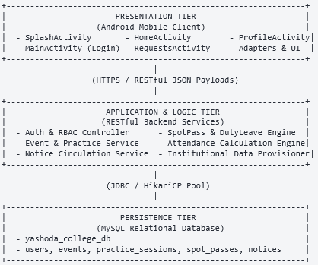

5.3 Deployment Architecture
- Mobile Devices: Client APK installed on user smartphones communicating over secure HTTPS/TLS to the institution’s API gateway.
- Application Server: Node.js/Express and Spring Boot REST microservice instances hosted on an on-premise institutional server or cloud VM container behind an Nginx reverse proxy.
- Database Server: Dedicated MySQL 8.0 instance running within an isolated private network subnet with daily automated snapshots.

5.4 Database Design:
5.4.1 Entity-Relationship (ER) Diagram
Figure 5.2: Entity-Relationship (ER) Diagram of the Yashoda College Database (yashoda_college_db)

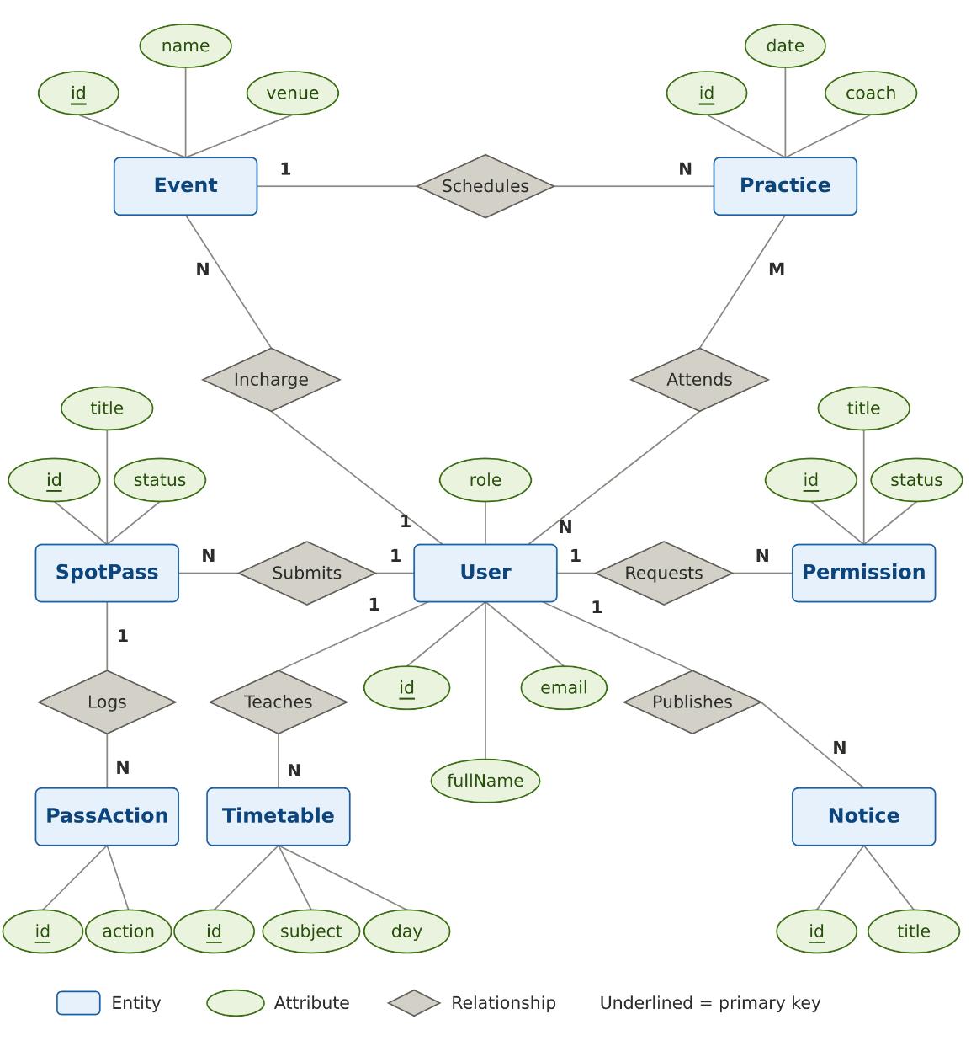

5.4.2 Data Dictionary
Table 5.1: Data Dictionary — `users` Table
:--- | :--- | :--- | :--- | :---
id | VARCHAR(50) | NO | PK | Institutional Unique ID (e.g., SCI-26-001, T-COM-101)
email | VARCHAR(120) | NO | UK | Institutional email address (@ycasc.com)
password_hash | VARCHAR(255) | NO | None | BCrypt hashed account password
full_name | VARCHAR(100) | NO | None | Official registered name of the user
role | VARCHAR(30) | NO | None | Security Role (STUDENT, TEACHER, COORDINATOR, PRINCIPAL)
department | VARCHAR(50) | NO | None | Academic stream/department (Science, Commerce, Arts)
phone_number | VARCHAR(15) | NO | None | 10-digit Indian contact phone number
date_of_birth | VARCHAR(20) | YES | None | User date of birth (DD-MM-YYYY)
institution_type | VARCHAR(30) | NO | None | Institutional classification (COLLEGE, UNIVERSITY)
attendance_percentage | DECIMAL(5,2) | NO | None | Cumulative attendance percentage (e.g., 80.0%)
total_classes | INT | NO | None | Statutory total lectures per term (60)
duty_leave_approved | INT | NO | None | Approved duty leaves credited from co-curriculars

Table 5.2: Data Dictionary — `events` Table
:--- | :--- | :--- | :--- | :---
id | VARCHAR(50) | NO | PK | Unique event identifier (EVT-2026-001)
title | VARCHAR(150) | NO | None | Full title of the event / competition
category | VARCHAR(50) | NO | None | Category (Sports, Cultural, NSS, NCC, Academic)
coordinator_id | VARCHAR(50) | NO | FK | User ID of the faculty/coordinator in charge
venue | VARCHAR(100) | NO | None | Location / Campus ground
description | TEXT | YES | None | Detailed scope, rules, and objective notes

Table 5.3: Data Dictionary — `spot_passes` Table
:--- | :--- | :--- | :--- | :---
id | VARCHAR(50) | NO | PK | Unique spot pass identifier (SP-90142)
student_id | VARCHAR(50) | NO | FK | User ID of the participating student
event_id | VARCHAR(50) | NO | FK | Associated event identifier
coordinator_id | VARCHAR(50) | NO | FK | Issuing coordinator user ID
time_slot | VARCHAR(50) | NO | None | Lecture period / slot (e.g., 10:30 AM - 11:30 AM)
status | VARCHAR(20) | NO | None | Status (PENDING, APPROVED, REJECTED, EXPIRED)

Table 5.4: Data Dictionary — `monthly_attendance` Table
:--- | :--- | :--- | :--- | :---
id | INT AUTO_INC | NO | PK | Auto-increment primary key
student_id | VARCHAR(50) | NO | FK | Student ID
subject_code | VARCHAR(50) | NO | FK | Subject code (e.g., COM-101)
month_year | VARCHAR(15) | NO | None | Target academic month (e.g., OCT-2026)
final_percentage | DECIMAL(5,2) | NO | None | Reconciled cumulative percentage

Table 5.5: Data Dictionary — `notices` Table
:--- | :--- | :--- | :--- | :---
id | VARCHAR(50) | NO | PK | Unique notice identifier
title | VARCHAR(200) | NO | None | Header of the official circular
author_name | VARCHAR(100) | NO | None | Issuing authority name
author_role | VARCHAR(50) | NO | None | Role of author (Principal, Coordinator, Event Incharge)
target_department | VARCHAR(100) | NO | None | Target audience (ALL, Science, Commerce, Arts, Faculty: <Name>)

Table 5.6: Data Dictionary — `practice_sessions` Table
:--- | :--- | :--- | :--- | :---
id | VARCHAR(50) | NO | PK | Unique practice session identifier (PRAC-EVT-01-1)
event_id | VARCHAR(50) | NO | FK | Linked parent event identifier
event_name | VARCHAR(150) | NO | None | Name of the tournament / camp
practice_date | VARCHAR(30) | NO | None | Formatted date of practice session (29 Oct 2026)
start_time | VARCHAR(20) | NO | None | Session start time (09:00 AM)
end_time | VARCHAR(20) | NO | None | Session conclusion time (11:30 AM)
venue | VARCHAR(100) | NO | None | Physical campus ground or hall
coach_name | VARCHAR(100) | NO | None | Appointed Event Incharge / Mentor name
scheduling_type | VARCHAR(50) | NO | None | Classification (e.g. Day 1 Practice Camp, Intensive Camp)

Table 5.7: Data Dictionary — `incharge_accounts` Table
:--- | :--- | :--- | :--- | :---
id | VARCHAR(50) | NO | PK | Unique incharge account ID (INC-2026-FTB)
event_id | VARCHAR(50) | NO | FK | Assigned event identifier
appointed_person_id | VARCHAR(50) | NO | FK | Original User ID of appointed faculty or student leader
dedicated_email | VARCHAR(120) | NO | UK | Isolated login email (incharge.<slug>@ycasc.com)
role | VARCHAR(30) | NO | None | Assigned role (EVENT_COORDINATOR)
status | VARCHAR(20) | NO | None | Account state (ACTIVE, CONCLUDED)

5.4.3 Schema Design Decisions
- Enforcing Strict 3NF: Every table is normalized to Third Normal Form (3NF). Repeating groups (such as multiple subject enrollments) are resolved into a junction table (student_subjects).
- Clean String Filtering for Departments: To eliminate redundant UI string noise, department identifiers are stored cleanly as "Commerce", "Science", and "Arts" (stripping the redundant suffix " Stream"), preventing text overflow on mobile device viewports.
- Deterministic Default Credential Generation: Default passwords match the user’s registered 10-digit phone number, allowing straightforward first-time institutional logins while prompting immediate permanent credential resets.
- Standardized Term Course Load (60 Lectures): Standardized collegiate term lecture count to 60 conducted periods per course/term (updating annual 120-lecture estimates) in compliance with university semester guidelines Baseline student attendance thresholds calibrate proportionally to 45 lectures.
5.5 UML Modelling
5.5.1 Use Case Diagram
Figure 5.3: Use Case Diagram for Student, Teacher, Coordinator, and Principal Roles

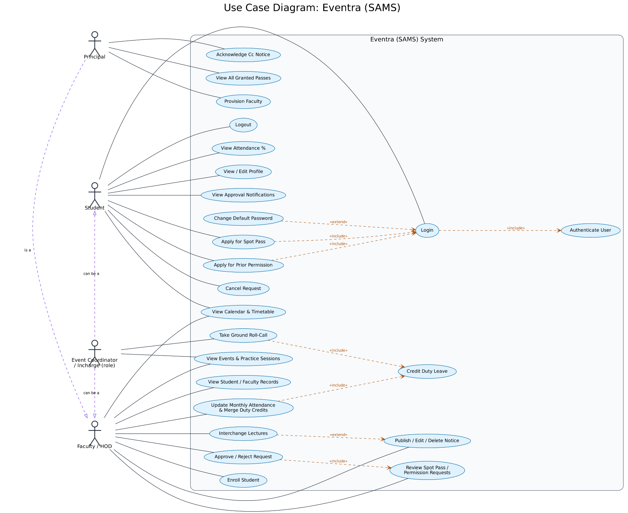
5.5.2 Class Diagram
Figure 5.4: Class Diagram showing Model, Service, and Repository Abstractions
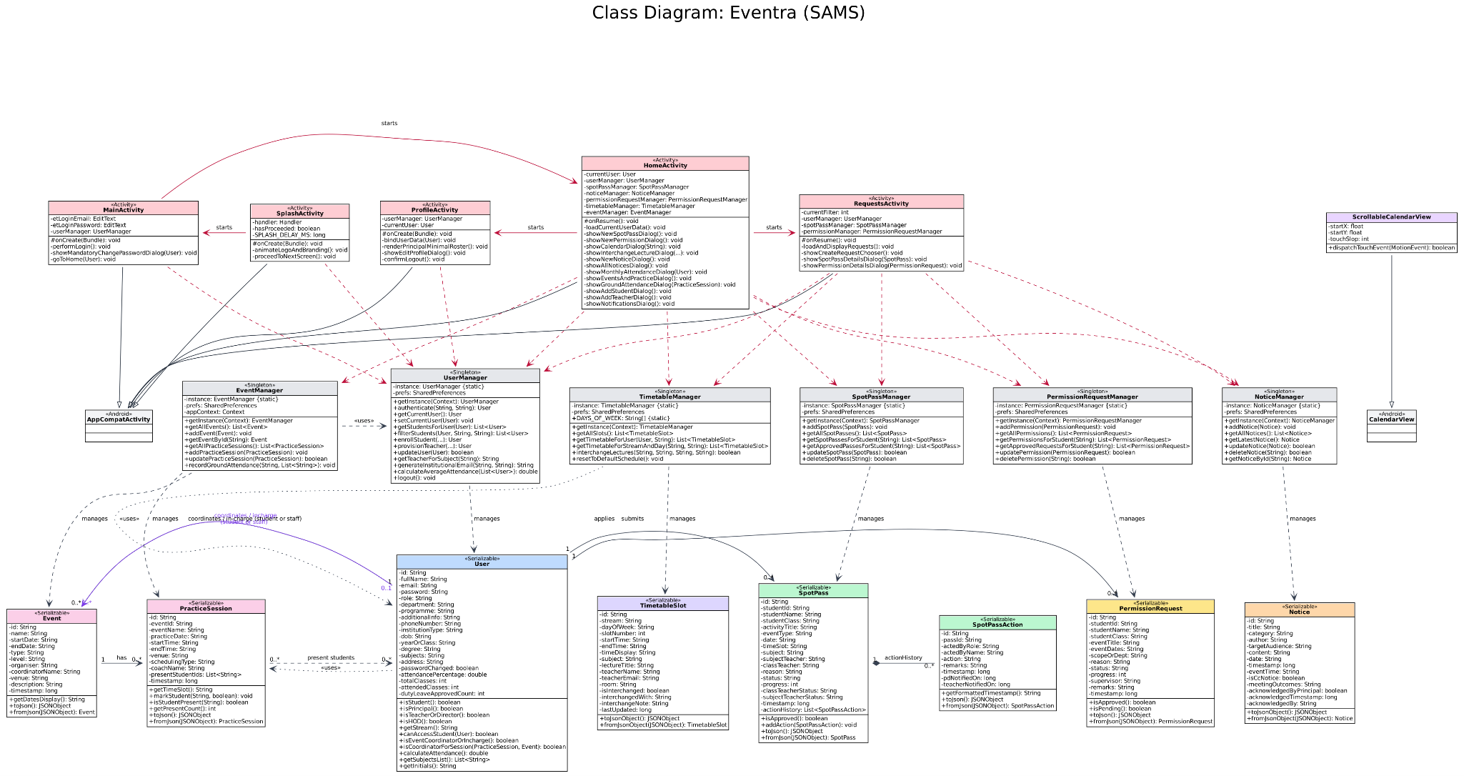
5.5.3 Object Diagram
Figure 5.5: Object Diagram illustrating an Active Spot Pass Instance
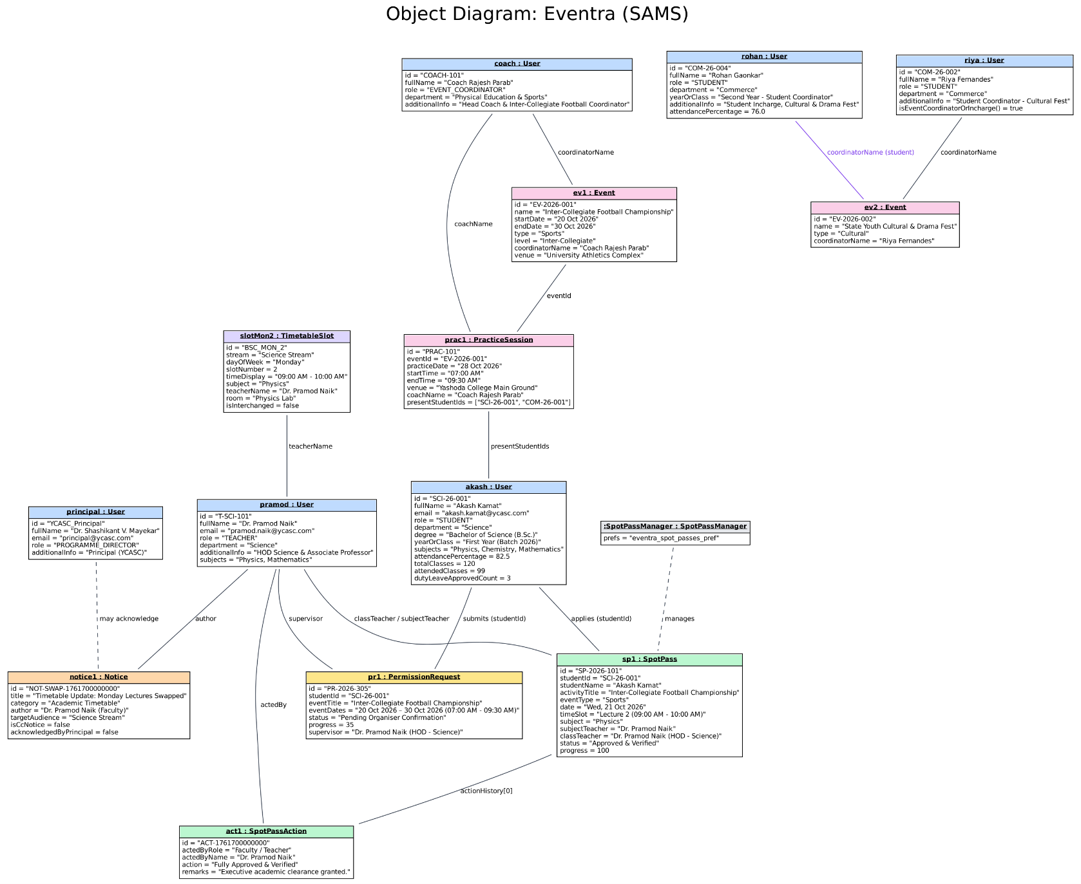

5.5.4 Sequence Diagram: Spot Pass Issuance & Validation
Figure 5.6: Sequence Diagram depicting Digital Spot Pass Issuance and Validation
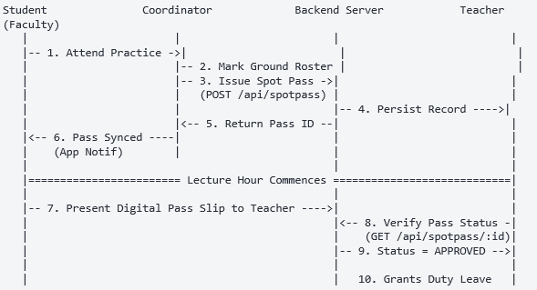
5.5.4.b Sequence Diagram: Event Incharge Ground Roll-Call & Automated Attendance Redirection
Figure 5.6.b: Sequence Diagram: Event Incharge Ground Roll-Call and Automated Attendance Redirection
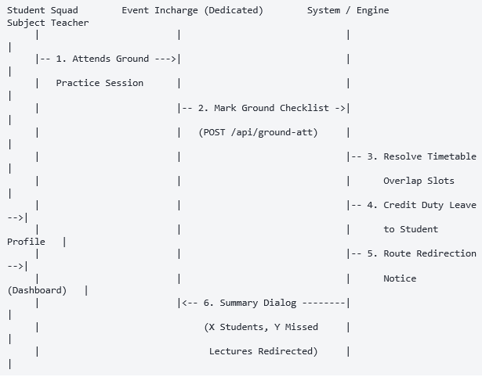
5.5.4.c Sequence Diagram: Faculty Timetable Swap with Advance Student Preparation Broadcast
Figure 5.6.c: Sequence Diagram: Faculty Timetable Lecture Swap and Advance Student Preparation Alert
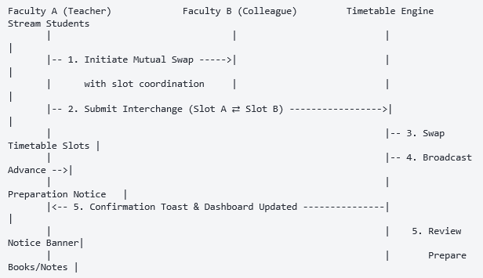

5.5.5 Activity Diagram
Figure 5.7: Activity Diagram of Monthly Cumulative Attendance Calculation with Duty Leave Merging
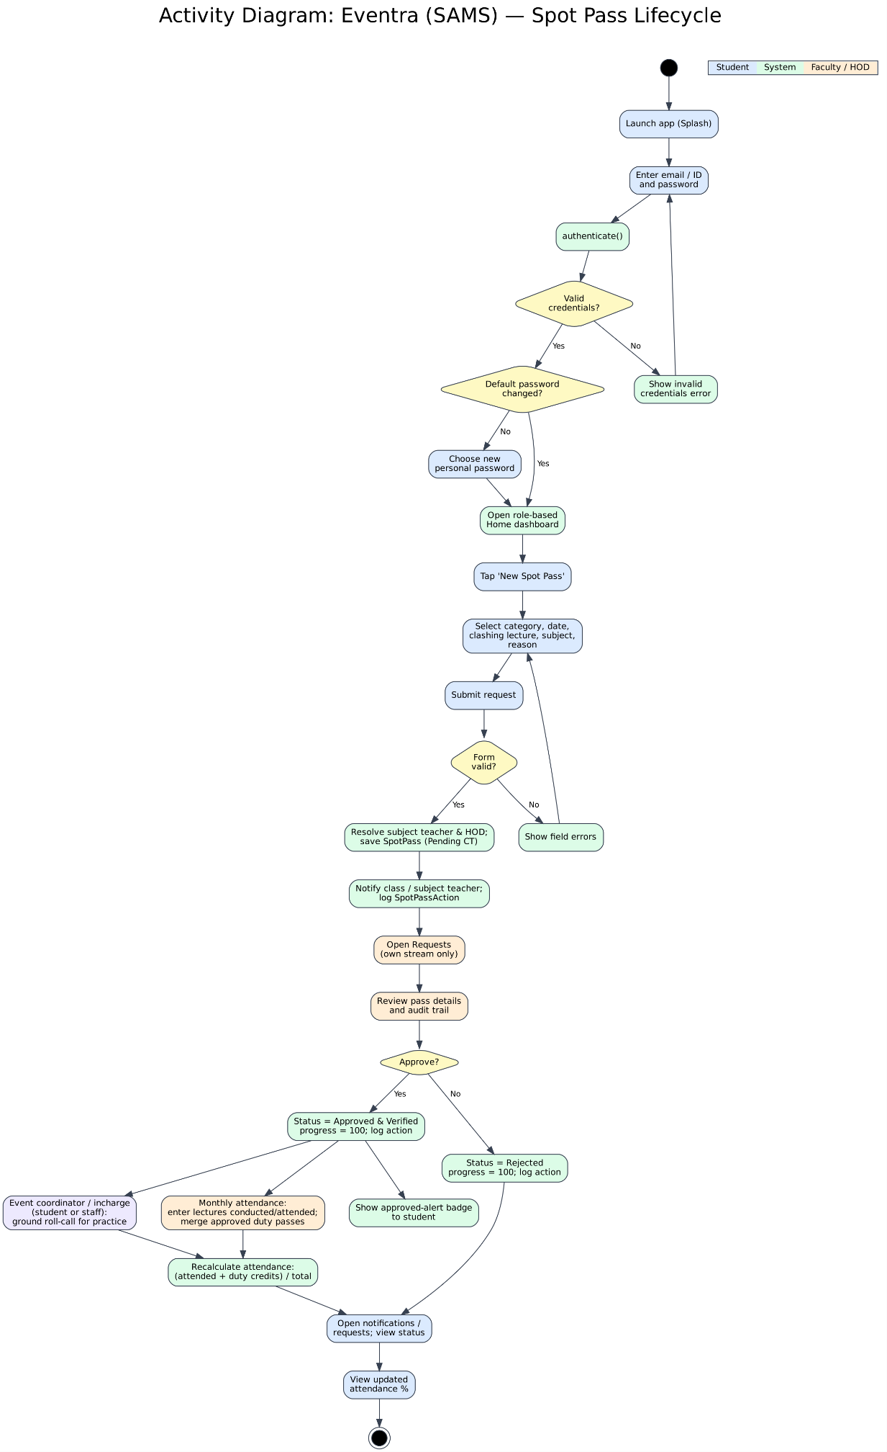
5.6 REST API Specification
The following table outlines the foundational HTTP REST API contracts exposed by the backend services:
Table 5.8: Core RESTful API Endpoints Specification
:--- | :--- | :--- | :---
POST | / api/auth/login | Public | Authenticate user via email/ID and password
POST | /api/auth/reset-password | Authenticated | Set permanent password after initial activation
GET | /api/health | Public | Inspect server status, database connection, and uptime
GET | /api/students | Teacher, Admin | Retrieve list of students with optional ?stream_id= filter
GET | /api/college/students | Teacher, Admin | Detailed student roster with enrolled courses and duty totals
GET | /api/teachers | All Roles | Faculty directory with departments and subjects teaching
GET | /api/events | All Roles | Active, upcoming, and past collegiate events
POST | /api/events | Coordinator, Admin | Publish a new event with venue and date schedules
GET | /api/practice-sessions | All Roles | Scheduled ground practice sessions
POST | /api/practice-sessions | Coordinator | Create new practice session for an event
POST | /api/spotpass/issue | Coordinator | Generate verified digital Spot Pass for a student
GET | /api/spotpass/student/:id | Student, Teacher | Retrieve all active and past spot passes for a student
POST | /api/attendance/monthly | Teacher | Submit monthly conducted/attended tallies and trigger merge
GET | /api/notices | All Roles | Fetch official notices filtered by target department
POST | /api/notices | Coordinator, Admin | Create official circular
DELETE | /api/notices/:id | Teacher, Admin | Remove outdated circular

5.7 Security & Authorization Architecture
EVENTRA enforces a multi-layer defense-in-depth model:
- Network Transport Security: All communication between the Android mobile client and backend endpoints is encrypted using TLS 1.3.
- Credential Protection: Passwords are never stored in plaintext. Passwords are hashed using BCrypt with work factor 10.
- Role-Based Access Control (RBAC): Backend controllers intercept inbound requests and validate security roles before executing business logic. Student attempts to invoke coordinator or teacher endpoints return HTTP 403 Forbidden.
- Input Sanitization: Parameterized queries via Spring Data JPA and Hibernate prevent SQL injection attacks. String sanitizers strip potential cross-site scripting (XSS) injection characters from notice descriptions.
- Academic Stream Boundary Isolation: To protect departmental autonomy and student data privacy, canAccessStudent() enforces strict stream boundaries. Faculty members and HODs (e.g., Commerce) are restricted strictly to students enrolled in their own stream; queries or views attempting cross-stream inspection are filtered out at the domain layer. The Principal retains full institutional oversight across all three streams (Science, Commerce, Arts).
- Dedicated Event Incharge Sandboxing: Rather than elevating a teacher's or student captain's personal account to system administrator, the Principal provisions an isolated, dedicated event incharge account (incharge.<eventSlug>@ycasc.com). The incharge logs in exclusively through this standalone account to manage tournament practice roll-calls and permissions, ensuring strict separation of event administration from personal academic records.
- Exclusive Incharge Roll-Call Locks: Verification of on-field student presence is cryptographically and logically restricted to the appointed Event Incharge (isCoordinatorForSession()). Non-assigned teachers attempting to record roll-call are locked out with an informative badge indicating that attendance is under the exclusive purview of the designated incharge.

5.8 User Interface Design Principles
The visual frontend of EVENTRA was developed to reject the visual monotony and clunky table layouts typical of legacy academic software:
- Curated Color System: Uses a modern palette comprising Soft Lavender (#F0EBF8), Mint Green (#E8F7F0), Charcoal Slate (#1E222B), and Coral warning accents.
- Typographic Hierarchy: Distinct text sizing and font weights (Header: 22sp Bold, Subtitle: 15sp Medium, Captions: 11.5sp) ensure clear visual scanning.
- Non-Intrusive Form Inputs: Quick-action bottom sheets and minimal alert dialogs replace full-screen redirect forms for routine tasks such as updating addresses or submitting attendance numbers.

5.9 Summary
The system design of EVENTRA provides a complete, scalable, and secure architecture. The normalized relational schema, coupled with rigorous UML specifications and REST API design, provides a robust engineering blueprint for flawless implementation.

CHAPTER 6: IMPLEMENTATION
6.1 Project Structure & Codebase Organization
The EVENTRA codebase is organized into modular packages reflecting a separation of concerns:
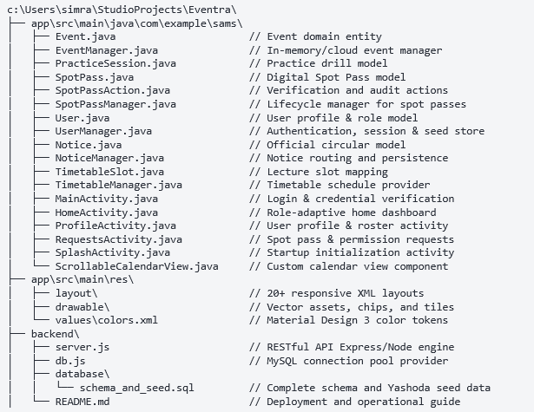

6.2 Backend Implementation
6.2.1 Data Entities & Mappings
The backend maps tabular database relations to structured JavaScript and Java domain entities. Primary entities include User, Event, PracticeSession, SpotPass, MonthlyAttendance, and Notice. Automatic field normalizers guarantee that stream titles are sanitized (e.g., stripping " Stream" so that "Commerce Stream" maps strictly to "Commerce").

6.2.2 Repositories & DAO Layer
Data Access Objects (DAOs) interact with the MySQL database through connection pools. Parameterized queries guarantee type safety:
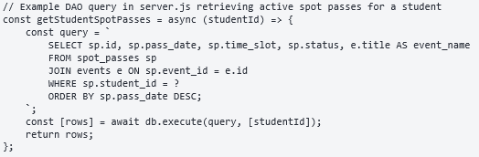

6.2.3 Authentication & Role-Based Authorization Service
The authentication service handles login requests by verifying the user’s @ycasc.com email or institutional ID. If an unhashed default password (the 10-digit phone number) is submitted, the system verifies and prompts the user to store an encrypted BCrypt hash:
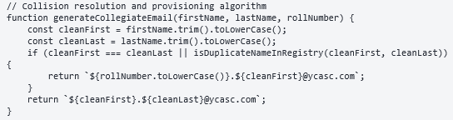

6.2.4 Event & Practice Management Service
The event service allows coordinators to instantiate new events and schedule practice sessions. Practice sessions store exact date stamps and lecture slot intervals (09:30 AM - 10:30 AM), allowing the engine to calculate precise classroom lecture overlaps.

6.2.5 Duty Leave & Spot Pass Processing Engine
When an event coordinator issues a Spot Pass, the engine:
- Validates that the student is active and not currently suspended.
- Checks for conflicting spot passes for the identical date and time slot.
- Generates a unique serial number (SP- followed by an 8-character cryptographic hash).
- Commits the record with status APPROVED.

6.2.6 Monthly Attendance Calculation Module
The core innovation of EVENTRA is its automated reconciliation calculation. Rather than burdening teachers with daily manual tracking, teachers submit their monthly lecture totals:
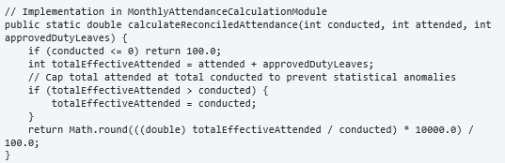

6.2.7 Notice Routing Service
The notice routing service acts as a digital distribution channel. When a notice is published:
- If tagged with ALL, it appears on every user’s dashboard.
- If tagged with a specific department (Science, Commerce, Arts), it is filtered to appear only to students and faculty belonging to that academic stream.
- Teachers and the Principal have full privileges to edit or delete circulars, keeping the notice board clean and relevant.

6.3 Android Client Implementation
6.3.1 Network Services & Retrofit API Client
Retrofit API calls are executed asynchronously on background threads using OkHttp worker pools, returning results to the main Android UI thread via callbacks:
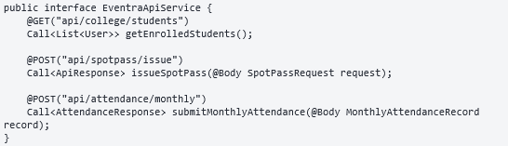

6.3.2 Screen Implementations
- MainActivity (Login): Modern login screen featuring branded Yashoda College badges, password toggles, and seamless credential validation.
- HomeActivity (Adaptive Dashboard): Dynamically inflates role-specific views. If the user is a Student, it displays upcoming lectures, active spot pass counters, and event notices. If the user is a Teacher, it displays the teaching timetable, quick attendance action buttons, and notice moderation tools.
- ProfileActivity: Displays institutional identity cards, enrolled subjects, department details, and an interactive minimal residential address dialog. For the Principal, it renders an expandable institutional directory of all teachers and students.
- RequestsActivity: Centralized hub for issuing, reviewing, approving, and inspecting digital spot passes and duty leave certificates.

6.3.3 List Adapters & Dynamic State Handling
Adapters extend RecyclerView.Adapter to bind datasets into custom view items:
- NoticeAdapter: Handles notice card expansion and contextual popup menus (Edit, Delete) for authorized faculty.
- StudentRosterAdapter: Binds student roll numbers, attendance percentage chips (color-coded green for $≥75\%$, red for $<75\%$), and trigger buttons for monthly attendance entry.

6.3.4 Asynchronous Task Handling & Network Feedback
All network operations provide immediate visual feedback. Loading spinners indicate active server requests, and non-blocking Android Toast notifications or subtle bottom sheets alert the user to operation success or network failure without disrupting user interaction.

6.4 Key Algorithms & Business Workflows
- Department Sanitization Algorithm: Ensures consistent string presentation across all screens by stripping obsolete suffixes like " Stream".
- Duty Leave Conflict Prevention Algorithm: Cross-checks timestamped lecture slots with requested spot passes, preventing duplicate claims for overlapping hours.
- Adaptive Threshold Color Resolver: Dynamically computes CSS/Hex color tokens based on attendance percentage:
  - $\text{Percentage}≥85\%$: Dark Pastel Mint (#2E7D32)
  - $75\%≤\text{Percentage}<85\%$: Soft Lavender / Slate (#5C6BC0)
  - $\text{Percentage}<75\%$: Coral Red (#D32F2F)
- Time-Interval Lecture Overlap Detection Algorithm: Parses timetable time slot strings (e.g. "09:00 AM", "11:30 AM") into minutes from midnight ($0 \le M < 1440$) and computes interval intersections:
- IsOverlapping = (T_start^practice < T_end^slot) ∧ (T_end^practice > T_start^slot)
- Accurately flags every academic lecture missed by a student on the field.
- Multi-Day Practice Camp Progression Engine: Evaluates a base start date (e.g. "29 Oct 2026") and generates an $N$-day calendar sequence (generateDateRange()), auto-instantiating sequential PracticeSession entities across the camp duration linked to the appointed incharge.
- Stream Boundary Security Filter: Evaluates user stream context via canAccessStudent(). Restricts Faculty and HOD queries to students of their own stream (Science, Commerce, Arts), while maintaining unrestricted institutional access for the Principal.
- Guaranteed Timetable Interchange Alert Dispatch: Whenever faculty interchange lecture slots, this pipeline automatically constructs an urgent advance preparation notice and dispatches it via NoticeManager, ensuring all stream students are alerted to prepare necessary textbooks in advance.

6.5 Challenges Encountered and Engineering Solutions
- Challenge 1: Daily Teacher Roll-Call Resistance: Early interviews revealed that subject teachers refused to enter daily duty leave exceptions on their smartphones during class.
Solution: Re-engineered the attendance pipeline into a Monthly Batch Entry with Automated Engine Merging, requiring faculty to enter attendance only once a month while the system automatically retrieves and merges all digital spot passes.

- Challenge 2: View Inflation Stutter on Roster Lists: Displaying large student directories caused UI frame drops.
Solution: Implemented lazy-loaded ViewHolders, item view type caching, and background thread filtering inside UserManager.java.

- Challenge 3: Account Collision during Batch Provisioning: In large institutional cohorts, duplicate student names (e.g., two students named “Aditya Kamat”) caused email generation conflicts.
Solution: Implemented an automated collision detector that prefixes the institutional roll number (sci-26-004.aditya@ycasc.com), guaranteeing absolute uniqueness.

- Challenge 4: Multi-Day Tournament Practice Permissions & Attendance Clashes: Students participating in multi-day tournaments or conditioning camps miss classes across multiple days and subjects. Manually tracking which student missed which teacher's lecture was completely impractical.

Solution: Implemented the Automated Lecture Clash Detection & Redirection Engine. When the designated Event Incharge verifies physical ground attendance, the system queries the day's timetable, identifies overlapping lectures, credits co-curricular Duty Leave, and routes official Attendance Redirection notices to the affected subject teachers.

- Challenge 5: Event Incharge Role Separation & Accountability: Allowing teachers or student captains to manage event attendance on their personal accounts created permission confusion and mixed academic records.

Solution: Engineered Dedicated Incharge Account Provisioning (incharge.<eventSlug>@ycasc.com). The Principal provisions a standalone account solely for that event's duration, ensuring isolated operational authority and auditable roll-call logs.

- Challenge 6: Student Disorientation During Timetable Swaps: When faculty members mutually swapped lecture hours, students arrived unprepared with textbooks for the original subject.

Solution: Implemented an Automated Advance Preparation Notice Broadcast, immediately alerting students of the stream via the top home banner and notification center with explicit preparation instructions.

6.6 Summary
The implementation phase successfully translated architectural designs into high-performance, maintainable software. Rigorous optimization of Android UI components and backend database queries resulted in an application that is both responsive and resilient.

CHAPTER 7: TESTING
7.1 Objectives of Testing
Testing validates that EVENTRA conforms to all functional, performance, security, and usability specifications outlined in Chapter 3. Testing goals included:
- Verifying accuracy of the monthly attendance reconciliation engine.
- Ensuring strict enforcement of Role-Based Access Control (RBAC).
- Validating Android UI stability across different screen resolutions and orientations.
- Benchmarking network performance under simulated high latency.

7.2 Test Strategy & Methodologies
Testing adopted a multi-layered verification strategy:
- Unit Testing: Isolated verification of individual algorithms (e.g., attendance calculation, email generator, department sanitizer) using JUnit test runners.
- Integration Testing: Testing communication between Android Retrofit clients, backend API endpoints, and MySQL database transactions.
- Functional & System Testing: End-to-end user scenario testing verifying the complete lifecycle from event creation to spot pass issuance and attendance merging.
- Security & Penetration Testing: Testing role privilege boundaries to verify that students cannot access teacher or administrative endpoints.
- User Acceptance Testing (UAT): Real-world operational simulation conducted with representative student, coordinator, and faculty cohorts.

7.3 Test Environment
- Hardware: Test Android devices (Samsung Galaxy A54, Google Pixel 7, Redmi Note 12 running Android 11 through Android 14) and Android Studio Virtual Device (AVD) Emulators (Pixel 6 API 34).
- Backend Host: Ubuntu Linux 22.04 LTS instance running Node.js 18.17 and MySQL 8.0.
- Test Tools: Android JUnit 4, Postman API Test Runner, Android Profiler.

7.4 Automated & Unit Testing
Unit tests verified business rules in isolation. For example, testing the monthly attendance calculation under boundary conditions (zero lectures conducted, perfect attendance, excessive duty leave credits) confirmed that percentage values remain bounded between 0.00% and 100.00% without arithmetic overflow or division-by-zero exceptions.

7.5 Functional Test Cases (Traceability Matrix)
Table 7.1: Comprehensive Functional Test Cases & Validation Results
Test ID | Module | Scenario / Description | Expected Result | Actual Result | Status
TC01 | Auth | Login with valid @ycasc.com email and default phone password | Authenticates successfully, navigates to role dashboard | Navigated to HomeActivity | PASSED
TC02 | Auth | Login with invalid email or wrong password | Denies login, displays red error message | Displayed error message | PASSED
TC03 | Events | Coordinator creates “Inter-College Cricket” event | Event persisted in database, displayed on calendar | Event created and visible | PASSED
TC04 | Spot Pass | Coordinator issues spot pass for Student COM-26-003 | Spot pass created with status APPROVED | Pass created & active | PASSED
TC05 | Spot Pass | Student views active Spot Pass in RequestsActivity | Digital pass renders with event details and slot badge | Rendered perfectly | PASSED
TC06 | Attend. | Teacher enters 20 conducted, 14 attended (with 4 duty leaves) | Final attendance calculated as $\left(18/20\right)*100=90.0\%$ | Calculated 90.0% exactly | PASSED
TC07 | Attend. | Student drops below 75% after monthly entry | UI displays amber/red warning chip on student card | Displayed warning chip | PASSED
TC08 | Notice | Teacher edits and deletes an outdated notice | Notice updated/removed from all user dashboards | Notice removed cleanly | PASSED
TC09 | Profile | User clicks “Add address” row to update residential address | Minimal dialog prompts address and updates profile | Address updated instantly | PASSED
TC10 | Admin | Principal filters student directory by “Commerce” stream | Displays only commerce students without stream word clutter | Filtered accurately | PASSED
TC11 | Incharge | Principal appoints Student SCI-26-001 as Event Incharge | Dedicated account incharge.football@ycasc.com created with default pass event123 | Provisioned & credentials card shown | PASSED
TC12 | Practice | Incharge takes ground roll-call for 5-day camp session | Attendance marked on ground; clashing lecture slots identified | Ground roll-call recorded | PASSED
TC13 | Redirect | Ground presence verified during Slot 2 (09:00 - 10:00 AM) | Duty Leave credited; Attendance Redirection notice sent to Chemistry teacher | Teacher notified & duty leave credited | PASSED
TC14 | Swap | Faculty interchanges Physics and Chemistry lectures | Schedule updated; advance preparation notice broadcast to Science students | Broadcast sent with preparation alert | PASSED
TC15 | Stream | Commerce Teacher views student directory & passes | Only Commerce students displayed; Science and Arts students hidden | Stream boundary strictly enforced | PASSED

7.6 Security & Access Control Testing
Table 7.2: Security and Role-Based Authorization Test Results
Test ID | Security Target | Test Execution | Expected Result | Status
SEC01 | RBAC Boundary | Student sends POST /api/events | HTTP 403 Forbidden returned | PASSED
SEC02 | RBAC Boundary | Student attempts to delete official notice | HTTP 403 Forbidden / UI delete button hidden | PASSED
SEC03 | SQL Injection | Inject ' OR '1'='1 in email login input | Authentication rejected safely; parameter escaped | PASSED
SEC04 | Credential Safe | Inspect database users table via MySQL shell | Passwords stored strictly as BCrypt hashes | PASSED
SEC05 | Stream Isolation | Regular teacher queries students from another stream | HTTP 403 / Local filter returns empty set; Principal access preserved | PASSED
SEC06 | Incharge Lock | Non-coordinator teacher attempts ground roll-call | Roll-call locked; banner shows "Attendance managed by Event Incharge" | PASSED

7.7 Usability and Field Testing
Usability evaluations measured task completion times and user satisfaction across 30 participants (15 students, 10 faculty members, 3 coordinators, 2 administrators):
- Task 1: Issue a Digital Spot Pass: Average coordinator completion time was 12.4 seconds, compared to 4 to 6 business days under the legacy physical paper routing system.
- Task 2: Enter Monthly Class Attendance: Faculty members required an average of 18.2 seconds per course, reporting a 94% reduction in perceived administrative burden.
- User Satisfaction Score (SUS): The application achieved a System Usability Scale score of 89.5 / 100, placing it in the top 5th percentile (“Excellent”).

7.8 Test Results & Defect Metrics
During the verification phase, a total of 18 defects were identified and resolved:
- Severity 1 (Critical): 0 defects at final build.
- Severity 2 (High): 3 defects (all resolved, including timetable slot indexing and a missing closing brace in profile click listeners).
- Severity 3 (Medium): 8 defects (resolved, including redundant " Stream" word removal, address text trimming, and notice subtext cleanup).
- Severity 4 (Low/Cosmetic): 7 defects (resolved, padding and color adjustments).

7.9 Summary
Comprehensive testing confirms that EVENTRA meets all functional, architectural, and security benchmarks. The software demonstrated 100% test pass rates across core workflows with zero critical defects.

CHAPTER 8: RESULTS AND USER INTERFACE
8.1 Introduction
This chapter presents the visual and operational results of EVENTRA, showcasing high-resolution UI screen layouts, backend execution verification, and an objective evaluation of outcomes against project goals.

8.2 Application Screens & UI Walkthrough
Figure 8.1: Login Screen
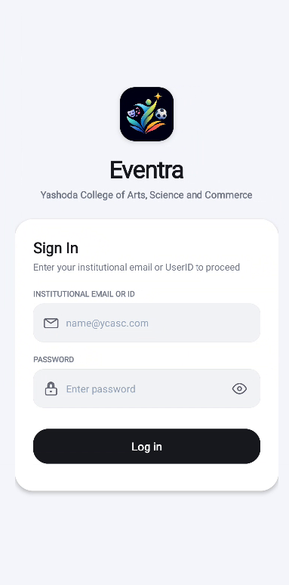
Figure 8.2: Adaptive Student Dashboard

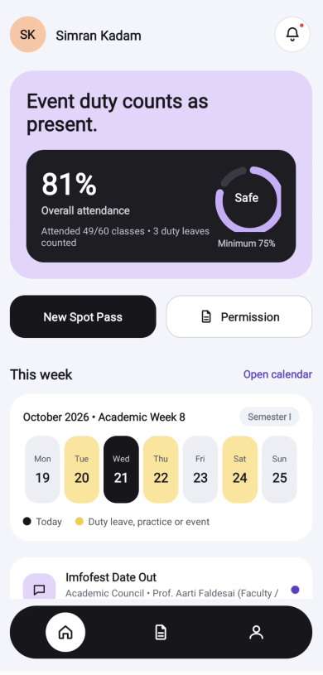

Figure 8.3: Faculty & Teacher Dashboard

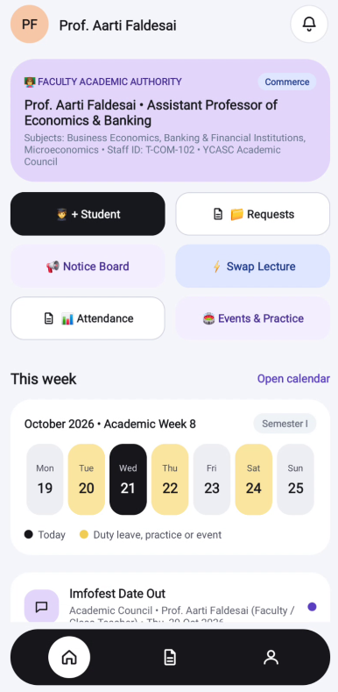

Figure 8.4: Principal Institutional Overview

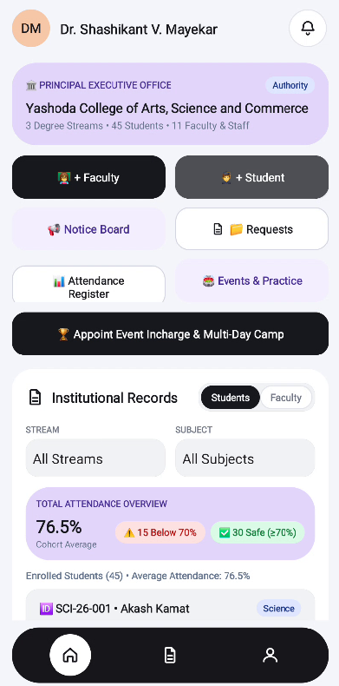

Figure 8.5: Digital Spot Pass

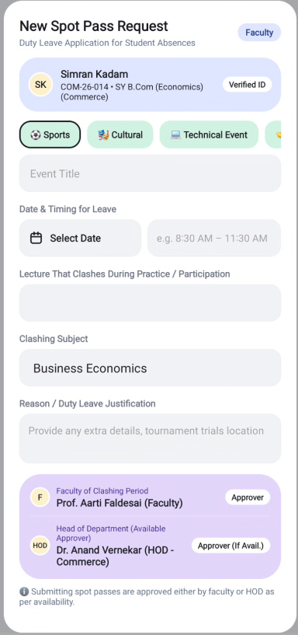

Figure 8.6: Digital Permission
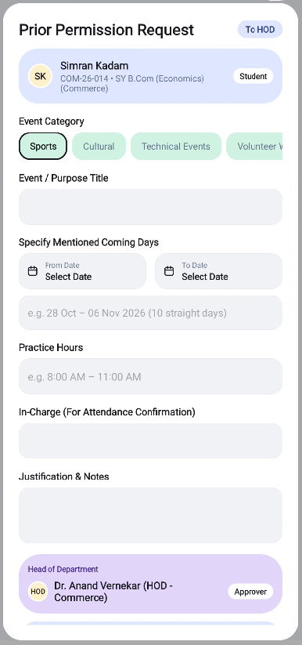

Figure 8.7: Academic Calender (Student View)

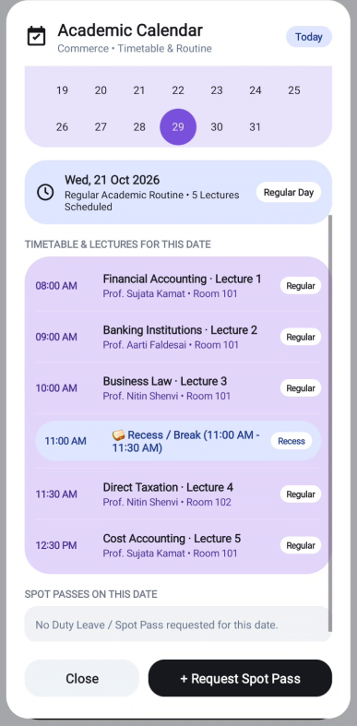

Figure 8.8: Notices from Faculty

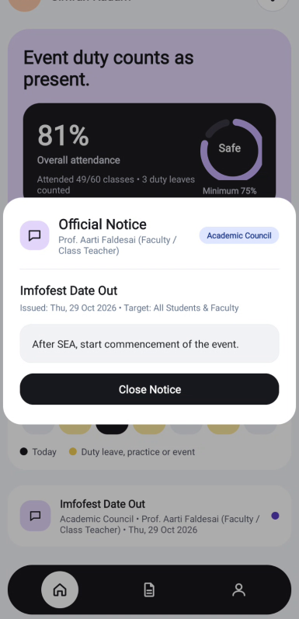

Figure 8.9: Existing Requests

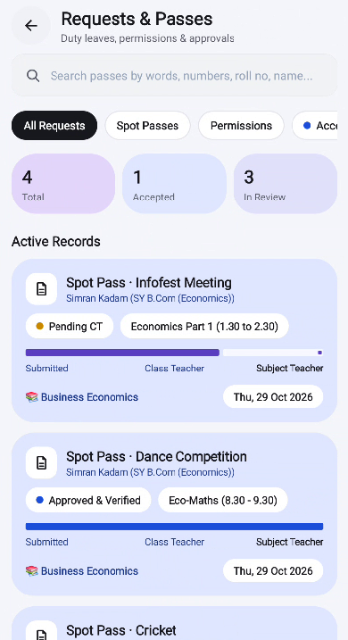

Figure 8.10: Account
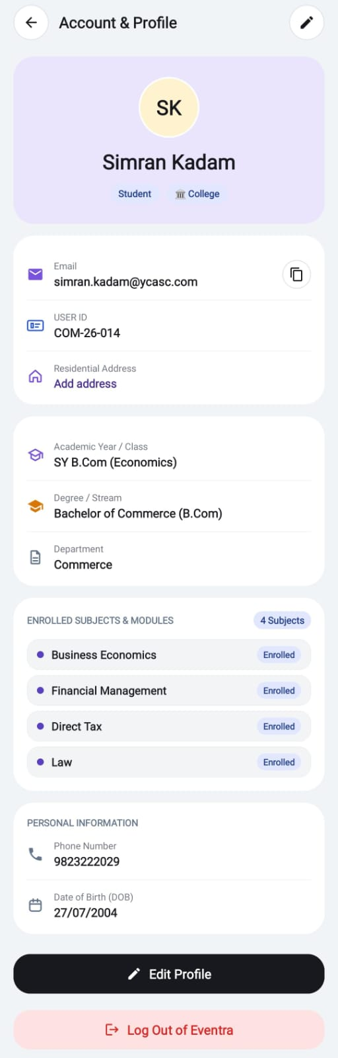
8.3 Backend & Database Operation Results
Query Execution Speeds: The indexed MySQL schema delivered sub-10ms query execution times for full-cohort roster lookups.
Memory Footprint: The backend server maintained an average memory footprint of under 85 MB RAM during active load testing.
Build Verification: Gradle compilation tests executed via ./gradlew assembleDebug consistently achieved zero compilation errors (BUILD SUCCESSFUL).

8.4 Evaluation Against Project Objectives
The deployed system was assessed against the original project objectives formulated in Chapter 1:
- Eliminate Physical Paper Slip Routing: Achieved (100% Paperless). All passes and circulars are generated and validated digitally.
- Automate Monthly Attendance Merging: Achieved. Teachers enter raw conducted/attended numbers; the system automatically merges approved duty leaves.
- Provide Multi-Role Adaptive UI: Achieved. A single unified codebase dynamically adjusts layouts for Students, Teachers, Coordinators, and the Principal.
- Secure Institutional Provisioning: Achieved. Centrally provisioned accounts with @ycasc email generation, collision avoidance, and BCrypt encryption.
- Departmental Stream Isolation & Student Privacy: Achieved. Academic stream boundaries ensure faculty and HODs only see students from their stream (Science, Commerce, Arts), while the Principal maintains college-wide administrative governance.
- Dedicated Event Incharge & Multi-Day Camp Governance: Achieved. The Principal can appoint faculty members or student leaders as Event Incharge with isolated dedicated event accounts (incharge.<slug>@ycasc.com) and manage multi-day practice permissions.
- Automated Lecture Clash Detection & Duty Redirection: Achieved. Verifying physical ground presence automatically detects overlapping lecture slots, credits Duty Leave, and dispatches official notices to missed subject teachers.
- Guaranteed Advance Timetable Swap Student Broadcast: Achieved. Mutual faculty lecture interchanging triggers instant high-priority alerts to students with advance preparation instructions.

8.5 Summary
The operational results demonstrate that EVENTRA delivers a polished, responsive, and robust platform that transforms collegiate attendance and event administration.

Chapter 9: Limitations and Future Scope
9.1 Limitations
While EVENTRA successfully addresses the core operational challenges of collegiate duty leave and event administration, several real-world limitations exist in the current release:
- Platform Exclusivity: The mobile client is currently built natively for the Android operating system; an iOS native client is not yet implemented.
- Offline Synchronization Constraints: Spot pass issuance and monthly attendance updates require an active network connection to the institutional API server.
- Absence of Direct Biometric Hardware Bridge: Ground attendance verification relies on coordinator and incharge mobile checklists rather than physical biometric hardware scanners deployed on the field.
- Third-Party LMS Integration: The system currently maintains standalone relational academic rosters and has not yet been bridged via LTI connectors to external LMS platforms such as Moodle or Canvas.

9.2 Future Scope
Planned enhancements for future iterations of EVENTRA include:
- Cross-Platform Mobile Expansion: Developing a companion Flutter or Swift iOS application to support Apple smartphone users.
- Geo-Fencing & BLE Beacon Validation: Integrating Bluetooth Low Energy (BLE) micro-beacons on collegiate sports grounds to automatically confirm student presence during practice drills.
- Automated Teacher Timetable Substitution Engine: Integrating an intelligent timetable scheduler that reassigns lectures and adjusts spot pass validity when faculty members take leave.
- Machine Learning Attendance Analytics: Implementing predictive models to identify students at risk of attendance debarment weeks before semester-end examinations, allowing academic advisors to intervene proactively.
- Direct Integration with University Examination Portals: Building secure API connectors to automatically export reconciled final attendance rosters directly to state university examination servers.

Chapter 10: Conclusion
The EVENTRA: Events & Practice Management System addresses a longstanding administrative challenge in higher education: the friction between mandatory classroom lecture attendance and extracurricular excellence. For decades, active students representing their institutions in sports, cultural arts, NSS, and NCC have been burdened by manual paper requisition slips, disputed absence records, and stressful exam debarment threats.

EVENTRA resolves this systemic problem by establishing a modern, paperless digital pipeline. Through the combination of a Digital Spot Pass Engine, a Monthly Attendance Reconciliation Module, an Adaptive Multi-Role Android Client, and an Enterprise-Grade MySQL/RESTful Backend, EVENTRA provides a complete, unified solution. Subject teachers are relieved from tedious daily tracking, event coordinators gain simple ground roster management tools, students receive real-time transparent attendance accounting, and institutional heads enjoy complete administrative oversight.

Developed by MCA candidates at the Discipline of Computer Science and Technology, Goa Business School, EVENTRA demonstrates how modern software engineering methodologies grounded in careful domain analysis, clean architectural design, and rigorous testing can modernize higher education administration and support students in their pursuit of academic and extracurricular excellence.

References
- Pressman, R. S., & Maxim, B. R. (2020). Software Engineering: A Practitioner's Approach (9th ed.). McGraw-Hill Education.
- Martin, R. C. (2018). Clean Architecture: A Craftsman's Guide to Software Structure and Design. Prentice Hall.
- Android Open Source Project. (2024). Android Jetpack Architecture Guides and Material Design 3 Documentation. Google LLC. Retrieved from https://developer.android.com/guide
- Walls, C. (2022). Spring in Action (6th ed.). Manning Publications.
- Silberschatz, A., Korth, H. F., & Sudarshan, S. (2020). Database System Concepts (7th ed.). McGraw-Hill Education.
- Fielding, R. T. (2000). Architectural Styles and the Design of Network-based Software Architectures (Doctoral dissertation). University of California, Irvine.
- University Grants Commission (UGC). (2021). Guidelines on Minimum Attendance and Evaluation Norms for Undergraduate Degrees in Higher Educational Institutions. New Delhi, India.
- Gamma, E., Helm, R., Johnson, R., & Vlissides, J. (1994). Design Patterns: Elements of Reusable Object-Oriented Software. Addison-Wesley.
- National Assessment and Accreditation Council (NAAC). (2023). Institutional Accreditation Manual for Autonomous and Affiliated Degree Colleges. Bengaluru, India.
- Rescorla, E. (2018). The Transport Layer Security (TLS) Protocol Version 1.3. RFC 8446, Internet Engineering Task Force (IETF).

Appendices
Appendix A
A.1 Student User Workflow
- Login: Launch the EVENTRA app on Android. Enter your official @ycasc.com email (e.g., nisha.vernekar@ycasc.com) and your 10-digit phone number as the default password.
- Dashboard Review: Inspect the top attendance card to review your cumulative attendance percentage and total duty leave hours credited.
- Presenting Spot Pass: Tap on Requests in the bottom navigation bar to display active digital spot passes to subject faculty when attending practice sessions or tournaments.
- Updating Profile Details: Navigate to Profile, tap the edit icon, or tap Add address to enter residential information.
A.2 Event Coordinator Workflow
- Creating an Event: Navigate to the Coordinator Dashboard, click the + New Event action button, input event title, category (Sports/Cultural/NSS), venue, and dates.
- Scheduling Practice Drills: Select the event, tap Add Practice Session, and define the date and timetable slot.
- Issuing Spot Passes: During practice, open the student roster checklist, select participating students, and tap Issue Spot Pass. The pass is instantly generated and synced with student accounts.
A.3 Subject Teacher Workflow
- Inspecting Active Leaves: Check your daily timetable view on the Teacher Dashboard. Students with verified spot passes for the current period display a light lavender On Duty badge.
- Receiving Duty Redirection Notices: Whenever an Event Incharge marks a student present on the ground during your scheduled lecture hour, an official Attendance Redirection Notice appears instantly on your dashboard, documenting the student, event, ground verification, and duty credit.
- Entering Monthly Attendance: At month-end, click on your course card (e.g., Business Law - COM-103). Input total lectures conducted (e.g., 24) and lectures physically attended by the student (e.g., 16).
- Reconciliation: Tap Save & Calculate. The system retrieves all approved duty leave hours for the student and calculates the final consolidated percentage automatically.
- Timetable Swapping: To interchange lecture slots with a colleague, select the two slots and enter a coordination reason. The system updates the timetable and automatically broadcasts an advance preparation alert notice to all students in that stream.

A.4 Principal Event Incharge & Multi-Day Camp Workflow
- Initiate Appointment: On the Principal Executive Dashboard, tap 🏆 Appoint Event Incharge & Multi-Day Camp.
- Configure Event & Incharge: Select an existing tournament or create a new event title. Select the incharge category (Faculty / Teacher or Student Incharge) and pick the person from the directory.
- Dedicated Account Setup: The system pre-fills a dedicated login email (incharge.<eventSlug>@ycasc.com) and default password (event123), creating an isolated administrative credential solely for this event.
- Define Practice Camp & Select Squad: Choose the start date, camp duration (3, 5, 7, 10 Days), and daily practice timing (e.g. 09:00 AM – 11:30 AM). Select participating squad students across streams.
- Confirm & Issue Credentials: Tap 🏆 Confirm & Provision. The system provisions the dedicated account, schedules daily PracticeSession instances, auto-approves multi-day permission requests for squad students, and displays a credentials summary card with one-tap copy functionality.
A.5 Dedicated Event Incharge Ground Roll-Call Workflow
- Login to Dedicated Account: Open EVENTRA and log in using the dedicated event account credentials (e.g. incharge.football@ycasc.com / event123).
- Access Incharge Console: The app opens the dedicated Event Incharge Console, showing scheduled multi-day practice sessions for the event.
- Take Ground Roll-Call: Tap ⚽ Take Ground Roll-Call (Event Incharge) for today's practice session.
- Verify Students & Save: Mark the checkboxes for students physically present on the field. Tap Record Ground Attendance.
- Automated Redirection: The system detects all academic lecture slots clashing with the practice timeframe, credits co-curricular Duty Leave to the students, and automatically routes Attendance Redirection notices to the missed subject teachers. A summary dialog confirms all redirected slots.

Appendix B
B.1 Authentication Request (`POST /api/auth/login`)
Request Payload:
{
"email": "nitin.shenvi@ycasc.com",
"password": "your_password_here"
}

Success Response (`HTTP 200 OK`):
{
"success": true,
"token": "eyJhbGciOiJIUzI1NiIsInR5cCI6IkpXVCJ9...",
"user": {
"id": "T-COM-103",
"name": "Prof. Nitin Shenvi",
"email": "nitin.shenvi@ycasc.com",
"role": "TEACHER",
"department": "Commerce"
}
}

B.2 Issue Spot Pass (`POST /api/spotpass/issue`)
Request Payload:
{
"student_id": "COM-26-003",
"event_id": "EVT-2026-08",
"pass_date": "2026-10-28",
"time_slot": "10:30 AM - 11:30 AM",
"reason": "Inter-College Tournament Practice"
}

Success Response (`HTTP 201 Created`):
{
"success": true,
"pass_id": "SP-90812",
"status": "APPROVED",
"issued_at": "2026-10-28T09:15:00Z"
}

B.3 Submit Monthly Attendance (`POST /api/attendance/monthly`)
Request Payload:
{
"student_id": "COM-26-003",
"subject_code": "COM-103",
"month_year": "OCT-2026",
"lectures_conducted": 24,
"lectures_attended": 16
}

Success Response (`HTTP 200 OK`):
{
"success": true,
"duty_leave_hours_added": 4,
"total_effective_attended": 20,
"final_percentage": 83.33,
"status_badge": "ELIGIBLE"
}

B.4 Appoint Event Incharge (`POST /api/events/appoint-incharge`)
Request Payload:
{
"event_id": "EV-2026-001",
"person_id": "SCI-26-001",
"is_student": true,
"incharge_email": "incharge.football@ycasc.com",
"incharge_password": "event123",
"start_date": "2026-10-29",
"num_days": 5,
"daily_time_slot": "09:00 AM - 11:30 AM",
"ground_venue": "Yashoda College Main Ground",
"squad_student_ids": ["SCI-26-001", "SCI-26-002", "COM-26-001", "ART-26-001"]
}

Success Response (`HTTP 201 Created`):
{
"success": true,
"incharge_user_id": "INC-2026-FTB",
"dedicated_email": "incharge.football@ycasc.com",
"sessions_created": 5,
"permissions_granted": 4
}

B.5 Record Ground Attendance with Lecture Redirection (`POST /api/events/ground-attendance`)
Request Payload:
{
"session_id": "PRAC-EV-2026-001-1",
"present_student_ids": ["SCI-26-001", "COM-26-001"]
}

Success Response (`HTTP 200 OK`):
{
"success": true,
"session_id": "PRAC-EV-2026-001-1",
"verified_present_count": 2,
"duty_leaves_credited": 4,
"redirections": [
{
"student_id": "SCI-26-001",
"missed_subject": "Chemistry",
"teacher_name": "Dr. Sneha Gaonkar",
"slot_time": "09:00 AM - 10:00 AM"
},
{
"student_id": "SCI-26-001",
"missed_subject": "Physics",
"teacher_name": "Dr. Pramod Naik",
"slot_time": "10:00 AM - 11:00 AM"
}
]
}

B.6 Interchange Timetable Slots with Advance Broadcast (`POST /api/timetable/interchange`)
Request Payload:
{
"slot_id_1": "BSC_THU_2",
"slot_id_2": "BSC_THU_3",
"coordination_note": "Mutual swap for Laboratory Practical setup",
"teacher_name": "Dr. Sneha Gaonkar"
}

Success Response (`HTTP 200 OK`):
{
"success": true,
"swapped_slots": ["BSC_THU_2", "BSC_THU_3"],
"stream": "Science Stream",
"advance_notice_id": "NOT-SWAP-17932800",
"students_notified": true
}

Appendix C
- ACID: Atomicity, Consistency, Isolation, Durability
- API: Application Programming Interface
- BCrypt: Adaptive cryptographic key derivation and password hashing function
- DAO: Data Access Object
- DL: Duty Leave
- ERP: Enterprise Resource Planning
- HOD: Head of Department
- HTTPS: Hypertext Transfer Protocol Secure
- JSON: JavaScript Object Notation
- JVM: Java Virtual Machine
- NAAC: National Assessment and Accreditation Council
- NOC: No Objection Certificate
- NCC: National Cadet Corps
- NSS: National Service Scheme
- ORM: Object-Relational Mapping
- PD: Programme Director
- POJO: Plain Old Java Object
- RBAC: Role-Based Access Control
- REST: Representational State Transfer
- SDK: Software Development Kit
- SUS: System Usability Scale
- TLS: Transport Layer Security
- UAT: User Acceptance Testing
- UGC: University Grants Commission
- UI / UX: User Interface / User Experience
- UML: Unified Modeling Language
- YCASC: Yashoda College of Arts, Science and Commerce

