Answer to Question 1:
SELECT
d.dept_name AS Department, e.emp_name AS Employee, e.salary AS Salary
FROM employee e
JOIN department d
ON e.dept_id = d.dept_id
JOIN (
SELECT dept_id, AVG(salary) AS avg_salary
FROM employee
GROUP BY dept_id
HAVING count(*) >=3
) as dept
ON e.dept_id = dept.dept_id
AND e.salary > dept.avg_salary;
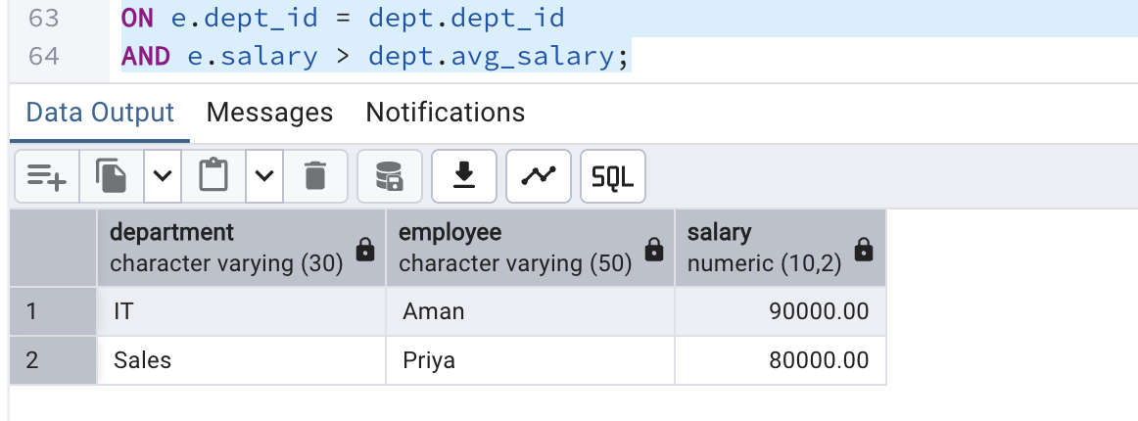

ANSWER TO QUESTION 2:

CREATE OR REPLACE FUNCTION do_audit()
RETURNS TRIGGER AS $$
BEGIN
IF (TG_OP = 'INSERT') THEN
INSERT INTO customer_audit(customer_id, customer_name, action, action_time)
VALUES (NEW.customer_id, NEW.customer_name, 'ADDED', CURRENT_TIMESTAMP);
RETURN NEW;
ELSEIF (TG_OP = 'DELETE') THEN
INSERT INTO customer_audit(customer_id, customer_name, action, action_time)
VALUES (OLD.customer_id, OLD.customer_name, 'REMOVED', CURRENT_TIMESTAMP);
RETURN OLD;
END IF;
RETURN NULL;
END;
$$ LANGUAGE plpgsql;

CREATE TRIGGER trg_audit
AFTER INSERT OR DELETE ON bank_customer
FOR EACH ROW
EXECUTE FUNCTION do_audit();

