Caroline Fernelius

[caroline.fernelius@gmail.com](mailto:caroline.fernelius@gmail.com)

**“Subjects hinder talk”**

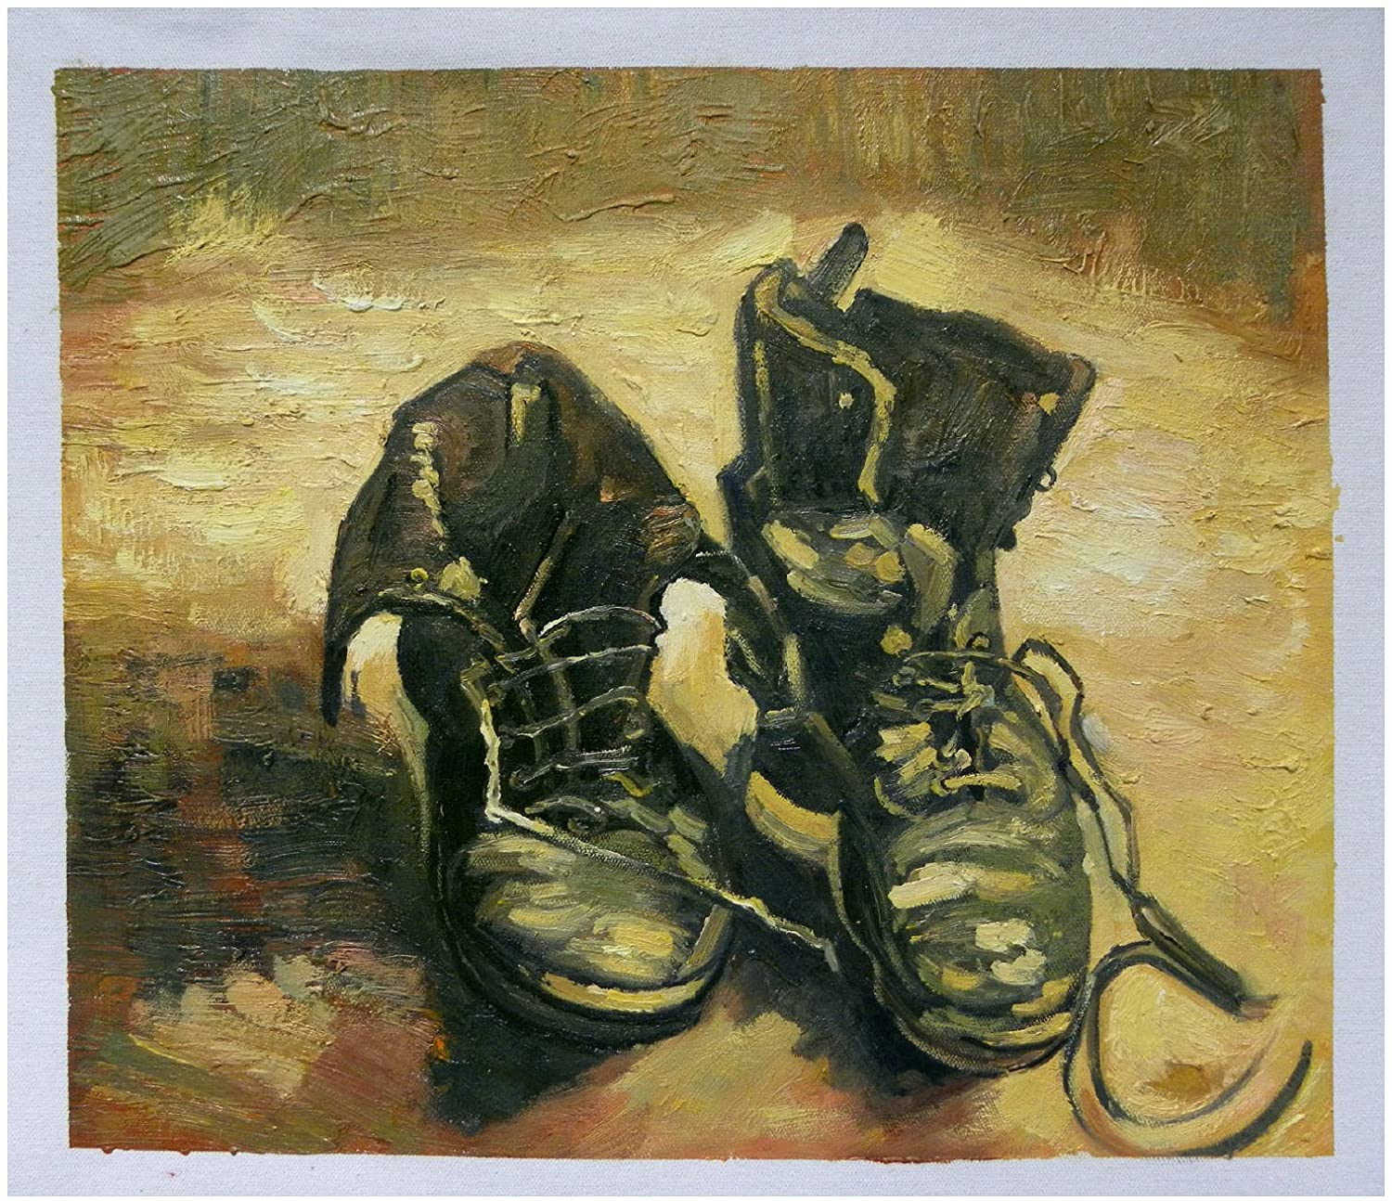

*“What is a pair in this case? Are you going to make my question disappear? Is it in order not to hear it that you’re speeding up the exchange of these voices, of these unequal tirades? Your stanzas disappear more or less rapidly, simultaneously intercut and interlaced, held together at the very crossing point of their interruptions. Caesuras that are only apparent, you won’t deny it, and a purely faked multiplicity. Your periods remain without innumerable origin, without destination, but they have authority in common. And you keep me at a distance, me and my request, measuredly, I’m being avoided like a catastrophe. But inevitably I must insist: what is a pair in this case?”*

To tell it slant, *The Truth in Painting* (1987)[1] sees a Jacques Derrida on the brink of tears. In its concluding essay, “Restitutions,” a staged correspondence-of-sorts among Derrida, Martin Heidegger and Meyer Schapiro on the topic of a Vincent van Gogh still-life of shoes and its (ever-contested) instruction in various problems of ontology and aesthetics, the philosopher winds up drunk on the immensurate possibility and pain of language that moves.

The short of it, if we back up a bit, is that the writer has undertaken a relatively straightforward operation, has tried to conduct a restitution of his own in wrangling the object (the subject) of the painting (in this instance, boots) back from the clutches of the (viewing) subject’s own unending narcissism or compulsive need to situate and settle the owner of the rendered shoes. But midway into schooling Heidegger and Schapiro on the inanity of the question *whose are the shoes?* Derrida runs into a big problem, the problem of bandit language. Here, in this corner of hell, it is as if différance has exceeded its vibrational form. Words have actually detached themselves from their otherwise fixed positions and have begun to dance in the ruins of *“Are you going to make my question disappear?”—*an inquiry that embarrasses itself in the light of that which supplants it, i.e. the far more ominous, *“will my question disappear of its own accord?”*

This self-willing, autonomous disappearing and re-appearing of language raises innumerable quandaries, and it would be obviously outside the scope of the present project to identify and attend to all of them. Though it would, decidedly, behoove us to pay (aha!) attention to the problem of scope itself.[2] The problem of scope, at least for those most intimately involved in this polylogue, has something to do with the framing, or the capture of art, which of course is at its heart a kind of insurance policy against indeterminacy. Without it, there’s no telling where those shoes (Van Gogh’s, Schapiro’s, Heidegger’s, the city-man’s, the peasant-woman’s, etc.) might go. What they might do—until an unassuming set of laces probes in the direction of the back of the canvas and threatens to break everything open:

“...the laces go through the eyelets (which also go in pairs) and pass on to the invisible side. And when they come back from it, do they emerge from the other side of the leather or the other side of the canvas? The prick of their iron point, through the metal-edged eyelets, pierces the leather and the canvas simultaneously. How can we distinguish the two textures of invisibility from each other?” (304)

I say threatens because we cannot assume that breaking is actually on the proverbial table, and it is still possible that Derrida, in spite of himself, wants it both ways. So let us review the case: the painting in and of itself is rather like an eyelet. Neither possesses *topos*, nor bottom. To put it very plainly, an eyelet or a painting is not on the ground. In the case of the latter, the frame constitutes a cosmetic stop-gap for only one of the sources of the scramble (what is inside versus outside of the thing itself *but* *only* *in terms of the viewing subject*) and leaves other, more pernicious darknesses behind. For a painting is not on the ground. Its eschewal of true lateral form means that we will have trouble discerning what is underneath or behind or on top of. And it soon becomes clear that it is not, to return to the original question, so much a matter of breaking. The back of the canvas registers the pressure of the pointure of the eyelet and, having nowhere to put it, no safety valve in which to express the excesses of misbehaving objects, dilates—perhaps out of respect for our old murmuring dreams of spatial determinacy, perhaps in outright protest. In either instance the result is the same: the shoes, sensing their position, their static confinement, cannot simply escape out the back door. And Schapiro and Heidegger cannot simply *goad them out*, using grubby hands or sweet nothings or other strange, even unspeakable instruments.

So as it stands, the shoes are still laughing, making a scene over our hubris, our pointed, elaborately doomed efforts to make them move of our own accord, to get them out, to put them on and walk around a bit. Intriguingly, Derrida’s refrain *what is a pair?* frustrates the plot in an ever-escalating manner. Let us count the ways. First, a pair’s being hinges on the “supplément of detachment”—a pair is only a pair insofar as I can abscond with its pairness by removing a half, which, in modifying or even obliterating the use value of that pair, unravels everything. The dreamer in Derrida would like, apparently, to replace this pairness with the aesthetic, philosophical oddity of two unrelated shoes appearing in tandem, unbound by the conceit of the pair and undone, or hollowed, of its Heideggerian equipmental being. If this is the case, we would see at once that breaking it (the pair) is instead no breaking at all; rather, the uncritical preservation of the pair as such actually affirms the standing possibility of its detachment.

The point is that there is a play to be made here with Derrida and not-breaking. For the philosopher brings us, again and again, to the sudden edge of collapse—a kind of imminent total dismemberment—only to inadvertently[3] surrender to the promise of the whole, as evidenced by both the dilating idea-field of the canvas, which balloons to accommodate the pointy eyelet of those fidgety shoes, and the instance of the pair.

This curious incongruity may finally be a clue among too-few in the unraveling of the mystery of the moving words—and why Derrida was so openly petrified of them. When he decries the “caesuras,” stanzas “intercut and interlaced,” it is as if brokenness itself unites all instances of language gone wrong, language that abandons its post and the will of the speaking subject. And so in a moment of cosmic irony, the deconstructionist howls over the injustice of rupture.

Until he stops.

Derrida’s critical uptake of the remnant/residue/remainder perhaps only makes sense in this context of his refusal of fragmentation, or his apparently numerous yet unnamed stakes in objects as self-contained, whole, and distinct. The remainder then becomes a means of shoring up a defense against the threat of broken or completely missing (i.e. phantom) objects. And conveniently for Derrida, and for us, this question of what remains is intimately connected with his own dreams for the shoes—Van Gogh’s shoes, who dragged us, phantom-limbed, into this mess:

Derrida writes of his interlocutors’ taking as axiomatic the pairness of the pair: “If there is a pair, then a contract is possible, you can look for the subject, hope is still permitted” (282). What Derrida is after, then, may be described as a sort of lawlessness in the form of ownerless (subjectless) shoes, made all the more likely by their not being a pair, by the shoes’ constituting then a form of reposeful refuse. Derrida claims to do what remains undone; he wants to unwrite this presumed affiliation with phenomenology’s basic orientation (the subject observing objects). The viewing subject, who appears too to be a stand-in for the critic in “Restitutions,” would excuse himself. The shoes would somehow themselves speak.

Though this is not the triumph that one might initially imagine. The object, stripped of its use value “because [the shoes] are painted” and already removed from the purview of the domineering (viewing) subject, is by the end little more than a residue of its former being. Derrida theorizes the residue, called the *remainder*, thusly:

“Shoes are also what you let fall. Particularly old shoes. The instance of the fall, the

fallen, or the downfallen. You let something fall like an old shoe, an old slipper, an old

sock. The remainder is also this lowness” (305).

We are told that the remainder has something to do with the beautiful just as Derrida sketches it fangs; he cannot help it, he claims, but deliver the news of a bottomed-out object, abandoned shoes on a deep, atmospheric charcoal. The shoes are ghoulish when subtracted of their work-being; ghastly things, that much is understood. That’s the price of admission: in order to return the object to itself, it is the object who must get out of the way, self-immolate. And we, for our part, have to just leave the shoes there.

Derrida, increasingly exasperated: “But what is it to abandon a picture?” (329).

$✽$

The truth of the matter is that this tale has been told before, and sooner or later we will begin scraping up the sticky residue of Derrida that has congealed all over the 19th century.[4] What I mean by this is that there are strange, even suspect resonances between a certain correspondence among Derrida, Heidegger, and Schapiro and the 19th century transatlantic world, whose literary output was undoubtedly shaped by the rise of the public art museum and the formalization of the art historical discipline. To hear Jonah Siegel tell it in his monograph *Desire and Excess* (2000), the marvel of archeological unearthings caused a scene in the gallery, where critics such as John Ruskin and William Hazlitt wept openly at the sight of the ineffable rendered rubble, the statuary of antiquity reduced, by perilous time, to fragment or dust.

As a response-in-kind to the tyranny of time, or the historicizing project of the 19th century Western world writ large,[5] poetry mounted a formidable restitution of its own. But instead of snatching the object back from the clutches of the critic or the viewing subject (or the critic-subject), these wranglings concern the purview of time itself. And in so wrangling, these texts must reverse the Derridean script; they must worship the remainder, the remnant, the residue itself—not as lowness, the dereliction of the abandoned shoes, but as the only flares of resistance available in the age of the museum catalogue, with its many-fingered hands. In other words, the poet and the art historian offer their love not to the whole (for only in their dreams does the torso on display at the British Museum sprout limbs) but to the beams of light that indicate the just off-view presence of the sun in a William Turner landscape, or the strange, staticky pulsating of the artist’s ear in Titian’s *Self-Portrait*.

In the essay’s present form, we can begin to set up (but not bring to any easy resting place) the problematic’s most striking features by using a couple of poems by Emily Dickinson as micro test-cases. “The One that could repeat the Summer Day” (1863) reveals an attention to our preestablished concerns in highly distilled form, more than a century prior to the composition of “Restitutions”:

The One that could repeat the Summer Day —

Were greater than Itself — though He –

Minutest of Mankind – should be —

And He — could reproduce the Sun —

At Period of Going down —

The Lingering — and the Stain — I mean —

When Orient have been outgrown —

And Occident — become Unknown —

His Name — remain —

The liberally applied em dash, supposed harbinger of fragmentation, functions instead as exhalation, elongation. With its force we have no choice but to move slowly through the (light-drenched) poetic line, which takes us to the brink of total sun and away again; the point here is not the object in its fullness but the fact of both our approach and its recent departure from the frame. Indeed, when the I takes care to clarify what she “means,” it’s on the authority of the stain, ontologically and aesthetically. But perhaps most striking for our purposes is that in contrast with Derrida’s, Dickinson’s remainder is exalted, the “Period of Going down” His own fantastical rendering.

Even more curious of the Dickinsonian remainder is that it often reveals not only the ontological status of the whole but its categorical identity. In “I held a Jewel in my fingers” (1861), for instance, we only come to understand the type of gem beheld by the I after it’s beheld no longer; only the residue reveals its source:

I held a Jewel in my fingers –

And went to sleep –

The day was warm, and winds were prosy –

I said "'Twill keep" –

I woke – and chid my honest fingers,

The Gem was gone –

And now, an Amethyst remembrance

Is all I own –

Like in the previous piece, an em dash after the final word of the poem expresses continuity as opposed to fracture. In the vein of Van Gogh’s laces, perhaps, the mark emanates outwards, gesticulating towards the empty space that envelopes but also gives rise to the text. In so doing, it does more than neutralize the impact of the “gone.” Rather, it shores up a nonverbal defense against the theft of the gem, ensuring that the Amethyst remembrance, once identified, remains in perpetuity.

$✽$

Well, we’ve been dreaming about poetry and meanwhile those shoes are still rattling around, loose “like old teeth,” and what we’ve done is we’ve picked up the remainder and put it back down again, no better than he in claiming to leave the shoes be and yet taking a skewer to their insides in the form of sprawling, unforgiving prose. “Shoes are to be used,” that’s clear, but what of what remains? How do we capture that? Relaunch it into space? Knit it a scarf? What is the mode of our present engagement? And what does it have to do with an undated correspondence between Emily Dickinson and her sister Susan, in which the poet proclaims simply: “But subjects hinder talk.” I have tried to write this sentence so many times, but the best I can muster is this: there is so much wanting here. Dickinson amplifying an era in her desiring the trace of the object itself, and Derrida just trying to leave the thing be and yet stuck in the repetition of revisitations, his own maddening state of things: wanting to avoid the “police-like internal investigations” on the one hand (what even is internal to the painting?) and yet this sickly sweet devotion to the whole—the encapsulation of the shoes as independent figurines, deadened by nature of their being painted (“still life” as *nature morte*) but freed in self-ownership, the objects restituted from the subject’s gaze and from the provisioning of the pair.

But no “hasty step here, no hurrying pace toward the answer” (262). Derrida, in his defense, warned us against the very temptation: “Hurrying along is perhaps what no one has ever been able to avoid when faced with the provocation of this famous picture.” Alright, so we have slowed to nearly full repose, barreling towards the end, I suppose, and now, I must ask: But what is it to abandon a poem? And if George Berkeley says that in departing the room containing the table, the table, no figment of static, physical reality, actually ceases to be until precisely the moment of my return, what would that have to do with the problem of piecing Dickinson to paper? In other words, where does the poem, the painting go? Am I going insane, or is the opening premise of the project, Derrida’s anxiety over words that move of their own accord, actually coming full circle, tracing the whole of our engagement, our ever-ballooning inquiry?

If my rendering is faithful enough, then the writing itself will constitute the remainder. Though this is not the triumph that one might initially imagine. For Derrida was right concerning at least one source of collapse, of rupture: if reading, writing, and looking constitute the triumvirate of activities that, when taken together, begin to reveal the truth of the shoes, then the project will detonate on command—there is, at any given moment of productivity, a lacuna at the site of one. If I am looking at the painting in order to write about it, in order to engage in the correspondence amongst Derrida, Heidegger, and Schapiro, the painting will for a brief moment in time be lost to pen; a logistical problem becomes a philosophical one. And if I were to write about a poem which is also, in its way, about the painting, the problem doubles; I can only hold one at a time, a play of ever-shifting blindspots. So the final question re-subsumes, at last, an old form: “How can we distinguish the two textures of invisibility from each other?” And what to make of those imperceptible bits which bend instead of break?

1. I’m working with the U Chicago publication of this manuscript, translated by Geoff Bennington and Ian McLeod.
2. The joke here is two-fold, as summarized at the beginning of Derrida’s essay: “*Returning* will have great scope in this debate (and so will *scope*), if, that is, it’s a matter of knowing to whom and to what certain shoes, and perhaps shoes in general, *return*. To whom and to what, in consequence, one would have to restitute them, render them, to discharge a debt. —Why always say of painting that it renders, that it restitutes?”
3. I say inadvertently because we have only arrived here not via a “police-like investigation” of the “insides” of the text but by a process of reading which is really always already *refracting*. In other words, the analytics exposes the text to itself, that is, exposes the text to the text. In the spirit of this paper, a mirror shown a mirror does not shatter but expands ad infinitum.
4. But how can an earlier time bear the mark of a later? The answer is likely some version of the following: Because I made it so. And yet. Reading Derrida through 19th century art, or reading 19th century art through Derrida, mimics the mirroring of historical representation. It dramatizes the strangeness of living in time, as we do, and of witnessing that we are always already both being made and making. History haunts itself reflexively. When we hold a mirror up to the text, we are doing the same with the historical, an apparition which reveals nothing more than a ghost upon a ghost upon a ghost.
5. György Lukács, whose analysis of the rise of the historical novel in nineteenth century Europe concludes that a lived reality of mass death, courtesy of the French Revolution, encouraged a sudden understanding of the particularities of one’s time, or a cultivation of what he coins historical consciousness, is helpful to the project. In a similar spirit, contact with the burgeoning museum, which has been understood since its inception as a mausoleum in disguise, will have encouraged a similar *devotion to and rejection of* the 19th century’s grander historicizing regime.