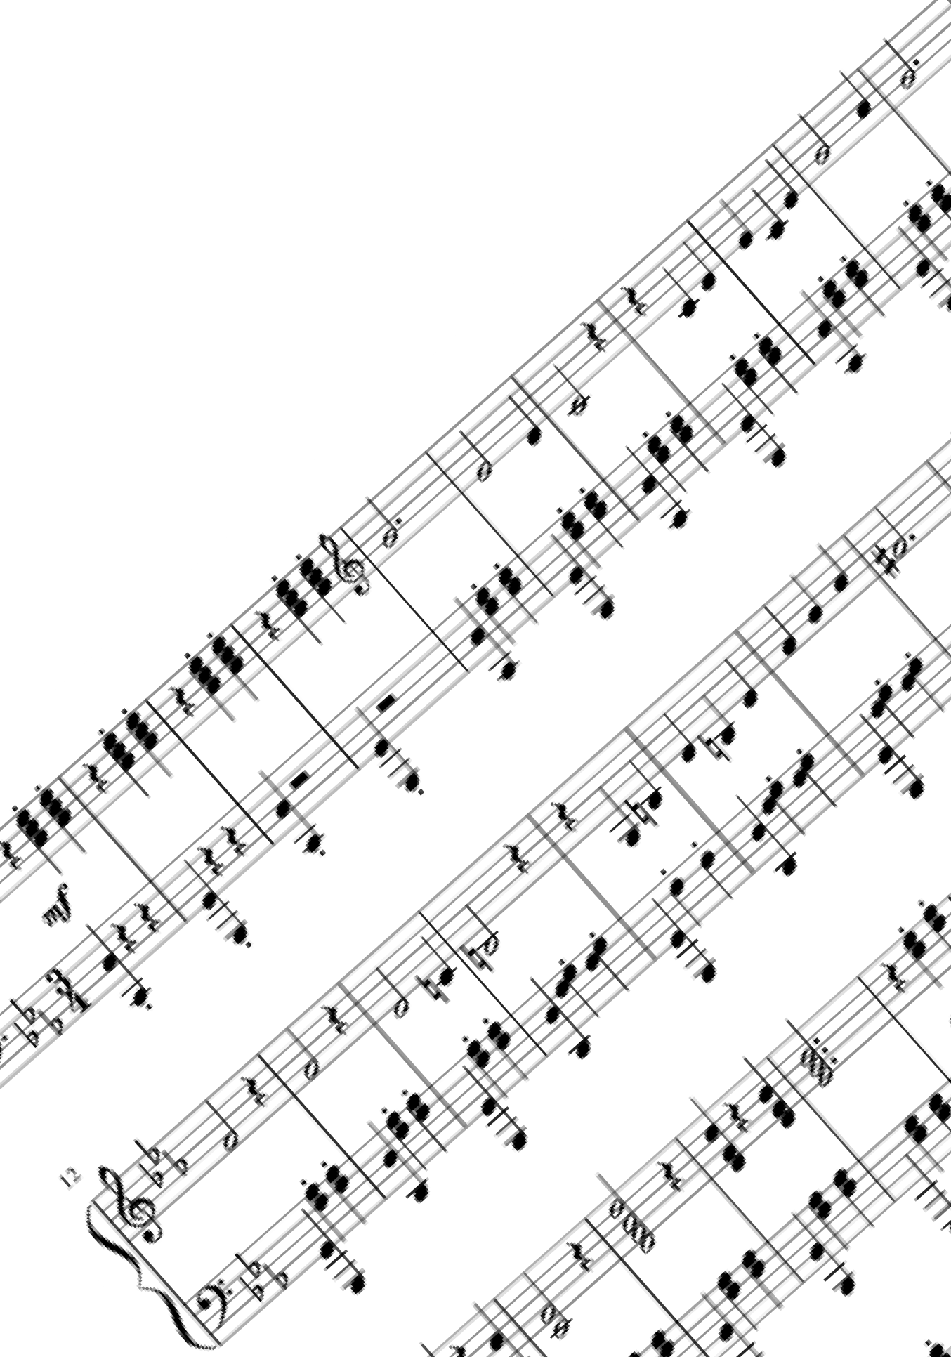The Starry Waltz

# Ekphrasis

about Shostakovich

# Al Hannoyer

***The Starry Waltz***

Ekphrasis about Dmitri Shostakovich

***Al Hannoyer***

Above our eyes, a waltz has just begun, Taking place in the open sky tonight, Flooding the vast world with all of their light,

Stars and moon dance before the setting sun,

It almost look like a ferocious fight,

Like night flowers blossoming in a dale,

All the stars shining bright and yet so pale, It’s a dark ballet, the joust of a knight,

I hear a brave nocturnal nightingale, Echoing his tune in the deep silence,

With might and beauty, pride and assurance, All his notes telling an enchanted tale,

Can you see him as he’s taking his chance, Singing his chant towards the silver witch, Bringing his beautiful art to his pitch,

Trying to seduce the moon with his dance,

Spassiba bolshoi D. Shostakovich,

For the brightness in this sad world so dun, I listen to the music that does stun, Everyone, old or young, poor or rich.

PITCH

*The Starry Waltz* is an ekphrasis about Dmitri Shostakovich’s music and the Waltz No 2 in particular. The music takes shape of a starry ballet and a nightingale trying to seduce the moon.This poem is composed of 5 quatrains of decasyllables. It can appeal to readers between 7 and 100, who love music and poetry.

AUTHOR

Aurélien “Al” Hannoyer was born in 1990 near Paris, France. He began writing songs, poems and short stories at the age of six. Always passionate about reading fantasy books above all, he did literary studies and then got his double master’s degree of marketing, communications and management. He has written two novels, several short stories and some poetry. He now lives in Paris, writing the next adventures of his heroes. He likes nothing more than sit and imagine stories. Three of his poems have been published by The Antonym Magazine in May 2021, *The Arising City* being featured on Instagram.

Contact : [aurelien.hannoyer@gmail.com](mailto:aurelien.hannoyer@gmail.com)

+33(0)769428006

8 rue Marx Dormoy 75018 Paris, France