MARK OF THE WEB

* Open Browser
* Go to: <https://github.com/thecelestialjewel/CS160-Fortune>
* Click ‘Clone or download’, select Download Zip:  
  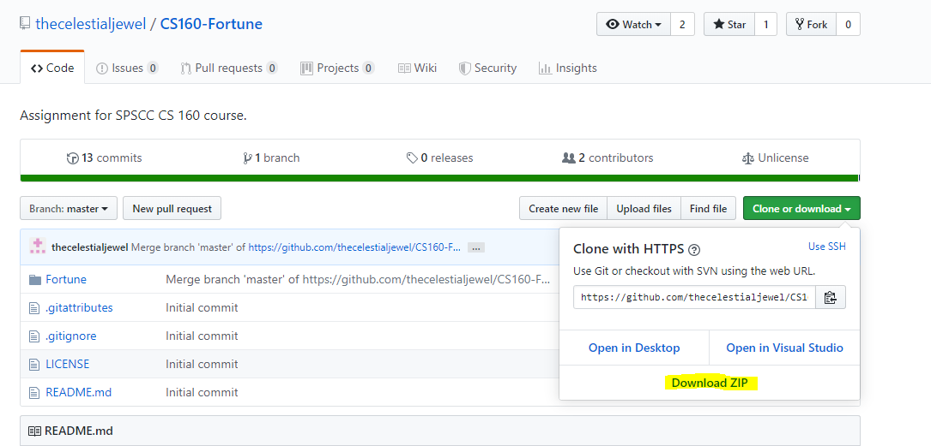
* Go to your download locations.
* Extract the zip file in same location.  
  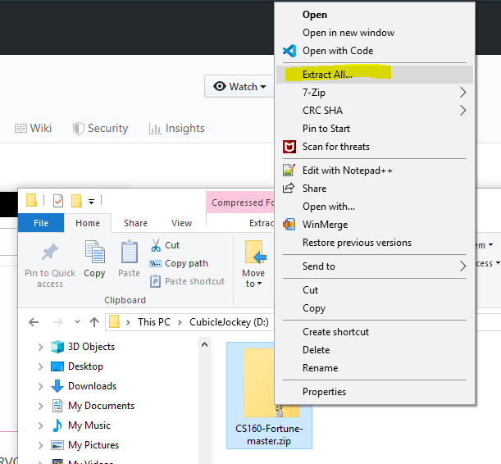
* Open the newly unzipped folder and navigate to the folder containing the solution (.sln) file.
* Right click the file RemoveMarkOfTheWeb.ps1 and Select Properties  
  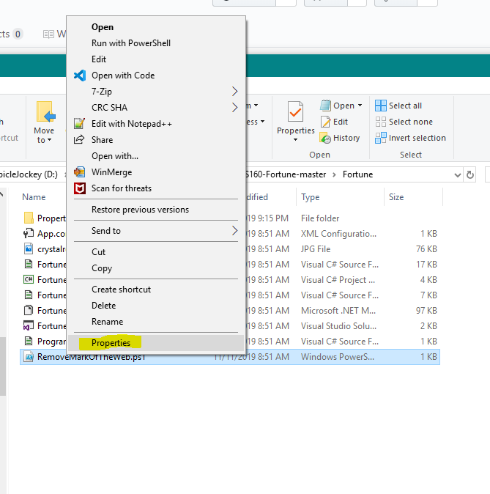
* Check the box ‘Unblock’, then click apply:  
  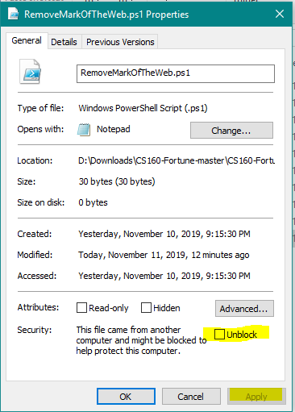
* Right-click the file RemoveMarkOfWeb.ps1 and select ‘Run with PowerShell’
* Now open the Solution File Fortune.sln. Mark of the web should no longer bother Fortune.resx file.