**Assignment 4 (Term Project)**

Student Enrollment System

**Group Member:**

[Acevedo Aguilera, Ismael](javascript://)

[Jacome Gomez, Vinicio](javascript://)

[Jose, Christy](javascript://)

[Prathan, Sorada](javascript://)

**Centennial College**

**COMP-214 (Section: 006)**

**Professor Zoran Sarajlic**

**December 2, 2022**

**Table of Contents**

Section 1: Problem Domain Description 1

Section 2: ER Diagram 2

Section 3: User Interface Screens 3

# Section 1: Problem Domain Description

The purpose of this project is to create an enrollment system for higher education institutes. This enrollment system assists educational institutions to manage all the activities related to student enrollment process from enrolling student to the course and handling student-related fee calculation for payment effectively. Overall, the information required for the business includes student, course, program, department and section. As an enrollment is processed the business functionalities are as followed:

* Enroll student to the institutions automatically.
* Enroll student to the program automatically.
* Display alert if capacity of a section of particular course is fully occupied.
* Calculate student fees according to the program chosen and the type of student – domestic or international.
* Store and backup data of student’s enrollment history.

# Section 2: ER Diagram

# Section 3: User Interface Screens

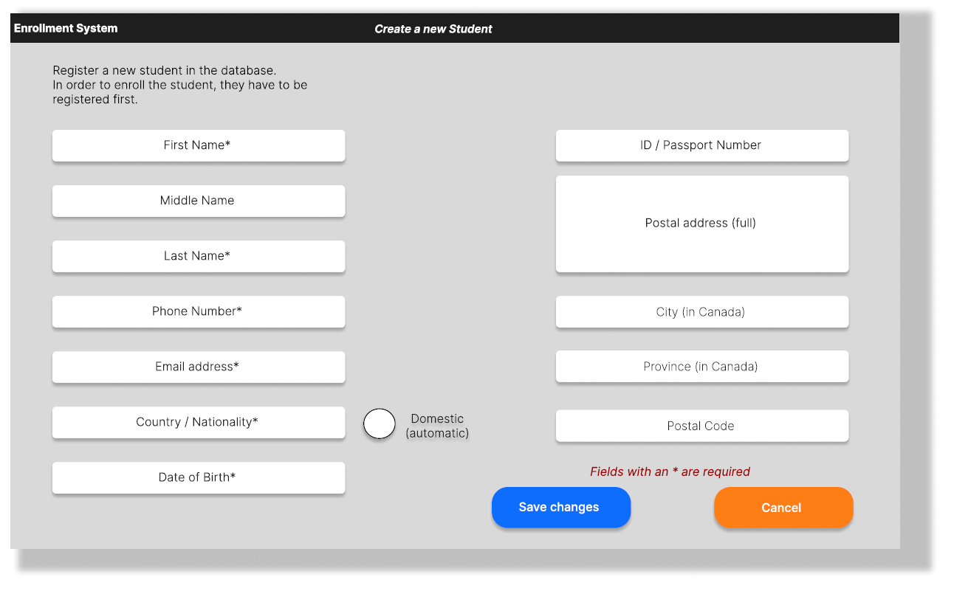**User Interface for create a new student**

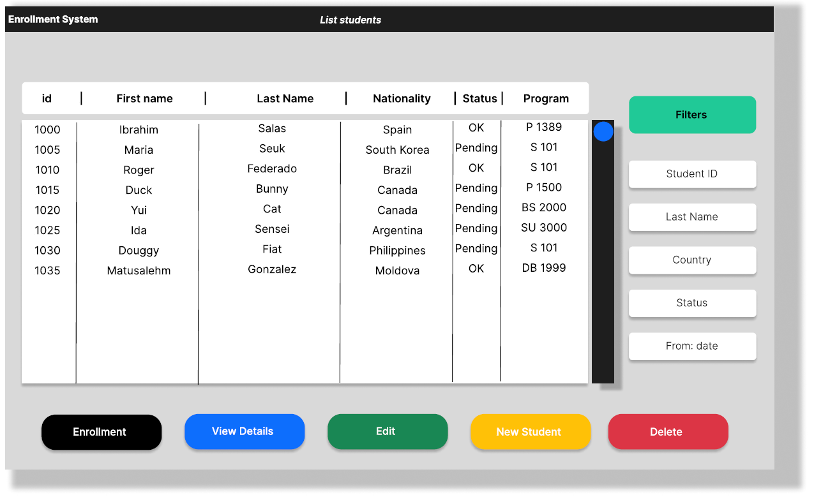**User Interface for list students**

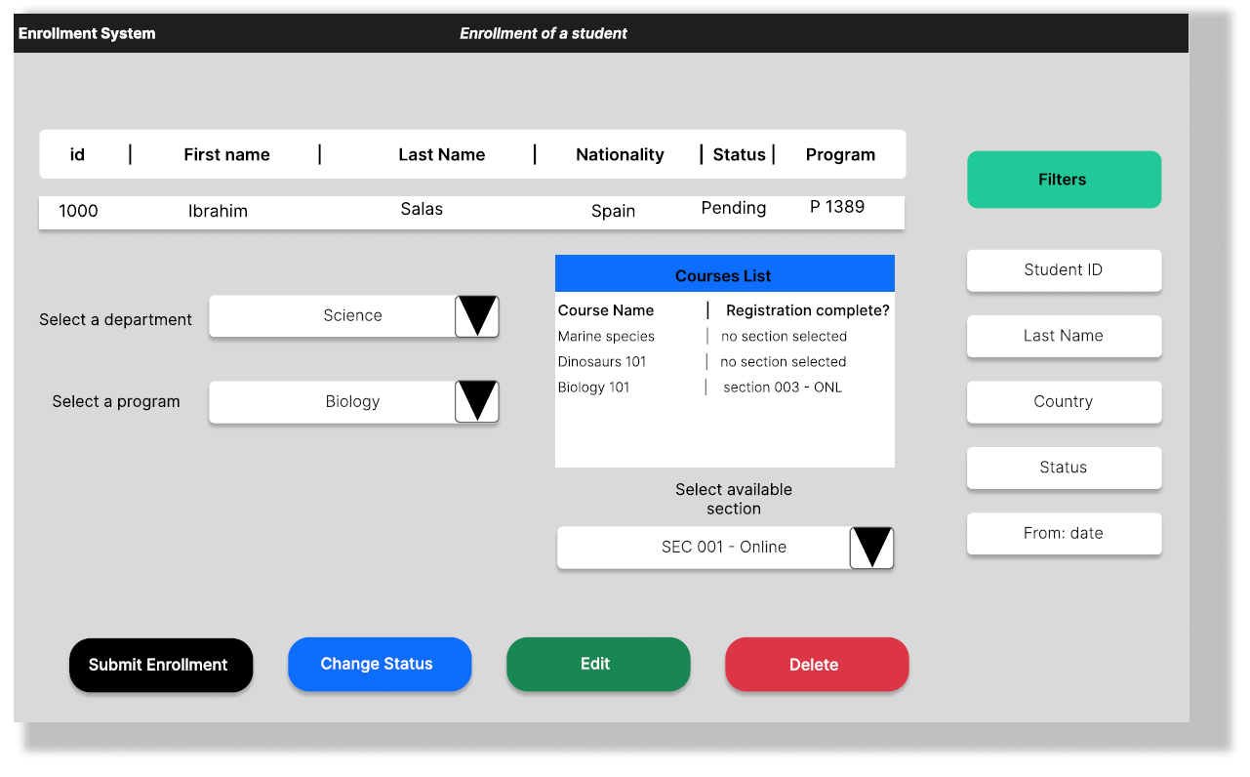**User Interface Enrollment of a student**