General Overview

Our research project consists of an analysis of president Trump’s Twitter tweets from the announcement of his candidacy on June 16, 2015, to the recent present of November 28, 2018. With those tweets, we desired to answer a few questions.

1) Politicians often keep the content of their public declarations within two contexts: critiques of political and policy matters, and critiques of someone’s character or behavior. We wanted to see if Trump tweets mostly about political matters, or if he tweets mostly about peoples’ character. We also wanted to see if this trsend changed from before presidency, to during presidency.

2) We wanted to know what sort of political topics Trump tweeted about, and when he tweeted about them. We also wanted to know what political topics Trump tweeted about the most.

3) We wanted to know if any public events that occurred in the given time frame had an influence on the types of political topics Trump tweeted about.

4) We wanted to know what political topics that Trump spoke about were the most popular with the public.

5) The popularity of political topics can change with time, and we wanted to see how the popularity of certain topics that Trump spoke about changed over the course of roughly three years.

Some assumptions:

To answer these questions, some assumptions must be made on the data, and thus, an understanding must be had that the conclusions drawn, while interesting, are only educated inferences.

- When we refer to political topics, we are assuming that one keyword can define the entire context of a tweet, and the same goes for character. Acknowledging this, we tried to use keywords that were less universal and context-dependent.

-When we refer to the popularity of a topic, we are assuming that the number of likes a tweet gets is representative of the public’s interest in that topic.

Data and Conclusions

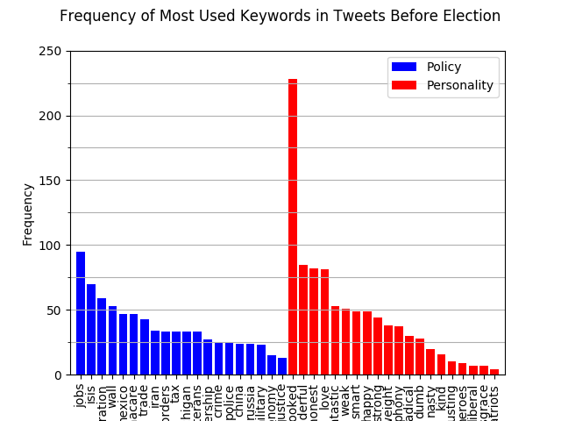

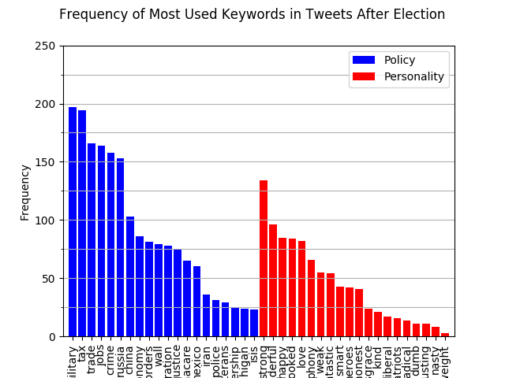

- Immediately it’s clear to see that Trump tweeted about policy about as much as he tweeted about peoples’ character.

- Trump’s frequency of tweets increased by a large margin after he became president.

- Trump increased the amount of political declarations he was making after becoming president, when compared to before.

- Trump’s usage of the term ‘crooked’ before presidency was over 150% more frequent than any other word.

Conclusions:

It’s interesting to note how Trump speaks of peoples’ character as much as he does their politics. Perhaps the frequent reference to peoples’ character influences the public’s opinion on the politics those people support.

One would be inclined to think that upon gaining one of the toughest jobs in the world, there would be less time to tweet. However, Trump has managed to vastly increase the output of his twitter feed since being president.

Trump actually didn’t tweet about policy very much when running for president. However, once he became president, that become the majority of his tweets.

‘Crooked’ is a term used often by Trump to refer to previous secretary of state, Hilary Clinton. It’s also used when referring to the Democratic National Convention, as well as other politicians. Perhaps having consistency in his accusations, Trump can create a persona of sorts for his followers to see in the people accused.

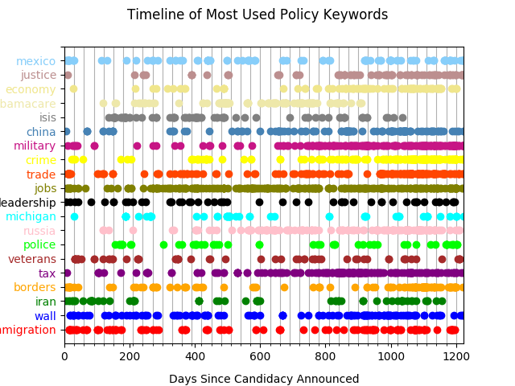

This timeline graph represents all the dates of all of Trump’s most frequently discussed topics.

- Taxes, the military, the economy, crime, China, and Russia weren’t mentioned much in his running for president, but became quite frequent over the past year.

- The frequency of Mexico, trade, leadership, veterans, and the border wall stayed fairly consistent over the time interval.

- The wall, immigration, and especially jobs have been very frequent and consistent.

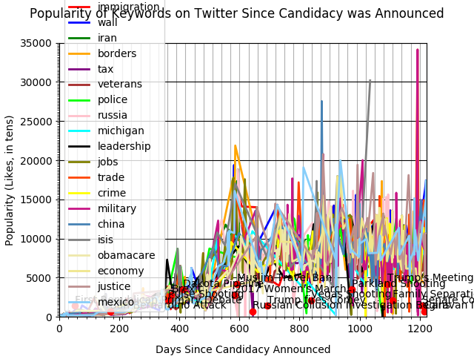

- This graph simply has too much data on it to fit into a standard computer screen. It’s suggested that a projector is used to obtain best view for data analysis. The overwhelming amount of data is also why this graph has been split Into four other graphs which can be analyzed. The four other graphs are in the folder provided.

- Each line represents a frequent political topic, and it’s correspondence to the y-axis represents it’s popularity. Each word is plotted throughout the given time interval with the dates of public events plotted along the x-axis.

There is a large purple spike at the very right of the graph which represents the military. When considering the other graphs along with this one, it seems that Trump increased his frequency of military tweets along with the public’s likes. A curious question that develops, is if the public is liking the military tweets more because Trump is tweeting about it more, or if Trump is tweeting about it more because the public likes it.

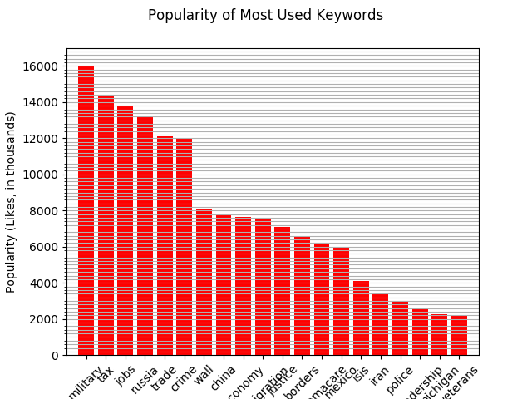

This graph shows the popularity of certain topics to the public when tweeted by Trump.

- The military is a topic that is much more popular than any other topic among Trump’s followers.

- Taxes and jobs are a popular topic among the public, which also happen to be topics which Trump tweets about most frequently.

- Isis, Iran, police, leadership, Michigan, and veterans are a less popular topic among the public.

Concluding Remarks

- Due to the large increase in the frequency of tweets upon becoming president, it’s difficult to see if there were any decreases in frequency of certain words over time.

- We can expect an increase in frequency and popularity of tweets related to China and Russia, considering the events that occurred nearing the end of the time interval.

- Topics regarding the wall, and jobs remained very consistent since Trump’s announcement of candidacy.

- Trump didn’t speak much about policy in his campaign. Perhaps people find it more interesting and entertaining to hear/read about corrupt politicians than actual politics, and that by remaining on a primarily personality-based twitter campaign, Trump was able to keep the public’s support. Which could explain why the seemingly odd increase of policy-based tweets, and decrease of personality-based tweets after becoming president.